LAB ASSIGNMENT 2
KARISHUMA VIKRAM
- Integer array using pointers
#include <stdio.h>

int main() {
int arr[5] = {10, 20, 30, 40, 50};
int *ptr = arr;

printf("Elements:\n");
for(int i = 0; i < 5; i++)
printf("%d ", *(ptr + i));

printf("\nModified Elements:\n");
for(int i = 0; i < 5; i++)
*(ptr + i) += 5;

for(int i = 0; i < 5; i++)
printf("%d ", arr[i]);

return 0;
}
Output
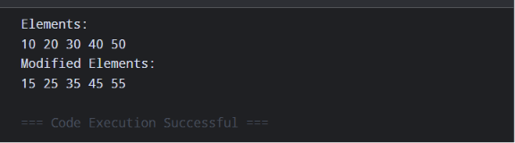

- Calculate string length using pointers
#include <stdio.h>

int main() {
char str[100];
char *ptr;
int len = 0;

printf("Enter a string: ");
fgets(str, sizeof(str), stdin);

ptr = str;

while(*ptr != '\0') {
len++;
ptr++;
}

printf("Length = %d", len - 1); // exclude '\n'
return 0;
}
Output
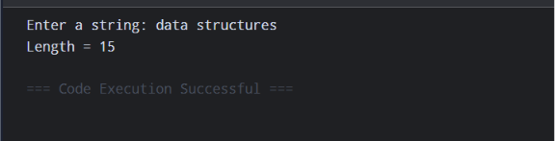

- Function to calculate sum and product of two numbers using pointers
#include <stdio.h>

void calc(int a, int b, int *sum, int *product) {
*sum = a + b;
*product = a * b;
}

int main() {
int x, y, sum, product;

printf("Enter two numbers: ");
scanf("%d%d", &x, &y);

calc(x, y, &sum, &product);

printf("Sum = %d\n", sum);
printf("Product = %d\n", product);

return 0;
}
Output
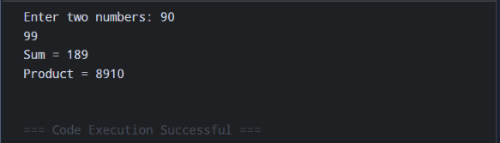

- Create an array of structures. Use dynamic memory allocation to allocate memory space and use a structure pointer with pointer arithmetic to iterate and access/modify members.
#include <stdio.h>
#include <stdlib.h>

struct Student {
int rollNo;
char name[30];
float marks;
};

int main() {
int n;

printf("Enter number of students: ");
scanf("%d", &n);

struct Student *ptr;

ptr = (struct Student *)malloc(n * sizeof(struct Student));

if (ptr == NULL) {
printf("Memory allocation failed!\n");
return 1;
}
for (int i = 0; i < n; i++) {
printf("\nStudent %d\n", i + 1);

printf("Roll No: ");
scanf("%d", &((ptr + i)->rollNo));

printf("Name: ");
scanf("%s", (ptr + i)->name);

printf("Marks: ");
scanf("%f", &((ptr + i)->marks));
}

for (int i = 0; i < n; i++) {
(ptr + i)->marks += 5;
}

printf("\nStudent Details:\n");
for (int i = 0; i < n; i++) {
printf("Roll No: %d\n", (ptr + i)->rollNo);
printf("Name: %s\n", (ptr + i)->name);
printf("Marks: %.2f\n\n", (ptr + i)->marks);
}

free(ptr);

return 0;
}
Output
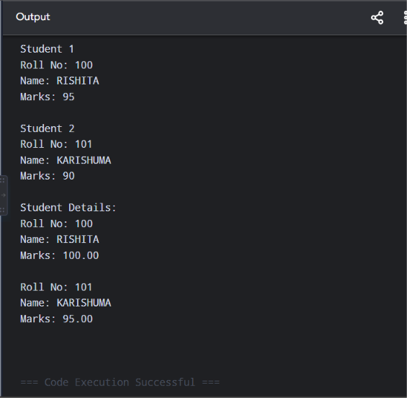

- Define two functions with same signature. Declare a function pointer and use it to call both functions.
#include <stdio.h>

int add(int a, int b)
{
return a + b;
}

int multiply(int a, int b)
{
return a * b;
}

int main()
{
int (*fp)(int, int);

fp = add;
printf("Sum = %d\n", fp(10, 5));

fp = multiply;
printf("Product = %d\n", fp(10, 5));

return 0;
}
Output
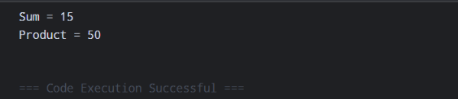

- Declare an integer, a pointer to it, and a double pointer. Print the values and addresses at each level.
#include <stdio.h>

int main()
{
int num = 100;
int *ptr = &num;
int **dptr = &ptr;

printf("Value of num = %d\n", num);
printf("Address of num = %p\n", (void*)&num);

printf("Value stored in ptr = %p\n", (void*)ptr);
printf("Value pointed by ptr = %d\n", *ptr);

printf("Value stored in dptr = %p\n", (void*)dptr);
printf("Value pointed by dptr = %p\n", (void*)*dptr);
printf("Value using **dptr = %d\n", **dptr);

return 0;
}
Output
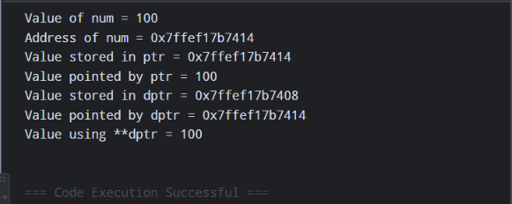

- Sort an array of floating point numbers using Selection Sort
#include <stdio.h>

int main()
{
int n, i, j, min;
float a[100], temp;

printf("Enter number of elements: ");
scanf("%d", &n);

printf("Enter elements:\n");
for(i = 0; i < n; i++)
scanf("%f", &a[i]);

for(i = 0; i < n - 1; i++)
{
min = i;

for(j = i + 1; j < n; j++)
{
if(a[j] < a[min])
min = j;
}

temp = a[i];
a[i] = a[min];
a[min] = temp;
}

printf("Sorted array:\n");
for(i = 0; i < n; i++)
printf("%.2f ", a[i]);

return 0;
}
Output
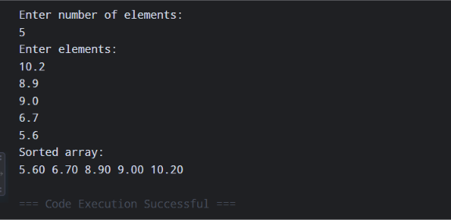

- Define a structure Student with id, name and grade. Create an array of Student structures and sort them based on different fields.
#include <stdio.h>
#include <string.h>

struct Student
{
int id;
char name[30];
char grade;
};

int main()
{
struct Student s[10], temp;
int n, i, j;

printf("Enter number of students: ");
scanf("%d", &n);

for(i = 0; i < n; i++)
{
printf("\nStudent %d\n", i + 1);

printf("ID: ");
scanf("%d", &s[i].id);

printf("Name: ");
scanf("%s", s[i].name);

printf("Grade: ");
scanf(" %c", &s[i].grade);
}

for(i = 0; i < n - 1; i++)
{
for(j = i + 1; j < n; j++)
{
if(s[i].id > s[j].id)
{
temp = s[i];
s[i] = s[j];
s[j] = temp;
}
}
}

printf("\nStudents Sorted by ID:\n");
for(i = 0; i < n; i++)
{
printf("%d %s %c\n",
s[i].id,
s[i].name,
s[i].grade);
}

return 0;
}
Output
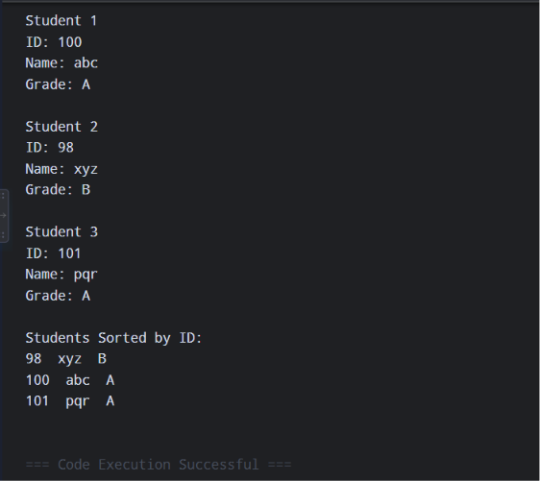
- Sort negative no.s using radix sort
#include <stdio.h>
#include <stdlib.h>

void countingSort(int arr[], int n, int exp)
{
int output[n];
int count[10] = {0};

for (int i = 0; i < n; i++)
count[(arr[i] / exp) % 10]++;

for (int i = 1; i < 10; i++)
count[i] += count[i - 1];

for (int i = n - 1; i >= 0; i--)
{
output[count[(arr[i] / exp) % 10] - 1] = arr[i];
count[(arr[i] / exp) % 10]--;
}

for (int i = 0; i < n; i++)
arr[i] = output[i];
}

void radixSort(int arr[], int n)
{
if (n == 0) return;

int max = arr[0];
for (int i = 1; i < n; i++)
if (arr[i] > max)
max = arr[i];

for (int exp = 1; max / exp > 0; exp *= 10)
countingSort(arr, n, exp);
}

int main()
{
int n;
printf("Enter number of elements: ");
scanf("%d", &n);

int arr[n];

printf("Enter elements:\n");
for (int i = 0; i < n; i++)
scanf("%d", &arr[i]);

int neg[n], pos[n];
int negCount = 0, posCount = 0;

for (int i = 0; i < n; i++)
{
if (arr[i] < 0)
neg[negCount++] = -arr[i];
else
pos[posCount++] = arr[i];
}

radixSort(neg, negCount);
radixSort(pos, posCount);

printf("Sorted array:\n");

for (int i = negCount - 1; i >= 0; i--)
printf("%d ", -neg[i]);

for (int i = 0; i < posCount; i++)
printf("%d ", pos[i]);

printf("\n");

return 0;
}
Output
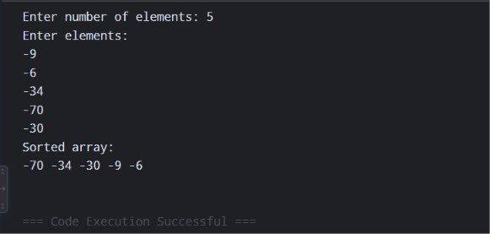

- Write a program to copy one array to another using pointers
#include <stdio.h>

int main()
{
int n;

printf("Enter the number of elements: ");
scanf("%d", &n);

int arr1[n], arr2[n];

printf("Enter the elements of the first array:\n");
for(int i = 0; i < n; i++)
{
scanf("%d", &arr1[i]);
}

int *p1 = arr1;
int *p2 = arr2;

for(int i = 0; i < n; i++)
{
*(p2 + i) = *(p1 + i);
}

printf("Copied array elements are:\n");
for(int i = 0; i < n; i++)
{
printf("%d ", arr2[i]);
}

return 0;
}
Output
