IT23302-Data structures

Homework :

- (a) Define an integer array. Declare an integer pointer and initialize it to point to the first element of the array. Use pointer arithmetic to traverse the array and print the elements.

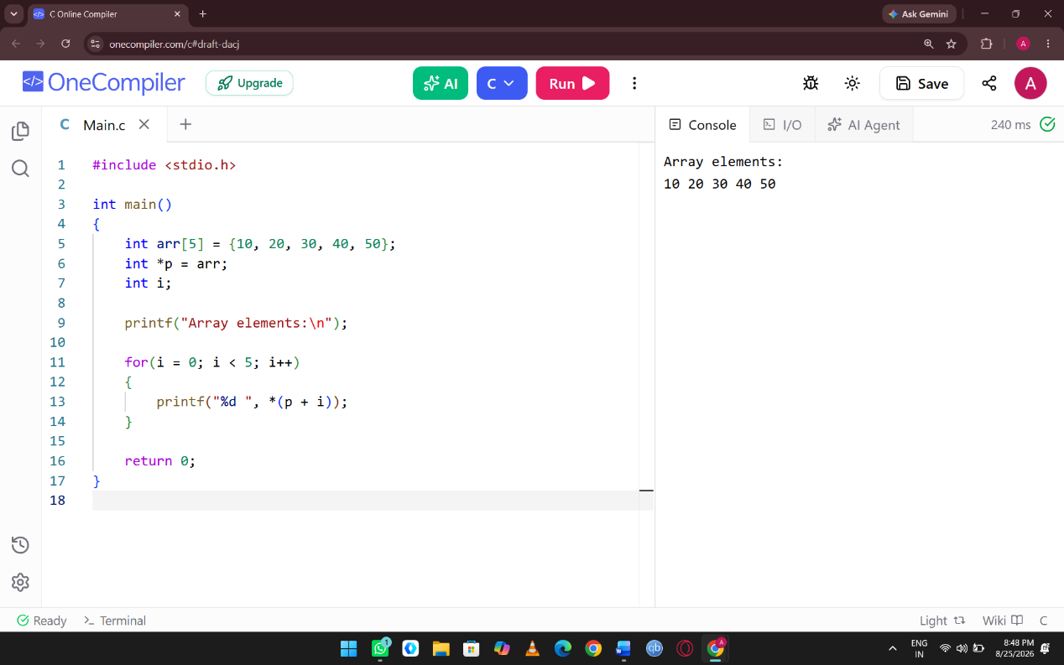

(b) Modify the elements of the array using pointer arithmetic.
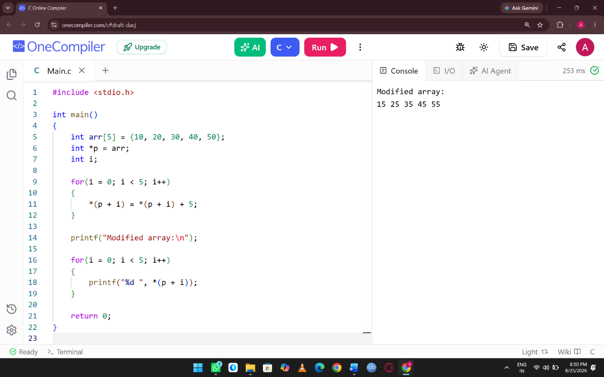
- Calculate string length using pointers.

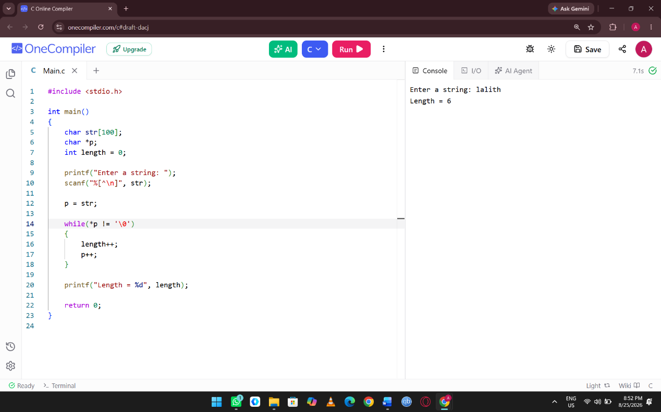

3.Write a function that calculates both the sum and product of two numbers. Return these two results using pointers passed as arguments to the function.

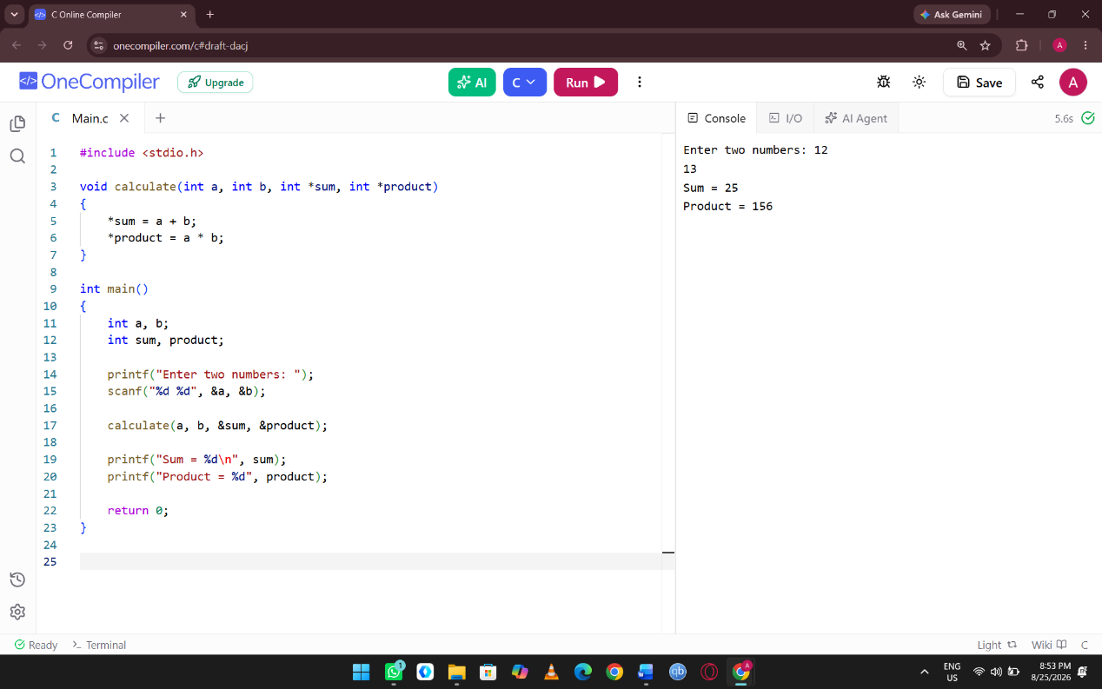

4.Create an array of structures. Use dynamic memory allocation to allocate memory space and use a structure pointer with pointer arithmetic to iterate and access / modify members.

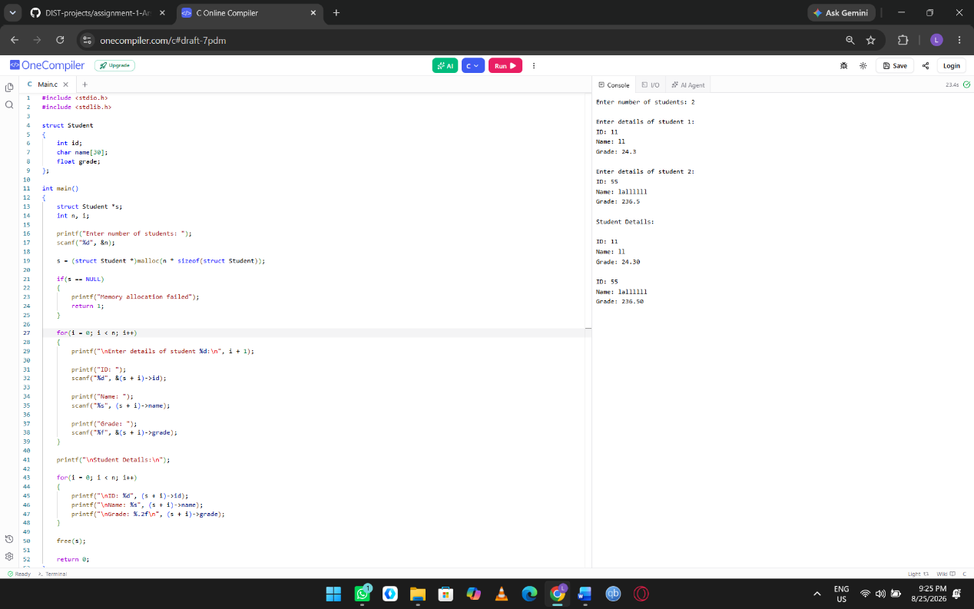

5.Define two functions with the same signature. Declare a function pointer and use the pointer to call both functions

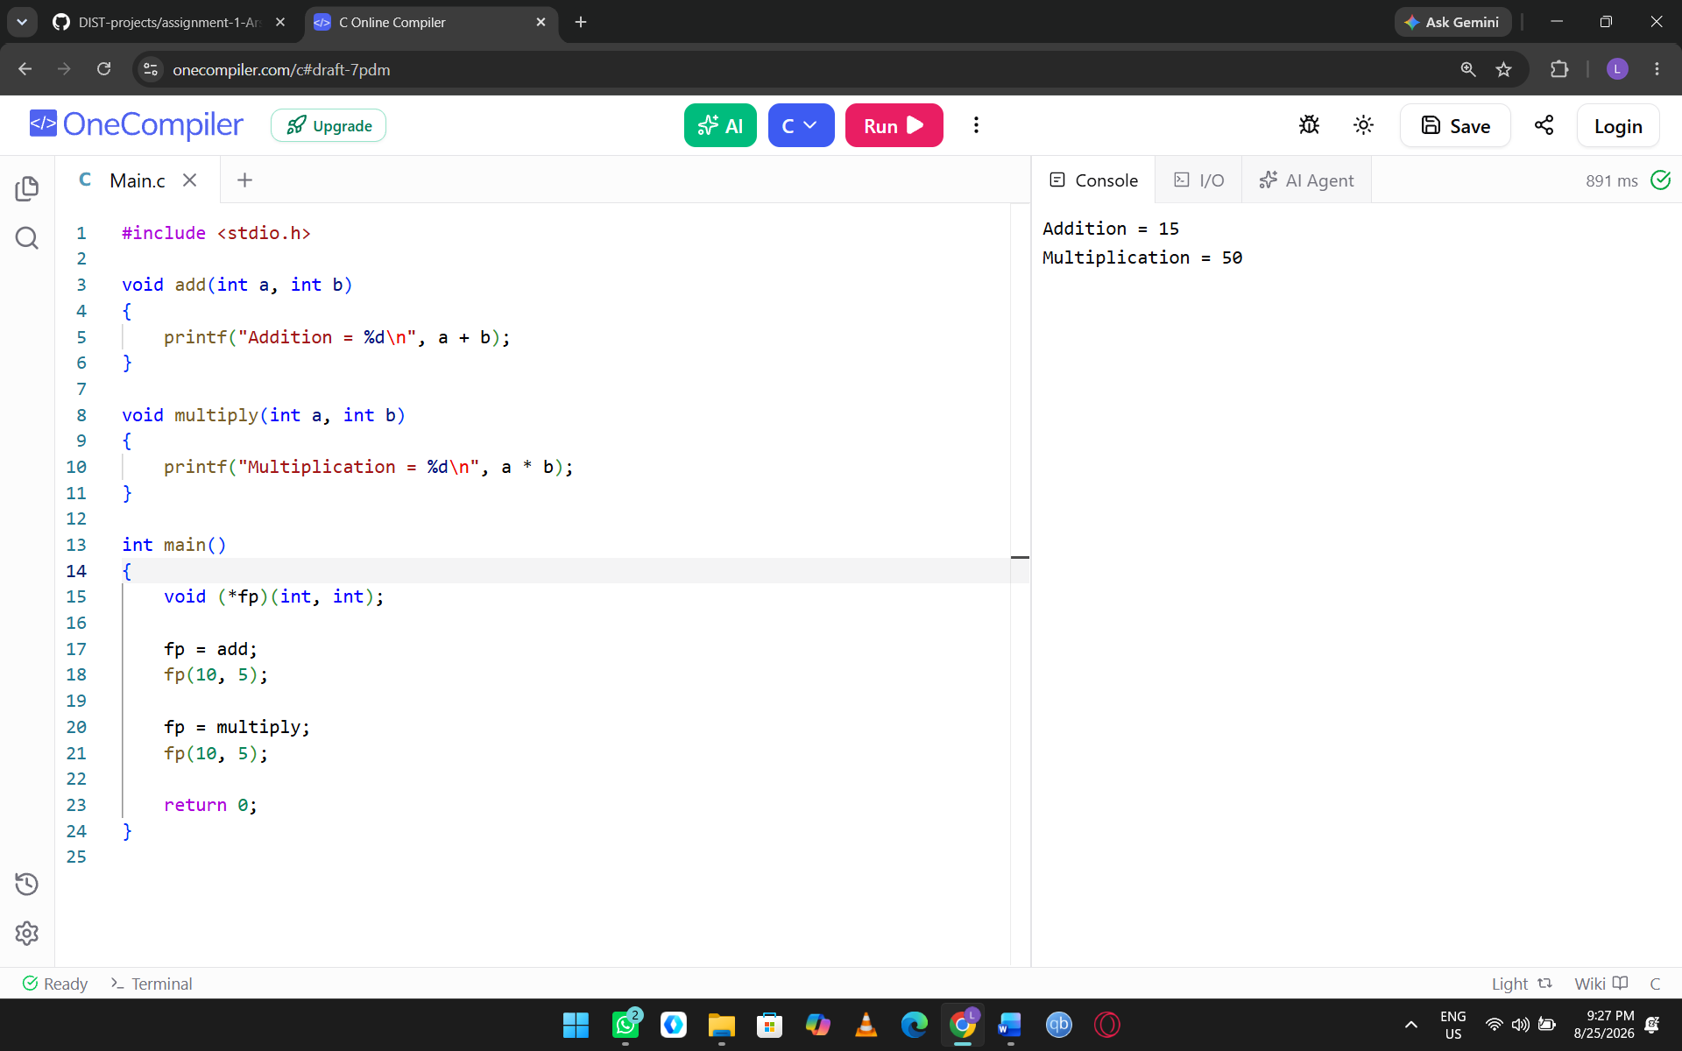

6.Declare an integer, a pointer to it, and a double pointer. Print the values and addresses at each level.

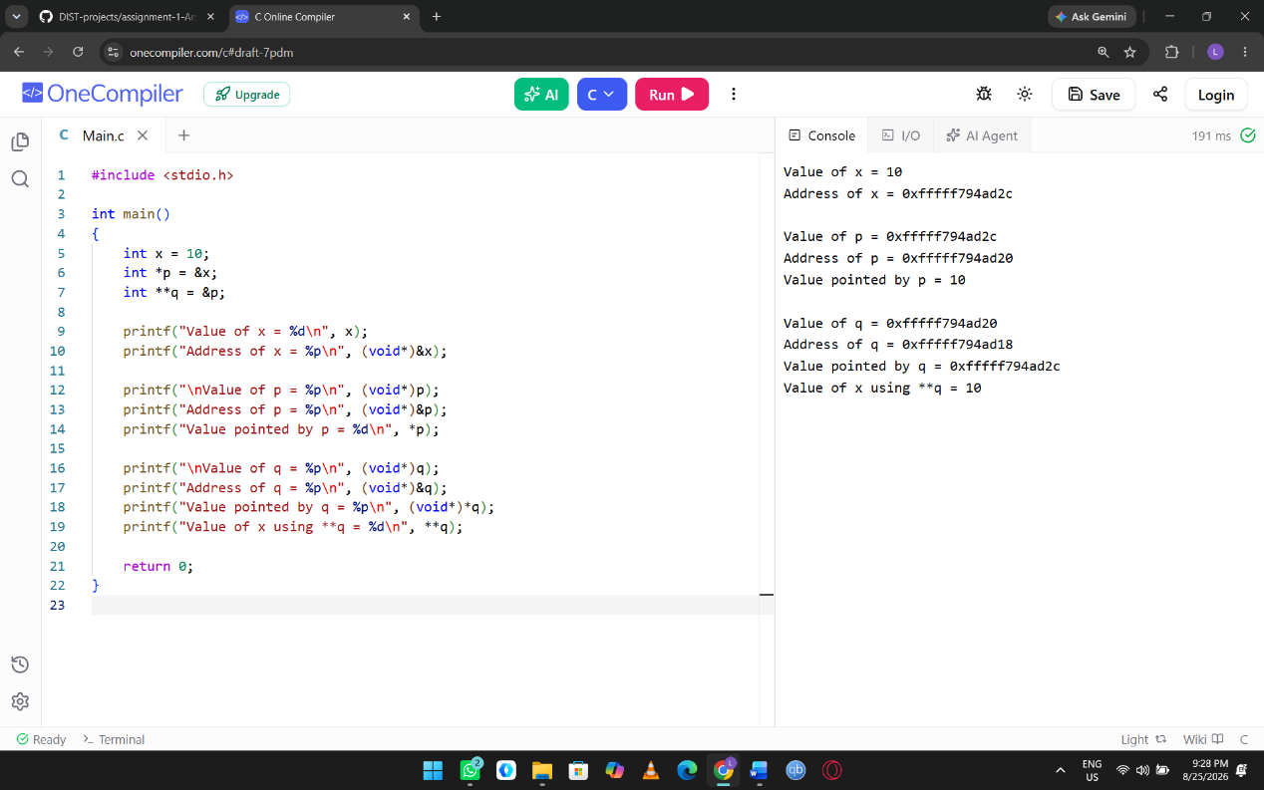

7.Sort an array of floating point numbers using Selection sort.

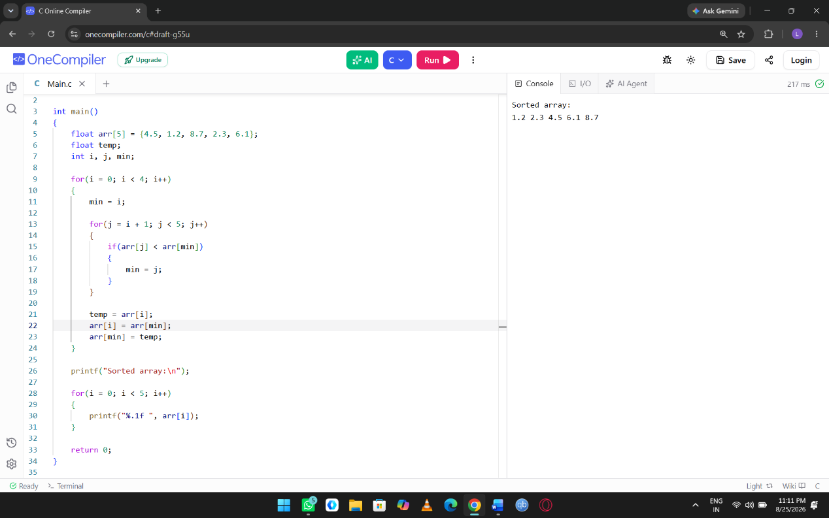

8.Define a structure Student with id, name, and grade. Create an array of Student structures and sort them based on different fields.

Output :

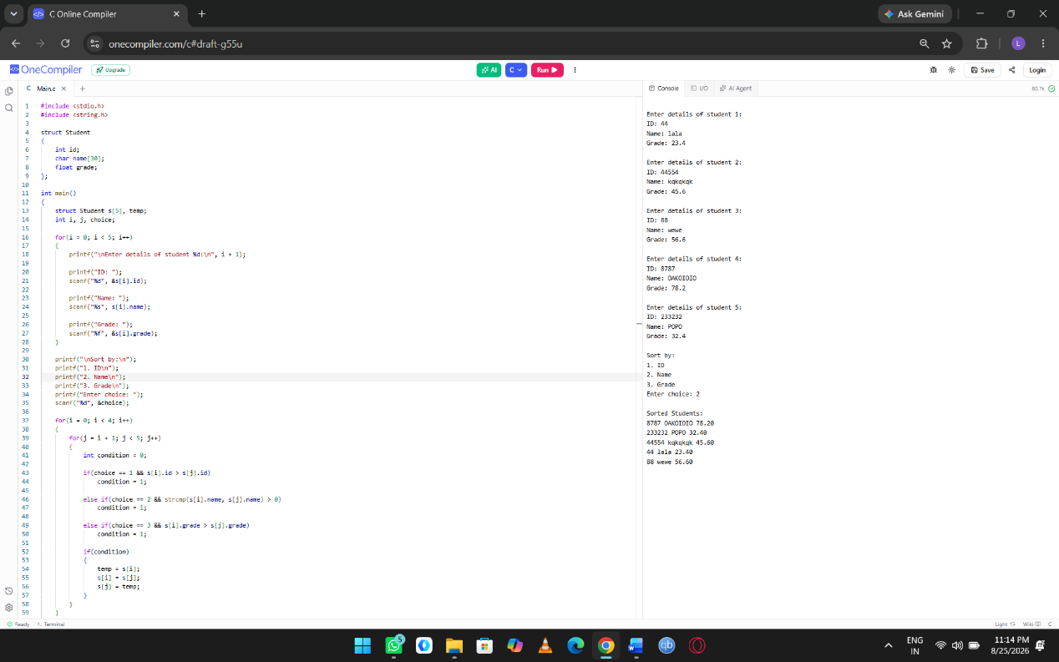

9.Sort a set of negative numbers using radix sort.

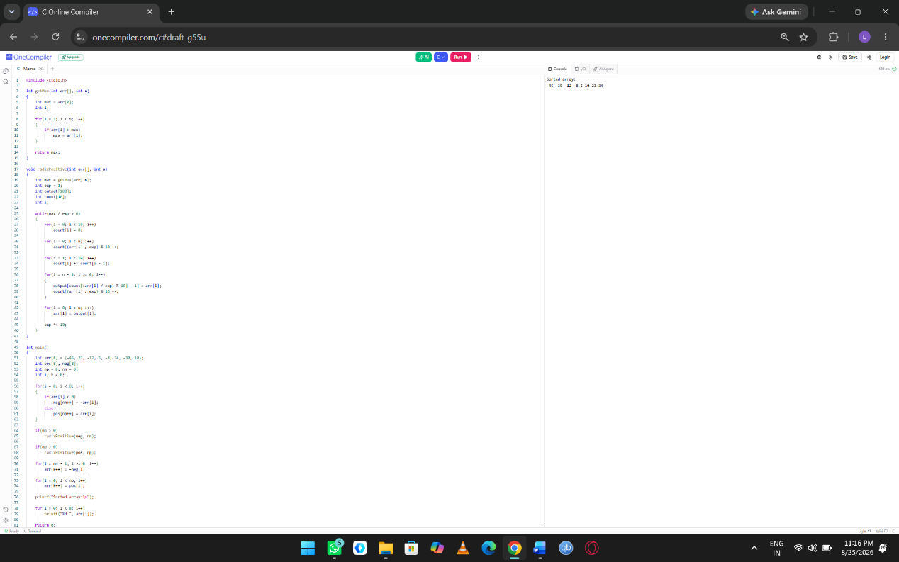

10.Write a C program to copy one array to another using pointers.

