Declaration
I, Nasibu Y. Isaka, registration number 2106307225519, declare that this report is my own original work and that it has not been presented, and will not be presented, to any other institution for a similar or any other award.

Certification
The undersigned certifies that he has read and hereby recommends for acceptance by the Dar es Salaam Institute of Technology a project report titled Blockchain-Based NGO Donation Management System, submitted in partial fulfilment of the requirements for the award of NTA Level 8 in the Department of Computer Studies.

Dedication
This work is dedicated to my family, mentors and all people working to make charitable support more transparent and accountable.

Acknowledgements
I sincerely thank my supervisor, Dr Gustaph Sanga, for guidance throughout this project. I also appreciate the Department of Computer Studies, the people who contributed early questionnaire feedback, and my family and colleagues for their support during design, implementation and testing.

Abstract
NGO donation systems need to make contribution and fund-release records more visible without making ordinary donors adopt cryptocurrency. This project designed and implemented ChangiaTanzania, a blockchain-based NGO donation management system that combines familiar web and local-payment workflows with privacy-preserving Ethereum proof recording. An iterative Agile approach was used, informed by retained questionnaire themes, document review, source inspection and technical testing. The system implements donor, fundraiser and administrator roles; campaign management; beneficiary verification; payment-session handling; idempotent payment callback finalisation; receipts; donation history; notifications; dashboards; audit logs; exports; controlled disbursements; and public receipt verification. PostgreSQL is the operational source of truth. After a verified payment or completed disbursement, the backend records a deterministic proof hash through a smart contract, while public verification omits donor identity and payment references. The implementation demonstrates that blockchain can serve as a narrow tamper-evident proof layer alongside conventional application controls rather than replacing payment or operational systems. Tests cover key authentication, payment, proof, campaign-review, beneficiary and disbursement-control scenarios. The report records two material limitations: the response-level questionnaire export was unavailable, so no quantitative survey claims are made; and production payment credentials, infrastructure hardening, load testing and independent user acceptance testing remain required. The work provides a credible foundation for transparent NGO donation management and identifies controlled integration of the evaluator-branch risk subsystem and on-chain escrow contract as future work.

List of Abbreviations
Abbreviation | Meaning
API | Application Programming Interface
CSV | Comma Separated Values
DFD | Data Flow Diagram
DIT | Dar es Salaam Institute of Technology
ERD | Entity Relationship Diagram
FR | Functional Requirement
JWT | JSON Web Token
NFR | Non-functional Requirement
NGO | Non-Governmental Organization
NTA | National Technical Award
ORM | Object Relational Mapping
RBAC | Role Based Access Control
RPC | Remote Procedure Call
SDLC | Software Development Life Cycle
SRS | Software Requirement Specification
TZS | Tanzanian Shilling
UAT | User Acceptance Testing
UML | Unified Modeling Language

List of Appendices
Appendix | Title
A | Questionnaire
B | Document Review Matrix
C | Source Code (selected excerpts)
D | User Manual
E | Installation Guide
F | Test Cases
G | Gantt Chart
H | Budget
I | Additional Screenshots
J | Full Entity Relationship Diagram

CHAPTER ONE: INTRODUCTION

1.1 Background of the Study
NGOs depend on credible stewardship of donations. Digital payment confirmation does not, by itself, show a donor whether a contribution was recorded correctly or whether later disbursement followed agreed controls. Tanzania is an appropriate setting for a locally usable solution because mobile money has expanded access to financial services (World Bank, 2017). Blockchain can preserve a verifiable record of material events, although it does not remove governance and privacy responsibilities (Howson, 2021; Sung et al., 2023).
ChangiaTanzania is a web-based donation management system. PostgreSQL is the operational source of truth; Ethereum stores minimal cryptographic proofs after verified payment or completed disbursement. Donors need no cryptocurrency wallet. The system supports donors, verified fundraisers and administrators, with campaign review, beneficiary verification, controlled disbursements, public receipt verification, reporting, notifications and audit records.

1.2 Problem Statement
Conventional donation workflows often separate payment collection, campaign administration and utilisation reporting. A donor may receive an acknowledgement but lack an independent way to check the integrity of a later record or trace a completed disbursement. Cryptocurrency-first charity platforms can improve traceability but do not suit users who normally use local mobile-money services. The problem addressed is the absence of a practical, role-controlled platform that combines familiar Tanzanian payment rails with privacy-preserving, verifiable transaction proofs.

1.3 Aim of the Project
To design and implement a blockchain-based NGO donation management system that improves transparency, accountability and secure administration of campaigns, donations and beneficiary disbursements while retaining familiar local payment workflows.

1.4 Specific Objectives
- To implement secure role-based access for donors, fundraisers and administrators.
- To implement campaign, beneficiary and donation management with payment confirmation and downloadable receipts.
- To record privacy-preserving proofs of completed donations and disbursements on Ethereum and provide public receipt verification.
- To implement accountable fund release through beneficiary verification, balance checks, separation of duties, audit logging and reporting.
- To implement decision support through explainable risk assessment, review queues, notifications and dashboards.

1.6 Scope of the Project
The project delivers a responsive web system for registered NGOs and community fundraisers: account security, campaigns, beneficiaries, donations, payment-provider abstraction, receipts, notifications, reports, audit logs and public blockchain-proof lookup. The evaluator-subsystem branch also contains an integration-ready hybrid risk-assessment module; it is reported as branch work, not as a deployed develop-branch feature. The system does not process cryptocurrency payments, store PII on-chain, provide a native mobile application, or claim production-mainnet use.

1.7 Significance of the Project
Donors receive receipts, a personal history and a public verification route that reveals no donor identity. NGOs and fundraisers receive structured campaign, beneficiary and reporting workflows. Administrators receive separation-of-duties controls, audit records and exports. The work demonstrates a practical integration of conventional payment services, a relational application and public-chain proof without forcing users to understand wallets or digital assets.

1.8 Limitations
The current public-chain configuration is a test environment; live merchant credentials and production chain custody are outside this report. Local uploads should be replaced by durable object storage before production. Cloud free-tier cold starts can affect initial latency. The response-level questionnaire export is unavailable, so this report presents only its documented themes and does not invent quantitative results.

CHAPTER TWO: LITERATURE REVIEW

2.1 Introduction
This chapter reviews the concepts and prior systems that inform ChangiaTanzania, distinguishing a blockchain proof ledger from the operational database.

2.2 Theoretical Literature Review
Blockchain is a replicated ledger whose records are cryptographically linked. In this project its role is deliberately narrow: a hash of a completed event can later be reconciled without publishing personal data. Donation-traceability research identifies immutable event records and end-to-end traceability as a response to uncertainty over charitable funds (Alabdulkarim et al., 2022). Sung et al. found that transparency, immutability and efficiency features of a blockchain donation system improved perceived nonprofit trustworthiness (Sung et al., 2023).
Technology is not a substitute for governance. Howson identifies trade-offs between transparency, power and beneficiary interests in crypto-giving (Howson, 2021). ChangiaTanzania therefore holds personal and operational data off-chain, exposes only a restricted verification result, and uses role separation and audit logs for governance.

2.3 Empirical Literature Review
Charity frameworks commonly emphasise traceability, notification and auditable histories (Alabdulkarim et al., 2022; Muneeb et al., 2020). Their cryptocurrency orientation creates an adoption mismatch for a mobile-money context. World Bank analysis describes Tanzania’s mobile-money expansion as a major contributor to financial inclusion (World Bank, 2017). ChangiaTanzania consequently verifies a fiat payment first, then creates a database donation and records its proof asynchronously.

2.4 Existing Systems Review
Generic crowdfunding platforms demonstrate campaign pages, online collection and receipts, but their operational controls are not necessarily visible to an individual donor. Blockchain charity frameworks offer stronger traceability but frequently assume cryptocurrency payment and wallet use (Muneeb et al., 2020). Neither pattern alone combines local fiat-payment abstraction, beneficiary verification, campaign-owner controls, cumulative self-release limits and privacy-preserving public proof lookup.

2.5 Project Research Gap
The gap is an implementable accountability workflow that does not move ordinary donors into cryptocurrency. ChangiaTanzania keeps donation value off-chain, makes PostgreSQL the authoritative operational record, and anchors a deterministic proof hash only after verified completion. Its fund-release workflow adds governance that a proof alone cannot supply.

2.6 Proposed System
A donor browses an active campaign, starts a payment session and receives a receipt after a verified callback. The transaction is committed atomically, totals are updated and an asynchronous service records proof. Fundraisers own their campaigns but cannot publish without approval; beneficiaries remain administrator-verified; disbursements are constrained by available balance and approval rules.

2.7 Conceptual Framework
Inputs are credentials, campaign data, payment callbacks and payout requests. Processing validates input, applies roles and business rules, writes PostgreSQL transactions, produces notifications and queues proof recording. Outputs are receipts, dashboards, exports, audit entries and verification results. Public verification, administrative reviews and risk assessments form the feedback loop.

2.8 Strengths of the Proposed System
Key strengths are familiar payment journeys, operational data separated from immutable proof data, role-based governance, idempotent payment finalisation, public verification without PII disclosure and provider abstraction. A pending chain write never blocks a successfully verified payment and can later be reconciled.

CHAPTER THREE: PROJECT RESEARCH METHODOLOGY

3.1 Introduction
The project used applied systems development: early user-problem evidence was translated into requirements, then delivered through iterative implementation and technical verification.

3.2 Research Design
An iterative Agile approach was used. The system was built in vertical stages: public campaigns, authentication, donations, blockchain proof, administration, community fundraising and payment/deployment improvements. A Google Forms questionnaire provided problem and preference themes; document review and observation supplemented it.

3.3 Study Area
The context was Tanzania. The questionnaire was shared through Tanzania Red Cross Society cooperation chat groups and among students, focusing on donation trust, tracking and payment preferences.

3.4 Target Population and their Categories
The intended population was potential donors, NGO stakeholders and students. Administrative workflows were analysed from the perspectives of a neutral NGO operator and a community fundraiser.

3.6 Sample Size
The response export and collection dates were not retained with the repository. This report therefore does not claim a numerical sample size or inferential findings. A future evaluation should retain anonymised response data, consent information and collection dates.

3.7 Data Collection Methods
The questionnaire collected early user views. Document review examined requirements, platform documentation and donation-control literature. Observation examined expected platform behaviour and the developed application. Interviews were not used within the available project time.

3.8 Data Collection Instruments
The instruments were a structured Google Forms questionnaire and document-review matrix. Questionnaire themes concerned trust, tracking, transparency, blockchain verification and donation management.

3.9 Data Required for Each Objective
Objective | Evidence | Method
Secure access | roles, sessions and access rules | source review and API tests
Donation workflow | payment, receipt and history | E2E tests
Proof | hash, transaction and lookup | contract/API tests
Accountable payout | beneficiary, balance and approval controls | business rules and E2E tests
Decision support | risk signals and review path | evaluator-branch code/tests

3.10 Ethical Considerations
Participation was voluntary and findings are reported only as aggregate themes. Public verification returns campaign, amount, date and transaction reference but no donor identity, email or payment reference. On-chain data is a proof hash rather than personal data.

3.11 Data Analysis Methods
The retained questionnaire findings were analysed thematically. Technical evidence was analysed through requirements traceability, source inspection, automated test results and manual workflow verification. No quantitative result is presented without its source data.

3.12 Development Methodology
Agile development was appropriate because payments, blockchain and role controls have interdependencies. Each stage added a usable capability and was checked through linting, type checking, builds and targeted end-to-end tests. Git history preserves the iteration record.

3.13 Software and Hardware Used
React, TypeScript, Vite and Tailwind CSS implement the client. Node.js, Express, Drizzle ORM and PostgreSQL implement the server. Solidity, Hardhat and Ethers implement blockchain proof. Development used Windows 11, VS Code, PowerShell, Git and npm; deployment targets are Vercel, Render and Neon PostgreSQL.

3.14 Summary
The methodology combines user-problem themes with iterative implementation and reproducible technical verification, while explicitly acknowledging missing response-level survey data.

CHAPTER FOUR: DATA ANALYSIS

4.1 Introduction
This chapter reports evidence available without overstating it: retained questionnaire themes, requirements analysis and reproducible technical tests.

4.2 Respondent Demographics
The questionnaire was shared through Tanzania Red Cross Society cooperation chat groups and a student population. The original report did not retain individual demographic fields or the response export. Demographic totals and percentages are therefore not reproduced.

4.3 Analysis of Collected Data
The retained questionnaire summary identified uncertain trust in existing NGO donation systems, difficulty tracking a donation after payment, demand for transparent tracking, support for blockchain-backed records, preference for mobile money, and demand for improved donation management. These are design inputs, not generalisable statistical estimates.
Finding | ChangiaTanzania response
Uncertain trust | Public receipt verification and audit records
Tracking is difficult | Receipt, history, campaign progress and proof status
Transparency is expected | Verifiable donation and disbursement proofs
Local payment is preferred | Tanzanian payment-provider abstraction
Management needs improvement | Campaign, beneficiary, payout and reporting modules

4.4 Interpretation of Findings
The evidence supports an accountability architecture rather than a payment page alone. It explains the system’s payment-to-proof workflow, limited public verification view, and administrative controls around beneficiaries and payouts. It does not establish that blockchain itself causes trust.

4.5 Identified Problems
The analysis identified insufficient post-donation visibility, limited traceability of fund use, reliance on privileged administration and mismatch between cryptocurrency-first platforms and local payment habits.

4.6 Functional Requirements Identified
The resulting functional requirements are specified and traced in Section 5.4: access, campaigns, payments, history, proofs, beneficiaries, disbursements, reports, notifications and risk review.

4.7 Non-functional Requirements Identified
Security, reliability, usability, maintainability, availability and scalability were identified as essential qualities. Section 5.5 converts them into testable acceptance targets.

4.8 Summary
The available evidence supports a transparent, mobile-money-compatible workflow. Absence of raw survey data limits quantitative claims but does not prevent requirements tracing and technical evaluation.

CHAPTER FIVE: SYSTEM REQUIREMENT SPECIFICATION

5.1 Introduction
This chapter specifies what ChangiaTanzania must do and its operational constraints.

5.2 Existing System Analysis
Manual records and generic online fundraising leave a weak link between payment acknowledgement, fund use and independently checkable evidence. Centralised data also needs governance controls to prevent a single user from creating and approving exceptional payouts.

5.3 Proposed System
The proposed system combines a public interface, protected role workspaces, payment-provider adapters, PostgreSQL operations, Ethereum proof recording and report exports. It addresses visibility with receipts and proof lookup, and governance with beneficiary verification, approval rules and immutable audit logs.

5.4 Functional Requirements
ID | The system shall | Priority
FR-01 | register, authenticate and manage secure user sessions | High
FR-02 | enforce donor, fundraiser and administrator permissions | High
FR-03 | list, search and display active campaigns | High
FR-04 | let authorised owners create, edit, submit and archive campaigns | High
FR-05 | create payment sessions and finalise verified callbacks idempotently | High
FR-06 | issue receipts and show each donor’s donation history | High
FR-07 | create and publicly verify donation and disbursement proofs | High
FR-08 | manage beneficiaries and restrict payouts to verified beneficiaries | High
FR-09 | enforce balance, threshold and self-approval rules for disbursements | High
FR-10 | notify users and provide dashboards, audit records and exports | Medium
FR-11 | provide a risk-review API and queue when the evaluator branch is integrated | Medium

5.5 Non-functional Requirements
Quality | Acceptance target / evidence
Security | bcrypt passwords, JWT access, rotating httpOnly refresh token, RBAC, validation and rate limits
Reliability | one atomic payment finalisation; duplicate callbacks do not double-credit
Privacy | public lookup exposes no donor PII or payment reference; no PII on-chain
Maintainability | strict TypeScript, layered API and provider interfaces
Usability | responsive client with loading, empty, error and success states
Availability | a proof-write failure does not discard a verified payment
Scalability | PostgreSQL pagination and constraints; production load testing remains required

5.6 User Requirements
Donors need browsing, donation, receipts, history and verification. Fundraisers need controlled ownership of campaigns, beneficiaries and permitted payouts. Administrators need oversight, review, verification, reports, audit logs and user controls.

5.7 System Requirements
The client requires a modern browser and internet connection. Server deployment requires Node.js 20+, PostgreSQL and protected secrets. Blockchain proof requires an Ethereum RPC endpoint, backend wallet and contract address. Development uses React, Vite, Express, Drizzle, Hardhat and Solidity.

5.8 Feasibility Study
The solution uses mature tooling and preserves familiar fiat payments. Development and test deployment can use low-cost tiers and test ETH, but production must budget for gateway fees, storage, monitoring and gas. A production NGO must meet applicable payment, data-protection and charity regulations. The staged Git history demonstrates schedule feasibility.

5.9 Software Requirement Specification
The human actors are Donor, Fundraiser and Administrator; the payment provider and Ethereum network are external systems. The functional requirements above are the formal SRS baseline and are traced in Chapter Seven.

CHAPTER SIX: SYSTEM DESIGN

6.1 Introduction
Chapter Five states what the system must do; this chapter explains how it is structured to do it. The design uses a layered web architecture, relational data model, Ethereum proof registry and documented process controls.

6.2 System Architecture
The React client communicates with the Express API. Routes delegate to controllers, services and repositories; the repository layer persists operational state to PostgreSQL. Payment providers and Ethereum are external integrations behind service boundaries, ensuring that a provider or proof-write failure does not corrupt the completed donation record.
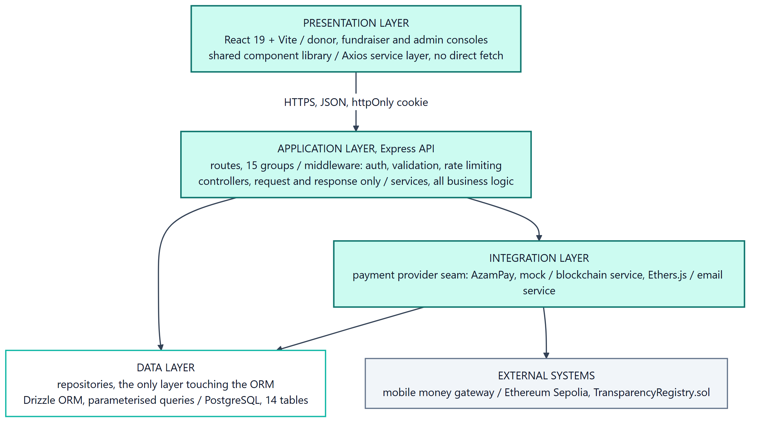
System architecture, layered view

6.3 Data Modeling

6.3.1 Context Diagram
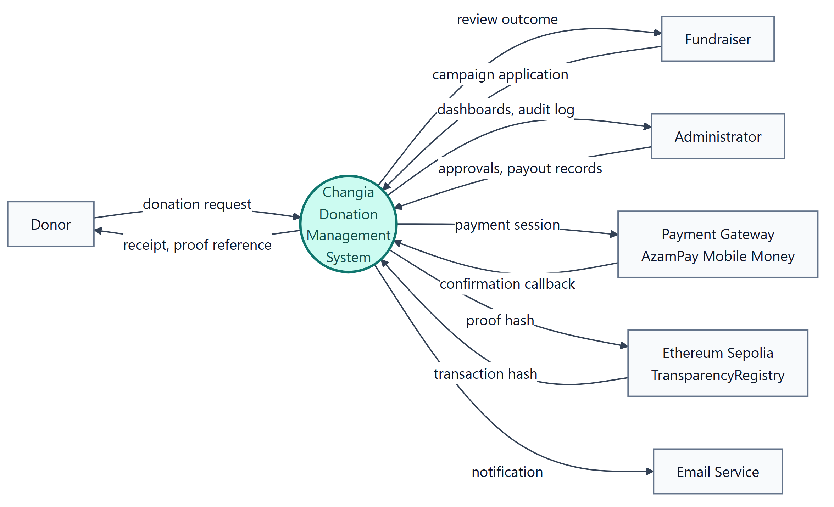
Context diagram, DFD level 0

Data Flow Diagrams
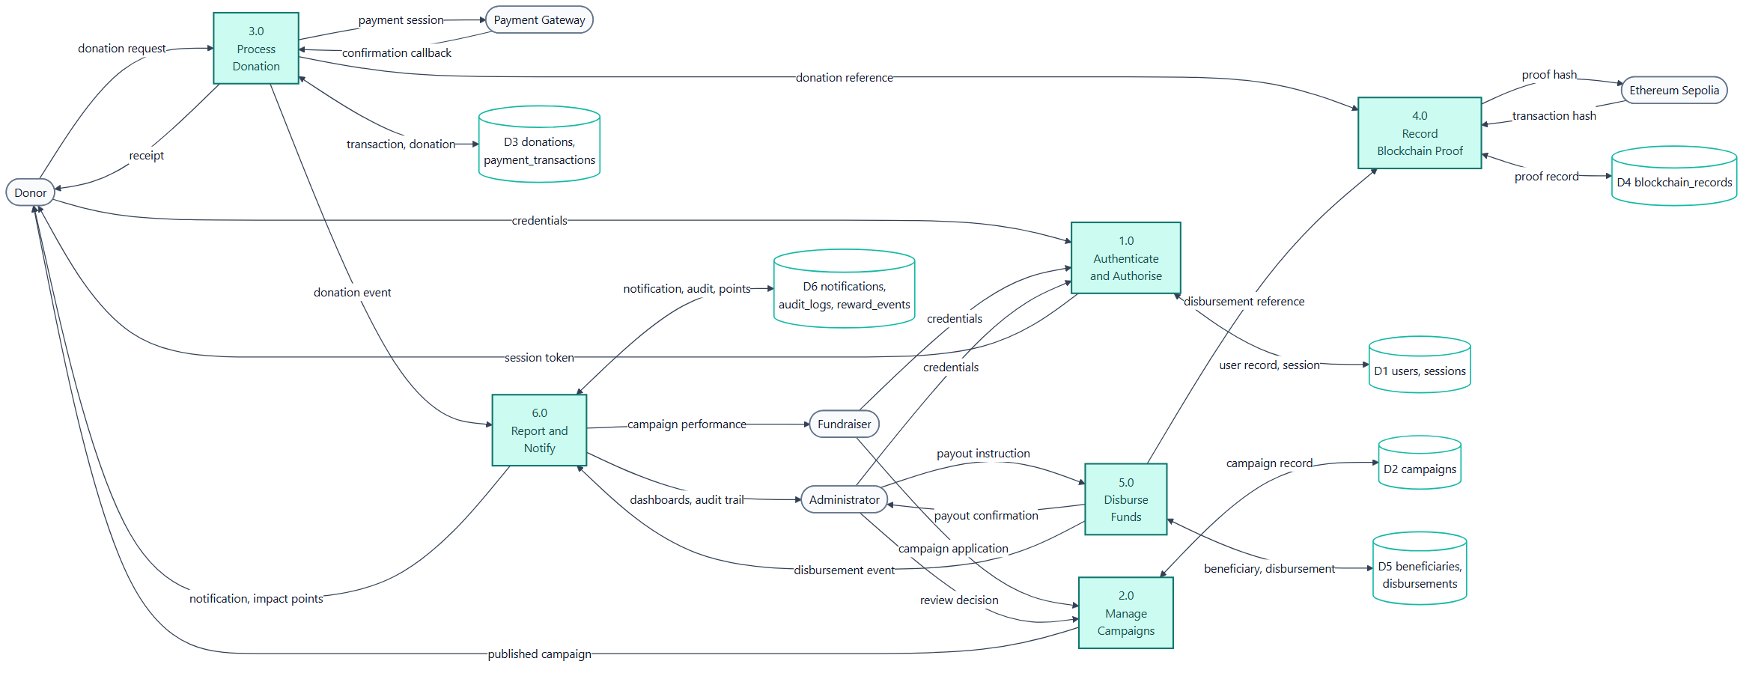
Data flow diagram, level 1

6.4.1 Database Design
The relational model holds users, sessions, password resets, campaigns, donations, payment transactions, beneficiaries, disbursements, approvals, blockchain records, notifications, audit logs, rewards and fundraiser applications. IDs are BIGINT values and money is stored in whole Tanzanian shillings. Donations, disbursements and blockchain records are immutable business records; mutable entities use controlled status changes or soft deletion.
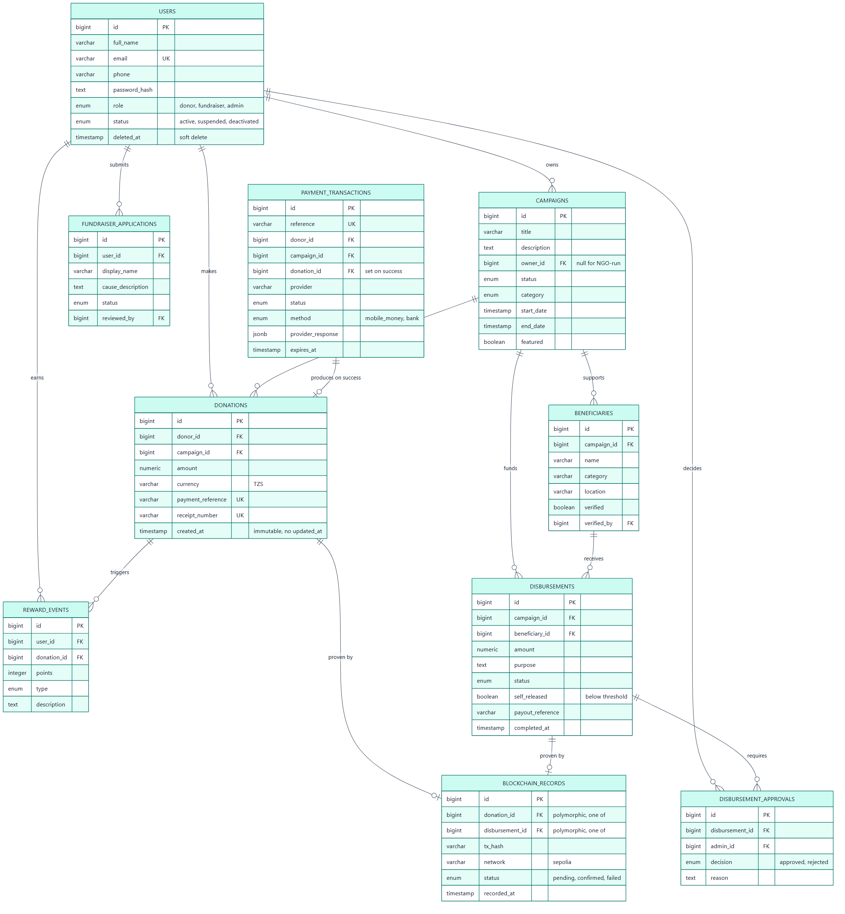
Entity relationship diagram

6.5 Process Modeling

6.5.1 UML Models
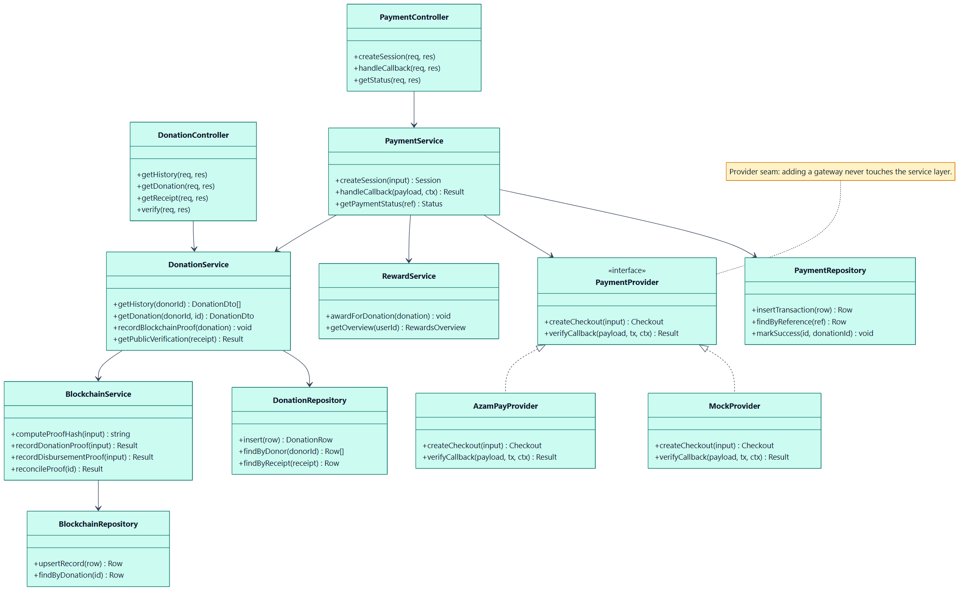
Class diagram, backend service layering
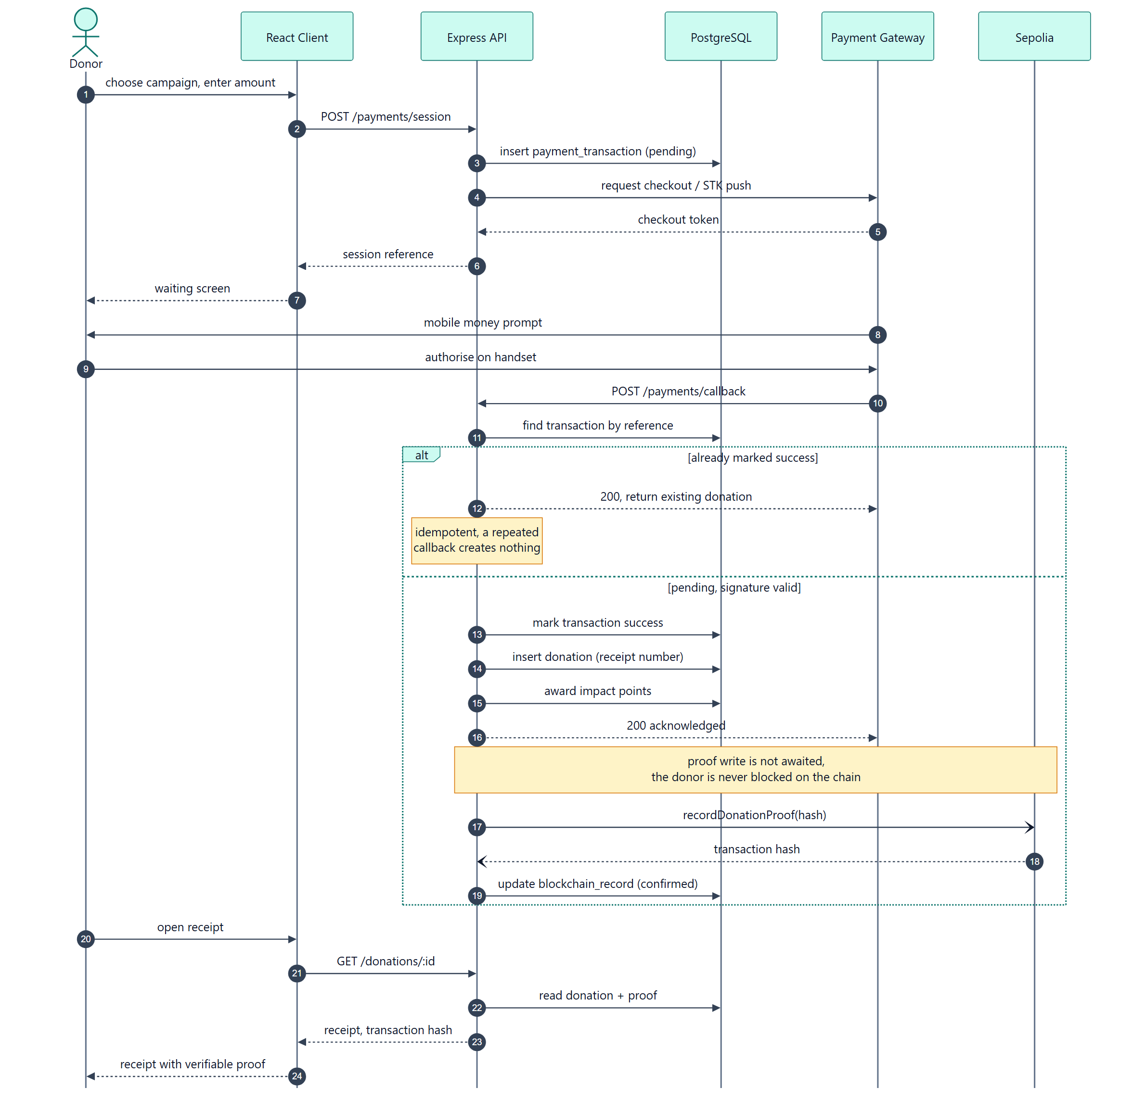
Sequence diagram, donation and proof recording
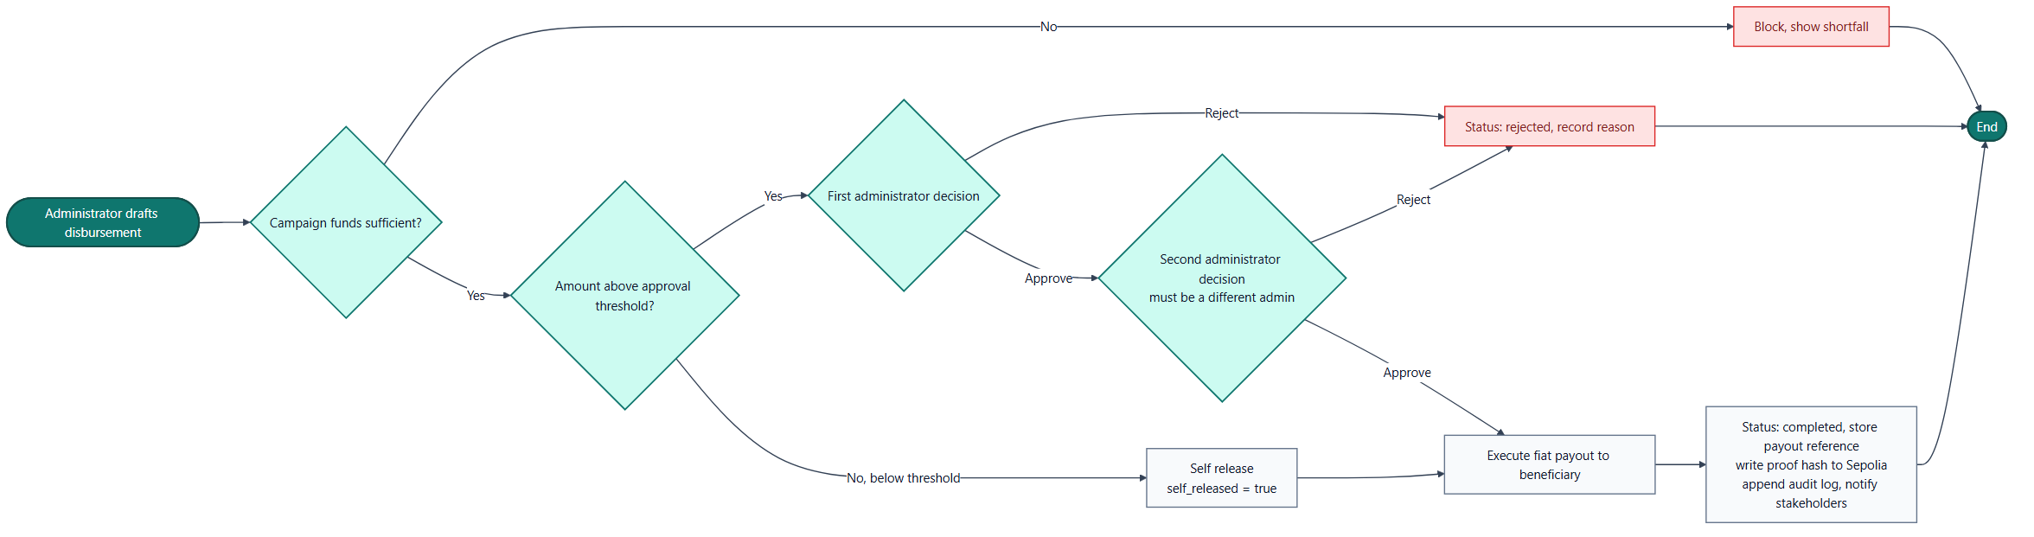
Activity diagram, disbursement dual approval
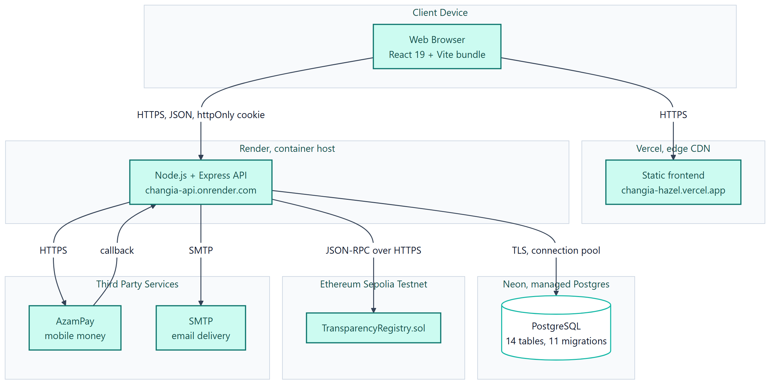
Deployment diagram

6.7 User Interface Design
The public interface prioritises campaign discovery, understandable donation controls and proof lookup. Protected interfaces are role-specific: donors see history and receipts; fundraisers see their owned campaigns and permitted actions; administrators receive operational navigation, reviews, audit records and reports. Each page includes explicit loading, empty, error and success states.

6.9 Machine Learning and Dataset Design
The evaluator-subsystem branch implements an explainable hybrid risk assessment. Rules produce human-readable signals while an Isolation Forest identifies unusual combinations of transaction features. The model is unsupervised because labelled fraud history is unavailable; it is only fitted after sufficient donation history and is re-fitted on a schedule. Reviews can later create the labels needed for supervised evaluation. This work is not merged into develop and is therefore not claimed as a deployed feature.

6.9.1 Algorithms of the Working System
For a completed donation, the service combines donation identifier, campaign identifier, amount, receipt number, payment reference and timestamp into a SHA-256 proof hash. The database finalises the donation before attempting the chain write. For payouts, the service checks campaign ownership, verified beneficiary, available balance and threshold/initiator rules before completing a disbursement.

6.10 Flowcharts of the Working System
The payment workflow is: validate request; create provider session; verify callback; atomically create donation and payment completion; update campaign; schedule proof; notify donor. The disbursement workflow validates beneficiary and balance, then either completes under permitted rules or waits for a separate administrator decision.

6.11 Security Design
This design implements the Security NFR in Section 5.5 with bcrypt password hashing, short-lived JWT access tokens, rotating httpOnly refresh tokens, RBAC, account lockout, rate limits, validation, parameterised database access, audit logging and safe upload names. The proof registry stores hashes rather than donor data, and public verification omits donor identity and payment references.

CHAPTER SEVEN: SYSTEM IMPLEMENTATION, TESTING AND RESULTS

7.1 Introduction
ChangiaTanzania was implemented as a TypeScript web application with a separately tested Solidity proof contract.

7.2 Development Environment
Development used Windows 11, Visual Studio Code, PowerShell, Git and npm. The client uses React/Vite; the API uses Express; PostgreSQL is accessed through Drizzle; contracts are built with Hardhat.

7.3 Software Tools Used
React, TypeScript, Vite, Tailwind CSS, shadcn/ui, Node.js, Express, PostgreSQL, Drizzle ORM, Zod, Ethers, Solidity, Hardhat, ESLint and Git were used. CSV, Excel and PDF libraries support exports.

7.4 Implementation of Modules
Module | Capability | Requirements
Identity | registration, login, reset, sessions and RBAC | FR-01, FR-02
Campaigns | public browsing and owner/admin management | FR-03, FR-04
Donations | payment sessions, callback finalisation, receipts, history | FR-05, FR-06
Proofs | deterministic hashes, registry writes and public verification | FR-07
Payouts | beneficiary verification, balance and approvals | FR-08, FR-09
Operations | notifications, dashboard, audit log and exports | FR-10
Evaluator branch | explainable rules, statistical signals and review queue | FR-11
Payment finalisation is idempotent and precedes asynchronous proof recording; a chain failure cannot lose a verified donation and later verification can reconcile pending proof.

7.5 Testing Strategy
Testing combines smart-contract unit tests, API end-to-end tests, client build/lint/type checks and manual browser workflows. Contract tests cover proof registration and duplicate rejection. API tests cover registration, authorisation, payment finalisation, proof lookup, campaign review, beneficiary verification, disbursement controls and reports. The evaluator branch adds analytics and Isolation Forest tests. Independent UAT and production load testing remain future work.

7.6 Test Cases
ID | Description | Input | Expected Result | Status
TC-01 | Registration | Valid credentials | Account/session created | Pass
TC-02 | Duplicate callback | Same reference twice | One donation and credit | Pass
TC-03 | Public proof lookup | Receipt number | Status without PII | Pass
TC-04 | Campaign review | Fundraiser submission | Not public before approval | Pass
TC-05 | Beneficiary control | Unverified beneficiary | Payout rejected | Pass
TC-06 | Separation of duties | Initiator approves own payout | Approval rejected | Pass
TC-07 | Balance control | Excess payout | Request rejected | Pass
TC-08 | Duplicate proof | Existing identifier | Contract rejects it | Pass

7.7 Results
The tested implementation satisfies the core workflow: donor payment, receipt, history and verification; controlled campaign and beneficiary management; and disbursements restricted by ownership, verification, balance and approval rules. The repository contains passing Hardhat and API test suites for these flows.

7.8 Discussion of Results
The implementation is strongest where application controls and blockchain proof complement each other. Proof makes a completed event tamper-evident; database transactions, RBAC and audit logs control operations. It does not prove an off-chain beneficiary outcome. Current limits are live credentials, production hardening, controlled user evaluation and performance testing. The hybrid fraud module and CharityVault contract exist on an unmerged evaluator branch and must be integrated and deployment-tested before being claimed as production features.

7.9 System Screenshots
The final demonstration journey is sign-in, campaign browsing, payment, receipt/proof status and history. Administration evidence covers review, beneficiary verification, payout approval, audit records and exports. Screenshots should be captured from the final deployment immediately before submission so they cannot become stale.

CHAPTER EIGHT: CONCLUSION AND RECOMMENDATIONS

8.1 Summary
ChangiaTanzania applies familiar web and mobile-money-oriented donation workflows alongside blockchain proofs and administrative controls. The work covers the complete operational path from campaign publication to donation, receipt, proof verification, beneficiary management, controlled disbursement, audit record and export.

8.2 Achievement of Objectives
The project achieved secure role access through authentication and RBAC; donation management through payment sessions, idempotent callbacks and receipts; transparency through deterministic on-chain proofs and public lookup; accountability through beneficiary, balance and approval controls; and administrative support through dashboards, reports, notifications and audit records. The evaluator branch demonstrates a further risk-review capability pending integration.

8.3 Conclusion
The system shows that blockchain can be useful as a restrained proof mechanism rather than a replacement for normal payment and database infrastructure. Transparency improves when verifiable records are combined with privacy protection, operational auditability and separation of duties. The implementation is a credible foundation for NGO donation management but requires formal operational rollout work before production financial use.

8.4 Recommendations
Before production deployment, the project should complete payment-provider certification, replace local file storage, introduce monitoring and backup procedures, perform independent security and load tests, and conduct structured end-user acceptance testing with retained consent and survey data.

8.5 Future Work
Future work should merge and evaluate the hybrid fraud/risk subsystem, integrate the CharityVault escrow/multisignature contract after governance review, move proofs to an appropriate production network, add durable object storage and expand accessibility and mobile support. Mainnet use should follow security audit, key-management and compliance preparation rather than being enabled solely because the code exists.

REFERENCES
Alabdulkarim, L. et al. (2022). Blockchain-based donations traceability framework. Journal of King Saud University - Computer and Information Sciences, 34(10), 9442–9454. https://doi.org/10.1016/j.jksuci.2022.09.021
Howson, P. (2021). Crypto-giving and surveillance philanthropy: Exploring the trade-offs in blockchain innovation for nonprofits. Nonprofit Management and Leadership, 31(4), 805–820. https://doi.org/10.1002/nml.21452
Muneeb, M. et al. (2020). A framework to make charity collection transparent and auditable using blockchain technology. Computers & Electrical Engineering, 83, 106588. https://doi.org/10.1016/j.compeleceng.2020.106588
Sung, J., Bock, G.-W., & Kim, H.-M. (2023). Effect of blockchain-based donation system on trustworthiness of NPOs. Information & Management, 60(5), 103812. https://doi.org/10.1016/j.im.2023.103812
World Bank. (2017). Tanzania economic update. https://documents1.worldbank.org/curated/en/340591491579331322/pdf/114125-NWP-P156957-PUBLIC-add-series-9th-TEU-April-7-2017-reduced.pdf

APPENDICES

Appendix A: Questionnaire

Appendix B: Document Review Matrix

Appendix C: Source Code (selected excerpts)

Appendix D: User Manual

Appendix E: Installation Guide

Appendix F: Test Cases

Appendix G: Gantt Chart

Appendix H: Budget

Appendix I: Additional Screenshots

Appendix J: Full Entity Relationship Diagram

