Declaration
I, Nasibu Y. Isaka, registration number 2106307225519, declare that this report is my own original work and that it has not been presented, and will not be presented, to any other institution for a similar or any other award.

Certification
The undersigned certifies that he has read and hereby recommends for acceptance by the Dar es Salaam Institute of Technology a project report titled Blockchain-Based NGO Donation Management System, submitted in partial fulfilment of the requirements for the award of NTA Level 8 in the Department of Computer Studies.

Dedication

Acknowledgements

Abstract

List of Abbreviations
Abbreviation | Meaning
API | Application Programming Interface
CSV | Comma Separated Values
DFD | Data Flow Diagram
DIT | Dar es Salaam Institute of Technology
ERD | Entity Relationship Diagram
FR | Functional Requirement
JWT | JSON Web Token
NFR | Non-functional Requirement
NGO | Non-Governmental Organization
NTA | National Technical Award
ORM | Object Relational Mapping
RBAC | Role Based Access Control
RPC | Remote Procedure Call
SDLC | Software Development Life Cycle
SRS | Software Requirement Specification
TZS | Tanzanian Shilling
UAT | User Acceptance Testing
UML | Unified Modeling Language

List of Appendices
Appendix | Title
A | Questionnaire
B | Document Review Matrix
C | Source Code (selected excerpts)
D | User Manual
E | Installation Guide
F | Test Cases
G | Gantt Chart
H | Budget
I | Additional Screenshots
J | Full Entity Relationship Diagram

CHAPTER ONE: INTRODUCTION

1.1 Background of the Study

1.2 Problem Statement

1.3 Aim of the Project

1.4 Specific Objectives

1.6 Scope of the Project

1.7 Significance of the Project

1.8 Limitations

CHAPTER TWO: LITERATURE REVIEW

2.1 Introduction

2.2 Theoretical Literature Review

2.3 Empirical Literature Review

2.4 Existing Systems Review

2.5 Project Research Gap

2.6 Proposed System

2.7 Conceptual Framework

2.8 Strengths of the Proposed System

CHAPTER THREE: PROJECT RESEARCH METHODOLOGY

3.1 Introduction

3.2 Research Design

3.3 Study Area

3.4 Target Population and their Categories

3.6 Sample Size

3.7 Data Collection Methods

3.8 Data Collection Instruments

3.9 Data Required for Each Objective

3.10 Ethical Considerations

3.11 Data Analysis Methods

3.12 Development Methodology

3.13 Software and Hardware Used

3.14 Summary

CHAPTER FOUR: DATA ANALYSIS

4.1 Introduction

4.2 Respondent Demographics

4.3 Analysis of Collected Data

4.4 Interpretation of Findings

4.5 Identified Problems

4.6 Functional Requirements Identified

4.7 Non-functional Requirements Identified

4.8 Summary

CHAPTER FIVE: SYSTEM REQUIREMENT SPECIFICATION

5.1 Introduction

5.2 Existing System Analysis

5.3 Proposed System

5.4 Functional Requirements

5.5 Non-functional Requirements

5.6 User Requirements

5.7 System Requirements

5.8 Feasibility Study

5.9 Software Requirement Specification

CHAPTER SIX: SYSTEM DESIGN

6.1 Introduction

6.2 System Architecture
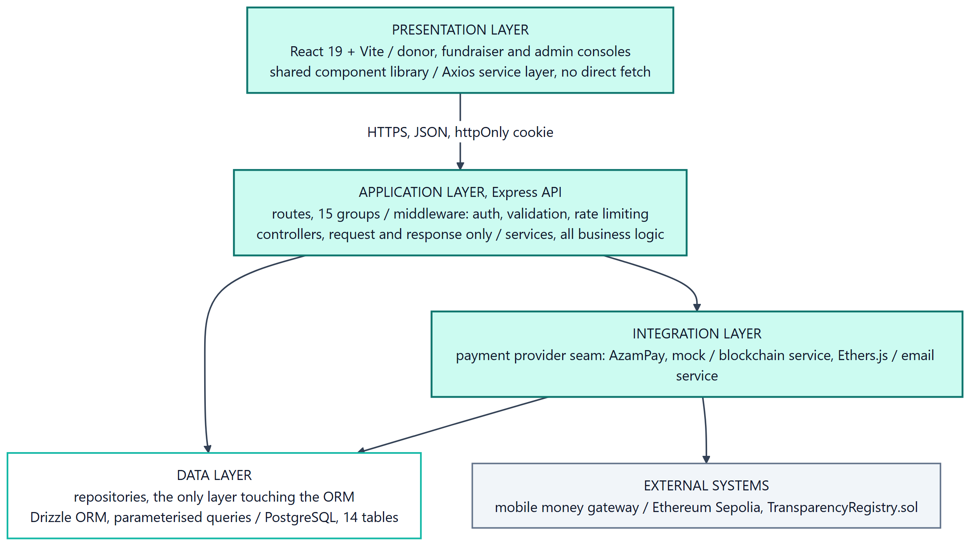
System architecture, layered view

6.3 Data Modeling

6.3.1 Context Diagram
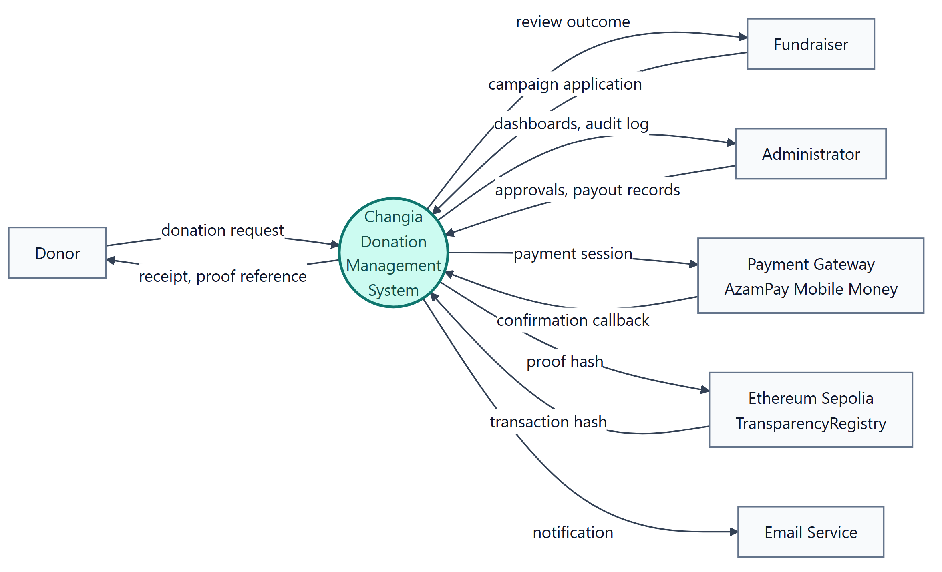
Context diagram, DFD level 0

Data Flow Diagrams
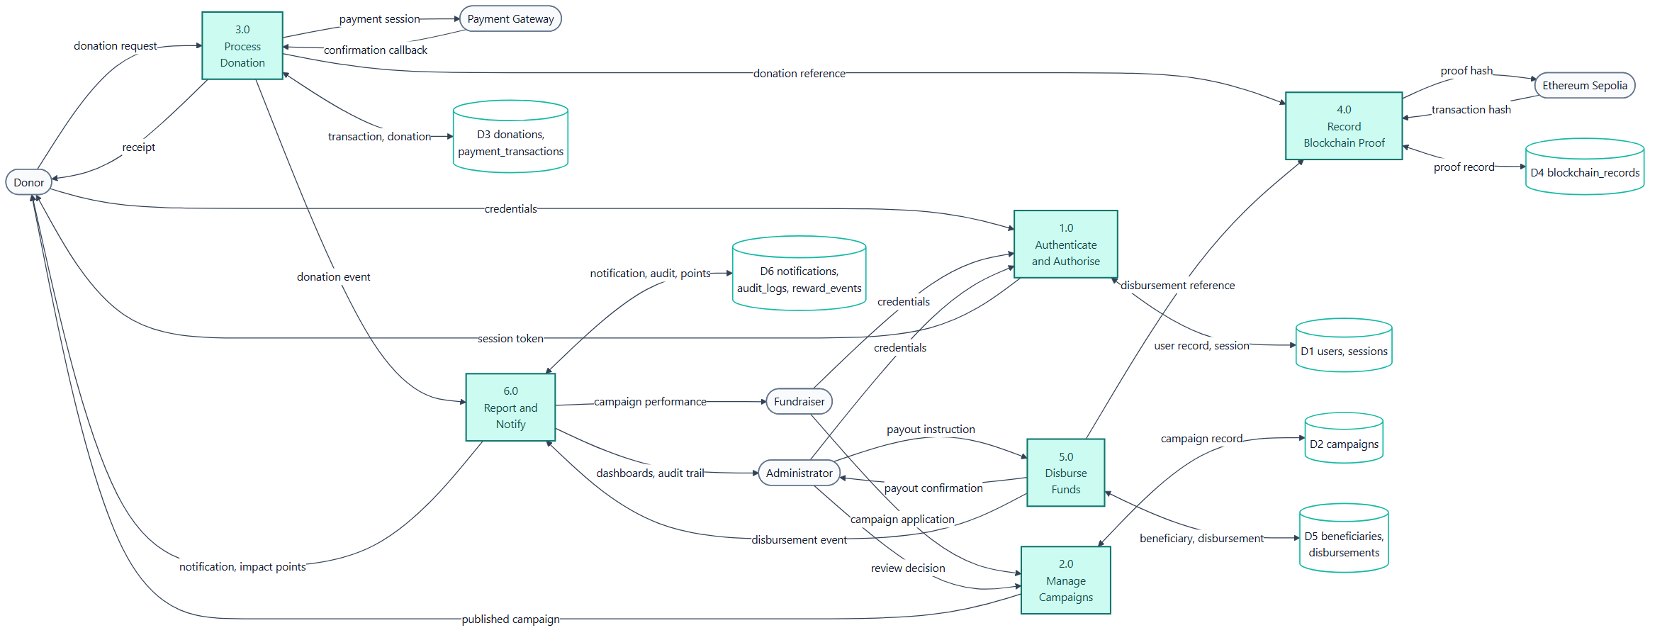
Data flow diagram, level 1

6.4.1 Database Design
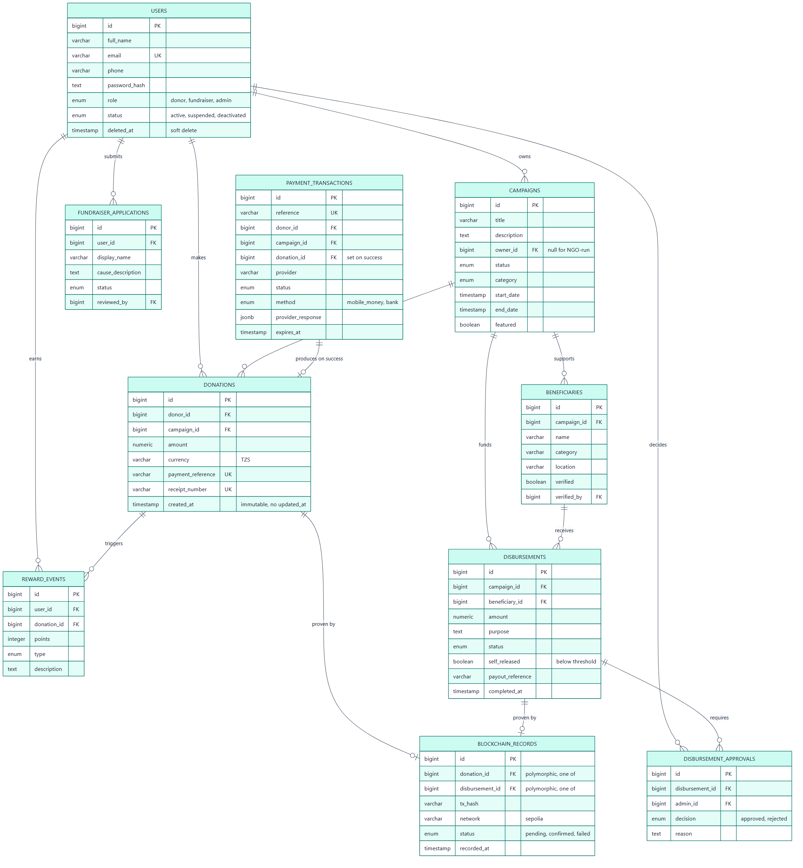
Entity relationship diagram

6.5 Process Modeling

6.5.1 UML Models
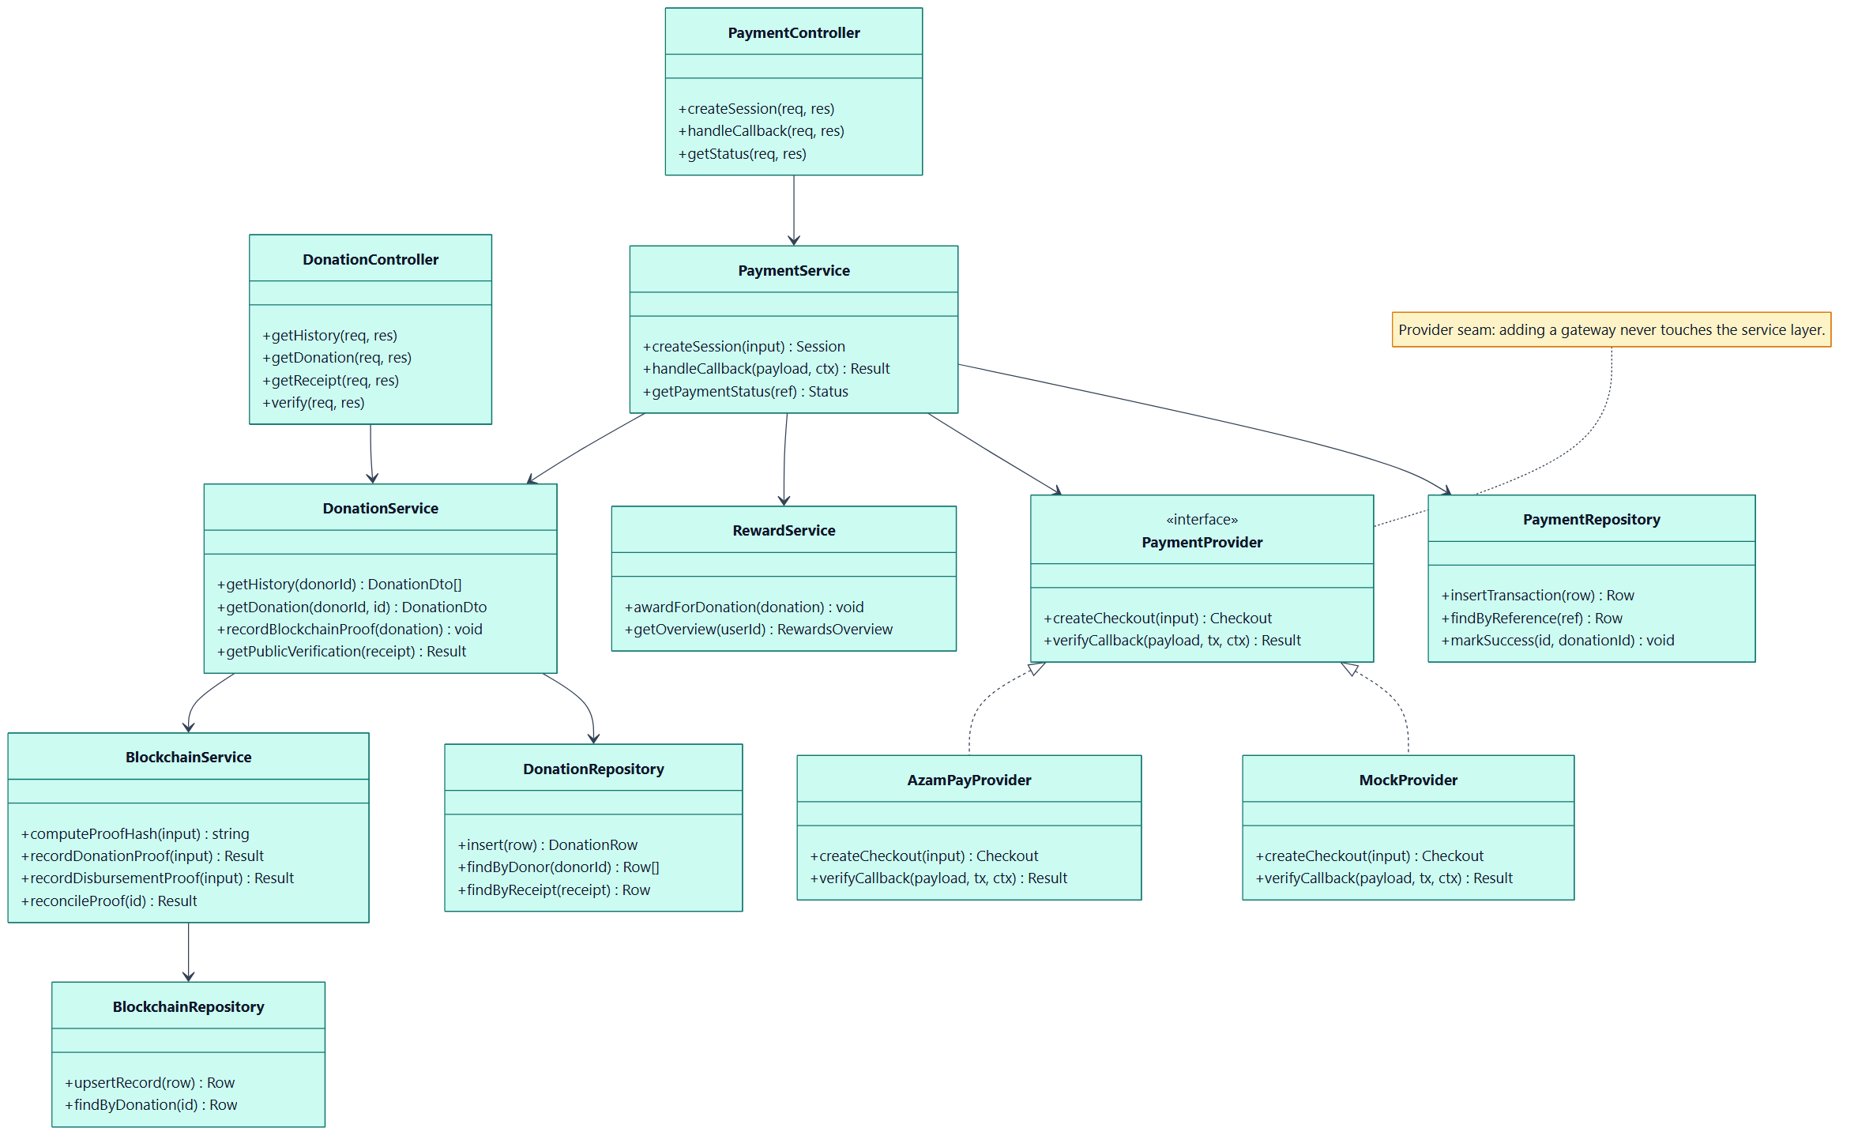
Class diagram, backend service layering
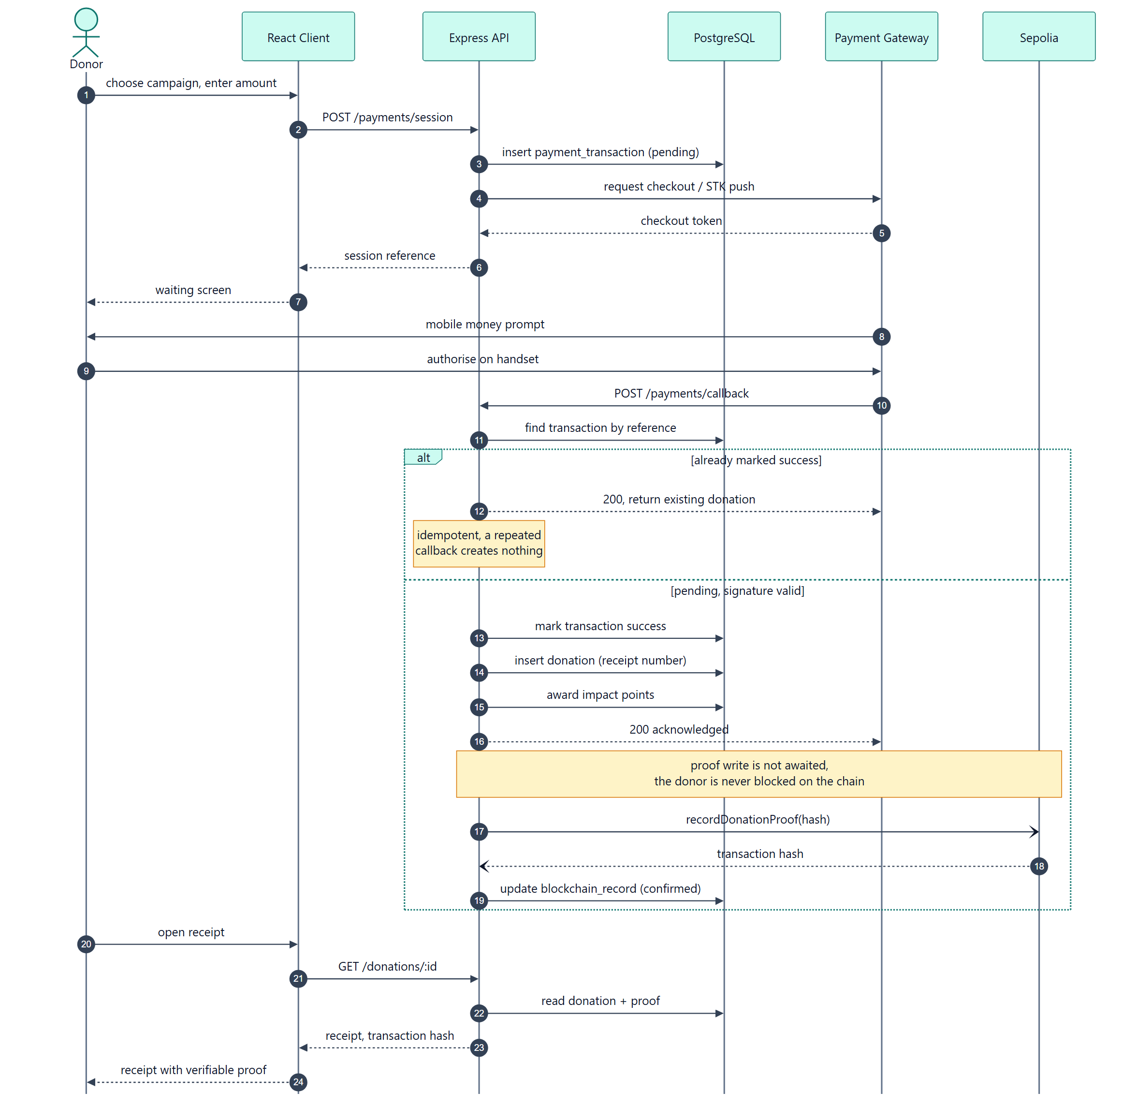
Sequence diagram, donation and proof recording
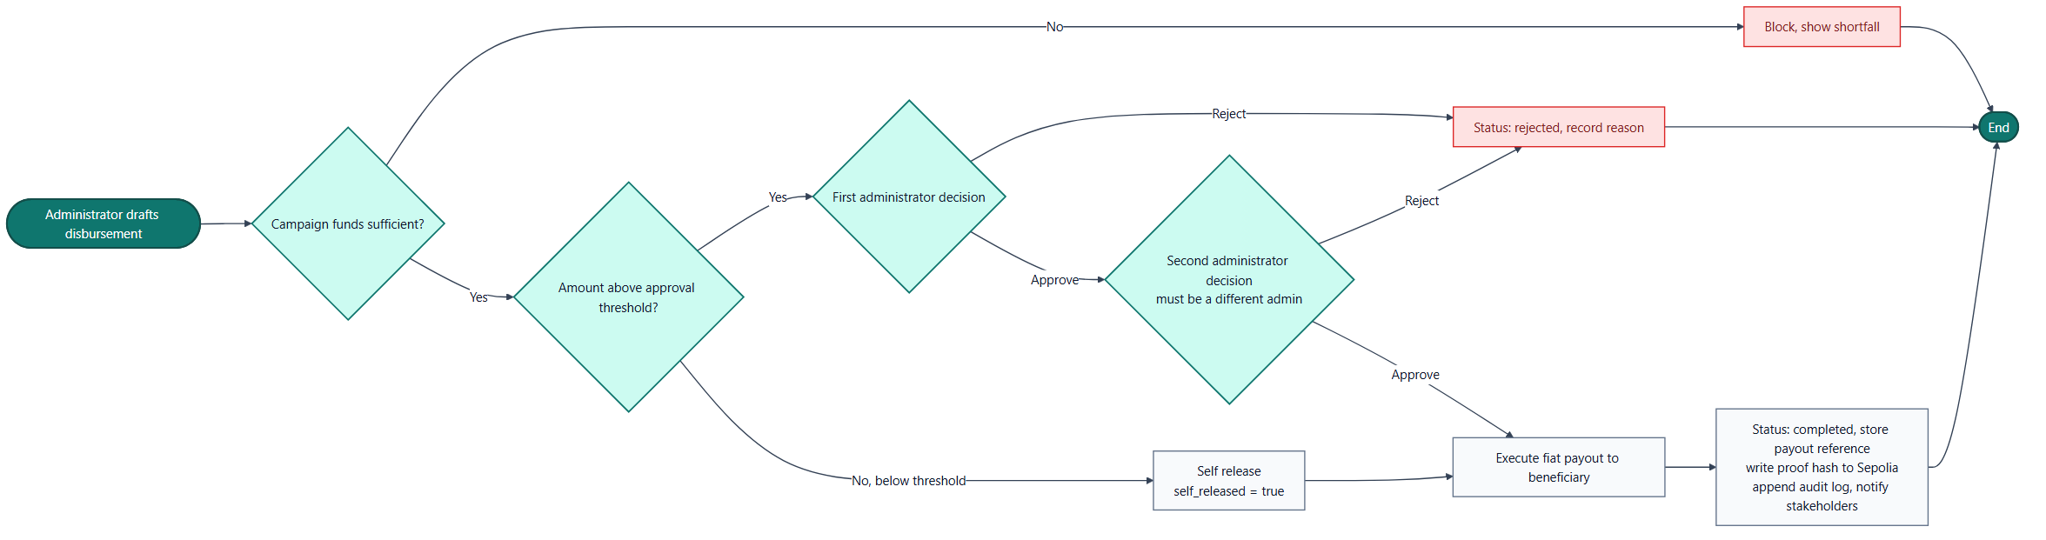
Activity diagram, disbursement dual approval
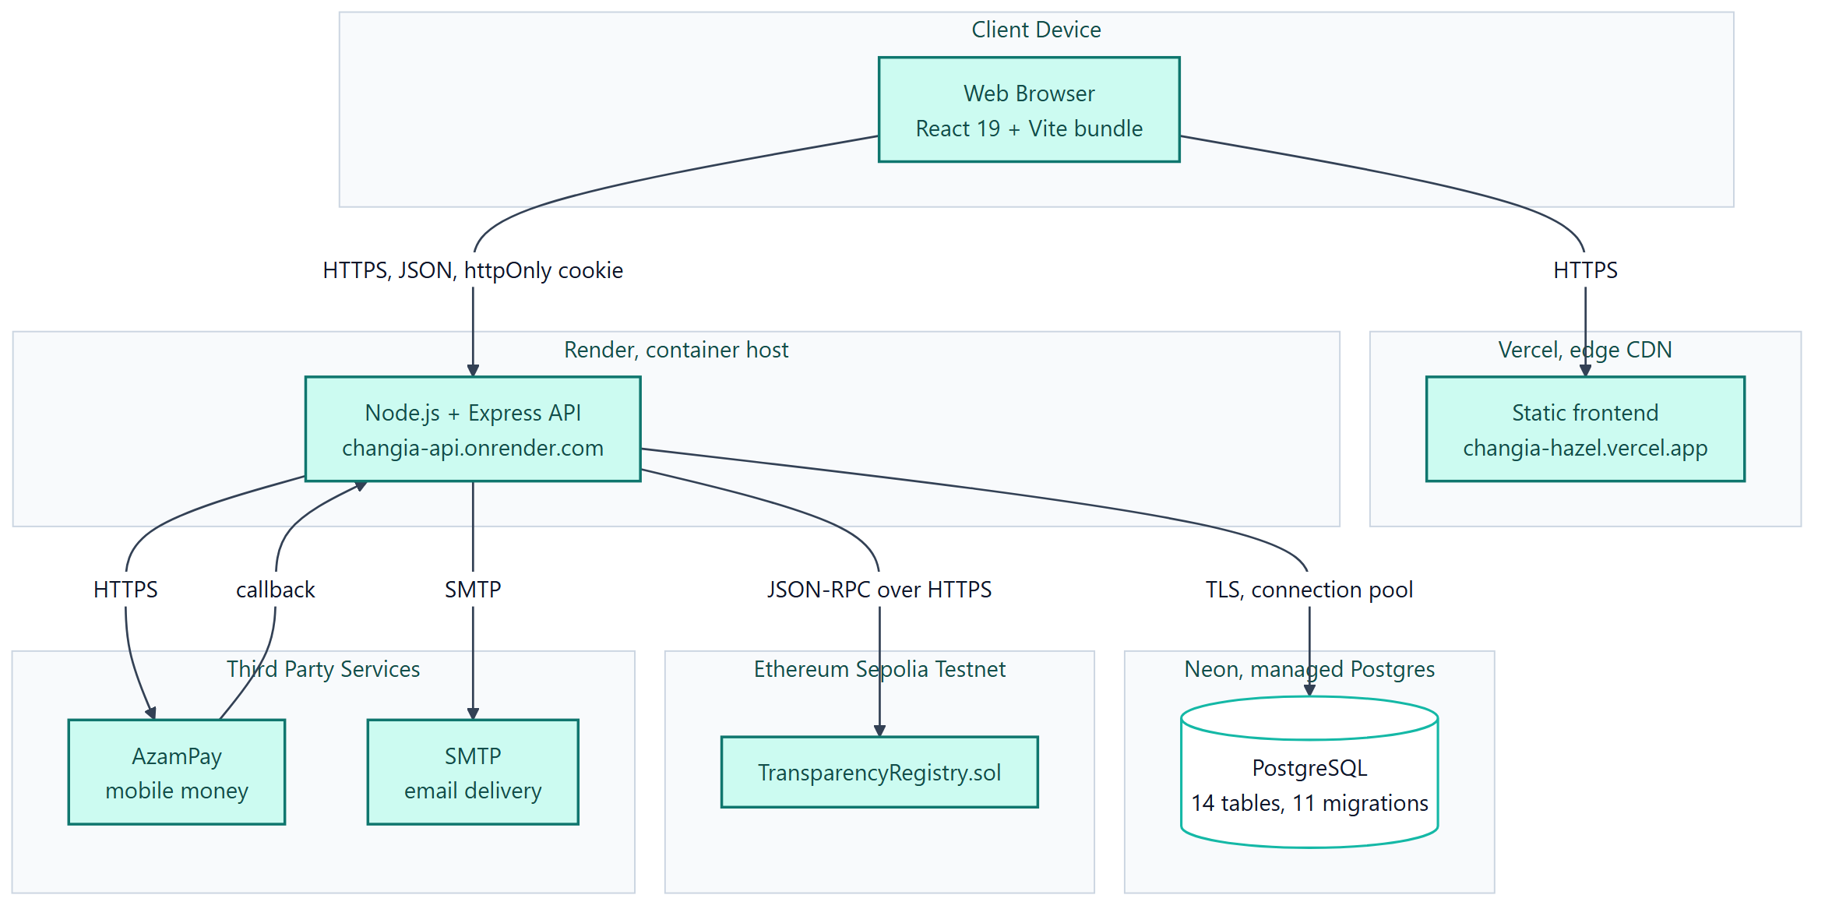
Deployment diagram

6.7 User Interface Design

6.9 Machine Learning and Dataset Design

6.9.1 Algorithms of the Working System

6.10 Flowcharts of the Working System

6.11 Security Design

CHAPTER SEVEN: SYSTEM IMPLEMENTATION, TESTING AND RESULTS

7.1 Introduction

7.2 Development Environment

7.3 Software Tools Used

7.4 Implementation of Modules

7.5 Testing Strategy

7.6 Test Cases

7.7 Results

7.8 Discussion of Results

7.9 System Screenshots

CHAPTER EIGHT: CONCLUSION AND RECOMMENDATIONS

8.1 Summary

8.2 Achievement of Objectives

8.3 Conclusion

8.4 Recommendations

8.5 Future Work

REFERENCES

APPENDICES

Appendix A: Questionnaire

Appendix B: Document Review Matrix

Appendix C: Source Code (selected excerpts)

Appendix D: User Manual

Appendix E: Installation Guide

Appendix F: Test Cases

Appendix G: Gantt Chart

Appendix H: Budget

Appendix I: Additional Screenshots

Appendix J: Full Entity Relationship Diagram

