DIT524 V17 – Group 02

G.U.A.R.D.

Gothenburg University Assistive Response Devise

Requirements Specification

**Supervisors:**

Maria Chiara Lucatello

Mayra Soliz

**Team members:**

Axel Granli

Boyan Dai

Erik Laurin

Gabriel Marian Bulai

Joacim Eberlen

Justinas Stirbys

Shaun McMurray

Table of Contents

Intro 3

Project Domains 3

Requirements 5

Controller 5

Controller Functions 5

Following a user 5

Following a user Functions 5

Tracking Traveler 6

Tracking Functions 6

System Qualities 6

Quality Attribute Reasoning 6

Prioritization 7

# Intro

The aim of the project is to create a SmartCar with the ability to be controlled via the mobile application as well as imbued it with a certain level of autonomy. The application will provide the choice to control the SmartCar manually or to initiate “following mode” once the Smart Car is in range. The SmartCar will be fitted with sensors to allow obstacles detection and eventually obstacle avoidance. The obstacle avoidance will contribute to improving the car’s following feature. Furthermore, the application should also possess camera support and allow the users to stream the video from the car to their mobile device. An additional goal of the project is to enable the SmartCar to track travelers via their mobile’s GPS coordinates.

# Project Domains

The SmartCar (Figure 1) and Mobile Application (Figure 2) domain models attached to this document will show the epics and features of the system which can be consulted by different categories of interested parties. In the case of G.U.A.R.D system school project, the concern will be captured by the following stakeholders:

* Development Team: Programmers who are actually implementing the SmartCar environment and the relative phone application are the first users of the system with direct interest to improve the project and make it accessible to the internet community.
* School teachers and supervisors: Considered to be the image of the product owner, they will be grading the project according to the coherence between project idea and its implementation within the requirements specification, and level of quality.
* Internet community: The project is placed in a public github repository and contains the source code of both SmartCar and the android application. The latter will be, as well, published in android market. In this way, the community will have access to the project, being able to ameliorate its features and quality besides getting inspiration for other personal projects.

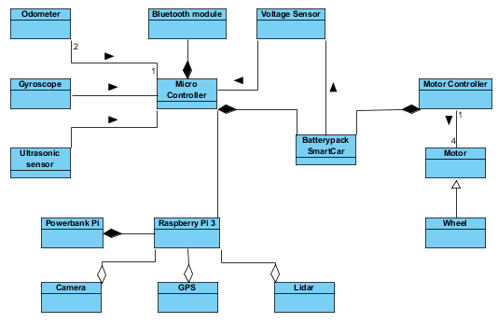

Figure 1 - SmartCar Domain

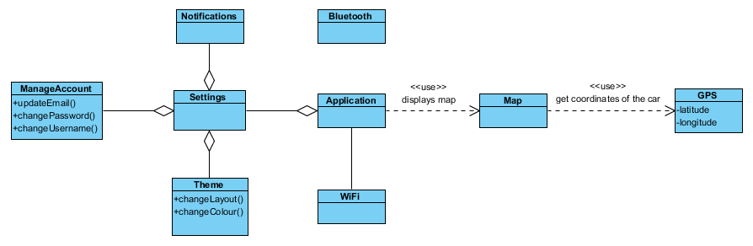

Figure 2 - Mobile Domain

# Requirements

## Controller

A digital analog controller is used to give the SmartCar movement Commands

1. The Traveler loads the app and is greeted with a splash screen with the G.U.A.R.D logo.
2. Main screen of the app loads with a button “Control”
3. Traveler clicks “Control” and is taken to SmartCar control screen
4. A digital analog controller displayed for the traveler to interact
5. SmartCar’s speed and direction changes according to the controller
6. If the SmartCar goes directly towards the obstacle, the car will automatically stop in 15cm range
7. The traveler has an option to click “Camera View”
8. If the “Camera View” is clicked, a live view stream from the SmartCar is shown with the analog controller acting as an overlay
9. The Traveler can continue giving movement commands with the controller and see the video livestream

### Controller Functions

1. Shows obstacles
2. Enables movement
3. Stops automatically before hitting stuff
4. Displays battery level
5. Option to display video

## Following a user

The SmartCar follows the Traveler while avoiding obstacles.(object recognition, GPS location)

1. The Traveler initiates the following user by pressing “Following” button via mobile app.
2. The Traveler stands in front of the SmartCar.
3. The Traveler pairs its mobile device with the SmartCar via bluetooth.
4. The Mobile App suggests the Traveler to start his/her travel.
5. The Mobile app constantly sends its GPS location to the SmartCar.
6. The SmartCar follows the Traveler via GPS location
7. The SmartCar scans for object its path using ultrasonic sensors.
8. The following will stop when The Traveler arrives to their destination or presses “Stop Following” button.

### Following a user Functions

1. Avoids obstacles
2. Pairs with mobile
3. Shows location on map via app
4. Camera support
5. In case of interruption, the SmartCar stops and notifies traveler

## Tracking Traveler

The SmartCar successfully tracks the Traveler while avoiding obstacles

1. The Traveler initiates the tracking by pressing a button “Track” in the mobile app.
2. The App gets the location of the Traveler.
3. The App shares the location with the SmartCar.
4. The SmartCar checks the battery to see if it has enough power to travel.
5. The SmartCar sends a message to the mobile app stating that it is on its way.
6. The App provides a confirmation message saying the tracking has begun to the traveler.
7. The SmartCar starts travelling to the sent location.
8. The SmartCar starts the sensors in order to avoid obstacles.
9. When the SmartCar is 3 meters away from the traveler, the SmartCar sends a message to the mobile app stating that it is arrived.
10. The SmartCar starts beeping to get the Traveler’s attention.
11. The mobile app provides a confirmation message stating that the SmartCar has arrived.
12. The traveler will click the “Confirm” button when he/she finds the SmartCar and the beeping will stop.

### Tracking Functions

1. Avoids obstacles
2. Plans path
3. Integrated with map
4. Integrated with camera
5. Shows estimated time of arrival

## System Qualities

1. Responsiveness
2. Ease of use and comfort
3. Testability
4. Precision
5. Consistency
6. Simplicity and readability

## Quality Attribute Reasoning

The most important attribute for this project is Responsiveness, without a responsive system the main feature would not give any real value and a user would not use it. The Ease of use attribute has been ranked second as it is necessary for ensuring that the user finds the application suggestive and simple to use, thus ensuring the the user's satisfaction and continuous use.

With proper system testing the failures and faults of the program become easier to catch and fix. Additionally, testing would provide a way to evaluate system measurements’ precision and consistency; therefore testability was ranked over Precision and Consistency.

Furthermore, the attributes Precision and Consistency allows for implementation of functions of critical nature; such as obstacle detection and avoidance, by always providing quality data.

The development team has decided to use pair programing and practice collective code ownership amongst other agile principles and practices, hence simplicity and readability has been added to this quality list. As it would provide ease while reading code as well as reduce the time refactoring the code. It would also ease system maintainability and time spent familiarizing with the code.

# Prioritization

The list of stakeholders presented in the upper section of the document may have different requirements which cannot be satisfied while having budget, team skills, or time interval constraints. Therefore a prioritization of the current backlog has to be made in order to clearly evidentiate and communicate the chosen features to be implemented first. The development team will use a MoSCoW method approach, in order to establish the order of importance in the implementation of different features. However, using an iterative and incremental agile methodology, tasks including higher priority user stories are not exclusively initiated at the opening sprints, for different reasons such as availability of hardware at a certain sprint, or the ability to develop other features rapidly and with ease.

|  |  |  |  |  |  |
| --- | --- | --- | --- | --- | --- |
| User Story ID | REQUIREMENTS BACKLOG | MUST | SHOULD | COULD | WON'T |
| 1 | As a Traveler I would like to establish a connection to the SmartCar, so that I would have access to the SmartCar’s controls | X |  |  |  |
| 2 | As a SmartCar I would like to have collision prevention, so that I would stop before hitting objects | X |  |  |  |
| 3 | As a Traveler I would like to have access to the SmartCar’s controls via a mobile application, so that I could control the SmartCar from multiple locations or while traveling | X |  |  |  |
| 4 | As a Traveler I want a digital joystick present in mobile application to control the SmartCar’s movement, so that I can specify the movement speed and angle | X |  |  |  |
| 5 | As a SmartCar I would like a gyroscope implemented, so to that I know the relative direction I am heading in | X |  |  |  |

|  |  |  |  |  |  |
| --- | --- | --- | --- | --- | --- |
| User Story ID | REQUIREMENTS BACKLOG | MUST | SHOULD | COULD | WON'T |
| 6 | As an Admin I would like to implement Raspberry Pi with the SmartCar, so that I could increase the potential of the SmartCar | X |  |  |  |
| 7 | As a Traveler I would like to have access to the SmartCar’s location via a mobile application, so that I could view its position in multiple locations or while traveling |  | X |  |  |
| 8 | As a Traveler I would like to see the SmartCar’s video feed so that I could view it several locations or while traveling |  | X |  |  |
| 9 | As an Admin I want a test environment to test new features, sto that I could prevent system faults and failures at implementation |  | X |  |  |
| 10 | As an Admin I want to see the SmartCar location on the map, so I would know its physical position |  | X |  |  |
| 11 | As an Admin I would like to see the route the SmartCar, so that I could improve the traveling of the SmartCar |  | X |  |  |
| 12 | As a Traveler, I would like to see the current battery status of the Smart Car in the mobile application, so that I know the remainder battery  Acceptance Criteria: Notifications are displayed in the mobile app when the battery gets low |  | X |  |  |
| 13 | As a Traveler, I would like to see the distance of objects from my SmartCar, so that I would get a better understanding of the SmartCar’s surroundings |  | X |  |  |
| 14 | As a SmartCar I would like mapping of immediate surroundings, so that I enable obstacle avoidance |  | X |  |  |
| 15 | As a SmartCar I would like to improve my driving capabilities over time, so that I could improve collision prevention and avoidance |  | X |  |  |
| 16 | As an SmartCar I would like to recognize objects using a camera, so that I could improve my ability to drive and navigate |  | X |  |  |
| 17 | As a SmartCar I would like to have the ability to follow Travelers, so that I could ensure their safety |  | X |  |  |
| User Story ID | REQUIREMENTS BACKLOG | MUST | SHOULD | COULD | WON'T |
| 18 | As an Admin I want Travelers to create an account, so that I could monitor who is using the SmartCar |  |  | X |  |
| 19 | As a Traveler I would like an option change my profile, so that I can keep the most relevant and up to date information |  |  | X |  |
| 20 | As a Traveler I would like to use Facebook/Google login, so that creating an account would be easier and quicker |  |  | X |  |
| 21 | As an Admin I would like to know the location of Traveler currently connected to the SmartCar, so that I could notify the authorities of their location in case of emergency |  |  | X |  |
| 22 | As a Admin I would like the mobile application to have a logo and a splash screen, so that the application would be visually pleasing |  |  | X |  |
| 23 | As a SmartCar I would like to have the ability to self-navigate, so that I could make decisions on where to go while traveling |  |  | X |  |
| 24 | As a Traveler I would like an option to get help and leave feedback, so that I could get clarifications of any problems I have faced while using the app |  |  | X |  |
| 25 | As a Traveler I would like a settings option in the menu, so that I could tune the app's settings |  |  | X |  |
| 26 | As a Traveler I would like an option to change the app's aesthetics to make the app more appealing |  |  | X |  |