Embedded Systems Lab

SYNOPSIS

Team Details:

Batch No.: A2

Team No.: 2

Section : A

Branch : Information Technology

Members : 220911478 – Ishan Surana

220911482-Divej Ahuja

220911486-Vaibhavv Maheshwari

220911488-Sparsh Gupta

Project Title : Distance Measuring using Doppler Effect

Problem Statement: Write a program to use a Doppler Sensor to LPC 1768 and display the distance of an object on a 7-segment display.

Brief:

A short pulse of 10us is applied to trigger pin to start distance measurement. After receiving the pulse HC-SR04 sensor sends a burst of 8 ultrasonic pulses at 40khz.

It uses the echo tech to find distance between objects.

It calculates the time required for waves to reach back.Time required by the waves to reach back is used to calculate distance.

We are using HC-SR04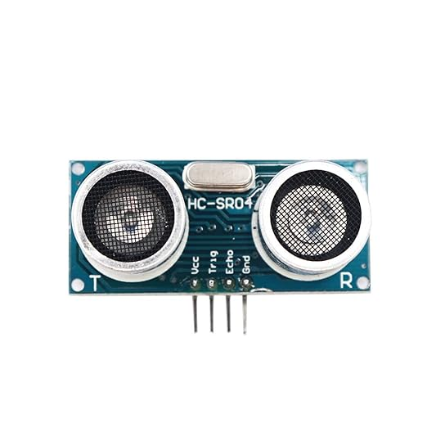

Components Required:

-LPC-1768 DEVELOPMENT BOARD

-HC-SRO4 ULTRASONIC SENSOR

-RESISTORS

-BREADBOARD AND JUMPER WIRES