BLE-Controlled BOT

1) INTRODUCTION :
The project basically focuses on designing a Bluetooth Controlled Obstruction Detection Bot, for obstruction detection an ultrasonic sensor is employed, the special feature of this project is that the Bluetooth version used is 4.0 which is BLUETOOTH LOW ENERGY.

2) MATERIALS REQUIRED :
a) Arduino UNO
b) Jumper Wires :
(i) Male to Male : 15
(ii) Male to Female : 15
c) Chassis - 15 cm (approx.)
d) Battery - 9 V
e) DC Motor - 2
f) Motor Driver - L293d
g) Bluetooth Module - HM10
h) Ultra Sonic Sensor - HC-SR04
i) Wheels

3) MATERIAL SPECIFICATIONS :
a) Arduino UNO :
The Arduino Uno is an open-source microcontroller board based on the Microchip ATmega328P microcontroller and developed by Arduino.cc. The board is equipped with sets of digital and analog input/output (I/O) pins that may be interfaced to various expansion boards (shields) and other circuits. The board has 14 digital I/O pins (six capable of PWM output), 6 analog I/O pins, and is programmable with the Arduino IDE (Integrated Development Environment), via a type B USB cable. It can be powered by the USB cable or by an external 9-volt battery, though it accepts voltages between 7 and 20 volts.
Technical specifications :
- Microcontroller: Microchip ATmega328P [7]
- Operating Voltage: 5 Volts
- Input Voltage: 7 to 20 Volts
- Digital I/O Pins: 14 (of which 6 can provide PWM output)
- Analog Input Pins: 6
- DC Current per I/O Pin: 20 mA
- DC Current for 3.3V Pin: 50 mA
- Flash Memory: 32 KB of which 0.5 KB used by bootloader
- SRAM: 2 KB
- EEPROM: 1 KB
- Clock Speed: 16 MHz
- Length: 68.6 mm
- Width: 53.4 mm
- Weight: 25 g
Pins :
- LED: There is a built-in LED driven by digital pin 13. When the pin is high value, the LED is on, when the pin is low, it is off.
- VIN: The input voltage to the Arduino/Genuino board when it is using an external power source (as opposed to 5 volts from the USB connection or other regulated power source). You can supply voltage through this pin, or, if supplying voltage via the power jack, access it through this pin.
- 5V: This pin outputs a regulated 5V from the regulator on the board. The board can be supplied with power either from the DC power jack (7 - 20V), the USB connector (5V), or the VIN pin of the board (7-20V). Supplying voltage via the 5V or 3.3V pins bypasses the regulator, and can damage the board.
- 3V3: A 3.3 volt supply generated by the on-board regulator. Maximum current drawn is 50 mA.
- GND: Ground pins.
- IOREF: This pin on the Arduino/Genuino board provides the voltage reference with which the microcontroller operates. A properly configured shield can read the IOREF pin voltage and select the appropriate power source, or enable voltage translators on the outputs to work with the 5V or 3.3V.
- Reset: Typically used to add a reset button to shields that block the one on the board.
Special pin functions :
Each of the 14 digital pins and 6 analog pins on the Uno can be used as an input or output, under software control (using pinMode(), digitalWrite(), and digitalRead() functions). They operate at 5 volts. Each pin can provide or receive 20 mA as the recommended operating condition and has an internal pull-up resistor (disconnected by default) of 20-50K ohm. A maximum of 40mA must not be exceeded on any I/O pin to avoid permanent damage to the microcontroller. The Uno has 6 analog inputs, labeled A0 through A5; each provides 10 bits of resolution (i.e. 1024 different values). By default, they measure from ground to 5 volts, though it is possible to change the upper end of the range using the AREF pin and the analogReference() function.
In addition, some pins have specialized functions:
- Serial / UART: pins 0 (RX) and 1 (TX). Used to receive (RX) and transmit (TX) TTL serial data. These pins are connected to the corresponding pins of the ATmega8U2 USB-to-TTL serial chip.
- External interrupts: pins 2 and 3. These pins can be configured to trigger an interrupt on a low value, a rising or falling edge, or a change in value.
- PWM (pulse-width modulation): pins 3, 5, 6, 9, 10, and 11. Can provide 8-bit PWM output with the analogWrite() function.
- SPI (Serial Peripheral Interface): pins 10 (SS), 11 (MOSI), 12 (MISO), and 13 (SCK). These pins support SPI communication using the SPI library.
- TWI (two-wire interface) / I²C: pin SDA (A4) and pin SCL (A5). Support TWI communication using the Wire library.
- AREF (Analog reference): Reference voltage for the Analog inputs.
b) DC Motor :
A DC motor is any of a class of rotary electrical machines that converts direct current electrical energy into mechanical energy. The most common types rely on the forces produced by magnetic fields. Nearly all types of DC motors have some internal mechanism, either electromechanical or electronic, to periodically change the direction of current flow in part of the motor .A DC motor's speed can be controlled over a wide range, using either a variable supply voltage or by changing the strength of current in its field windings.
c) Motor Driver :
A motor driver is an integrated circuit chip which is usually used to control motors in autonomous robots. Motor driver act as an interface between Arduino and the motors . The most commonly used motor driver IC’s are from the L293 series such as L293D, L293NE, etc. These ICs are designed to control 2 DC motors simultaneously. L293D consist of two H-bridge. H-bridge is the simplest circuit for controlling a low current rated motor. We will be referring the motor driver IC as L293D only. L293D has 16 pins.
SPECIFICATIONS :
- Motor/Logic supply 5 to 36 V
- Logic controls input 7 VDC max
- Inhibit facility/enable
- High Noise immunity
- Over temperature protection Capable of delivering output current up to 600 mA per channel
- The control/interface lines are accessible with Berg connector
- Header connector for motor and supply connection
- PCB dimensions 36 mm x 24 mm
d) BLE Module :
The HM-10 is a readily available Bluetooth 4.0 module. This module is used for establishing wireless data communication. The module is designed by using the Texas Instruments CC2540 or CC2541 Bluetooth low energy (BLE) System on Chip (SoC). The module design and firmware originated from the Jinan Huamao Technology Company.
HM-10 Pin Configuration :
HM-10 is a 34-pin module. In them most are not compulsory use pins. We only need four pins of all 34 to establish a communication. We will describe the function of each pin below.
HM-10 Module Features :
- BT Version: Bluetooth Specification V4.0
- BLE chip - Bluetooth Low Energy consumption
- Send and receive no bytes limit.
- Working frequency: 2.4GHz ISM band
- UART Serial Interface
- Full-Speed USB Interface
- 12 General Purpose Input/output Pins
- In-System-Programmable Flash- 128 KB or 256KB
- 8-KB SRAM
- 32-kHz Sleep Timer With Capture
- Long range: Open space have 100 Meters
- Potable size
- HM-10 MODULE Specifications
- Operating voltage of MODULE: 2.0V – 3.6V
- Can operate on LOW voltages
- Consumes 235uA on battery backup
- Input RF level: 10dBm
- Maximum voltage: + 3.9V
- Operating temperature: -40ºC to +85ºC
- ESD: 750 V
HM-10 Pin Configuration :
HM-10 is a 34-pin module. In them most are not compulsory use pins. We only need four pins of all 34 to establish a communication. We will describe the function of each pin below.

Pin Name Description
STATE ---
UART_TX UART interface-Transmit
UART_RX UART interface-receive
VCC 3.3 V
GND 0 V
ENABLE 5 V
BLE-ARDUINO INTERFACE :
AT Commands :
AT commands are commands which are used to control the modems where AT stands for Attention. These commands were derived from Hayes commands which were used by the Hayes smart modems. Every wireless, as well as the dial up modems, require an AT command to interact with a computer machine. These AT commands along with other extended commands also require Hayes command set as a subset.
Used to check the interaction between the computer and the module. This command is usually replied with an OK if the port and the module can connect correctly, else wise it comes back with a result code ERROR.
For changing the default and factory set-up settings of the Bluetooth module , upload a blank code to the Arduino , then interface Bluetooth Module with Arduino open Serial Monitor and write AT, a response in form of OK will come, showing the connections are fine.
For checking out all the AT Commands present, type AT+HELP , the following list of commands will appear on Serial Monitor.
CONNECTIONS :
HM 10 Arduino
RX TX(PIN 1)
TX RX(PIN 0)
VCC 3.3 V(PIN)
GND GND(PIN)

AT COMMANDS

Command Description
AT Check if the command terminal work normally
AT+RESET Software reboot
AT+VERSION Get firmware, Bluetooth, HCI and LMP version
AT+HELP List all the commands
AT+NAME Get/Set local device name
AT+PIN Get/Set pin code for pairing
AT+PASS Get/Set pin code for pairing
AT+BAUD Get/Set baud rate
AT+LADDR Get local Bluetooth address
AT+ADDR Get local Bluetooth address
AT+DEFAULT Restore factory default
AT+RENEW Restore factory default
AT+STATE Get current state
AT+PWRM Get/Set power on mode(low power)
AT+POWE Get/Set RF transmit power
AT+SLEEP Sleep mode
AT+ROLE Get/Set current role.
AT+PARI Get/Set UART parity bit.
AT+STOP Get/Set UART stop bit.
AT+START System start working.
AT+IMME System wait for command when power on
AT+IBEA Switch iBeacon mode
AT+IBE0 Set iBeacon UUID 0
AT+IBE1 Set iBeacon UUID 1
AT+IBE2 Set iBeacon UUID 2
AT+IBE3 Set iBeacon UUID 3
AT+MARJ Set iBeacon MARJ
AT+MINO Set iBeacon MINO
AT+MEA Set iBeacon MEA
AT+NOTI Notify connection event
AT+UUID Get/Set system SERVER_UUID
AT+CHAR Get/Set system CHAR_UUID

e) Ultra Sonic Sensor :
An ultrasonic sensor is an instrument that measures the distance to an object using ultrasonic sound waves.
An ultrasonic sensor uses a transducer to send and receive ultrasonic pulses that relay back information about an object’s proximity. High-frequency sound waves reflect from boundaries to produce distinct echo patterns.
WORKING :
Ultrasonic sensors work by sending out a sound wave at a frequency above the range of human hearing. The transducer of the sensor acts as a microphone to receive and send the ultrasonic sound. Our ultrasonic sensors, like many others, use a single transducer to send a pulse and to receive the echo. The sensor determines the distance to a target by measuring time lapses between the sending and receiving of the ultrasonic pulse.
The working principle of this module is simple. It sends an ultrasonic pulse out at 40kHz which travels through the air and if there is an obstacle or object, it will bounce back to the sensor. By calculating the travel time and the speed of sound, the distance can be calculated.
f) Wheels :
This wheel has two degrees of freedom and can traverse Front or Reverse. The centre of the wheel is fixed to the robot chassis. The angle between the robot chassis and wheel plane is constant. Fixed wheels are commonly seen in most WMR’s where the wheels are attached to motors and are used to drive and steer the robot.

4) TOOLS :
- Arduino IDE
- MIT App INVENTOR
- BLE Scanner

5) Circuit Diagram :
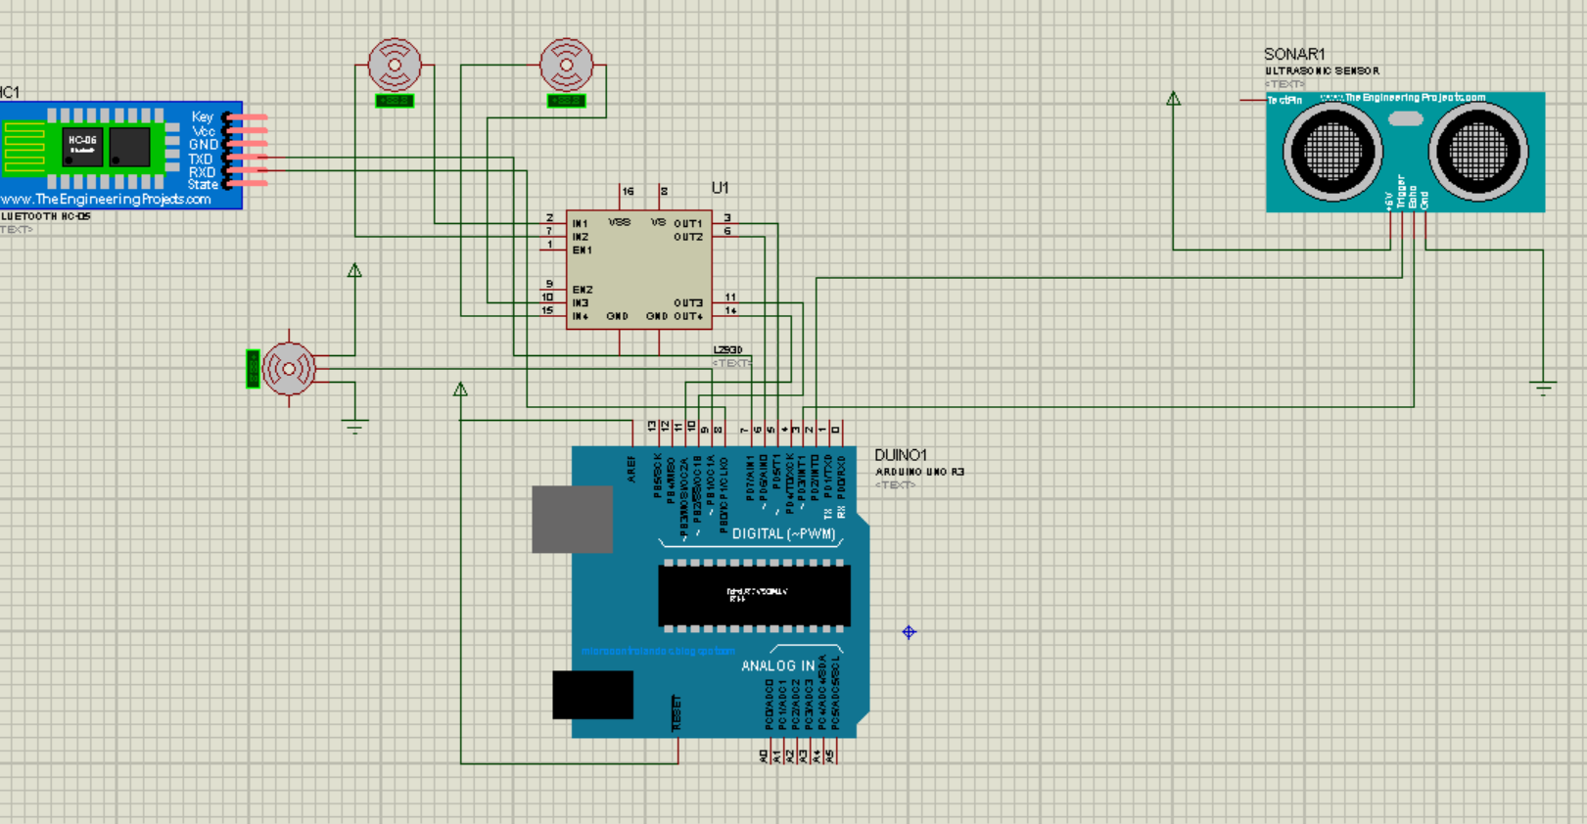

6) CONNECTIONS :

Arduino Pin | Components Connections
0 | TX
1 | RX
2 | Trig (Ultrasonic Sensor)
3 | Echo (Ultrasonic Sensor)
4 | ---
5 | Motor Driver
6 | Motor Driver
7 | TX(HM-10)
8 | RX(HM-10)
9 | Servo (Signal)
10 | Motor Driver
11 | Motor Driver
12 | ---
13 | ---
GND | GND (HM10, Servo, Motor Driver, Ultrasonic Sensor)
5V | VCC (Servo, Motor Driver, Ultrasonic Sensor)
3.3V | VCC (HM10)

7)Working :
a) When the scanning button present o the mobile app designed by MIT App Inventor is pressed, the app scans the nearby devices displayed on a BLE list on the app, when the Bluetooth name (HM-10) name is found and pressed it gets connected which is shown on the status bar on the app.
b) When Control Commands are passed vias buttons present on the app, the directions of the Bot can be controlled via Bluetooth connection.
c) The Bot detects any obstruction present by Ultra Sonic sensor which sends an ultrasonic pulse out at 40kHz which travels through the air and if there is an obstacle or object, it will bounce back to the sensor. By calculating the travel time and the speed of sound, the distance can be calculated .The minimum safe distance is kept to be 15 centimetres.

8) BOT CODE(in Arduino) :

#include <NewPing.h>
#include <SoftwareSerial.h>
#include <Servo.h>
#define TRIGGER_PIN 2 // Arduino pin tied to trigger pin on the ultrasonic sensor.
#define ECHO_PIN 3 // Arduino pin tied to echo pin on the ultrasonic sensor.
#define MAX_DISTANCE 200 // Maximum distance we want to ping for (in centimeters). Maximum sensor distance is rated at 400-500cm.

NewPing sonar(TRIGGER_PIN, ECHO_PIN, MAX_DISTANCE); // NewPing setup of pins and maximum distance.
SoftwareSerial serial(7, 8);

int pos = 0;
Servo servo;
char value = ' ';
long duration;
int distance;

void setup()
{
servo.attach(9);
servo.write(90);
serial.begin(115200);
pinMode(5, OUTPUT);
pinMode(6, OUTPUT);
pinMode(10, OUTPUT);
pinMode(11, OUTPUT);

}

void loop()
{
delay(50); // Wait 50ms between pings (about 20 pings/sec). 29ms should be the shortest delay between pings.
serial.print("Ping: ");
serial.print(sonar.ping_cm()); // Send ping, get distance in cm and print result (0 = outside set distance range)
serial.println("cm");

if (serial.available())
{

if (distance > 15)
{
value = serial.read();
switch (value)
{

case 'F':
digitalWrite(5, HIGH);
digitalWrite(6, LOW);
digitalWrite(10, LOW);
digitalWrite(11, HIGH);
break;

case 'B':
digitalWrite(5, LOW);
digitalWrite(6, HIGH);
digitalWrite(10, HIGH);
digitalWrite(11, LOW);
break;

case 'R':
digitalWrite(5, HIGH);
digitalWrite(6, LOW);
digitalWrite(10, LOW);
digitalWrite(11, LOW);
break;

case 'L':
digitalWrite(5, LOW);
digitalWrite(6, LOW);
digitalWrite(10, LOW);
digitalWrite(11, HIGH);
break;

case 'S' :
digitalWrite(5, LOW);
digitalWrite(6, LOW);
digitalWrite(10, LOW);
digitalWrite(11, LOW);
break;
}

}
else
{
digitalWrite(5, LOW);
digitalWrite(6, LOW);
digitalWrite(10, LOW);
digitalWrite(11, LOW);
}
}
}

