ELECTRONIC PIANO USING 555 TIMER IC

PRINCIPLE :
Main heart of this circuit is 555timer IC. The 555 timer is operated in Astable Multivibrator mode. In Astable Multivibrator mode, the circuit produces accurate free running waveforms, which can be adjusted.

CIRCUIT COMPONENTS :
- 555 Timer IC
- 5 Resistors – R1 to R5
- Potentiometer – RV1
- Capacitors – C1 and C2
- Speaker of capacity 8ohms.

WORKING :
The circuit consists of five 1 kohm resistors connected in series. There are six buttons connected in the circuit. When one button is pressed it produces a tone. Similarly, five buttons produce five different tones. That means, it just works as a toy piano. When the first button from right is pressed it produces high pitch tone. When the last button is pressed it delivers a low tone. This is because of the resistance connected to the buttons. The low thresh hold voltage obtained at the fifthth pin slows the charging and discharging of 10 micro farad capacitor at the speaker. As the resistance value increases voltage at the threshold pin decreases and low frequency passes through speaker.

CIRCUIT DIAGRAM :

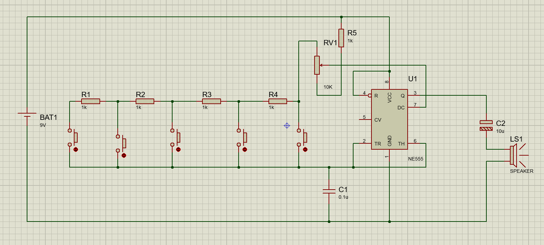

DESIGN :
The 555 IC is a timer IC that produces frequency, the 555 Timer is operated in Astable Multivibrator mode .The supply voltage VCC is 9V. Five 1k resistors are connected in series. Second and sixth pins are shorted to allow retriggering of 555 timer IC after every timing cycle. These two pins are grounded through a capacitor. Fourth pin is reset pin it is shorted with eighth pin i.e. VCC to avoid sudden resets. Seventh pin is discharge pin. It is connected to series resistors through a variable resistor. Output is taken from third pin. The obtained frequency is applied to the 8 ohms speaker through a 10 microfarad capacitor.

