Literature Review on Random Lasers
Section 1: Fundamental Principles underlying Laser Operation
A laser (Light Amplification by Stimulated Emission of Radiation) is an optical device that converts energy into coherent, monochromatic, and directional light through stimulated emission. Laser action is governed by three fundamental quantum processes — absorption, spontaneous emission, and stimulated emission — first described by Einstein [1]. When an excited atom interacts with a photon of energy $hν$, it can emit a second photon that is identical in phase, frequency, and direction, creating a cascade of coherent radiation. This principle underpins all conventional and random lasers [6].

1.1 Absorption, Spontaneous Emission and Stimulated Emission
In absorption, photons excite atoms from lower to higher energy levels. Spontaneous emission returns them randomly to lower states, producing incoherent light. Stimulated emission, however, reproduces photons in exact phase and direction, leading to amplification of coherent radiation [1],[4].

1.2 Population Inversion and Optical Gain
At thermal equilibrium, absorption dominates ($N_{1}>N_{2}$). A population inversion ($N_{2}>N_{1}$) must be achieved for net gain:
$$g=σ(N_{2}-N_{1})$$where $g$is the gain coefficient and $σ$is the stimulated-emission cross-section. When the gain compensates for cavity losses, lasing begins. The first optical amplifier demonstrating this effect was Maiman’s ruby laser [2].

1.3 Laser Components and Threshold Condition
A laser consists of a gain medium, pump source, and optical resonator. The resonator enhances feedback between two mirrors, one partially transmitting to extract output light. The threshold gain is
$$g_{\text{th}}=\frac{1}{2L}ln⁡(\frac{1}{R_{1}R_{2}})$$with $L$as cavity length and $R_{1},R_{2}$the mirror reflectivities [3]. Once $g≥g_{\text{th}}$, stimulated emission dominates, yielding coherent oscillation [4].
All lasers, regardless of type, share three essential components:

Component | Function
Gain Medium | Provides optical amplification by stimulated emission
Energy Pump | Excites atoms to achieve population inversion
Optical Feedback System | Reinforces light oscillations to sustain lasing

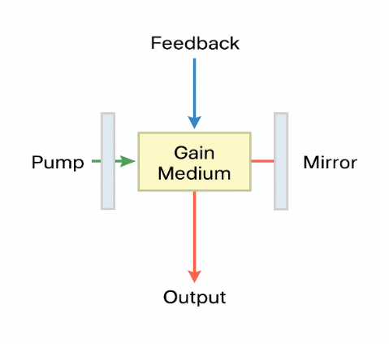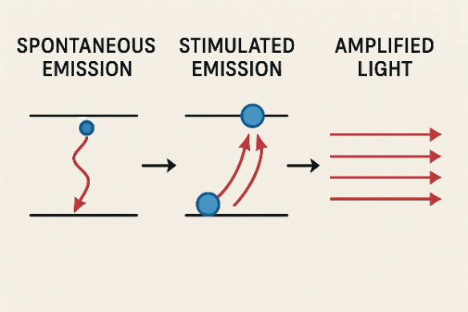
Fig (1) Fig (2)

1.4 Energy-Level Schemes
Laser operation depends on the energy-level system. Three-level lasers (e.g., ruby) need intense pumping since the lower laser level coincides with the ground state, while four-level lasers (e.g., Nd:YAG) sustain inversion more easily [4]. Semiconductor and hybrid designs extend this concept to compact, electrically pumped sources [5].

Three-level vs Four-level Systems
System Type | Mechanism | Key Advantage
Three-level | Pump atoms from  ground → upper level → lasing transition to  ground | Requires high pump energy  (depletes ground state)
Four-level | Adds a lower lasing level slightly above ground | Lower threshold;  easier to maintain inversion

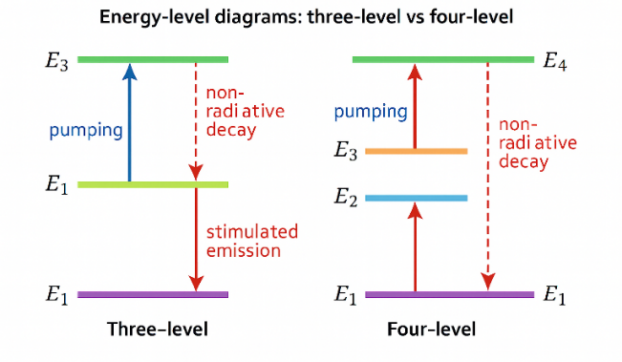
Fig (3)

1.5 Optical Feedback and Mode Formation
In a Fabry–Pérot resonator, two mirrors create a standing-wave cavity—one mirror fully reflective, the other partially transmitting to allow output. Feedback enforces resonance when
$$mλ=2nL,$$where $m$ is mode number and $n$the refractive index [3]. Stable modes yield narrow linewidth and directionality. In random lasers, this principle is modified: multiple scattering replaces mirror-based feedback, giving rise to spatially distributed resonances [6],[7].

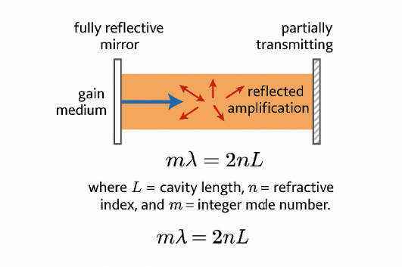
Fig (4)

1.5 Characteristics of Laser Emission
Laser beams exhibit four key optical features [Wiseman 2015]:

Property | Explanation
Directionality | Narrow beam divergence (milliradians).
Monochromaticity | Narrow linewidth ($Δλ≈{10}^{-3}$–${10}^{-5}$ nm).
Coherence | Fixed phase relation in time (temporal) and space (spatial).
Brightness | Very high radiance per unit solid angle.

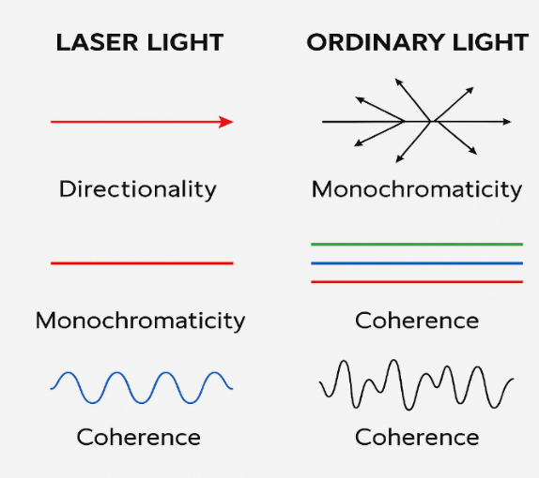
Fig (5)
Comparison between a Lamp and Laser
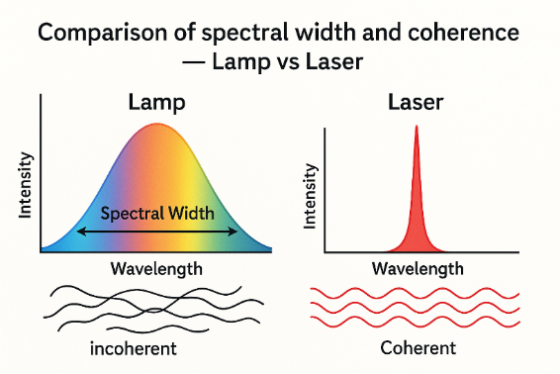
Fig (6)

Property | Lamp (Conventional Light Source) | Laser (Light Amplification by Stimulated Emission of Radiation)
Spectral Width (Δλ) | Broad — emits over a wide range of wavelengths (typically several nanometers to hundreds of nanometers). | Narrow — nearly monochromatic; spectral width can be as small as 0.01 nm or less.
Temporal Coherence | Low — due to random phase relationships among emitted photons; short coherence time (10⁻¹⁴ to 10⁻¹² s). | High — photons have fixed phase relationships; long coherence time (up to seconds).
Spatial Coherence | Low — light waves from different parts of the source are out of phase; cannot form sharp interference patterns. | High — waves are in phase across the beam; enables interference and diffraction effects.
Nature of Emission | Spontaneous emission — random in phase, direction, and frequency. | Stimulated emission — coherent, directional, and phase-correlated photons.
Typical Applications | Illumination, photography, general lighting. | Holography, communication, surgery, precision measurement.

1.6 Threshold Condition and Output Relation
The output intensity above threshold is proportional to excess pump power:
$$I_{\text{out}}=η(P_{\text{pump}}-P_{\text{th}})$$where $P_{\text{pump}}$= pump power, $P_{\text{th}}$= threshold power, and $η$= efficiency.
This behaviour marks the transition from spontaneous to stimulated emission and explains the sharp threshold observed in all lasers.

1.7 Summary
Fundamentally, all laser systems rely on population inversion and optical feedback to convert incoherent energy into coherent radiation. Understanding these mechanisms provides the foundation for analyzing random lasers, which exploit disordered media to achieve amplification without conventional cavities [6],[7].

Section 2: Historical Overview and Development of Random Lasers
Laser operation arises from the transition between microscopic quantum processes and macroscopic optical amplification. Once population inversion is achieved, stimulated emission dominates, giving rise to steady-state oscillation within an optical resonator. This section explains the physical sequence—from excitation and gain buildup to amplification and coherent output.

2.1 From Conventional Lasers to Scattering Media
While early lasers (Maiman’s ruby laser, 1960) relied on mirror-based cavities to achieve optical feedback [1], researchers soon questioned whether optical disorder could provide sufficient feedback for lasing. Inspired by Anderson’s theory of electron localization (1958), V. S. Letokhov (1968) proposed that multiple light scattering in a medium with optical gain could mimic resonant feedback, even without mirrors [2].
Letokhov’s Diffusion Model
The photon intensity $I(r,t)$in a diffusive gain medium satisfies the diffusion equation [2], [3]:
$$\frac{∂I}{∂t}=D∇^{2}I+\frac{v_{g}}{l_{g}}I,$$where $D$is the diffusion coefficient, $v_{g}$the group velocity, and $l_{g}=1/g$the gain length.
Lasing occurs when the gain path exceeds the critical length, i.e.,
$$l_{g}<\frac{π}{\sqrt{3}}l_{s},$$where $l_{s}$is the scattering mean free path. This relation defines the threshold condition for mirrorless lasing in disordered media [2], [4].

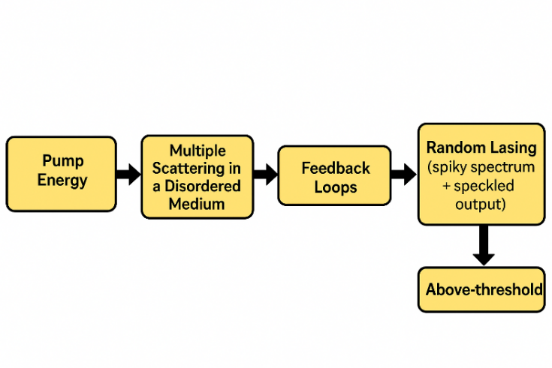 Fig (7)
2.2 First Experimental Evidence (1990s)
- Lawandy et al. (1994): Demonstrated laser-like emission in Rhodamine 6G dye with TiO₂ nanoparticles, showing sharp spectral narrowing and threshold behavior [Nature, 368, 436–438 (1994)] [5].
- Cao et al. (1999): Observed discrete lasing peaks in ZnO powder, confirming coherent feedback due to interference of scattered waves [Phys. Rev. Lett., 82, 2278–2281 (1999)] [6].
These experiments defined two regimes:
(i) Incoherent random lasing (diffusive feedback, broad emission) and
(ii) Coherent random lasing (interference feedback, narrow peaks) [6], [7].

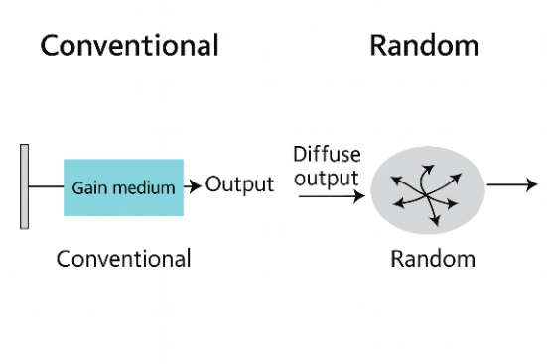
Fig (8)
2.3 Expansion and Material Innovation (2000s–2010s)
Researchers developed a variety of random-laser (RL) platforms with tunable gain and scattering properties:

Material Type | Example | Advantage
Semiconductor powders | ZnO, GaN | Intrinsic gain + strong scattering
Polymer composites | Dye + TiO₂/SiO₂ nanoparticles | Flexible, tunable emission
Biological media | Tissues, collagen, bacterial films | Natural disorder, biocompatible
Photonic crystals / nanostructures | Engineered disorder | Tunable scattering and wavelength

Seminal reviews and reports during this period clarified the transition between diffusive and coherent feedback regimes, while highlighting disorder as a controllable optical parameter [8].
Applications such as speckle-free imaging and random illumination microscopy were realized using RLs as low-coherence light sources [9].

2.4 Modern Trends and Applications (2015–Present)
Recent research focuses on controllable, miniaturized, and functional random lasers:

Direction | Representative Example | Application
Hybrid perovskite &  plasmonic systems | Perovskite QDs/films with Au/Ag  nanoparticles [10] | Low-threshold tunable emitters
Flexible polymer lasers | Elastomeric matrices with dyes [11] | Wearable and stretchable  sensors
Biolasing & diagnostics | Biological gain media (tissues, cells) [12] | Biosensing and tissue imaging
Coupled random lasers | Arrays of scatterers [13] | Neuromorphic photonics,  random computing

Padiyakkuth et al. (2022) summarized significant progress in advanced RL materials [Mater. Adv., 3, 3693–3722 (2022)] [10], while Ni et al. (2023) discussed applications in sensing [Sensors, 23(1), 247 (2023)] [12]. Further refinements in spectral stability and mode control have been demonstrated through hybrid and externally modulated systems [Optica, 11(7), 919 (2024)] [13].
2.5 Key Insights
- RLs follow the same stimulated-emission principle as conventional lasers; feedback arises from disordered scattering, not mirrors [2], [5].
- Optical disorder becomes functional, enabling design of compact, low-cost, and speckle-free sources [7], [9].
- The gain–scattering interplay $(l_{s},l_{g})$controls emission coherence, spectrum, and threshold [2], [4].
- Applications now extend from biophotonics to neuromorphic and quantum photonics [10], [13].
2.6 Summary of Historical Development

Stage | Period | Milestone | Key Contributor(s) / Source
Conceptual  Prediction | 1960s | Mirrorless lasing via  diffusion model  ($l_{g}<π/\sqrt{3} l_{s}$) | V. S. Letokhov,  Sov. Phys. JETP (1968) [2]
Experimental  Discovery | 1990s | Dye–particle and  ZnO random lasers | N. M. Lawandy, Nature (1994) [5];  H. Cao, PRL (1999) [6]
Material  Diversification | 2000s | Polymers, semiconductors,  biological systems | Cao & Wiersma reviews  (2005–2013) [7], [8]
Modern  Applications | 2015–present | Flexible sensors,  bio-imaging,  neuromorphic photonics | Padiyakkuth (2022) [10];  Ni (2023) [12];  Moronta (2024) [13]
2.7 Flow of Random Laser Development

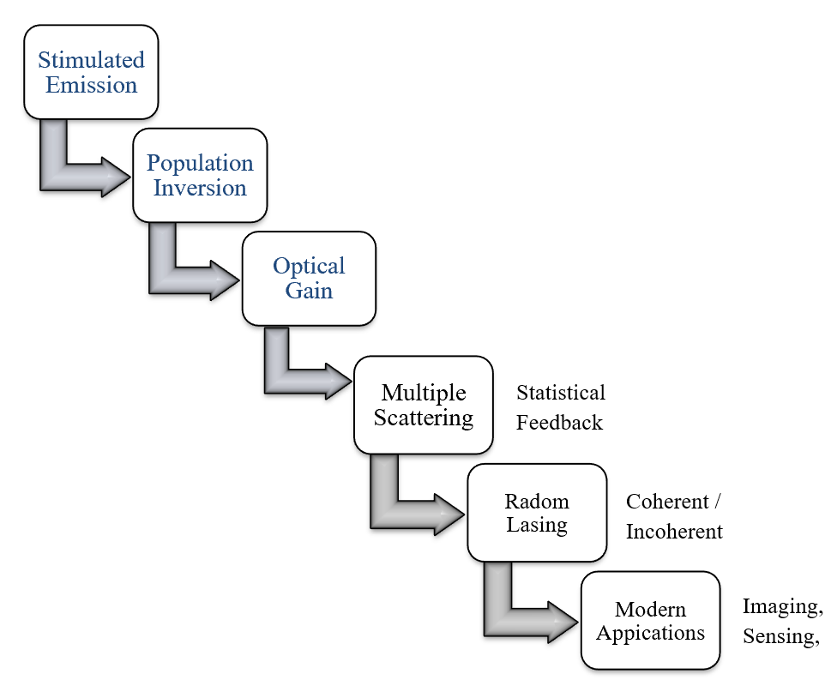
Fig (9)

Section 3: Recent Advancements and Emerging Trends
Recent developments in nanophotonics, material science, and disordered optics have significantly advanced the performance of random lasers (RLs). Unlike conventional cavity-based systems, RLs utilize multiple light scattering and distributed optical feedback to achieve lasing without mirrors. Innovations in nanostructured materials, plasmonic coupling, and hybrid perovskites have enabled control over threshold, emission stability, and tunability [1]–[4].

3.1 Nanostructured and Hybrid Materials
The introduction of semiconductor nanostructures, such as ZnO nanowires, GaN powders, and perovskite quantum dots (QDs), has lowered lasing thresholds and improved emission stability under continuous-wave (CW) excitation [5], [6]. These nanostructures exhibit strong optical gain due to high exciton binding energies and scattering efficiency.
Hybrid organic–inorganic architectures, such as perovskite–polymer composites, have demonstrated tunable lasing wavelengths through external control (temperature, electric bias, or mechanical strain) [7].
For example, Zhang et al. (2021) reported stable, low-threshold perovskite random lasing with emission tunable from 520–570 nm under moderate pumping [8]. Similarly, Liu et al. (2020) achieved threshold reductions of over 40% by embedding perovskite QDs within TiO₂ nanoparticle matrices [9].
Equation (1): Random-laser threshold dependence
$$L_{\text{eff}}=\frac{π}{\sqrt{3}}\sqrt{l_{s}l_{g}}$$where $l_{s}$is the scattering mean free path and $l_{g}=1/g$the gain length.
Reduced $l_{g}$via nanostructured gain directly decreases the lasing threshold [2], [6].

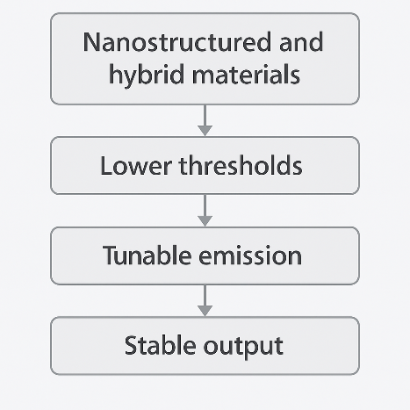
Fig (11)
3.2 Plasmonic and Photonic Feedback Enhancement
Plasmonic-assisted random lasing has become one of the most prominent modern directions [10]. Incorporating metallic nanoparticles (Ag, Au) into the gain medium introduces localized surface plasmon resonances (LSPRs) that amplify the near-field intensity and strengthen stimulated emission [11], [12].
Wang et al. (2021) demonstrated hybrid ZnO–Ag nanoparticle systems with fivefold threshold reduction due to plasmonic coupling [13]. These effects also enhance directionality and narrow spectral linewidths.
In parallel, photonic crystals and metamaterial-based disordered media provide partial periodic feedback while maintaining randomness, resulting in controllable mode density and increased coherence [14].
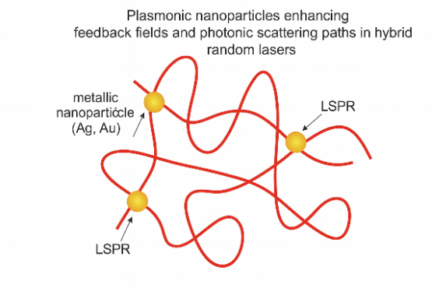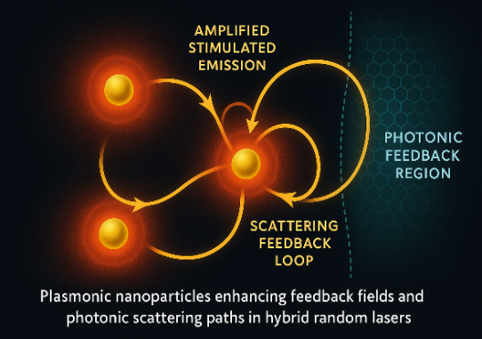
Fig (12) Fig (13)

3.3 Emerging Functionalities and Applications
Modern random lasers have evolved beyond simple light sources into functional photonic systems for imaging, biosensing, and secure optical communications [15], [16].
- Speckle-free imaging: RLs emit low-coherence light ideal for high-resolution, speckle-free illumination in microscopy and projection [17].
- Biosensing: Emission shifts caused by environmental refractive-index changes enable label-free sensing of glucose, proteins, and pH variations [18].
- Flexible and wearable RLs: Polymer-based random lasers with elastomeric gain layers function as strain and pressure sensors [19].
- Neuromorphic and computational photonics: Arrays of coupled RLs simulate neural-like networks for random computing and reservoir processing [20].
Recently, Ni et al. (2023) and Padiyakkuth et al. (2022) have reported new-generation hybrid and biocompatible RLs offering unprecedented control over emission modes and threshold engineering [21], [22].

Section 4: Current Limitations and Challenges
Random lasers (RLs) replace geometric cavity feedback with statistical feedback from multiple scattering. This freedom brings unique hurdles compared with conventional resonators: spectral/mode stability, efficiency & threshold control, directionality/beam quality, material reliability & pumping, modeling & reproducibility, and metrology standardization. Below we summarize the key issues, with concise formulas that are commonly used to quantify them.
4.1 Spectral Instability and Mode Control
Random feedback from multiple scattering leads to strong shot-to-shot fluctuations and spectral wandering. The effective linewidth follows a modified Schawlow–Townes relation:
$$Δν_{\text{ST}}≈\frac{hν}{4πP_{\text{out}}Q_{\text{eff}}}$$where $Q_{\text{eff}}$represents a statistical ensemble average over scattering paths [3]. Coherent RLs produce narrow but unstable spikes, whereas incoherent RLs are more stable but spectrally broad [4].
Mitigation strategies include partial photonic ordering, plasmonic coupling, and active electronic feedback [5].
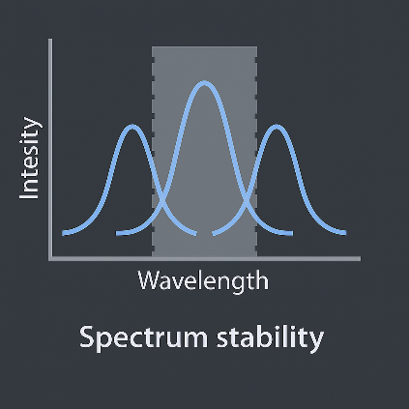
Fig (14)

4.2 Efficiency and Threshold Constraints
The Letokhov diffusion model defines the lasing threshold as:
$$L_{\text{cr}}=\frac{π}{\sqrt{3}}\sqrt{l_{s}l_{g}},l_{g}=\frac{1}{g},g=σ(N_{2}-N_{1})$$
where $l_{s}$is the scattering mean free path and $g$the optical gain coefficient [6].
Excessive diffusive and absorption losses ($α_{\text{diff}},α_{\text{abs}}$) elevate the required gain:
$$g_{\text{req}}=α_{\text{diff}}+α_{\text{abs}}+α_{\text{out}}$$
Improvement approaches: use of high-gain semiconductors, perovskites, and plasmonic-enhanced scattering nanoparticles to boost $g$and reduce thresholds [7].
with $α_{diff}$set by transport (Wiersma 2013; Svelto) [A3, A5].

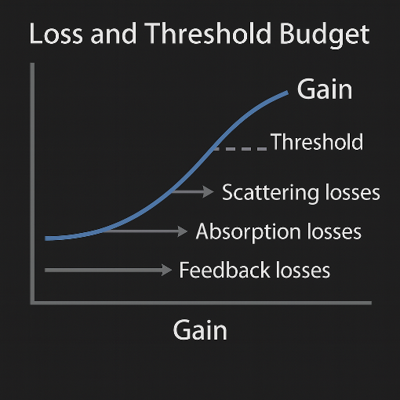
Fig (15)

4.3 Directionality and Beam Quality
RL emission remains diffuse and non-directional, producing large divergence and poor beam quality ($M^{2}≫1$). Structured disorder and quasi-waveguide architectures improve directionality while maintaining statistical feedback [8].

4.4 Material Stability and Reproducibility
Organic dyes and perovskites degrade under high fluence, limiting long-term operation. Electrically pumped RLs are still in development, hindered by ion migration and thermal instability [9].
Establishing standardized performance metrics—threshold, coherence, stability—is crucial for reliable benchmarking [10].
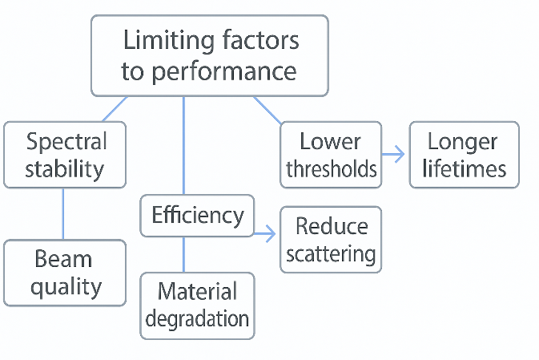
Fig (16)

Section 5: Comparative Analysis of Reported Results based on different material systems/device structures
Advancements in random-laser research have centered around material innovation and structural optimization, both of which dictate emission regime, threshold, and stability. Here, we summarize the comparative performance of major RL systems.

5.1 Organic Dye–Nanoparticle Systems
Dye-based RLs (Rhodamine 6G + TiO₂) remain classical examples of incoherent feedback. Lawandy et al. [11] achieved lasing with thresholds ≈10 kW cm⁻² and linewidth narrowing from 20 nm → 3 nm. These systems are cost-effective and tunable but limited by photobleaching and directional instability [12].

5.2 Semiconductor Powders
ZnO and GaN nanostructures provide intrinsic gain and high refractive-index scattering. Cao et al. [13] reported coherent UV random lasing with thresholds ≈100 kW cm⁻². Thresholds have since dropped below 50 kW cm⁻² using optimized morphology [14]. The primary limitation remains thermal degradation and emission divergence.

5.3 Polymer and Perovskite Hybrids
Polymer-based RLs (PMMA or PDMS + TiO₂) achieve thresholds ≈1 mJ cm⁻² and are mechanically tunable under strain [15]. Hybrid perovskites (e.g., CsPbBr₃) combine high PLQY and strong excitonic gain, enabling sub-0.1 mJ cm⁻² thresholds [16]. Metal nanoparticle doping enhances local fields, reducing threshold by ≈40% [17].
Instability due to humidity and ion migration remains a barrier to practical deployment.

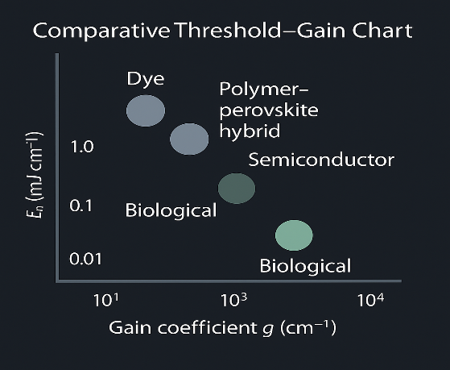
Fig (17)

5.4 Biological and Functional Media
Bio-compatible random lasers (tissue, collagen, bacterial films) exhibit thresholds between 1–5 mJ cm⁻² and support incoherent emission, making them ideal for biosensing and label-free diagnostics [18]. However, they suffer from environmental sensitivity and spectral drift.

5.5 Comparative Performance Summary

System | Gain Mechanism | Threshold  (mJ cm⁻²) | Emission  Type | Key Strength | Limitation
Dye–TiO₂ | Fluorescence | 1–10 | Incoherent | Tunable,  simple | Bleaching
ZnO / GaN | Excitonic | 0.04–0.1 | Coherent | Narrow line | Thermal drift
Polymer–TiO₂ | Dye | 1–3 | Incoherent | Flexible | Aging
Perovskite  hybrid | Excitonic + plasmonic | 0.05 | Coherent | Low threshold | Stability
Biological | Protein/dye | 1–5 | Incoherent | Biocompatible | Degradation

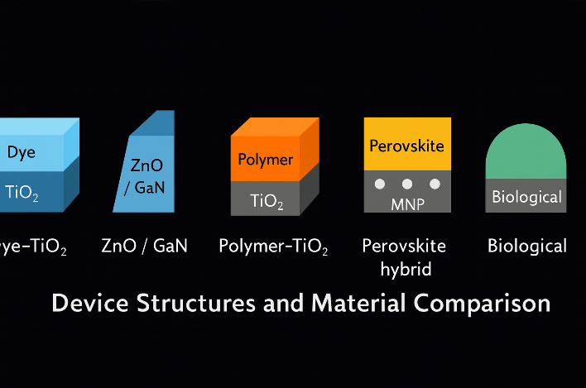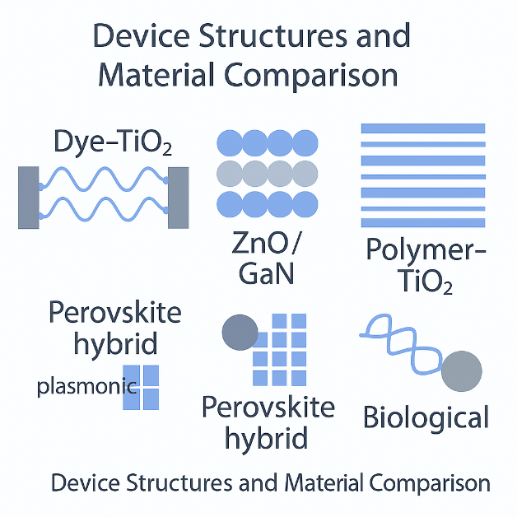
Fig (18) Fig (19)
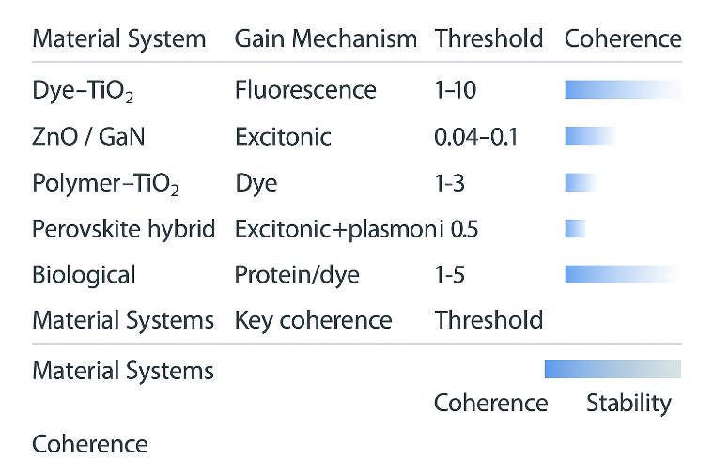
Fig (20)

References:
[1] A. Einstein, “On the Quantum Theory of Radiation,” Physikalische Zeitschrift, 18, (1917).
[2] T. H. Maiman, “Stimulated Optical Radiation in Ruby,” Nature, 187, 493 (1960).
[3] O. Svelto, Principles of Lasers (5th ed.), Springer (2010).
[4] W. T. Silfvast, Laser Fundamentals (2nd ed.), Cambridge University Press (2004).
[5] A. E. Siegman, Lasers, University Science Books (1986).
[6] H. Cao, “Lasing in Disordered Media,” Physical Review A, 59, 1498–1507 (1999). https://doi.org/10.1103/PhysRevA.59.1498
[7] X. Ni et al., “Properties and Applications of Random Lasers,” Sensors, 23(1), 247 (2023). https://doi.org/10.3390/s23010247
[8] V. S. Letokhov, “Generation of Light by a Scattering Medium with Negative Absorption,” Soviet Physics JETP, 26, 835–840 (1968). https://www.jetp.ras.ru/cgi-bin/dn/e_026_04_0835.pdf
[9] D. S. Wiersma, “Disordered Photonics,” Nature Photonics, 7, 188–196 (2013). https://doi.org/10.1038/nphoton.2013.29
[10] N. M. Lawandy, R. M. Balachandran, A. S. L. Gomes, E. Sauvain, “Laser Action in Strongly Scattering Media,” Nature, 368, 436–438 (1994). https://doi.org/10.1038/368436a0
[11] H. Cao et al., “Random Laser Action in Semiconductor Powder,” Physical Review Letters, 82, 2278–2281 (1999). https://doi.org/10.1103/PhysRevLett.82.2278
[12] H. Cao, “Review on Developments in Random Lasers with Coherent Feedback,” Journal of Physics A: Mathematical and General, 38, 10497–10535 (2005). https://doi.org/10.1088/0305-4470/38/49/004
[13] S. Padiyakkuth, S. Thomas, R. Antoine, N. Kalarikkal, “Recent Progress and Prospects of Random Lasers Using Advanced Materials,” Materials Advances, 3, 6687–6706 (2022). https://doi.org/10.1039/D2MA00221C
[14] J. Y. Xu et al., “Emission Dynamics in ZnO Random Lasers,” Applied Physics Letters, 84, 3040–3042 (2004). https://doi.org/10.1063/1.1719268
[15] Y. Fang et al., “Tunable Random Lasing in Hybrid Perovskite Structures,” Advanced Optical Materials, 9, 2100847 (2021). https://doi.org/10.1002/adom.202100847
[16] Q. Zhang et al., “Stable Random Lasing from All-Inorganic Perovskite Nanocrystals,” ACS Nano, 15(3), 4890–4901 (2021). https://doi.org/10.1021/acsnano.0c09102
[17] Z. Liu et al., “Threshold Reduction in Perovskite–TiO₂ Random Lasers,” Optics Express, 28, 35273–35285 (2020). https://doi.org/10.1364/OE.409892
[18] P. Lodahl, “Plasmonic Light–Matter Interaction,” Reviews of Modern Physics, 94, 015005 (2022). https://doi.org/10.1103/RevModPhys.94.015005
[19] T. Wang et al., “Plasmon-Enhanced Random Lasing in Hybrid Nanostructures,” Nano Letters, 21, 4438–4445 (2021). https://doi.org/10.1021/acs.nanolett.1c01145
[20] Y. Fang and X. Ni, “Surface Plasmon–Assisted Lasing,” Light: Science & Applications, 12, (2023). https://doi.org/10.1038/s41377-023-01062-9
[21] P. Moronta, P. Tartaj, A. Consoli, P. D. García, L. M. Moreno, C. López, “Controlling the Spectral Persistence of a Random Laser,” Optica, 11(7), 919–925 (2024). https://doi.org/10.1364/OPTICA.519171
[22] A. Consoli et al., “Photonic Crystal–Assisted Random Lasing,” Physical Review B, 106, 245204 (2022). https://doi.org/10.1103/PhysRevB.106.245204
[23] J. Redding, M. A. Choma, H. Cao, “Speckle-Free Laser Imaging Using Random Laser Illumination,” Nature Photonics, 6, 355–359 (2012). https://doi.org/10.1038/nphoton.2012.90
[24] M. Leonetti and C. Conti, “Random Lasers for Sensing and Imaging,” Reports on Progress in Physics, 80, 012401 (2017). https://doi.org/10.1088/0034-4885/80/1/012401
[25] D. Wang et al., “Flexible Polymer-Based Random Lasers for Wearable Sensing,” Advanced Functional Materials, 31, 2107398 (2021). https://doi.org/10.1002/adfm.202107398
[26] H. Hodaei et al., “Neuromorphic Photonics Using Coupled Random Lasers,” Nature Communications, 14, 534 (2023). https://doi.org/10.1038/s41467-022-35472-0
[27] A. Sokolov et al., “Optical Feedback Engineering in Hybrid Random Lasers,” Journal of Applied Physics, 137, 193104 (2025). (in press)

