11/5/2020

Home Automation

Making our Homes Smarter

Divya Gavane

Samruddhi Nabriya

Disha Athani

Gargi Jain

Shruti Dalvi

**Project aim:**

The aim of the project is to design and construct a home automation system that will remotely switch on or off any household appliances connected to it, using a microcontroller on phone, or Bluetooth based android application.

**Objective :**

The main objective of the project is to develop a home automation system using an Arduino board with Bluetooth being remotely controlled by any App installed on Android or OS smartphone. As technology is advancing so houses are also getting smarter. Remote controlled home automation systems provide a most modern solution with smartphones. In order to achieve this, a Bluetooth module is interfaced to an Arduino board at the receiver end while on the transmitter end, a GUI application on the cell phone sends ON/OFF commands to the receiver where loads are connected. By touching the specific location on GUI, the load can be turned ON/OFF Remotely through this technology. The loads are operated by an Arduino board through relays.

**Project scope and limitation:**

This project work is complete on its own remotely and automatically switches on or off of electrical appliances not limited to household appliances and sends a feedback message indicating the present state of the appliances.

**Components:**

**HARDWARE REQUIREMENT:**

1. Arduino AND Genuino-101

2. HC-05 Bluetooth Module

3. Breadboard

4. Connecting wires

5. 9V power supply

6. Smartphone(Bluetooth enabled)

7. 2 channel 12V, 10A relay board module

**Software components used:**

1. Arduino IDE

2. MIT App Inventor

**TECHNICAL SPECIFICATION OF THE PROJECT:**

1. A Smartphone or an android mobile which should have the android app installed in it.
2. Bluetooth receiver module:- Our project will be connected to the smartphone using Bluetooth technology.
3. Controller or the main processing circuit:-

In this project, Arduino is the main controlling/ processing unit.

1. LCD Display:-The liquid crystal display is optional but shows important messages like device status once command is received from Bluetooth.
2. Relay to control devices:- We have used 12volts Single push single throw

relays.

1. For the demo purpose, we connected a DC device to a relay(12 volts DC

bulb).You can connect any AC/DC devices to the remaining 3relays.

**Working of the Prototype :**

Basic Working :

A home assistant is an integration of technologies in which the home appliances like fans, lights, iron, washing machine, television, etc. can be controlled from anywhere in the house using your mobile phones. Let’s take an example: You are sleeping in your bedroom and you have left the light on in your living room. Instead of getting up and manually switching the light off you can use your phone to do this task for you without getting up.

The technologies used in this project are:

1. Arduino-101

2. Bluetooth Module

**Steps performed :**

1. The command is interpreted and converted into encrypted data by the app. The path through which this command to reaches the appliance includes several components and tech.
2. The appliances are connected to an Arduino-101 board via relays this board works like the brain of the whole set-up.
3. This board receives the user’s command in the encrypted form from the mobile app via Bluetooth.
4. Arduino processes this data and sends a digital signal with the expected command to the respective relay which in turn makes the appliance operate according to the command (completes the circuit and the appliance is switched on and vice-versa).
5. In our project we are first trying the basics like controlling fans and lights ,switching them on and off.

**The Basic Working Command Line is:**

1. Processing on MIT Inventor app.

2. Digital input of processed data to Arduino-101 via Bluetooth.

3. Processing on Arduino-101.

4. Digital output from Arduino-101 to respective relay.

5. Working of respective relay according to the command and the

appliance operates according to it.

Arduino-101 :

The command received via Bluetooth from the app is processed using the code

inserted into it via USB.

Code:

# define CH4

# define CH5

void setup()

{

Serial.begin(9600);

pinMode(CH4, OUTPUT);

pinMode(CH5, OUTPUT);

digitalWrite(CH4, HIGH);

digitalWrite(CH5, HIGH);

delay(2000);

}

void loop()

{

delay(100);

if(Serial.available())

{

char c = Serial.read();

Serial.print(c);

if(c==’2’)//light on

{

digitalWrite(CH4 ,LOW);

delay(100);

}

else if(c==’3’)//fan on

{

digitalWrite(CH5,LOW);

delay(100);

}

else if(c==’-2’)//light off

{

digitalWrite(CH4,HIGH);

delay(100);

}

else if(c==’-3’)//fan off

{

digitalWrite(CH5,HIGH);

delay(100);

}

else if(c==’0’)//goodbye

{

digitalWrite(CH5,LOW);

digitalWrite(CH4,LOW);

delay(10000);

}

else if(c==’1’)//all on

{

digitalWrite(CH5,HIGH);

digitalWrite(CH4,HIGH);

delay(10000);

}

}

}

**Command Relay Output :**

Turn the light on CH4 relay channel receives power LED is turned on. Switch off the Light CH4 relay channel power is cut off LED is switched off. Switch on the Fan CH5 relay channel receives power Fan is switched on. Switch of the Fan CH5 relay channel power is cut off Fan is switched off.

**Observation :**

|  |  |  |
| --- | --- | --- |
| COMMAND | RELAY | OUTPUT |
| Press Button 1 | Relay connected to 4th pin of Arduino named CH4 receives power also CH5 named 5th pin receives power. | LED turned ON  Fan turned ON |
| Press Button 2 | CH4’s and CH5’s input power is cut off. | LED and Fan turned OFF |
| Press Button 3 | Relay connected to 4th pin of Arduino named CH4 receives power | LED turned ON |
| Press Button 4 | CH4’s input power is cut off | LED turned OFF |
| Press Button 5 | Relay connected to 5th pin of Arduino named CH5 receives power | Fan turned ON |
| Press Button 6 | CH5’s input power is cut off | Fan turned OFF |

**Implementation up till now :**

1. For the core circuit diagram using Arduino-101, relays, the appliances

and the Bluetooth model we are trying many simulation Software like

Proteus, Fritzing, etc.

2.App on Home Automation created using the platform of MIT App Inventor.

**Circuit Diagram :**

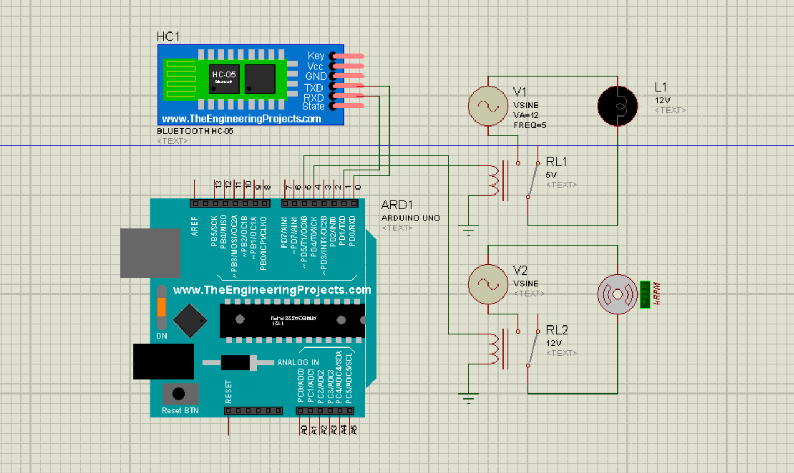

**MIT APP :**

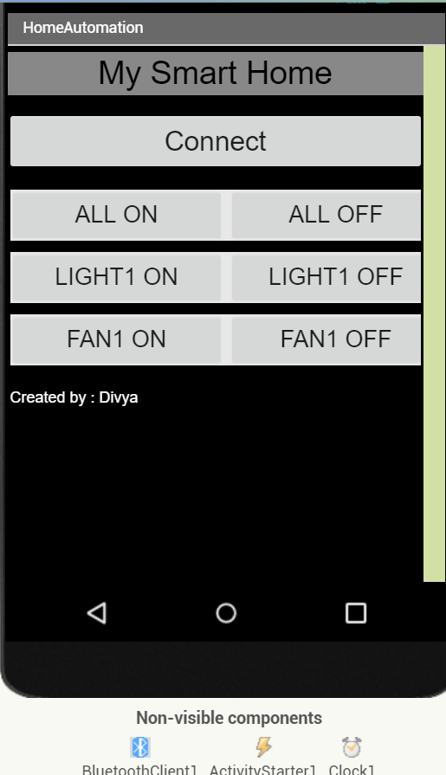

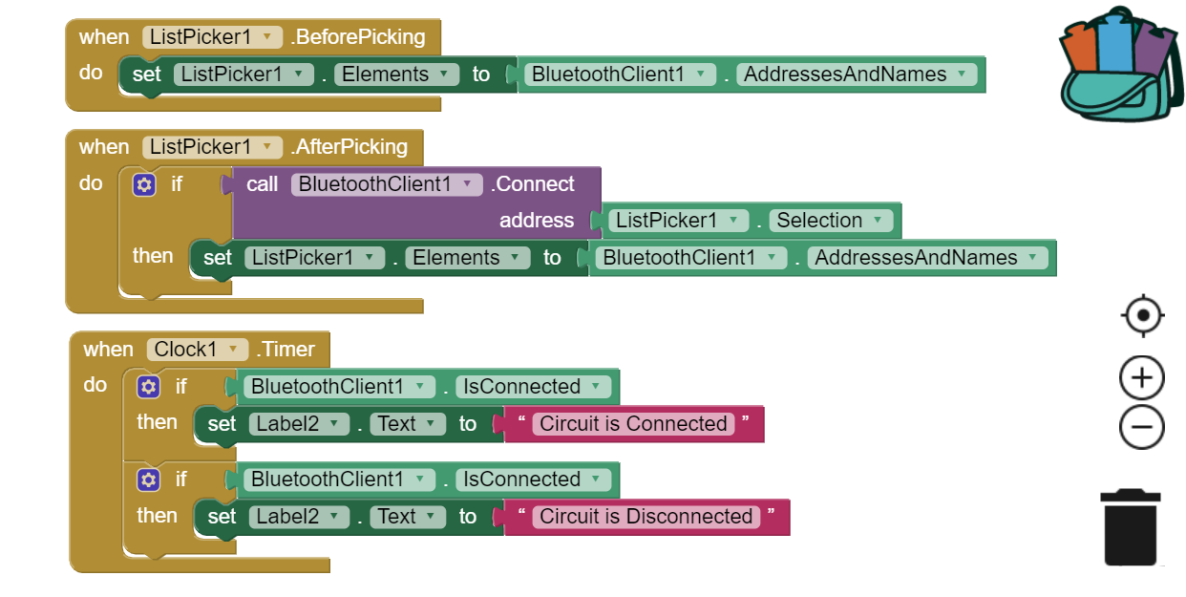

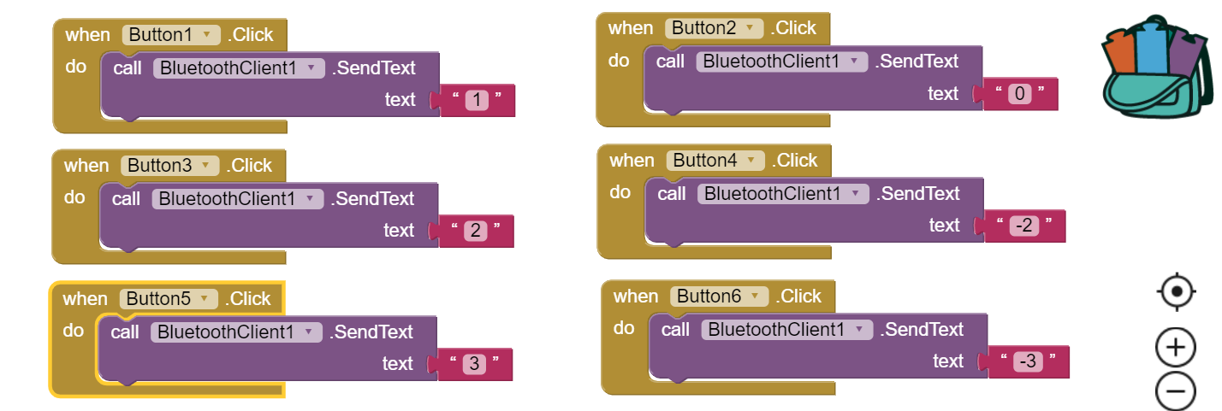

**FUTURE SCOPE :**

1.Research on advancing this initial prototype into something more productive is going on. For example: Suppose a person isn’t in close proximity to the appliance or the Arduino-101 so Bluetooth would not work. Internet needs to be implemented.

2.In order to know the consumption of units this data needs to be extracted from the electric meter and needs to be reported to the user via text message. This requires use of LDR sensor and GSM module.

3. AI-Virtual Assistant :

In order to control the appliances like fan and lights we use an app which is installed in the phone. This app uses AI-virtual assistant technology to take commands from the user. It has a wake-up call or phrase which activates the app which uses Bluetooth to connect with Arduino-101. This app sends message via Bluetooth to the Arduino-101; the brain of the whole setup; which then initializes the further process. For this you need an application or an app installed in your mobile phone which can take your command and do such tasks for you. This app needs to understand your command in natural language as you speak so you need the help of an AI virtual assistant. This assistant takes your command in natural language oral voice commands (depends on the way your assistant works) and the app interprets the command.