**Frontend Development with React.js**

**Project Documentation format**

**1.INTRODUCTION:**

**Project Title**: Rhythmic tunes: your melodic companion

**Team Members**: DIVYA R, HARINI P, KAVYA K, PRIYADHARSHINI T

**2.PROJECT OVERVIEW:**

* 1. **Purpose**: The primary goal of Music Streaming is to provide a seamless platform for music enthusiasts, enjoying, and sharing diverse musical experiences. Our objectives include: User-Friendly Interface: Develop an intuitive interface that allows users to effortlessly explore, save, and share their favourite music tracks and playlists.
  2. **Features**: Song Listings: Display a comprehensive list of available songs with details such as title, artist, genre, and release date.
  3. Playlist Creation: Empower users to create personalized playlists, adding and organizing songs based on their preferences.
  4. Playback Control: Implement seamless playback control features, allowing users to play, pause, skip, and adjust volume during music playback.
  5. Offline Listening: Allow users to download songs for offline listening, enhancing the app's accessibility and convenience.
  6. Search Functionality: Implement a robust search feature for users to easily find specific songs, artists, or albums within the app.

3.**ARCHITECTURE:**

**Component Structure**: The project structure may vary depending on the specific library, framework, programming language, or development approach used. It's essential to organize the files and directories in a logical and consistent manner to improve code maintainability and collaboration among developers.

* 1. **State Management**: With just a few taps, you're transported to a world of music tailored to your tastes. As you walk, the app’s smart playlist kicks in, starting with an upbeat pop song that gets your feet tapping. As you board the train, the music shifts to a relaxing indie track, perfectly matching your need to unwind during the commute.
  2. **Routing**: outline routing for a **Rhythm Tunes App** based on a typical music streaming app structure. I'll assume you're using **React (Web App)** with **React Router** for client-side navigation. If it's a **mobile app** (React Native, Flutter), and can adjust accordingly.

1. **Setup Instructions**
   1. **Prerequisites**: React.js, HTML, CSS, and JavaScript
   2. **Installation**: ● Create a new React app: npm create vite@latest Enter and then type project-name and select preferred frameworks and then enter
   3. ● Navigate to the project directory: cd project-name npm install
   4. ● Running the React App: With the React app created, you can now start the development server and see your React application in action
   5. ● Start the development server: npm run dev This command launches the development server, and

**Folder structure:** **rhythmic-tunes**

1. **│── public**
2. **│── src**
3. **│ ├── assets**
4. **│ ├── components**
5. **│ │ ├── Navbar.js**
6. **│ │ ├── Footer.js**
7. **│ │ ├── SongCard.js**
8. **│ │ ├── Player.js**
9. **│ ├── pages**
10. **│ │ ├── Home.js**
11. **│ │ ├── Favorites.js**
12. **│ │ ├── Playlist.js**
13. **│ │ ├── Search.js**
14. **│ │ ├── Player.js**
15. **│ ├── services**
16. **│ │ ├── songService.js**
17. **│ ├── utils**
18. **│ │ ├── formatDate.js**
19. **│ ├── context**
20. **│ │ ├── SongContext.js**
21. **│ ├── index.js**
22. **│── .gitignore**
23. **│── package.json**
24. **│── README.md**

**3.Running the Application**:

To start the application- <https://github.com/DIVYA1527/DIVYA-R>

1. **Component Documentation**
   1. **Key Components**: **Navbar.js** (Navigation Bar),
   2. **SongCard.js** (Reusable Song Card)
   3. **Player.js** (Music Player)
   4. **Home.js** (Landing Page)
   5. **Reusable Components**: **SongCard.js (Reusable Song Card)**
   6. Displays song details (title, artist, album cover, and play button).
   7. Supports add to favourites and add to playlist functionality.
2. **State Management**
   1. **Global State:** The Rhythmic Tunes project uses Context API to manage global state across the application. This helps to store and manage data such as:
   2. Currently playing song
   3. User’s favourites
   4. Playlist management

2.**Local State:** Local state is used inside a single component to store and update UI-related data, such as:  
 Search input values  
 Play/pause state of a song  
 Modal open/close states

**User Interface:** **STEP 1:**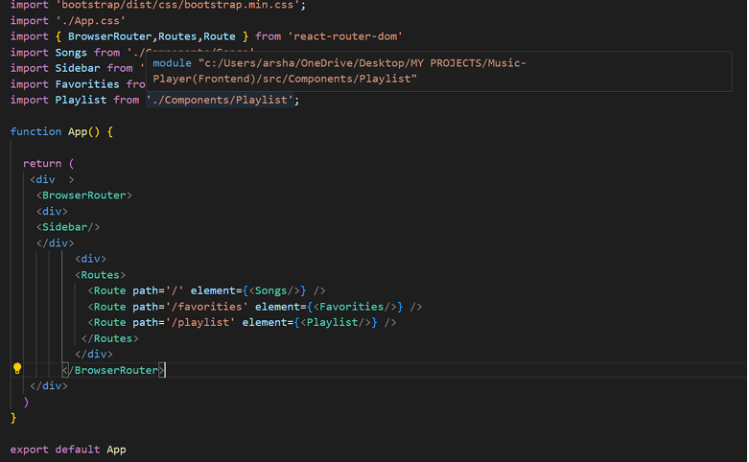

**STEP2**

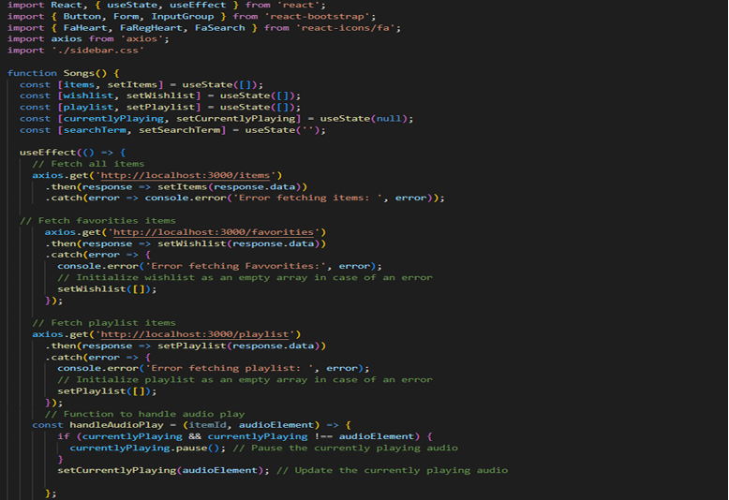

**STEP3:**

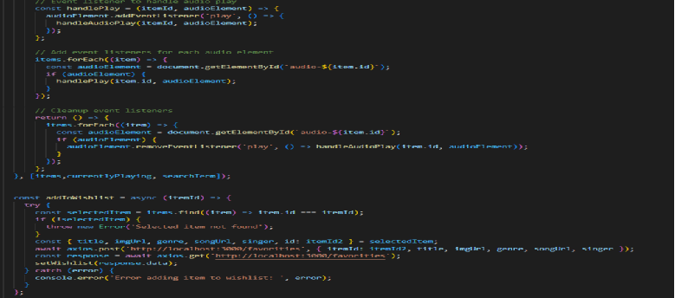

1. **Styling**

* **CSS Frameworks/Libraries**: The Rhythmic Tunes project uses Bootstrap and Tailwind CSS for styling. These frameworks provide a responsive, modern, andclean UI while reducing the need for custom CSS.
* **Theming**: Explain if theming or custom design systems are implemented.

1. **Testing**

The Rhythmic Tunes project uses Jest and React Testing Library for unit andintegration testing, ensuring that individual components (e.g., Navbar, SongCard, Player) function correctly. Cypress is used for end-to-end (E2E) testing, simulating real user interactions like searching for a song, adding it to a playlist, and playing music. Tests cover UI rendering, user interactions, API calls (mocked with Jest),and form validations. Additionally, Lighthouse is used for performance and accessibilitytesting, ensuring the app meets web standards. This structured testing approach enhances reliability and prevents regressions in future updates.

1. **Screenshots or Demo**

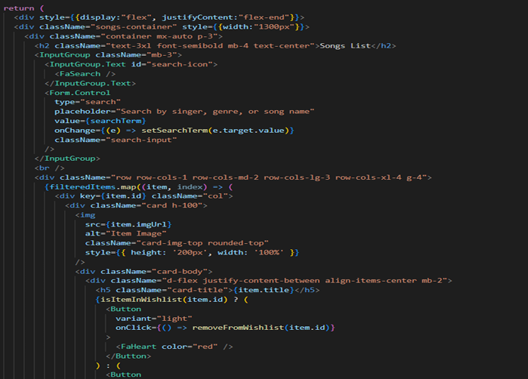

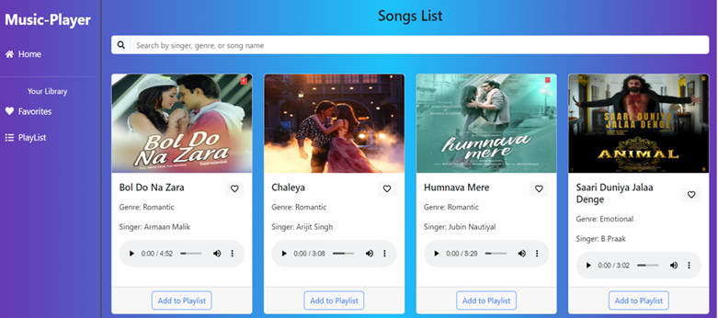

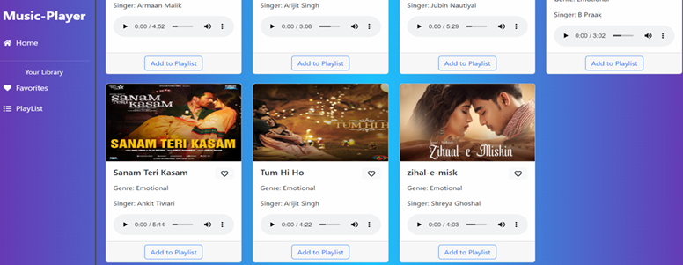

1. **FUTURE ENHANCEMENT:**

Future enhancements for the Rhythmic Tunes project will focus on improving user experience, performance, and scalability. Key upgrades include implementing real-time song recommendationsusing AI, enhancing offline listening support by allowing users to download songs, and integrating a dark mode for better UI customization.

Additionally, introducing social features, such as user-generated playlists, likes, andcomments, will enhance engagement, making the platform more interactive. To improve audio quality, support for high-fidelity streaming (FLAC, 320kbps MP3) can be introduced.

On the technical side, migrating to a Redux state management system can optimize performance for larger datasets, while progressive web app (PWA) support will allow users to access the app offline. Adding OAuth authentication (Google, Facebook login) will simplify user registration.

For backend scalability, shifting from a JSON-based server to a real-time database (Firebase, MongoDB) will enhance data handling and performance. Furthermore, cloud-based media storage (AWS S3, Firebase Storage) can be integrated for secure and efficient music streaming, ensuring a seamless user experience as the app grows.