EXPERIMENT – 2
Objective
To design a simple interactive prototype of a Bus Ticket Booking System using Figma.

Step 1: Login to Figma
- Open browser → go to figma.com
- Click Login / Sign Up
- Login using Google or email.

Step 2: Create a New Design File
- Click New Design File
- Rename file as:
Bus Ticket Booking Prototype

Step 3: Create Frame (Mobile Screen)
- Click Frame Tool (F)
- Select device: Android / iPhone (375 × 812)
- This represents the mobile app screen.

Step 4: Design Home Screen
Add these UI elements:
Header
- Text: Bus Booking App
Input Fields
- From City
- To City
- Travel Date
Button
- Search Buses
Arrange neatly using rectangles and text.

Step 5: Design Bus List Screen
- Duplicate first frame (Ctrl + D)
- Add:
- Bus Name
- Time
- Price
- Book Now button
Create 2–3 sample bus listings.

Step 6: Design Seat Selection Screen
Duplicate frame again:
Add:
- Seat grid (rectangles as seats)
- Selected seat in different color
- Proceed to Payment button

Step 7: Design Payment Screen
Duplicate frame:
Add:
- Ticket summary
- Total price
- Payment method dropdown
- Pay Now button

Step 8: Create Confirmation Screen
Duplicate frame:
Add:
- Booking Confirmed
- Ticket number
- Travel details
- Download Ticket button

Step 9: Create Prototype Links
- Click Prototype tab
- Connect:
- Search Buses → Bus List Screen
- Book Now → Seat Selection
- Proceed → Payment
- Pay Now → Confirmation

Step 10: Preview Prototype
- Click Play ▶ icon
- Test full booking flow.

Step 11: Save and Share
- Click Share
- Set permission to Anyone with link – View
- Copy link.
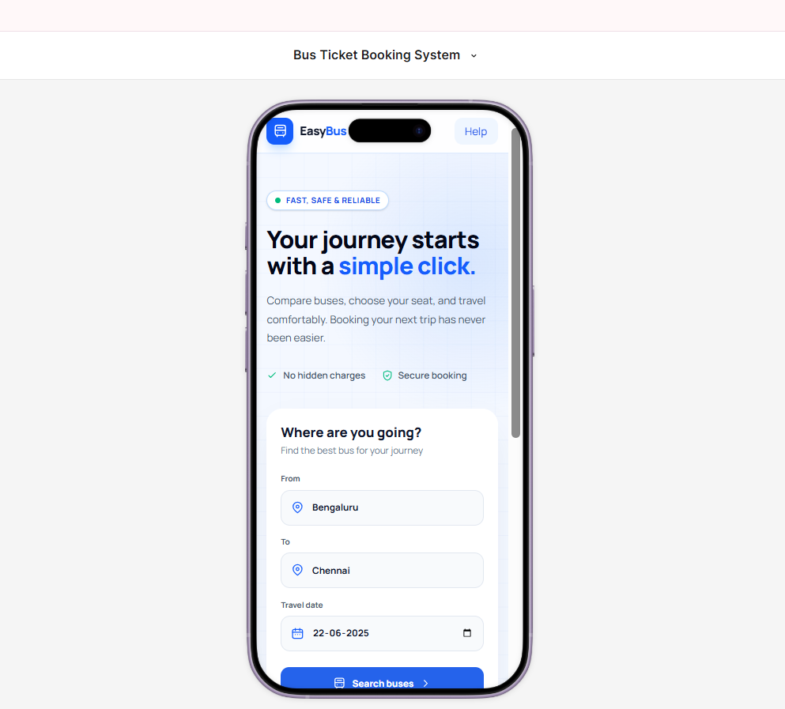
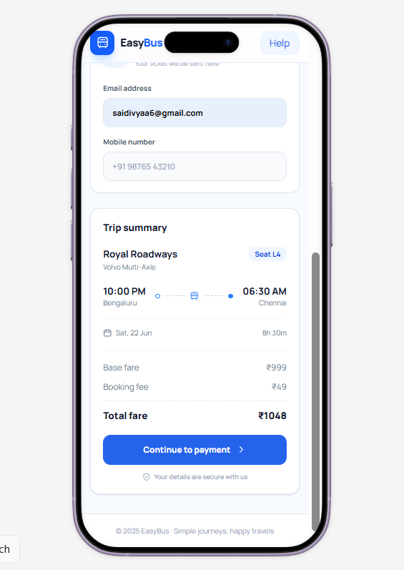
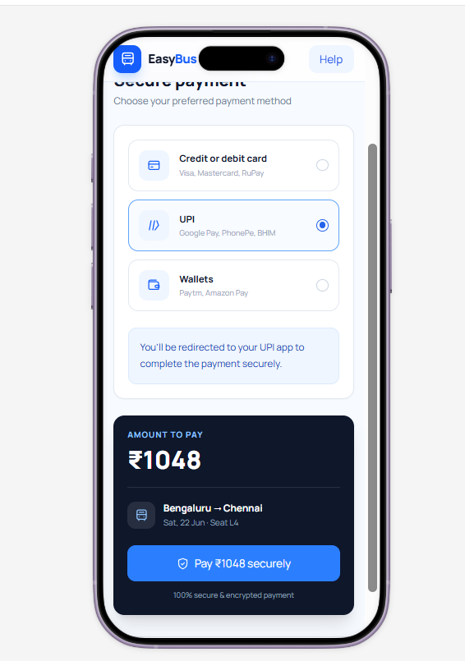
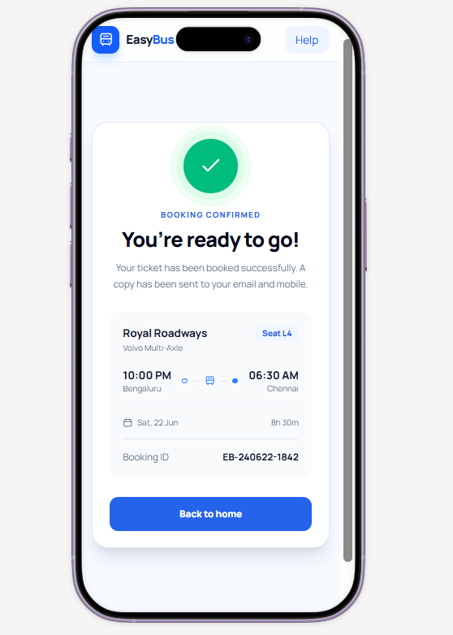
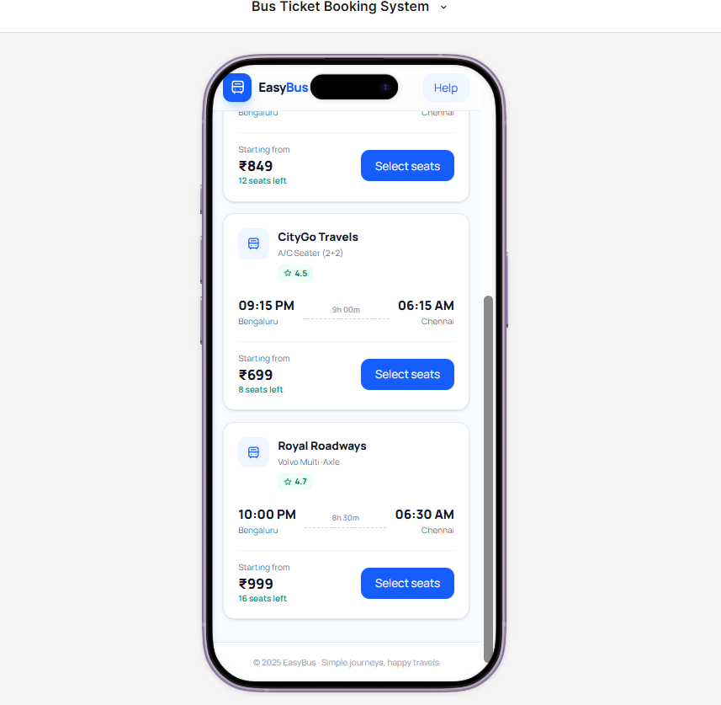
Result
Thus, a simple prototype of a Bus Ticket Booking System was successfully designed using Figma.

