Graphics and multimedia

Create a Multimedia Application that Integrates Images, Sound, and Video in a Simple User Interface

# AIM

To develop a simple multimedia application that integrates:  Images

 Audio

 Video

EXPERIMENT : 7

ROLL NO : 231701012

NAME : Divya Dharrshan T

into a unified user interface using Python and suitable libraries.

# Program

import tkinter as tk

from tkinter import filedialog

from PIL import Image, ImageTk

from playsound import playsound import cv2

import threading

# Function to play audio def play_audio():

playsound('sample_audio.mp3') # Replace with your audio file

# Function to play video def play_video():

cap = cv2.VideoCapture('sample_video.mp4') # Replace with your video file while cap.isOpened():

ret, frame = cap.read() if not ret:

break

cv2.imshow("Video", frame)

if cv2.waitKey(25) & 0xFF == ord('q'):

break

cap.release()

cv2.destroyAllWindows()

# Function to load and display image def load_image():

img = Image.open('sample_image.jpg') # Replace with your image file img = img.resize((300, 300))

img_tk = ImageTk.PhotoImage(img) panel.configure(image=img_tk) panel.image = img_tk

# GUI Setup window = tk.Tk()

window.title("Multimedia Application")

btn_img = tk.Button(window, text="Show Image", command=load_image) tbhtrne_aduidnigo.T=htrke.aBdu(tttaorng(ewt=inpdlaoyw_a, tuedxito=)".sPtlaaryt(A))udio", command=lambda: tbhtrne_avdidineog.T=htrke.Badu(tttaorng(ewti=npdlaoyw_,vtideexto=)".sPtlaaryt(V))ideo", command=lambda:

panel = tk.Label(window) panel.pack()

btn_img.pack(pady=5) btn_audio.pack(pady=5) btn_video.pack(pady=5)

window.mainloop()

OUTPUT

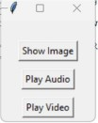

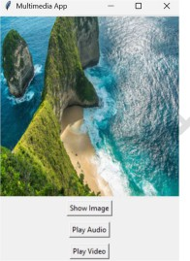

# Result

A multimedia application was successfully created that integrates image, audio, and

video functionality into a single interactive Python interface.