Graphics and multimedia

Capture Video/Audio from Webcam or Microphone and Display on Multimedia Interface

# AIM

To develop a program that captures:  Live video from the webcam

 Live audio from the microphone

EXPERIMENT : 8

ROLL NO : 231701012

NAME : Divya Dharrshan T

and displays or records them using a simple multimedia interface.

# Program

iimport cv2

import sounddevice as sd

from scipy.io.wavfile import write import threading

import tkinter as tk

# Audio recording function def record_audio():

duration = 5 # seconds

fs = 44100 # sampling rate print("Recording Audio...")

audio = sd.rec(int(duration * fs), samplerate=fs, channels=2) sd.wait() # Wait until recording is finished

write('recorded_audio.wav', fs, audio) print("Audio recording saved.")

# Video capture function def capture_video():

cap = cv2.VideoCapture(0)

print("Press 'q' to stop video.") while True:

ret, frame = cap.read()

if not ret: break

cv2.imshow('Webcam Feed', frame) if cv2.waitKey(1) & 0xFF == ord('q'):

break

cap.release()

cv2.destroyAllWindows()

# GUI Setup window = tk.Tk()

window.title("Capture Audio and Video")

btn_audio = tk.Button(window, text="Record Audio", command=lambda: threading.Thread(target=record_audio).start())

btn_video = tk.Button(window, text="Start Webcam", command=lambda: threading.Thread(target=capture_video).start())

btn_audio.pack(pady=10) btn_video.pack(pady=10)

window.mainloop()

OUTPUT

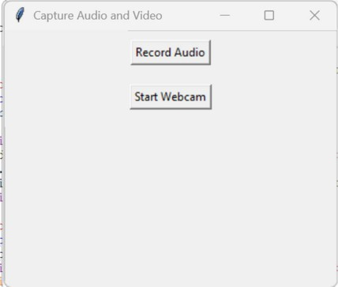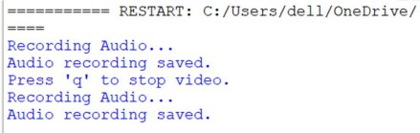

# Result

Live video and audio were successfully captured using the webcam and microphone and displayed/saved through a multimedia interface.