DIVYADHARSHINI T

KSRCE

**SQL**

--Create Table

create table students

(

stdId number(6),

name varchar(30),

phoneNo number(10)

);

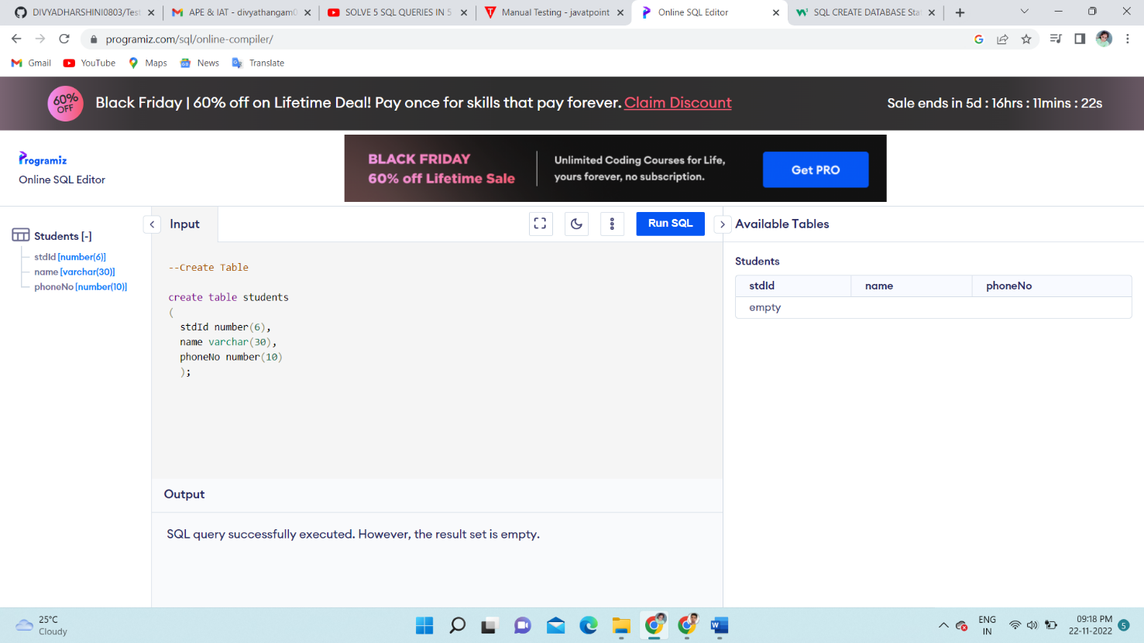

-- insert values

-- Method 1

insert into students

values (100,'Albert',9876543210);

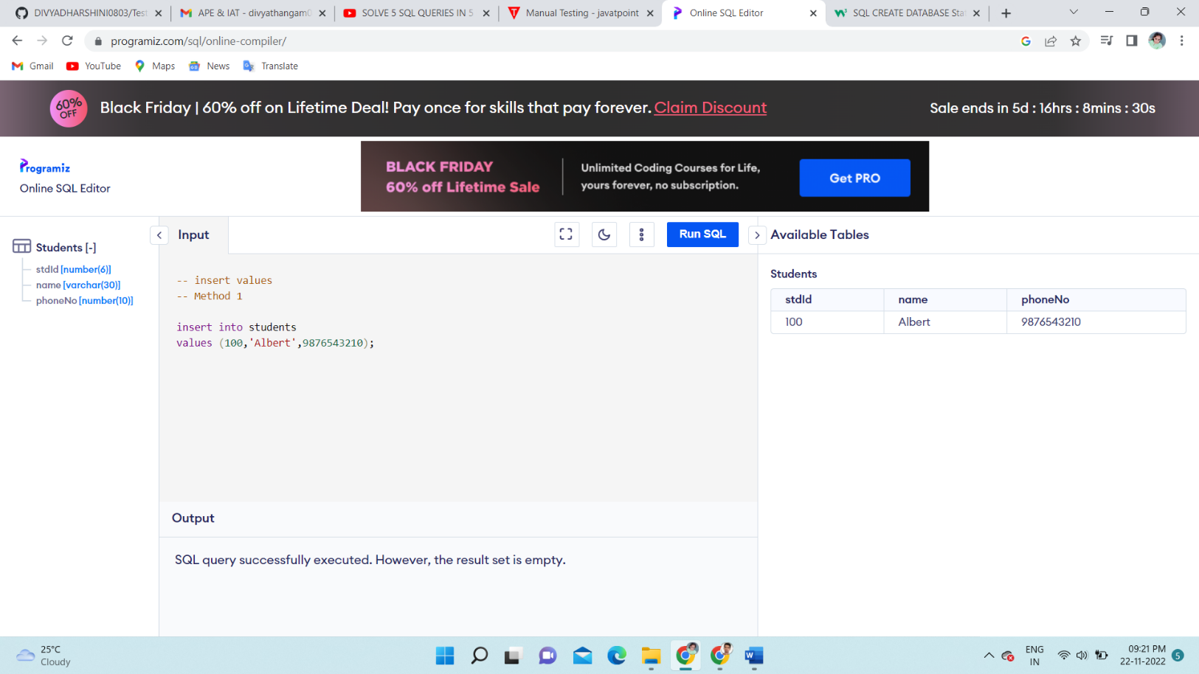

--Insert values

-- Methode 2

insert into students (stdId,name)

values (100,'Sam');

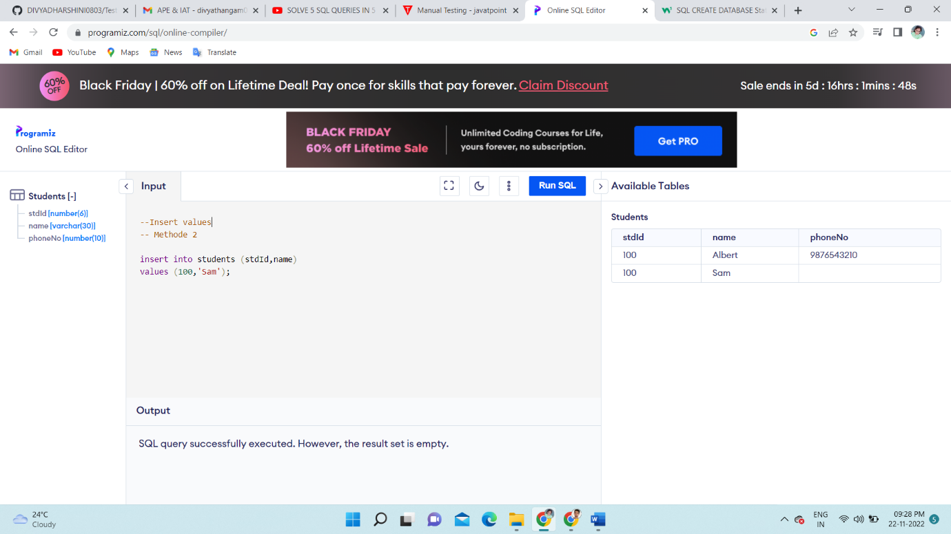

--Update

update students set stdId = 101;

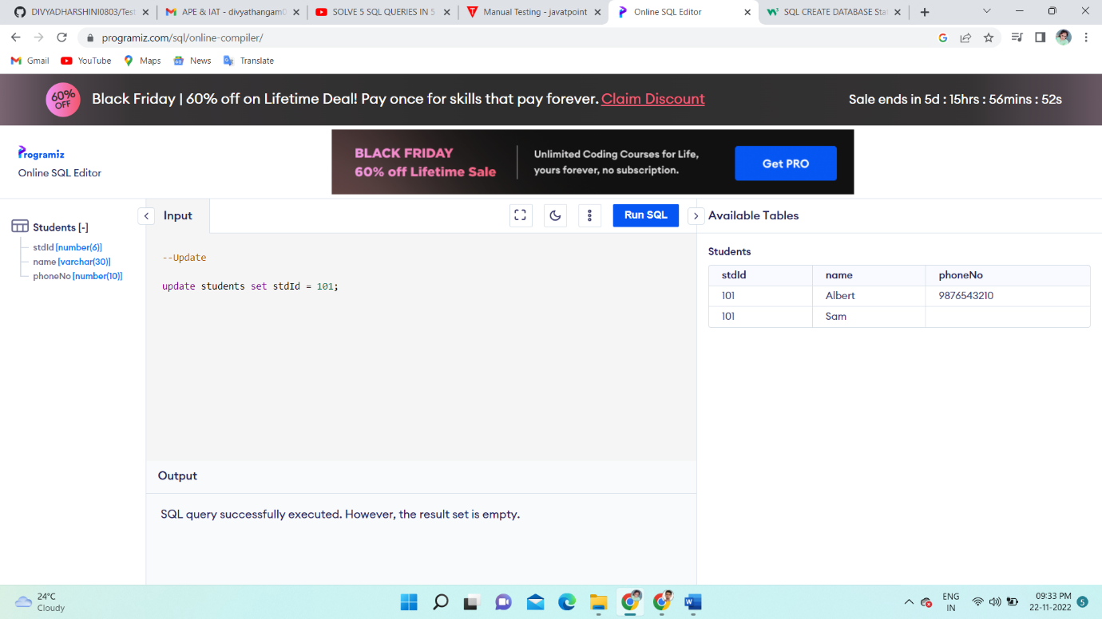

--Update

update students set stdId = 100 where phoneNo = 9876543210;

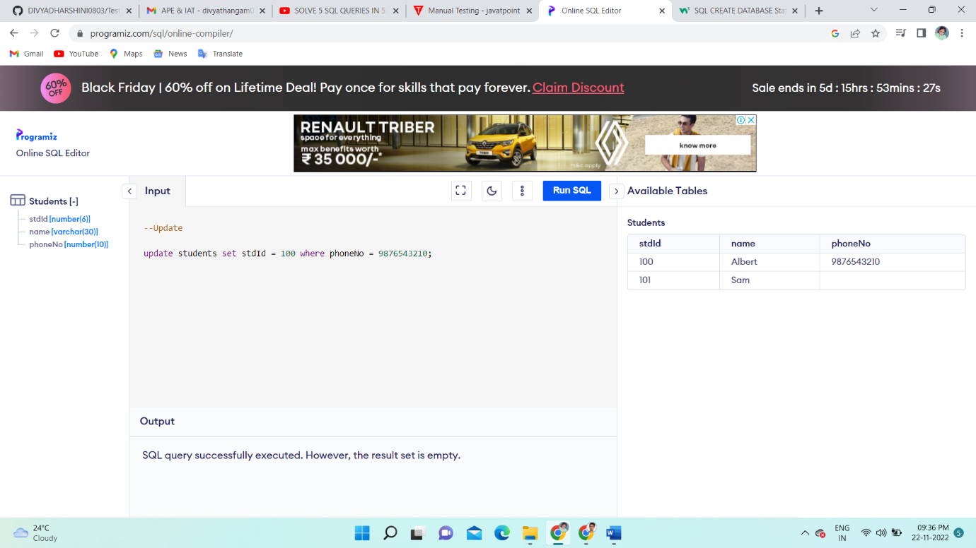

--Alter

--Add

alter table students add email number;

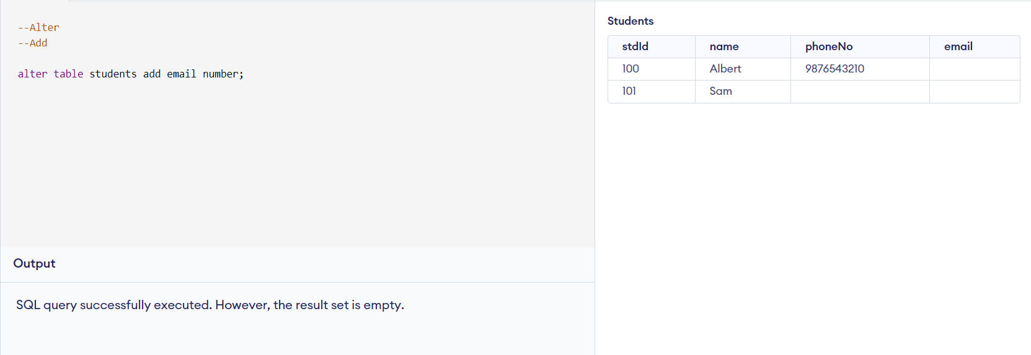

--Alter

--Modify

update students set email = 'abcd@gmail.com' where stdId = 100;

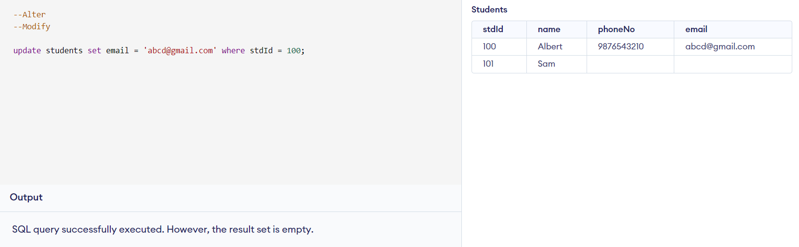

--Where

SELECT * FROM Customers

WHERE Customer_id=3;

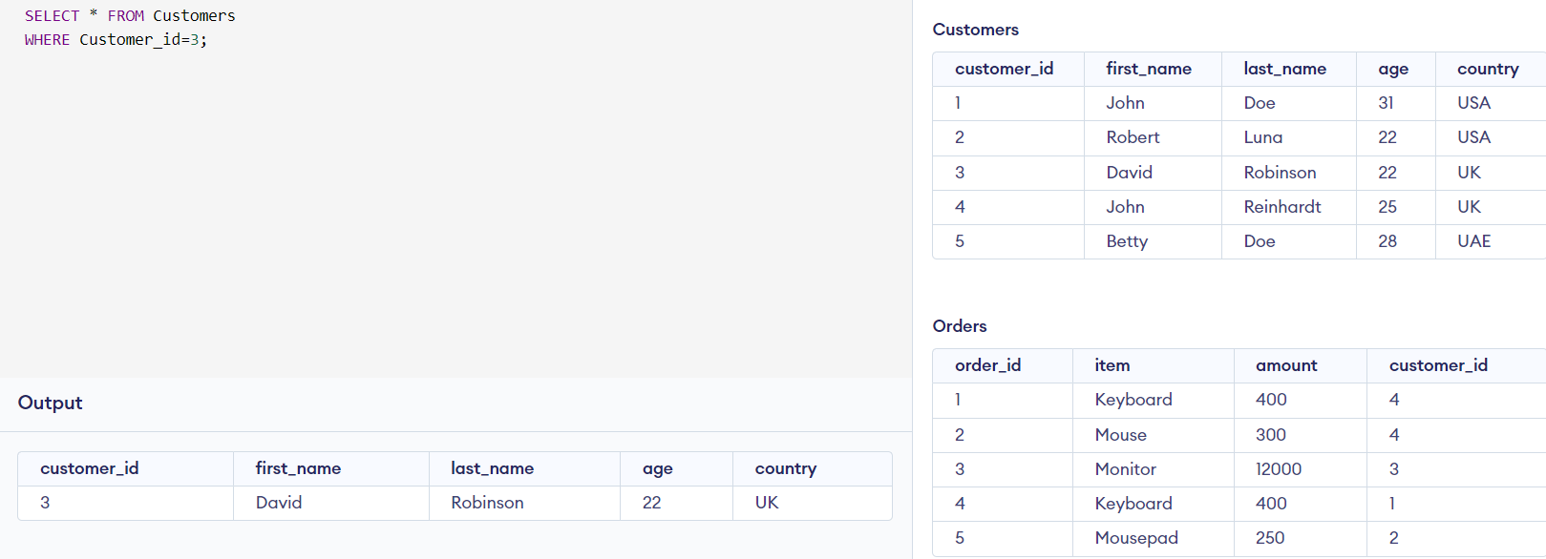

Joints

Inner Joints

SELECT Orders.Order_id, Customers.Customer_id

FROM Orders

INNER JOIN Customers ON Orders.Customer_id = Customers.Customer_id;

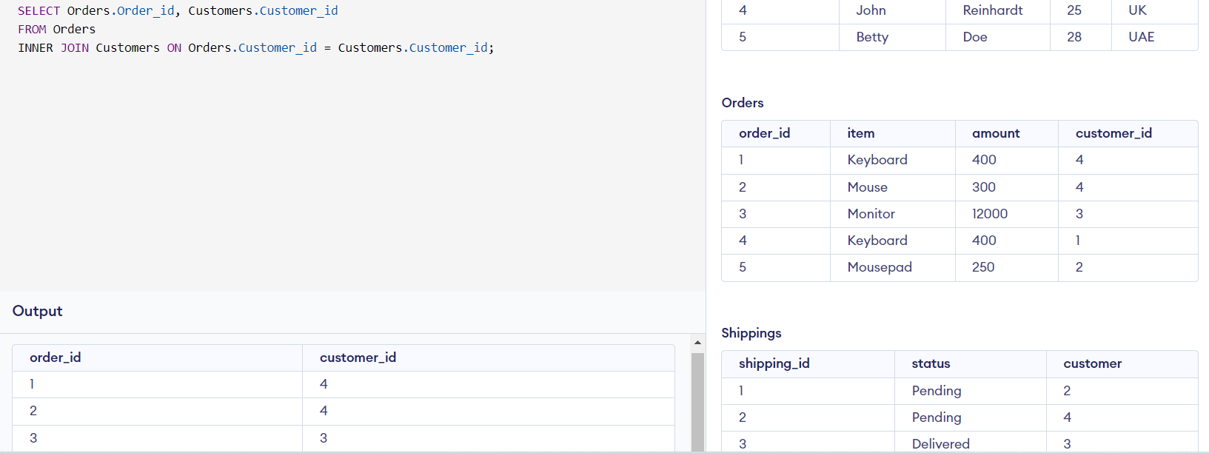

Left joint

SELECT Customers.Customer_id, Orders.Order_id

FROM Customers

LEFT JOIN Orders

ON Customers.Customer_id=Orders.Customer_id

ORDER BY Customers.Customer_id;

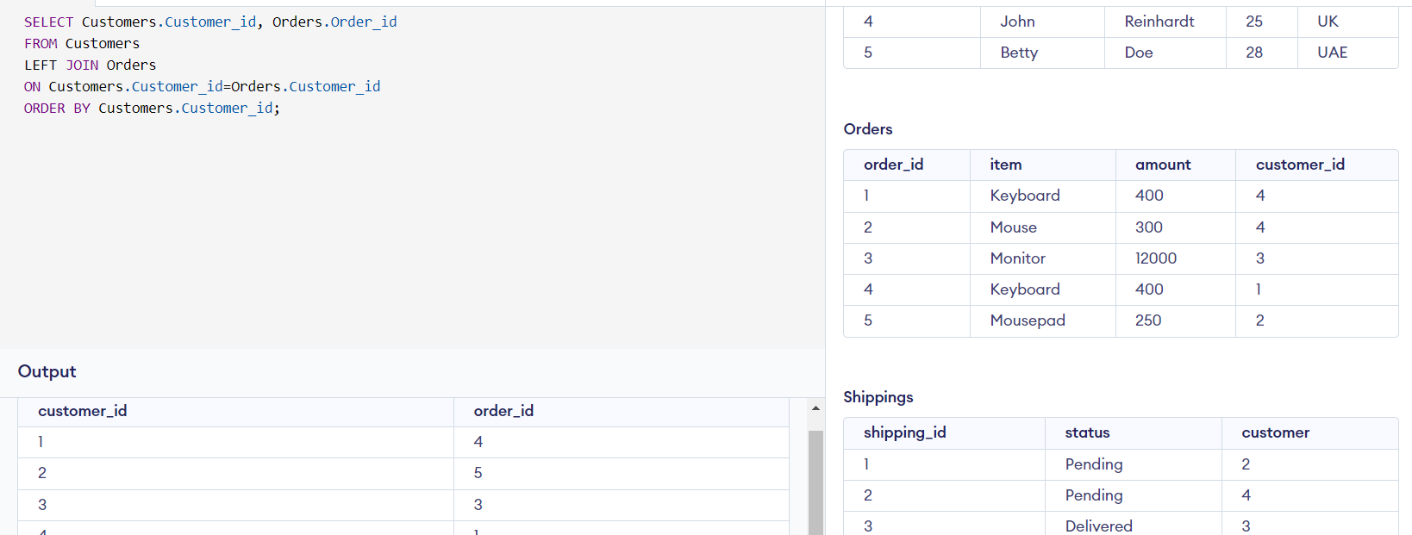

Union

SELECT customer_id FROM Customers

UNION

SELECT customer_id FROM Orders

ORDER BY customer_id;

