**BCSE203E- Web Programming**

**Assessment 6.1 Report**

**Register No: 22BCT0143**

**Description:**

Index.html was created.

HTML Tags:

* <!DOCTYPE html>
* <html>
* <head>
* <meta>
* <title>
* <link>
* <style>
* <body>
* <header>
* <h1>, <h2>, <h3>
* <p>
* <nav>
* <a>
* <main>
* <section>
* <article>
* <table>
* <thead>, <tbody>, <tr>, <th>, <td>
* <ul>, <ol>, <li>
* <aside>
* <figure>, <figcaption>
* <footer>
* <div>
* <button>
* <script>

CSS Tags:

* body
* header
* nav
* a
* main
* section
* article
* table
* thead, tbody, tr, th, td
* ul, ol, li
* aside
* figure, figcaption
* footer
* div
* button
* class
* id

**Source Code:**

Index.html

<!DOCTYPE html>

<html lang="en">

<head>

    <meta charset="UTF-8">

    <meta name="viewport" content="width=device-width, initial-scale=1.0">

    <title>Divyamaan Bhati's Portfolio</title>

    <link rel="stylesheet" href="styles.css">

    <style>

        body {

            color: #333;

            background-color: aquamarine;

            text-align: left;

            display: flex;

            flex-wrap: wrap;

            justify-content: space-between;

        }

        header {

            background-color: #2b1d85;

            padding: 10px;

            text-align: center;

            width: 100%;

            z-index: 1;

            font-family: cursive;

            font-style: oblique ;

            color:burlywood; ;

        }

        nav {

            background-color: #2c3e50;

            padding: 10px;

            text-align: center;

            width: 100%;

            z-index: 1;

        }

        .main {

            padding: 10px;

            width:79%;

            position:relative;

            left:0;

        }

    </style>

</head>

<body>

    <header >

        <h1>DIVYAMAAN'S Portfolio</h1>

        <p><strong><i>Not All Those Who Wander Are Lost </i></strong></p>

    </header>

    <nav>

        <a href="index.html">Home</a>

        <a href="about.html">About Me</a>

        <a href="contact.html">Contact Me</a>

        <a href="hobbies.html">Hobbies</a>

    </nav>

    <main>

        <section>

            <h2>Creating a Simple HTML Portfolio</h2>

            <p>Being a web developer and having a portfolio helps a lot while applying for opportunities and acts as a showcase of our talent, so in this article, we will learn how to make a simple one-page portfolio by just using HTML. This portfolio might contain some very important information of yours like:</p>

            <ul>

                <li>About us section</li>

                <li>Your projects</li>

                <li>Your achievements</li>

                <li>Your contact details</li>

                <li>Contact us Page</li>

            </ul>

            <p>You can enhance your portfolio by adding more details and making it visually appealing. However, this article is specifically designed for beginners who want to create a simple HTML portfolio.</p>

            <h3>Why do we create a Portfolio?</h3>

            <ul>

                <li>Showcase Skills: Exhibit your skills and projects visually in a portfolio.</li>

                <li>Career Opportunities: Boost job and freelance prospects with a professional portfolio.</li>

                <li>Connections: Make lasting connections using your portfolio for job or service opportunities.</li>

            </ul>

            <h3>Who is a portfolio for?</h3>

            <ul>

                <li>Graphic Designers</li>

                <li>Web Developers</li>

                <li>Photographers</li>

                <li>UX/UI Designers</li>

                <li>Artists</li>

                <li>Content Creators</li>

                <li>Software Engineers</li>

                <li>Videographers</li>

                <li>Fashion Designers</li>

            </ul>

        </section>

    </main>

    <footer>

        <h3>Contact Information:</h3>

        <p>Mobile: 9887652601</p>

        <p>E-Mail: <a href="mailto:divyamaanbhati@gmail.com">divyamaanbhati@gmail.com</a></p>

    </footer>

</body>

</html>

About.html

<!DOCTYPE html>

<html lang="en">

<head>

    <meta charset="UTF-8">

    <meta name="viewport" content="width=device-width, initial-scale=1.0">

    <title>Divyamaan Bhati - About Me</title>

    <link rel="stylesheet" href="styles.css">

    <style>

        body {

            color: #333;

            background-color: aquamarine;

            text-align: left;

            display: flex;

            flex-wrap: wrap;

            justify-content: space-between;

        }

        header {

            background-color: #2b1d85;

            padding: 10px;

            text-align: center;

            width: 100%;

            z-index: 1;

            font-family: cursive;

            font-style: oblique ;

            color:burlywood; ;

        }

        nav {

            background-color: #2c3e50;

            padding: 10px;

            text-align: center;

            width: 100%;

            z-index: 1;

        }

        .main {

            padding: 10px;

            width:79%;

            position:relative;

            left:0;

        }

        .image-container {

            width: 20%;

            position:absolute;

            bottom: 0;

            right: 0;

            height:auto;

            background-color:cadetblue;

            padding: 20px;

            z-index: 0;

            box-sizing: border-box; /* Ensure padding is included in width calculation */

        }

        .image-container img {

            width: 100%;

            height: auto;

        }

        .container {

            display: flex;

            justify-content: space-between;

        }

        .column {

            width: 48%; /* Adjust the width as needed, leaving some space for margins */

        }

    </style>

</head>

<body>

    <header >

        <h1>DIVYAMAAN'S Portfolio</h1>

        <p><strong><i>Not All Those Who Wander Are Lost </i></strong></p>

        <p style="text-align: right;"><a href="#bottom">Bottom</a></p>

    </header>

    <nav>

        <a href="index.html">Home</a>

        <a href="about.html">About Me</a>

        <a href="contact.html">Contact Me</a>

        <a href="hobbies.html">Hobbies</a>

    </nav>

    <main class="main">

        <section>

            <a name="top"></a>

            <h2>About</h2>

            <article>Greetings! I am a passionate undergraduate student pursuing a Bachelor of Technology in Computer Science, driven

                by a profound interest in the dynamic realm of programming. My journey commenced during my plus two schooling, where I

                discovered the versatile capabilities of Python, sparking a fascination with its applications in solving real-world

                problems. This curiosity led me to choose Computer Science as my major, seeking to delve deeper into the intricacies

                of the field.

            </article>

            <br>

            <article>

                As an aspiring professional in the tech industry, I am dedicated to cultivating not only technical proficiency but

                also fostering collaborative and critical thinking skills. This internship represents a transformative step, offering

                exposure to cutting-edge technologies, networking opportunities, and the chance to contribute meaningfully to ongoing

                research projects. I am confident that my passion for programming, coupled with the guidance available, will make this

                internship a rewarding and impactful chapter in my academic and professional journey.

            </article>

            <br>

            <article>

                I am grateful for the opportunity to share my aspirations, and I eagerly anticipate the challenges and learning

                experiences that lie ahead in my pursuit of excellence in the field of computer science.

            </article>

        </section>

        <br>

        <section>

            <a id="section2"><h2>Educational Qualification</h2></a>

            <table style="border-collapse: collapse; width: 100%; border: 1px solid #3498db;">

                <thead>

                    <tr>

                        <th style="border: 1px solid #3498db;">Educational Qualification</th>

                        <th style="border: 1px solid #3498db;">Institution</th>

                        <th style="border: 1px solid #3498db;">Year Completed</th>

                    </tr>

                </thead>

                <tbody>

                    <tr>

                        <td style="border: 1px solid #3498db;">B.Tech CSE with IOT</td>

                        <td style="border: 1px solid #3498db;">VIT University, Vellore</td>

                        <td style="border: 1px solid #3498db;">2022 - <b>Current</b></td>

                    </tr>

                    <tr>

                        <td style="border: 1px solid #3498db;">Senior Secondary</td>

                        <td style="border: 1px solid #3498db;">St. Xavier's School, Nevta</td>

                        <td style="border: 1px solid #3498db;">2021</td>

                    </tr>

                    <tr>

                        <td style="border: 1px solid #3498db;">Secondary</td>

                        <td style="border: 1px solid #3498db;">St. Xavier's School, Nevta</td>

                        <td style="border: 1px solid #3498db;">2019</td>

                    </tr>

                </tbody>

            </table>

        </section>

        <br>

        <div class="container">

            <div class="column">

                <a name="bottom"></a>

            <h2>Skills</h2>

            <ul>Working knowledge of:

                    <ol type="1">

                        <li>Python</li>

                        <li>JAVA</li>

                        <li>C</li>

                        <li>C++</li>

                    </ol>

            </ul>

            <ul>Hardworking and punctual</ul>

            <ul>Attention to detail</ul>

            <ul>Basic Knowledge of core CS Concepts:

                <ol type="1" style="color: #333;">

                    <li>DSA</li>

                    <li>OOPS</li>

                    <li>Web Dev</li>

                    <li>AI-ML</li>

            </ul>

            </div>

            <div class="column">

        <article>

            <h2>Personal Information:</h2>

            <ul>

                <li>DOB: 02/11/2003</li>

                <li>Languages Known: English and Hindi</li>

                <li>Gender: Male</li>

                <li>Marital Status: Unmarried</li>

                <li>Citizenship: Indian</li>

            </ul>

        </article>

            </div>

            <div class="column">

                <h2>Personality Traits:</h2>

                <ul>

                    <li>Positive Thinking</li>

                    <li>Adaptable and Creative</li>

                    <li>Analytical and Futuristic</li>

                    <li>Ambitious and Competent</li>

                </ul>

            </div>

        </div>

    </main>

    <div class="image-container">

            <figure>

                <a href="https://nptel.ac.in/noc/E_Certificate/NPTEL23CS20S4490016704108223">

                    <img src="The Joy of Computing using Python.jpg" alt="Logo">

                </a><br>

                <br>

                <img src="902f7b67-2c04-42b6-b69a-baf2055d0bfc.png" alt="Logo">

                <br>

                <br>

                <a href="https://nptel.ac.in/noc/E_Certificate/NPTEL23BT55S4497037420156316">

                <img src="Wildlife Ecology .jpg" alt="Logo">

                </a>

                <figcaption>Certificates</figcaption>

            </figure>

    </div>

    <footer align="center">

        <h3>Contact Information:</h3>

        <p>Mobile: 9887652601</p>

        <p>E-Mail: <a href="mailto:divyamaanbhati@gmail.com" style="color: #3498db;">divyamaanbhati@gmail.com</a></p>

        <p style="text-align: right;"><a href="#top">Top</a></p>

    </footer>

</body>

</html>

Contact.html

<!DOCTYPE html>

<html lang="en">

<head>

    <meta charset="UTF-8">

    <meta name="viewport" content="width=device-width, initial-scale=1.0">

    <title>Divyamaan Bhati - Contact Me</title>

    <link rel="stylesheet" href="styles.css">

    <style>

        body {

            color: #333;

            background-color: aquamarine;

            text-align: left;

            display: flex;

            flex-wrap: wrap;

            justify-content: space-between;

        }

        header {

            background-color: #2b1d85;

            padding: 10px;

            text-align: center;

            width: 100%;

            z-index: 1;

            font-family: cursive;

            font-style: oblique ;

            color:burlywood; ;

        }

        nav {

            background-color: #2c3e50;

            padding: 10px;

            text-align: center;

            width: 100%;

            z-index: 1;

        }

        .main {

            padding: 10px;

            width:79%;

            position:relative;

            left:0;

        }

        .image-container {

            width: 20%;

            position:absolute;

            bottom: 0;

            right: 0;

            height:auto;

            background-color:tomato;

            padding: 20px;

            z-index: 0;

            box-sizing: border-box; /* Ensure padding is included in width calculation */

        }

        .image-container img {

            width: 100%;

            height: auto;

        }

        footer {

            position: fixed;

            bottom: 0;

            width: 100%;

            height: auto;

            text-align: center;

            background-color:#c72222;

            padding: 20px;

            color: #fff;

        }

    </style>

</head>

<body style="color: #333; background-color: #f4f4f4; text-align: left;">

    <header >

        <h1>DIVYAMAAN'S Portfolio</h1>

        <p><strong><i>Not All Those Who Wander Are Lost </i></strong></p>

    </header>

    <nav>

        <a href="index.html">Home</a>

        <a href="about.html">About Me</a>

        <a href="contact.html">Contact Me</a>

        <a href="hobbies.html">Hobbies</a>

    </nav>

    <main>

        <section>

            <h2>Contact Me</h2>

            <p>Mobile: 9887652601</p>

        <p>E-Mail: <a href="mailto:divyamaanbhati@gmail.com" style="color: #3498db;">divyamaanbhati@gmail.com</a></p>

        <p>LinkedIn: <a href="https://www.linkedin.com/in/divyamaanbhati/" style="color: #3498db;">divyamaanbhati</a></p>

        <p>GitHub: <a href="https://github.com/DIVYAMAANBHATI" style="color: #3498db;">DIVYAMAANBHATI</a></p>

        <p>Instagram:<a href="https://www.instagram.com/divyamaan_?igsh=bmp3OXF1cXptNnVj" style="color: #3498db;">divyamaan_</a></p>

        </section>

    </main>

    <footer align="center">

        <h3>Contact Information:</h3>

        <p>Mobile: 9887652601</p>

        <p>E-Mail: <a href="mailto:divyamaanbhati@gmail.com" style="color: #3498db;">divyamaanbhati@gmail.com</a></p>

    </footer>

</body>

</html>

Hobbies.html

<!DOCTYPE html>

<html lang="en">

<head>

    <meta charset="UTF-8">

    <meta name="viewport" content="width=device-width, initial-scale=1.0">

    <title>Divyamaan Bhati - About Me</title>

    <link rel="stylesheet" href="styles.css">

    <style>

        body {

            color: #333;

            background-color:aquamarine;

            text-align: left;

            display: flex;

            flex-wrap: wrap;

            justify-content: space-between;

        }

        header {

            background-color: #2b1d85;

            padding: 10px;

            text-align: center;

            width: 100%;

            z-index: 1;

            font-family: cursive;

            font-style: oblique ;

            color:burlywood; ;

        }

        nav {

            background-color: #2c3e50;

            padding: 10px;

            text-align: center;

            width: 100%;

            z-index: 1;

        }

        .main {

            padding: 10px;

            width:100%;

            position:relative;

            left:0;

        }

        body {

            font-family: Arial, sans-serif;

            line-height: 1.6;

            margin: 20px;

        }

        .container {

            display: flex;

            justify-content: space-between;

        }

        .column {

            width: 48%; /* Adjust the width as needed, leaving some space for margins */

        }

        footer {

            bottom: 0;

            width: 100%;

            height: auto;

            text-align: center;

            background-color:#c72222;

            padding: 20px;

            color: #fff;

        }

    </style>

</head>

<body>

    <header >

        <h1>DIVYAMAAN'S Portfolio</h1>

        <p><strong><i>Not All Those Who Wander Are Lost </i></strong></p>

    </header>

    <nav>

        <a href="index.html">Home</a>

        <a href="about.html">About Me</a>

        <a href="contact.html">Contact Me</a>

        <a href="hobbies.html">Hobbies</a>

    </nav>

    <main class="main">

        <section>My Hobbies include, but are not limited to :

            <ul>

                <li>Sports such as Basketball, Cricket, Badminton, Swimming, etc.</li>

                <li>Being an avid reader</li>

                <li>Writing short poetry</li>

            </ul>

            <div class="container">

            Here are some of my poems:

            <div class="column">

            <article style="text-align: right;">

                <h1>O Heirs of those that were burnt</h1>

        <p>Keep your lineage carefully hidden</p>

        <p>Bide your time, keep allies close</p>

        <p>Hide your strength for they still hunt.</p>

                <br>

        <p>Yet seeds of disarray are already sown</p>

        <p>Their Waterloo heretofore written</p>

        <p>The time of retaliation draws close</p>

        <p>Save friend from foe before they drown.</p>

        <p>-Divyamaan Bhati</p>

        </article>

        </div>

        <div class="column">

        <article style="text-align: right;">

            <h1>Oh sweet Eleftheria</h1>

            <p>Whence shall thee gaze upon me</p>

            <p>In midnight ravings and daylight flailings</p>

            <p>My heart only yearns for thee.</p>

    <br>

            <h1>Oh boundless Eleftheria</h1>

            <p>Where shall I espy thou</p>

            <p>On treacherous paths or smooth roads</p>

            <p>My eyes forage for a glance at thou</p>

    <br>

            <h1>Oh bashful Eleftheria</h1>

            <p>What must thy touch feel like</p>

            <p>Shall thee guide me or shall thee consume me</p>

            <p>Oh Eleftheria! Oh Eleftheria!</p>

            <p>-Divyamaan Bhati</p>

        </article>

        </div>

            </div>

        </section>

        <footer align="center">

            <h3>Contact Information:</h3>

            <p>Mobile: 9887652601</p>

            <p>E-Mail: <a href="mailto:divyamaanbhati@gmail.com" style="color: #3498db;">divyamaanbhati@gmail.com</a></p>

        </footer>

    </body>

    </html>

**Screenshots:**

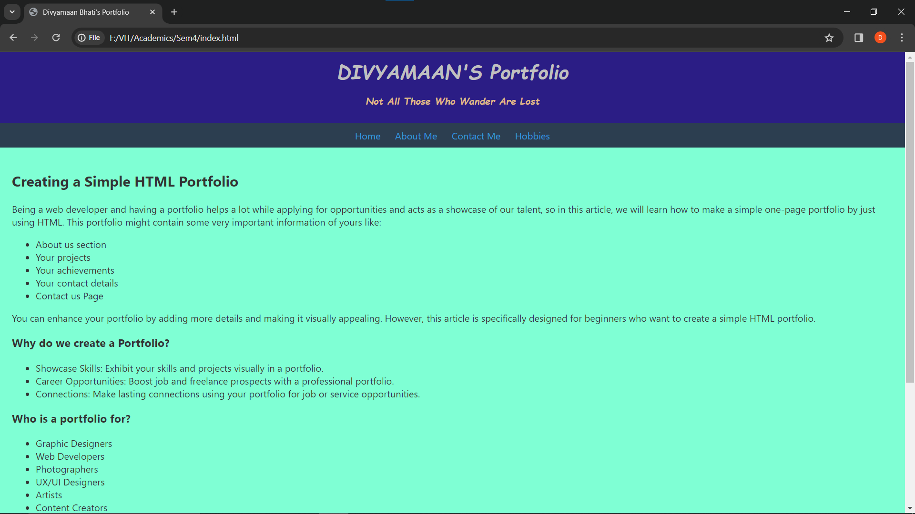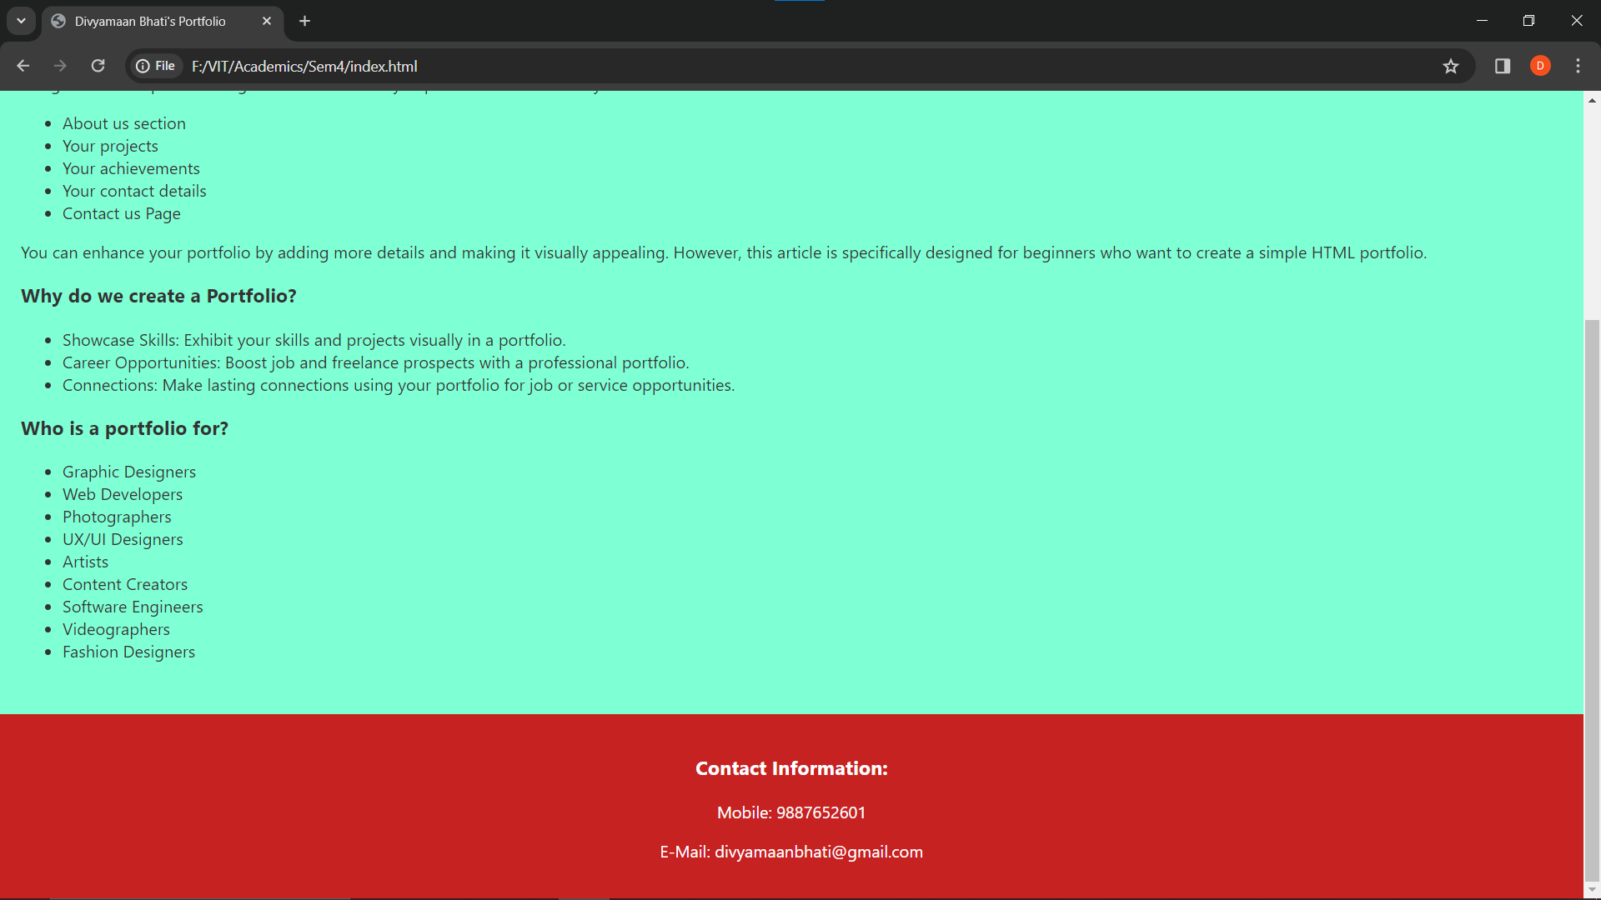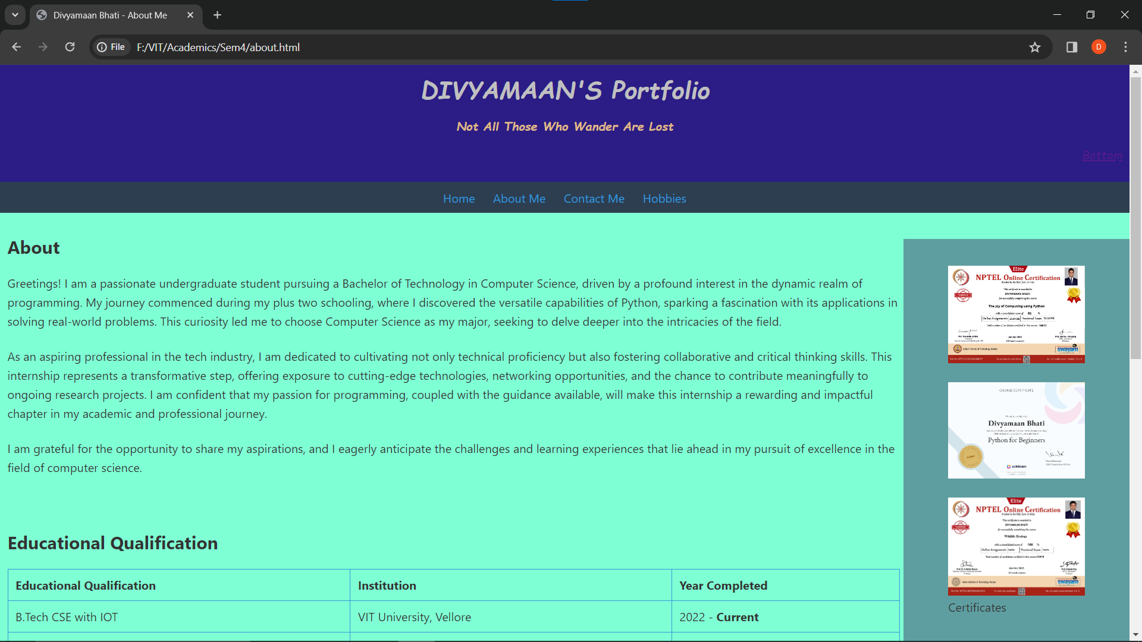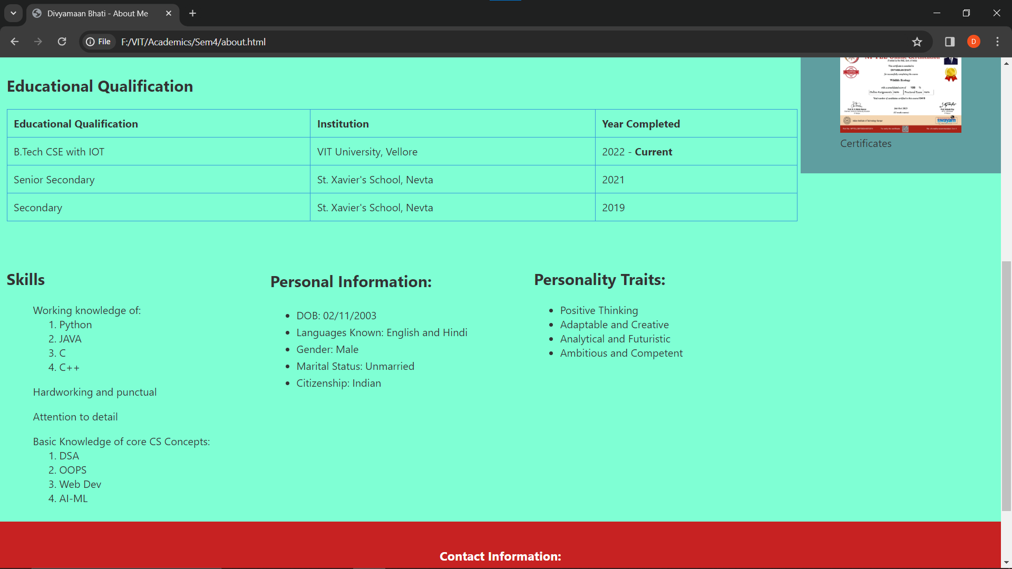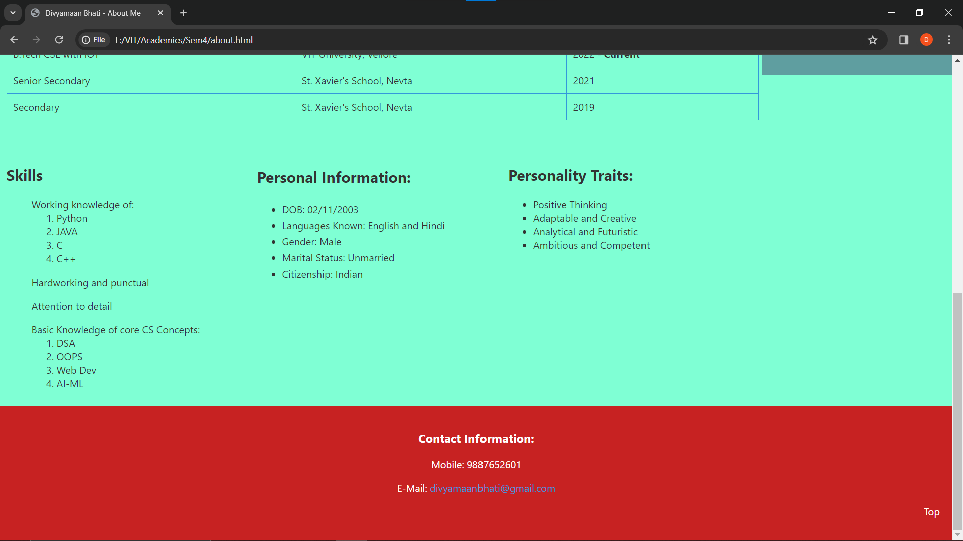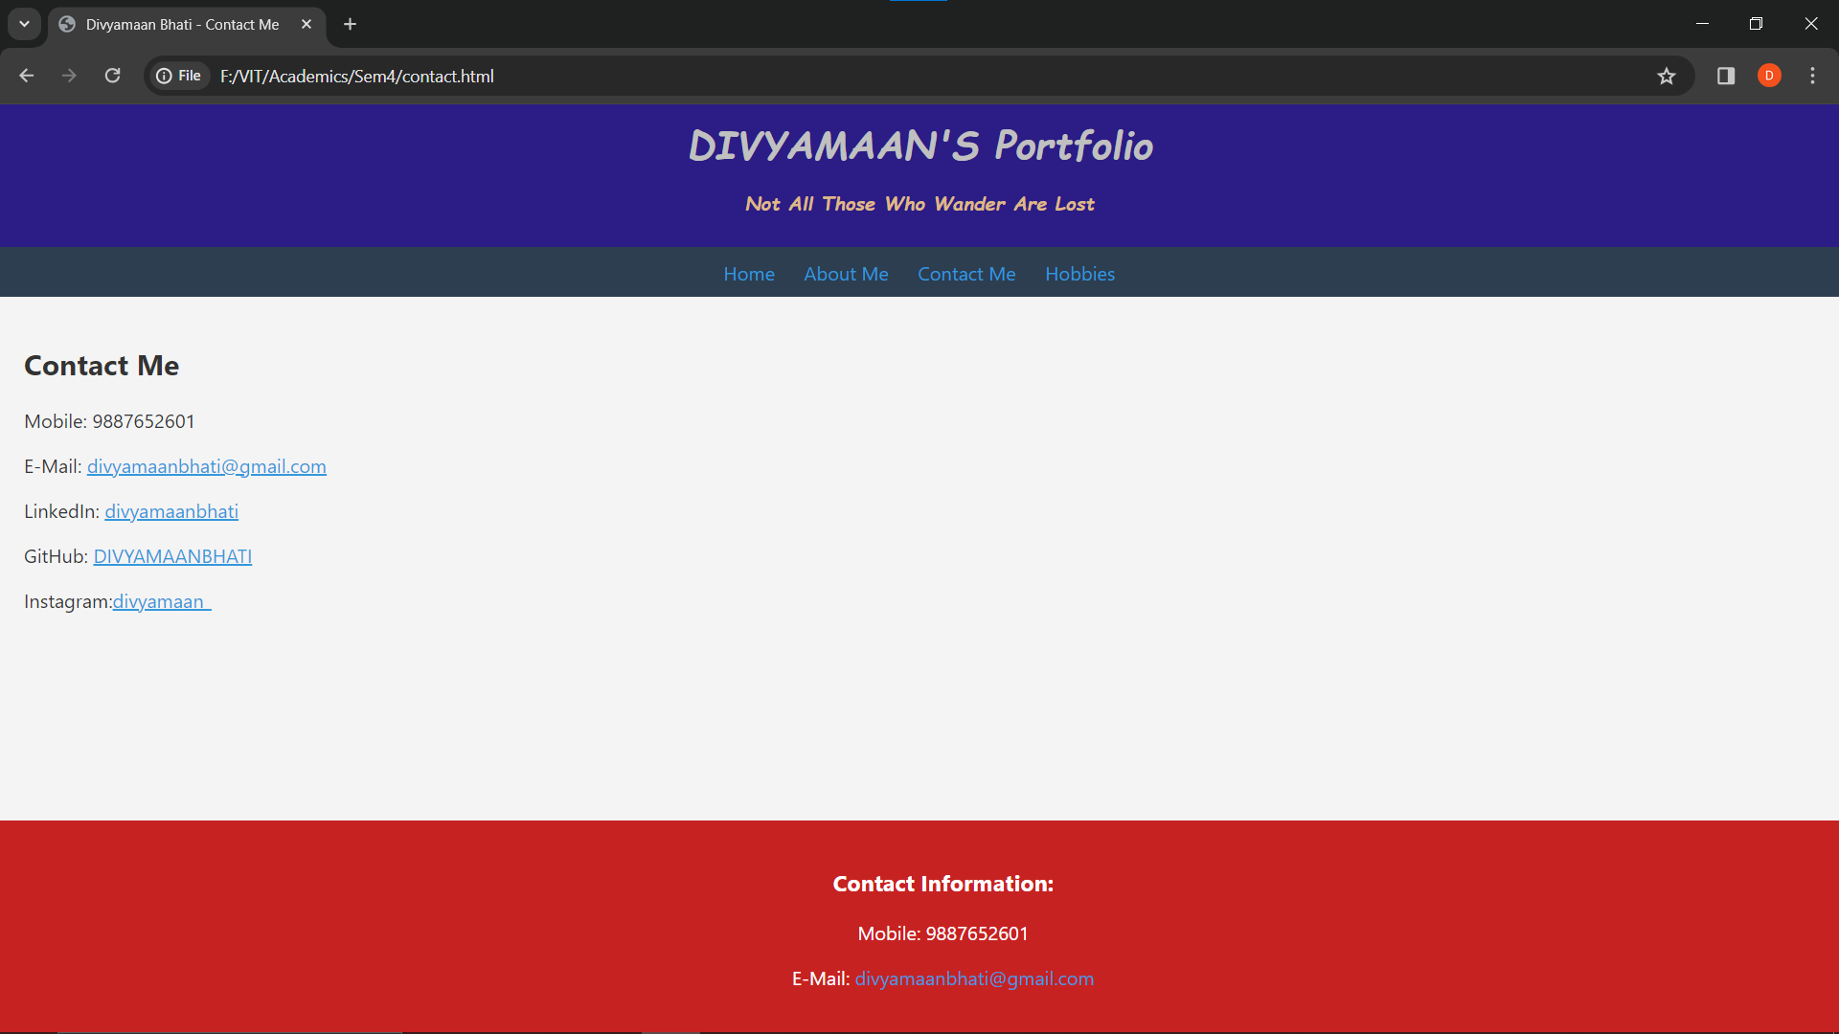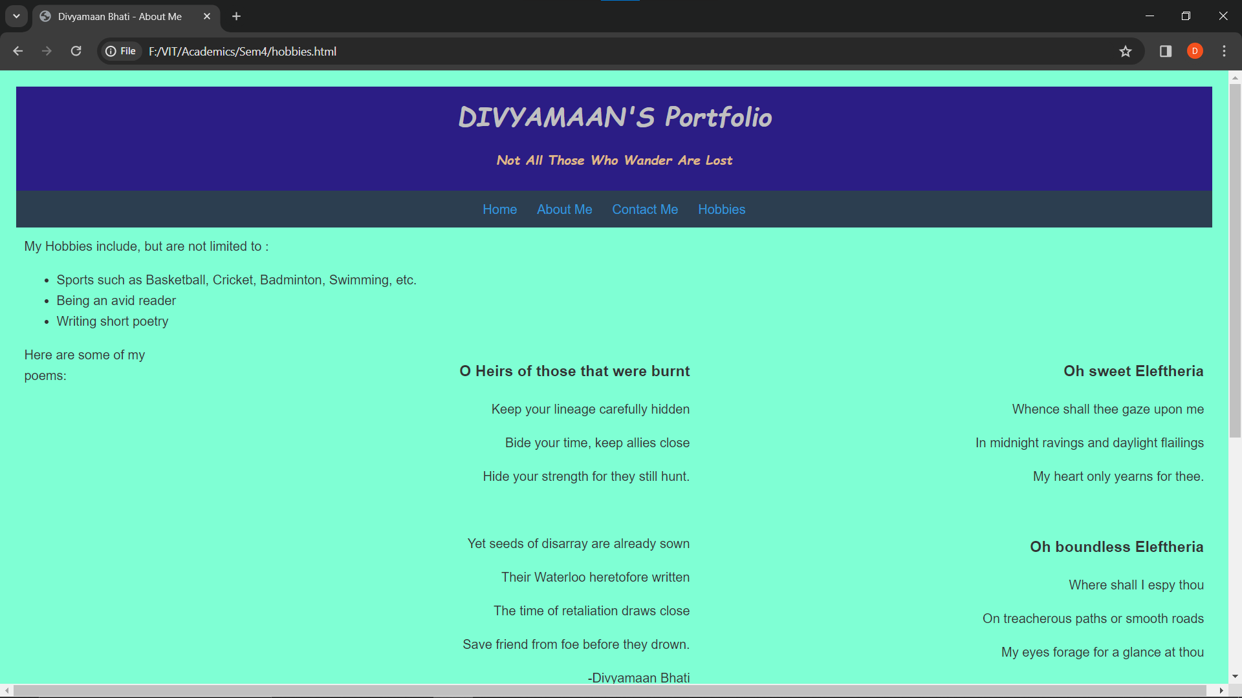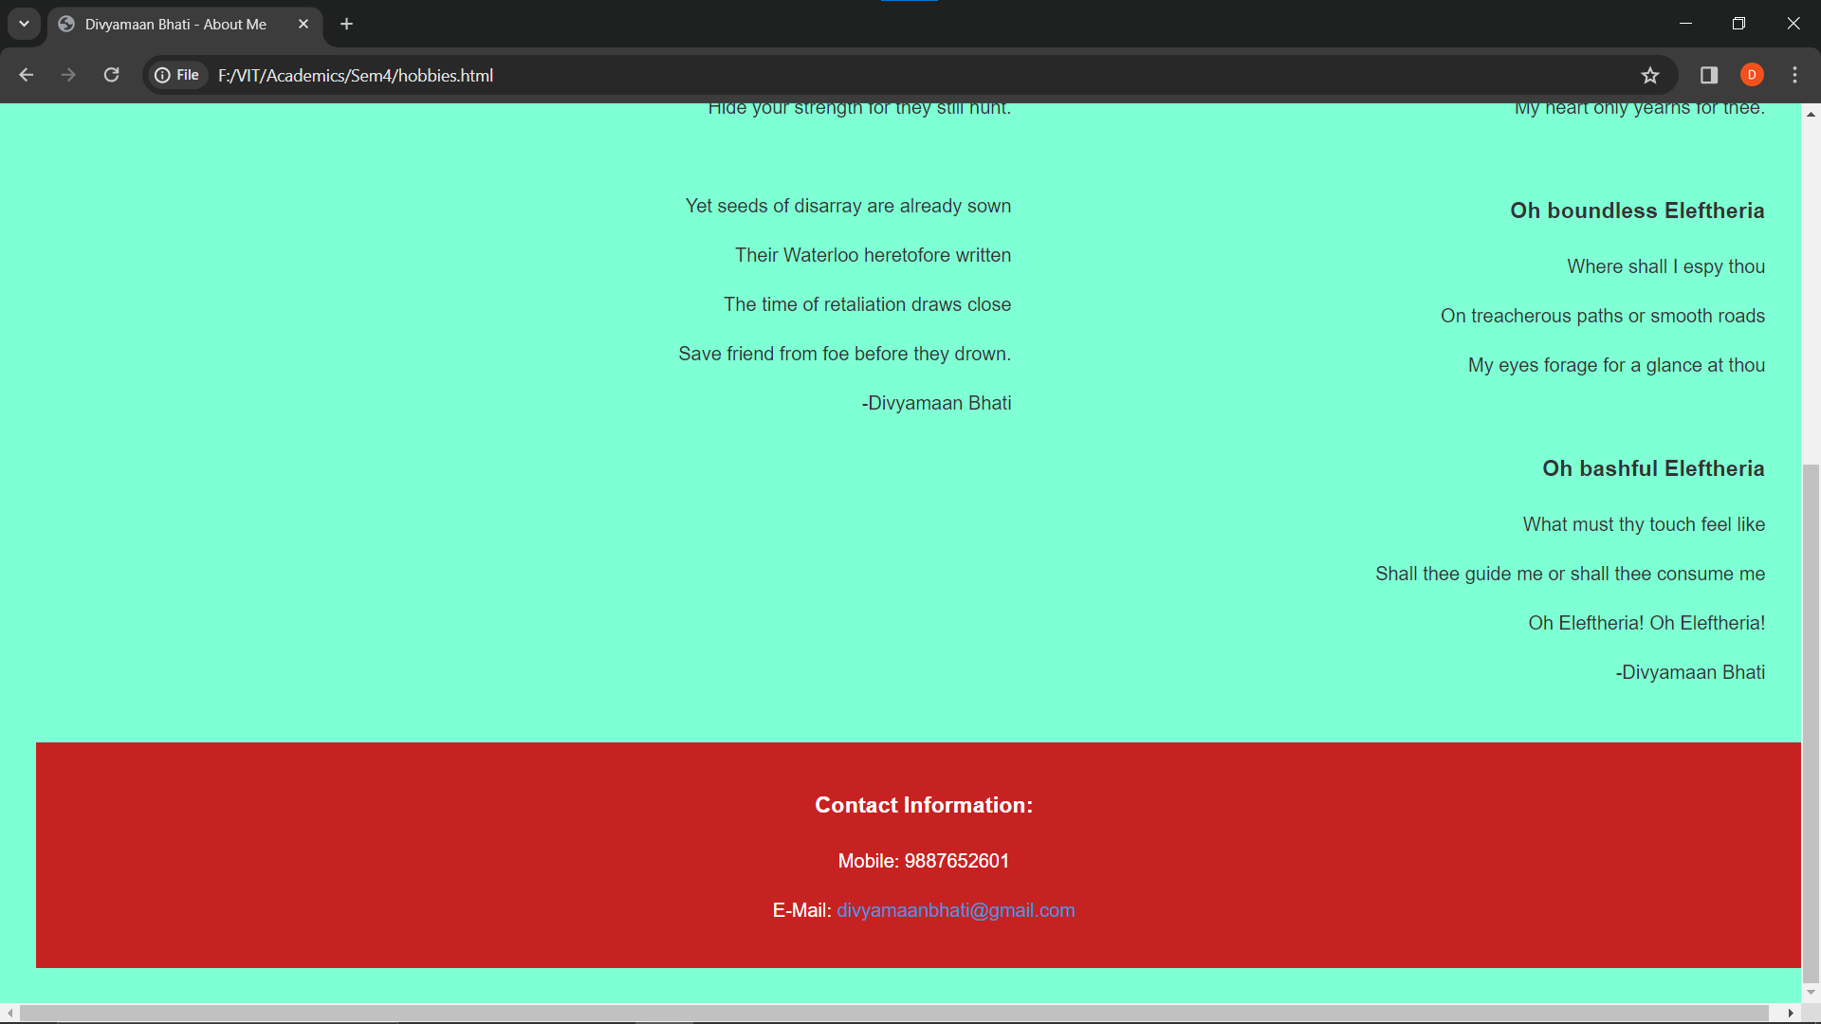

**Steps for Web Hosting using GIT:**

All the files were uploaded into a github repository

Since the video size exceeded github limits, the video has been uploaded on google drive and its link will be shared underneath.

Github Repository link: <https://github.com/DIVYAMAANBHATI/22BCT0143.git>

Video Google drive link: <https://drive.google.com/drive/folders/1WzjoO3xjDgsO-mBSwEtvPPHtx6oYJSTU?usp=drive_link>