CYBERNAUT EDTECH · INTERNSHIP MINI PROJECT 1 · WEB-02
ScholarTrack
Scholarship & Fellowship Deadline Tracker
Project Report — web scraping, change detection and a student dashboard built on real official data
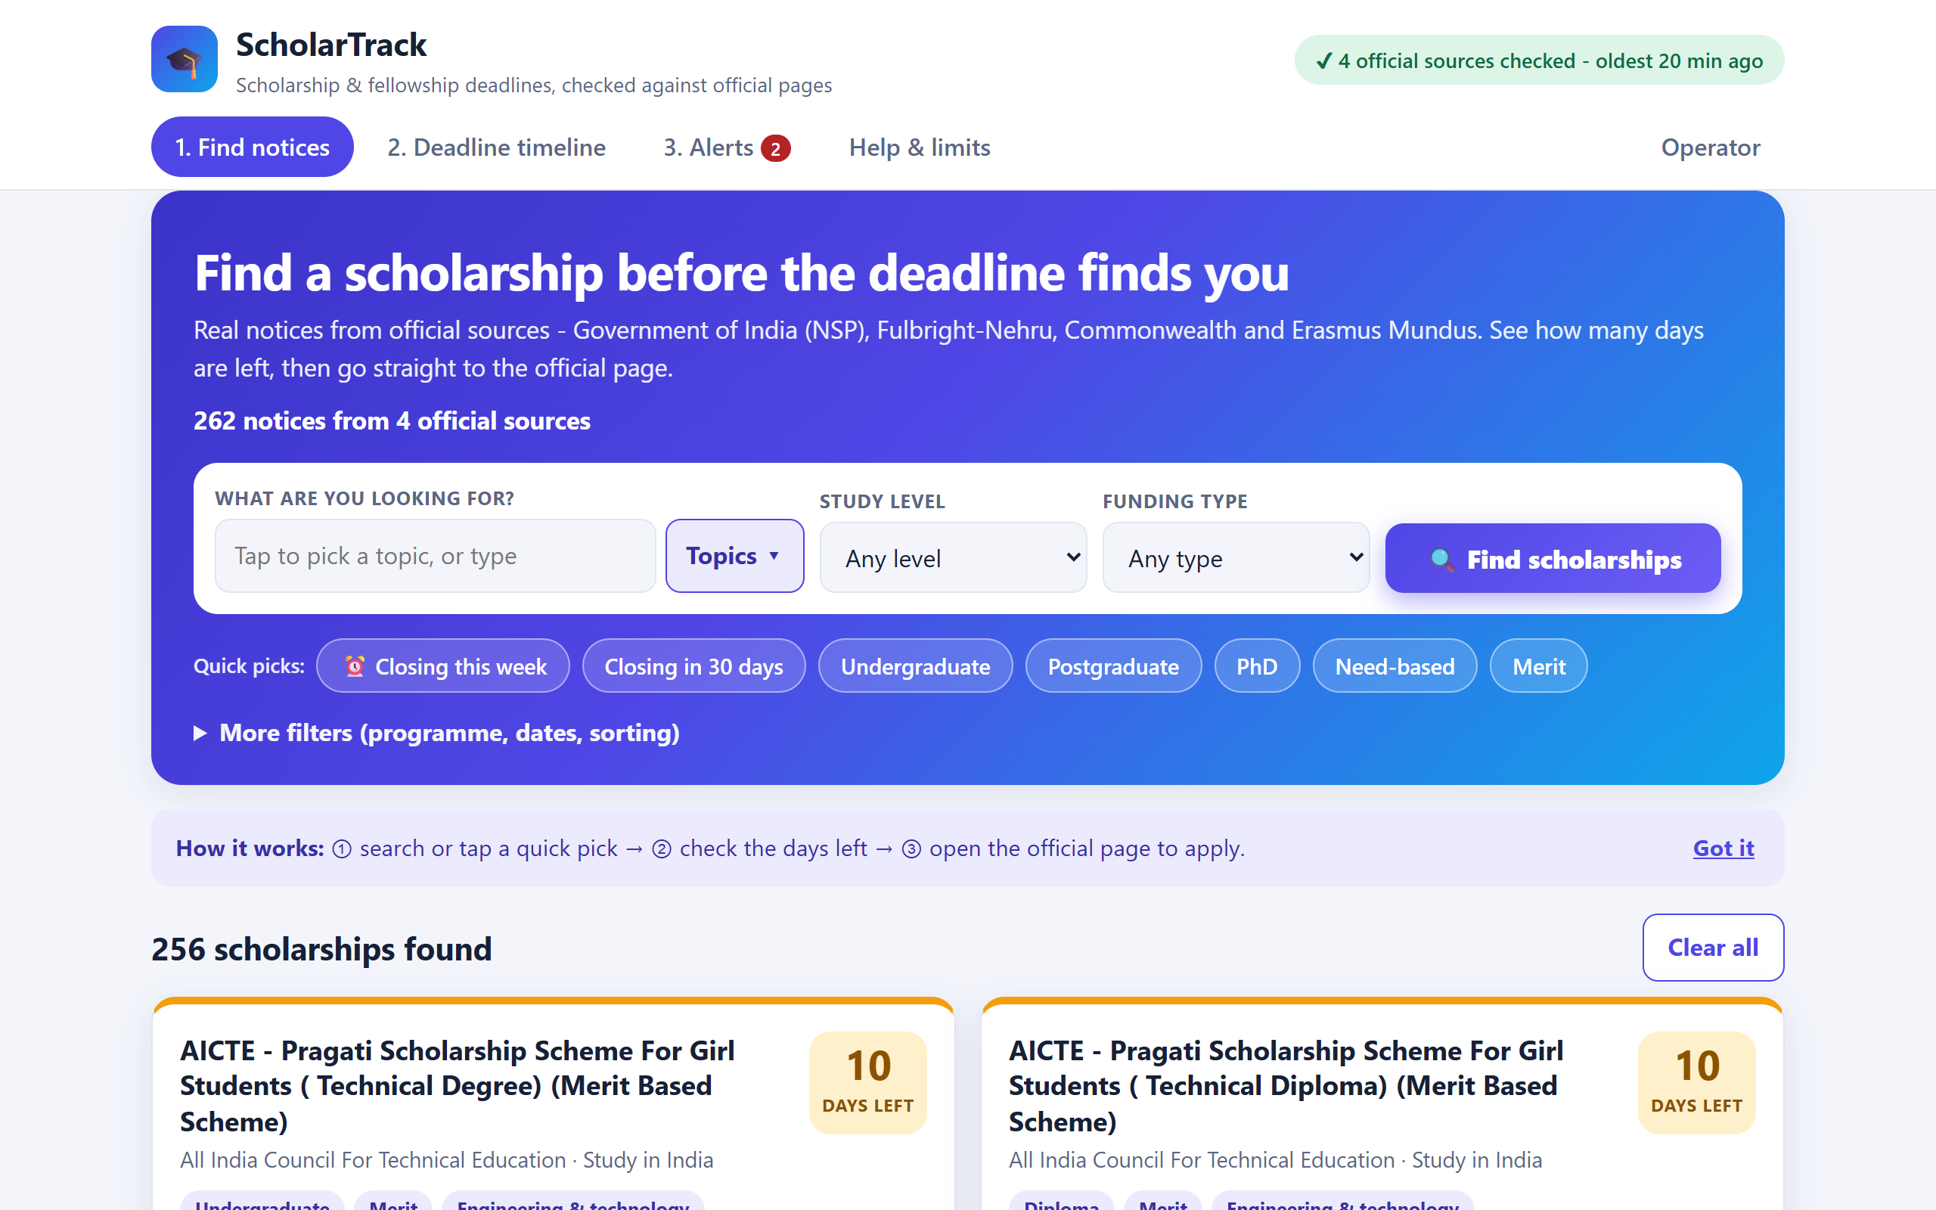

Submitted by
DIVYESH HARI G
Project | WEB-02 · ScholarTrack (Web Scraping track)
Organisation | Cybernaut EdTech — Endeavour to Explore
Academic year | 2026 – 2027
Date of submission | 21 October 2026

Abstract
Scholarship information is scattered across government portals, university pages and funding bodies, each with its own layout and date format, and copies elsewhere go out of date. ScholarTrack is a verifiable notice tracker that collects scholarship and fellowship announcements only from approved official public pages, normalises eligibility, benefits and deadlines, records every change, and presents a searchable, source-linked dashboard. It never converts an unknown deadline into an arbitrary date and never labels a stale snapshot as live. The system collected 262 real notices from four official sources (National Scholarship Portal of India, USIEF Fulbright-Nehru, Commonwealth Scholarship Commission UK and the EU Erasmus Mundus catalogue), detected a real deadline change on 21 October 2026, and passes 78 automated tests including all six mandatory acceptance tests.

1. Introduction

1.1 Problem statement
Students miss deadlines or act on stale or misleading information because notices are fragmented, dates are revised, notices are withdrawn and there is no single trustworthy place that says how fresh the information is.

1.2 Objectives
- Collect time-sensitive scholarship and fellowship announcements from approved public sources.
- Normalise eligibility, benefits and application deadlines (with timezones).
- Warn when dates change and clearly separate confirmed fields from unknown ones.
- Present a searchable, source-linked student dashboard plus an operator dashboard.

1.3 User personas
- Aisha, final-year undergraduate: needs master's funding, has little time; filters by level and funding type, checks the timeline weekly and always opens the official page.
- Mr. Rao, scholarship-office advisor: advises hundreds of students; relies on alerts when a deadline moves or a notice is withdrawn.
Usefulness and limits of scheduled monitoring: one sorted, source-linked view with change alerts and honest freshness labels; but it is not real-time (sources are checked every 6 h, the EU catalogue daily), it covers only approved sources and it never decides eligibility.

2. Source Selection and Data Rights
Every source was checked on 21 October 2026 for robots.txt, copyright/terms and page structure (full record in docs/SOURCE_APPROVAL.md).
Source | Notices | Layout (adapter) | robots.txt | Rights decision
National Scholarship Portal (Govt of India) | 31 | blocks | none published | Copyright policy asks for permission: store facts + link only
USIEF Fulbright-Nehru (Indian citizens) | 8 | detail_pages | allows / | No prohibition found: facts + link only
Commonwealth Scholarship Commission UK | 5 | detail_pages | allows all | All rights reserved: facts + link only
EU Erasmus Mundus Catalogue (EACEA) | 218 | cards + pagination | path allowed | CC BY 4.0: reuse with attribution

Crawl policy: obey robots.txt (401/403 = disallow, 5xx = skip and flag); at least 2 s between requests to a host; 20 s timeout; at most 3 attempts with exponential backoff; no login, CAPTCHA handling or personal data; no off-site redirects; HTML only, 2 MB cap; an identifying User-Agent. Two fictional demo portals exist only for the mentor's live challenges (start-demo.bat). Mentor sign-off, and NSP's permission before public deployment, are still to be obtained.

3. System Design (SRS)

3.1 Requirements
- Functional: collector adapters for 4 layouts; capture title, provider, level, residency rule, deadline and URL; eligibility keywords without automated decisions; countdown with timezone and missing-deadline handling; revision and withdrawal tracking; search by level, programme and funding type; alert queue with source citation and verification state; operator dashboard for failed scrapes.
- Non-functional: polite scheduled refresh with backoff, timeout, retry ceiling and failure logs; database constraints and idempotent upserts; token-protected operator API with secrets outside code; clear freshness labels; responsive, accessible UI; reproducible setup.

3.2 Technology stack
Layer | Choice | Reason
Backend / API | Python 3.11+, FastAPI, Uvicorn | Readable, fast, built-in validation and test client
Scraping | httpx, BeautifulSoup + lxml | Timeouts and mock transport; tolerant of malformed HTML
Storage | SQLite with SQL migration files | Real constraints and transactions, zero setup
Time | zoneinfo + tzdata | Correct IANA zones and daylight saving
Frontend | HTML, CSS, JavaScript (no build step) | Works offline, accessible markup
Testing | pytest + HTML fixtures | 78 offline tests

3.3 Architecture
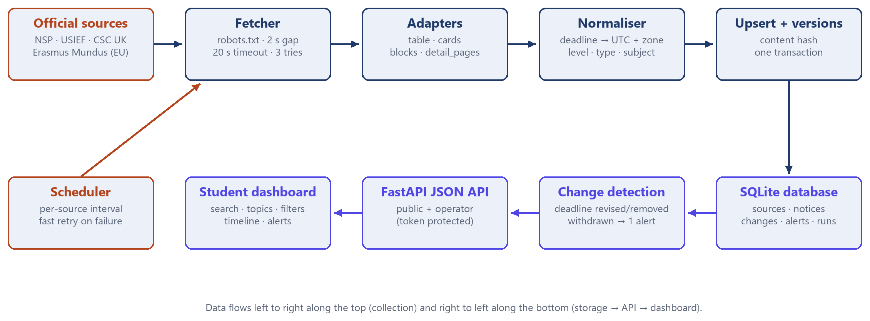
Figure 1: ScholarTrack architecture

3.4 Database design
Table | Purpose | Key constraints
sources | Approved sources, adapter, refresh interval, health | CHECK on adapter and status values
notices | One row per announcement; due_at stored in UTC with its timezone | PK notice_id = SHA-1(source + page key); UNIQUE(source_id, external_key); FK to sources
changes | Version history (deadline revised / set / removed, withdrawn, reinstated, details) | UNIQUE(notice_id, version)
alerts / delivery_log | Alert queue and every delivery attempt | UNIQUE(change_id): one alert per change
scrape_runs | Every refresh: HTTP status, attempts, found / new / changed, error | Audit trail for the operator

4. Implementation

4.1 Collection
A polite Fetcher reads robots.txt, throttles per host and retries only on 429/5xx/timeouts. Four adapters handle the four page layouts: table (columns matched by header text), cards (with Next-page pagination, used for the 11-page Erasmus catalogue), blocks (NSP's Label : value badges, taking the student closing date rather than verification dates) and detail_pages (CSC and USIEF: follow each scholarship page and read the deadline by a configured rule). Selectors live in sources.json, so a redesign usually needs only a configuration change.

4.2 Normalisation
Text on the official page | Stored (UTC) | Flags
31-10-2026 (NSP) | 2026-10-31T18:29:00Z | time and zone assumed
16:00 GMT on Tuesday 8 December 2026 (CSC) | 2026-12-08T16:00:00Z | none
16:00 BST on Tuesday 20 October (no year) | 2026-10-20T15:00:00Z | year from weekday
To be announced / Rolling / 31 March | NULL (unknown) | raw text kept

Study level (School to Professional, including Indian terms such as post-matric), funding type and one of eleven subject groups are derived from the text; eligibility keywords are only highlighted.

4.3 Change detection, alerts and freshness
Each notice has a content hash of the fields a student cares about. Same hash: only verified_at changes. New hash: the row is updated, its version increases, a changes row records old and new deadlines, and every meaningful change raises exactly one alert. A notice missing from a complete read becomes 'unlisted', never deleted. Failed sources are retried after 2, 4, 8 minutes, stale data is labelled by its true age, and a bundled snapshot keeps the page useful offline.

4.4 Source code (key parts)
Listing 1 — Deadline parsing: unknown stays unknown, everything else becomes a UTC instant app/normalize.py, lines 121-166
121 def parse_deadline(text: str | None, default_tz: str = "UTC", today: datetime | None = None) -> Deadline:
122 raw = (text or "").strip()
123 unknown = Deadline(None, None, False, False, raw, None)
124 if UNKNOWN_RE.match(raw):
125 return unknown
126 found = _find_date(raw, today or datetime.now(timezone.utc))
127 if not found:
128 return unknown
129 year, month, day, (start, end), year_inferred = found
130 remainder = raw[:start] + " " + raw[end:]
131
132 hour, minute, time_assumed, after_time = 23, 59, True, ""
133 tm = _TIME.search(remainder)
134 if tm:
135 hour, minute = int(tm.group("h")), int(tm.group("mi"))
136 ap = (tm.group("ap") or "").lower().replace(".", "")
137 if ap == "pm" and hour < 12:
138 hour += 12
139 elif ap == "am" and hour == 12:
140 hour = 0
141 if hour > 23 or minute > 59:
142 return unknown
143 time_assumed = False
144 after_time = remainder[tm.end():]
145 remainder = remainder[:tm.start()] + " " + remainder[tm.end():]
146
147 detected = _detect_tz(after_time, remainder)
148 tz_assumed = detected is None
149 if detected is None:
150 try:
151 detected = (ZoneInfo(default_tz), default_tz)
152 except ZoneInfoNotFoundError:
153 detected = (timezone.utc, "UTC")
154 tz_obj, label = detected
155
156 local = datetime(year, month, day, hour, minute, tzinfo=tz_obj)
157 utc = local.astimezone(timezone.utc)
158 return Deadline(
159 due_at=utc.strftime("%Y-%m-%dT%H:%M:%SZ"),
160 timezone=label,
161 tz_assumed=tz_assumed,
162 time_assumed=time_assumed,
163 raw=raw,
164 local_display=f"{local.day} {local.strftime('%b %Y, %H:%M')} {label}",
165 year_inferred=year_inferred,
166 )

Listing 2 — Idempotent upsert with version-aware change detection and one alert per change app/pipeline.py, lines 97-137
97 def upsert_notice(conn: sqlite3.Connection, rec: dict, source_name: str) -> str:
98 """Returns 'new' | 'changed' | 'unchanged'. Safe to run repeatedly with the same input."""
99 old = conn.execute("SELECT * FROM notices WHERE notice_id = ?", (rec["notice_id"],)).fetchone()
100 now = rec["now"]
101 cols = ("url", "listing_url", "notice_type", "title", "provider", "education_level", "discipline", "region",
102 "residency_rule", "funding_category", "benefit_text", "eligibility_excerpt", "eligibility_keywords",
103 "due_at", "due_raw", "timezone", "tz_assumed", "time_assumed", "year_inferred", "content_hash",
104 "notice_status")
105 if old is None:
106 names = ["notice_id", "source_id", "external_key", *cols, "captured_at", "first_seen_at", "verified_at"]
107 values = [rec[c] for c in names[:3 + len(cols)]] + [now, now, now]
108 conn.execute(f"INSERT INTO notices ({', '.join(names)}) VALUES ({', '.join('?' * len(names))})", values)
109 return "new"
110
111 if old["content_hash"] == rec["content_hash"] and old["notice_status"] != "unlisted":
112 # Same content: refresh the "last verified" stamp and the display-only fields (e.g. tz label).
113 conn.execute("UPDATE notices SET verified_at = ?, url = ?, listing_url = ?, timezone = ?, due_raw = ? "
114 "WHERE notice_id = ?", (now, rec["url"], rec["listing_url"], rec["timezone"], rec["due_raw"],
115 rec["notice_id"]))
116 return "unchanged"
117
118 if old["content_hash"] == rec["content_hash"]: # reappeared after being unlisted, nothing else changed
119 conn.execute("UPDATE notices SET notice_status = ?, verified_at = ? WHERE notice_id = ?",
120 (rec["notice_status"], now, rec["notice_id"]))
121 return "unchanged"
122
123 kind = _classify(old, rec)
124 version = old["version"] + 1
125 sets = ", ".join(f"{c} = ?" for c in cols)
126 conn.execute(f"UPDATE notices SET {sets}, captured_at = ?, verified_at = ?, version = ? WHERE notice_id = ?",
127 [rec[c] for c in cols] + [now, now, version, rec["notice_id"]])
128 cur = conn.execute(
129 "INSERT INTO changes (notice_id, version, change_type, previous_deadline, updated_deadline, "
130 "previous_local, updated_local, detected_at) VALUES (?, ?, ?, ?, ?, ?, ?, ?)",
131 (rec["notice_id"], version, kind, old["due_at"], rec["due_at"],
132 nz.format_local(old["due_at"], old["timezone"]), nz.format_local(rec["due_at"], rec["timezone"]), now))
133 if kind in ALERTING:
134 # UNIQUE(change_id) on alerts + UNIQUE(notice_id, version) on changes => one alert per revision.
135 conn.execute("INSERT INTO alerts (change_id, notice_id, message, created_at) VALUES (?, ?, ?, ?)",
136 (cur.lastrowid, rec["notice_id"], _message(kind, rec, old, source_name), now))
137 return "changed"

Listing 3 — Polite fetching: robots.txt, rate limit, timeout and bounded retry with backoff app/fetcher.py, lines 92-127
92 def get(self, url: str) -> FetchResult:
93 if not self.allowed(url):
94 raise FetchError("robots_disallowed", f"robots.txt disallows {url}")
95 host = urlsplit(url).netloc
96 last_error: FetchError | None = None
97 for attempt in range(1, self.max_retries + 1):
98 self._throttle(url)
99 try:
100 resp = self.client.get(url, headers={"User-Agent": self.user_agent}, follow_redirects=True)
101 except httpx.TimeoutException as exc:
102 last_error = FetchError("timeout", f"timeout fetching {url}: {exc}", attempts=attempt)
103 except httpx.HTTPError as exc:
104 last_error = FetchError("network", f"network error fetching {url}: {exc}", attempts=attempt)
105 else:
106 if urlsplit(str(resp.url)).netloc != host:
107 raise FetchError("offsite_redirect", f"{url} redirected to {resp.url}", attempts=attempt)
108 if resp.status_code == 200:
109 ctype = resp.headers.get("content-type", "text/html").lower()
110 if "html" not in ctype and "xml" not in ctype and "text" not in ctype:
111 raise FetchError("bad_content", f"unexpected content-type {ctype}", 200, attempt)
112 if len(resp.content) > self.max_bytes:
113 raise FetchError("bad_content", "response too large", 200, attempt)
114 return FetchResult(str(resp.url), 200, resp.text, attempt)
115 last_error = FetchError("http_error", f"HTTP {resp.status_code} for {url}", resp.status_code, attempt)
116 if resp.status_code not in RETRYABLE_STATUS:
117 raise last_error # 403/404 etc.: do not hammer
118 retry_after = resp.headers.get("retry-after", "")
119 if retry_after.isdigit():
120 self._sleep(min(int(retry_after), 30))
121 if attempt < self.max_retries:
122 pause = self.backoff * (2 ** (attempt - 1))
123 log.warning("fetch attempt %d/%d failed (%s); retrying in %.1fs",
124 attempt, self.max_retries, last_error, pause)
125 self._sleep(pause)
126 assert last_error is not None
127 raise last_error

5. Output
Screenshots of the running application on 21 October 2026 with live data from the four official sources.
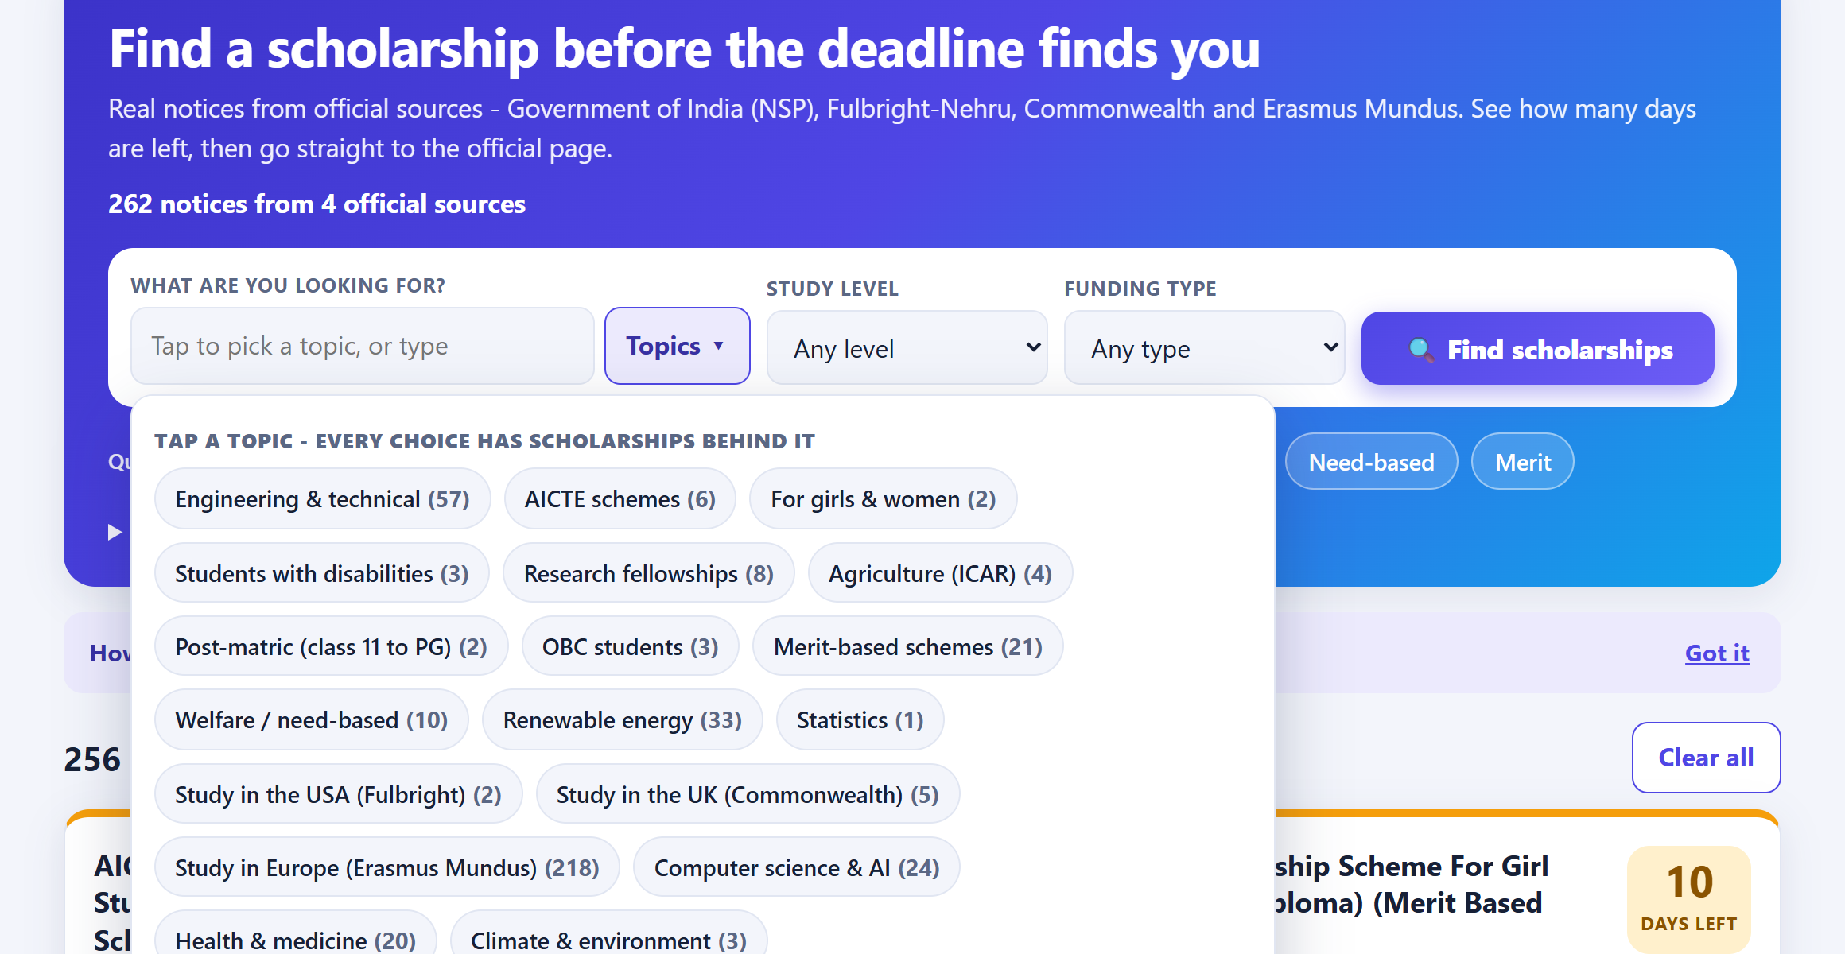
Figure 2: Home page with the topic picker — every topic shows how many scholarships it finds
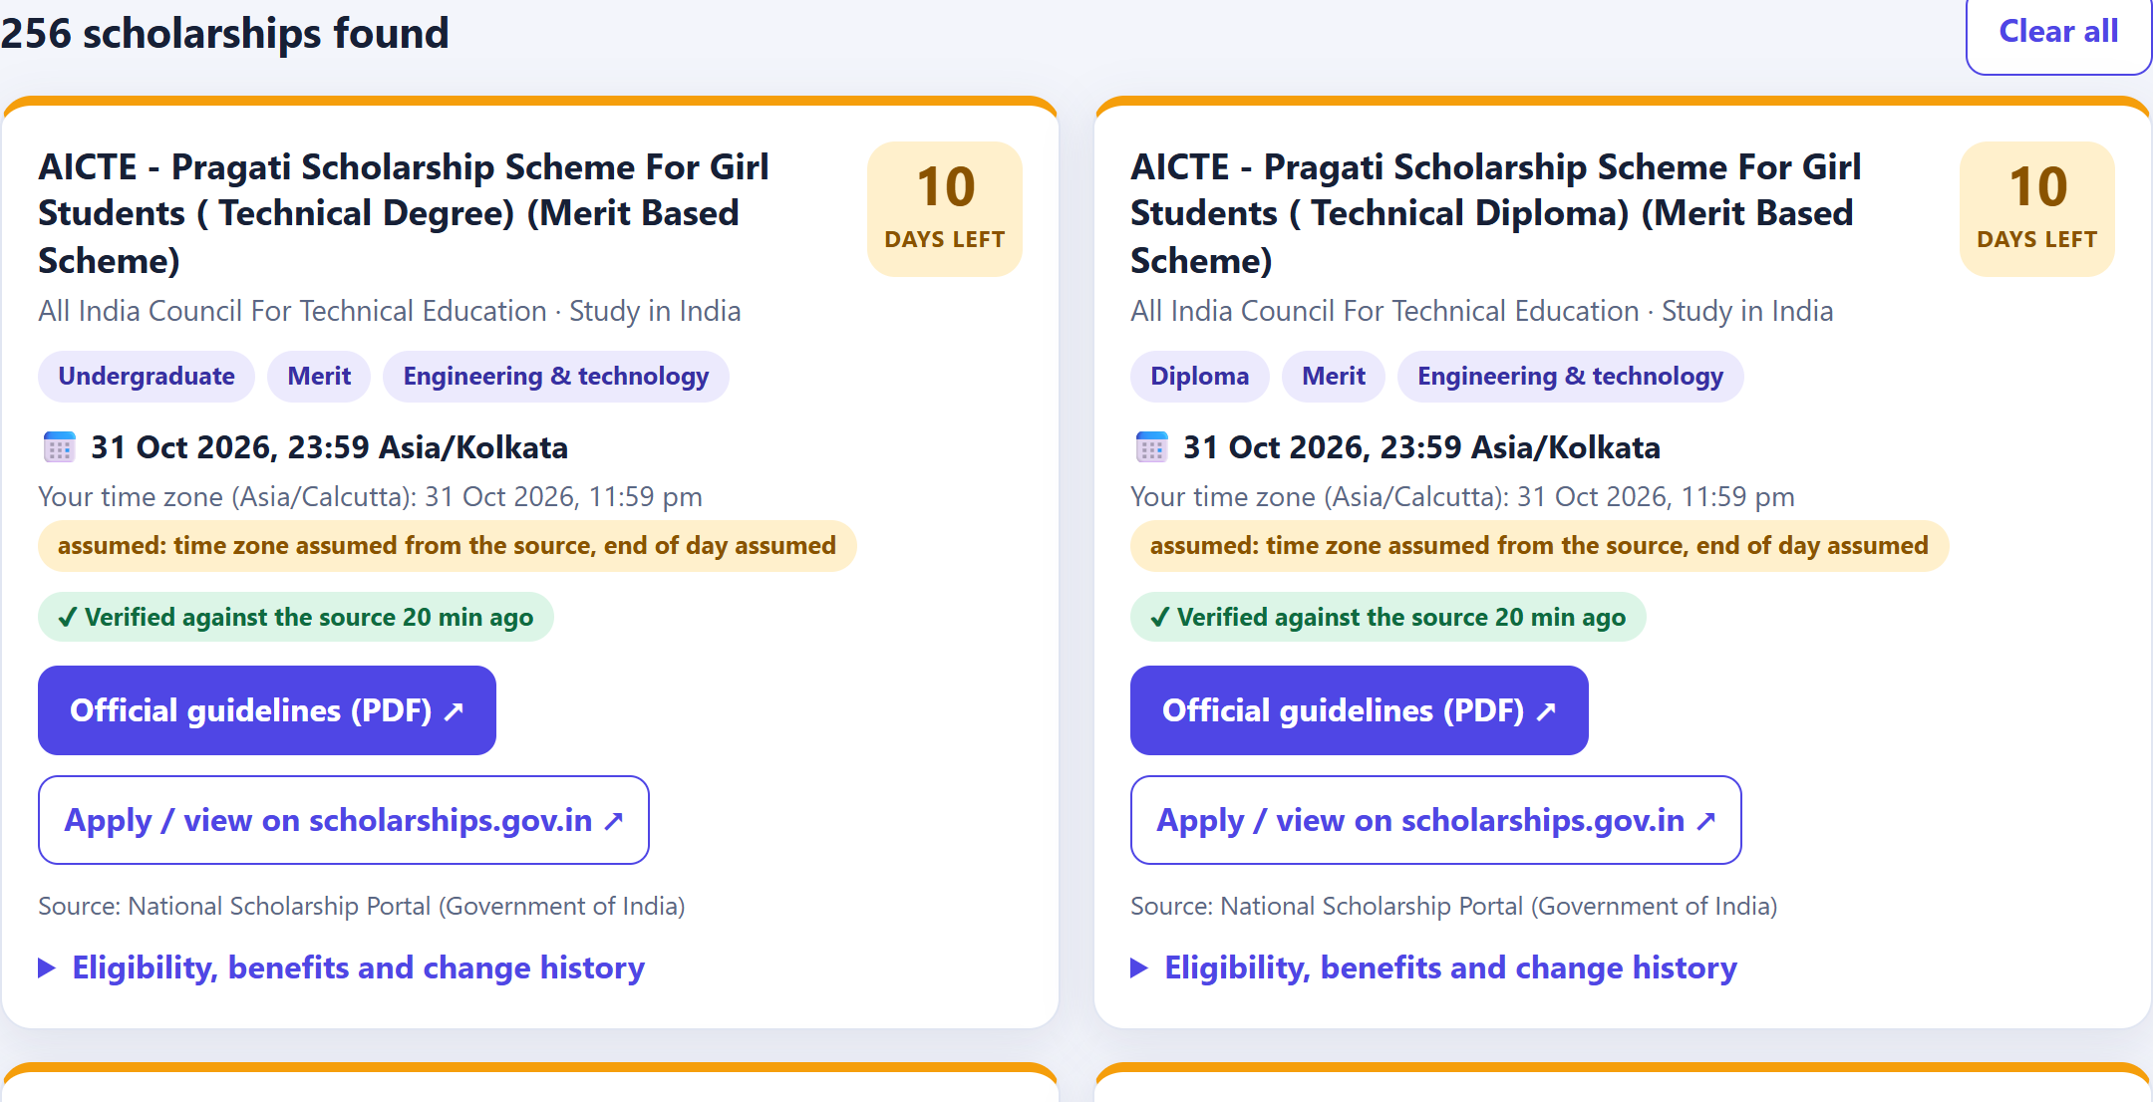
Figure 3: Result cards with days-left badge, deadline in the source's and the viewer's timezone, verification state and official links
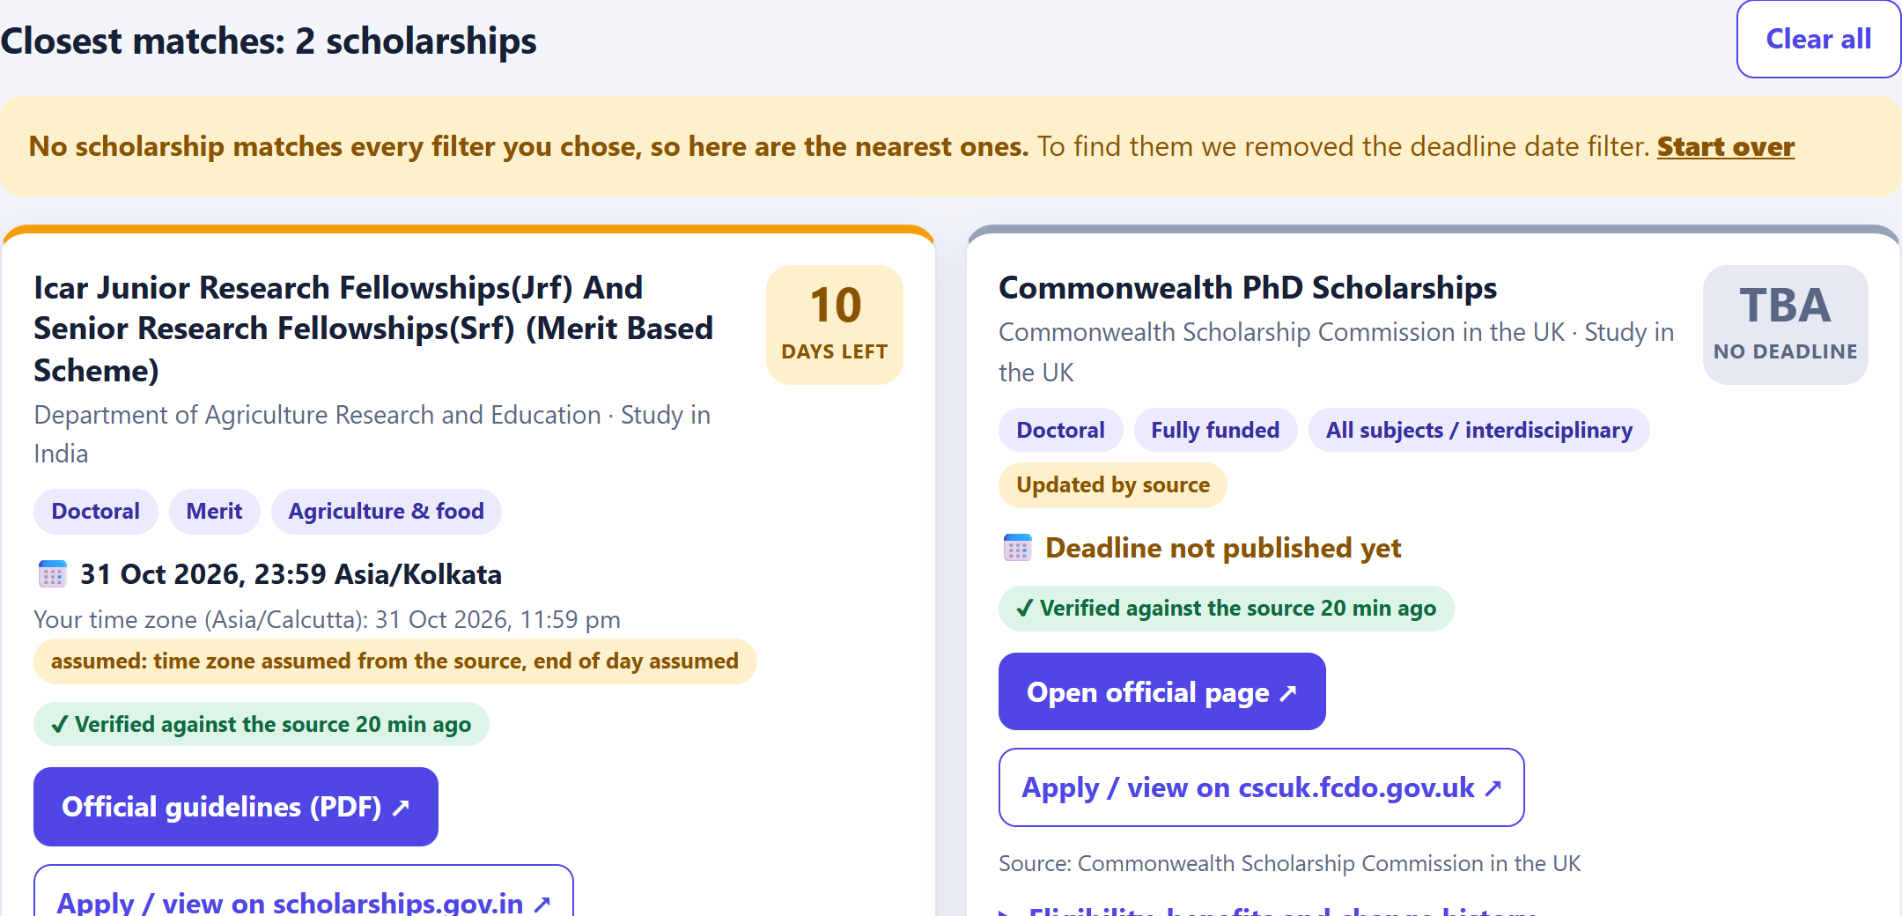
Figure 4: No dead ends — when no notice matches every filter, the closest matches are shown and the relaxed filter is named
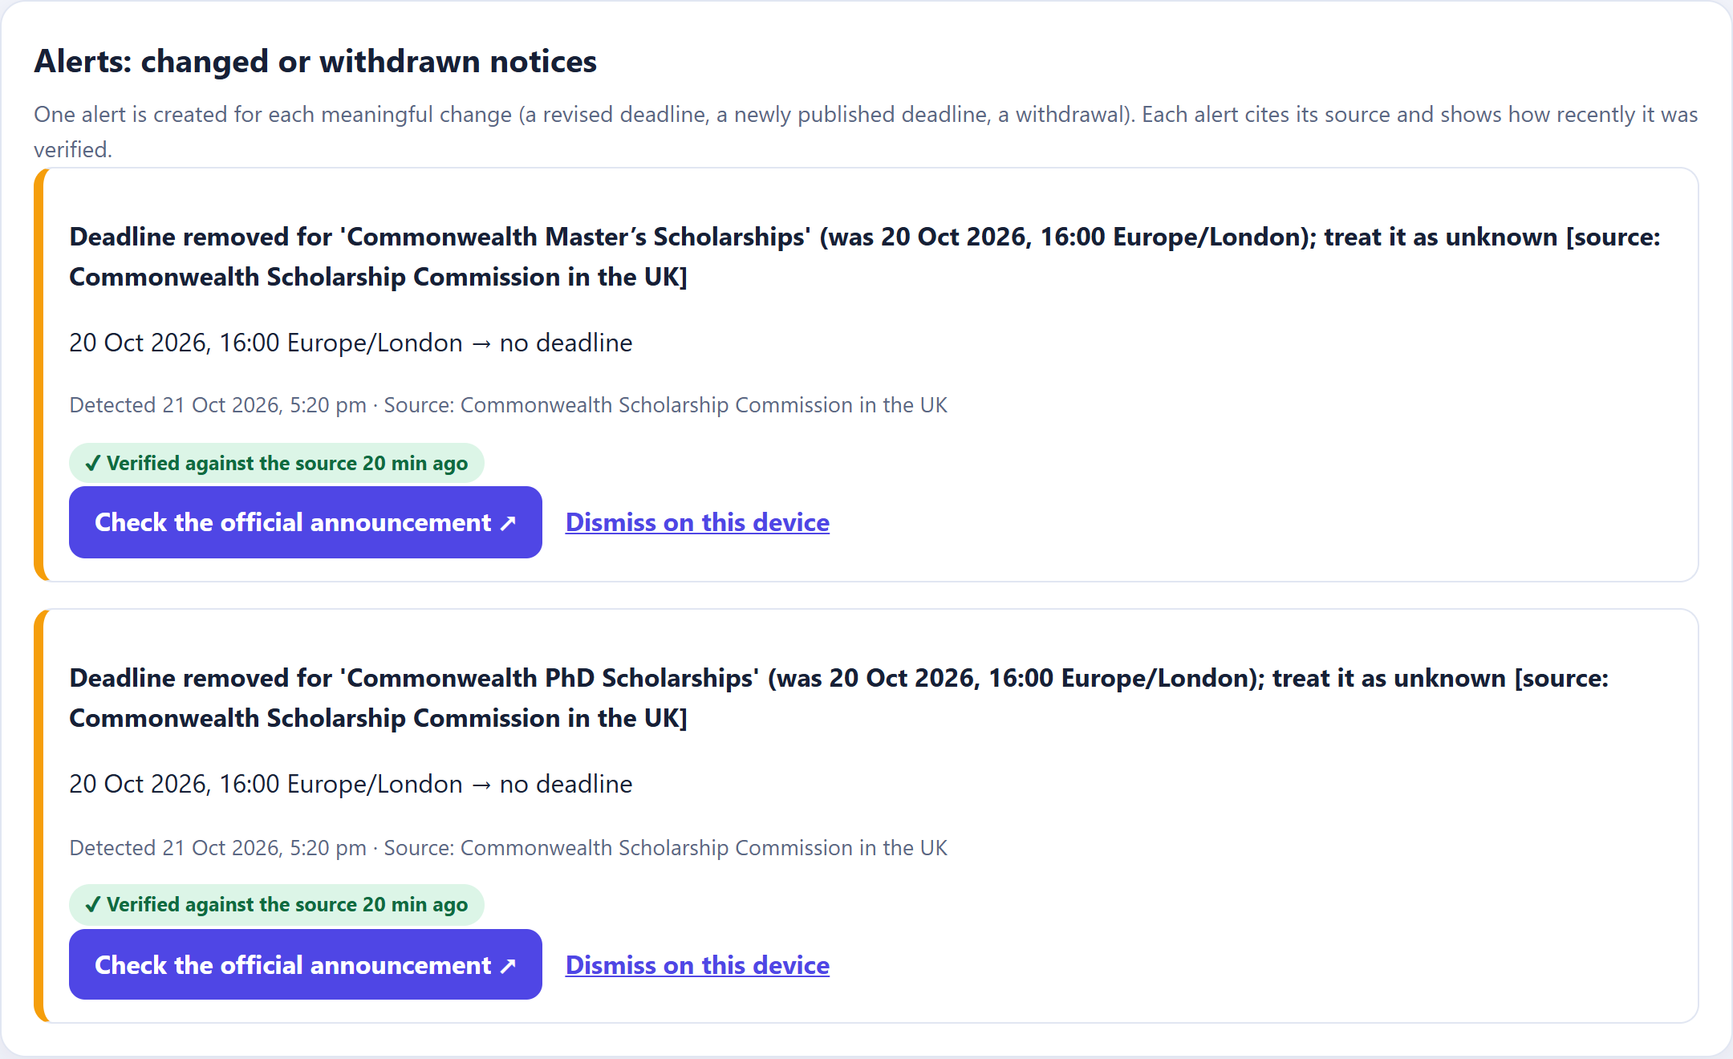
Figure 5: A real change detected on 21 Oct 2026 — the Commonwealth pages removed their closing date after it passed
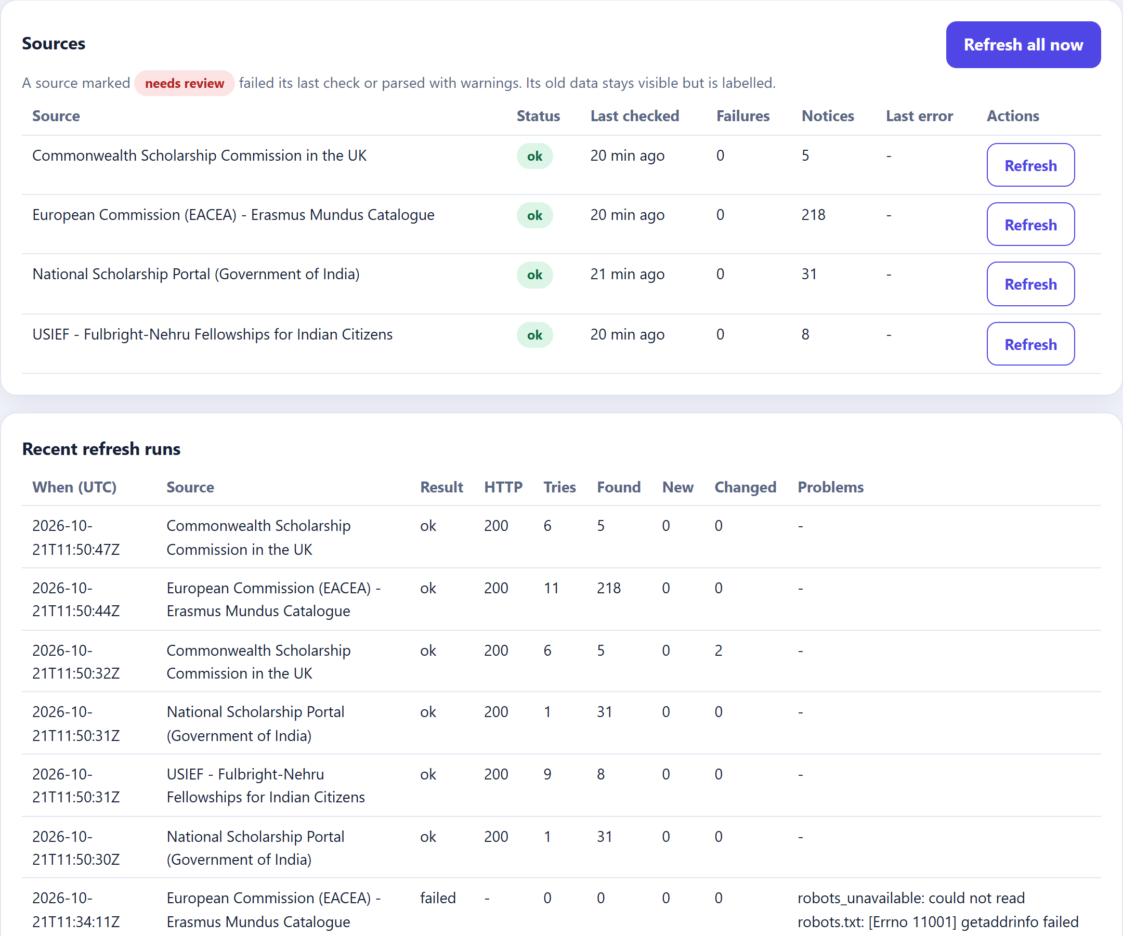
Figure 6: Operator dashboard — source health and run history, including a failed run during a network outage

6. Testing
78 automated test cases run in about 3 seconds without internet access: normalisation (12 functions, 23 cases: unknown deadlines, IST/EST/IANA/UTC-offset parsing, levels), adapters (4: malformed rows, missing fields, duplicates, layout change), fetcher (7: robots.txt, retry and backoff, retry ceiling, timeouts, rate limit), pipeline (17: idempotency, corrections, one alert per revision, outages, unlisting, constraints), real layouts (12: NSP blocks, detail pages, pagination, migration) and API (15: access control, timezone-aware filters, revision flow, closest matches).

Mandatory acceptance test | Result
Unknown deadline is never converted to an arbitrary date | PASS
A source correction appears as an update, not a new notice | PASS
Date filters work on timezone-aware deadlines | PASS
Inaccessible source is flagged instead of silently skipped | PASS
Each notice links to the original official announcement | PASS
Alert triggers once per meaningful deadline revision | PASS
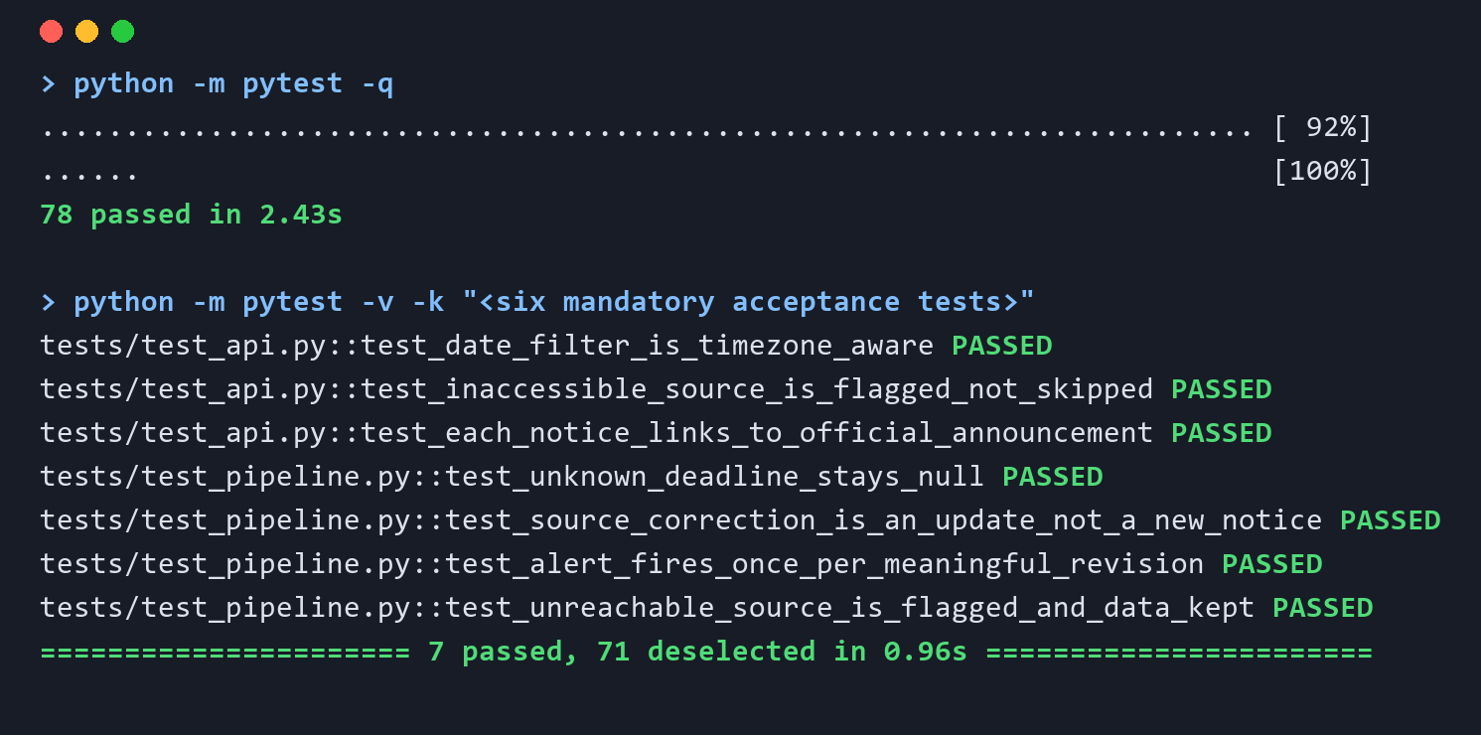
Figure 7: Test run — all 78 tests pass; the acceptance tests shown individually

7. Evaluation, Ethics and Conclusion
- Collection quality: 262 notices from 4 sources in about one minute; all 31 NSP deadlines and every stated USIEF and CSC deadline extracted; Erasmus deadlines correctly shown as not published.
- Alert precision: the only alerts raised were the two genuine Commonwealth changes, confirmed against the live pages; repeat runs created no duplicates.
- Usability: all 189 combinations of level, funding type and quick filters return results, exact or explained closest matches.
- Ethics: public pages only, robots.txt and rate limits respected, no personal data, data minimisation, attribution and official links, no automated eligibility decisions.
- Limitations: not real-time; Erasmus programmes publish deadlines on their own sites; several USIEF/CSC deadlines are closed for this cycle; subjects are inferred from titles; mentor and NSP permission pending.
- Future work: email alerts with personal watchlists, more official sources (Chevening, state portals), calendar export, hosted deployment over HTTPS.
Deployment: pip install -r requirements.txt, then python run.py (or start.bat); configuration through environment variables; one Uvicorn worker behind HTTPS; back up data/scholartrack.db.
Conclusion: ScholarTrack meets the WEB-02 objectives with real data: it collects politely from official sources, keeps unknown information honest, detects and reports changes once, and gives students a clear path to the official page before every deadline.

