RGB Lights Compaing Three LED Lights Red,Green & Blue. We Adjusting the Brightness Of the LED it Create new Colour. So the LED Adjusting Brightness using Codes(0-255).

►As the LEDs are very close to each other, we can only see the final colors result rather than the three colors individually.

►To have an idea on how to combine the colors, take a look at the following chart. This is the simplest color mixing chart, there are more complex color charts on the web.

►RGB LEDs have 4 pins which can be distinguished by their length. The longest one is the ground (-) or voltage (+) depending if it is a common cathode or common anode LED, respectively.



RGB LED is acombination of 3 LEDs in just one package

· 1x **R**ed LED

· 1x **G**reen LED

· 1x **B**lue LED

The color produced bythe RGB LED is a combination of the colors of each one of these three LEDs.

**Mixing colors**

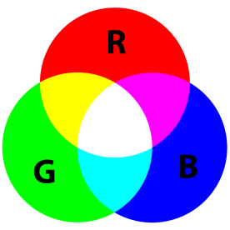

To produce other colors, you can combine the three colors in different intensities. To generate different colors you can use PWM to adjust the brightness of each LED. As the LEDs are very close to each other, we can only see the final colors result rather than the three colors individually.

R G B

(255,255,255)= White color

The 255 is full brightness of the led light

**RGB LED Two Types:**

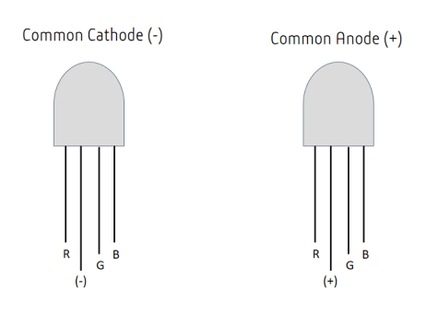

**RGB LED BLINK:**

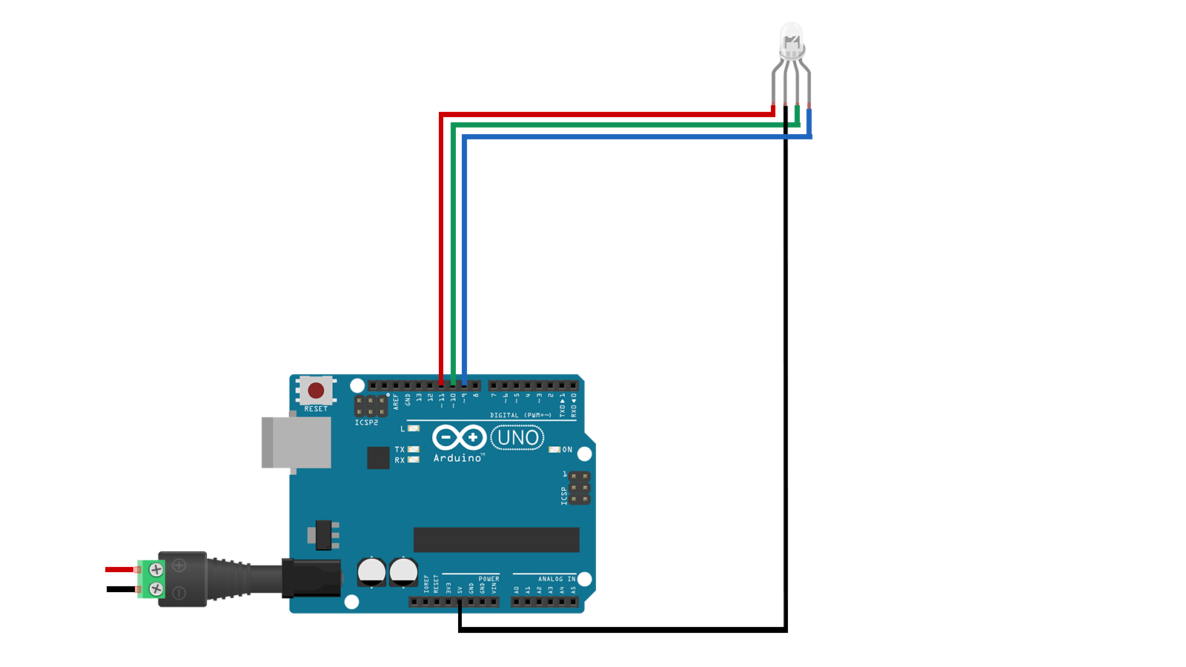

**ARDUINO** **UNO** **USING** **BLUETOOTH** **RGB** **CONTROLLER:**



**ARDUINO NANO USING BLUETOOTH RGB CONTROLLE:**

