1. Default state

Relay Contacts: Close

Push Button: Open

Micro Controller signal: Open Collector state

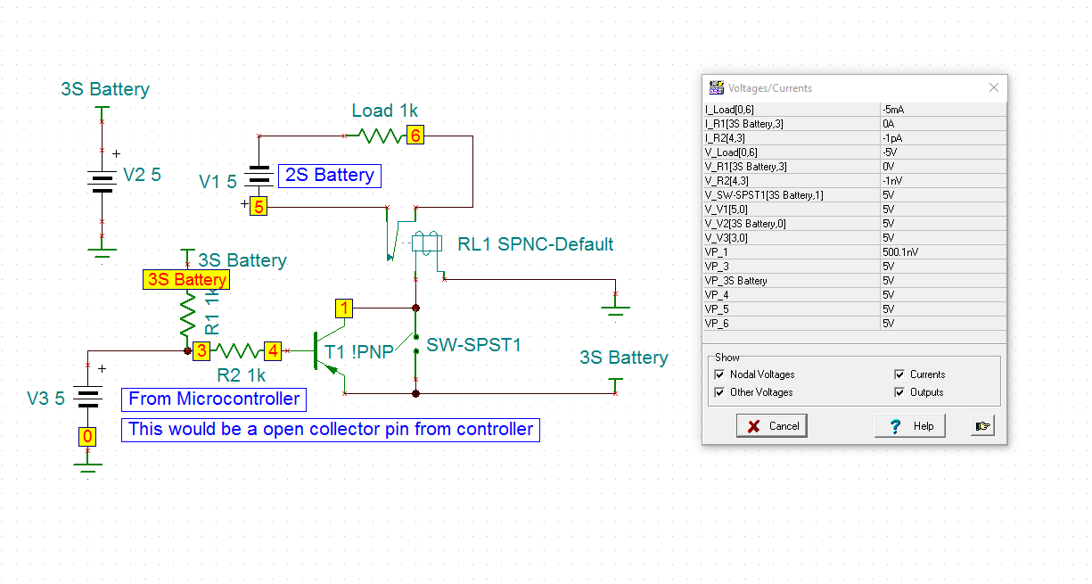

1. Manual Emergency Button Press

Relay Contacts: Open

Push Button: Closed

Micro Controller signal: Open Collector state

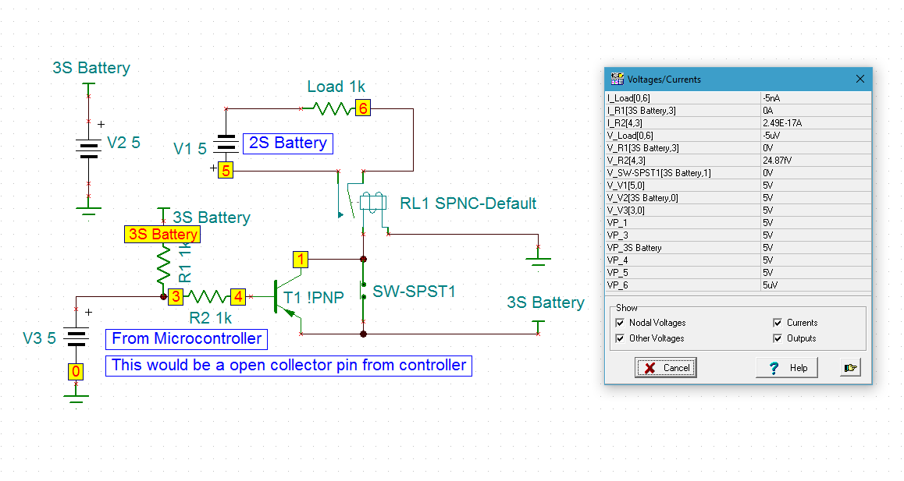

1. Microcontroller shuts down power to motors

Relay Contacts: Open

Push Button: Open

Micro Controller signal: Pulled Low

