**Obtaining the Parts for Your Own DIY Rotating Tank**

*The parts used to build the DIY Rotating Tank can all be purchased online from shop.lego.com and other retailers. This document lists the necessary components and describes how to order them. Prices and links reflect time of writing (April 30th, 2017).*

**Required components**

**OXO Turn Table**

Search google.com for the ‘OXO Softworks 16" Turn Table’ or use the following link. Purchase 1 turn table.

From amazon.com -> $16.99 each

<http://a.co/16P3tM1>

|  |  |
| --- | --- |
|  |  |

**LEGO Power Functions Components**

|  |  |  |  |
| --- | --- | --- | --- |
| Picture | Part Name | Link | Quantity |
|  | LEGO® Power Functions XL-Motor | <https://tinyurl.com/legoxlmotor> | 1  ($9.99 each) |
|  | LEGO® Power Functions Battery Box | <https://tinyurl.com/legobattery> | 1  ($6.99 each) |
| LEGO Power Functions Cost | | | $16.98 |

**LEGO Pick-a-Brick Components**

To find and purchase LEGO parts for structure

* go to the Pick-a-Brick section of the <https://shop.lego.com/en-US/> website

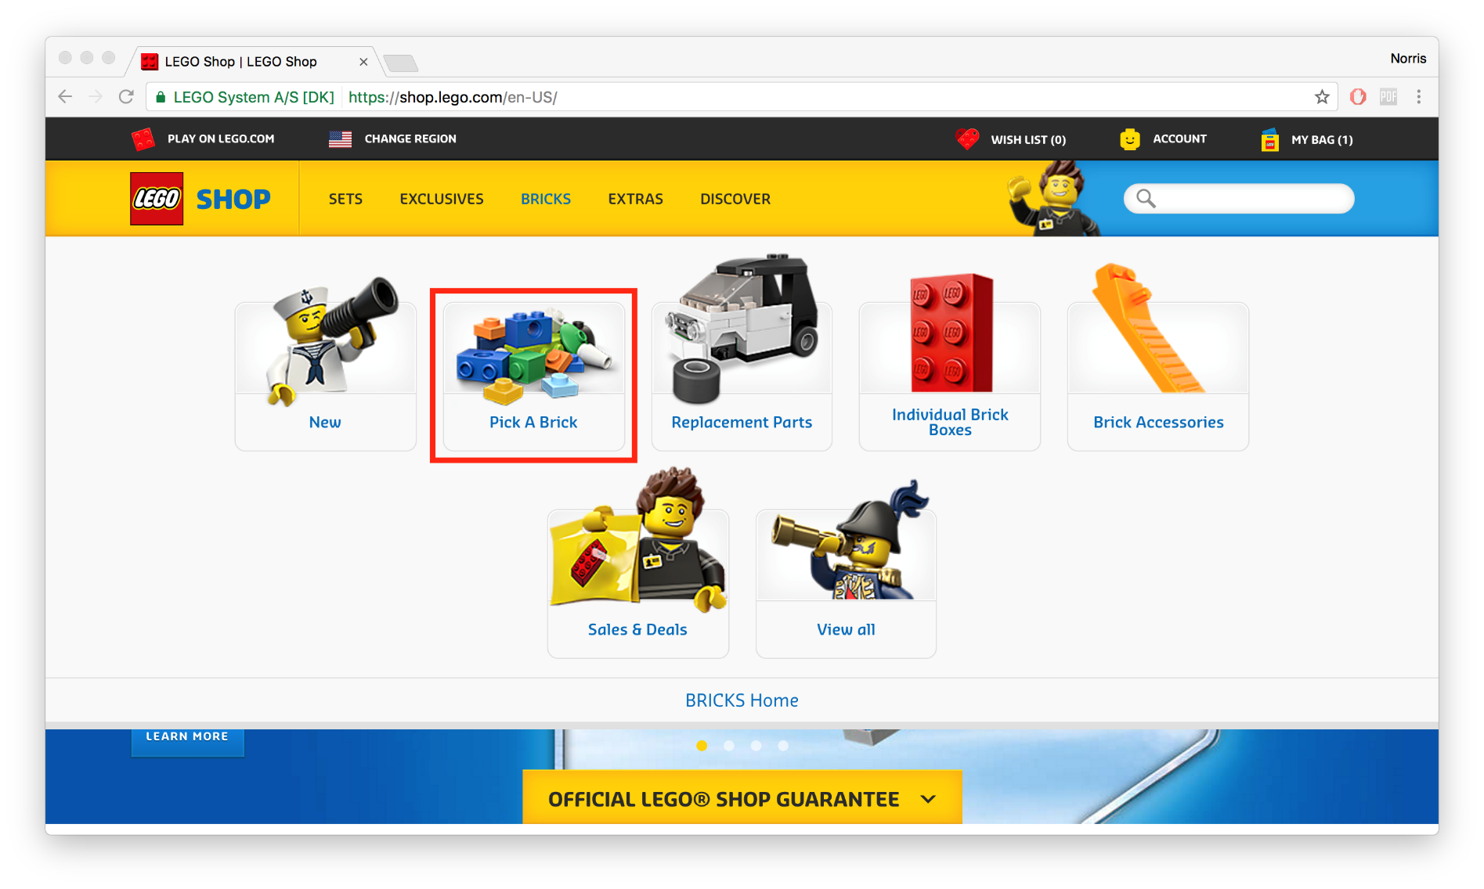

* scroll down to the ‘Advanced Search’ box and input the following Design ID codes into the appropriate search bar

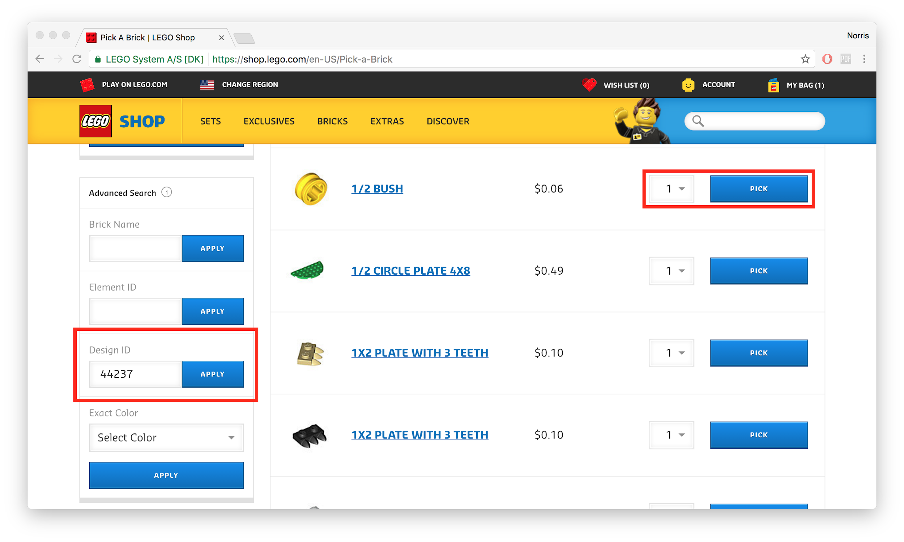

* select quantity of parts using the box adjacent to the “Pick” box

|  |  |  |  |
| --- | --- | --- | --- |
| Picture | Part Name | Design ID | Quantity |
|  | Brick 2x4 | 3001 | 6  ($0.20 each) |
|  | Plate 2x4 | 3020 | 3  ($0.14 each) |
|  | Plate 4x4 | 3031 | 2  ($0.20 each) |
|  | Plate 6x10 | 3033 | 1  ($0.82 each) |
|  | Technic Brick 1x10 | 2730 | 1  ($0.41 each) |
|  | Technic Brick 1x6 | 3894 | 1  ($0.29 each) |
|  | Angle Plate 1x2 / 2x2 | 21712 | 4  ($0.10 each) |
|  | Cross Axle 4M | 3705 | 1  ($0.10 each) |
|  | Connector Peg with Friction | 2780 | 4  ($0.06 each) |
|  | Rim Wide 18/14 with Cross | 55982 | 1  ($0.21 each) |
|  | Tyre Normal Wide 4x14 | 92402 | 1  ($0.69 each) |
| LEGO Pick a Brick Cost | | | $5.18 |

**Required components total cost: $39.15**

**Tank options**

*There are two main options for the tank that sits on top of the Lazy Susan and holds the water that you’ll use to visualize the fluid flows:*

1. Gardener’s edge 12” clear plastic pot saucer: <https://www.gardenersedge.com/12in-clear-plastic-pot-saucer/p/PTD-12/>. $1.99. Cheap and big, but note that the side walls are not totally rigid. It always holds its shape during demonstrations, but this makes filling it and emptying it more difficult.

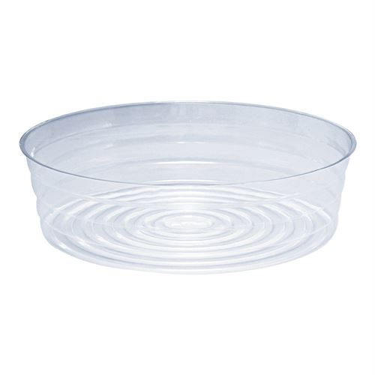

1. Royal Imports Flower Acrylic Vase, 5” cylinder x 5” tall: <https://smile.amazon.com/dp/B016V20GG8/>. $10.99 on Amazon. Smaller than the Gardener’s Edge saucer and more expensive, but has rigid side walls that make it easier to work with.

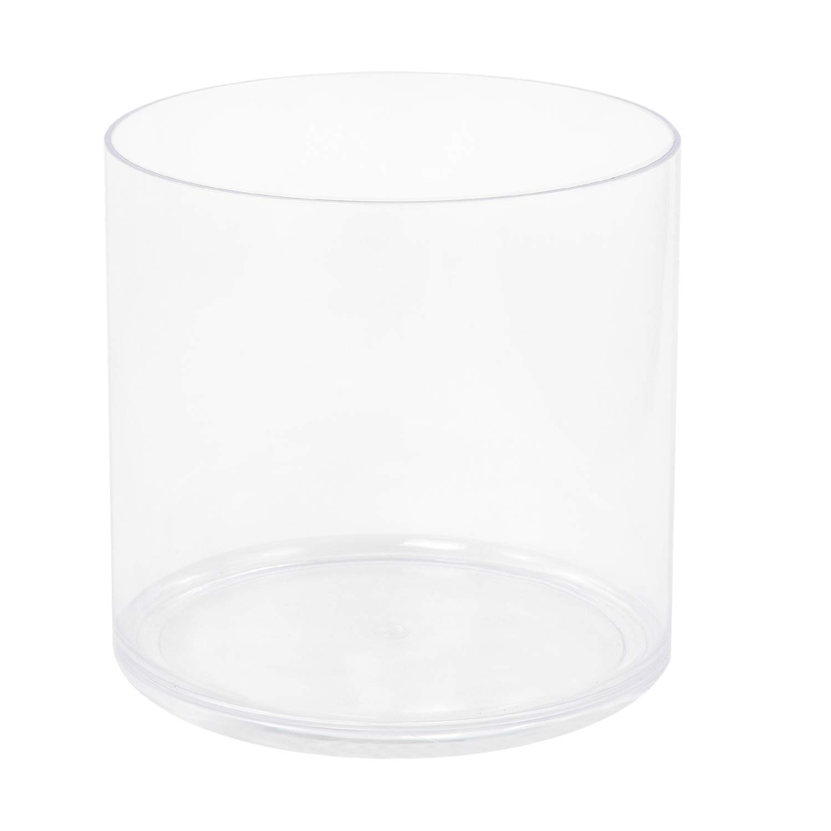

**Optional components**

*Optional components provide the ability to change speed of rotation. Purchase the following components in addition to required components.*

**LEGO Power Functions Components**

|  |  |  |  |
| --- | --- | --- | --- |
| Picture | Part Name | Link | Quantity |
|  | LEGO® Power Functions IR Speed Remote Control | <https://tinyurl.com/legoremote> | 1  ($12.99 each) |
|  | LEGO® Power Functions IR Receiver | <https://tinyurl.com/legoreceiver> | 1  ($14.99 each) |
| LEGO Power Functions Cost | | | $27.98 |

**Required + optional components total cost: $67.13 (not including the tank)**