**Hackdash #3, 2018 Group answers**

Groups:

1)

2)

3)

**Questions:**

1. What is the gene name of the 12391th row of the output of tximport? (**2 points**)

Correct answer:



Group1:

Group2:

Group3:

2. What are the total number of counts for each sample within Txi_gene$counts (**2 points**)

Correct answer:



Group1:

Group2:

Group3:

3. How many genes were filtered out for having cpm>1 in at least 5 samples? **(2 points)**



Group1:

Group2:

Group3:

3. Create a dendrogram and include an image here. Describe how your samples are clustering. (**2 points**)

Correct answer: grouping by disease vs. healthy skin

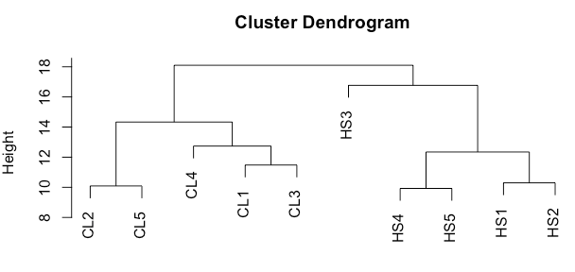

Group1:

Group2:

Group3:

4. Complete a PCA and include an image here. What do PC1 correspond to? Are there any outliers in the dataset? Which sample was this? (**4 points**)

Correct answer:

PC1: disease vs. healthy skin

Sample HS3

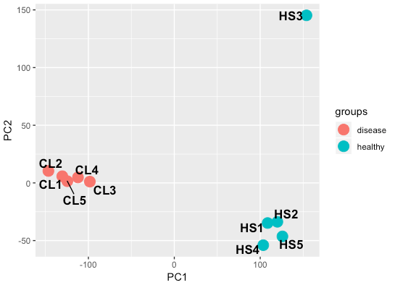

Group1:

Group2:

Group3:

5. How many genes are differentially expressed (FDR < 0.05, abs LFC > 1) when you compare disease vs. healthy skin? How many of them were up and downregulated in disease relative to healthy skin? (**2 points**)

Correct answer: 5642 total DEGs

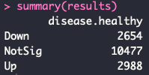

Group1:

Group2:

Group3:

6. Create a heatmap of all differentially expressed genes (FDR < 0.05, abs LFC > 1). Label the groups with colors. (**4 points**)

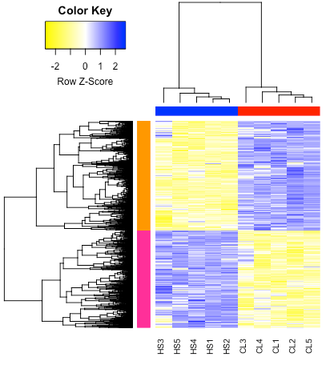

Group1:

Group2:

Group3:

7. Comparing cutaneous leishmaniasis to healthy skin, and using GO BP terms and the DAVID web resource, what are the two most enriched Annotation Clusters upregulated in disease? **(5 points)**

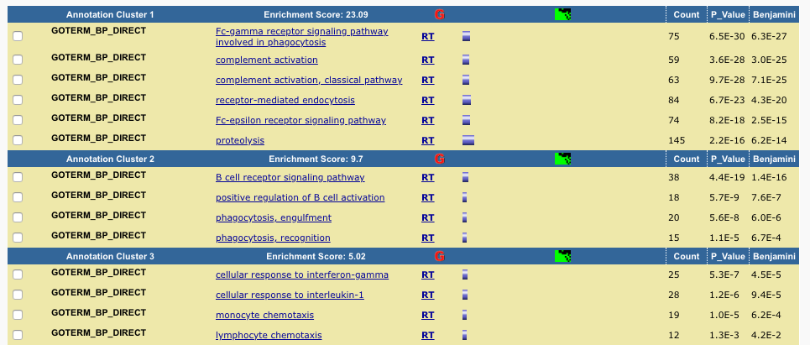

8. Using GSEA software to investigate only the Biocarta portion of the C2 collection from MSigDB, answer the following questions:

a) What are the top 3 enriched pathways in disease condition? Indicate normalized enrichment score and FDR. **(3 points).**

b) What is the 11th enriched pathway in disease condition relative to healthy skin? Indicate NES and FDR. **(3 points)**

c) What is the 4th enriched pathway in disease condition relative to healthy skin? How many genes from the dataset were observed in this pathway? How many genes had significant sore enrichment in this pathway? How many genes this pathway has originally from the database? **(4 points).**

d) Give a brief description and interpretation of enriched signatures in healthy skin relative to disease. **(2 points).**

Correct answers:

a) NKT (NES 2.33), CTLA4 (NES 2.22)and IL12 (NES 2.16) pathways. FDR <0.000 for all these pathways.

b) STATHMIN pathway NES 1.84 and FDR 0.007.

c) INFLAM pathway, 19 genes observed, 16 genes enriched and 29 genes total in the pathway.

d) It was observed that there wasn’t enriched pathways in heathy skin relative to disease, FDR>1.

RESULTS:

|  |  |  |  |  |  |  |  |
| --- | --- | --- | --- | --- | --- | --- | --- |
| Group | Q1 | Q2 | Q3 | Q4 | Q5 | Q6 | **Score** |
|  |  |  |  |  |  |  |  |
|  |  |  |  |  |  |  |  |
|  |  |  |  |  |  |  |  |