Business Template

Subway Database
Logo / Image

Contents
1 Business Description 3
1.1 Business background 3
1.2 Problems. Current Situation 3
1.3 The benefits of implementing a database. Project Vision 3
2 Model description 4
2.1 Definitions & Acronyms 4
2.2 Logical Scheme 4
2.3 Objects 5

Business Description

Business background
The metro system in any city is a critical part of public transportation. With multiple lines, stations, and trains running at frequent intervals, managing this infrastructure efficiently is challenging. The metro management needs an efficient database system that can track detailed information about subway stations, routes, schedules, trains, ticketing, maintenance activities, employees, and payments. The aim is to provide up-to-date information on metro services and ensure smooth operations.

Problems. Current Situation
Currently, metro management faces several issues:
- Lack of integrated information regarding stations, schedules, and ticketing.
- Manual tracking of maintenance activities, leading to delays.
- Poor communication between departments handling trains, stations, and employees.
- Inability to quickly respond to passenger queries or provide accurate real-time information.
Without a centralized database, managing these processes is inefficient and error prone.

the Benefits of implementing a database. Project Vision
The implementation of a robust database system would:
- Centralize all metro-related information, improving coordination between different departments.
- Automate maintenance schedules and tracking of repairs.
- Provide real-time data on train arrivals, departures, and operating frequencies, improving the passenger experience.
- Streamline ticketing and payment processes, ensuring quick transactions and accurate financial records.
This database project aims to improve overall efficiency, reduce costs, and provide passengers with reliable and updated information.

Model description

Definitions & Acronyms
PK – Primary Key, UNIQUE identifier for each record in a table.
FK – Foreign Key, a reference to a primary key in another table.
Subway Line – A metro line consisting of several stations.
Station – A metro stop where trains arrive and depart.
Train – A vehicle that runs on the subway tracks, transporting passengers.
Ticket – A document or digital pass allowing access to the metro system.
Schedule – The timing for trains arriving or departing from stations.
Maintenance – Activities related to repairing and maintaining subway infrastructure

Logical Scheme
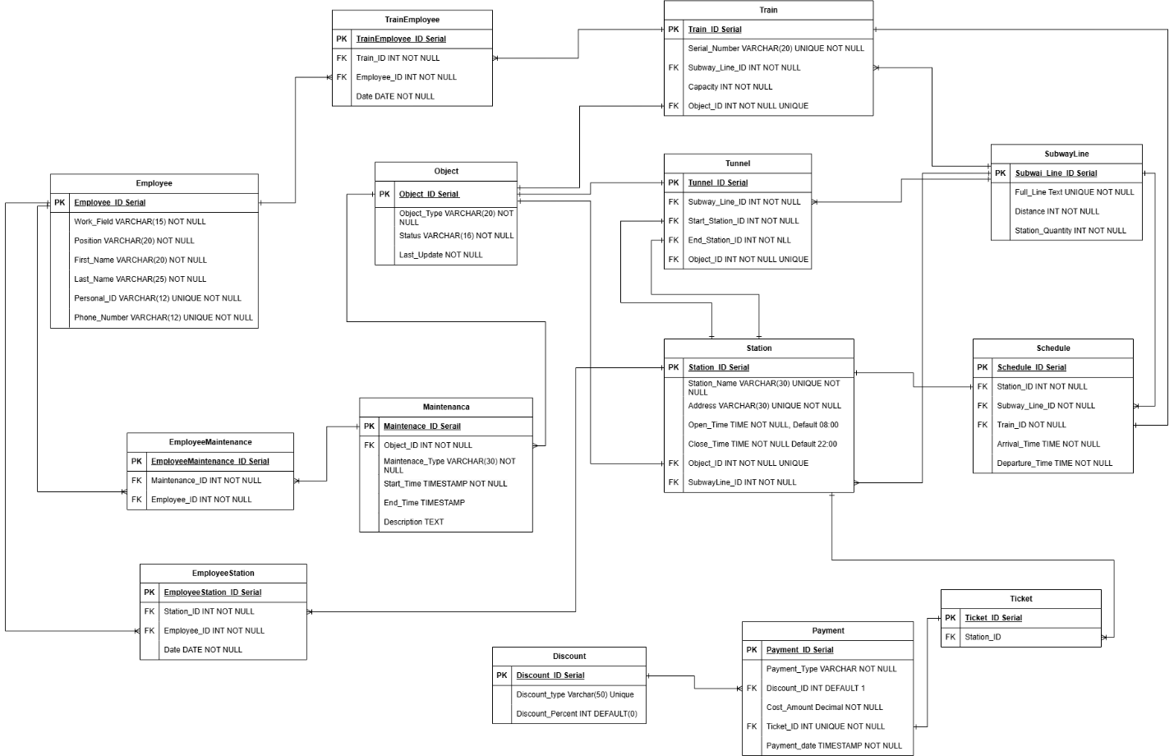

Objects
In any type of relationship, the first one will be a table that describes. (one to many, one for the described table)
Table Description
Object for centralized service management: The table can store general data, mainly maintenance data, about each infrastructure object in Object, and Train, Station, and Tunnel will refer to Object. Then, the Maintenance table will be able to refer to the Object, and there will not need to create a separate table for each maintenance object.

Table Name | Field name | Field Description | Data Type
Object | Object_ID | Identifier, PK | Serial
 | Object_type | Type of the object | VARCHAR(20)
 | Status | Current status of the object | VARCHAR(16)
 | Last_update | Date and time of changing status before and after maintenance or when out of service | TIMESTAMP
Relationships
Train, Station, and Tunnel (associated objects, one-to-one) and Maintenance(one-to-many).

Example with data

Object_ID | Object_Type | Status | Last_update
1 | Station | Under Maintenance | 2024-11-10 04:00
2 | Train | Under Maintenance | 2024-11-10 04:00
3 | Train | Under Maintenance | 2024-10-29 13:00
4 | Train | Out of Service
5 | Tunnel | Active | 2024-11-01 08:00
6 | Station | Active
7 | Tunnel | Active | 2024-11-10 04:10
8 | Station | Active
For the tunnel and station under maintenance will be only at inactive time, before or after subway working hours, or when accident occurred.
A more convenient view for presenting data from many to many using the maintenance and maintenaceemployee tables at the bottom of the document.

Table Description
SubwayLine table holds information about the subways full lines, including their starting and ending stations, distance, and the number of stations.

Table Name | Field name | Field Description | Data Type
SubwayLine | Subway_Line_ID | Identifier, PK | Serial
 | Full_Line | Names of all stations on line, UNIQUE | Text
 | Distance | Kilometers | Int
 | Station_Quantity |  | Int
Relationships
Station(one-to-many), Train(one-to-many), Tunnel(one-to-many), Schedule(one-to-one) tables.

Example with data

Subway_Line_ID | Full_Line | Distance | Station Quantity
1 | Zhibek Zholy-Abay-Seyfulina-Almaly-Momyshuly-Alatau-Moscow | 21 | 7

Table Description
Station table contains details of each station, including its name, address, operating hours, and associated object and subwayline.
Table Name | Field name | Field Description | Data Type
Station | Station_ID | Identifier, Serial, PK | Int
 | Station_Name | Name of the station, UNIQUE, NOT NULL | VARCHAR(30)
 | Address | UNIQUE, NOT NULL | VARCHAR(30)
 | Open_Time | Station opening time, NOT NULL, Default 08:00 | Time
 | Close_Time | Station closing time, NOT NULL, Default 22:00 | Time
 | Object_ID | Reference to associated object, FK, NOT NULL | INT
 | SubwayLine_ID | The metro line to which the station belongs, FK, NOT NULL | INT
Relationships
SubwayLine(many-to-one), Tunnel(one-to-one), Schedule(one-to-one), EmployeeStation(many-to-one), Pass(one-to-many) and Object(one-to-one) tables.

Example with data

Station_ID | Station_Name | Address | Object_ID | SubwayLine_ID
1 | Zhibek Zholy | Zhibek Zholy 1 | 1 | 1
2 | Abay | Abay 57 | 6 | 1
3 | Seyfullina | Seyfaulina 21 | 8 | 1
Open and close time by default.

Table Description
Train table contains information about serial_number ,subwayline, capacity and object_id.

Table Name | Field name | Field Description | Data Type
Train | Train_ID | Identifier, PK | Serial
 | Serial_Number | UNIQUE serial number for train, UNIQUE, NOT NULL | VARCHAR(20)
 | SubwayLine_ID | The metro line to which the train belongs, FK, NOT NULL | INT
 | Capacity | Train Capacity, NOT NULL | INT
 | Object_ID | Reference to associated object, FK, NOT NULL | INT
Relationships
TrainEmployee(many-to-one), Schedule (one-to-one), Object(one-to-one), SubwayLine(many-to-one)

Example with data

Train_ID | Serial_Number | SubwayLine_ID | Capacity | Object_ID
1 | TR0001 | 1 | 800 | 2
2 | TR0002 | 1 | 600 | 3
3 | TR0003 | 1 | 0 | 4

There is no carriage for broken ones.

Table Description
Stores information about tunnels, including the associated subway line, start and end stations, and related object. The tunnel is the gaps between stations throughout the entire subway line.

Table Name | Field name | Field Description | Data Type
Tunnel | Tunnel_ID | Identifier, PK | Serial
 | SubwayLine_ID | The metro line to which the tunnel belongs, FK, NOT NULL | INT
 | Start_Station_ID | The stations between which the tunnel is located, NOT NULL | INT
 | End_Station_ID |  | INT
 | Object_ID | Reference to associated object, FK, NOT NULL | INT
Relationships
Object(one-to-one), SubwayLine(many-to-one), Station(one-to-one)
Example with data

Tunnel_ID | SubwayLine_ID | Start_Station_ID | End_Station_ID | Object_ID
1 | 1 | 1 | 2 | 5
2 | 1 | 2 | 3 | 7

Table Description
Defines the train schedule for each station on a subway line, including arrival and departure times.

Table Name | Field name | Field Description | Data Type
Schedule | Schedule_ID | Identifier, PK | Serial
 | Station_ID | The station to which the schedule belongs, FK, NOT NULL | INT
 | SubwayLine_ID | SubwayLine schedule, FK, NOT NULL | INT
 | Train _ID | Reference to train, FK, NOT NULL | INT
 | Arrival_Time | Train arrival time, NOT NULL | TIME
 | Departure_Time | Train departure time, NOT NULL | TIME
Relationships
Train(one-to-one), SubwayLine(many-to-one), Station(one-to-one)
Example with data

Schedule_ID | Station_ID | SubwayLine_ID | Train _ID | Arr | Dep
1 | 1 | 1 | 2 | 08:05 | 08:08
2 | 2 | 1 | 3 | 08:15 | 08:18

Arr – Arrival time, Dep – Departure time

Table Description
Maintenance table contains data about repair, check or maintenance of objects.

Table Name | Field name | Field Description | Data Type
Maintenance | Maintenance_ID | Identifier, PK | Serial
 | Object_ID | Object that on maintenance, FK, UNIQUE, NOT NULL | INT
 | Maintenance_Type | Type of maintenance, FK, NOT NULL | VARCHAR(30)
 | Start_Time | Start date of maintenance, NOT NULL | TIMESTAMP
 | End_Time | End date of maintenance | TIMESTAMP
 | Description | What work was done | TEXT
Relationships
Object(many_to_one), Employeemaintenance(many-to-one)
Example with data

Maintenance _ID | Object_ID | Maintenance_Type | Start | End
1 | 3 | Repair | 2024-10-29 13:00 | null
2 | 5 | scheduled inspection | 2024-11-01 06:00 | 2024-11-01 08:00
3 | 7 | scheduled inspection | 2024-11-01 06:00 | 2024-11-01 08:00
4 | 2 | scheduled inspection | 2024-11-02 04:00 | 2024-11-02 06:00
5 | 1 | scheduled inspection | 2024-11-10 04:00 | NULL
6 | 2 | Repair | 2024-11-10 04:00 | NULL
7 | 7 | scheduled inspection | 2024-11-10 04:10 | NULL
Description ignored
Table Description
Employee table stores employee details, including personal information and contact data.
Table Name | Field name | Field Description | Data Type
Employee | Employee_ID | Identifier, Serial, PK | Int
 | Work_Field | Field of work, NOT NULL | VARCHAR(15)
 | Position | Employee's position or role, NOT NULL | VARCHAR(20)
 | First_Name | NOT NULL | VARCHAR(20)
 | Last_Name | NOT NULL | VARCHAR(20)
 | Personal_ID | Unique personal ID, NOT NULL | VARCHAR(12)
 | Phone_Number | Unique, NOT NULL | VARCHAR(12)
Relationships
TrainEmployee, EmployeeStation, EmployeeMaintenance (many-to-one)
Example with data

Employee _ID | Work_Field | Position | First_Name | Last_name | Personal_ID
1 | Train | Train Operator | Dias | Yermekov | 021114500029
2 | Train | Inspector | Aziz | Abikenov | 990113300029
3 | Train | Inspector | Maira | Aslanova | 980707400029
4 | Station | Ticketing Clerk | Lucas | Thomas | 830927300009
5 | Station | Safety Inspector | Lee | Mason | 780315300008
6 | Station | Platform Attendant | Elizabeth | Williams | 721123400010
7 | Maintenance | Maintenance Technician | William | Randow | 650504300006
8 | Maintenance | Electrical Engineer | William | Davis | 871223300005
9 | Maintenance | Mechanical Engineer | John | Smith | 900812300007
Phone numbers ignored.

Table Description
TrainEmployee table links employees to the trains they work on.
Bridge between many to many with Trains and Employees
Table Name | Field name | Field Description | Data Type
TrainEmployee | TrainEmployee _ID | Identifier, PK | Serial
 | Train_ID | Reference to train, FK, NOT NULL | INT
 | Employee_ID | Reference to Employee, FK, NOT NULL | INT
 | Date | The date of the employee's work on a particular train, NOT NULL | DATE
Relationships
Train, Employee (one-to-many)

Example with data

TrainEmployee_ID | Train_ID | Employee_ID | Date
1 | 1 | 1 | 2024-11-08
2 | 2 | 2 | 2024-11-08
3 | 1 | 3 | 2024-11-08
4 | 2 | 1 | 2024-11-09
5 | 2 | 3 | 2024-11-09
6 | 1 | 2 | 2024-11-09

Table Description
EmployeeStation table links employees to the station they work.
Bridge between many to many with Stations and Employees
Table Name | Field name | Field Description | Data Type
EmployeeStation | EmployeeStation_ID | Identifier, PK | Serial
 | Station_ID | Reference to train, FK, NOT NULL | INT
 | Employee_ID | Reference to Employee, FK, NOT NULL | INT
 | Date | The date of the employee's work at a particular station, NOT NULL | DATE
Relationships
Station, Employee (one-to-many)

Example with data

EmployeeStation_ID | Station_ID | Employee_ID | Date
1 | 1 | 4 | 2024-11-08
2 | 2 | 5 | 2024-11-08
3 | 1 | 6 | 2024-11-08
4 | 2 | 4 | 2024-11-09
5 | 1 | 5 | 2024-11-09
6 | 1 | 6 | 2024-11-09

Table Description
EmployeeMaintenance table links employees to the maintenace they work on.
Table Name | Field name | Field Description | Data Type
EmployeeStation | EmployeeStation_ID | Identifier, PK | Serial
 | Station_ID | Reference to train, FK, NOT NULL | INT
 | Employee_ID | Reference to Employee, FK, NOT NULL | INT
Relationships
Station, Employee (one-to-many)

Example with data
EmployeeMaintenance_ID |  | Maintenance_ID | Employee_ID
1 | 1 |  | 8
2 | 1 |  | 9
3 | 2 |  | 7
4 | 3 |  | 7
5 | 4 |  | 7
6 | 5 |  | 7
7 | 6 |  | 8
8 | 6 |  | 9
9 | 7 |  | 7

Table Description
Discount defines discounts available for payments.
Table Name | Field name | Field Description | Data Type
Discount | Discount _ID | Identifier, PK | Serial
 | Discount_Type | Type of discount, UNIQUE, NOT NULL | VARCHAR(50)
 | Discount_Percent | NOT NULL | INT
Relationship

Example with data

Discount_ID | Discount_Type | Discount_Percent
1 | Standart | 0
2 | School Student | 100
3 | University Student | 50
4 | Disability | 100
5 | Senior Sitizen | 50

Table Description
Payment table contains information about subway objects, including type, status, and last update.

Table Name | Field name | Field Description | Data Type
Payment | Payment_ID | Identifier, PK | Serial
 | Payment_type | Card or cash, NOT NULL | VARCHAR(4)
 | Discount_ID | Discount applied, FK, NOT NULL, DEFAULT 1 | INT
 | Cost_Amount | Payment amount, NOT NULL | DECIAML(3,2)
 | Ticket_ID | Link to the ticket that is being paid for, UNIQUE NOT NULL, FK | INT
 | Payment_Date | Date of payment, NOT NULL | TIMESTAMP
Relationships
Discount (many-to-one)
Example with data

Payment_ID | Payment_Type | Discount_ID | Cost_Amount | Ticket_ID | Pay_Date
1 | Card | 1 | 100 | 1 | 2024-11-08 08:00
2 | Cash | 5 | 50 | 2 | 2024-11-08 08:00
3 | Cash | 2 | 0 | 3 | 2024-11-08 08:01

Table Description
Ticket table represents tickets purchased on station by passengers. Even if tickets can be used at any station, most tickets will be used at the same station where they were purchased. This data helps to analyze the popularity of stations and predict the flow of passengers
Table Name | Field name | Field Description | Data Type
Ticket | Ticket_ID | Identifier, PK | Serial
 | Station_ID | Link to the station where the ticket was purchased, FK, UNIQUE, NOT NULL | INT
Relationships
Station(many-to-one)

Example with data

Ticket_ID | Station_ID
1 | 1
2 | 1
3 | 1

Tickets can be used on any station

Object_ID | Object_Type |  |  | Status |  | Last_update
1 | Station |  |  | Under Maintenance |  | 2024-11-10 04:00
2 | Train |  |  | Under Maintenance |  | 2024-11-10 04:00
3 | Train |  |  | Under Maintenance |  | 2024-10-29 13:00
4 | Train |  |  | Out of Service
5 | Tunnel |  |  | Active |  | 2024-11-01 08:00
6 | Station |  |  | Active
7 | Tunnel |  |  | Active |  | 2024-11-10 04:10
8 | Station |  |  | Active
EmployeeMaintenance_ID |  | Maintenance_ID |  | Employee_ID
1 |  | 1 |  | 8
2 |  | 1 |  | 9
3 |  | 2 |  | 7
4 |  | 3 |  | 7
5 |  | 4 |  | 7
6 |  | 5 |  | 7
7 |  | 6 |  | 8
8 |  | 6 |  | 9
9 |  | 7 |  | 7
Maintenance _ID | Object_ID |  | Maintenance_Type |  | Start |  | End
1 | 3 |  | Repair |  | 2024-10-29 13:00 |  | null
2 | 5 |  | scheduled inspection |  | 2024-11-01 06:00 |  | 2024-11-01 08:00
3 | 7 |  | scheduled inspection |  | 2024-11-01 06:00 |  | 2024-11-01 08:00
4 | 2 |  | scheduled inspection |  | 2024-11-02 04:00 |  | 2024-11-02 06:00
5 | 1 |  | scheduled inspection |  | 2024-11-10 04:00 |  | NULL
6 | 2 |  | Repair |  | 2024-11-10 04:00 |  | NULL
7 | 7 |  | scheduled inspection |  | 2024-11-10 04:10 |  | NULL

