Business Template

MUSEUM database
Logo / Image

Contents
1 Business Description 3
1.1 Business background 3
1.2 Problems. Current Situation 3
1.3 The benefits of implementing a database. Project Vision 3
2 Model description 3
2.1 Definitions & Acronyms 3
2.2 Logical Scheme 3
2.3 Objects 3

Business Description

Business background
The museum complex manages a collection of artworks, organizes exhibitions, and interacts with visitors. The database keeps track of artworks, artists, inventory, staff, and visitors.

Problems. Current Situation
Current issues:
- Manual record-keeping of artworks and their creators.
- Challenges in tracking exhibitions and inventory.
- Difficulty in efficiently managing exhibition schedules and staff allocation.

the Benefits of implementing a database. Project Vision
Implementing a database will:
- Automate the tracking of artworks, inventory, and exhibitions.
- Centralize information about artists, visitors, and staff.
- Simplify exhibition management, including dates, types, and participants.
- Ensure data integrity through constraints and relationships between tables.

Model description

Definitions & Acronyms
- Category – The category of an artwork (e.g., painting, sculpture).
- Art – An artwork with a unique name, description, and creation year.
- Artist – An artist, including their birthdate and brief description.
- Inventory – The tracking of artworks in inventory.
- Exhibition – An exhibition with a theme, type (online/offline), and event date.
- Employee – A museum employee with role information and a personal ID.
- Visitor – A visitor with a unique personal ID.
- Exhibition_Inventory – The connection between exhibitions and artworks.
- Exhibition_Visitor – The tracking of visitors attending exhibitions.
- Art_Artist – The connection between artworks and their creators.
- unique_exhibition_event_type: Ensures uniqueness of the combination of event_date and type in the museum_schema.exhibition table.
- unique_exhibition_inventory: Ensures uniqueness of the combination of exhibition_id and inventory_id in the museum_schema.exhibition_inventory table.
- unique_art_artist: Ensures uniqueness of the combination of art_id and artist_id in the museum_schema.art_artist table.
- unique_exhibition_visitor: Ensures uniqueness of the combination of exhibition_id and visitor_id in the museum_schema.exhibition_visitor table.

Logical Scheme
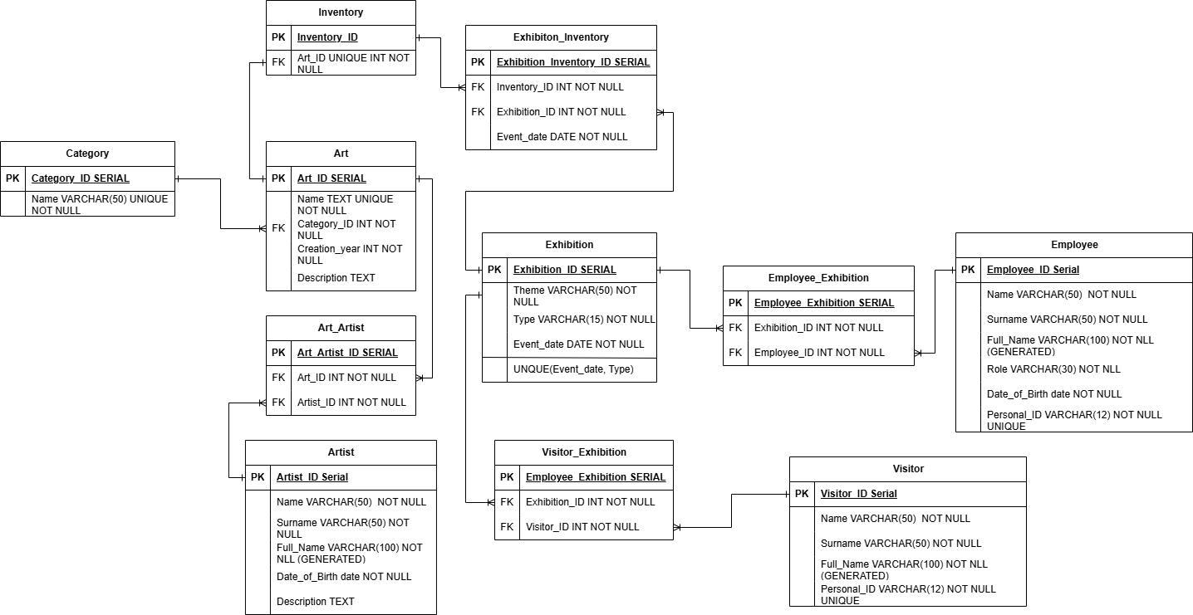

Objects

Table Description
This table stores categories for different types of artwork in the museum, such as paintings, antiques, etc.
Table Name | Field name | Field Description | Data Type
category | category_id | Unique identifier for each category, PK | SERIAL
 | name | Name of the category, UIQUE NOT NLL | VARCHAR(50)
Relationships : art table

Example with data

category_id | name
1 | Artifacts
2 | Painting
3 | Modern Art
4 | Antiques
5 | Specimens
6 | Historical objects

Table Description
This table holds information about artworks, including the name, creation year, description, and associated category.
Table Name | Field name | Field Description | Data Type
art | art_id | Unique identifier for each artwork, PK | SERIAL
 | name | Name of the artwork, UNIQUE, NOT NULL | TEXT
 | category_id | Foreign key referencing the category table, NOT NULL | INT
 | creation_year | Year the artwork was created, NOT NULL | INT
 | Description | Description of the artwork  NOT NULL | TEXT
Relationships : category table, artist through art_artist bridge table

Example with data

art_id | name | category_id | creation_year
1 | The Starry Night | 2 | 1889
2 | Impression, Sunrise | 2 | 1867
3 | The Pinner Qing Dynasty Vase | 4 | 1700
4 | The Big Wave off Kanagawa | 2 | 1831
5 | Almond Blossoms | 2 | 1889
6 | Altyn Adam | 1 | 1969
7 | Leonardo da Vinci’s Codex Leicester | 4 | 1500
Description ignored

Table Description
This table stores information about artists, including their name, surname, date of birth, and a brief description.
Table Name | Field name | Field Description | Data Type
art | artist_id | Unique identifier for each artist, PK | SERIAL
 | name | Artist's first name, NOT NULL | VARCHAR(50)
 | surname | Artist's last name, NOT NULL | VARCHAR(50)
 | full_name | Full name of the artist, generated automatically, NOT NULL | VARCHAR(100)
 | date_of_birth | Artist's date of birth  NOT NULL | DATE
 | description | Brief biography of the artist, NOT NULL | TEXT
Relationships : art through art_artist bridge table

Example with data

artist_id | name | surname | Full_name | date_of_birth
1 | Kemal | Akishevab | Kemal Akishevab | 1925-05-25
2 | Hokusai | Katsushika | Hokusai Katsushika | 1760-10-31
3 | Dias | Yermekov | Dias Yermekov | 2002-11-14
4 | Vincent | van Gogh | Vincent van Gogh | 1853-03-30
5 | Leonardo | da Vinci | Leonardo da Vinci | 1452-04-15
6 | Claude | Monet | Claude Monet | 1840-11-14
Description ignored

Table Description
This table manages the many-to-many relationship between artworks and artists.
Table Name | Field name | Field Description | Data Type
category | art_artist_id | Unique identifier for each record, PK | SERIAL
 | art_id | Foreign key referencing the art table, NOT NULL | INT
 | artist_id | Foreign key referencing the artist table, NOT NULL | INT
Relationships : The art_artist table links theart and artist tables.
Example with data

art_artist_id | art_id | artist_id
1 | 3 | 3
2 | 1 | 4
3 | 5 | 4
4 | 7 | 5
5 | 4 | 2
6 | 6 | 1
7 | 2 | 6

Table Description
This table stores information about the artworks we have in the museum’s inventory.
Table Name | Field name | Field Description | Data Type
inventory | inventory_id | Unique identifier for each inventory record, PK | SERIAL
 | art_id | Foreign key referencing the art table, NOT NULL UNIQUE | INT
Relationships : art table, inventory_exhibition table

Example with data

inventory_id | Art_id
1 | 2
2 | 5
3 | 6
4 | 4
5 | 1
6 | 7

Table Description
This table holds information about exhibitions, including the theme, type (online/offline), and event date.
Table Name | Field name | Field Description | Data Type
exhibition | exhibition_id | Unique identifier for each exhibition, PK | SERIAL
 | theme | Theme of the exhibition, NOT NULL | VARCHAR(50)
 | type | Year the artwork was created, NOT NULL | VARCHAR(15)
 | event_date | DATE of exhibition, NOT NULL | DATE
Relationships : related to the inventory table through the exhibition_inventory table.
connected to the employee and visitor tables through the employee_exhibition and exhibition_visitor tables respectively.

Example with data

exhibition_id | theme | type | event_date
1 | Artifacts | Online | 2024-09-01
2 | Antiques | Offline | 2024-09-12
3 | Artifacts | Online | 2024-11-30
4 | Paintings | Offline | 2024-12-01
5 | Leonardo da Vinci | Online | 2024-12-02
6 | Antiques | Offline | 2024-12-02

Table Description
This table holds information about exhibitions, including the theme, type (online/offline), and event date.
Table Name | Field name | Field Description | Data Type
exhibition _inventory | exhibition_inventory_id | Unique identifier for each exhibition, PK | SERIAL
 | inventory_id | Foreign key referencing the inventory table, NOT NULL | INT
 | exhibition_id | Foreign key referencing the exhibition table, NOT NULL | INT
 | event_date | DATE of exhibition, NOT NULL | DATE
Relationships: links the exhibition and inventory tables, indicating which artworks are displayed in which exhibitions.
Example with data

exhibition_inventory_id | inventory_id | exhibition_id | event_date
1 | 3 | 3 | 2024-11-30
2 | 5 | 4 | 2024-12-01
3 | 1 | 4 | 2024-12-01
4 | 4 | 4 | 2024-12-01
5 | 2 | 4 | 2024-12-01
6 | 6 | 5 | 2024-12-02
7 | 6 | 6 | 2024-12-02

Table Description
This table stores details about employees in the museum, including name, role, and personal ID.
Table Name | Field name | Field Description | Data Type
employee | Employee_id | Unique identifier for each employee, PK | SERIAL
 | name | First anme NOT NULL | VARCHAR(50)
 | surname | Last name NOT NULL | VARCHAR(50)
 | full_name | Full name of the employee, generated automatically, NOT NULL | VARCHAR(100)
 | role | Employee’s role NOT NULL | VARCHAR(30)
 | date_of_birth | Date of birth of the employee, NOT NULL | DATE
 | personal_id | Unique personal identifier for the person, UIQUE NOT NULL | VARCHAR(12)
Relationships: The employee table is linked to the exhibition table via the employee_exhibition table.
Example with data

Employee_id | name | surname | Full_name | role | Daet_of_birth | Persona_id
1 | Sarah | Wilson | Sarah Wilson | Designer | 1988-11-25 | 678901234567
2 | John | Doe | John Doe | Curator | 1980-03-15 | 123456789012
3 | Emily | Johnson | Emily Johnson | Manager | 1985-04-05 | 456789012345
4 | Jane | Smith | Jane Smith | Security | 1990-07-22 | 234567890123
5 | Michael | Davis | Michael Davis | Guide | 1992-02-18 | 567890123456
6 | Sam | Brown | Sam Brown | Guide | 1995-06-10 | 345678901234

Table Description
This table stores details about employees in the museum, including name, role, and personal ID.
Table Name | Field name | Field Description | Data Type
employee_exhibition | employee_exhibition_id | Unique identifier for each employee_exhibition, PK | SERIAL
 | exhibition_id | Foreign key referencing the exhibition table  NOT NULL | INT
 | employee_id | Foreign key referencing the employee table  NOT NULL | INT
Relationships: links the employee and exhibition tables

employee_exhibition_id | exhibition_id | employee_id
1 | 5 | 6
2 | 5 | 1
3 | 6 | 5
4 | 6 | 3
5 | 6 | 1
6 | 6 | 4

Table Description
This table stores information about museum visitors.
Table Name | Field name | Field Description | Data Type
employee | Employee_id | Unique identifier for each employee, PK | SERIAL
 | name | First name NOT NULL | VARCHAR(50)
 | surname | Last name NOT NULL | VARCHAR(50)
 | full_name | Full name of the visitor, generated automatically, NOT NULL | VARCHAR(100)
 | personal_id | Unique personal identifier for the person, UNIQUE NOT NULL | VARCHAR(12)
Relationships: linked to the exhibition table via the exhibition_visitor table
Example with data

Employee_id | name | surname | Full_name | Persona_id
1 | Bob | Baker | Bob Baker | 890123456789
2 | Alice | Adams | Alice Adams | 789012345678
3 | Charlie | Chaplin | Charlie Chaplin | 901234567890
4 | Frank | Foster | Frank Foster | 456789032345
5 | David | Duncan | David Duncan | 234565890123
6 | Eva | Edwards | Eva Edwards | 345678701234

Table Description
This table stores details about employees in the museum, including name, role, and personal ID.
Table Name | Field name | Field Description | Data Type
exhibition_visitor | exhibition_visitor_id | Unique identifier for each employee_exhibition, PK | SERIAL
 | exhibition_id | Foreign key referencing the exhibition table  NOT NULL | INT
 | visitor_id | Foreign key referencing the vistor table  NOT NULL | INT
Relationships: links the visitor and exhibition tables

visitor_exhibition_id | exhibition_id | visitor_id
1 | 4 | 1
2 | 5 | 2
3 | 5 | 6
4 | 6 | 3
5 | 6 | 4
6 | 6 | 5

