  - establish the connection to any of 1-2 provided mysql databases using your own user
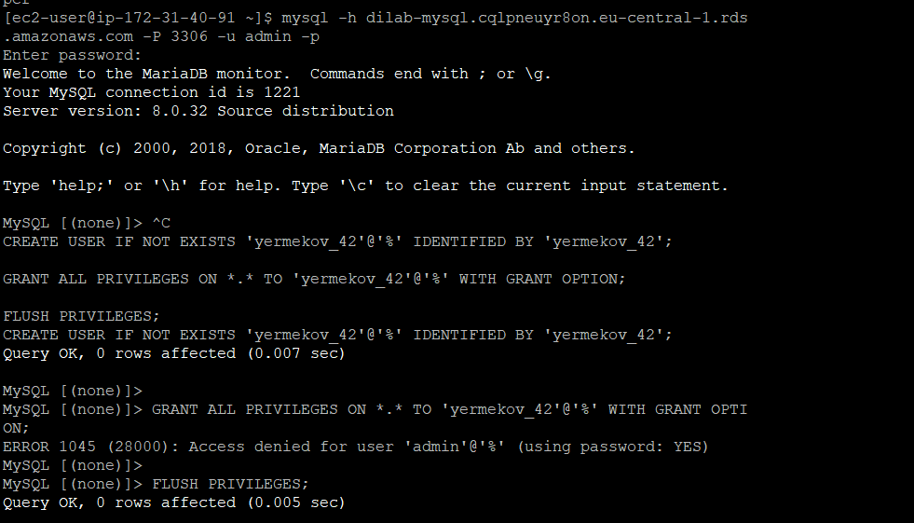
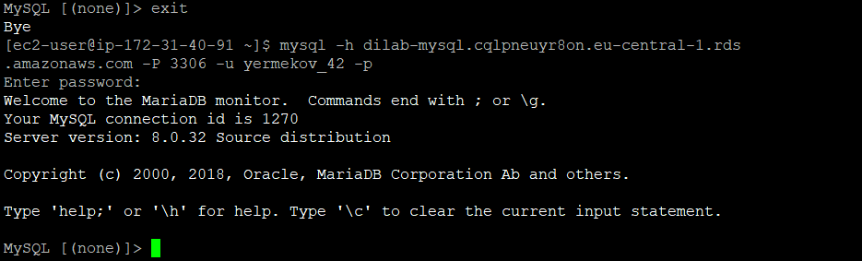
  - Creating table, view and procedure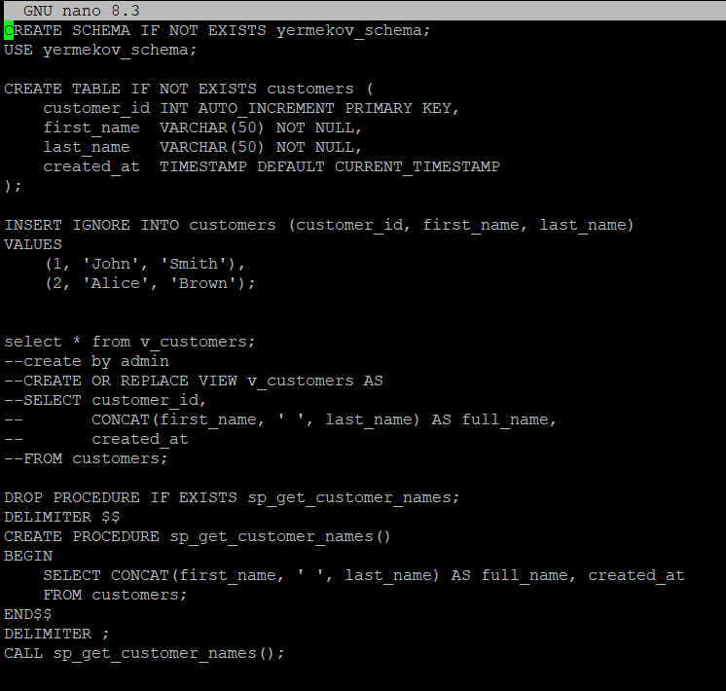
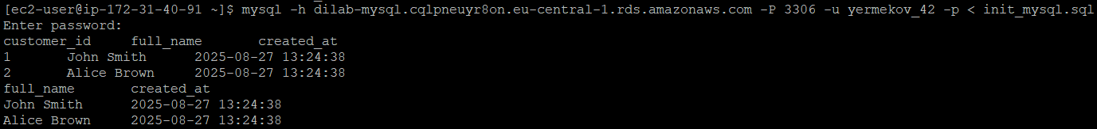

2.1 Queries
Top 5 actors by films quantity
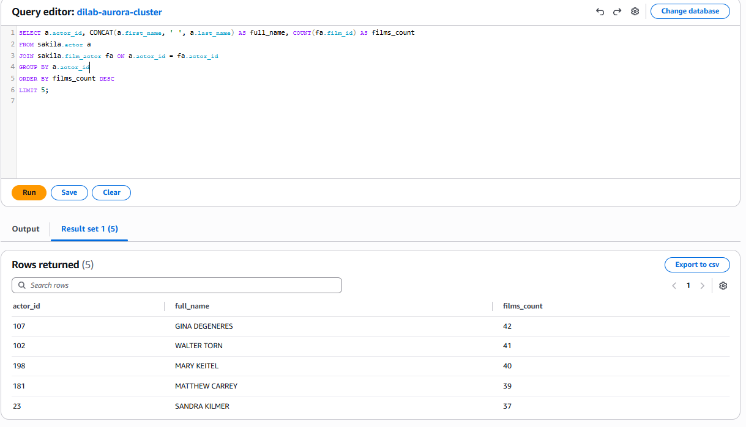
Films rented more than 31 times
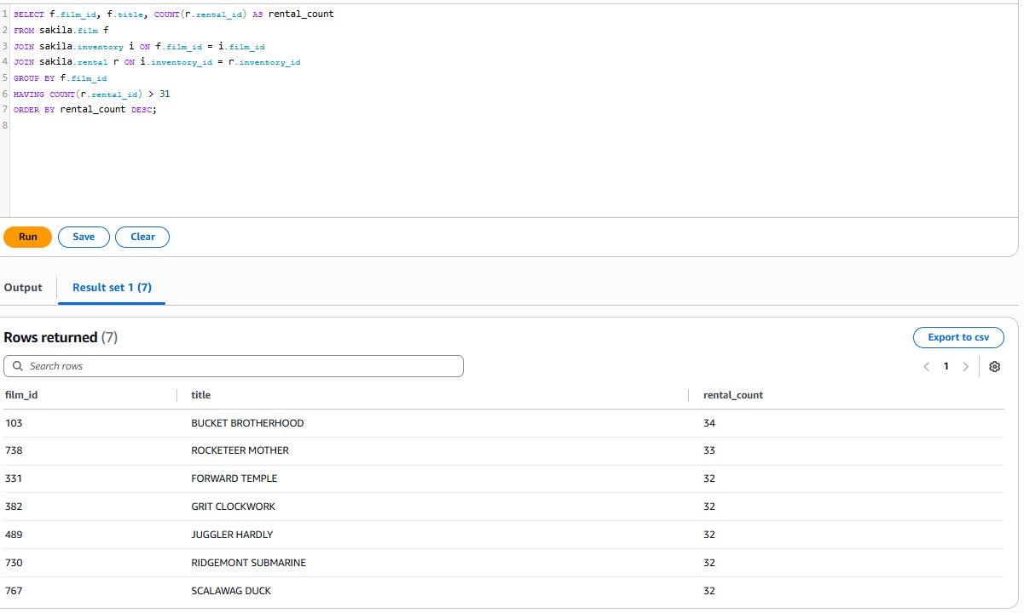

2.3 Connection to aurora through ec2
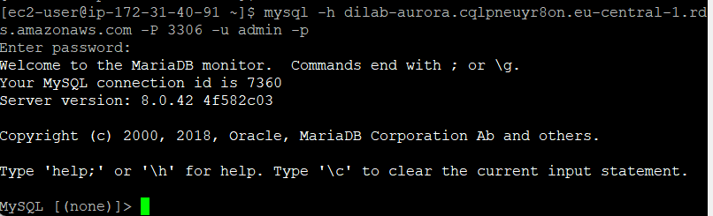
Aurora RDS is located inside a private VPC and does not have a public IP, so direct connection from a local PC is not possible. Connection can only be made through a bastion host (EC2) or via the AWS Query Editor, ensuring secure access to the database.

3.1 Creating Item in dynamodb table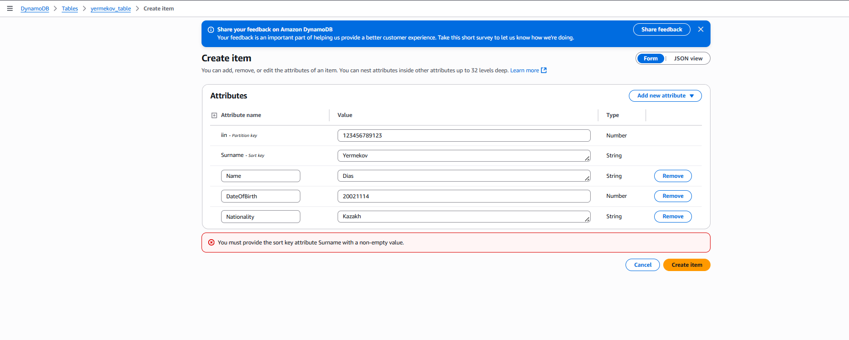
Table was deleted
3.2 Creating table, adding rows through cli 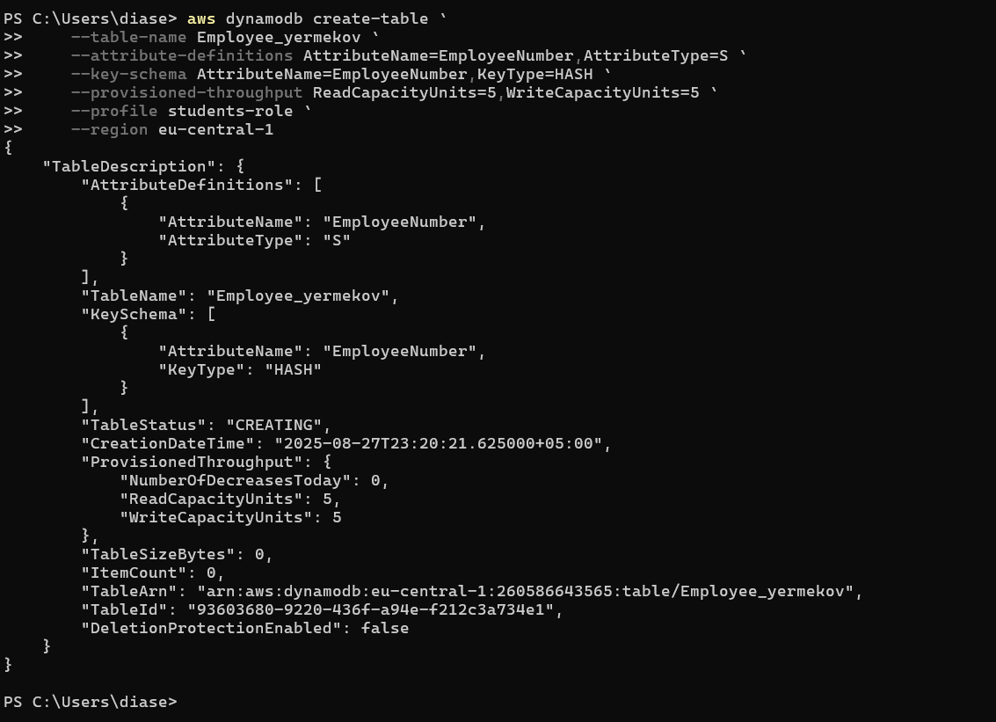
I couldn’t do all in one script, so did 1 by 1.
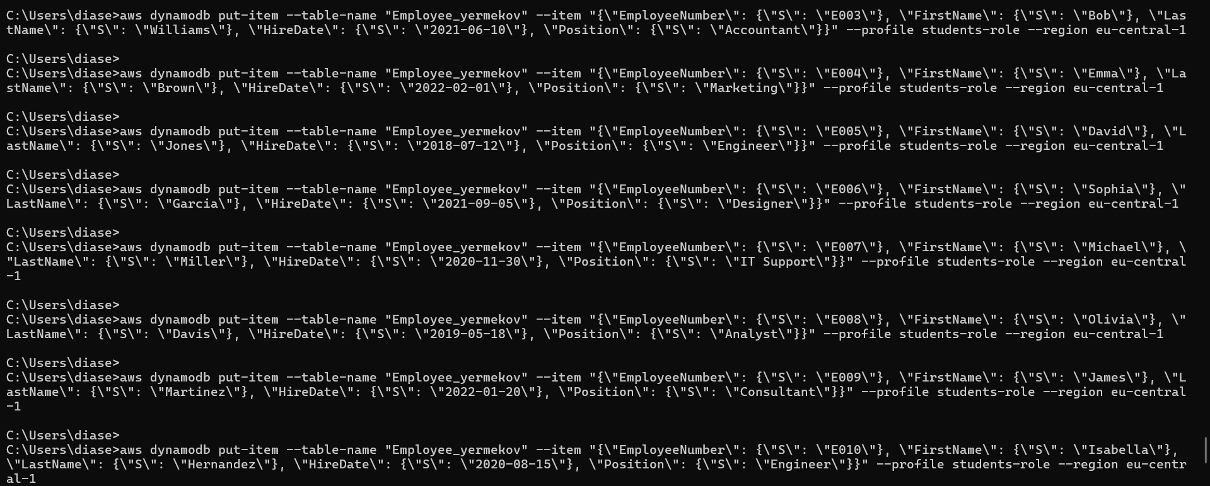
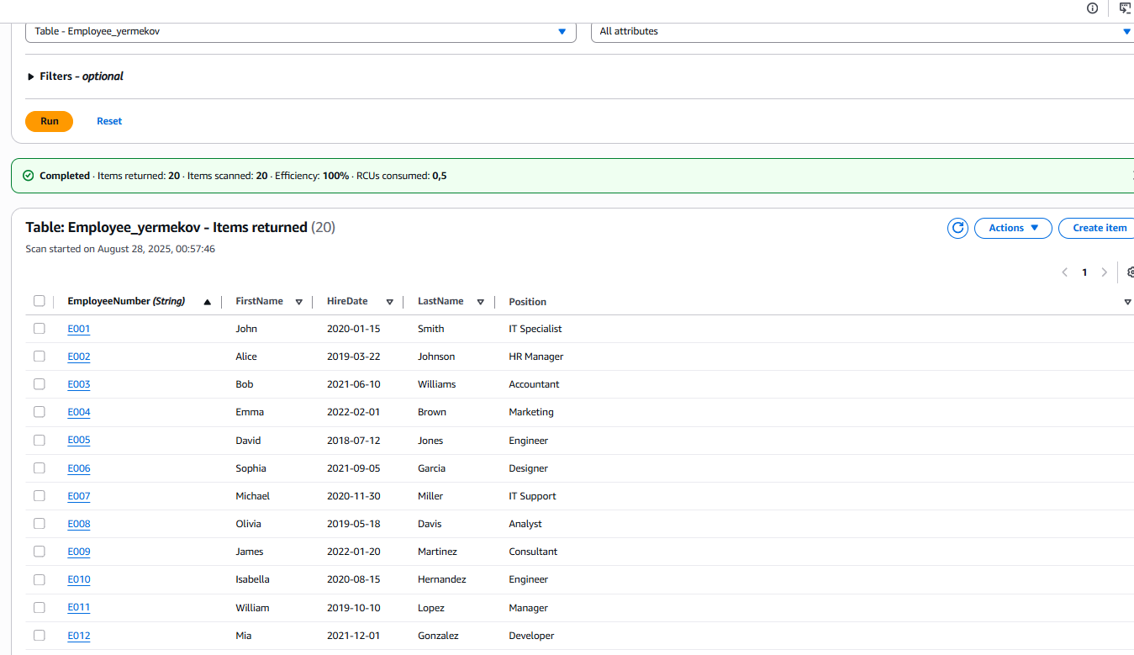
Retrieve 5 items
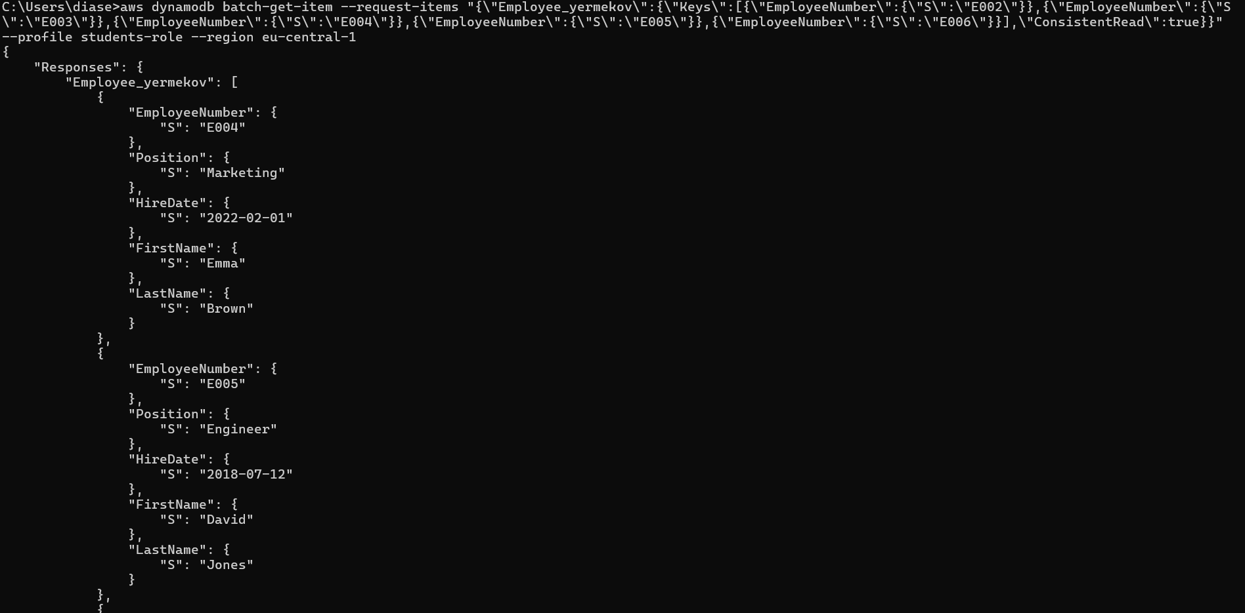
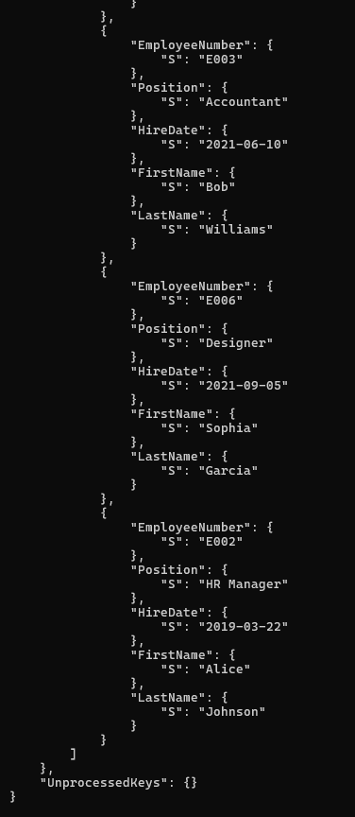
- Delete 2 rows from the table.
