Business Template

Balaji Fast Food Sales
Logo / Image

Contents
1 Business Description 3
1.1 Business background 3
1.2 Problems because of poor data management 3
1.3 Benefits from implementing a Data Warehouse 3
1.4 DATASETS DESCRIPTION 3
1.5 GRAIN / DIM / FACT 8
2 Business Layer 3NF 14
3 Business Layer Dimensional Model 4
4 Logical Scheme 4
5 Data Flow 4
6 Fact Table Partitioning Strategy 4

Business Description

Business background
Fast food is an integral part of modern urban life, offering quick, affordable, and delicious meal options for people on the go. Balaji Fast Food Sales specializes in serving a variety of high-quality fast food items that cater to diverse tastes and preferences. In this competitive market, success depends on understanding customer preferences, sales trends, and operational efficiency. To excel, it is crucial to systematically gather and analyze data on sales, customer behavior, and product performance.

Problems because of poor data management
Poor data management leads to missed opportunities and inefficiencies in decision-making. Without accurate and timely information about sales trends, customer preferences, and inventory levels, businesses like Balaji Fast Food Sales face challenges such as:
- Inability to forecast demand, leading to overstock or stockouts.
- Difficulty identifying top-performing or underperforming menu items.
- Lack of insights into customer buying patterns, hampering marketing efforts.
- Reduced ability to stay competitive in a dynamic market.

Benefits from implementing a Data Warehouse
Implementing a data warehouse for Balaji Fast Food Sales can address these issues effectively. A data warehouse can:
- Provide detailed insights into the best-selling menu items across different times and locations.
- Identify patterns in customer purchases, such as peak sales hours or popular combo preferences.
- Facilitate inventory optimization by tracking ingredient usage and wastage trends.
- Enhance strategic decision-making by offering reports on sales growth, profit margins, and market trends.
With a data warehouse, it becomes easier to answer questions like:
- Which menu items generate the highest revenue?
- Are there specific dates or seasons when certain items sell better?
- How does pricing impact the demand for different products?
Further data processing enables advanced analyses, such as:
- Correlation between promotions and sales increases.
- Segmentation of customers based on preferences and purchase frequency.
- Comparative performance evaluation of various outlets, if applicable.

DATASETS DESCRIPTION
The dataset for Balaji Fast Food Sales contains the following entities and their attributes, with additional details witr card Payments:
  - Fastfood Point (Future dimension):
- Point Name: The name of the fast food outlet (e.g., Balaji_1, Balaji_2).
- Point City: The city where the outlet is located (e.g., Atyrau, Almaty).
- Point Address: The exact address of the outlet (e.g., Satpaeva 127, Abay 99).
- Point Country: The country of operation (Kazakhstan).
Attributes of future dimension table (hierarchy):
Country (Country_ID, country_name)->City(City_ID, City_name, Country_ID(FK))->Fast food point (Point_ID, Address, City_ID(FK))

  - Customers (Future dimension):
- Customer First/Last Name: The name of the customer (e.g., generated using Faker for anonymization).
- Customer Phone Number
Attributes of future dimension table:
Cust_id
First_name
Last_name
Phone number
  - Discount (Future dimension):
- Discount%: The percentage of discount applied to a transaction (e.g., 10%, 15%, 20%).
Attributes of future dimension table:
Discount_ID
Date_of_discount
Percentage

  - Product (Future dimension):
- Product Name: The name of the product sold (e.g., Aalopuri, Panipuri, Cold Coffee).
- Product Type: The category of the product, either Fastfood or Beverages.
Attributes of future dimension table:
Category -> Product
Category_ID Prod_ID
Category_name Prod_name
Category_ID (FK)
Prod_price

  - Date (Future dimension):
- Order Date: The date when the transaction occurred, ranging from January 22, 2024, to January 23, 2025.
Attribute of future dimension table:
DATE (PK)
Day_of_week
Month
Week
Quarter
Year

  - Employee (Future dimension):
- Employee: The name of the employee responsible for the transaction (e.g., Dan Yohan, Johan Maretti).
Attribute of future dimension table:
Employee_ID
First_Name
Last_name
Date_of_Birth
Personal_ID
Phone_number

  - Channels:
Channels_ID
Channels_Name
Channels_Desc

  - Sales Information (Fact table):
- Order ID: A unique identifier for each transaction (e.g., ORD-000001).
- Item Price: The base price of the product before any discounts (e.g., 42.0 for Aalopuri, 9.0 for Cold Coffee).
- Quantity: The number of units of the product purchased in the transaction.
- Transaction Amount: The total amount paid by the customer after applying discounts, calculated as Item Price × Quantity - Discount.
- Transaction Type: The method of payment used (e.g., Cash).

The second dataset contains the following information
  - Fastfood Point (Future dimension):
- Point Name: The name of the fast food outlet (e.g., Balaji_1, Balaji_2).
- Point City: The city where the outlet is located (e.g., Atyrau, Almaty).
- Point Address: The exact address of the outlet (e.g., Satpaeva 127, Abay 99).
- Point Country: The country of operation (Kazakhstan).
Attributes of future dimension table (hierarchy):
Country (Country_ID, country_name)->City(City_ID, City_name, Country_ID(FK))->Fast food point (Point_ID, Address, City_ID(FK))

  - Customers (Future dimension):
- Customer First/Last Name: The name of the customer (e.g., generated using Faker for anonymization).
- Customer Phone Number
Attributes of future dimension table:
Cust_id
First_name
Last_name
Phone number
  - Discount (Future dimension):
- Discount%: The percentage of discount applied to a transaction (e.g., 10%, 15%, 20%).
Attributes of future dimension table:
Discount_ID
Date_of_discount
Percentage

  - Product (Future dimension):
- Product Name: The name of the product sold (e.g., Aalopuri, Panipuri, Cold Coffee).
- Product Type: The category of the product, either Fastfood or Beverages.
Attributes of future dimension table:
Category -> Product
Category_ID Prod_ID
Category_name Prod_name
Category_ID (FK)
Prod_price

  - Date (Future dimension):
- Order Date: The date when the transaction occurred, ranging from January 22, 2024, to January 23, 2025.
Attribute of future dimension table:
DATE (PK)
Day_of_week
Month
Week
Quarter
Year

  - Employee (Future dimension):
- Employee: The name of the employee responsible for the transaction (e.g., Alex Ivanov, Maria Petrova).
Attribute of future dimension table:
Employee_ID
First_Name
Last_name
Date_of_Birth
Personal_ID
Phone_number

  - Card Information (Future Dimension):
- Bank of Card: The bank to which the card belongs (e.g., Kaspi, Halyk Bank).
- Card Type: e.g. Visa, Mastercard

  - Channels:
Channels_ID
Channels_Name
Channels_Desc

  - Sales Information (Fact table):
- Order ID: A unique identifier for each transaction (e.g., CardORD-000001).
- Item Price: The base price of the product before any discounts (e.g., 42.0 for Aalopuri, 9.0 for Cold Coffee).
- Quantity: The number of units of the product purchased in the transaction.
- Payment Amount: The total amount paid by the customer after applying discounts, calculated as Item Price × Quantity - Discount.
- Payment Type: The method of payment used (e.g., Card).

The main differences between the two datasets are as follows:
- The first dataset focuses on cash payments, with payment_type set to Cash.
- The second dataset focuses on card payments, indicated by the attribute payment_type with the fixed value of Card and contains card information entity.
These differences primarily revolve around the type of payment method captured in each dataset.

GRAIN / DIM / FACT

Grain 4 steps
- Identify the Fact Table
The fact table is Sales Information. It contains the granular details of transactions, such as Order ID, Item Price, Quantity, Payment Amount, and Payment Type.
- Define the grain
Each record represents a single purchase made by a customer at a specific fast food outlet on a given date.
- Identify dimensions
Product Dimension
Point Dimension
Date Dimension
Customer Dimension
Employee Dimension
Channel Dimension (additional one, csv files will be updated)
Discount Dimension
Card Information Dimension (Only for dataset based on card)
- Identify facts
Order ID
A unique identifier for each transaction, used to track individual sales.
Product Price
The base price of a product before any discounts are applied.
Quantity
The number of units of a product purchased in the sale.
Payment Amount
The total amount paid by the customer after discounts, calculated as:
Payment Amount = Item Price × Quantity – Discount
Payment Type
The method of payment (e.g., Cash for cash dataset, Card for card dataset).

Fact Table
Column name | Description | Data Type
Order_ID | A unique identifier for each transaction, used to track individual sales. PK | BIGINT
Date | Date of sale, NOT NULL, FK to Date table | Date
Prod_Price | The base price of a product before any discounts are applied. NOT NULL | Decimal(5,2)
Quantity | The number of units of a product purchased in the sale. NOT NULL | INT
Payment_Amount | The total amount paid, NOT NULL | Decimal(6,2)
Payment_Type | The method of payment, NOT NULL | Varchar(4)
Product_ID | References to the Product table, NOT NULL | Varchar(10)
Store_ID | References to the store table, NOT NULL | Varchar(10)
Discount_ID | References to the Discount table, NOT NULL | Varchar(10)
Customer_ID | References to the Discount table, NOT NULL | Varchar(10)
Employee_ID | References to the Employee table, NOT NULL | Varchar(10)
Card_Info_ID | References to the Card_Info table, NOT NULL | Varchar(10)
Channel_ID | References to the Channel table, NOT NULL | Varchar(10)

Example with filled data

Only in card dataset
Order_ID | Prod_Price | Quantity | Payment_Amount | Payment_Type
CardORD-000001 | 31 | 8 | 248 | Card
Only in cash dataset
Order_ID | Prod_Price | Quantity | Payment_Amount | Payment_Type
ORD-000001 | 31 | 8 | 248 | Cash

Dimension Tables
Product Dimension
Describes the details of the products sold, such as their type and category.
Column name | Description | Data Type
Prod_ID | Unique identifier for product, PK | BIGINT
Prod_Name | Name of the product, NOT NULL | Varchar(64)
Category_ID | Unique identifier for category, FK NOT NULL | BIGINT
Category_Name | Name of the category, NOT NULL | Varchar(64)

Example with filled data

Prod_ID | Product_Code | Prod_Name | Category_ID | Category_Code | Category_Name
1 | P001 | Sandwich | 1 | C001 | Fastfood

Date Dimension
Describes the temporal aspects of transactions, such as dates and periods.
Column name | Description | Data Type
Date_ID | Unique identifier for date, PK | Date
Day_of_week | Day of the week, NOT NULL | Varchar(64)
Month | Month, NOT NULL | Varchar(64)
Week | Week number of the year, NOT NULL | INT
Qaurter | Quarter of the year, NOT NULL | INT
Year | Year, NOT NULL | INT

Example with filled data

Date_ID | DOW | Month | Week | Quarter | Year
22.01.2025 | Wednesday | January | 4 | 1 | 2025

Customer Dimension
Describes the customers involved in sales.
Column name | Description | Data Type
Cust_ID | Unique identifier for customer, PK | Date
Cust_First_Name | Customer's first name, NOT NULL | Varchar(64)
Cust_Last_Name | Customer's last name, NOT NULL | Varchar(64)
Cust_phone_number | Customer's phone, NOT NULL | Varchar(20)

Example with filled data

Cust_ID | Cust_First_Name | Cust_First_Name | Cust_Phone_Number
1 | Shelby | Reed | (952)553-1415x27785

Employee Dimension
Describes the employees responsible for handling transactions.
Column name | Description | Data Type
EMP_ID | Unique identifier for employee, PK | Date
EMP_First_Name | Employee’s first name, NOT NULL | Varchar(64)
EMP_Last_Name | Employee’s last name, NOT NULL | Varchar(64)
EMP_DOB | Date of birth of employee, NOT NULL | Date
EMP_Personal_ID | Unique pesronal identifier of employee, NON NULL UNIQUE | Varchar(12)
Emp_Phone_Number | Employee’s phone, Unique NOT NULL | Varchar(20)

Example with filled data

EMP_ID | EMP_First_Name |  | EMP_First_Name | EMP_DOB | EMP_Pers_ID |  | Cust_Phone_Number
1 |  | Alex | Ivanov | 15.03.1985 | EMP001 | 87010000001

+

  - Point Dimension
Describes the hierarchical geographic details of where transactions occur, from country to specific outlet.
Column name | Description | Data Type
Point_ID | Unique identifier for point, PK | BIGINT
Point_Name | Name of the point, NOT NULL | Varchar(64)
Address_ID | Unique identifier for address, NOT NULL | BIGINT
Address | Address, NOT NULL | Varchar(64)
City_ID | Identifier of city, NOT NULL | BIGINT
City_Name | Name of the city, NOT NULL | Varchar(64)
Country_ID | Identifier of country, NOT NULL | BIGINT
Country_Name | Name of the Country, NOT NULL | Varchar(64)

Example with filled data

Point_ID | Point_Name | Address_ID | Address
1 | Balaji 1 | 1 | Abay 99

City_ID | City_Name | Country_ID | Country_Name
1 | Almaty | 1 | Kazakhstan

Discount Dimension
Describes the discounts applied to transactions.

Column name | Description | Data Type
Discount_ID | Unique identifier for discount, PK | BIGINT
Discount_Percentage | Percentage of discount, NOT NULL | Decimal(2,2)
Discount_Date | Date of discount, NOT NULL | Date

Example with filled data

Discount_ID | Discount_Percentage |  | Discount_Date
1 | 0.10 | 25.03.2024

Card Information Dimension (Only for dataset based on card)
Describes the related details, such as card types and issuing banks.
Column name | Description | Data Type
Card_Info_ID | Unique identifier for card information, NOT NULL | BIGINT
Bank_ID | Identifier for Bank, NOT NULL | BIGINT
Bank_Name | Name of the bank, NOT NULL | Varchar(64)
Card_Type_ID | Identifier for card type, NOT NULL | BIGINT
Card_Type | Type of card (e.g., Visa, Mastercard), NOT NULL | Varchar(20)

Example with filled data

Card_Info_ID | Bank_ID | Bank_Name | Card_Type_ID | Card_Type
1 | 1 | Kaspi | 1 | Visa

Channel Dimension
Describes the channel of transactions.

Column name | Description | Data Type
Channel_ID | Unique identifier for channel, PK | BIGINT
Channel_Name | Name of the channel, NOT NULL | Varchar(30)
Channel_Desc | Description of the channel, NOT NULL | TEXT

Example with filled data

Channel_ID | Chanel_Name |  | Channel_Desc
1 | Online | Order made through the company website or mobile app
2 | In-store | Order made in physical store locations

Business Layer 3NF
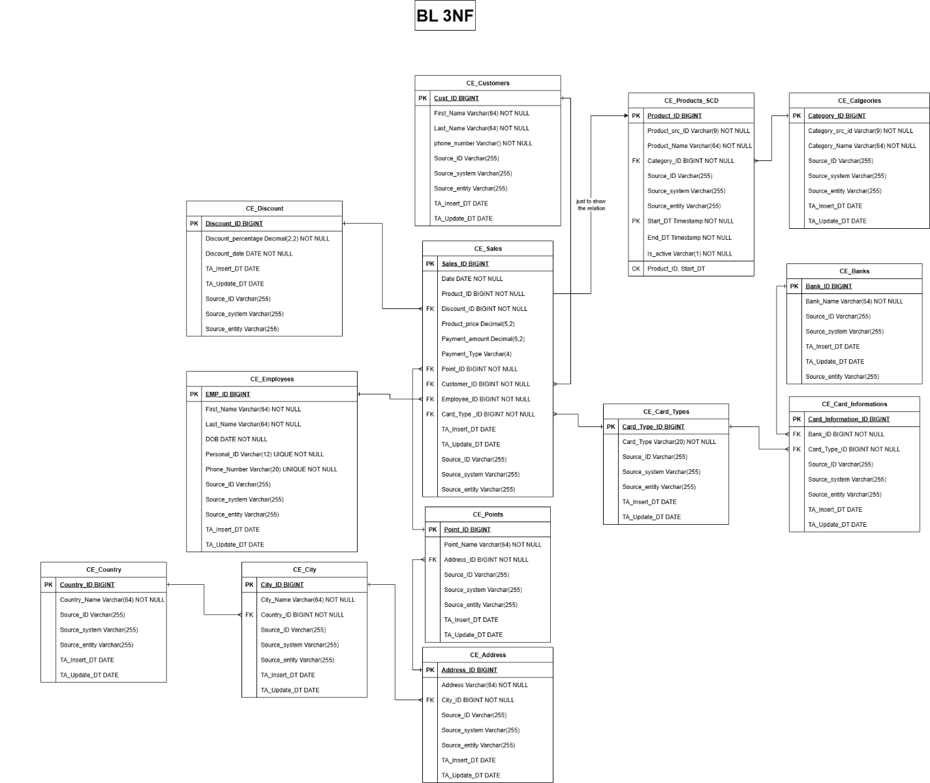
Design process:
- Data analysis – identify key dependencies and attributes
- Normalization - split entities (customers, employees etc.), remove redundancies, and set primary/foreign keys
- Logical Model (3NF) – structure tables, enforce constraints, add surrogate keys, and implement SCD2 attributes (CE_Poducts_SCD)
- Implement source triplet

Business Layer Dimensional Model
1. DIM model (you can see point as dimension, but in bl 3nf it is only part of employee. This was supposed to be the case at first, but I changed my mind because the point table would be more useful as a dimension. On Saturday I will update it)

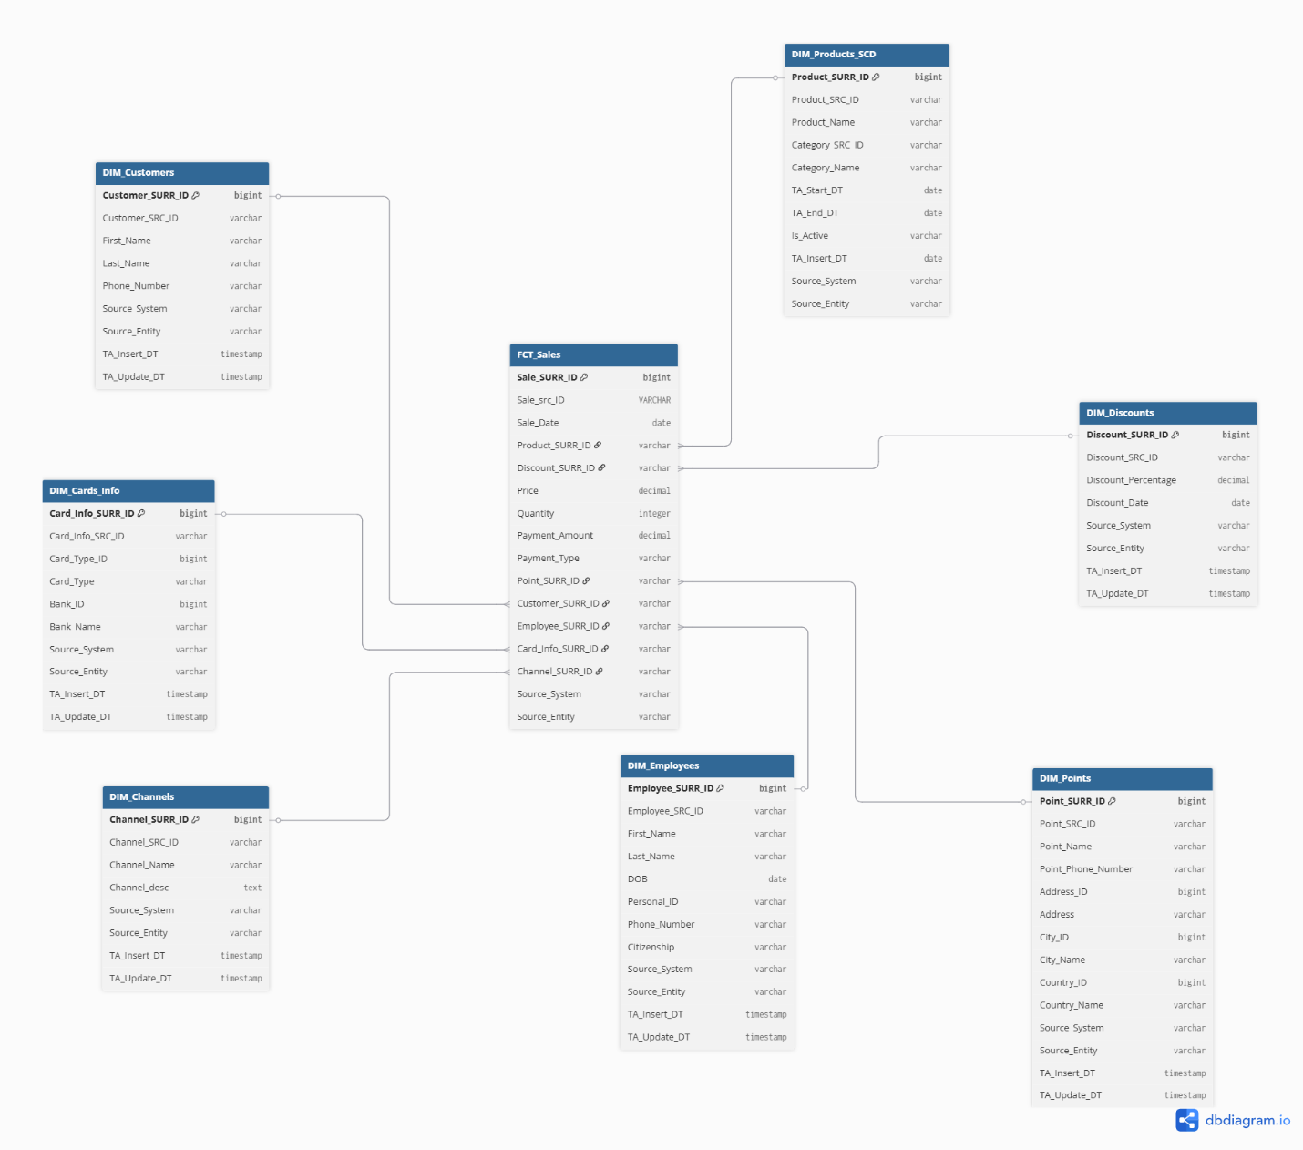
2. Date dimension script
CREATE TABLE IF NOT EXISTS DIM_DATES (
Date_ID DATE PRIMARY KEY,
Year INT NOT NULL,
Quarter INT NOT NULL,
Month INT NOT NULL,
Month_Name VARCHAR(20) NOT NULL,
Day INT NOT NULL,
Day_Of_Week INT NOT NULL,
Day_Name VARCHAR(20) NOT NULL
)
DO $$
DECLARE
current_date DATE := '2024-01-22’;
end_date DATE := '2025-01-23;
BEGIN
WHILE current_date <= end_date LOOP
INSERT INTO DIM_DATES (
Date_ID,
Year,
Quarter,
Month,
Month_Name,
Day,
Day_Of_Week,
Day_Name
)
VALUES (
current_date,
EXTRACT(YEAR FROM current_date)::INT,
EXTRACT(QUARTER FROM current_date)::INT,
EXTRACT(MONTH FROM current_date)::INT,
TO_CHAR(current_date, 'Month'),
EXTRACT(DAY FROM current_date)::INT,
EXTRACT(ISODOW FROM current_date)::INT, -- 1 (Mon) to 7 (Sun)
TO_CHAR(current_date, 'Day')
);
current_date := current_date + INTERVAL '1 day';
END LOOP;
END $$;

3. Metrics
• Price: The unit price of the product at the time of the sale.
• Quantity: The number of units sold in the transaction.
• Payment_Amount: The total amount paid by the customer for the sale.
• Sales: Total value of the sale, calculated as:
• Discount_Amount: The total discount applied, which could be calculated based on a discount rate or amount applied to the sale. This would depend on the Discount_SURR_ID.
• Payment_Amount: The amount from the sale after applying any discounts, calculated as:
Payment_Amount = Price * Quantity - Discount

Logical Scheme

Data Flow

Fact Table Partitioning Strategy

