2.a. Loading data
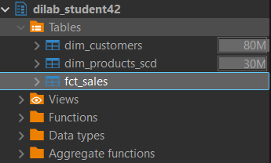
2.b. After loading your tables check its initial compression types, distribution style, sort keys. Make a description of your analysis.
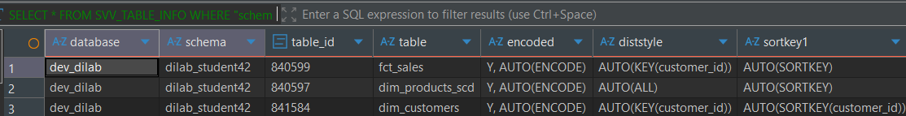
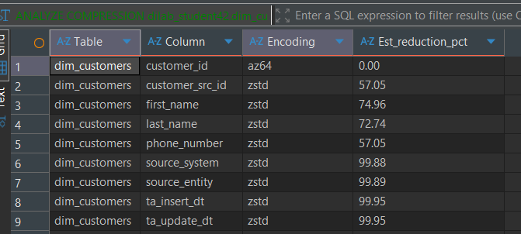
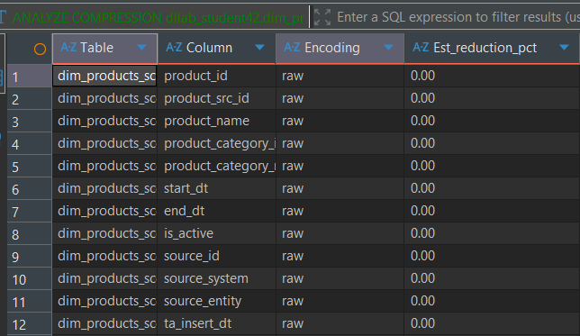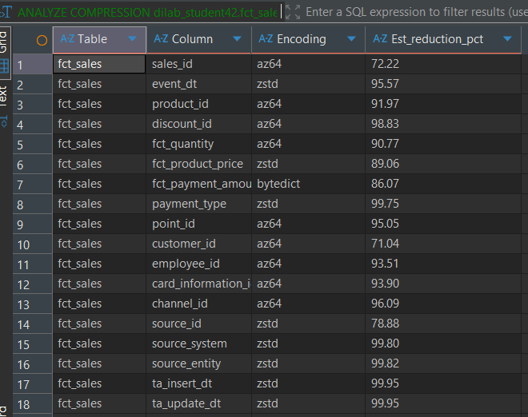
After loading the tables from S3 into Redshift, I checked their initial compression types, distribution styles, and sort keys. The results show that:
- Distribution style: The fct_sales table is distributed using AUTO(ALL), while both dim_customers and dim_products_scd use AUTO(KEY(customer_id)). This ensures that joins on customer_id can be optimized.
- Sort keys: Both dimension tables and the fact table use AUTO(SORTKEY(customer_id)), which also supports efficient joins and queries based on the customer dimension.
- Compression types:
  - dim_customers columns use mostly zstd encoding with high estimated reduction percentages (up to ~99%), showing strong compression benefits.
  - dim_products_scd columns remain with raw encoding and 0% reduction, meaning no compression was applied initially.
  - fct_sales columns use a mix of az64, zstd, and bytedict, achieving high space savings (often >90%).
Conclusion: Overall, dim_customers and fct_sales are well compressed with efficient encodings, while dim_products_scd lacks compression and could be optimized further to reduce storage and improve performance.

3.a. Identify compression types (encoding) of each column of this table
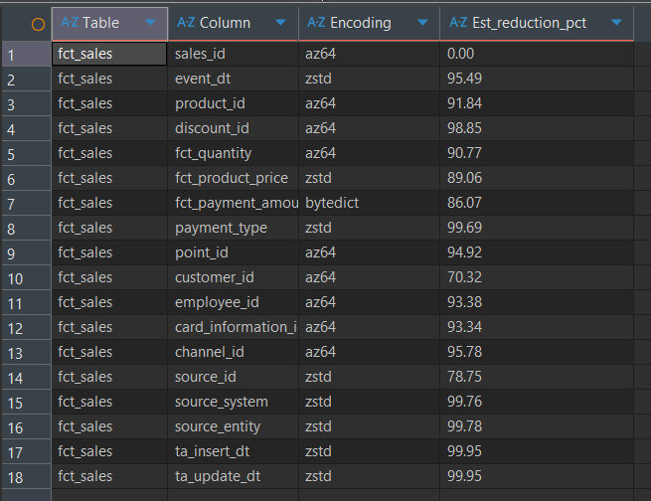
3. b and c: Created fct sales withcomp and withoutcomp
3.d. -- Comparing sizes of tables: fct_sales (defaultcomp, withoutcomp, analyzedcomp)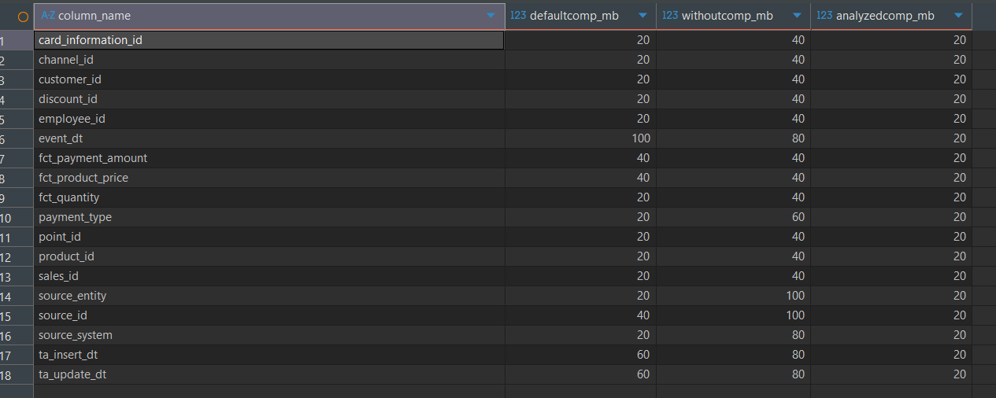

4a.

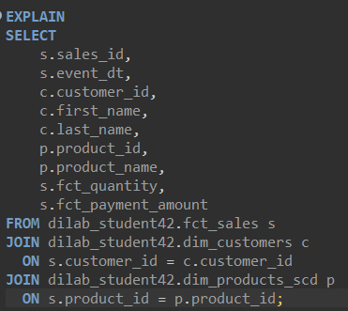
4b.
1st run 0.484s
2nd run 0.126s
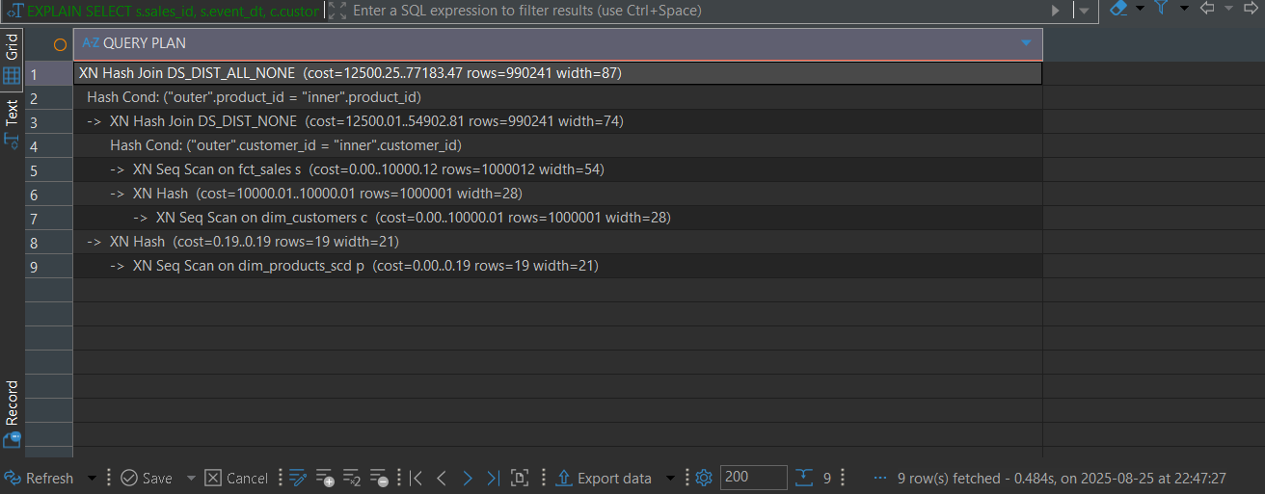
3rd run 0.138s

4c. The first execution is slower because Redshift loads data from disk and warms up caches. Subsequent runs are faster since data is already in memory, so the first run should not be used for comparison.
4d. fct_sales uses AUTO(KEY(customer_id)), dim_customers also uses AUTO(KEY(customer_id)), and dim_products_scd is AUTO(ALL). Both fact and customer tables have sort key on customer_id. This setup helps joins on customer_id but joins with products may require data redistribution.
5.a. I chose DISTKEY(product_id) for fct_sales and dim_products_scd to colocate joins on product_id and avoid data redistribution. For dim_customers, I kept DISTKEY(customer_id) to optimize joins on customer_id. As for sort keys, I used event_dt in fct_sales because filtering and reporting by date is common
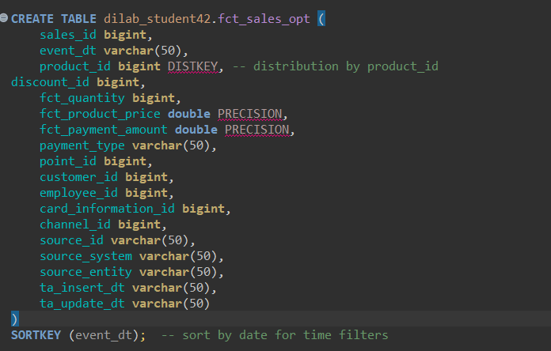
5b. In my case, the difference between “before” and “after” optimization is small, because Redshift had already applied AUTO optimization to these tables.
Execution time 0.1 – 0.130s
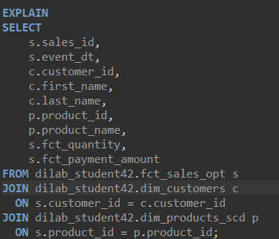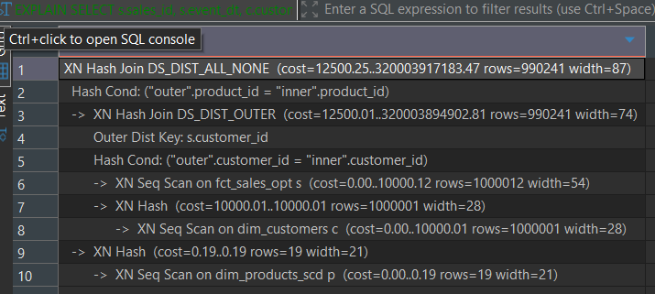
6. 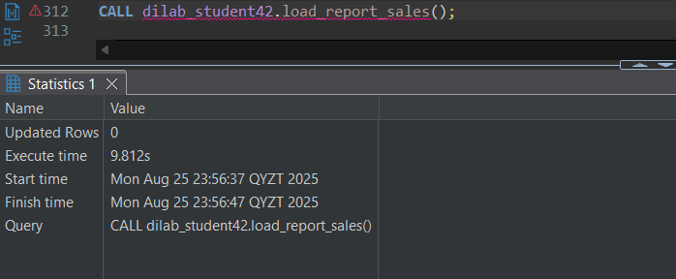
7. Not done.
COPY part
2.
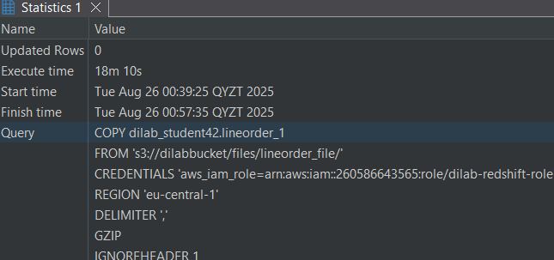
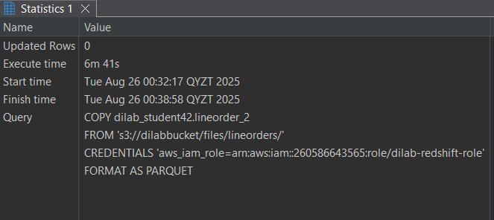

3. So, it took 18 minutes from 1 big file and 6 minutes 41 seconds from small files.
lineorder_1 (CSV, one big file, GZIP) → took ~18 minutes.
- Reason: Redshift has to process a single large compressed file sequentially. Parallelism is low, because only one slice/node can read that file at a time.
- Also CSV parsing is slower than columnar formats.
lineorder_2 (Parquet, many smaller files) → took ~6m 40s.
- Reason: Redshift COPY can read many small files in parallel across multiple nodes/slices.
- Parquet is a columnar format, so it loads faster, with less parsing overhead.

Partitions
1a + 2a.
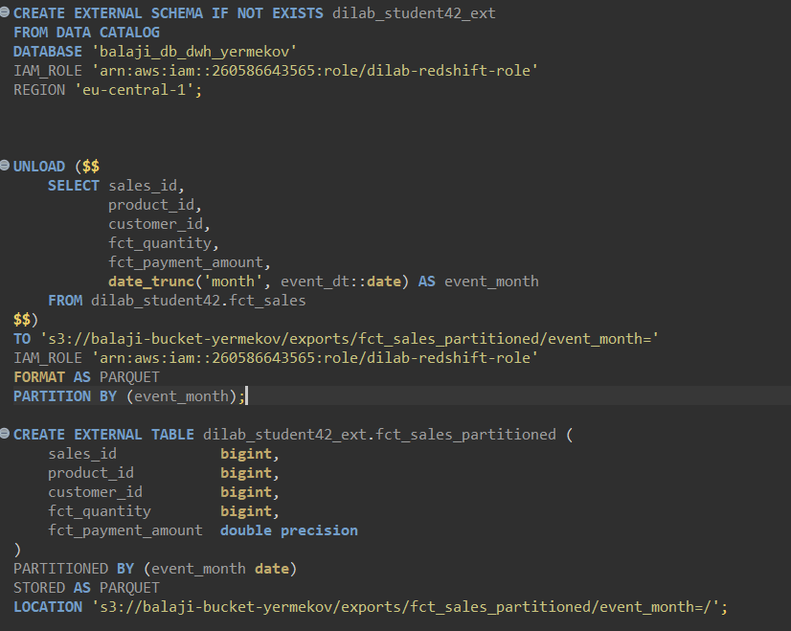

2c. I have compared row counts per month between the original fact table and the partitioned external table. The differences were 0, which confirms that the data was exported and partitioned correctly.
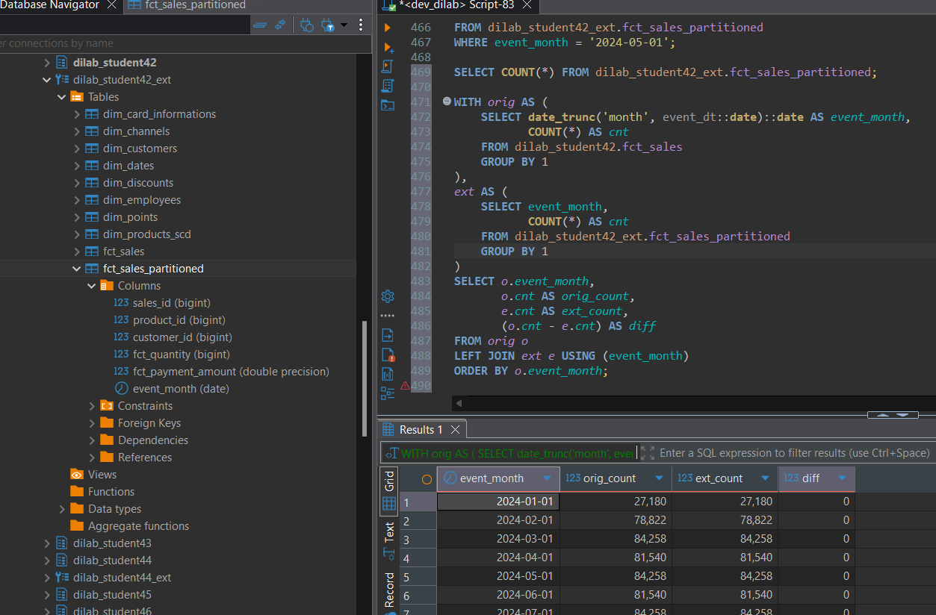
2d.
The query plan with WHERE event_month='2024-02-01' shows that Redshift Spectrum scans only the specific S3 folder for that partition instead of the full dataset. This demonstrates effective partition pruning and performance improvement.
