Part 1
- Creating Instance
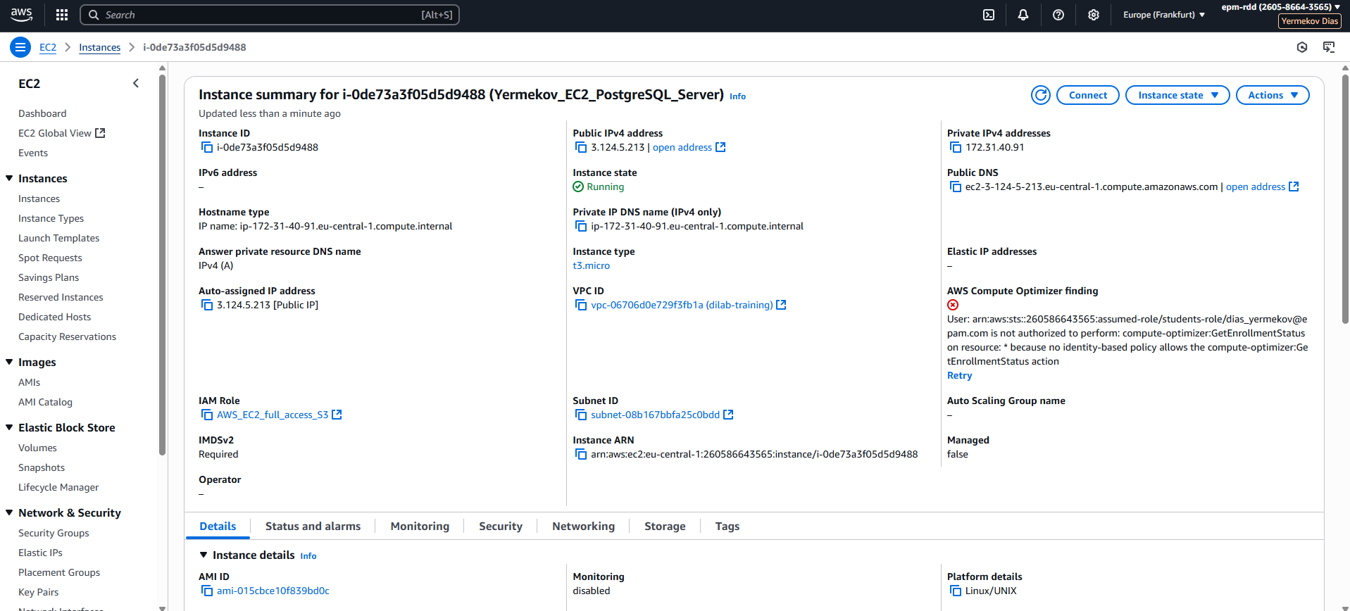
- Downloading postgresql
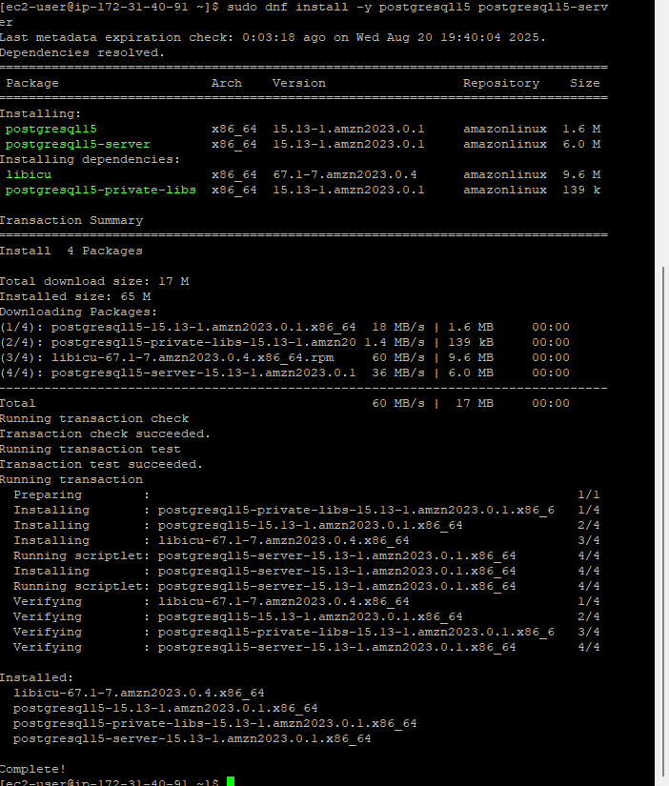

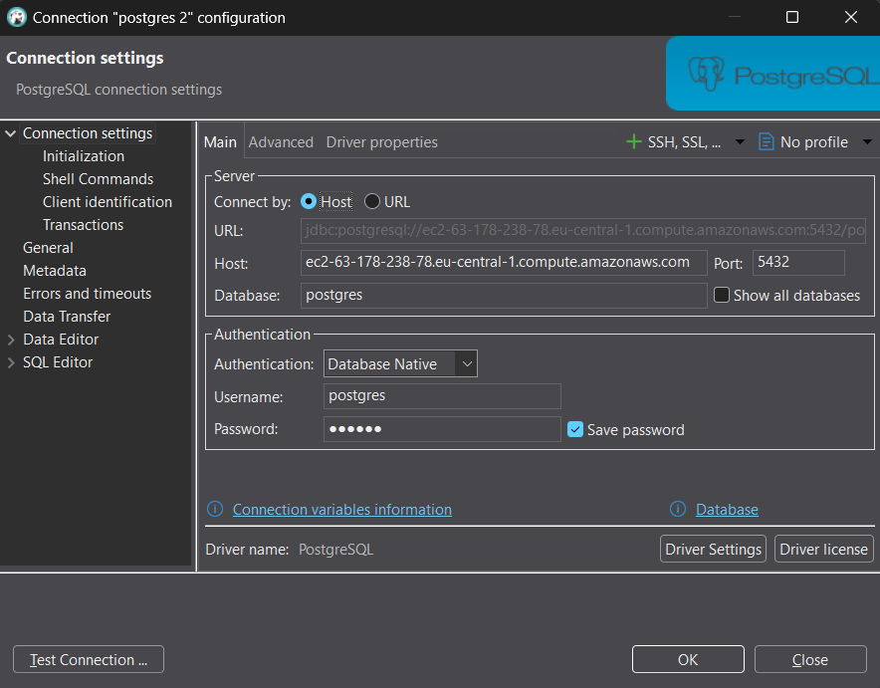
e.
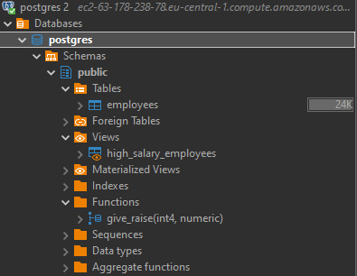
2. Copying file from bucket to ec2
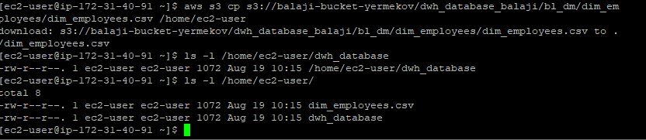
3. Creating snapshot
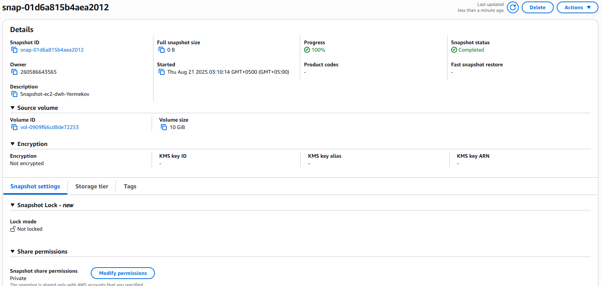
Creating image
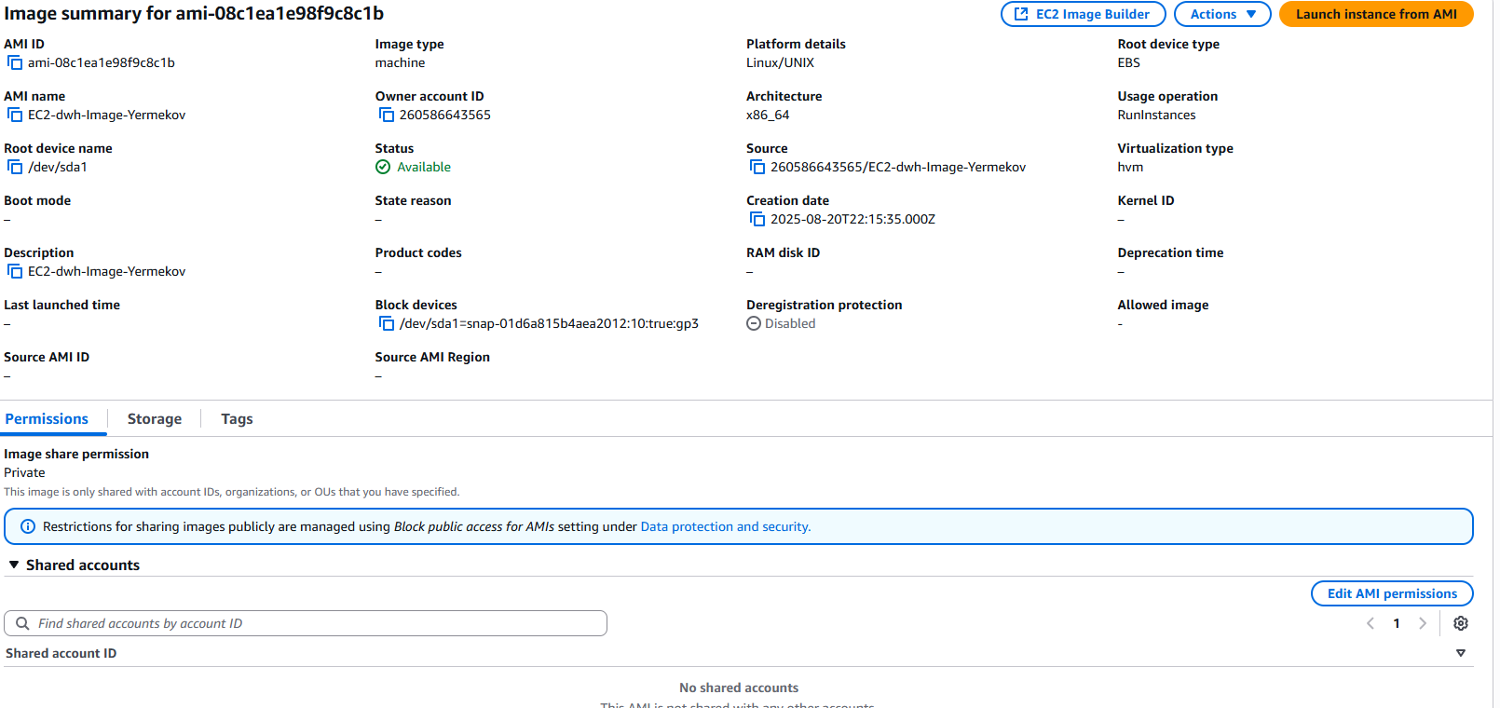
5. Launching backup of instance from image
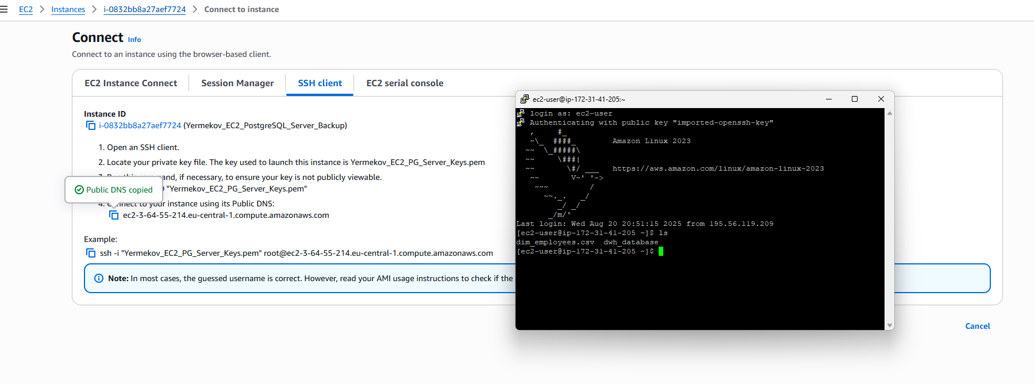
5. Downloading apache, enable and start it
then creatin index.html
The by public ip as a link go to the page.

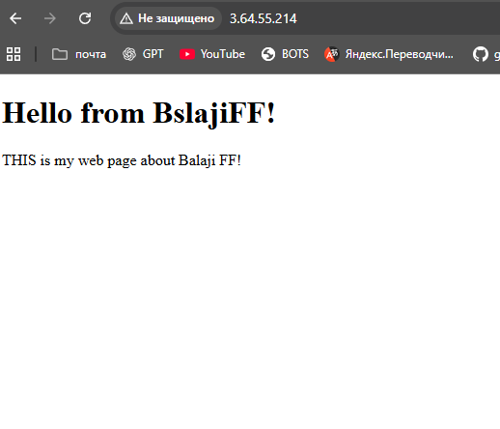
6. Creating Alarm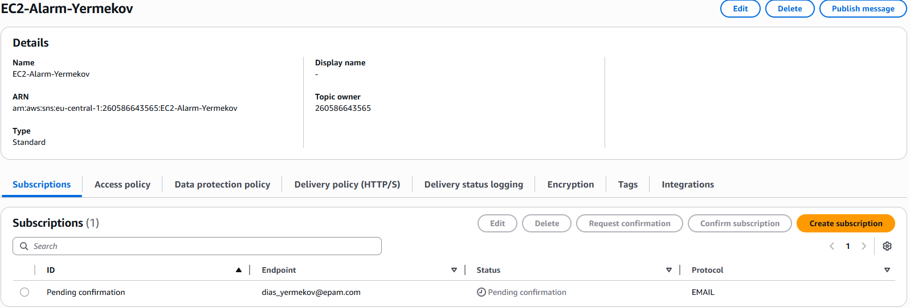

Creating subscription
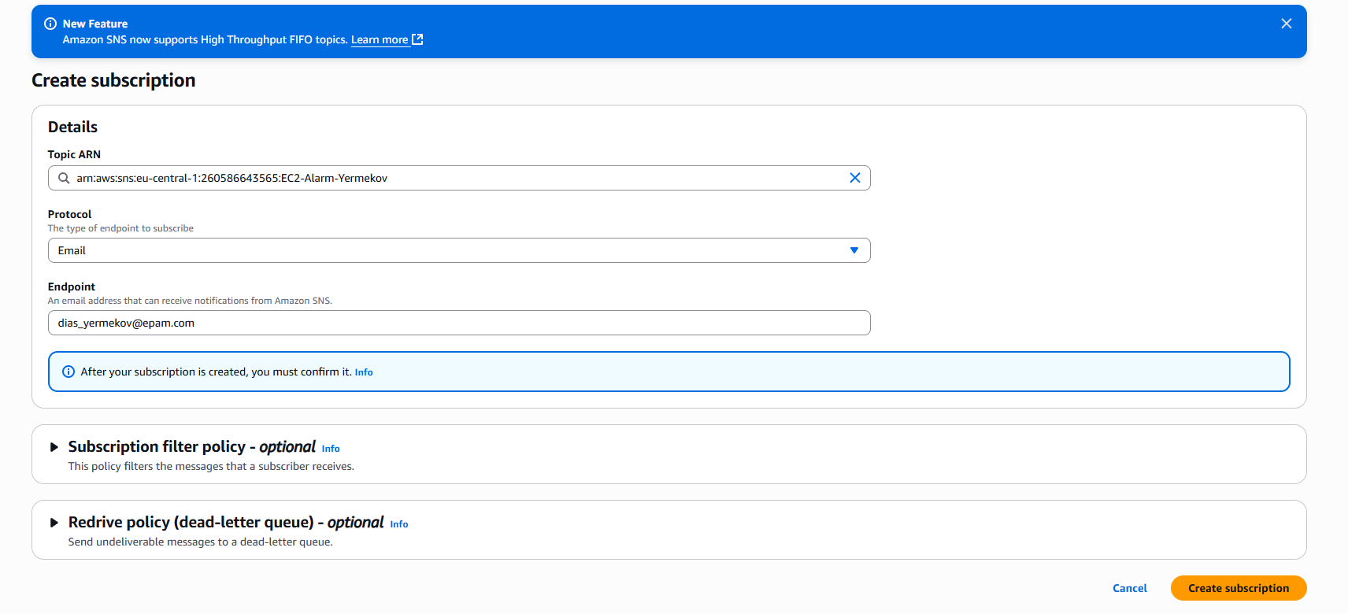
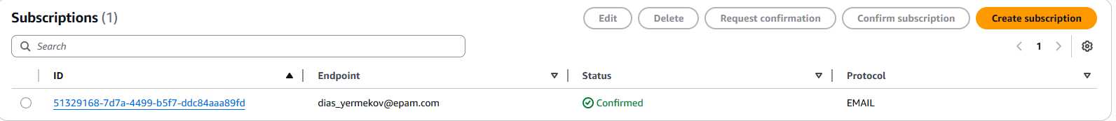
Creating Cloudwatch Alarm
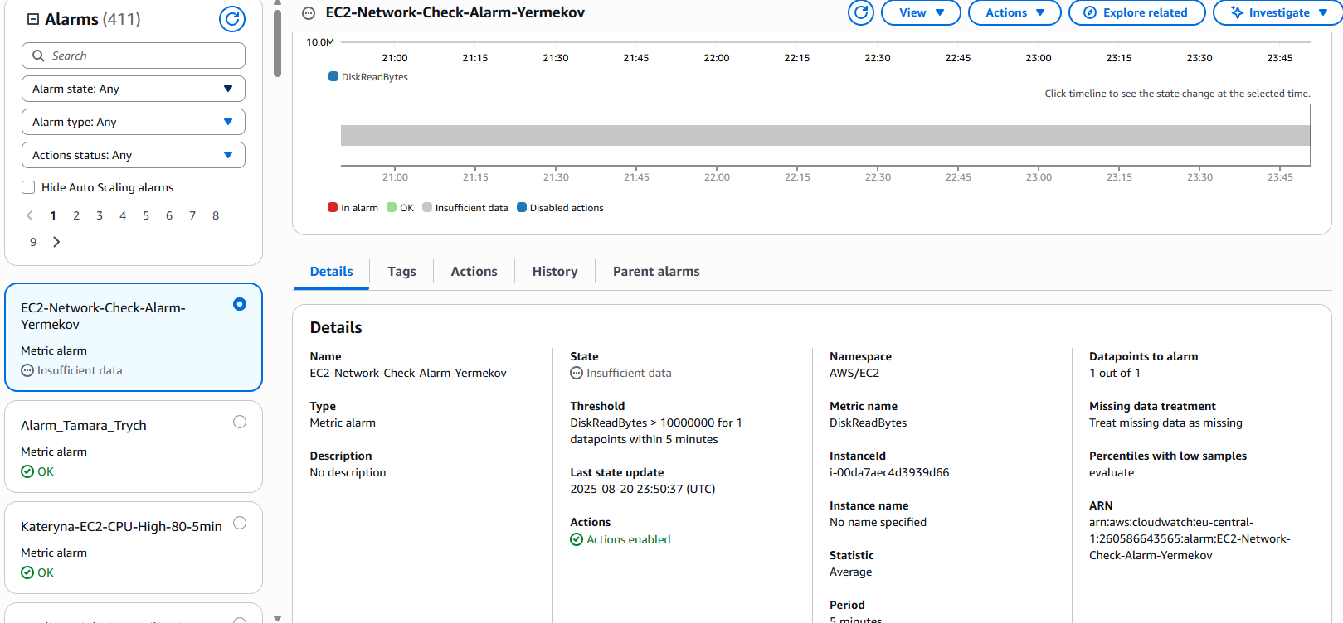

7. Creating clouddoramtion script.
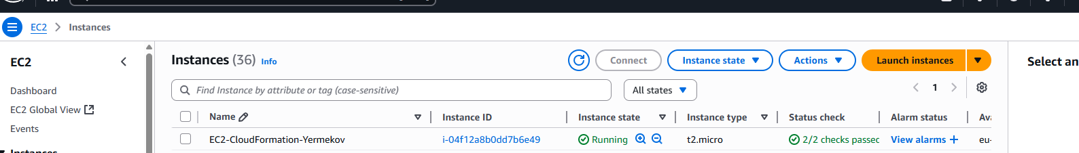
https://eu-central-1.console.aws.amazon.com/s3/upload/balaji-bucket-yermekov?region=eu-central-1&bucketType=general&prefix=CloudFormationScript/
AWSTemplateFormatVersion: '2010-09-09'
Description: 'Create an EC2 instance with a security group, key pair, available-zone(subnet) based on image.'

Resources:
MyEC2Instance:
Type: 'AWS::EC2::Instance'
Properties:
InstanceType: t2.micro
ImageId: ami-0f821f29cb873b94d
KeyName: Yermekov_EC2_PG_Server_Keys
SecurityGroupIds:
- sg-0c9e0944abff93553
SubnetId: subnet-08b167bbfa25c0bdd
Tags:
- Key: Name
Value: EC2-CloudFormation-Yermekov

