4.2 Basic Data Transformation
2. Create a column with full Customer name:
- Select DimCustomer table
- Duplicate ‘First Name’ and ‘Last Name’ columns by right-clicking on the column and selecting ‘Duplicate Column’.
- Select the duplicated columns using Ctrl buttons
- Click on ‘Merge Columns’ button
Merged two columns first_name and last_name as merged column Full name
Also you can see applied steps
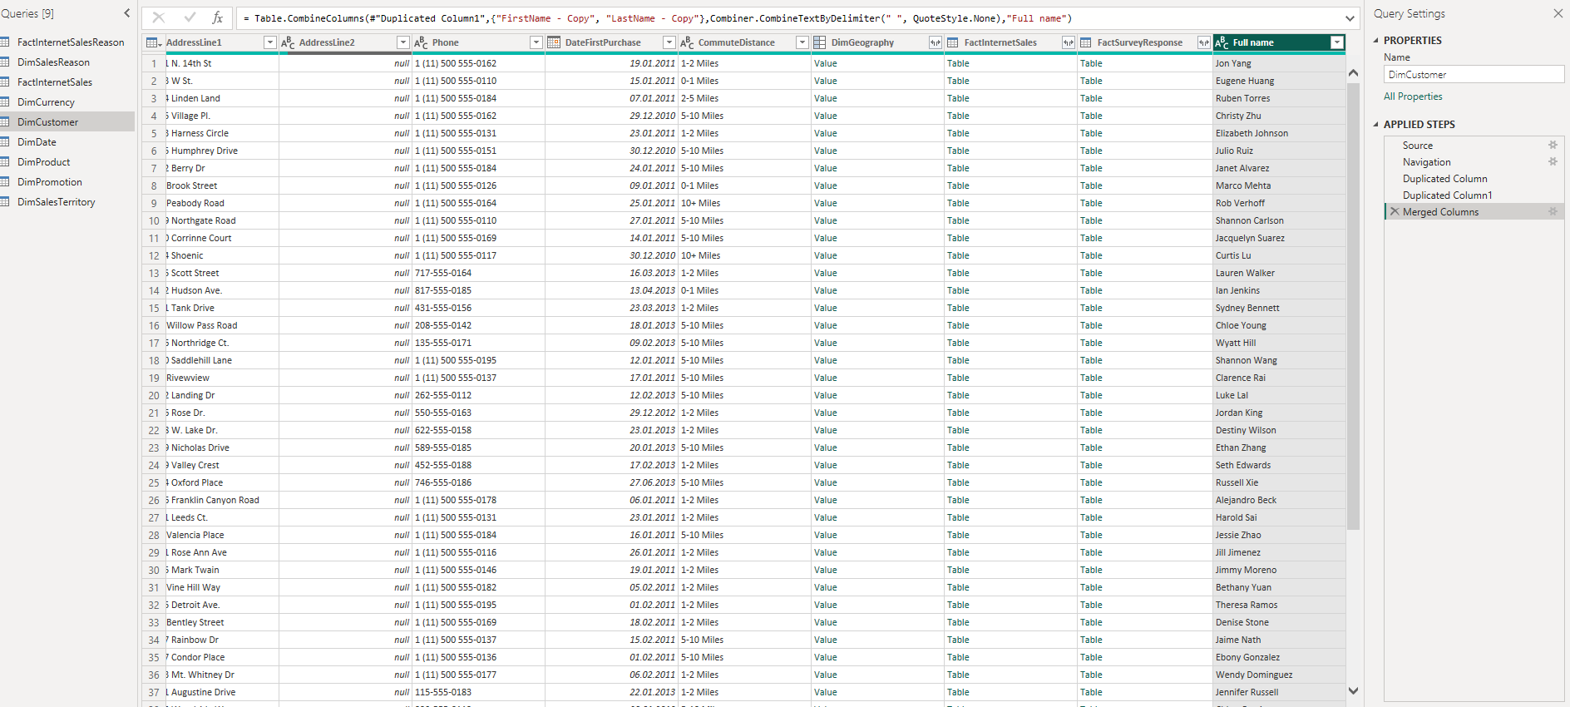
3. Change column type:
- Select ‘DiscountPct’ column in ‘DimPromotion’ table.
- Change Data Type to Percentage:
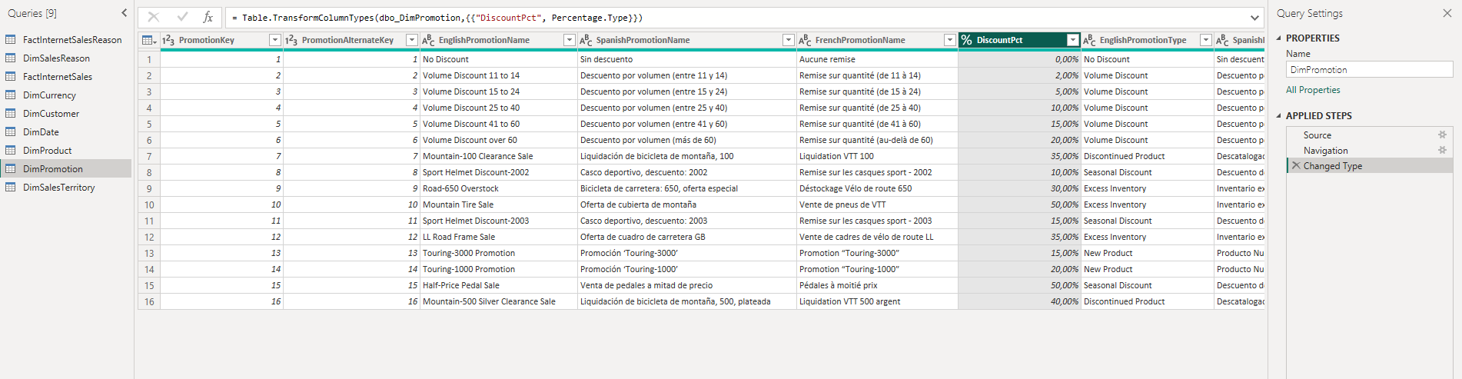

- Calculate the length of Promo campaign:
- Option #1
Select ‘StartDate’ and ‘EndDate’ columns in ‘DimPromotion’ table and apply option for Date Subtraction.
- Option #2
Create a Custom Column and type the necessary Custom column formula.
The name of new column – “Promotion, days”
UPD: Name was fixed
Also, deleted rename step
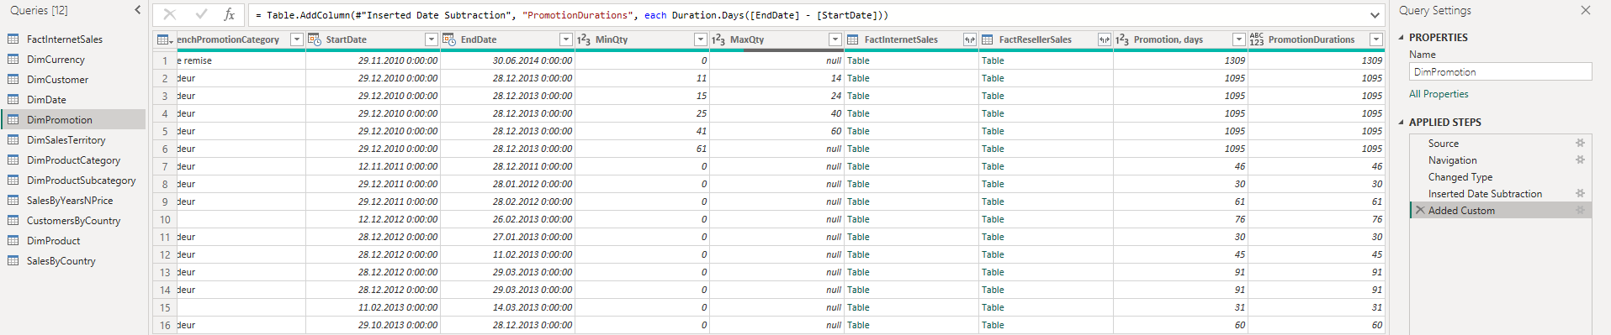
4.4 DATA PROFILING
Click on the View tab and select options Column Quality, Column distribution and Column profile.
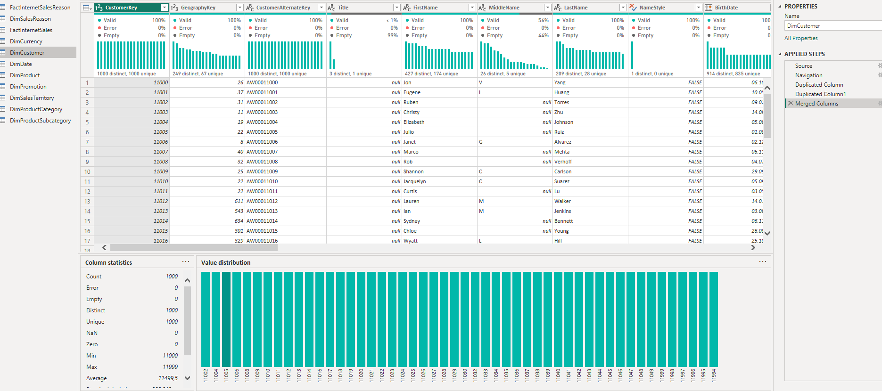

  - PIVOT COLUMN
- Create column ‘Order Year’ based on the ‘OrderDate’ column in the table ‘FactInternetSales’:
- On the Add Column tab select Custom Column.
- Extract year from the ‘OrderDate’ column.
UPD: without rename step
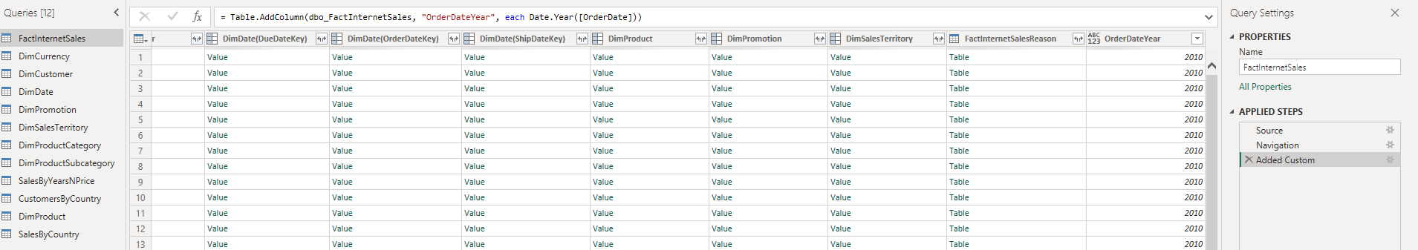
- Create a new table based on ‘FactInternetSales’:
- Right button click on the table ‘FactInternetSales’ choose Reference in the context menu.
- Set the new name ‘SalesByYearsNPrice’ for the created table.
- In the new table choose the columns ‘Order Year’, ‘OrderQuantity’, ‘DiscountAmount’, ‘SalesAmount’ using CTRL button for multiple selection.
- Right-click on the title of a selected column and click on the Remove Other Columns option.

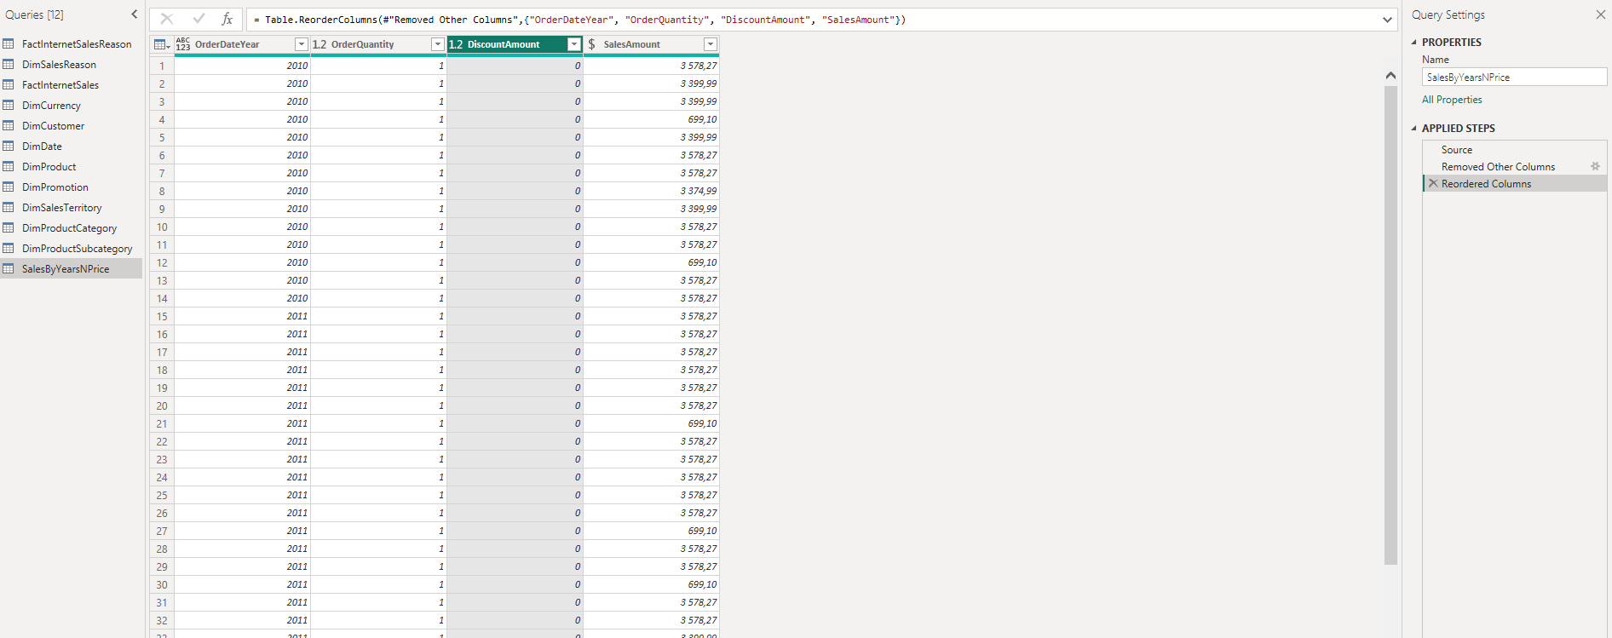
- Choose column ‘Order Year’ (‘SalesByYearsNPrice’ table), navigate on the Transform tab and click on Pivot Column
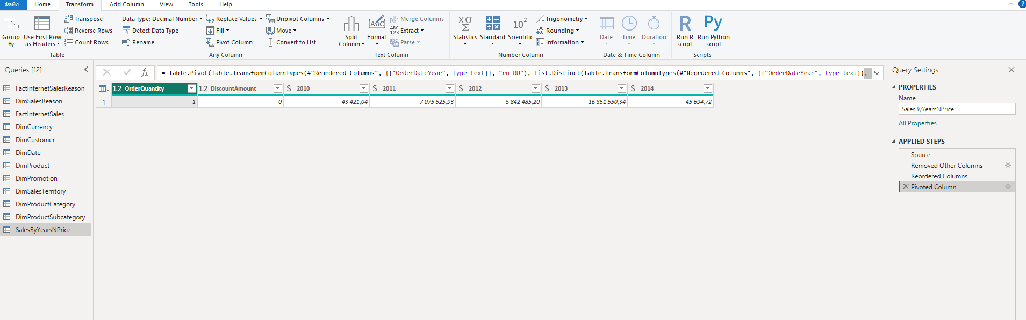

  - TABLE JOINING
Create a new table ‘SalesByCountry’ in a way you did it in the task 4.5.
‘SalesByCountry’ should contain columns:
- ProductKey,
- Order Year,
- SalesAmount,
- SalesTerritoryKey.

Join ‘SalesByCountry’ and ‘DimSalesTerritory’ tables:
- On the Home tab select Merge Queries-> Merge Queries.
- In the ‘Merge’ window select tables that you are planning to join and the key fields for the relations.
- Select Left Outer type of join.
- After the tables are joined, click on the expand icon of the joined column to show the ‘Sales territoryCountry’ column in the new table.
- Join DimProductCategory[EnglishProductCategory] column in the same way. (Hint: To complete this task you need to join 3 tables).

For country I joined two tables based on country key.
For DimProductCategory, first I joined SalesByCountry with DimProduct by ProductKey. Then I expanded the product, found the subcategory table, expanded it, and then found the category table and expanded that as well. After that, using EnglishProductCategory which I found, I joined DimProductCategory with SalesByCountry.
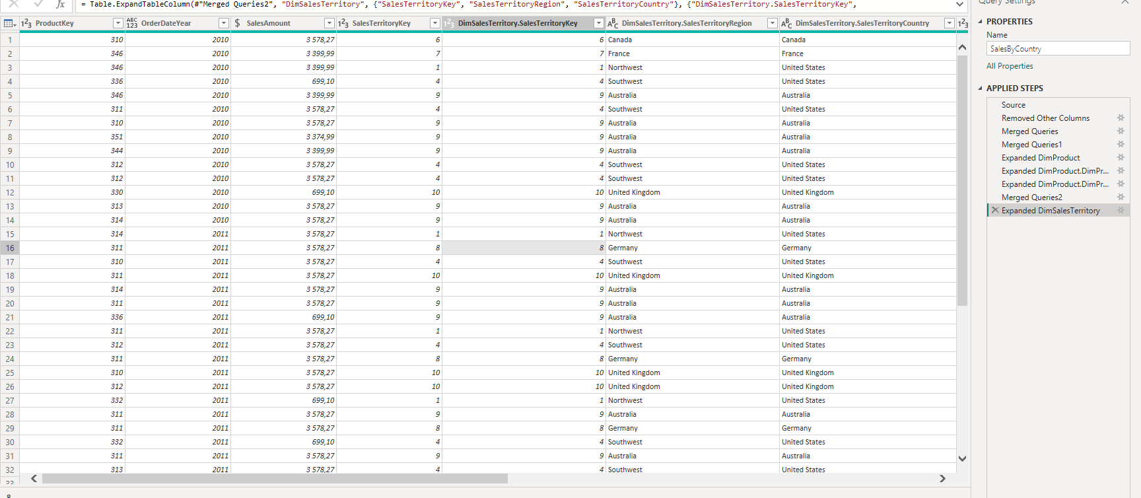

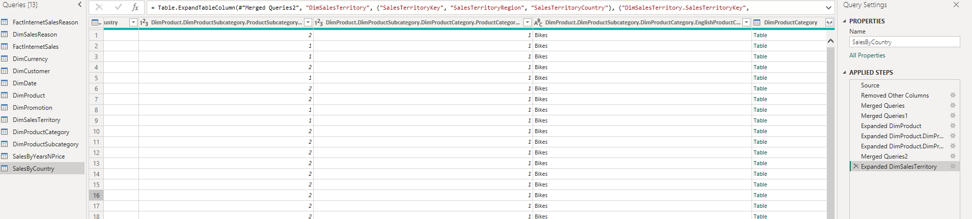
  - GROUPING DATA
- Navigate to the Transform tab and click on the Group By option.
- In the new Group By window choose Advanced option.
- Set the columns ‘Order Year’, ‘SalesTerritoryCountry’ and’ EnglishProductCategoryName’ as grouping columns by using Add grouping button.
- Set ‘Sales’ as a New column name, choose Sum as Operation and SalesAmount as Column.
- Click OK.
- Sort table by ‘Order Year’.
I grouped the data by:
- Order year
- Sales territory
- Product category name
Then I summed the Sales amount in each group.
Now I can clearly see how much each product category (like Bikes, Clothing, Accessories) earned in each year and region.
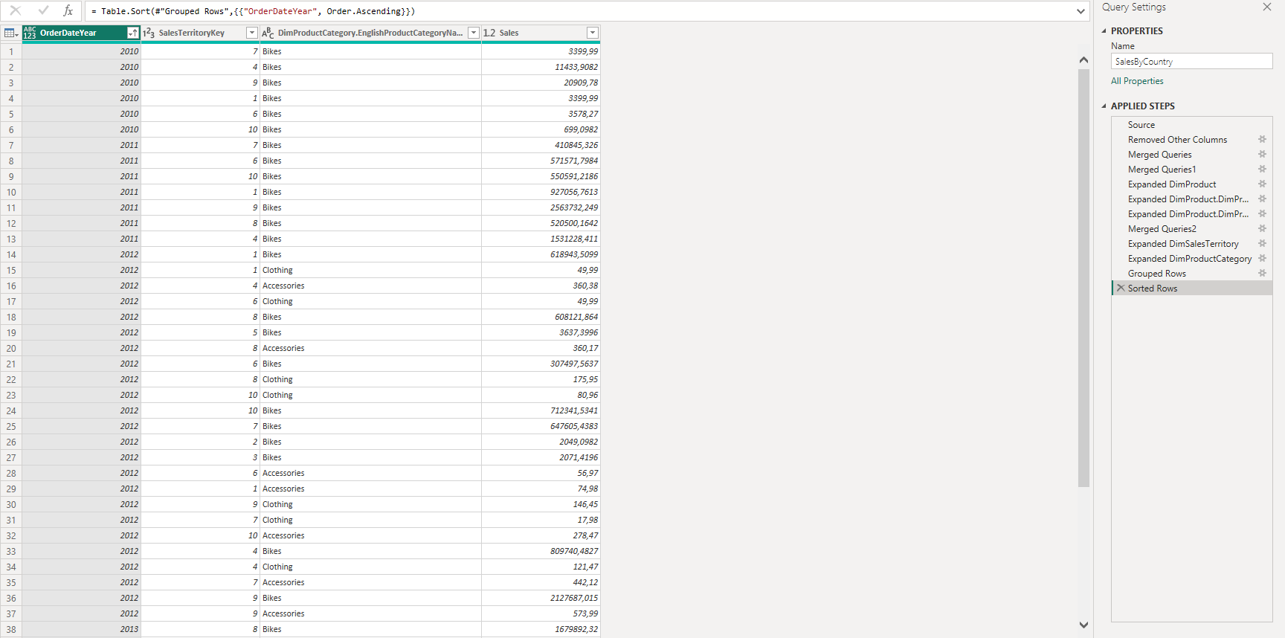

  - Load Data
- Press Close & Apply button on the Home area of the ribbon to load data into the report.
- Go to File -> Save as and save the report with PowerBILab1_[YourLastName] as project name.

  - IMPORT VS DIRECT QUERY
- Create a new .pbix file and connect to the source using Direct query.
- Describe the difference between Import and Direct query based on the results.
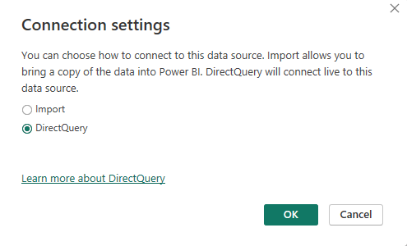
As I understand any changes that will be done in source will applied here to, cause direct query connect live to the data source.
Import is just a copy.
Also, while repeating tasks with direct query I didn’t see differences.
UPD:
- In which approach we downloading data?
We download data in the Import approach because we copy the data from the source into the Power BI model. In the DirectQuery approach, we connect live to the data source and retrieve the data only when accessing the data(report).
- Data refresh - is it needed, in which approach?
Data refresh is needed in the Import approach because Import stores a copy of the data as of a specific date.
For example, if we imported the data on 06.08.2025 and built a report, then on 09.08.2025 we would need to refresh the data because it may have changed in the source.
In DirectQuery, a scheduled data refresh is not required for keeping the data up to date, because queries are sent to the source each time the report is used.
- Which approach works faster?
Import works faster cause data are stored in memory.
While in directequery approach we need to get data from external source.
- Limitations for each approach (Can we build Power Query/Calculate DAX)?
Import approach:
Power Query: All transformations are available.
DAX: All DAX functions are supported, including calculated tables, calculated columns, and complex measures.
DirectQuery approach:
Power Query: Limited transformations — all steps must be translated into source queries (usually SQL). Some complex transformations are not supported or must be performed in the source system.
DAX: Not all functions are available. Calculated tables and some calculated columns are restricted.

  - WORKING WITH POWER BI MODEL

- Open the report.
- Switch to Modelling View. Check the relationship that were automatically created during data load
