- Create lab report
Create a report based on the data loaded. The report should fulfil the following requirements:

- The report should have a header with report name and company logo.
- The report should contain 3 different types of Slicers (Filters) – drop-down, list box and date filter.
- The report should contain at least 5 different visual types from standard list and at least 2 custom visuals. Explain the choice of custom visuals in the lab report.
- Disable interactions between one of the slicers and one of the visuals in your report. Don’t forget to include description of this step into you word document.

UPD:
Format->Edit interactions->Select slicer (subcategory filter)->press none button in visual (Total Amount of Sales).
Also, edit interactions->Select slicer (OrderDateYear filter)->press none button in visual (Total Amount of Sales).
Total Amount Sales shows total sales for all years and categories, without any filtering.
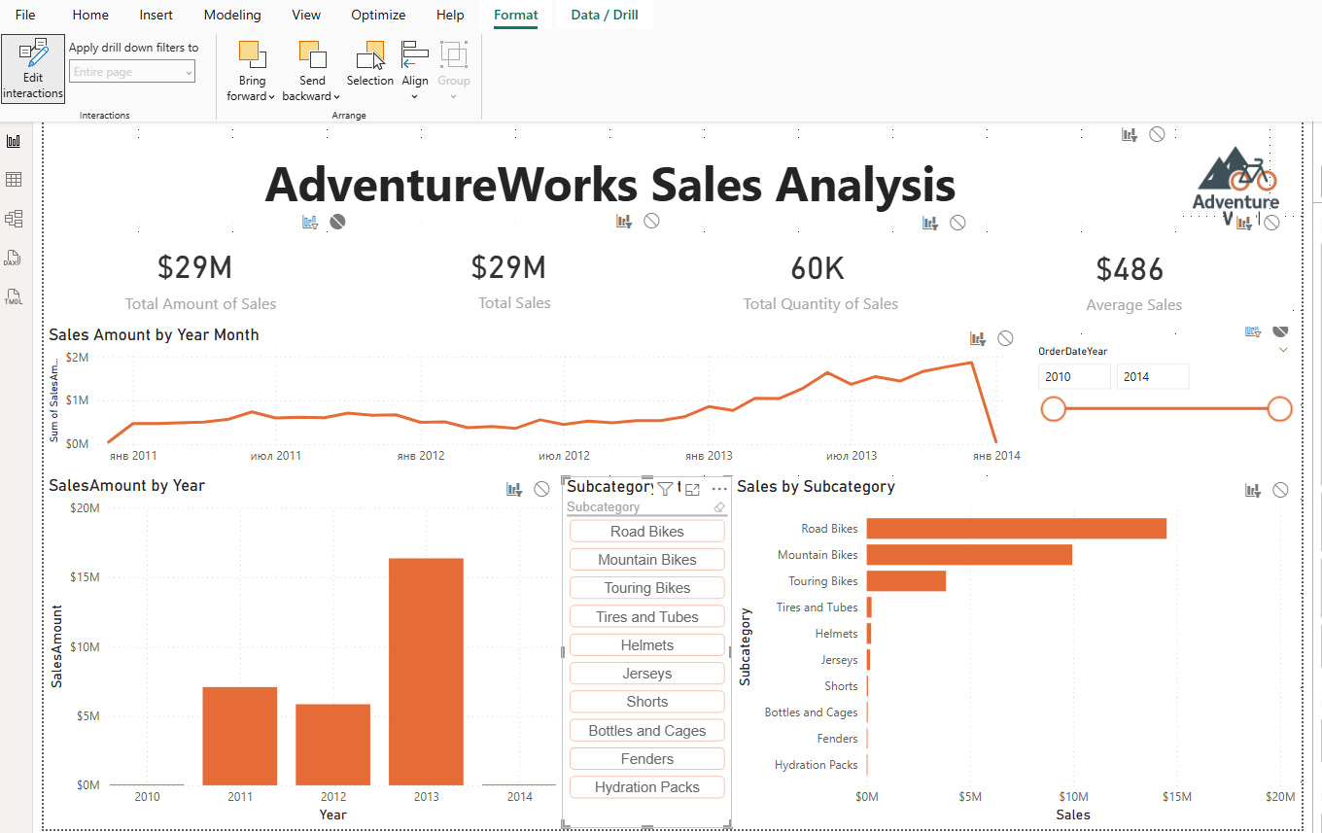

- The report should be developed using a chosen color palette to be visually appealing – e.g., the colors of the bars and lines in the chart should correspond to the logo colors.
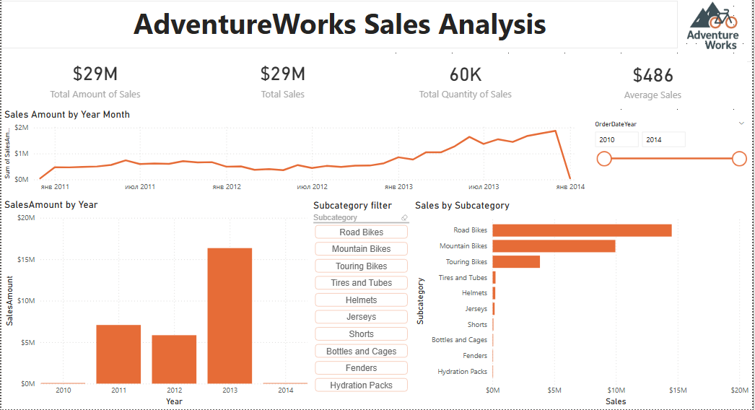
The top of the report includes four Cards (card visuals) showing important indicators:
- $29M – Total Amount of Sales
Shows total revenue for all period independent from slices.
Other Cards are interact with slices.
- $29M – Total Sales
Duplicate card for grouping or layout consistency.
- 60K – Total Quantity of Sales
Displays the total number of products sold.
- $486 – Average Sales
Shows the average transaction value.
The report also includes 5 other Power BI visuals:
- Line Chart – Sales Amount by Year-Month
Useful for showing sales trends over time.
- Clustered Column Chart – Sales Amount by Year
Makes it easy to compare total yearly revenue.
- Bar Chart – Sales by Subcategory
Highlights the best-performing product subcategories.
- Date Slicer – Year selection, between style
Filters all visuals by the selected year range.
Custom Visual
- Chiclet Slicer – Subcategory selection
Filters by product subcategories with easy search, only top 10 subcategories by sales with amount of sales > 10000 .
In this report all visuals except 1 card visual(Total amount of sales) are interacts with slicers.

- Add and configure a Map visual to the report. Add necessary tables from the AdventureWorks DWH if needed.
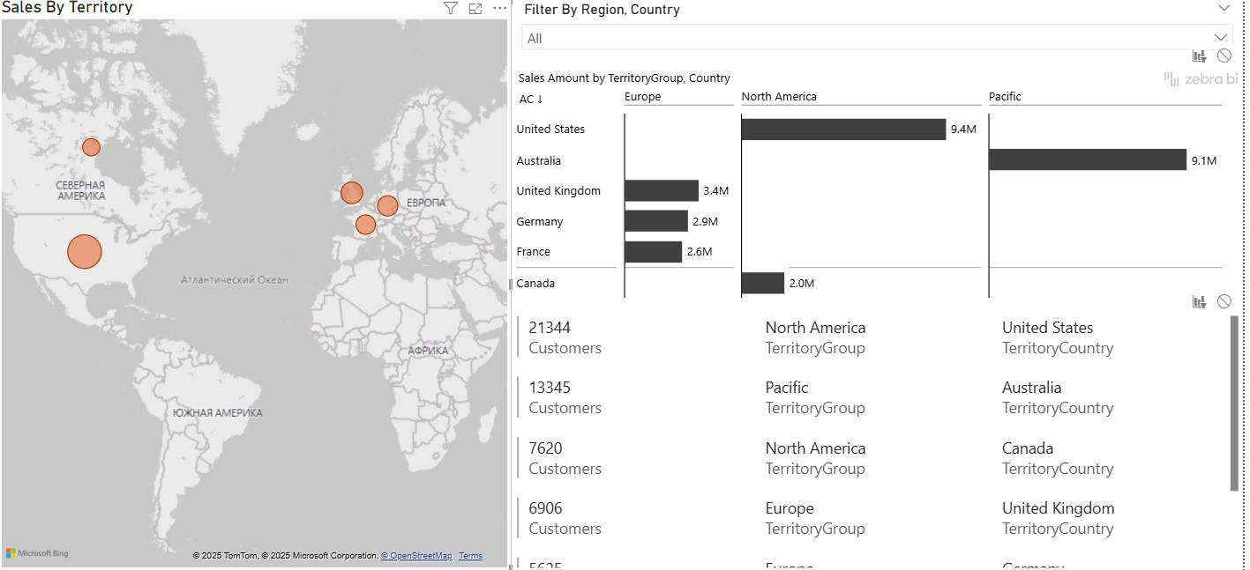
Slicer with hierarchy TerritoryGroup->Country
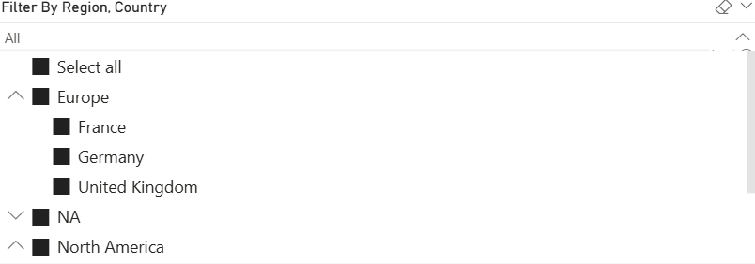
Map Visual based on Sales amount
ZebraBI Tables Custom visual to get analysis on sales amount by countries
Multi row Card visual - Customer counts by territory
- Configure mobile layout for your report.
done with auto layout with little replace of visuals.
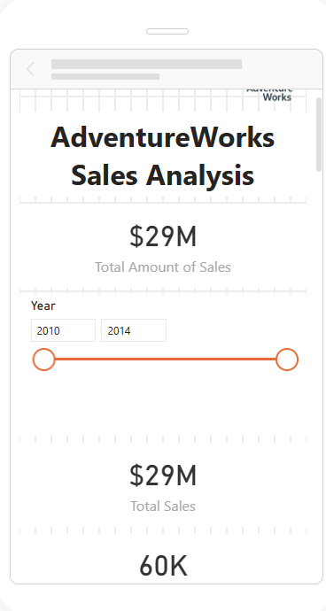
- Publish the report to Power BI Service Portal and include the screenshot of published report into lab work results email.
- Install Personal Gateway and configure data refresh once a day and include the screenshot into lab work results email.
- Share the report with your mentor and send email notification to him/her.
- **Create and include into lab report the URL link that will have a built-in filter in it (e.g., the link will open the report filtered by one Country)
UPD:
https://app.powerbi.com/groups/me/reports/969df6db-e573-4f26-9be6-351270b96757/ReportSection?filter=DimSalesTerritory/SalesTerritoryCountry eq 'Australia'
