Create lab report
Create a report on test data from your previous home tasks with following artefacts:
- Configure RLS based on a chosen security pattern. Give short description of your security groups and make screenshots of how it was configured in Power BI Desktop and Power BI Online Service.
Static Managed Roles were created to filter data by SalesTerritoryGroup in two tables: CustomersByCountry and DeemSalesTerritory. Each role restricts access to records where SalesTerritoryGroup equals a specific region (e.g., Europe, North America, Pacific). This ensures users only see data relevant to their assigned region.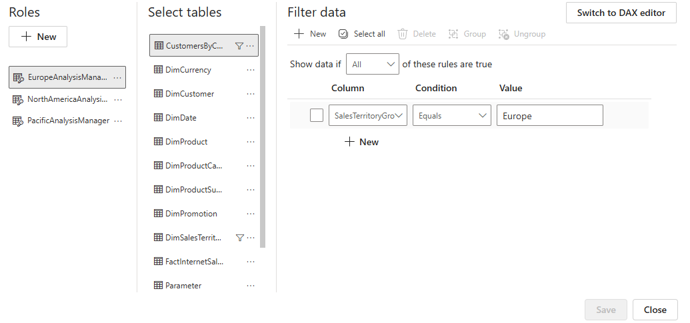
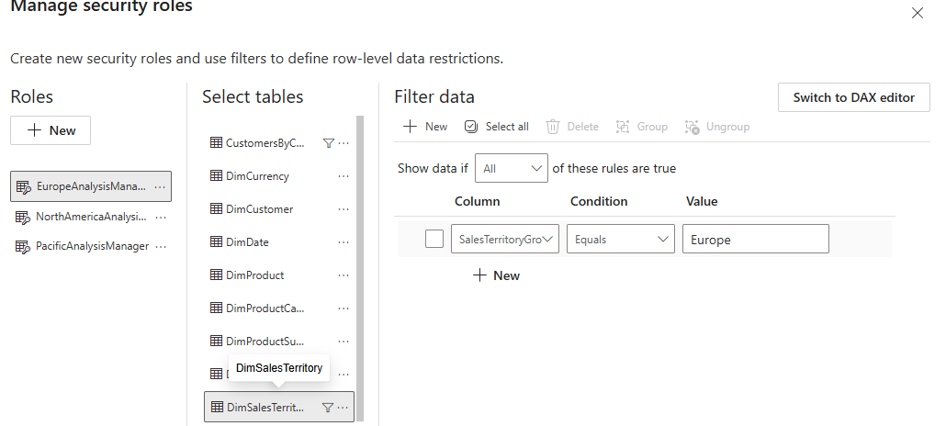

Then in security of semantic model I added myself to one of the RLS and checked if it works.
Didn’t add mentor because mentor will not be able to see full report.
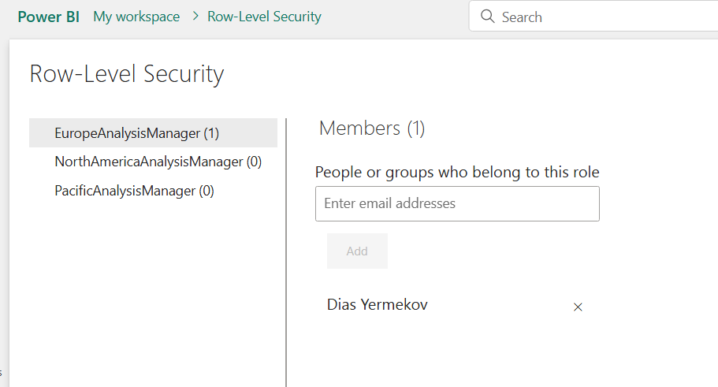
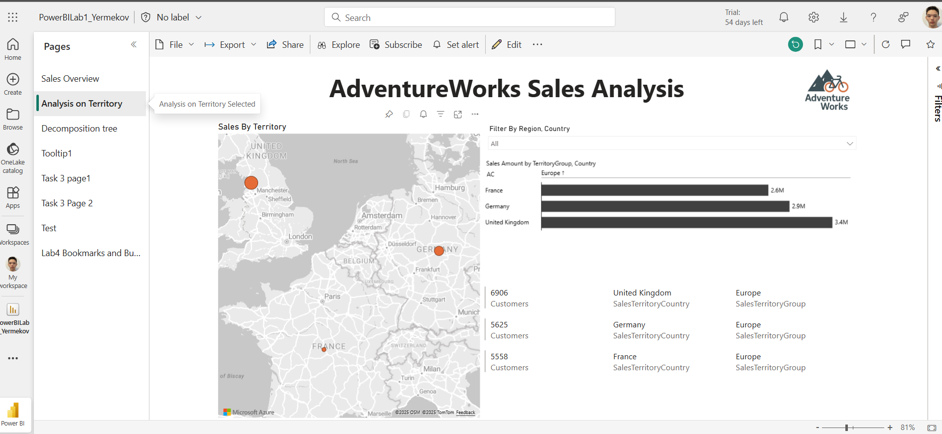
- Using bookmarks and buttons create a functionality to switch between bar chart and a map visual that are positioned in the same area. Give short description of you work.
First, created map and bar chart visuals.
Then, by selection I hided one of the visual and created bookmarks (done for both of the visuals).
Created group for these bookmarks.
And added bookmark navigator from buttons.
Selected group 1 as bookmark (the group where map and bar chart bookmarks).
And little styled it.
Page = Map & BarChart views
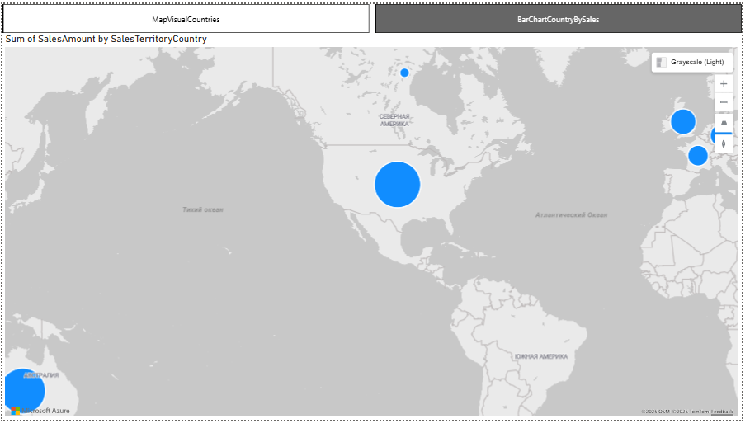
- On the page with YTD calculation created in previous lab work, add the possibility to switch between MTD, QTD and YTD views for the user. You can use different ways of implementation, so add a description of the method you used and specify why you choose this logic.
I used the method with bookmarks and a bookmark navigator, as in the previous task.
I chose this approach because it’s straightforward for me. Initially, I considered using a field parameter, but it became overcomplicated since the line graph contains two measures — YTD and YTD Previous Year — that need to be displayed together.
page = Sales&Quantities TD Comparisions 3.1
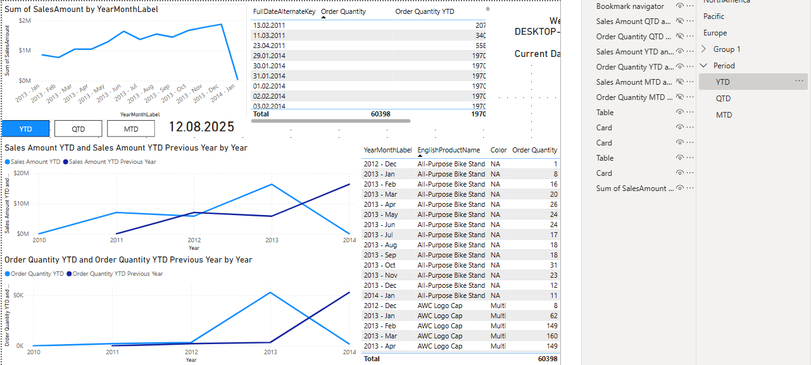

- Create a decomposition tree visual with at least 3 independent variables. Give short description of you work.
Added decomposition tree.
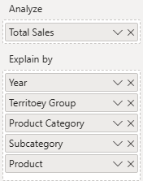
So, my tree analyzes data by sales amount and explains details by Year->Territory Group->Category->Subcategory->Product .
Page = Sales Decomposition Tree

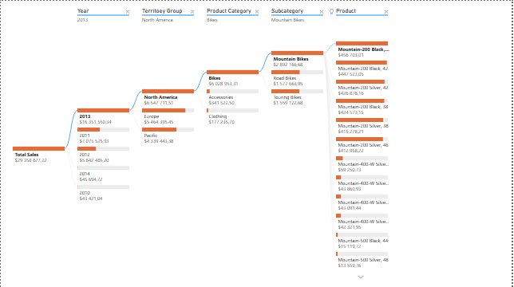
- Add a tooltip for the selected visual. Give short description of you work.
To create tooltip, I have created new page with visuals that will be shown as tips on another visual. I added tooltip to map visual in Analisy on Territory page. Tooltip shows detail of hovered country.
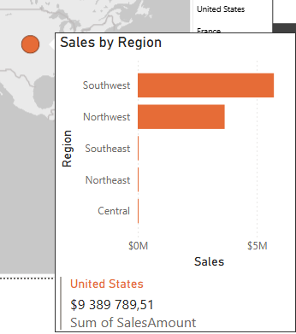
Tooltip consists of bar chart that shows sales amount by regions and multi row card tha shows name of country and total sales.

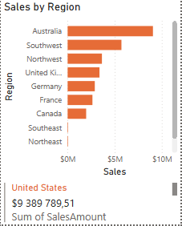
- *Try to create Custom visual in Power BI Desktop. Add description of the method you choosed and explain what the usage of your visual is and what opportunities the visual you created gives you in comparison with the default visuals.
Didn’t implement.

