**Practical – 1**

**Aim:Write A Program To Print Hello World In JAVA.**

class P1_050

{

public static void main(String args[])

{

System.out.println("Hello world!");

}

}

**Output:**

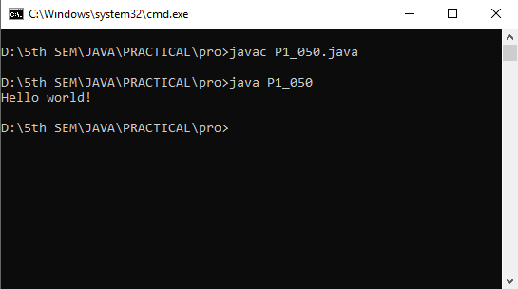

**Practical – 2**

**Aim: Write A Program In JAVA To Print 5 Elements Using Array.**

class P2_050

{

public static void main(String args[])

{

int a[] = new int[5];

System.out.println("Elements of an array are!!");

a[0] = 1;

a[1] = 2;

a[2] = 3;

a[3] = 4;

a[4] = 5;

for(int i = 0; i < 5; i++)

System.out.println(a[i]);

}

}

**Output:**

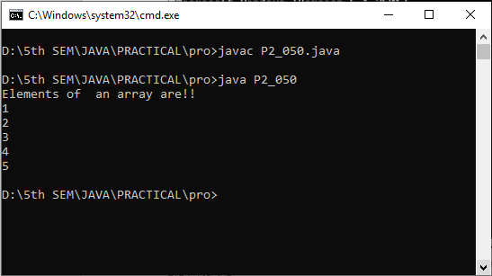

**Practical - 3**

**Aim: Write A Program To Check Whether The Given Number Is Prime Or Not.**

class P3_050

{

public static void main(String args[])

{

int n = 5;

int m = 0;

int f = 0;

m = n / 2;

if(n == 0 || n == 1)

{

System.out.println(n+ "is not a prime number");

}

else

{

for(int i = 2; i <= m; i++)

if(n % i == 0)

{

System.out.println(n+ "is not prime");

f = 1;

break;

}

if(f == 0)

{

System.out.println(n+ "is prime number");

}

}

}

}

**Output:**

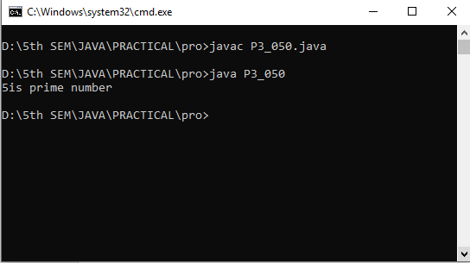

**Practical – 4**

**Aim: Write A Program To Print Prime Numbers Between 1 To 100.**

class P4_050

{

public static void main(String args[])

{

int i = 0;

int j = 0;

int a = 0;

System.out.println("Prime numbers between 1 to 100 are:");

for(i = 1; i <= 100; i++)

{

a = 0;

for(j = 2; j <= i/2; j++)

{

if(i % j == 0)

{

a = 1;

break;

}

}

if(a == 0 && i != 1)

{

System.out.println(i+ "");

}

}

}

}

**Output:**

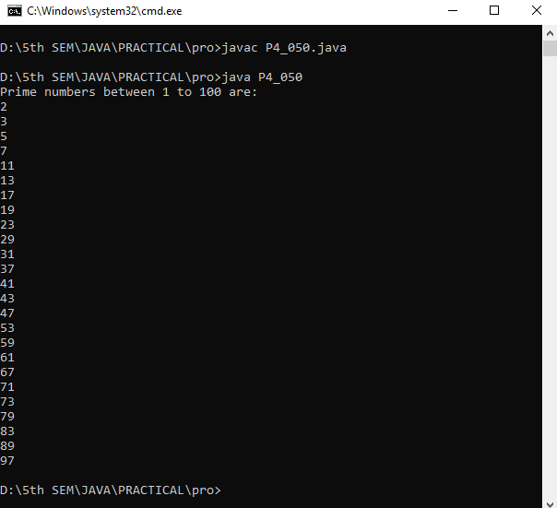

**Practical – 5**

**Aim: Write A Program To Find A Maximum Number From Given Three Numbers Using Conditional Operator.**

class P5_050

{

public static void main(String args[])

{

int a = 10;

int b = 20;

int c = 30;

int result;

int result2;

result = a > b?a : b;

result2 = c > result?c:result;

System.out.println("greatest number is:" +result2);

}

}

**Output:**

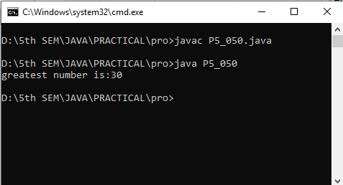

**Practical – 6**

**Aim: Write A Program To Find Second Maximum Number From Given Three Numbers Using Conditional Operator.**

class P6_050

{

public static void main(String args[])

{

int a = 10;

int b = 20;

int c = 30;

int result1, result2, result3;

result1 = a>b?a:b;

result2 = c>result1?c:result1;

result3 = result2>result1?result1:result2;

System.out.println(result3 + "is second maximum!!");

}

}

**Output:**

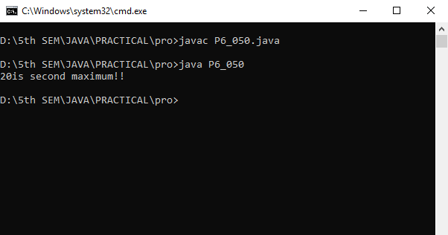

**Practical – 7**

**Aim: Write a program on addition of 2 number using class and object.**

class P7_050

{

public static void main(String args[])

{

P7_050 a1 = new P7_050();

a1.add(10, 20);

}

int add(int a, int b)

{

int c= a + b;

System.out.println("addition is: "+c);

return c;

}

}

**Output:**

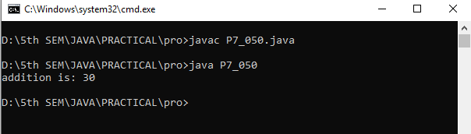

**Practical – 8**

**Aim: Write a program of arithmetic operation using class and object.**

class P8_050

{

public static void main(String args[])

{

P8_050 a1 = new P8_050();

a1.add(10, 20);

a1.sub(20, 10);

a1.mul(5, 2);

a1.div(10, 2);

}

double add(double a, double b)

{

double c= a + b;

System.out.println("addition is: "+c);

return c;

}

double sub(double x, double y)

{

double z= x - y;

System.out.println("Subtraction is:" +z);

return z;

}

double mul(double m, double n)

{

double o= m * n;

System.out.println("multiplication is:" +o);

return o;

}

double div(double e, double f)

{

double g= e/f;

System.out.println("division is:" +g);

return g;

}

}

**Output:**

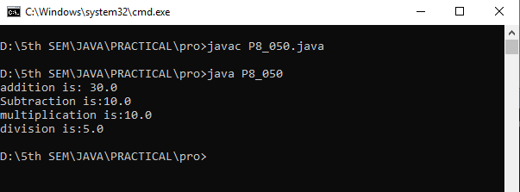

**PRACTICAL – 9**

**Aim: Write a program in Java to reverse of digit of a number using while loop.**

class P9_050

{

public static void main(String[]args)

{

int num=3691,reversed=0;

while(num !=0)

{

int digit=num % 10;

reversed=reversed * 10+digit;

num /=10;

}

System.out.println("Reversed Number:"+reversed);

}

}

**Output:**

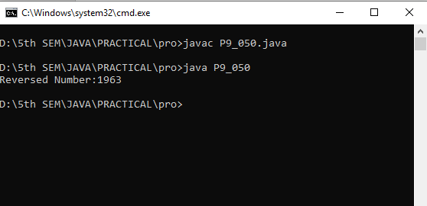

**PRACTICAL – 10**

**Aim: Write a Program to Print Two Dimensional Array.**

class P10_050

{

public static void main(String args[])

{

int a[][] = new int[3][3];

a[0][0] = 1;

a[0][1] = 2;

a[0][2] = 3;

a[1][0] = 4;

a[1][1] = 5;

a[1][2] = 1;

a[2][0] = 2;

a[2][1] = 3;

a[2][2] = 4;

for(int i=0;i<a.length;i++)

{

for(int j=0;j<a.length;j++)

{

System.out.println("a["+i+"]["+j+"] = " +a[i][j]);

}

}

System.out.println("");

int b[][] = new int[3][3];

b[0][0] = 1;

b[0][1] = 2;

b[0][2] = 3;

b[1][0] = 4;

b[1][1] = 5;

b[1][2] = 1;

b[2][0] = 2;

b[2][1] = 3;

b[2][2] = 4;

for(int i=0;i<b.length;i++)

{

for(int j=0;j<b.length;j++)

{

System.out.println("b["+i+"]["+j+"] = " +b[i][j]);

}

}

}

}

**Output:**

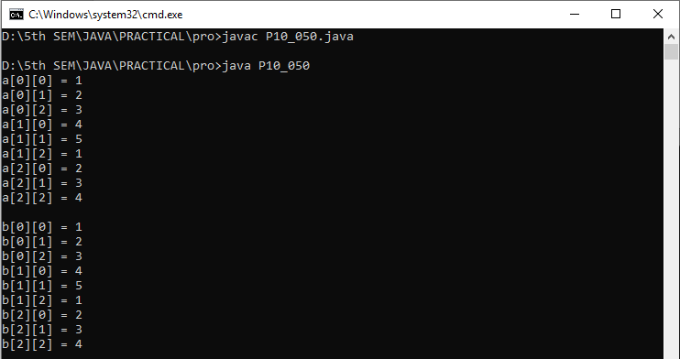

**PRACTICAL – 11**

**AIM:-Write a program to multiple 3 * 3 Matrix.**

class P11_050

{

public static void main(String args[])

{

int a[][]=new int[3][3];

int b[][]=new int[3][3];

int c[][]=new int[3][3];

a[0][0]=1;

a[0][1]=2;

a[0][2]=3;

a[1][0]=4;

a[1][1]=5;

a[1][2]=1;

a[2][0]=2;

a[2][1]=3;

a[2][2]=4;

b[0][0]=1;

b[0][1]=2;

b[0][2]=3;

b[1][0]=4;

b[1][1]=5;

b[1][2]=1;

b[2][0]=2;

b[2][1]=3;

b[2][2]=4;

for(int i=0;i<3;i++)

{

for(int j=0;j<3;j++)

{

c[i][j] = 0;

for (int k = 0; k < 3; k++)

{

c[i][j] += a[i][k] * b[k][j];

}

System.out.print(c[i][j] + " ");

}

System.out.println();

}

}

}

**Output:**

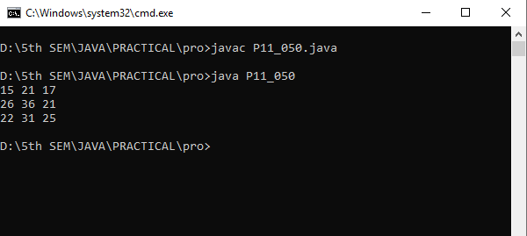

**Practical – 12**

**Aim: Write a Java program to print a given string.**

class P12_050

{

public static void main(String args[])

{

String s1="no";

String s2="one";

String s3=new String("Hello");

String s4=new String("World");

System.out.println(s1);

System.out.println(s2);

System.out.println(s3);

System.out.println(s4);

}

}

**Output:**

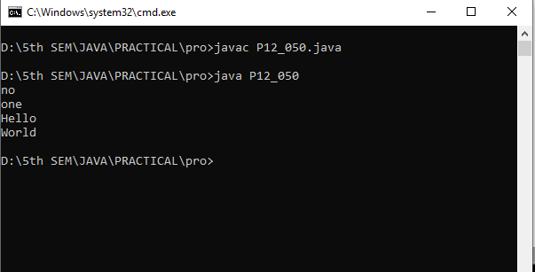

**Practical – 13**

**Aim: Write a Java program to print length of given string.**

class P13_050

{

public static void main(String args[])

{

String s1="no";

String s2="one!!";

System.out.println(+s1.length());

System.out.println(+s2.length());

}

}

**Output:**

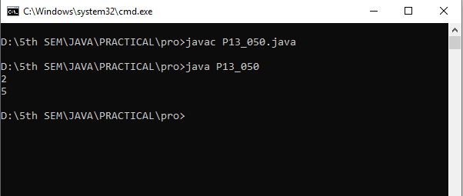

**Practical – 14**

**Aim: Write a Java program to convert String into uppercase and lowercase.**

class P14_050

{

public static void main(String args[])

{

String s1="no";

String s2="ONE";

System.out.println(s1.toUpperCase());

System.out.println(s2.toLowerCase());

}

}

**Output:**

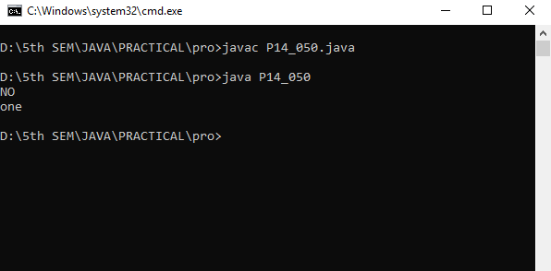

**Practical – 15**

**Aim: Write a program to concat given strings.**

class P15_050

{

public static void main(String args[])

{

System.out.println("We are concating two strings using '+' operator:");

System.out.println("");

String s1 = "hello there!";

System.out.println("how are you!!!" + s1);

System.out.println("");

System.out.println("");

System.out.println("We are concating two strings using 'concat' method:");

System.out.println("");

String s2 = "My name is";

System.out.println(s2.concat(" nothing!!"));

}

}

**Output:**

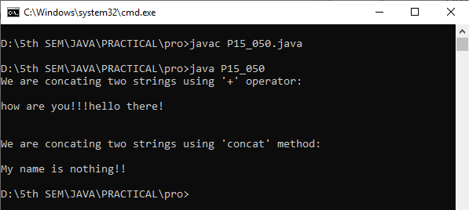

**Practical – 16**

**Aim: Write a program that shows concept of Character Extraction:**

1. **getChars()**
2. **charAt()**
3. **substring()**
4. **getChars() :**

class P16_1_1_050

{

public static void main(String args[])

{

// getChars using Simple code view!!

String s1 = "welcome world!!!!";

char ch[] = new char[10];

s1.getChars(6, 16, ch, 0);

System.out.println(ch);

}

}

**Output:**

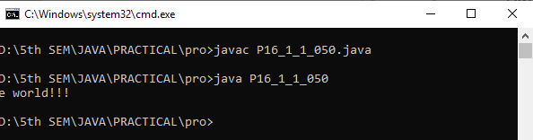

class P16_1_2_050

{

public static void main(String args[])

{

// getChars Using Exception code view!!

String s1 = "welcome world!!!!";

char ch[] = new char[10];

s1.getChars(6, 16, ch, 0);

System.out.println(ch);

try

{

s1.getChars(6, 16, ch, 0);

System.out.println(ch);

}

catch(Exception ex)

{

System.out.print(ex);

}

}

}

**Output:**

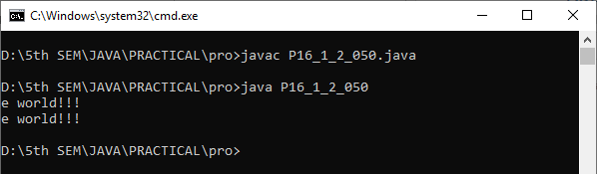

class P16_1_3_050

{

public static void main(String args[])

{

String s1 = "welcome world!!!!";

char ch[] = new char[5];

s1.getChars(6, 16, ch, 0);

System.out.println(ch);

try

{

s1.getChars(6, 16, ch, 0);

System.out.println(ch);

}

catch(Exception ex)

{

System.out.print(ex);

}

}

}

**Output:**

When error appears in getchars!!

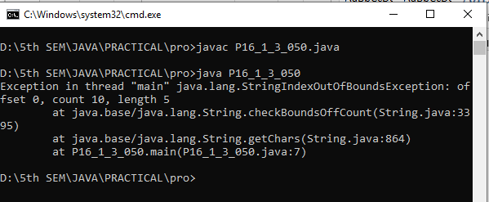

1. **charAt:**

class P16_050

{

public static void main(String args[])

{

String str = "hello world!!";

char ch = str.charAt(4);

System.out.println("character found: "+ch);

}

}

**Output:**

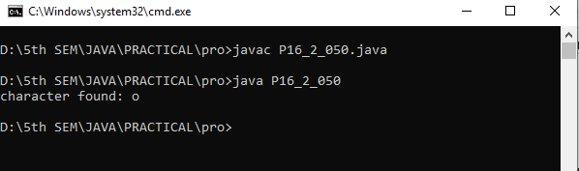

1. **substring() :**

class P16_3_050

{

public static void main(String args[])

{

String s1 = "Welcome To Parul University";

System.out.println("substring:"+s1.substring(3, 13));

System.out.println("substring in another way:"+s1.substring(4));

}

}

**Output:**

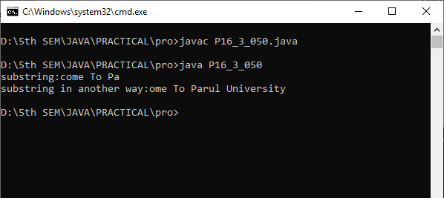

**Practical – 17**

**Aim: Write a program on StringBuffer using Append.**

class P17_050

{

public static void main(String args[])

{

String a = "test";

StringBuffer sBuffer = new StringBuffer(a);

sBuffer.append(" example of String Buffer");

System.out.println(sBuffer);

}

}

**Output:**

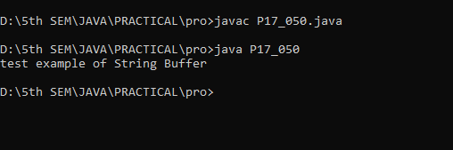

**Practical – 18**

**Aim: Write a program to show concept of Command line Argument in java.**

class P18_050

{

public static void main(String args[])

{

for(int i=0;i<args.length;i++)

{

System.out.println(args[i]);

}

}

}

**Output:**

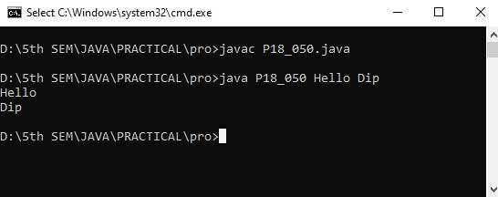

**Practical – 19**

**Aim: Write a program to demonstrate a static block which will be executed before main method in class.**

class P19_050

{

static

{

System.out.println("World");

}

public static void main(String args[])

{

System.out.println("Hello!");

}

}

**Output:**

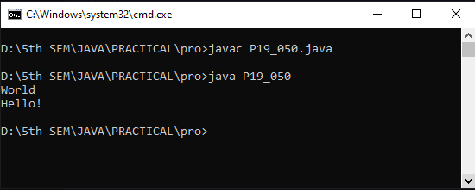

**Practical – 20**

**Aim: Write a program in java to demonstrate the use of 'This' keyword check weather ‘this’ can access private member of the class or not.**

class P20_050

{

int rollno;

String name;

P20_050(int rollno,String name)

{

this.rollno=rollno;

this.name=name;

}

void display()

{

System.out.println(rollno + " " + name);

}

public static void main(String aargs[])

{

P20_050 p1=new P20_050(111,"Bob");

P20_050 p2=new P20_050(112,"Alice");

p1.display();

p2.display();

}

}

**Output:**

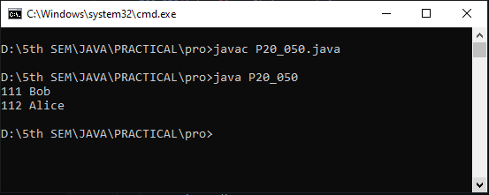

**Practical – 21**

**Aim: Write a program in java to implement concept of:**

1. **Single Inheritance**
2. **Multilevel Inheritance**
3. **Hierarchical Inheritance**
4. **Single Inheritance:**

class P21_1_050

{

public void print_1()

{

System.out.println("Hello!");

}

}

class two extends P21_1_050

{

public void print_2()

{

System.out.println("World");

}

public static void main(String[] args)

{

two g = new two();

g.print_1();

g.print_2();

g.print_1();

}

}

**Output:**

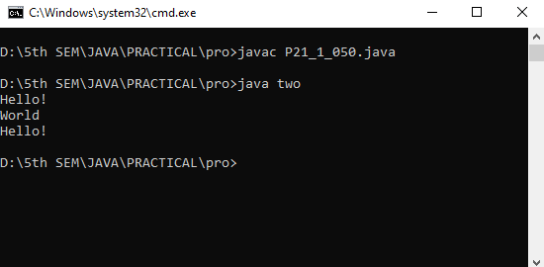

1. **Multilevel Inheritance:**

class P21_2_050

{

public void print_1()

{

System.out.println("Hello!");

}

}

class base extends P21_2_050

{

public void print_2()

{

System.out.println("World");

}

}

class two extends base

{

public void print_3()

{

System.out.println("Wassup!");

}

public static void main(String[] args)

{

two g = new two();

g.print_1();

g.print_2();

g.print_3();

}

}

**Output:**

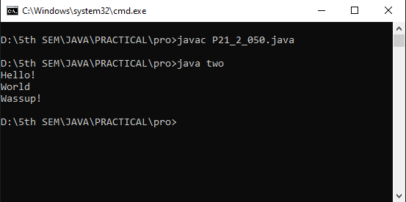

1. **Hierarchical Inheritance:**

class P21_3_050

{

public void print_1()

{

System.out.println("Hello!");

}

}

class base extends P21_3_050

{

public void print_2()

{

System.out.println("World");

}

}

class base2 extends P21_3_050

{

public void print_3()

{

System.out.println("NULL!");

}

}

class two extends P21_3_050

{

public void print_4()

{

System.out.println("Wassup!");

}

public static void main(String[] args)

{

base b = new base();

b.print_1();

b.print_2();

base2 b2 = new base2();

b2.print_1();

b2.print_3();

two t = new two();

t.print_1();

t.print_4();

}

}

**Output:**

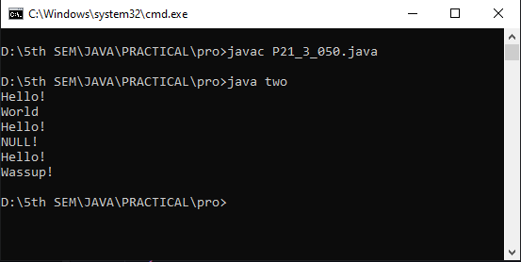

**Practical – 22**

**Aim: Write a program in java to check that if the given year is leap or not using inheritance.**

class P22_050

{

public int year=2020;

}

class chk extends P22_050

{

public void show()

{

if(year%4==0)

{

System.out.println("Year is Leap Year");

}

else

{

System.out.println("Year is not Leap year ");

}

}

public static void main(String args[])

{

chk c=new chk();

c.show();

}

}

**Output:**

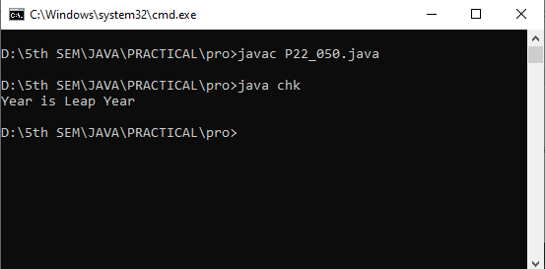

**Practical – 23**

**Aim: Write a program in java to implement interface P12 inherits from interfaces P1 & P2 every interface contains one method and one constant print all methods of interfaces using class Q.**

interface P1

{

int a = 10;

void print_p1();

}

interface P2

{

int b = 20;

void print_p2();

}

interface P12 extends P1,P2

{

int c = 30;

void print_p12();

}

class Q implements P12

{

public void print_p1()

{

System.out.println("Value of a:"+a);

}

public void print_p2()

{

System.out.println("Value of b:"+b);

}

public void print_p12()

{

System.out.println("Value of c:"+c);

}

public static void main(String args[])

{

Q q1 = new Q();

q1.print_p1();

q1.print_p2();

q1.print_p12();

}

}

**Output:**

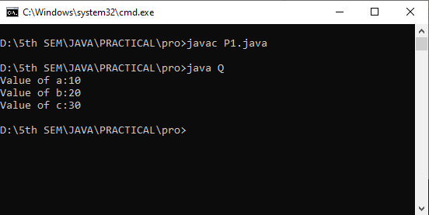

**Practical – 24**

**Aim: Write a program in java to demonstrate Multiple Inheritance using interface.**

interface PI1

{

void show_PI1();

}

interface PI2

{

void show_PI2();

}

class P24_050 implements PI1, PI2

{

public void show_PI1()

{

System.out.println("Hello");

}

public void show_PI2()

{

System.out.println("World!");

}

public static void main(String args[])

{

P24_050 p = new P24_050();

p.show_PI1();

p.show_PI2();

}

}

**Output:**

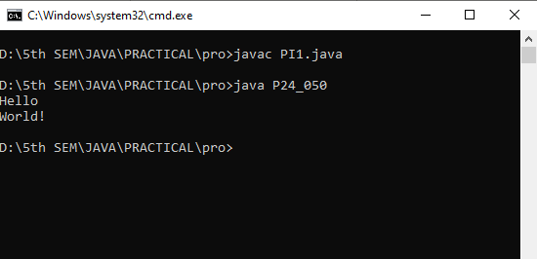

**Practical – 25**

**Aim: Write a program in java to demonstrate final class.**

final class A

{

public void show_a()

{

System.out.println("Hello!");

}

}

class B extends A

{

public void show_b()

{

//errors will be generated because when we declare any calss final it can't be inherited!!

System.out.println("World");

}

public static void main(String args[])

{

B b = new B();

b.show_a();

b.show_b();

}

}

**Output:**

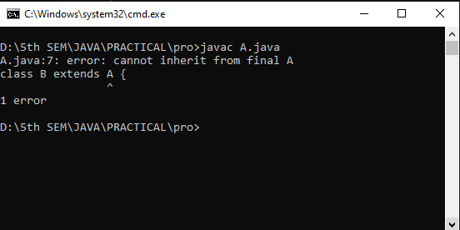

final class A1

{

public void show_a()

{

System.out.println("Hello!");

}

public static void main(String args[])

{

A1 a1 = new A1();

a1.show_a();

}

}

**Output:**

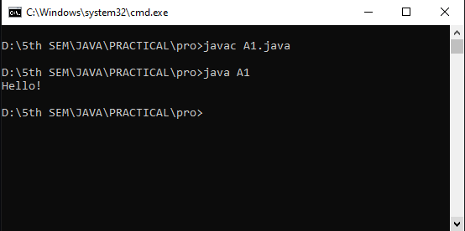

**Practical – 26**

**Aim: Write a program in java to create abstract class called shape it has 3 subclasses which are triangle, rectangle and circle define one method called area in abstract class override this method area in each 3 subclasses to calculate area of each shape.**

abstract class Shape

{

abstract void area();

}

class Triangle extends Shape

{

int d;

int b = 9;

int h = 5;

public void area()

{

d = b * h;

System.out.println("Area of triangle is:"+d);

}

}

class Rectangle extends Shape

{

int a;

int l = 3;

int w = 4;

public void area()

{

a = l * w;

System.out.println("Area of rectangle is:"+a);

}

}

class Circle extends Shape

{

double c;

double pi = 3.14;

int r = 5;

public void area()

{

c = pi * r * r;

System.out.println("Area of circle is:"+c);

}

public static void main(String args[])

{

Shape s;

s = new Triangle();

s.area();

s = new Rectangle();

s.area();

s = new Circle();

s.area();

}

}

**Output:**

