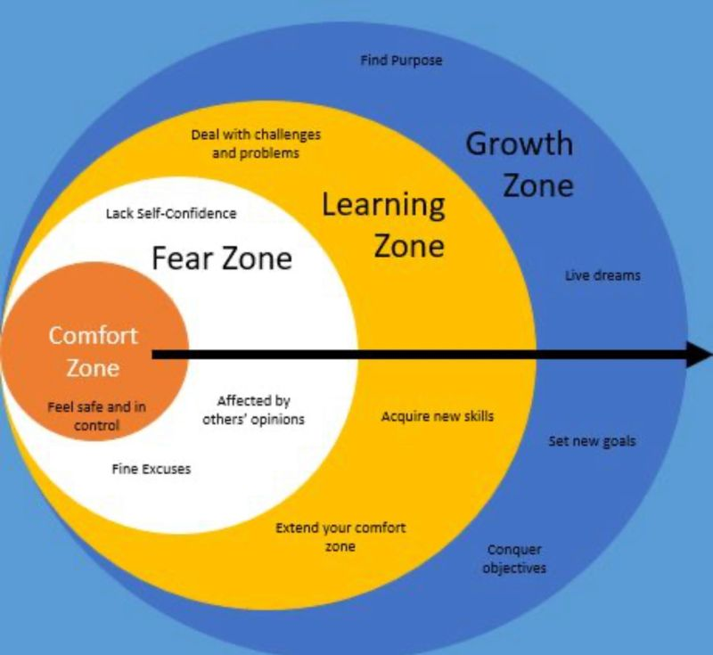

dvsvbsfdg | 45646654 | sfhsfbh

# About me

fdsjbgbfdgjh

# Work experience:

**FFF** *545456-545456*dfsjbhjsdfh

# Skills:

* adshjfbhjds