Software Design Document (SDD)
Module:Gyro Filter Driver
Version: 1
Author: David Mijares, Aldo De la Torre, Jose Paez

1. Introduction
1.1. Purpose
This document describes the design and architecture of the Gyro Filter driver module, based on the requirements defined in the SRS. It provides details on data structures, algorithms, and control flow to guide implementation and testing.
1.2. Scope
The Gyro Filter driver is a low-level software component for embedded systems. It abstracts hardware registers and provides a clean API for higher-level modules to read raw gyroscope samples, calibrate sensor bias, apply PT1/PT2/PT3 and biquad filtering, and deliver stable, ready-to-use angular-rate data in physical units.

1.3. Definitions and Acronyms
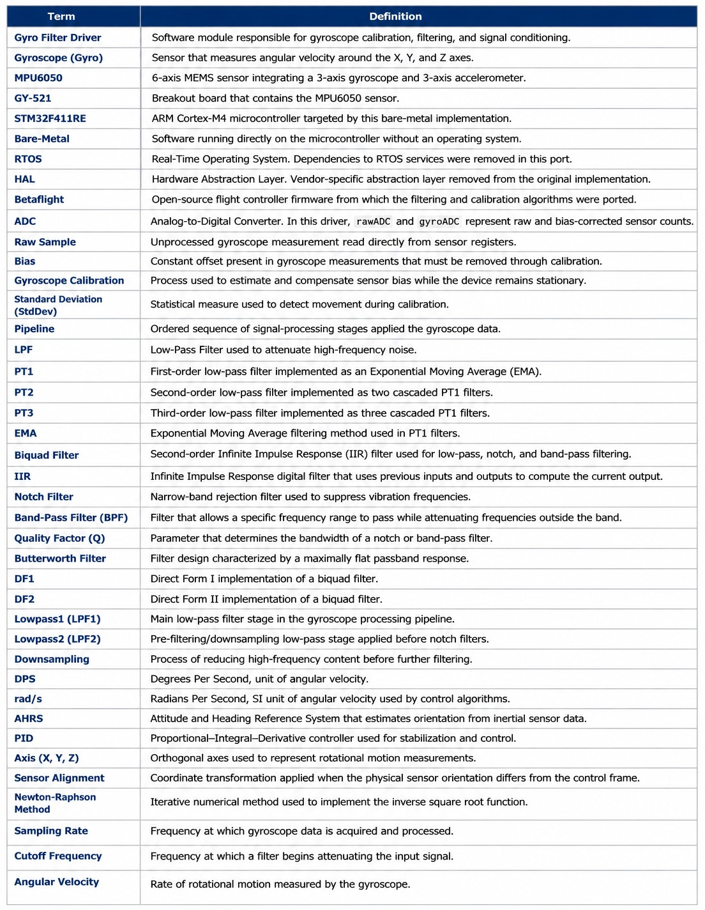

2. System Architecture
2.1. High-Level Design
- Layered Architecture:
  - Application Layer: Calls gyro_filter driver functions.
  - gyro_filter Driver Layer: Provides APIs (pt1FilterGain, pt1FilterInit, pt1FilterApply, pt2FilterGain, pt2FilterInit, pt2FilterApply, pt3FilterGain, pt3FilterInit, pt3FilterApply, biquadFilterGetNotchQ, biquadFilterInit, biquadFilterApply, biquadFilterApplyDF1, gyroCalibrationStart, gyroCalibrationIsComplete, gyroCalibrationUpdate, gyroPipelineInit, gyroPipelineUpdate).
  - Hardware Layer: Actual microcontroller gyro_filter registers.
2.2. Module Interfaces
- Public API: Functions declared in gyro_filter.h that provide gyroscope calibration, digital filtering, and signal-processing services. The API includes initialization routines, calibration management functions, filter configuration utilities, and gyroscope pipeline processing functions.
- Dependencies:
  - math_utils.h for mathematical helper functions and macros.
  - Standard C libraries (math.h, string.h, stdbool.h, stdint.h).
  - CMSIS device definitions for the STM32F411RE microcontroller.
  - Configuration parameters and data structures defined in gyro_filter.h.
- Provided Services:
  - PT1, PT2, and PT3 low-pass filtering.
  - Biquad low-pass, notch, and band-pass filtering.
  - Gyroscope bias calibration and motion detection during calibration.
  - Conversion of raw sensor measurements into physical units (°/s and rad/s).
  - Complete gyroscope processing pipeline including calibration, filtering, and output generation.

- External Interfaces:
  - Receives raw gyroscope samples acquired from the MPU6050/GY-521 sensor driver.
  - Provides filtered angular-rate measurements for flight-control, PID, or AHRS modules.

3. Detailed Design
3.1. Class Diagram
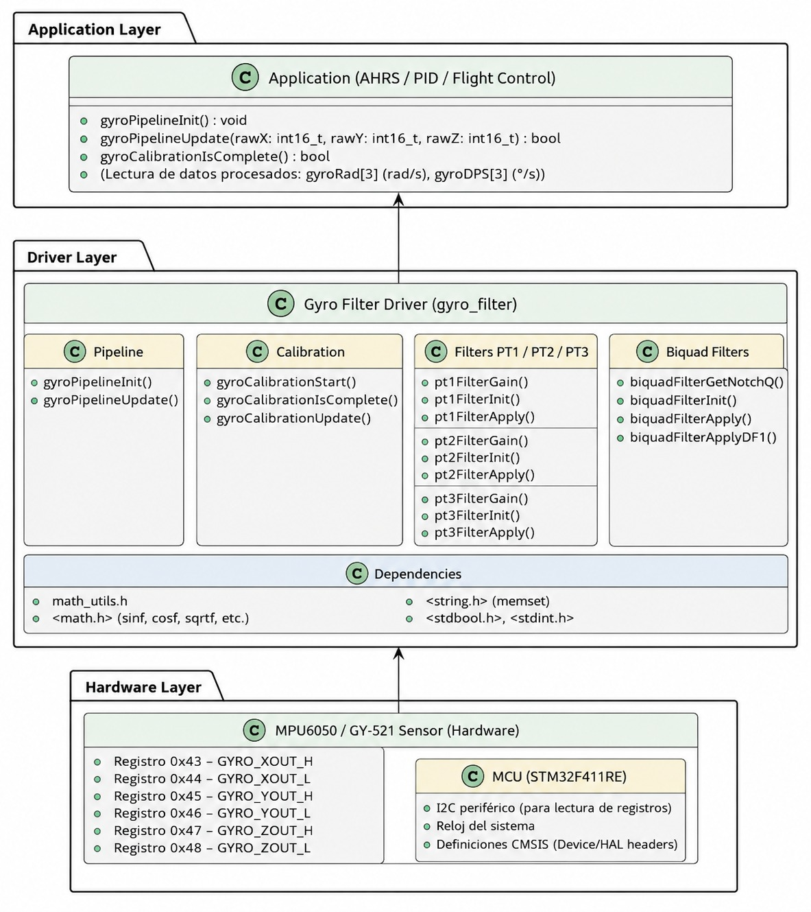
Figure 1. Class Diagram - gyro_filter Driver

3.2. Module Behavior (Sequence Diagrams, State Machines, etc.)
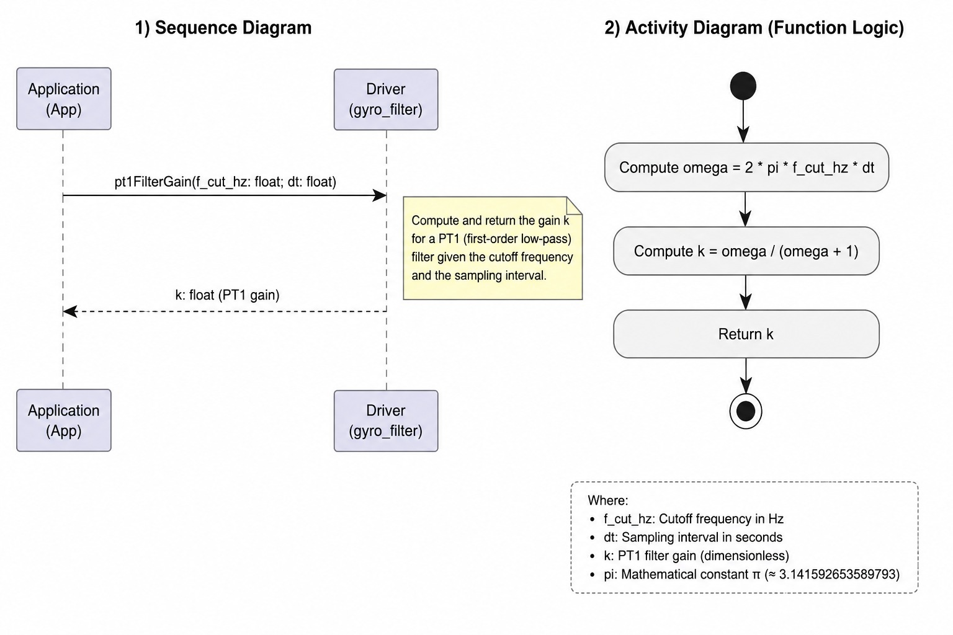
Figure 2. pt1FilterGain Diagram
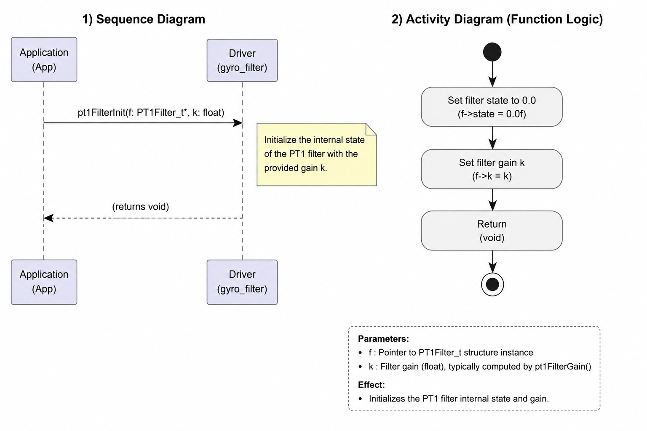
Figure 3. pt1FilterInit Diagram
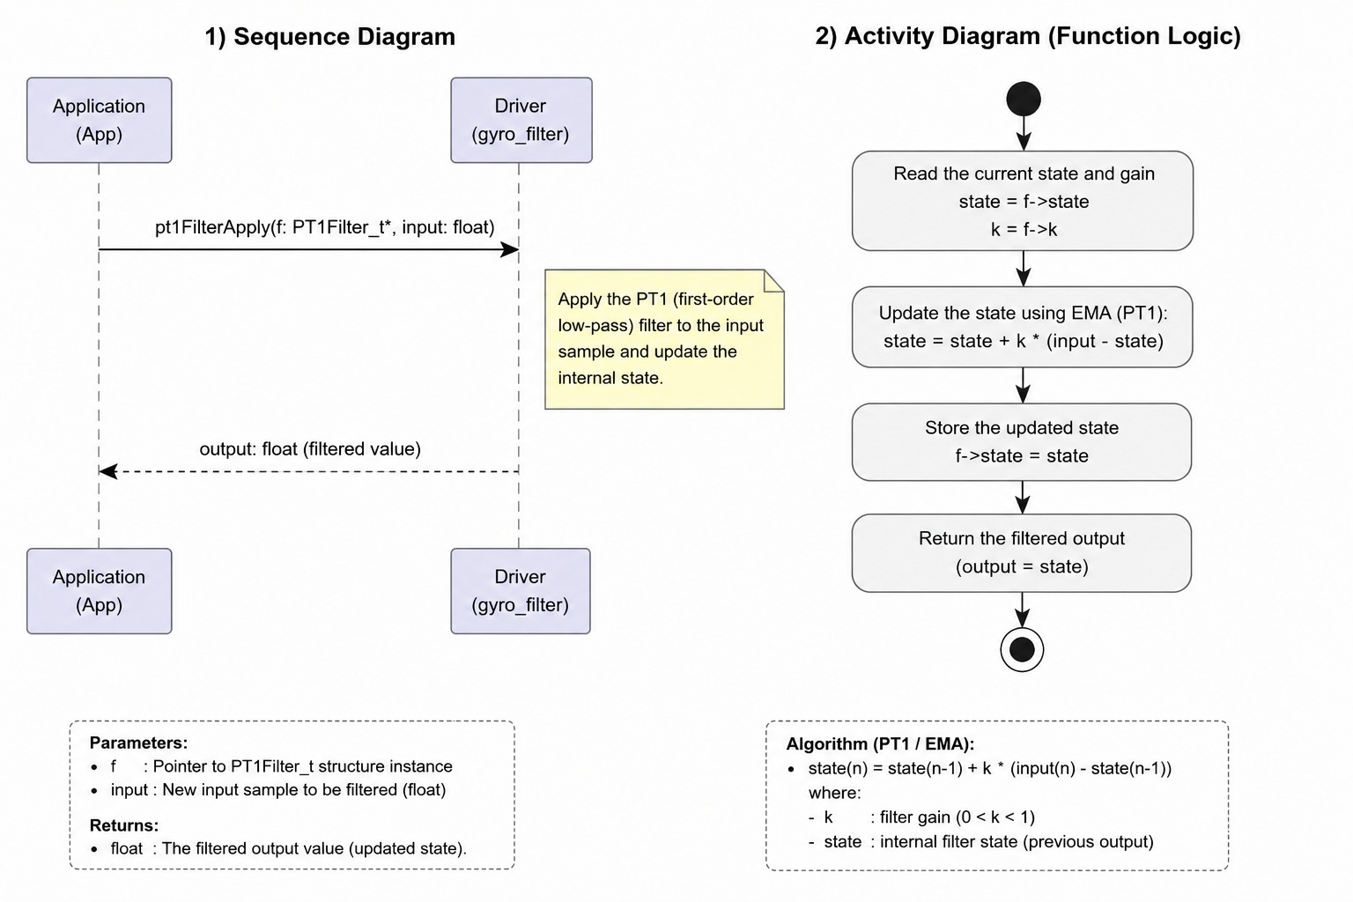
Figure 4. pt1FilterApply Diagram

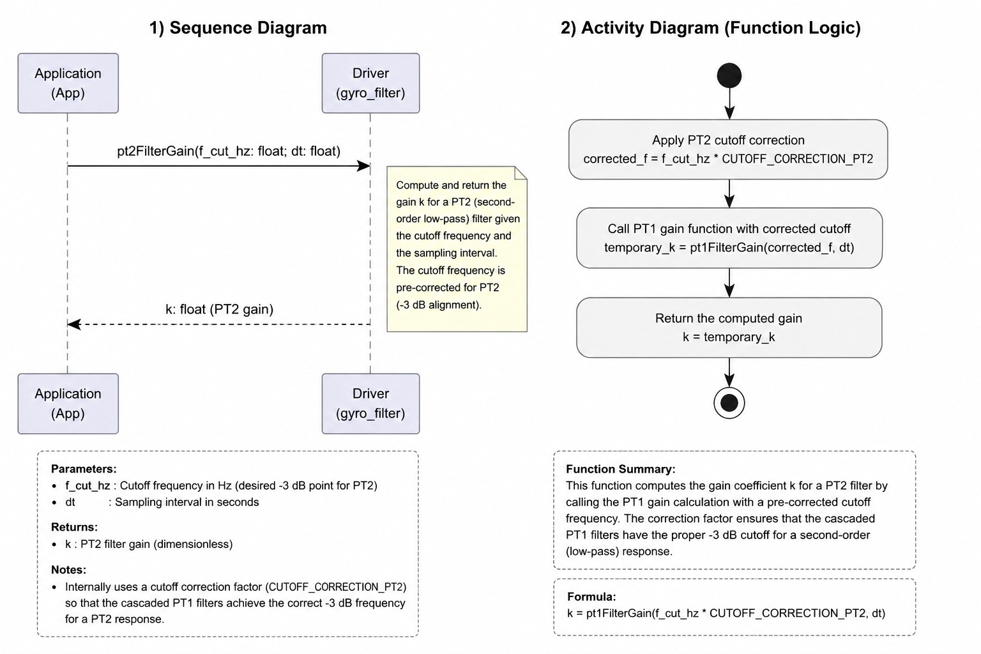
Figure 5. pt2FilterGain Diagram
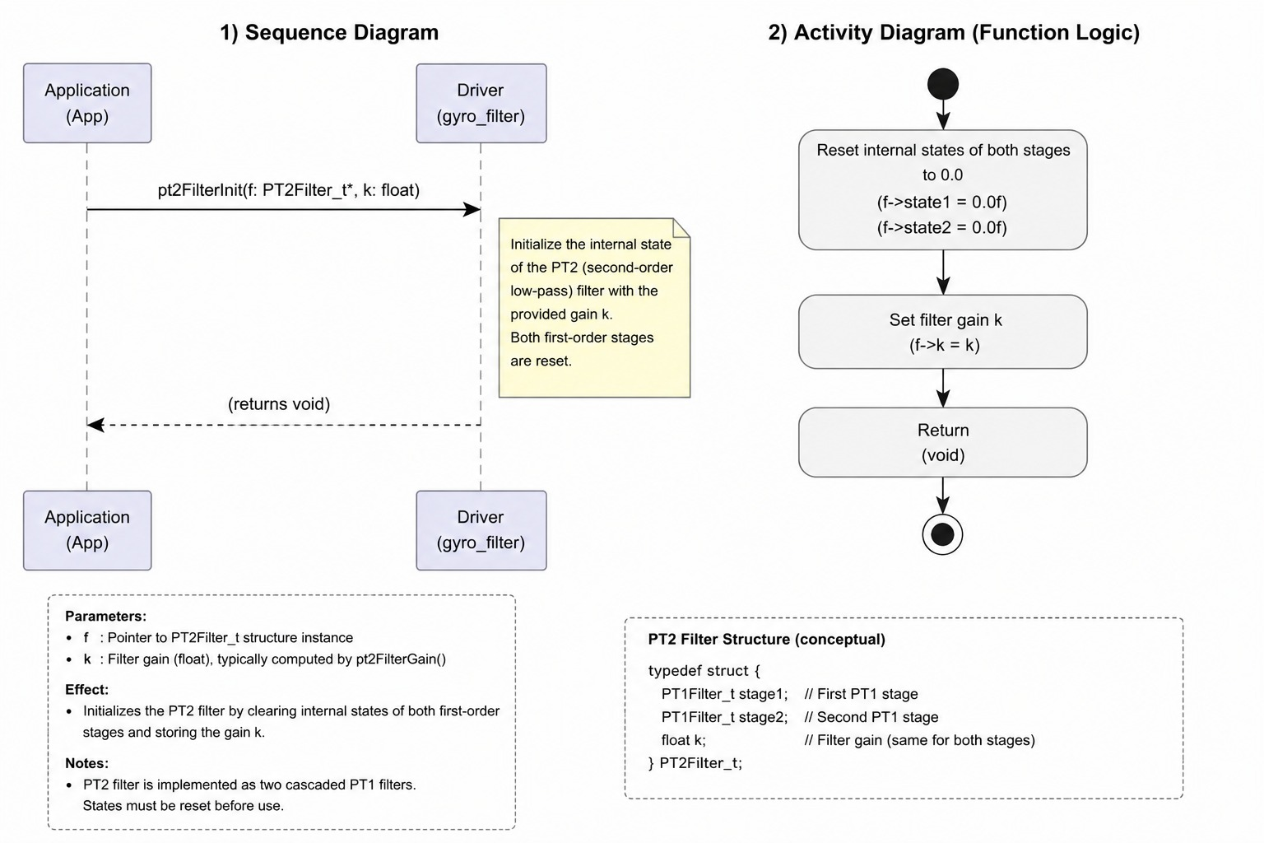
Figure 6. pt2FilterInit Diagram
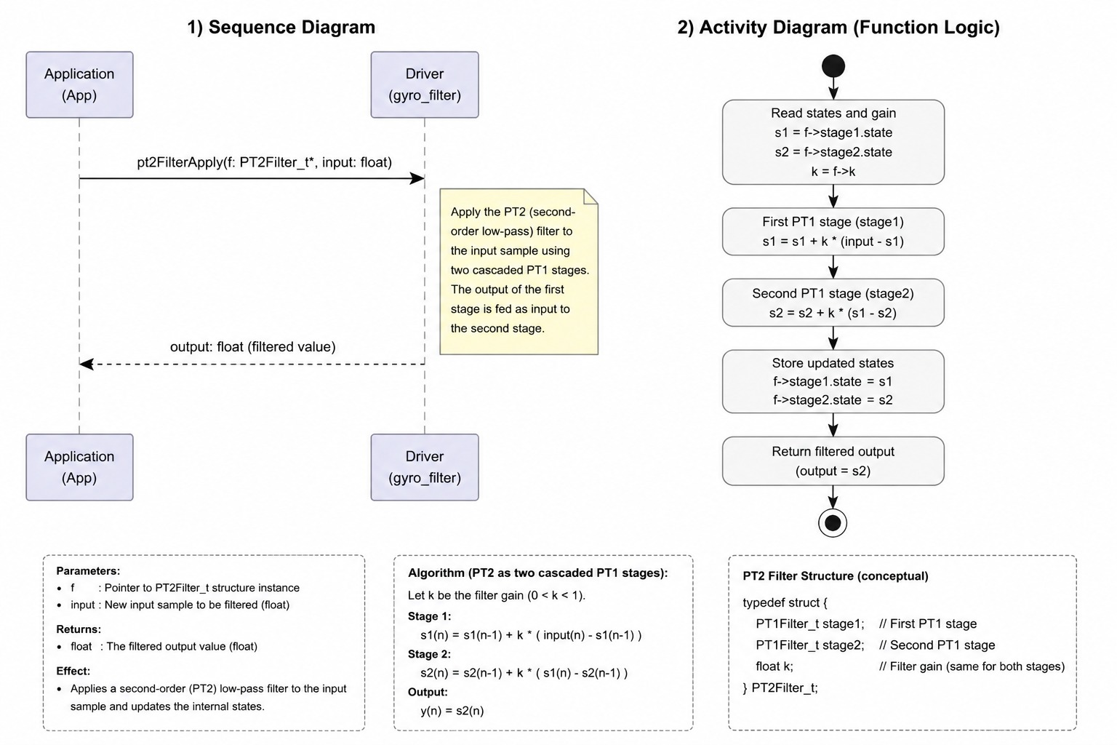
Figure 7. pt2FilterApply Diagram
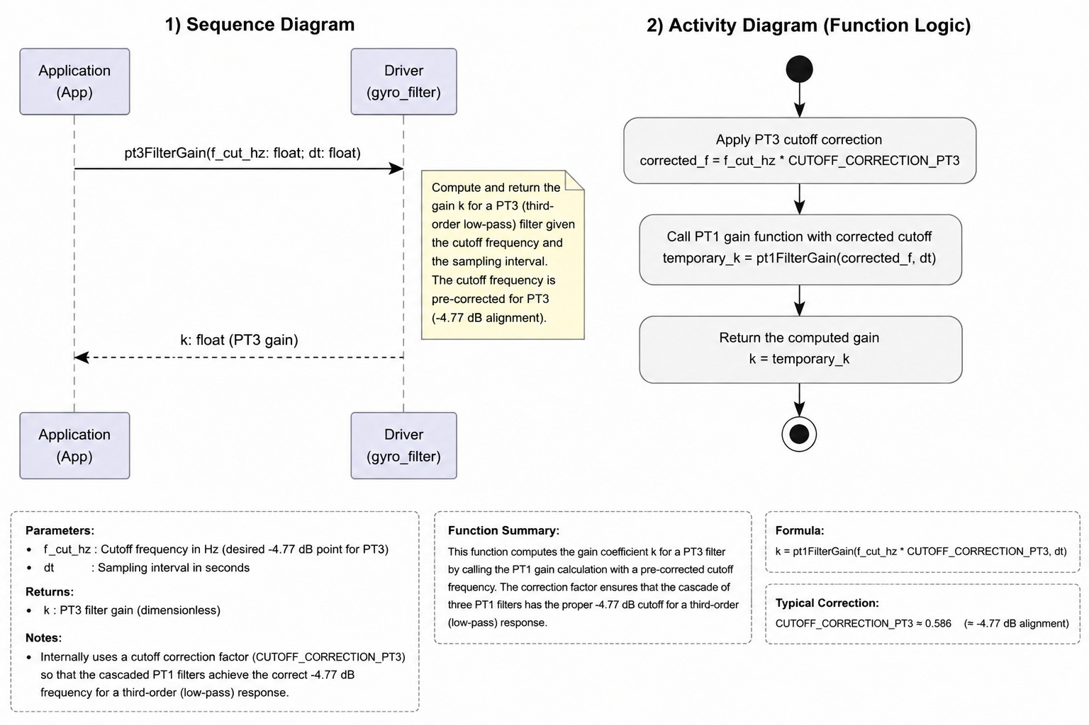
Figure 8. pt3FilterGain Diagram
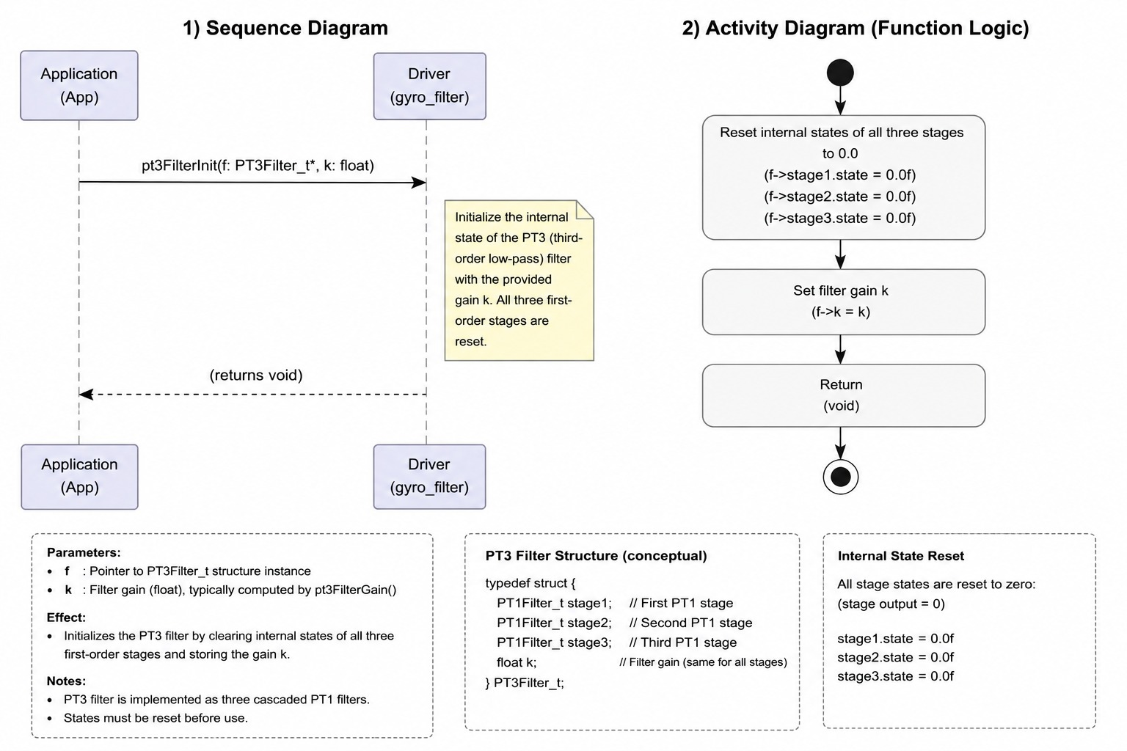
Figure 9. pt3FilterInit Diagram
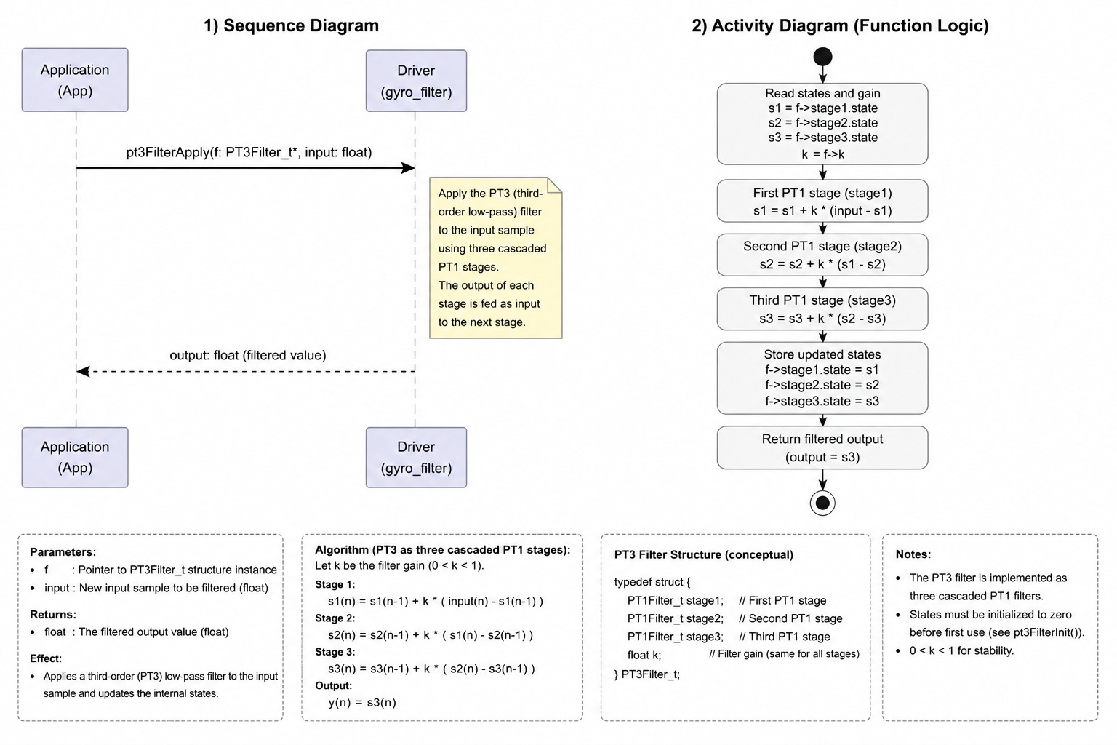
Figure 10. pt3FilterApply Diagram
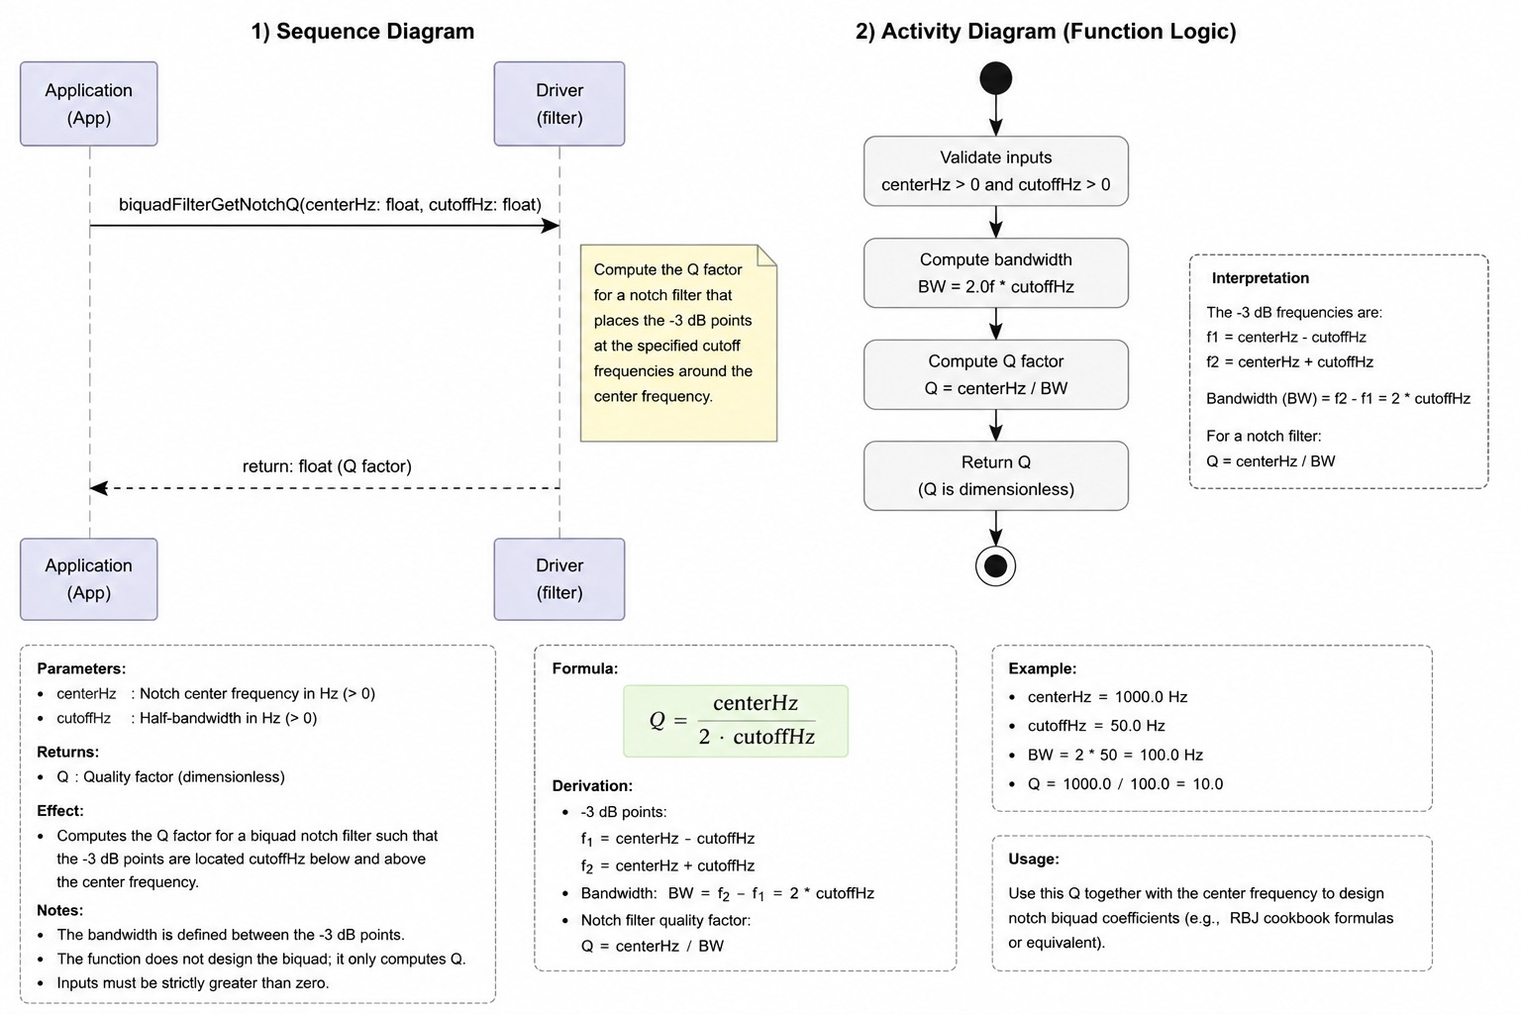
Figure 11. biquadFilterGetNotchQ Diagram

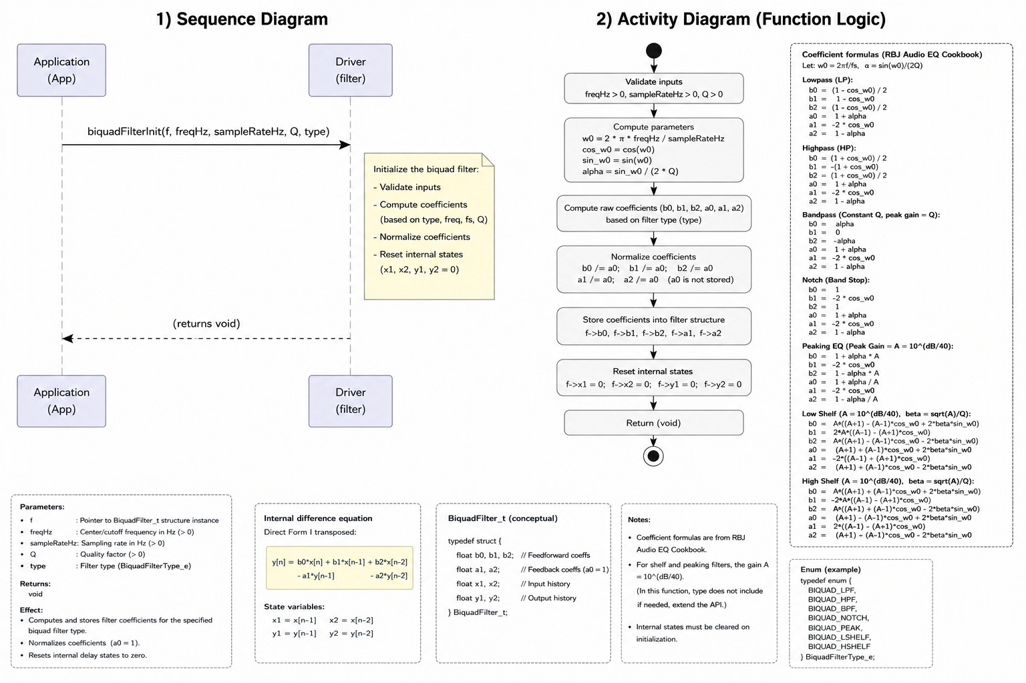

Figure 12. biquadFilterInit Diagram
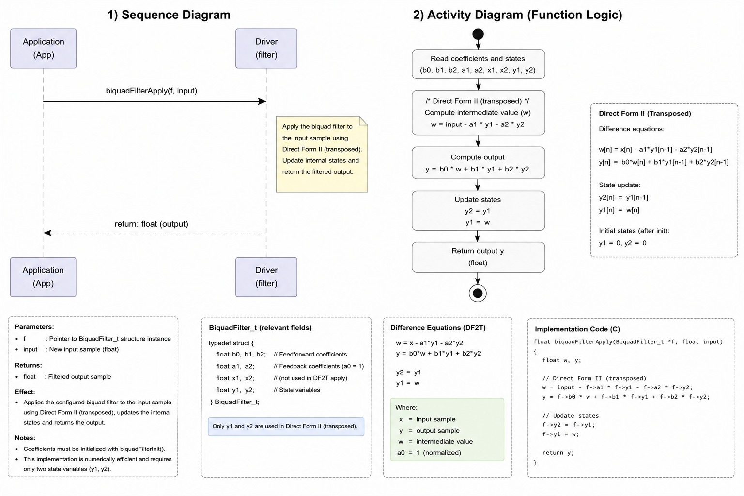

Figure 13. biquadFilterApplyDF1 Diagram
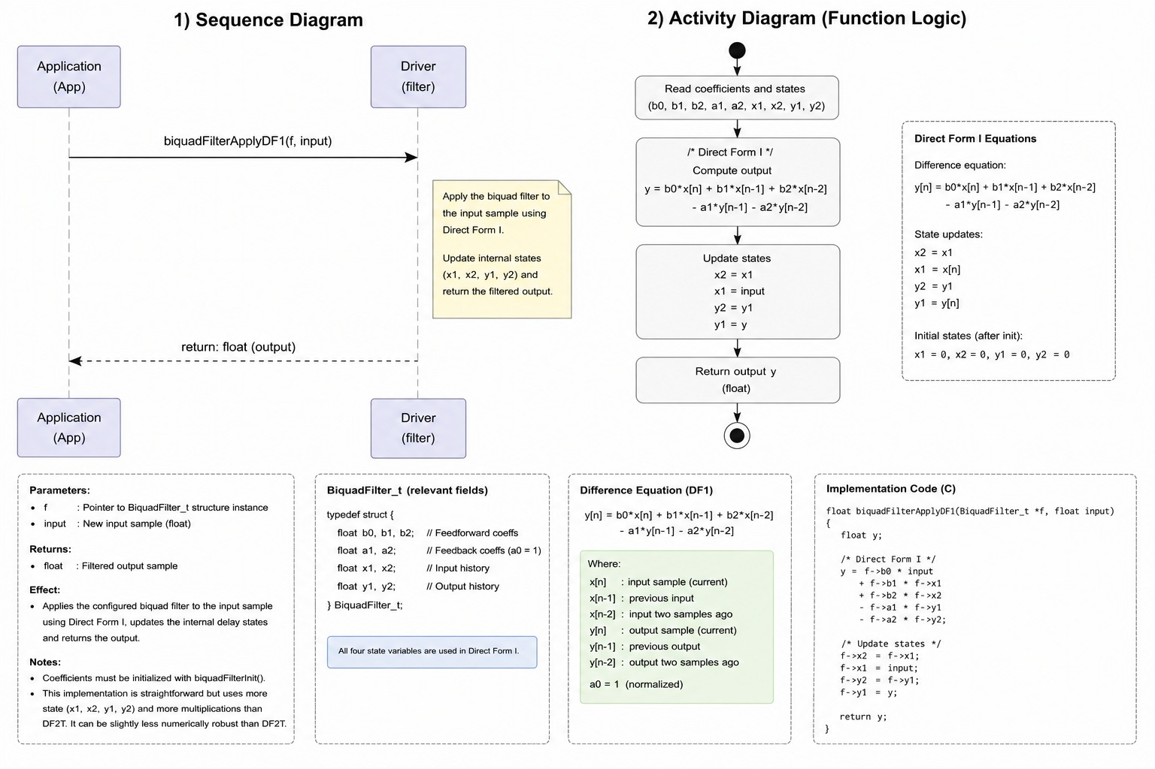
Figure 14. gyroCalibrationStart Diagram

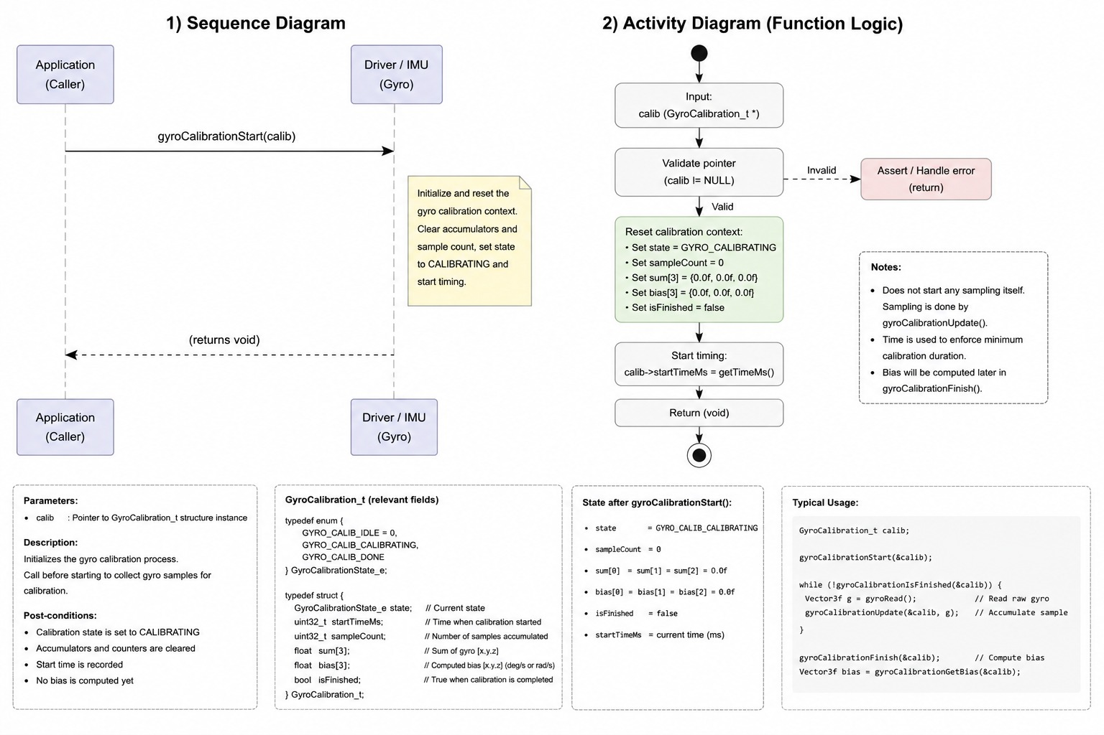
Figure 15. gyroCalibrationIsComplete Diagram
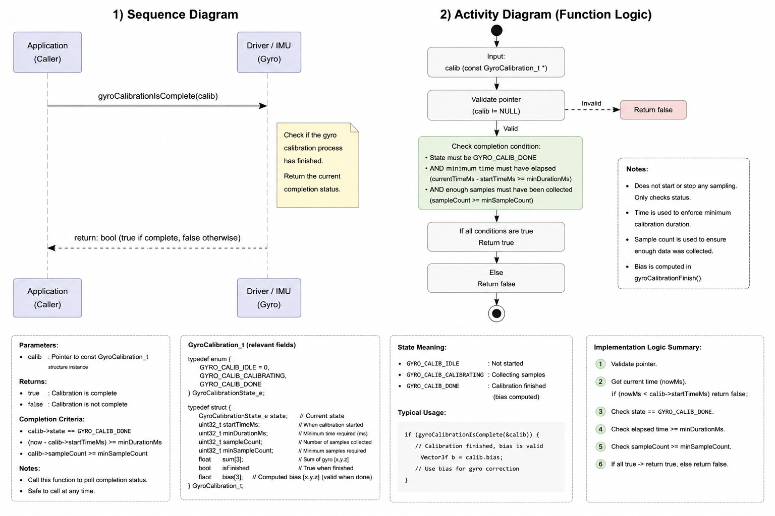
Figure 16. gyroCalibrationUpdate Diagram
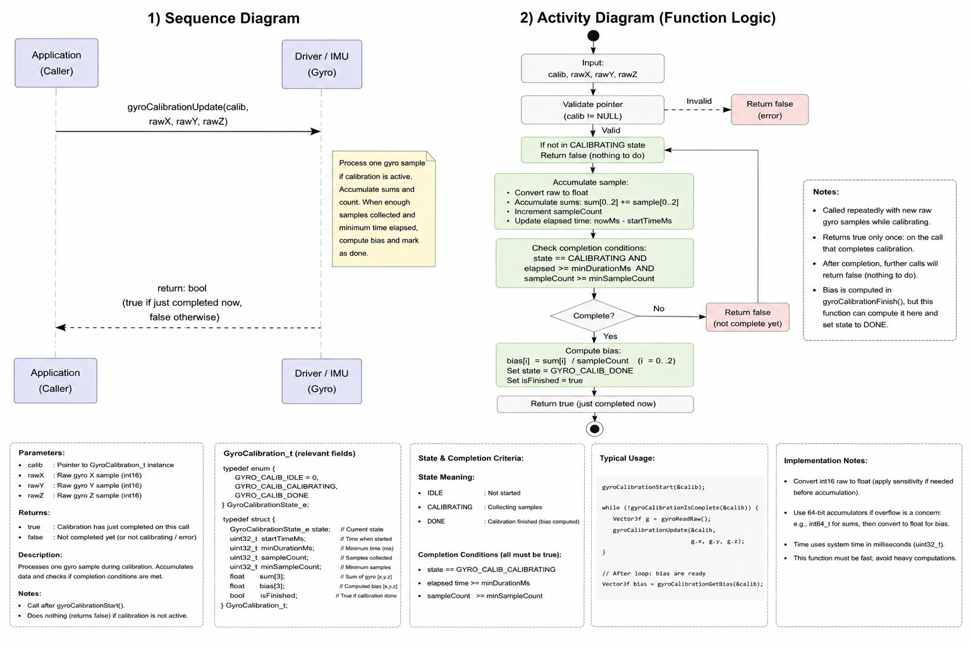
Figure 17. gyroPipelineInit Diagram
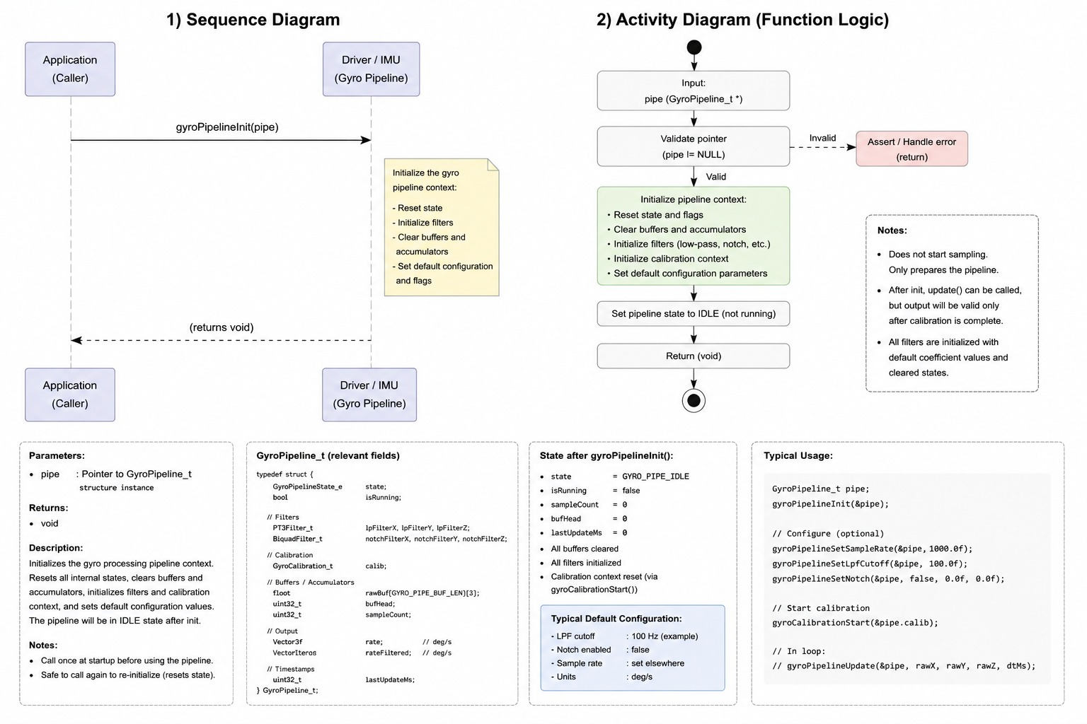
Figure 18. gyroPipelineUpdate Diagram
3.3. gyro_filter Driver
The Gyro Filter Driver is responsible for processing raw gyroscope measurements and transforming them into stable, calibrated, and filtered angular-rate data suitable for control applications such as PID controllers and AHRS systems. The driver acts as an intermediate layer between the hardware sensor (MPU6050/GY-521) and the application layer, abstracting the complexity of calibration and digital signal processing while providing a simple interface for higher-level modules.
The driver initialization process begins with gyroPipelineInit(), which configures the entire processing pipeline, resets all internal states, initializes the PT1/PT2 low-pass filters and biquad notch filters, and starts the gyroscope calibration procedure. During this stage, all filter memories and accumulators are cleared to ensure deterministic behavior from startup. The pipeline remains in a non-ready state until calibration has been completed successfully.
Gyroscope calibration is managed through the functions gyroCalibrationStart(), gyroCalibrationUpdate(), and gyroCalibrationIsComplete(). The calibration algorithm continuously accumulates raw sensor samples while the device remains stationary. For each axis, the driver computes the mean and standard deviation of the collected measurements. If excessive movement is detected, calibration is restarted automatically. Once a sufficient number of stable samples have been collected, the average value of each axis is stored as the gyroscope bias. These bias values are subsequently subtracted from all incoming measurements to compensate for sensor offset errors.

After calibration, the driver continuously processes incoming gyroscope samples through gyroPipelineUpdate(). Each new measurement undergoes a sequence of signal-conditioning stages. First, the previously calculated bias is removed from the raw sensor readings. The corrected values are then converted into physical units expressed in degrees per second (°/s). Next, the signal passes through a chain of digital filters designed to reduce measurement noise and mechanical vibrations. This chain consists of an initial PT1 low-pass filter, one or two optional biquad notch filters used to suppress specific vibration frequencies, and a final PT2 low-pass filter that provides the primary smoothing effect. The filtered result is finally converted into radians per second (rad/s), which is the unit typically required by control and attitude-estimation algorithms.

The filtering subsystem is implemented using reusable building blocks. PT1 filters provide first-order exponential smoothing, PT2 filters are implemented as two cascaded PT1 stages, and PT3 filters extend the concept to three cascaded stages for stronger attenuation of high-frequency noise. For more selective frequency rejection, the driver also provides configurable biquad filters that can operate as low-pass, notch, or band-pass filters. These filters maintain internal state variables between calls, allowing efficient real-time processing of streaming sensor data.
Overall, the driver implements a complete gyroscope signal-processing pipeline that performs bias compensation, noise reduction, vibration suppression, and unit conversion. By isolating these tasks within a dedicated module, the application layer receives clean and reliable angular-rate measurements without needing to manage calibration procedures or filter implementations directly. This modular design improves maintainability, portability, and reliability while preserving behavior consistent with the original Betaflight filtering algorithms.

4. Application Programming Interfaces
4.1. Data Types and Macros
- float: This data type represents floating-point values used for filter coefficients, cutoff frequencies, sampling intervals, angular velocities, filter states, and intermediate mathematical calculations within the gyroscope filtering algorithms.
- int16_t: This data type represents raw gyroscope measurements acquired directly from the MPU6050 sensor registers before calibration and filtering are applied.

- bool: This data type represents logical status values used to indicate calibration completion, filter activation, operation success, and pipeline readiness conditions.
- PT1Filter_t: This structure represents the internal state and gain coefficient of a first-order low-pass (PT1) filter.
- PT2Filter_t: This structure represents the internal states and gain coefficient of a second-order low-pass (PT2) filter implemented as two cascaded PT1 filter stages.
- PT3Filter_t: This structure represents the internal states and gain coefficient of a third-order low-pass (PT3) filter implemented as three cascaded PT1 filter stages.
- BiquadFilter_t: This structure represents the coefficients and internal state variables required for a second-order Infinite Impulse Response (IIR) biquad filter.
- BiquadFilterType_e: This enumeration represents the operating mode of a biquad filter, including low-pass, notch, and band-pass configurations.
- GyroCalibration_t: This structure represents the gyroscope calibration context, including accumulated samples, statistical data, calculated bias values, and calibration status information.
- GyroPipeline_t: This structure represents the complete gyroscope processing pipeline, including calibration data, filter instances, raw measurements, corrected measurements, and filtered outputs.
- Axis_e: This enumeration represents the gyroscope measurement axes (X, Y, and Z) used throughout the filtering and calibration processes.

- GyroCalibration_t:
Member Name | Type | Notes / Definition
Member Name | Type | Notes / Definition
sum | float[3] | Accumulator of raw gyroscope samples for each axis (X, Y, Z). Used to calculate the average value during calibration.
sumSq | float[3] | Accumulator of squared raw samples. Used to calculate variance and standard deviation for motion detection during calibration.
bias | float[3] | Computed gyroscope offset for each axis in raw ADC counts. This value is later subtracted from measurements to remove sensor bias.
cyclesRemaining | int32_t | Number of sampling cycles remaining before calibration is completed.

- PT1Filter_t:
Member Name | Type | Notes / Definition
state | float | Internal filter state. Stores the previous filtered output value.
k | float | Filter gain coefficient calculated from the cutoff frequency and sampling period.

- PT2Filter_t
Member Name | Type | Notes / Definition
state | float | Internal state of the first filtering stage.
state1 | float | Internal state of the second filtering stage.
k | float | Filter gain coefficient shared by both cascaded PT1 stages.

- PT3Filter_t
Member Name | Type | Notes / Definition
state | float | Internal state of the first filtering stage.
state1 | float | Internal state of the second filtering stage.
state2 | float | Internal state of the third filtering stage.
k | float | Filter gain coefficient applied to all three PT1 stages.

- BiquadFilter_t
Member Name | Type | Notes / Definition
b0 | float | First numerator coefficient of the biquad filter transfer function.
b1 | float | Second numerator coefficient of the biquad filter transfer function.
b2 | float | Third numerator coefficient of the biquad filter transfer function.
a1 | float | First denominator coefficient of the biquad filter transfer function.
a2 | float | Second denominator coefficient of the biquad filter transfer function.
x1 | float | Previous input sample (n−1).
x2 | float | Previous input sample (n−2).
y1 | float | Previous output sample (n−1).
y2 | float | Previous output sample (n−2).

- GyroPipeline_t
Member Name | Type | Notes / Definition
calib | GyroCalibration_t | Calibration structure responsible for gyroscope bias estimation and calibration management.
rawADC | float[3] | Raw gyroscope measurements for the X, Y, and Z axes in ADC counts.
gyroADC | float[3] | Bias-corrected gyroscope measurements (rawADC - bias).
gyroDPS | float[3] | Angular velocity values converted to degrees per second (°/s).
gyroRad | float[3] | Final filtered angular velocity output expressed in radians per second (rad/s).
lpf2 | PT1Filter_t[3] | Per-axis PT1 low-pass filters used for downsampling or preliminary signal smoothing.
lpf1 | PT2Filter_t[3] | Per-axis PT2 low-pass filters used as the primary gyro low-pass filtering stage.
notch1 | BiquadFilter_t[3] | First per-axis notch filter used to attenuate specific noise frequencies.
notch2 | BiquadFilter_t[3] | Second per-axis notch filter used for additional resonance or vibration suppression.
notch1Active | bool | Indicates whether the first notch filter is enabled.
notch2Active | bool | Indicates whether the second notch filter is enabled.
- BiquadFilterType_e
Member Name | Type | Notes / Definition
BIQUAD_LPF | enum value | Configures the biquad filter as a Low-Pass Filter (LPF).
BIQUAD_NOTCH | enum value | Configures the biquad filter as a Notch Filter for rejecting a specific frequency band.
BIQUAD_BPF | enum value | Configures the biquad filter as a Band-Pass Filter (BPF).

Macro Name | Type | Notes / Definition
GYRO_AXES | Macro (#define) | This macro represents the total number of gyroscope axes supported by the driver. The GYRO_AXES value is 3.
AXIS_X | Macro (#define) | This macro represents the array index corresponding to the X-axis gyroscope measurement. The AXIS_X value is 0.
AXIS_Y | Macro (#define) | This macro represents the array index corresponding to the Y-axis gyroscope measurement. The AXIS_Y value is 1.
AXIS_Z | Macro (#define) | This macro represents the array index corresponding to the Z-axis gyroscope measurement. The AXIS_Z value is 2.
GYRO_CALIB_CYCLES | Macro (#define) | This macro represents the number of samples required to complete gyroscope bias calibration. The GYRO_CALIB_CYCLES value is 2000.
GYRO_CALIB_MOVE_THRESHOLD | Macro (#define) | This macro represents the motion detection threshold used during calibration to determine whether the sensor is moving. The GYRO_CALIB_MOVE_THRESHOLD value is 110.0f.
GYRO_SCALE_DPS | Macro (#define) | This macro represents the conversion factor from raw MPU6050 counts to degrees per second. The GYRO_SCALE_DPS value is (1.0f / 16.4f).
GYRO_SCALE_RADS | Macro (#define) | This macro represents the conversion factor from raw MPU6050 counts to radians per second. The GYRO_SCALE_RADS value is (GYRO_SCALE_DPS * 0.017453292519943f).
GYRO_LOOP_HZ | Macro (#define) | This macro represents the gyroscope processing loop frequency in Hertz. The GYRO_LOOP_HZ value is 1000.
GYRO_DT | Macro (#define) | This macro represents the sampling period of the gyroscope processing loop in seconds. The GYRO_DT value is (1.0f / GYRO_LOOP_HZ).
GYRO_LPF1_HZ | Macro (#define) | This macro represents the cutoff frequency of the primary PT2 low-pass filter. The GYRO_LPF1_HZ value is 120.0f.
GYRO_LPF2_HZ | Macro (#define) | This macro represents the cutoff frequency of the PT1 low-pass filter used for downsampling. The GYRO_LPF2_HZ value is 200.0f.
GYRO_NOTCH1_HZ | Macro (#define) | This macro represents the center frequency of the first notch filter. A value of 0.0f disables the filter. The GYRO_NOTCH1_HZ value is 0.0f.
GYRO_NOTCH1_CUT_HZ | Macro (#define) | This macro represents the cutoff frequency used to calculate the Q factor of the first notch filter. The GYRO_NOTCH1_CUT_HZ value is 0.0f.
GYRO_NOTCH2_HZ | Macro (#define) | This macro represents the center frequency of the second notch filter. A value of 0.0f disables the filter. The GYRO_NOTCH2_HZ value is 0.0f.
GYRO_NOTCH2_CUT_HZ | Macro (#define) | This macro represents the cutoff frequency used to calculate the Q factor of the second notch filter. The GYRO_NOTCH2_CUT_HZ value is 0.0f.
CUTOFF_CORRECTION_PT2 | Macro (#define) | This macro represents the cutoff frequency correction factor applied when configuring PT2 filters. The CUTOFF_CORRECTION_PT2 value is 1.553773974f.
CUTOFF_CORRECTION_PT3 | Macro (#define) | This macro represents the cutoff frequency correction factor applied when configuring PT3 filters. The CUTOFF_CORRECTION_PT3 value is 1.961459177f.
BIQUAD_Q_BUTTERWORTH | Macro (#define) | This macro represents the standard Butterworth Q factor used when configuring biquad low-pass filters. The BIQUAD_Q_BUTTERWORTH value is 0.7071067811865476f.

4.2. Error Codes
The Gyro Filter Driver APIs do not define a dedicated error code enumeration. Functions in this module primarily return a bool value to indicate operation status or completion state.
Code | Notes / Definition
true | Operation completed successfully or the requested condition has been met (e.g., calibration completed, pipeline ready).
false | Operation is still in progress or the requested condition has not yet been met (e.g., calibration not completed, pipeline not ready).

4.3. Function Definitions
Function Name pt1FilterGain
Field | Description
Function name | pt1FilterGain
Syntax | float pt1FilterGain(float f_cut_hz, float dt)
Parameters (in) | f_cut_hz – Low-pass filter cutoff frequency in Hz.dt – Sampling period in seconds.
Parameters (inout) | None.
Parameters (out) | None.
Return value | float
 | Returns the filter gain coefficient (k) used by the PT1 filter implementation.
Description | Calculates the PT1 filter gain coefficient based on the specified cutoff frequency and sampling period.
Constraints | Cutoff frequency and sampling period must be greater than zero. No parameter validation is performed.
Available via | gyro_filter.h

Function Name: pt1FilterInit

Field | Description
Function name | pt1FilterInit
Syntax | void pt1FilterInit(PT1Filter_t *f, float k)
Parameters (in) | k – Filter gain coefficient.
Parameters (inout) | f – Pointer to the PT1 filter instance to initialize.
Parameters (out) | None.
Return value | void
 | No return value.
Description | Initializes a PT1 filter instance and sets its internal state.
Constraints | The filter pointer must be valid. No NULL pointer checking is performed.
Available via | gyro_filter.h

Function Name: pt1FilterApply
Field | Description
Function name | pt1FilterApply
Syntax | float pt1FilterApply(PT1Filter_t *f, float input)
Parameters (in) | input – Raw input sample.
Parameters (inout) | f – Pointer to the PT1 filter instance whose internal state will be updated.
Parameters (out) | None.
Return value | float
 | Returns the filtered output sample.
Description | Applies one iteration of the PT1 low-pass filter to the provided input sample.
Constraints | The filter instance must be initialized before use.
Available via | gyro_filter.h

Function Name: gyroCalibrationStart
Field | Description
Function name | gyroCalibrationStart
Syntax | void gyroCalibrationStart(GyroCalibration_t *calib)
Parameters (in) | None.
Parameters (inout) | calib – Pointer to the calibration structure to initialize.
Parameters (out) | None.
Return value | void
 | No return value.
Description | Starts the gyroscope calibration process by resetting accumulators, bias values, and calibration counters.
Constraints | The calibration structure pointer must be valid.
Available via | gyro_filter.h

Function Name: gyroCalibrationIsComplete

Field | Description
Function name | gyroCalibrationIsComplete
Syntax | bool gyroCalibrationIsComplete(const GyroCalibration_t *calib)
Parameters (in) | calib – Pointer to the calibration structure.
Parameters (inout) | None.
Parameters (out) | None.
Return value | bool
 | true if calibration has completed; otherwise false.
Description | Checks whether the gyroscope calibration procedure has finished.
Constraints | The calibration structure must have been initialized previously.
Available via | gyro_filter.h

Function Name: gyroCalibrationUpdate

Field | Description
Function name | gyroCalibrationUpdate
Syntax | bool gyroCalibrationUpdate(GyroCalibration_t *calib, int16_t rawX, int16_t rawY, int16_t rawZ)
Parameters (in) | rawX – Raw X-axis measurement.rawY – Raw Y-axis measurement.rawZ – Raw Z-axis measurement.
Parameters (inout) | calib – Calibration structure updated during processing.
Parameters (out) | None.
Return value | bool
 | Returns true when calibration is completed; otherwise returns false.
Description | Updates the calibration algorithm using the latest gyroscope sample and computes bias values once enough samples have been collected.
Constraints | Sensor must remain stationary during calibration for accurate bias estimation.
Available via | gyro_filter.h

Function Name: gyroPipelineInit
Field | Description
Function name | gyroPipelineInit
Syntax | void gyroPipelineInit(GyroPipeline_t *pipe)
Parameters (in) | None.
Parameters (inout) | pipe – Pointer to the gyroscope processing pipeline instance.
Parameters (out) | None.
Return value | void
 | No return value.
Description | Initializes all filters, configuration parameters, and starts gyroscope calibration.
Constraints | Must be called once before any call to gyroPipelineUpdate().
Available via | gyro_filter.h

Function Name: gyroPipelineUpdate

Field | Description
Function name | gyroPipelineUpdate
Syntax | bool gyroPipelineUpdate(GyroPipeline_t *pipe, int16_t rawX, int16_t rawY, int16_t rawZ)
Parameters (in) | rawX – Raw X-axis gyroscope sample.rawY – Raw Y-axis gyroscope sample.rawZ – Raw Z-axis gyroscope sample.
Parameters (inout) | pipe – Gyroscope processing pipeline instance updated during execution.
Parameters (out) | None.
Return value | bool
 | Returns true when calibration is complete and valid filtered output is available; otherwise returns false.
Description | Processes a single gyroscope sample through calibration, bias compensation, scaling, notch filtering, and low-pass filtering stages.
Constraints | gyroPipelineInit() must be called before use. Output values are not valid until calibration has completed.
Available via | gyro_filter.h

4.4. Internal Function Definitions
Field | Description
Function Name | gyroPipelineUpdate
Syntax | bool gyroPipelineUpdate(GyroPipeline_t *pipe, int16_t rawX, int16_t rawY, int16_t rawZ)
Parameters (in) | rawX  Raw gyroscope measurement from the X-axis sensor register.  rawY  Raw gyroscope measurement from the Y-axis sensor register.  rawZ  Raw gyroscope measurement from the Z-axis sensor register.
Parameters (inout) | pipe  Pointer to the gyroscope processing pipeline structure. The function updates calibration data, filter states, and processed output values contained in this structure.
Parameters (out) | None.
 | N/A.
Return Value | bool  Returns true when gyroscope calibration has been completed and valid filtered output data is available. Returns false while calibration is still in progress.
Description | Processes a single MPU6050 gyroscope sample through the complete signal-processing pipeline. The processing stages include calibration, bias compensation, unit conversion, optional notch filtering, low-pass filtering, and generation of angular velocity outputs in degrees per second and radians per second.
Constraints | gyroPipelineInit() must be called before using this function. Raw input values must correspond to MPU6050 gyroscope register data. Output values are not valid until the calibration procedure has completed. The function does not provide detailed error information when returning false.
Available Via | gyro_filter.h

Field | Description
Function Name | gyroPipelineInit
Syntax | void gyroPipelineInit(GyroPipeline_t *pipe)
Parameters (in) | None.  N/A.
Parameters (inout) | pipe  Pointer to the gyroscope pipeline structure to be initialized.
Parameters (out) | None.  N/A.
Return Value | void  No return value.
Description | Initializes all gyroscope processing components, including calibration structures, low-pass filters, notch filters, runtime configuration flags, and filter coefficients. The function also starts the gyroscope calibration process.
Constraints | Must be called once before any call to gyroPipelineUpdate(). The provided pointer must reference a valid GyroPipeline_t instance. No parameter validation is performed.
Available Via | gyro_filter.h

Field | Description
Function Name | gyroCalibrationUpdate
Syntax | bool gyroCalibrationUpdate(GyroCalibration_t *calib, const int16_t rawX, const int16_t rawY, const int16_t rawZ)
Parameters (in) | rawX, rawY, rawZ  Raw gyroscope measurements used for calibration bias estimation.
Parameters (inout) | calib  Pointer to the calibration structure. Internal accumulators, statistics, cycle counters, and bias values are updated during execution.
Parameters (out) | None.  N/A.
Return Value | bool  Returns true when calibration is complete. Returns false while additional samples are still required.
Description | Updates the gyroscope calibration process using the latest raw sensor sample. The function accumulates measurements, evaluates motion conditions, computes gyroscope bias values, and determines when calibration has been successfully completed.
Constraints | The gyroscope must remain stationary during calibration to ensure accurate bias estimation. Motion exceeding the configured threshold may cause calibration restart or invalid results. The function does not provide detailed error reporting.
Available Via | gyro_filter.h

5. Future Enhancements
The following enhancements may be considered for future versions of the Gyroscope Filter Driver:
- Dynamic Notch Filter Support
- Add dynamic notch filtering to automatically track and suppress vibration frequencies that change during operation, similar to advanced flight-controller implementations.
- Runtime Filter Configuration
- Allow filter cutoff frequencies, notch parameters, and calibration settings to be modified at runtime without recompilation.
- Additional Filter Types
- Support additional filtering methods such as PT3, Kalman, FIR, or adaptive filters for improved noise reduction and signal quality.
- Temperature Compensation
- Implement gyroscope bias compensation based on sensor temperature to improve long-term measurement accuracy.

- Enhanced Calibration Algorithms
- Introduce advanced calibration techniques, including automatic recalibration and bias tracking during operation.
- Error Reporting Mechanism
- Replace boolean status returns with a dedicated status/error code enumeration to provide detailed diagnostic information.
- Configurable Sampling Rate
- Support multiple sampling frequencies and automatic filter coefficient recalculation based on the selected update rate.
- DMA-Based Sensor Acquisition
- Integrate DMA-based I2C communication to reduce CPU utilization and improve real-time performance.
- Support for Additional IMUs
- Extend compatibility to newer inertial sensors such as MPU6500, MPU9250, ICM20602, ICM42688, and BMI270.
- Built-In Self-Test Functionality
- Add sensor health monitoring and self-test procedures to detect communication failures and sensor malfunctions.
- Performance Optimization
- Optimize filter calculations using ARM CMSIS-DSP libraries and floating-point unit (FPU) acceleration available on STM32F4 devices.
- Data Logging and Debug Support
- Provide optional debugging interfaces and telemetry outputs for filter tuning, calibration analysis, and performance evaluation.
- Thread-Safe Implementation
- Add synchronization mechanisms to support RTOS-based applications with concurrent access to gyroscope data.
- Unit Testing Framework
- Develop a comprehensive set of unit tests and validation procedures to verify filter behavior and calibration accuracy under different operating conditions.

