Software Design Document
MPU6050 Driver Module
Lab 05 – Microcontrollers and Embedded Systems
Module | MPU6050 Driver
Version | 1.0.0
Author(s) | J.M. Páez Sandoval, D.I. Mijares Meza, A.S. De La Torre Gomez
Institution | CETYS Universidad
Date | 29/05/2026

1. Introduction

1.1 Purpose
This document describes the design and architecture of the mpu6050_driver module for Lab 05. It covers the bus recovery sequence, GPIO alternate function configuration, sensor initialization, register configuration, and 14-byte burst read operation for the GY-521 breakout board (MPU6050).

1.2 Scope
The mpu6050_driver is a mid-level bare-metal module for the STM32F411RE targeting the InvenSense MPU6050 6-axis IMU over I2C1 at 400 kHz. It depends on i2c_driver (I2C.c) and gpio_driver (GPIO.c) for all hardware access. The module provides three public functions: initialization with bus recovery, single-register configuration, and a 14-byte burst read that returns raw accelerometer and gyroscope data in an MPU6050_t struct. Temperature data (bytes 6–7 of the burst) is read but discarded. The module is consumed by the flight controller pipeline in main.c.

1.3 Definitions, Acronyms, and Abbreviations
Term | Definition
MPU6050 | InvenSense 6-axis MEMS IMU: 3-axis accelerometer + 3-axis gyroscope
GY-521 | Breakout board carrying the MPU6050 with onboard 4.7 kΩ I2C pull-ups and 3.3V regulator
IMU | Inertial Measurement Unit — measures linear acceleration and angular velocity
MEMS | Micro-Electro-Mechanical System — silicon fabricated sensor
PWR_MGMT_1 | Register 0x6B — Power Management 1. SLEEP bit (bit 6) = 1 on power-on; cleared to 0 to wake sensor
ACCEL_XOUT_H | Register 0x3B — first of 14 consecutive registers: ACCEL (6) + TEMP (2) + GYRO (6)
WHO_AM_I | Register 0x75 — returns 0x68 to confirm device identity on the I2C bus
DLPF | Digital Low-Pass Filter — configured via register 0x1A (CONFIG). Value 0x02 = 98 Hz cutoff
Bus recovery | 9-clock-pulse sequence on SCL as GPIO output to release a stuck SDA line after a partial transaction
Big-endian | High byte transmitted first — MPU6050 default. buf[0]=AX_H, buf[1]=AX_L, etc.
ACC_SCALE_G | 1/16384 — scaling factor to convert raw accelerometer counts to g units (±2g mode)
GYRO_SCALE_DPS | 1/16.4 — scaling factor to convert raw gyroscope counts to deg/s (±2000 deg/s mode)

1.4 Requirements
All requirements are allocated in Docs/SRS/MPU6050_Driver_SRS.md (provided by instructor without modification).

2. System Architecture

2.1 High-Level Design
The mpu6050_driver sits between the flight controller pipeline (main.c) and the I2C driver. GPIO configuration for PB8/PB9 is performed internally by mpu6050_init() including the bus recovery sequence. The driver does not expose GPIO handles to the caller.

Layer | Modules
Application | main.c — calls mpu6050_init(), mpu6050_config(), mpu6050_readData() in the 1 kHz PID loop
Flight Controller | gyro_filter.c, imu_mahony.c — consume MPU6050_t fields (ax,ay,az,gx,gy,gz)
MPU6050 Driver | mpu6050_init(), mpu6050_config(), mpu6050_readData() — all sensor transactions
I2C Driver | i2c_init(), i2c_writeRegDevice(), i2c_readRegDevice() — raw I2C1 register access
Hardware | STM32F411RE I2C1. PB8=SCL, PB9=SDA, AF4, open-drain, 4.7 kΩ pull-up on GY-521 board

2.2 Module Interfaces
Public API declared in MPU6050.h. Dependencies: I2C.h, GPIO.h, stm32f4xx.h. No HAL. The caller does not configure GPIO before calling mpu6050_init() — the driver performs bus recovery and AF4 configuration internally.

3. Detailed Design

3.1 Class Diagram
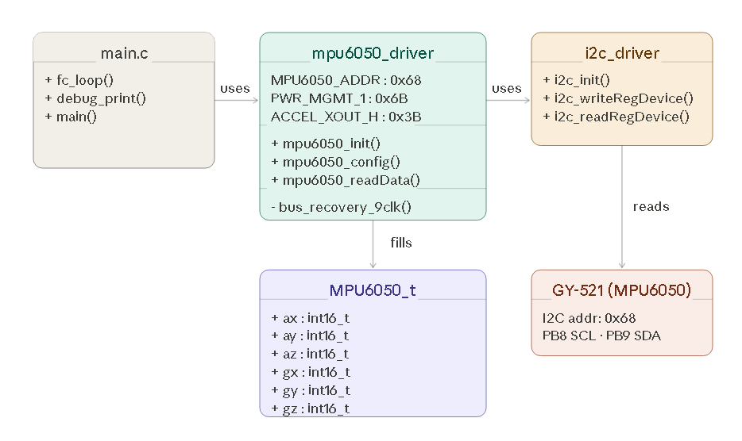
Figure 1. Class diagram - mpu6050_driver, MPU6050_t struct, i2c_driver dependency, and GY-521 hardware target.

3.2 Module Behavior
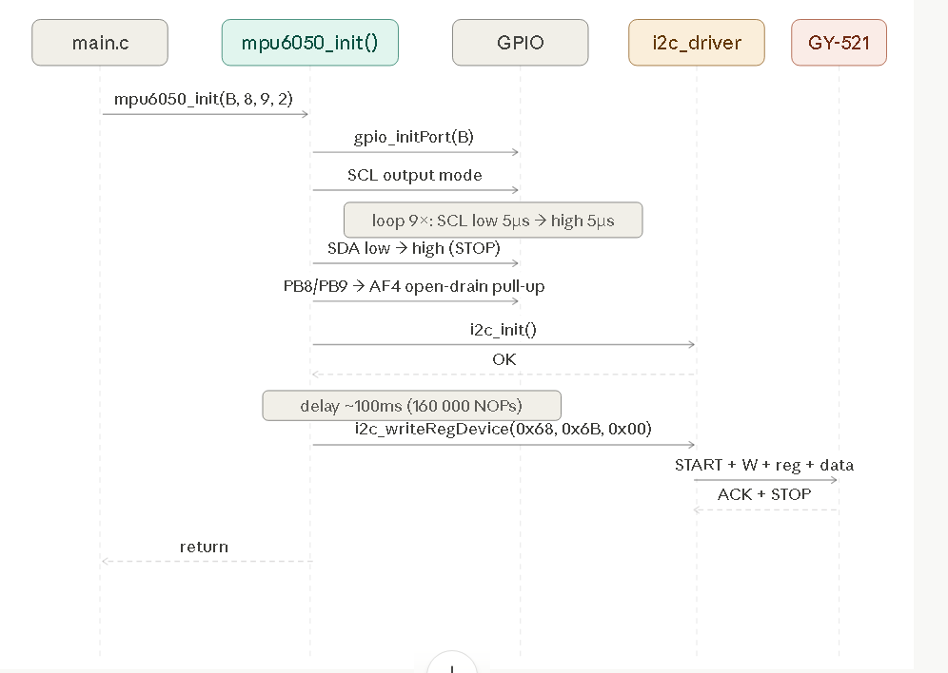
Figure 2. Sequence diagram — mpu6050_init(): bus recovery (9 SCL pulses), GPIO AF4 config, i2c_init(), 100 ms delay, PWR_MGMT_1 write.

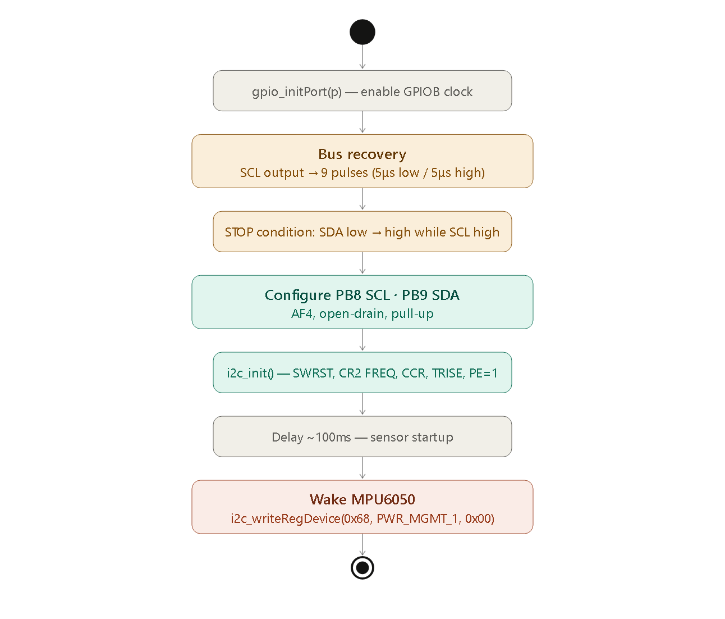
Figure 3. Activity diagram — mpu6050_init(): full initialization flow from gpio_initPort() to sensor wake-up.

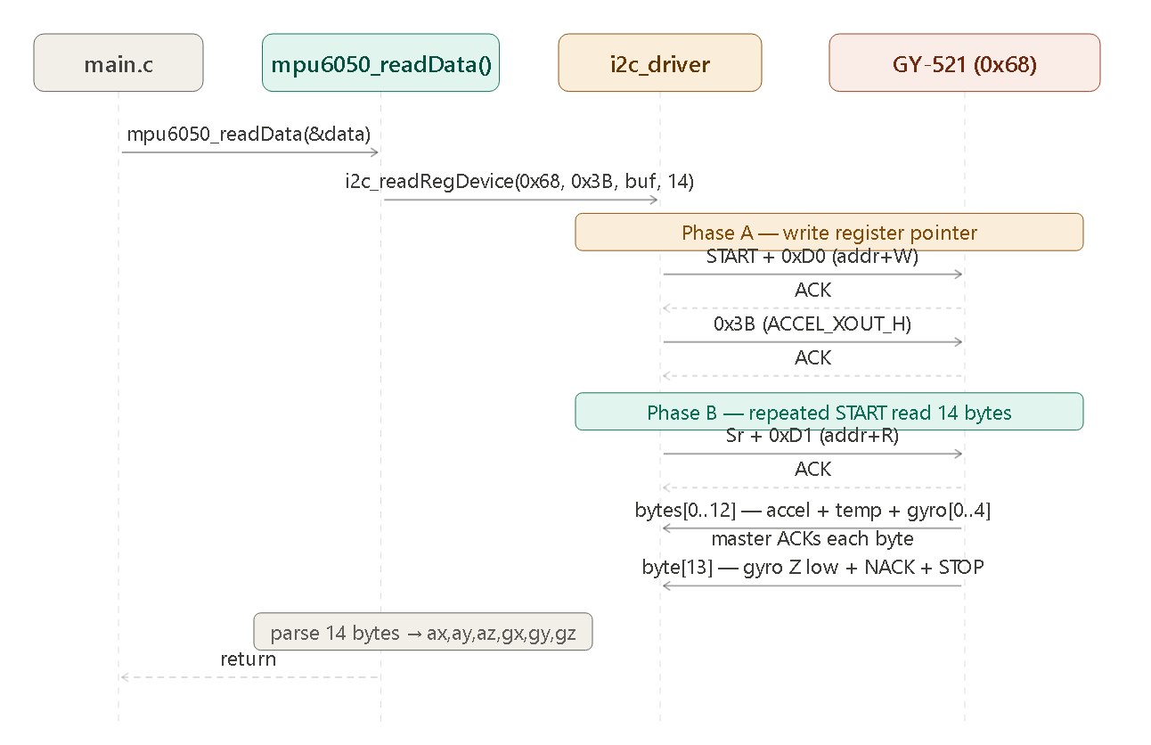
Figure 4. Sequence diagram — mpu6050_readData(): write register pointer (0x3B), repeated START, 14-byte burst read, big-endian parse.

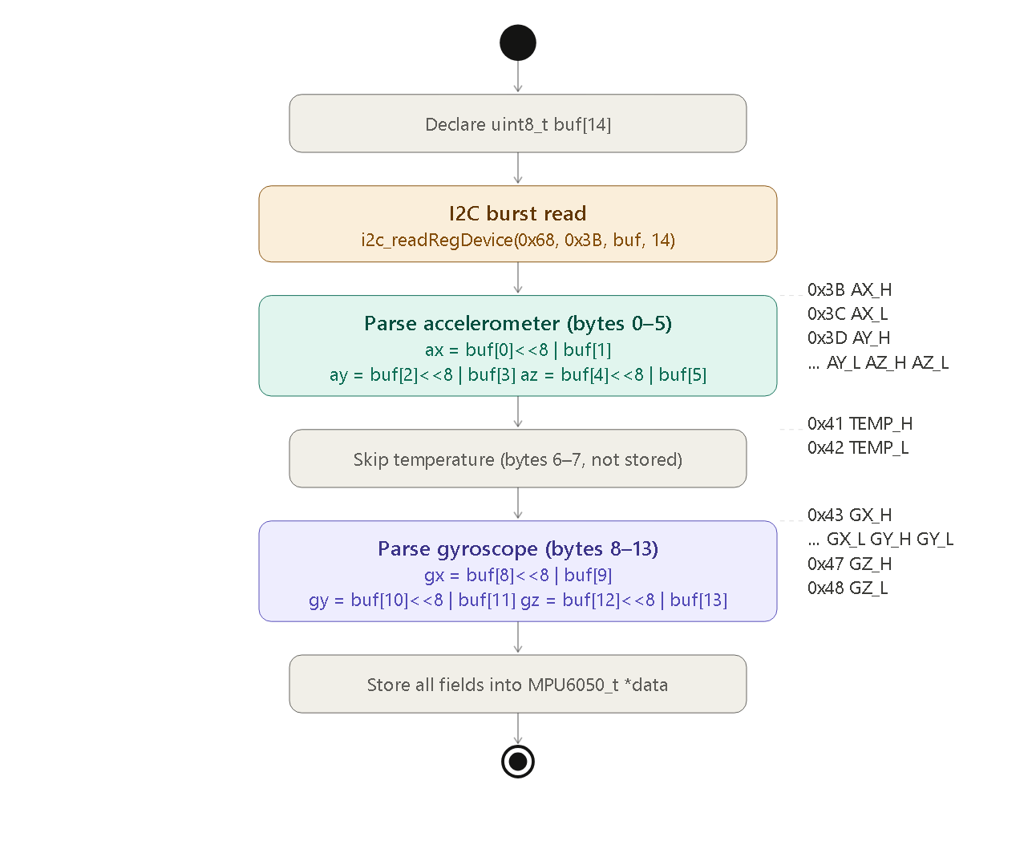
Figure 5. Activity diagram — mpu6050_readData(): burst read, skip temperature bytes 6–7, parse accel and gyro fields.

Figure 6. State diagram — MPU6050 driver states: UNINITIALIZED → SLEEPING → READY ↔ READING. mpu6050_config() is a self-transition on READY.

3.3 MPU6050 Driver Module Description
mpu6050_init() calls gpio_initPort() to enable the GPIOB clock, then performs bus recovery: it configures PB8 (SCL) as a push-pull output and drives 9 clock pulses at approximately 100 kHz (80 NOP cycles per half-period at 16 MHz HSI). It then drives a STOP condition (SDA low while SCL high, then SDA high). After bus recovery, it reconfigures PB8 and PB9 as AF4 open-drain with internal pull-up and calls i2c_init(). A blocking delay of approximately 100 ms (160 000 NOP iterations) allows the sensor to complete its internal startup sequence. Finally it calls i2c_writeRegDevice() to write 0x00 to PWR_MGMT_1 (register 0x6B), clearing the SLEEP bit and activating the sensor.

mpu6050_config() is a thin wrapper that calls i2c_writeRegDevice() to write a single byte to any MPU6050 register. It is used by main.c to configure GYRO_CONFIG (0x1B = 0x18 for ±2000 deg/s), ACCEL_CONFIG (0x1C = 0x00 for ±2g), and CONFIG (0x1A = 0x02 for 98 Hz DLPF).

mpu6050_readData() declares a 14-byte local buffer and calls i2c_readRegDevice() starting at ACCEL_XOUT_H (0x3B). The MPU6050 auto-increments its internal register pointer, returning bytes 0x3B through 0x48 in one atomic I2C transaction (write register pointer + repeated START + read 14 bytes). Bytes 0–5 carry accelerometer X/Y/Z (high byte first), bytes 6–7 carry temperature (discarded), and bytes 8–13 carry gyroscope X/Y/Z. Each 16-bit value is reconstructed as (buf[n]<<8 | buf[n+1]) and stored in the corresponding MPU6050_t field.

4. Application Programming Interfaces

4.1 Data Types and Macros
Type / Macro | Fields / Value | Notes
MPU6050_t | ax, ay, az, gx, gy, gz : int16_t | Raw sensor counts. Divide by 16384 for g, by 16.4 for deg/s
MPU6050_ADDR | 0x68 | I2C address when AD0 = GND (default on GY-521)
PWR_MGMT_1 | 0x6B | Power management register. Write 0x00 to clear SLEEP bit
ACCEL_XOUT_H | 0x3B | First register of 14-byte sensor data block
ACC_SCALE_G | 1.0f / 16384.0f | Defined in imu_mahony.h. Converts raw accel to g

4.2 Error Codes
The mpu6050_driver does not define its own error codes. mpu6050_init() and mpu6050_config() are void — I2C errors are silently absorbed by the i2c_driver timeout mechanism. mpu6050_readData() is also void; if the I2C transaction fails, the MPU6050_t struct retains its previous values or zeros from initialization.

4.3 Function Definitions

mpu6050_init
Function Name | mpu6050_init
Syntax | void mpu6050_init(port_t p, uint8_t scl_pin, uint8_t sda_pin, uint8_t mode)
Parameters (in) | p — GPIO port (B). scl_pin — 8 (PB8). sda_pin — 9 (PB9). mode — 2 (AF mode)
Return value | void
Description | Bus recovery (9 SCL pulses + STOP as GPIO output), GPIO AF4 open-drain pull-up config, i2c_init(), ~100 ms delay, write PWR_MGMT_1 = 0x00 to wake sensor.
Constraints | Blocking — ~100 ms startup delay uses NOP loops. Must be called before mpu6050_config() and mpu6050_readData(). OSPEEDR must remain at LOW for correct open-drain I2C.
Available via | MPU6050.h

mpu6050_config
Function Name | mpu6050_config
Syntax | void mpu6050_config(uint8_t reg, uint8_t value)
Parameters (in) | reg — MPU6050 register address. value — byte to write
Return value | void
Description | Thin wrapper over i2c_writeRegDevice(MPU6050_ADDR, reg, &value, 1). Used to configure GYRO_CONFIG, ACCEL_CONFIG, and DLPF after init.
Constraints | Single byte only. Call mpu6050_init() first. No NULL check — value is passed by value.
Available via | MPU6050.h

mpu6050_readData
Function Name | mpu6050_readData
Syntax | void mpu6050_readData(MPU6050_t *data)
Parameters (in) | data — pointer to MPU6050_t struct to populate
Return value | void
Description | Burst reads 14 bytes from 0x3B via i2c_readRegDevice(). Parses ax/ay/az from bytes 0–5, discards temp bytes 6–7, parses gx/gy/gz from bytes 8–13. Big-endian: value = (buf[n]<<8 | buf[n+1]).
Constraints | data must not be NULL. Temperature data is read but not stored. Call at 1 kHz maximum (I2C 400 kHz, 14 bytes ≈ 416 μs per transaction).
Available via | MPU6050.h

4.4 Internal Function Definitions
The mpu6050_driver has no static helper functions. The bus recovery sequence and all GPIO register operations are implemented inline in mpu6050_init(). The 14-byte parse is implemented inline in mpu6050_readData().

5. Future Enhancements
- Add WHO_AM_I verification in mpu6050_init(): read register 0x75 and return an error code if the response is not 0x68, enabling detection of wiring faults at startup.
- Return i2c_status_t from all public functions to propagate I2C timeout and NACK errors to the caller instead of silently discarding them.
- Add mpu6050_readAccel() and mpu6050_readGyro() variants that read only 6 bytes each for applications that need either sensor independently at higher throughput.
- Add FIFO-based burst read mode: configure the MPU6050 FIFO (registers 0x23–0x24) to accumulate samples and read them in batches, reducing I2C overhead at high sample rates.
- Add DMP (Digital Motion Processor) support: load the MotionApps firmware into the MPU6050 on-chip processor to compute quaternions in hardware, offloading the Mahony AHRS from the STM32.
- Replace NOP-based delay in mpu6050_init() with a timer-based delay using timer_delay_ms() for deterministic startup timing independent of clock frequency.

