Software Design Document
UART Driver Module
Lab 05 – Microcontrollers and Embedded Systems
Module | UART Driver
Version | 1.0.0
Author(s) | J.M. Páez Sandoval, D. I. Mijares Meza, A. S. De La Torre Gomez.
Institution | CETYS Universidad
Date | 29/05/2026

1. Introduction

1.1 Purpose
This document describes the design and architecture of the uart_driver module for Lab 05. It covers the bare-metal USART2 initialization sequence, character and string transmission, integer and float formatting helpers, and the mapping to the STM32F411RE ST-Link Virtual COM Port (VCP).

1.2 Scope
The uart_driver is a low-level bare-metal module for the STM32F411RE USART2 peripheral. It operates in transmit-only mode using polling (no interrupts, no DMA). It is fixed at 115200 baud with 8N1 framing. The module is used by main.c to stream real-time telemetry — attitude angles, PID outputs, and motor PWM values — over the ST-Link USB connection to a host serial terminal. GPIO configuration for PA2 (TX) is performed internally by uart_init().

1.3 Definitions, Acronyms, and Abbreviations
Term | Definition
UART / USART | Universal (Synchronous/) Asynchronous Receiver/Transmitter
VCP | Virtual COM Port — USART2 is routed through the ST-Link USB bridge on the Nucleo board
PA2 | GPIO pin A2 — USART2_TX (AF7). Not physically accessible; routed to ST-Link internally
8N1 | 8 data bits, No parity, 1 stop bit — standard serial framing
BRR | Baud Rate Register — USART2->BRR. Controls clock division for target baud rate
TXE | Transmit Data Register Empty flag (SR bit 7) — set when DR can accept next byte
TC | Transmission Complete flag (SR bit 6) — set when shift register is empty
AF7 | Alternate Function 7 — USART2 TX/RX function for PA2/PA3 on STM32F4
TE | Transmitter Enable bit (CR1 bit 3) — must be set to transmit
UE | USART Enable bit (CR1 bit 13) — enables the USART peripheral

1.4 Requirements
All requirements are allocated in Docs/SRS/UART_Driver_SRS.md (provided by instructor without modification).

2. System Architecture

2.1 High-Level Design
The uart_driver sits directly above the USART2 hardware registers. GPIO pin configuration for PA2 is performed internally by uart_init() using direct register access. The driver has no dependencies other than stm32f411xe.h.

Layer | Modules
Application | main.c — calls uart_sendLine(), uart_sendFloat(), uart_sendInt() for telemetry
UART Driver | uart_init(), uart_sendChar(), uart_sendString(), uart_sendFloat(), uart_sendInt(), uart_sendLine()
Hardware | STM32F411RE USART2 (APB1). PA2 = TX (AF7), routed to ST-Link VCP. 115200 baud, 8N1.

2.2 Module Interfaces
Public API declared in UART.h. Dependency: stm32f4xx.h only. No HAL. The driver configures PA2 as AF7 output internally — the caller does not need to configure GPIO before calling uart_init().

3. Detailed Design

3.1 Module Behavior
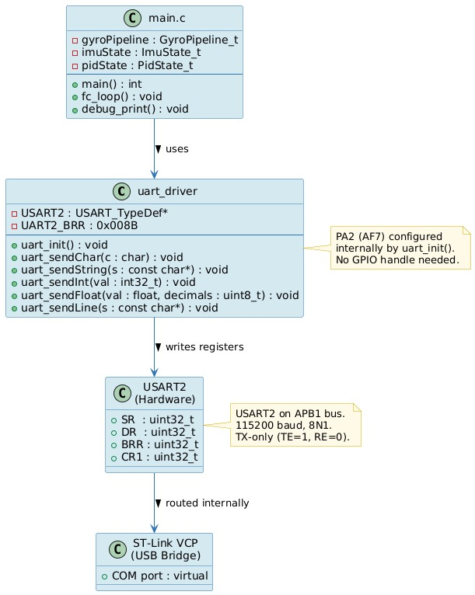
Figure 1. Sequence Diagram — uart_init(): clock enable (GPIOA + USART2), PA2 mode/AF/speed configuration, BRR write, CR1 TE+UE enable.

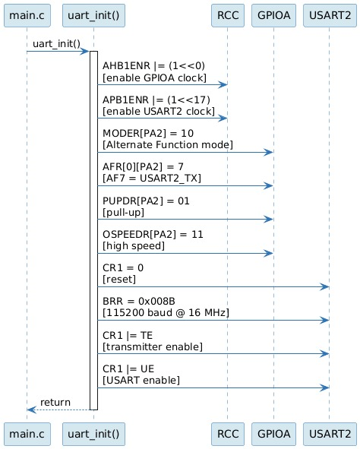
Figure 2. Activity Diagram — uart_sendChar(): poll TXE flag, write byte to DR.

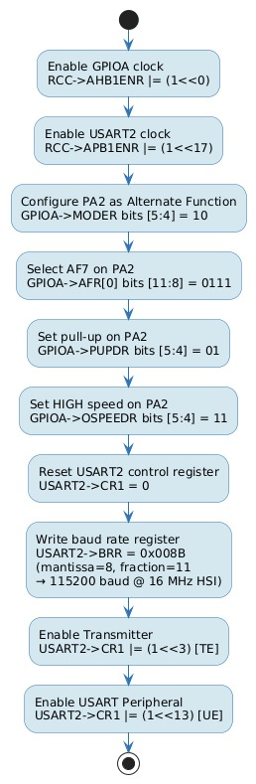
Figure 3. Activity Diagram — uart_sendFloat(): extract sign, integer part, decimal digits iteratively.

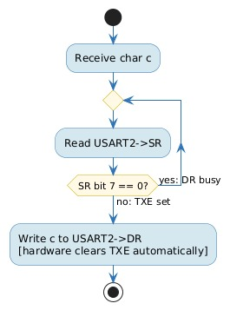
Figure 4. Activity Diagram — uart_sendChar(): polls TXE flag, writes byte to DR.

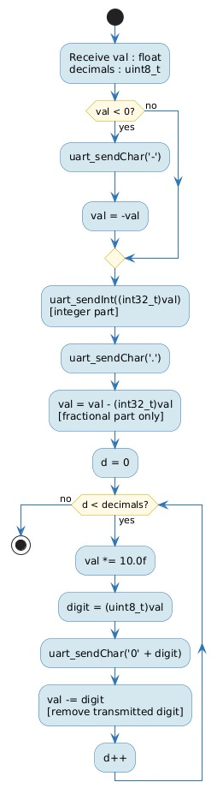
Figure 5. Activity Diagram — uart_sendFloat(): extracts sign, integer part, and decimal digits iteratively.

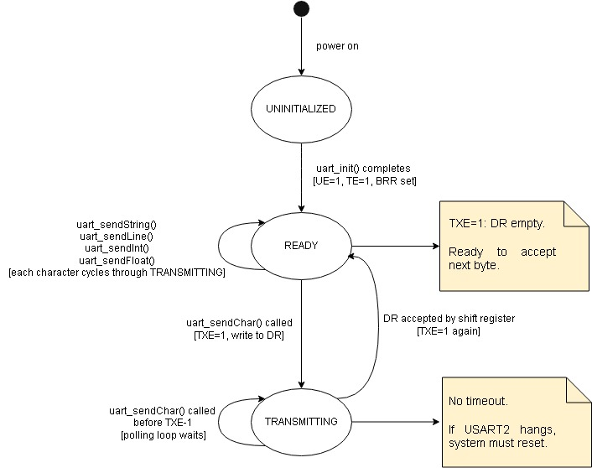
Figure 3. Activity Diagram — uart_init(): clock enable, GPIO AF7 configuration, BRR write, TE+UE enable.

3.2 UART Driver Module Description
uart_init() enables the APB2 clock for GPIOA and the APB1 clock for USART2. It configures PA2 as Alternate Function mode (MODER=10), selects AF7 in AFRL, sets output speed to HIGH, and enables the internal pull-up. It then writes BRR = 0x008B (derived from 16 MHz HSI: mantissa=8, fraction=11) for 115200 baud, sets TE and UE in CR1, and returns. No interrupt or DMA bits are set.

uart_sendChar() polls the TXE flag in USART2->SR. Once set, it writes the byte to USART2->DR. The hardware clears TXE automatically.

uart_sendString() iterates over a null-terminated string calling uart_sendChar() for each byte.

uart_sendInt() handles the sign bit, then extracts decimal digits into a local buffer using modulo/divide by 10, reverses the buffer, and transmits each character. A zero input transmits '0' directly.

uart_sendFloat() calls uart_sendInt() for the integer part, transmits a decimal point, then iterates over the requested number of decimal digits by multiplying the fractional part by 10 and extracting each digit individually.

uart_sendLine() calls uart_sendString() followed by uart_sendChar('\r') and uart_sendChar('\n') to terminate the line for both Windows and Unix terminals.

4. Application Programming Interfaces

4.1 Data Types and Macros
Macro / Constant | Value | Notes
UART2_BRR | 0x008B | BRR for 115200 baud at 16 MHz HSI. Mantissa=8, Fraction=11
(none) | — | No handle struct — module uses USART2 directly (single instance)

4.2 Error Codes
The uart_driver does not define error codes. All functions are void or return void. Transmit errors (e.g., stuck TXE) result in an infinite polling loop; the caller cannot recover without a system reset. This is acceptable for a debug-only telemetry channel.

4.3 Function Definitions

uart_init
Function Name | uart_init
Syntax | void uart_init(void)
Parameters (in) | None
Return value | void
Description | Enables GPIOA and USART2 clocks. Configures PA2 as AF7 (USART2_TX) with HIGH speed and pull-up. Writes BRR = 0x008B for 115200 baud at 16 MHz. Sets CR1: TE=1, UE=1.
Constraints | Must be called before any other uart_* function. USART2 clock is on APB1 (RCC->APB1ENR bit 17). GPIOA clock is on AHB1 (RCC->AHB1ENR bit 0).
Available via | UART.h

uart_sendChar
Function Name | uart_sendChar
Syntax | void uart_sendChar(char c)
Parameters (in) | c — byte to transmit
Return value | void
Description | Polls USART2->SR bit 7 (TXE) until set, then writes c to USART2->DR. Blocks until the data register is ready.
Constraints | Blocking — will spin indefinitely if USART2 is not initialized or the peripheral hangs. Call uart_init() first.
Available via | UART.h

uart_sendString
Function Name | uart_sendString
Syntax | void uart_sendString(const char *s)
Parameters (in) | s — null-terminated C string to transmit
Return value | void
Description | Iterates over s calling uart_sendChar() for each byte until '\0' is reached. Does not transmit the null terminator.
Constraints | s must be null-terminated. Passing NULL is undefined behavior.
Available via | UART.h

uart_sendInt
Function Name | uart_sendInt
Syntax | void uart_sendInt(int32_t val)
Parameters (in) | val — signed 32-bit integer to transmit as decimal ASCII
Return value | void
Description | Transmits the '-' character if val < 0, then negates val. Handles val == 0 by transmitting '0'. Otherwise extracts digits least-significant-first into a 12-byte buffer, reverses, and transmits.
Constraints | Maximum value: INT32_MIN (-2147483648) through INT32_MAX (2147483647). Output is always decimal (base 10).
Available via | UART.h

uart_sendFloat
Function Name | uart_sendFloat
Syntax | void uart_sendFloat(float val, uint8_t decimals)
Parameters (in) | val — float value to transmit. decimals — number of decimal places (0–6 recommended)
Return value | void
Description | Transmits '-' if val < 0, then calls uart_sendInt() for the integer part, transmits '.', then iterates decimals times multiplying the fractional part by 10 and transmitting each digit.
Constraints | No rounding — truncates the last digit. Large decimals values (>6) may produce garbage due to float precision limits. NaN and Inf are not handled.
Available via | UART.h

uart_sendLine
Function Name | uart_sendLine
Syntax | void uart_sendLine(const char *s)
Parameters (in) | s — null-terminated C string
Return value | void
Description | Calls uart_sendString(s) then transmits '\r' and '\n'. Produces CRLF line termination compatible with PuTTY, CoolTerm, and minicom.
Constraints | s must be null-terminated. Passing NULL is undefined behavior.
Available via | UART.h

4.4 Internal Function Definitions
The uart_driver has no static helper functions. All USART2 protocol steps (clock enable, GPIO config, BRR write, poll-and-transmit) are implemented inline in the public API functions.

5. Future Enhancements
- Add DMA-based TX to free the CPU during string transmissions (currently each byte blocks ~8.7 μs at 115200 baud).
- Add interrupt-driven TX with a circular buffer to prevent telemetry from stalling the 1 kHz PID loop.
- Add uart_sendHex() for printing raw register values during hardware debugging.
- Add RX support (PA3, AF7) with a ring buffer for future RC receiver input over UART.
- Implement printf-style uart_printf() using a lightweight formatting layer to reduce call-site verbosity in main.c.
- Add configurable baud rate parameter to uart_init() to support 921600 baud for higher-throughput Blackbox logging.

