Software Design Document (SDD)
Module: imu_mahony — AHRS Mahony Filter Driver

Module | imu_mahony
Version | 1.1.0
Authors | De La Torre Gomez Aldo Sebastian 37969 /  David Isaac Mijares Meza 32948 /  Jose Manuel Paez Sandoval 37945 /
Target | STM32F411RE Nucleo — GY-521 (MPU6050)
Based on | Betaflight 4.5.1 (GPL-3.0) — src/main/flight/imu.c
Date | 2025

1. Introduction

1.1. Purpose
This document describes the software design and architecture of the imu_mahony driver module developed for the STM32F411RE Nucleo board with a GY-521 (MPU6050) IMU, as part of the Microcontrollers and Embedded Systems course at CETYS Universidad. The design is ported from Betaflight 4.5.1 (GPL-3.0) and provides details on data structures, quaternion mathematics, algorithms, and control flow to guide implementation and testing of the Attitude and Heading Reference System (AHRS) based on the Mahony filter.
This SDD also serves as a reference for maintenance, testing, and future improvements of the orientation estimation subsystem of the drone firmware. It covers the same level of detail as SDD-GPIO_Driver v1.0, including per-function sequence diagrams, activity diagrams, a state diagram, and a full requirements table.

1.2. Scope
The imu_mahony driver is a low-level sensor-fusion software component. It abstracts all quaternion and rotation-matrix computations and provides a clean C API for higher-level modules to obtain the drone's 3D orientation in real time. The system performs the following specific operations:
- Fuses gyroscope (rad/s) and accelerometer (g) data using the Mahony AHRS complementary filter algorithm.
- Maintains a unit quaternion q = {w, x, y, z} representing the drone's 3D orientation without gimbal lock.
- Derives a 3×3 Direction Cosine Matrix (rMat / DCM) from the quaternion for gravity-vector comparison.
- Computes roll, pitch, and yaw Euler angles in decidegrees (×10) using the ZYX aerospace convention.
- Applies dynamic gain management: high proportional gain (Kp × 10) during the first 500 ms for fast convergence.
- Gates the integral correction term when the drone spin rate exceeds 20°/s to prevent integrator windup.
- Validates accelerometer magnitude (0.9 g – 1.1 g) before using it for tilt correction.
- Does not depend on HAL libraries — all math uses direct C floating-point arithmetic and standard libm.

The following Betaflight features were intentionally excluded to reduce complexity:
- GPS heading correction (Course Over Ground)
- Magnetometer support
- HEADFREE mode
- Scheduler / timeUs_t integration
- DEBUG_SET / ARMING_FLAG macros
- imuCalcKpGain() state machine (simplified to a cycle counter)
- Approximation functions sincosf_approx() / atan2_approx() (replaced by standard libm)

1.3. Definitions, Acronyms, and Abbreviations
Term | Definition
AHRS | Attitude and Heading Reference System — computes 3D orientation from IMU data
IMU | Inertial Measurement Unit — sensor package with gyroscope and accelerometer
MPU6050 | 6-axis gyroscope + accelerometer IC by InvenSense (mounted on GY-521 breakout)
Quaternion | Mathematical 4-component rotation representation q = {w,x,y,z}, with |q| = 1
rMat / DCM | Rotation Matrix / Direction Cosine Matrix — 3×3 matrix derived from the quaternion
Kp / Ki | Proportional / Integral gains of the Mahony PI filter in orientation error space
Euler | Roll, Pitch, Yaw angles using ZYX convention (yaw applied first, roll last)
Decidegree | Angle unit equal to 0.1°; used to store angles as int16_t without floats
g | Gravitational acceleration unit (~9.81 m/s²); accelerometer output normalized to this
LSB | Least Significant Bit — raw ADC output unit of the MPU6050 (16384 LSB/g at ±2g)
CCW / CW | Counter-clockwise / Clockwise — used to define positive rotation convention
Gimbal Lock | Singularity in Euler-angle representation at ±90° pitch — not present in quaternions
invSqrt | Fast inverse square root from math_utils.h: computes 1/√x efficiently
FR-x / NFR-x | Functional / Non-Functional Requirement x defined in SRS-imu_mahony

1.4. Requirements
All requirements for this module are allocated in SRS-imu_mahony v1.0. This document covers FR-1 through FR-6 (functional) and NFR-1 through NFR-4 (non-functional).
Req. ID | Type | Description
FR-1 | Functional | imuInit() shall initialize ImuState_t: set quaternion to identity {1,0,0,0}, clear all integral accumulators, set dcmKp = IMU_DCM_KP_FAST for 500 cycles, and compute the initial rotation matrix.
FR-2 | Functional | imuMahonyUpdate() shall execute the complete 8-step Mahony filter each call: gain management, spin rate, acc correction, integral update, gyro correction, quaternion integration, normalization, and Euler computation.
FR-3 | Functional | imuMahonyUpdate() shall normalize the accelerometer input before computing the cross-product error, and skip the correction step if useAcc == false or the vector magnitude is below 0.01.
FR-4 | Functional | imuMahonyUpdate() shall gate the integral term when spin_rate >= 20°/s and reset integralFBx/y/z to zero when dcmKi == 0 to prevent windup.
FR-5 | Functional | imuComputeEuler() shall compute roll, pitch, and yaw from rMat using the ZYX Euler convention, store as decidegrees int16_t, and normalize yaw to [0, 3600) decidegrees.
FR-6 | Functional | imuAccIsHealthy() shall return true only when the accelerometer vector magnitude is strictly between 0.9 g and 1.1 g.
NFR-1 | Non-Functional | No dynamic memory allocation; no HAL/LL dependency. All state is in caller-provided ImuState_t; all math uses float arithmetic and standard libm.
NFR-2 | Non-Functional | imuMahonyUpdate() shall complete in bounded O(1) time per call with no internal loops.
NFR-3 | Non-Functional | Quaternion norm shall be maintained at 1.0f ± 1e-6 after each update via invSqrt() normalization.
NFR-4 | Non-Functional | The driver shall support stable operation at 1 kHz (dt = 0.001 s) for typical drone angular rates up to ±2000°/s.

2. System Architecture

2.1. High-Level Design
The module follows a strict layered architecture where each layer communicates only with the layer directly below it:
- Application Layer: Calls imuInit() once at startup, then imuMahonyUpdate() every 1 ms. Reads attitude via the inline getters imuGetRollDeg(), imuGetPitchDeg(), imuGetYawDeg(). Passes imuAccIsHealthy() result as the useAcc flag.
- imu_mahony Driver Layer: Implements the Mahony AHRS filter. Maintains quaternion state, rotation matrix, and Euler angles in ImuState_t. Exposes the public API from imu_mahony.h.
- Math Utilities Layer: Provides invSqrt() and sq() via math_utils.h. These primitives are the only non-standard C dependencies.
- Hardware Layer: MPU6050 accessed externally via I²C/SPI. Raw data are pre-scaled to rad/s and g by the caller before reaching this driver. The driver has no direct sensor bus access.
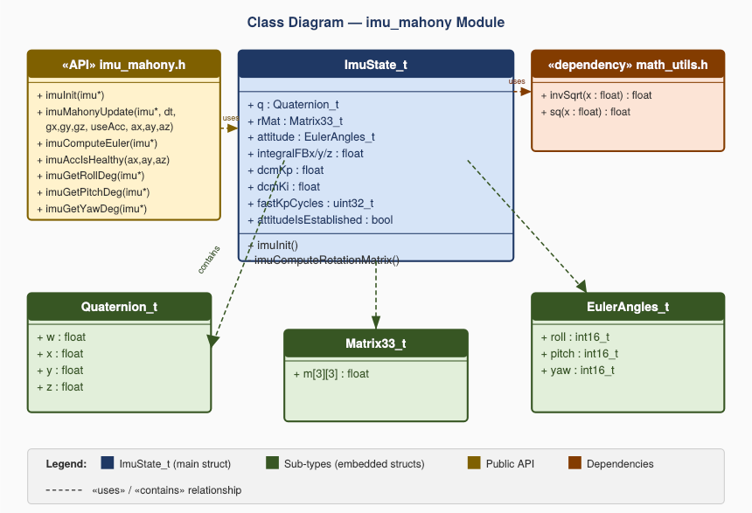
Fig. 1 — Layered Architecture Diagram. The imu_mahony driver sits between the application and the math utilities layer. Raw sensor data enter from the hardware layer (pre-scaled by the caller); orientation angles exit to the application layer. No layer skips.

2.2. Module Interfaces
- Public API: Functions and types declared in imu_mahony.h with the imu prefix. All public functions accept a pointer to the caller-allocated ImuState_t structure.
- Dependencies: math_utils.h (invSqrt, sq); <stdint.h>, <stdbool.h>, <string.h>, <math.h>. No HAL, LL, or vendor middleware required (NFR-1).
- Internal Functions: imuComputeRotationMatrix() is declared static in imu_mahony.c and is not part of the public API. Called automatically after each quaternion normalization.

3. Detailed Design

3.1. Module Description

A. imu_mahony Driver Module (imu_mahony.c / imu_mahony.h)
Responsible for the complete AHRS sensor-fusion pipeline. The core challenge is that the gyroscope measures angular velocity (rad/s), not absolute angles: pure integration accumulates drift indefinitely. The accelerometer measures absolute tilt but is noisy under vibration and linear acceleration. The Mahony filter solves this by using a PI controller in the orientation error space, represented as a unit quaternion.
Why quaternions instead of Euler angles or a rotation matrix:
- 4 floats vs. 9 floats (rotation matrix) — less memory and fewer multiplications per update.
- No gimbal lock — Euler angles have a mathematical singularity at ±90° pitch that quaternions avoid.
- Trivial renormalization — maintaining unit norm requires a single invSqrt() call.
- Smooth interpolation — quaternion SLERP provides smoother transitions than Euler blending.

B. Math Utilities (math_utils.h)
Provides two inlined primitives: sq(x) returns x×x; invSqrt(x) computes 1/√x efficiently. Both are used repeatedly in the update loop and in the accelerometer normalization step.

C. Application Integration (main.c / pid.c)
The application is responsible for: (1) scaling raw MPU6050 data to rad/s and g before passing to the driver; (2) calling imuAccIsHealthy() and passing its result as useAcc; (3) not consuming attitude angles until imuIsHealthy() returns true; (4) calling imuMahonyUpdate() at a fixed rate matching the dt parameter.

3.2. Module Behavior
The AHRS filter operates in three behavioral phases, modeled as states:
UNINITIALIZED — Before imuInit(): ImuState_t contains undefined data. attitudeIsEstablished = false. No angle output should be consumed.
FAST_CONVERGENCE — First 500 cycles after imuInit(): Quaternion starts at identity {1,0,0,0}. dcmKp = 2.5f (10× normal). The filter aggressively drives toward the accelerometer reading to establish orientation rapidly. fastKpCycles counts down from 500 to 0.
NORMAL_OPERATION — After cycle 500: dcmKp drops to 0.25f. Correction is gentler, prioritizing the gyroscope integration with slow accelerometer assistance. attitudeIsEstablished = true after the first update call.
ACC_GATED — Sub-state within NORMAL_OPERATION when spin_rate > 20°/s: The integral feedback (integralFBx/y/z) is frozen to prevent windup during rapid maneuvers. The proportional Kp correction may still apply.
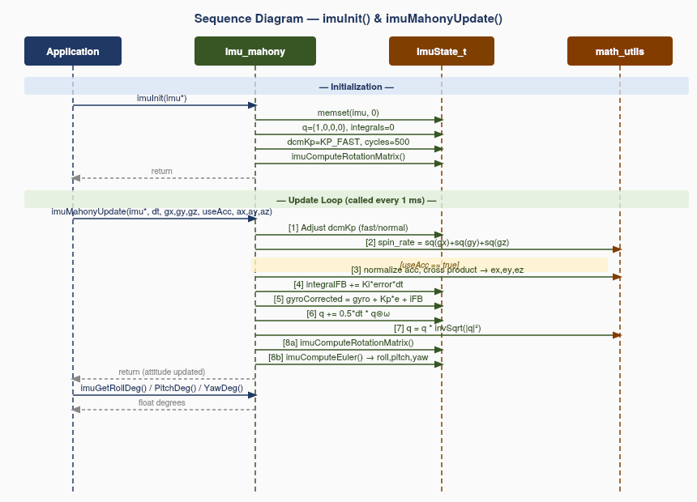
Fig. 2 — State Diagram: imu_mahony AHRS. System starts UNINITIALIZED, enters FAST_CONVERGENCE after imuInit() for the first 500 cycles (~500 ms at 1 kHz), then transitions to NORMAL_OPERATION. When spin_rate exceeds 20°/s the integral is gated (ACC_GATED sub-state); it re-enables when the drone spin slows below the threshold.

3.2.1. Per-Function Sequence and Activity Diagrams

imuInit() — FR-1: AHRS Initialization
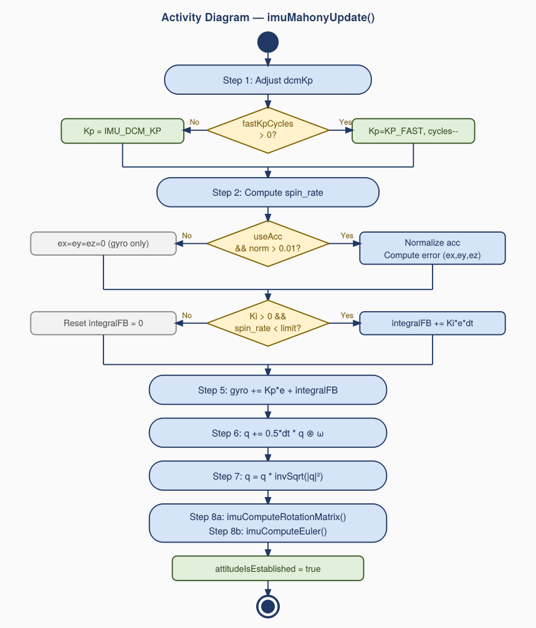
Fig. 3 — Sequence Diagram: imuInit(). The caller sends a single message to the imu_mahony driver. Internally the driver performs five sequential actions — memset, quaternion identity assignment, integral reset, gain configuration, and rotation matrix computation — all on the ImuState_t structure. No hardware register is accessed.

The sequence diagram for imuInit() shows that the function takes a single ImuState_t pointer and returns no status value (void). The caller sends one message to the driver; internally, the driver performs five actions with no conditional branching. First, memset(imu, 0, sizeof(ImuState_t)) clears all fields to zero in a single operation. Then the quaternion is set to identity {1.0f, 0.0f, 0.0f, 0.0f}, representing a drone at rest with no rotation relative to the world frame. Integral accumulators remain at zero from the memset. The high-gain convergence phase is configured: dcmKp = IMU_DCM_KP_FAST = 2.5f and fastKpCycles = 500. Finally, imuComputeRotationMatrix() is called to populate imu->rMat from the identity quaternion, producing the 3×3 identity matrix. This ensures rMat is valid before the first imuMahonyUpdate() call and prevents a null gravity vector in Step 3.
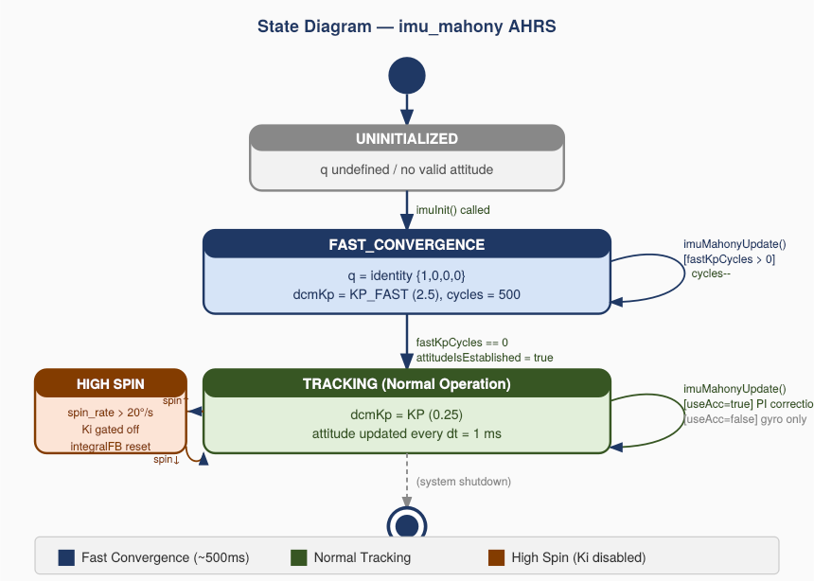
Fig. 4 — Activity Diagram: imuInit(). A purely sequential flow with no decision nodes. Five actions execute in order: clear structure, set quaternion identity, reset integrals, configure fast-gain countdown, compute initial rotation matrix. The absence of decision diamonds confirms imuInit() never fails — the caller is responsible for a valid non-NULL pointer.

The activity diagram for imuInit() shows a purely linear sequence of five actions with no decision nodes. The flow begins at the start node and proceeds directly to clearing the structure. The absence of decision diamonds confirms that imuInit() is a straight-line configuration function: it validates no arguments because responsibility for pointer validity rests with the caller. This is intentionally simpler than gpio_init() in the GPIO driver, which also has no argument validation but must write to multiple hardware peripheral registers.

imuMahonyUpdate() — FR-2, FR-3, FR-4: Core Mahony Filter Update
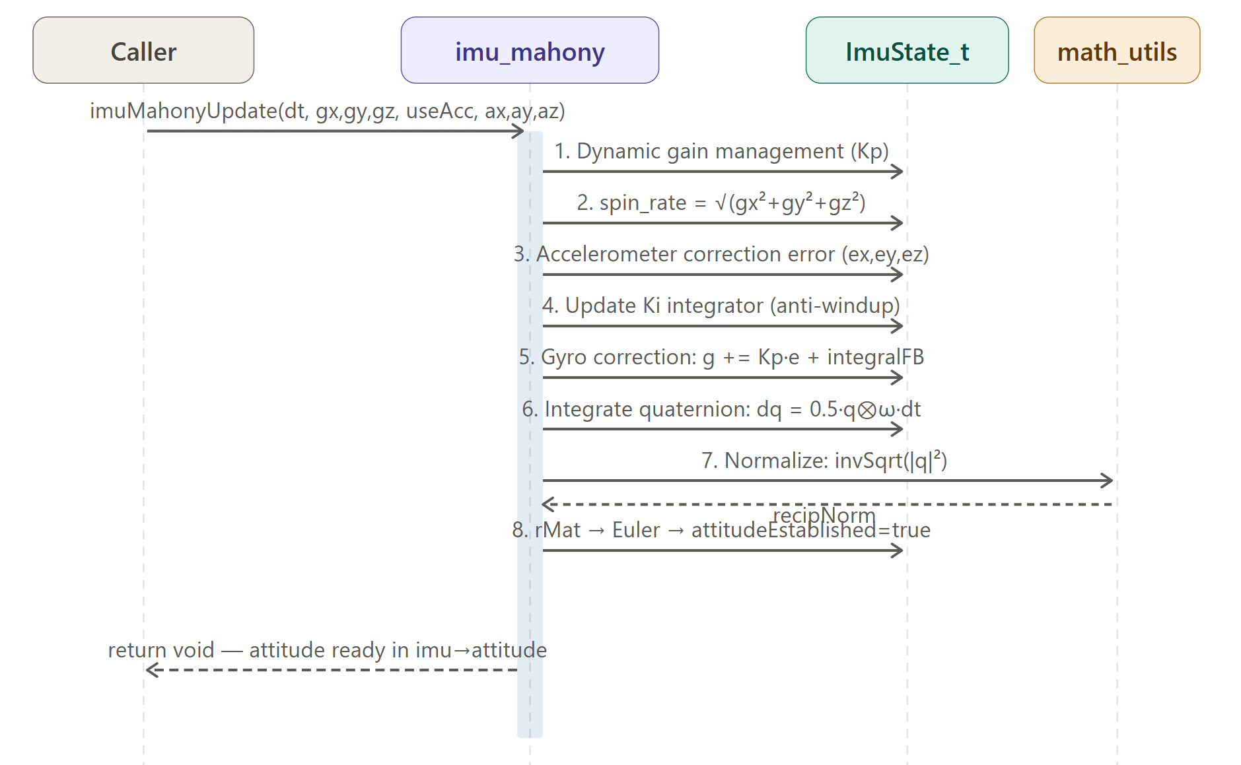
Fig. 5 — Sequence Diagram: imuMahonyUpdate() overview. The caller provides gyroscope (rad/s), accelerometer (g), dt, and useAcc. The driver executes 8 numbered steps in sequence, interacting with ImuState_t throughout, and calls imuComputeRotationMatrix() and imuComputeEuler() as sub-functions at Step 8.

The sequence diagram for imuMahonyUpdate() shows eight numbered steps executed in fixed order each call. The caller provides gyroscope angular rates (gx, gy, gz) in rad/s, accelerometer readings (ax, ay, az) in g, the integration time step dt in seconds, and the Boolean flag useAcc. All steps operate on the ImuState_t structure passed by pointer. The final step delegates to the two internal sub-functions. The function sets attitudeIsEstablished = true before returning, signaling to the caller that the orientation estimate is valid.
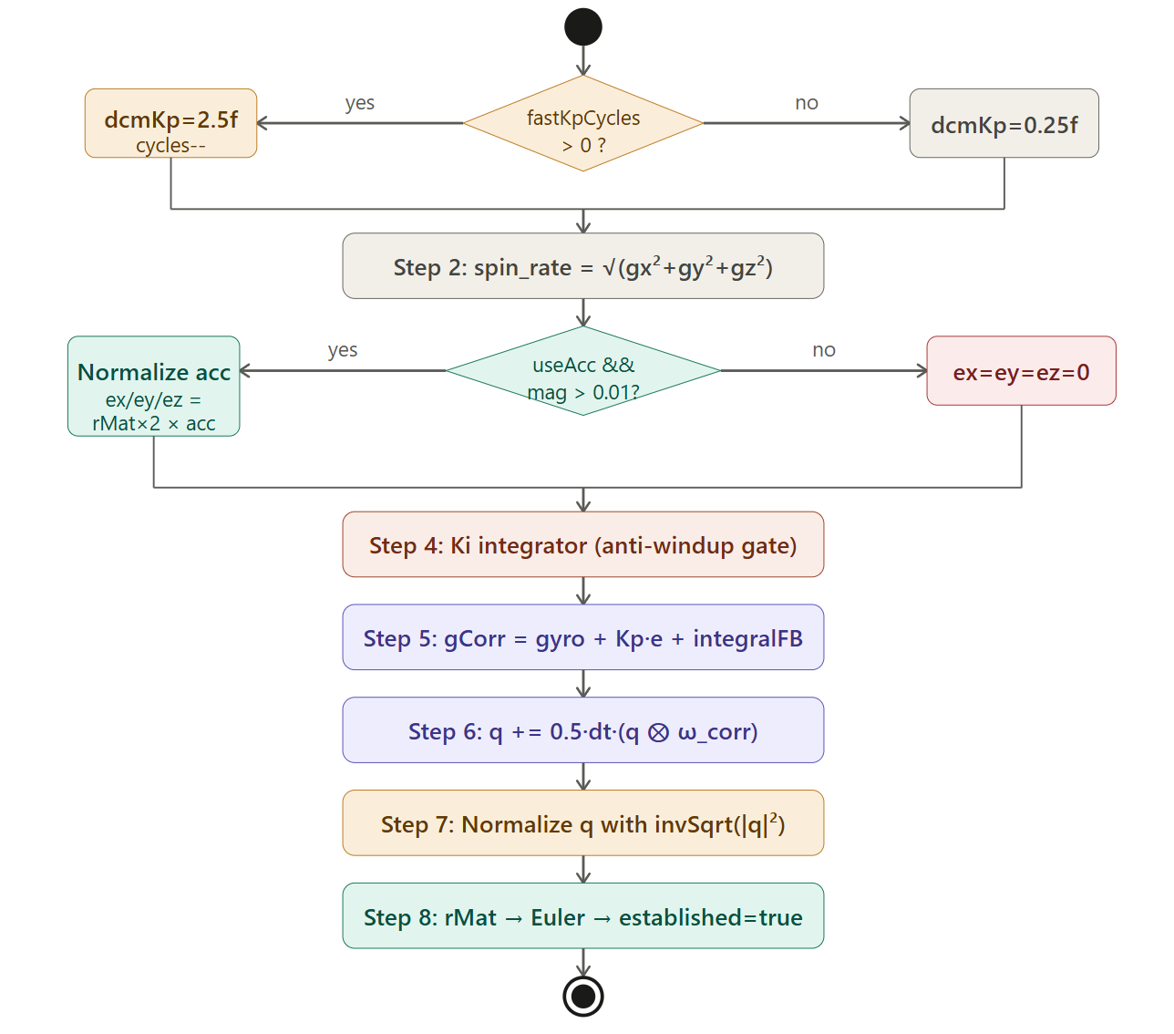
Fig. 6 — Activity Diagram: imuMahonyUpdate() detailing all 8 steps. Two decision nodes appear: one for the fast-gain countdown (Step 1) and one for the useAcc/magnitude guard (Step 3). The integral gate (Step 4) is also conditional on spin_rate and Ki. All paths converge at the quaternion normalization step.

The activity diagram for imuMahonyUpdate() expands all eight steps into a flowchart. Step 1 contains the first decision node: if fastKpCycles > 0, dcmKp is set to IMU_DCM_KP_FAST and the counter is decremented; otherwise dcmKp is set to normal IMU_DCM_KP. Step 2 is unconditional: spin_rate is computed as the Euclidean norm of the gyroscope vector. Step 3 introduces the second decision node (useAcc == true AND recipAccNorm > 0.01): on the true path the accelerometer is normalized and the orientation error cross product ex/ey/ez is computed; on the false path ex = ey = ez = 0. Step 4 checks whether Ki > 0 and spin_rate < 20°/s before accumulating integral terms. Steps 5–7 are unconditional: apply correction, integrate the quaternion, normalize. Step 8 calls both sub-functions and sets attitudeIsEstablished = true.

imuMahonyUpdate() — Step 3: Accelerometer Cross-Product Error [FR-3]
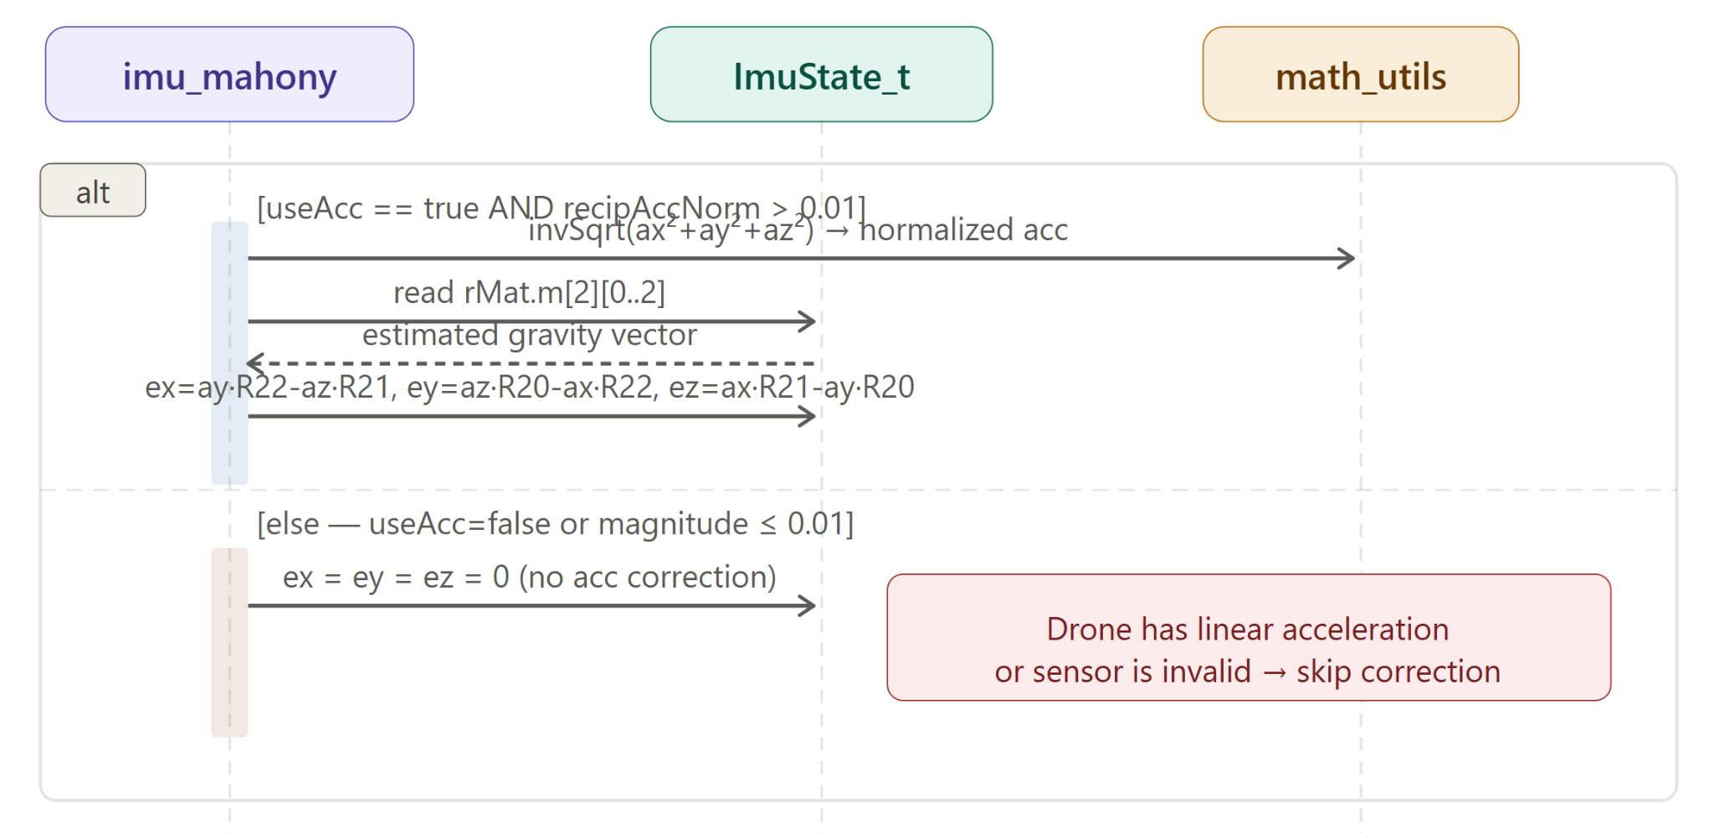
Fig. 7 — Sequence Diagram: Accelerometer correction step. An alt combined fragment splits the flow based on useAcc and vector magnitude. The true path shows normalization of the accelerometer vector followed by a cross product with rMat row 2 (the estimated gravity direction). The false path sets all error terms to zero.

Fig. 7 uses a UML alt combined fragment to model the conditional branching inside the accelerometer correction step. The upper guard [useAcc == true AND recipAccNorm > 0.01] leads to the correction path: the accelerometer vector (ax, ay, az) is normalized using invSqrt(), producing a unit vector representing the measured gravity direction. The driver then computes the cross product between the estimated gravity direction (row 2 of rMat: [rMat[2][0], rMat[2][1], rMat[2][2]]) and the normalized measured gravity. The cross product result (ex, ey, ez) is the orientation error: its magnitude is proportional to the angular difference, and its direction is the rotation axis that would align the two vectors. When the drone is perfectly level and the filter is converged, this cross product is zero. The lower [else] guard sets ex = ey = ez = 0, preventing the accelerometer from corrupting the estimate during maneuvers or when sensor data is invalid.
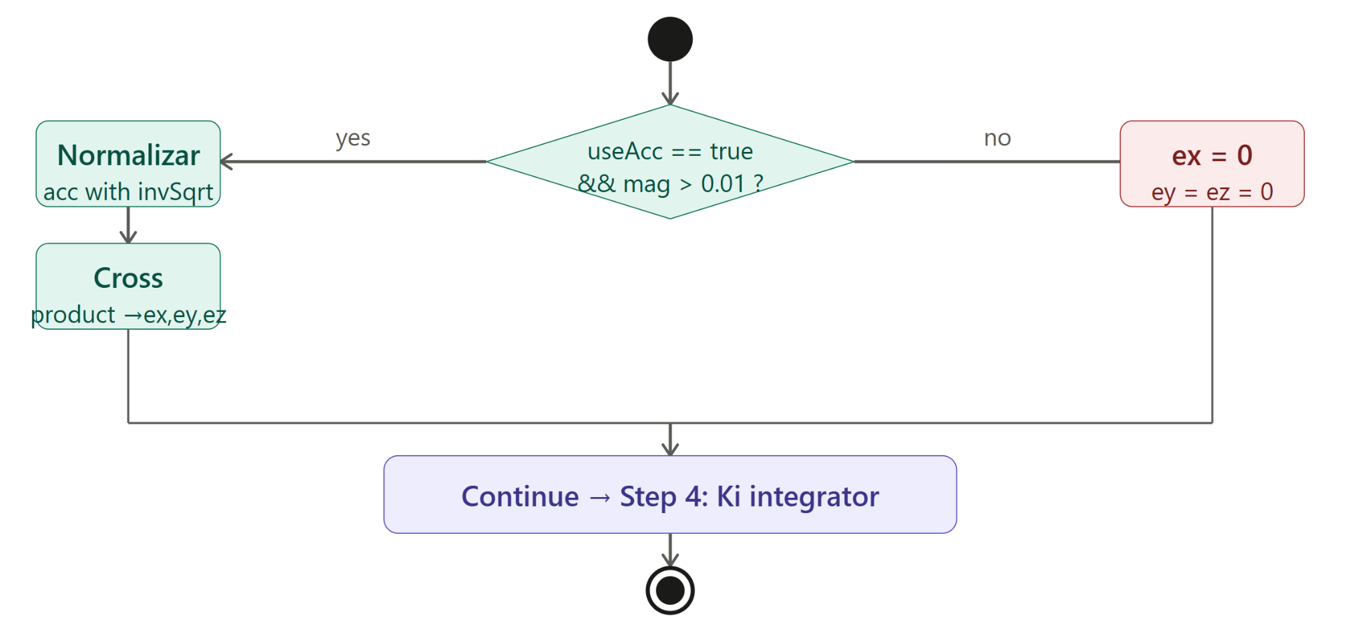Fig. 8 — Activity Diagram: Accelerometer correction decision node and cross-product computation. The decision evaluates useAcc and the near-zero magnitude guard (recipAccNorm > 0.01). Both the correction path and the zero-error path rejoin before the integral update step (Step 4).

imuMahonyUpdate() — Step 4: Integral Gate [FR-4]
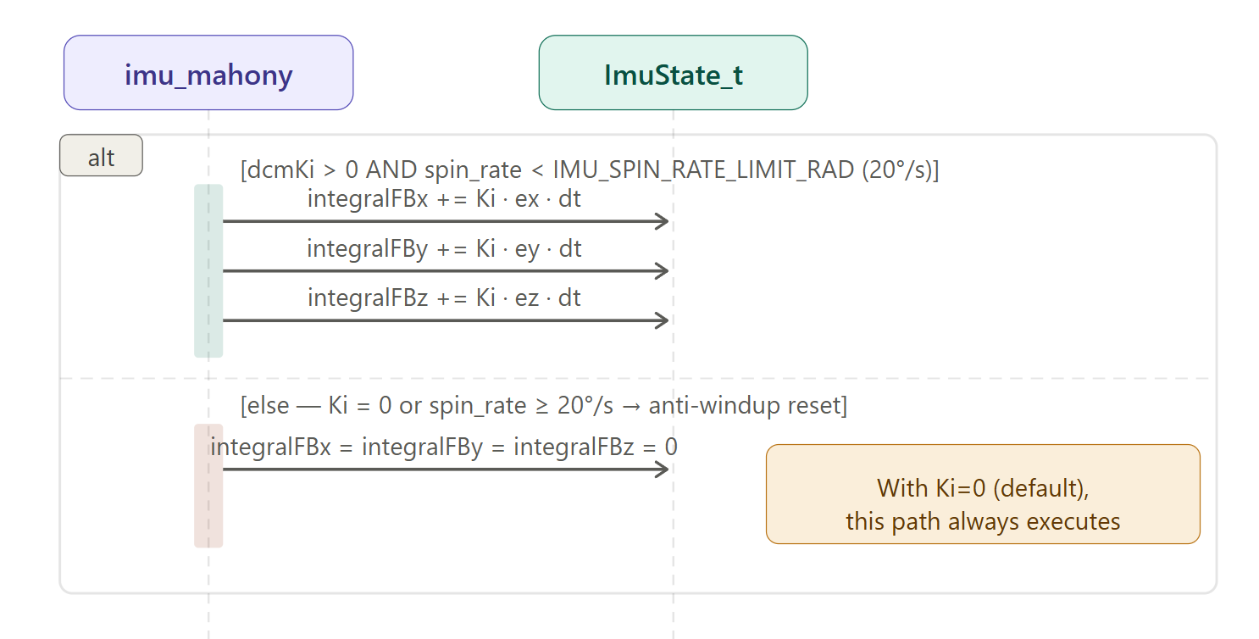
Fig. 9 — Sequence Diagram: Integral gate. An alt fragment evaluates dcmKi > 0 AND spin_rate < 20°/s. The true path accumulates integralFBx/y/z. The false path resets all three to zero to prevent windup. With default Ki=0, the false path always executes.

Fig. 9 uses an alt combined fragment to model the integral gate. The upper guard [dcmKi > 0 AND spin_rate < IMU_SPIN_RATE_LIMIT_RAD] represents the accumulation path: integralFBx += dcmKi × ex × dt, and similarly for y and z axes. This slow-acting bias compensation corrects residual gyroscope offset over time. The lower [else] guard resets all three accumulators to zero — this prevents integrator windup during rapid rotations, where the accelerometer error term may be large and spurious. With the default IMU_DCM_KI = 0.0f, the integrators are always zero and the Mahony filter operates as a pure proportional controller. This is intentional for the course project, which uses the low-noise MPU6050 at room temperature.
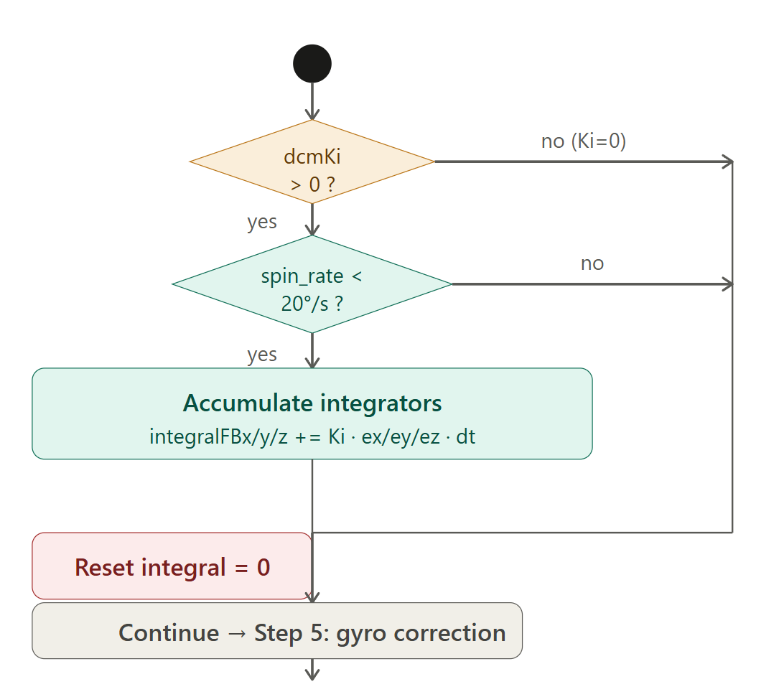
Fig. 10 — Activity Diagram: Integral gate with two nested conditions. First checks dcmKi > 0; second checks spin_rate < limit. Both false branches converge on the integral reset action. This ensures accumulators are always in a defined state regardless of gain configuration.

imuMahonyUpdate() — Steps 6 & 7: Quaternion Integration and Normalization
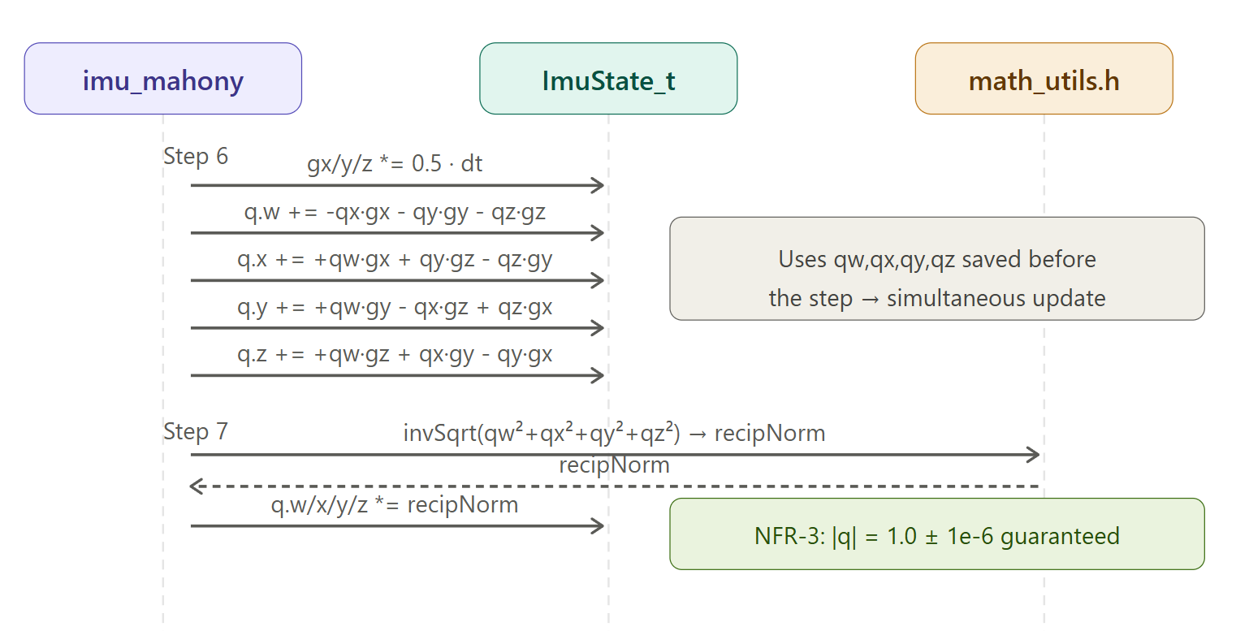
Fig. 11 — Sequence Diagram: Quaternion integration (Step 6) and normalization (Step 7). The corrected gyroscope rates are scaled by 0.5×dt and applied to the four quaternion components using the product rule. Normalization uses invSqrt() to restore unit norm.

Fig. 11 shows the quaternion update mechanics. The corrected gyroscope rates from Step 5 are first scaled by (0.5 × dt), which is the first-order linearization of the quaternion derivative dq/dt = 0.5 × q ⊗ ω. The four components are updated simultaneously using stored values (qw, qx, qy, qz) from before the step — this avoids using a partially updated component in a subsequent computation. The update equations are: q.w += −qx×gx − qy×gy − qz×gz; q.x += +qw×gx + qy×gz − qz×gy; q.y += +qw×gy − qx×gz + qz×gx; q.z += +qw×gz + qx×gy − qy×gx. After integration the quaternion norm drifts slightly from 1.0. Step 7 restores it: recipNorm = invSqrt(qw² + qx² + qy² + qz²) is computed once and all four components are multiplied by it, satisfying NFR-3.
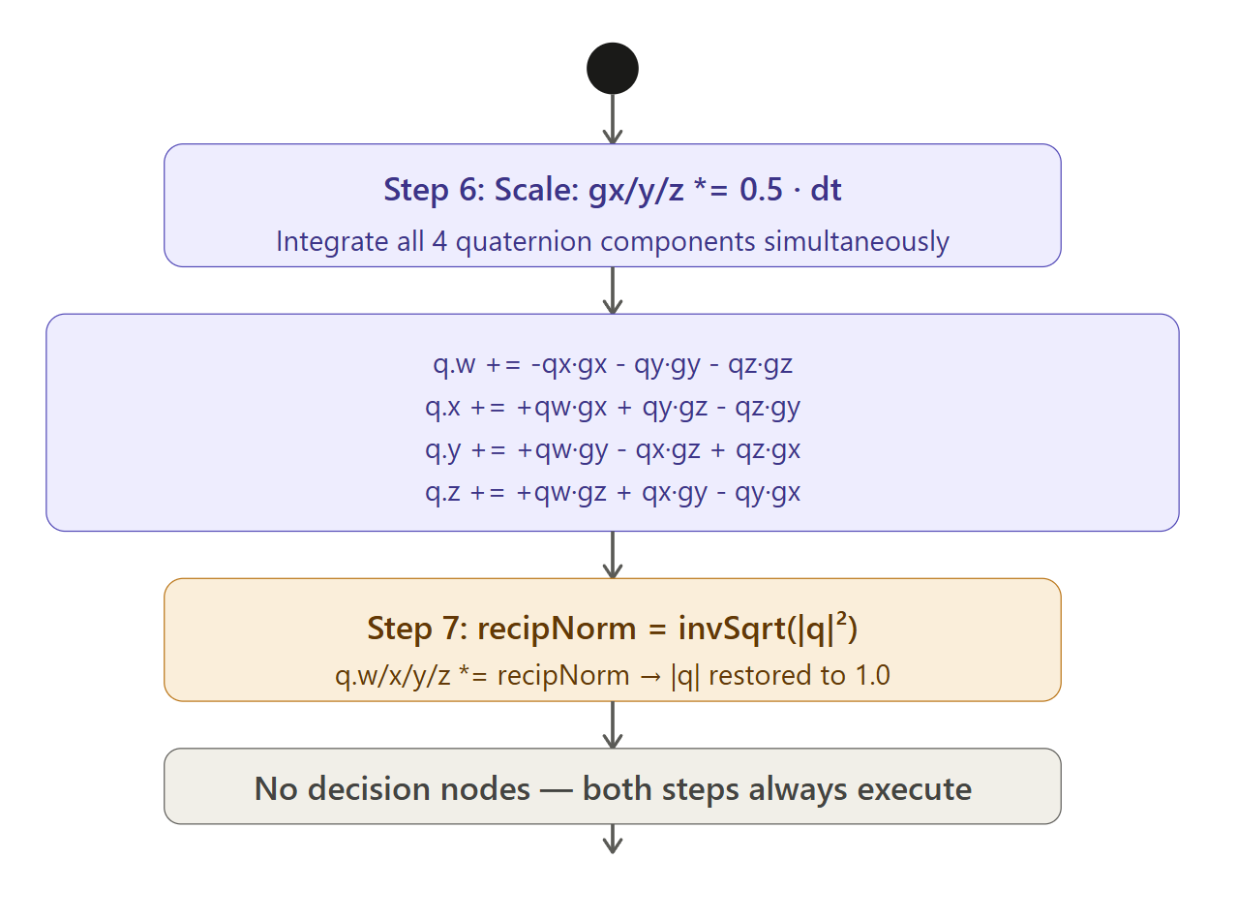
Fig. 12 — Activity Diagram: Steps 6 and 7. Step 6 shows the four simultaneous quaternion component updates. Step 7 shows the normalization action with invSqrt(). No decision nodes — both steps are always executed. Together they maintain the quaternion as a valid unit rotation after every update.

imuComputeEuler() — FR-5: Euler Angle Computation
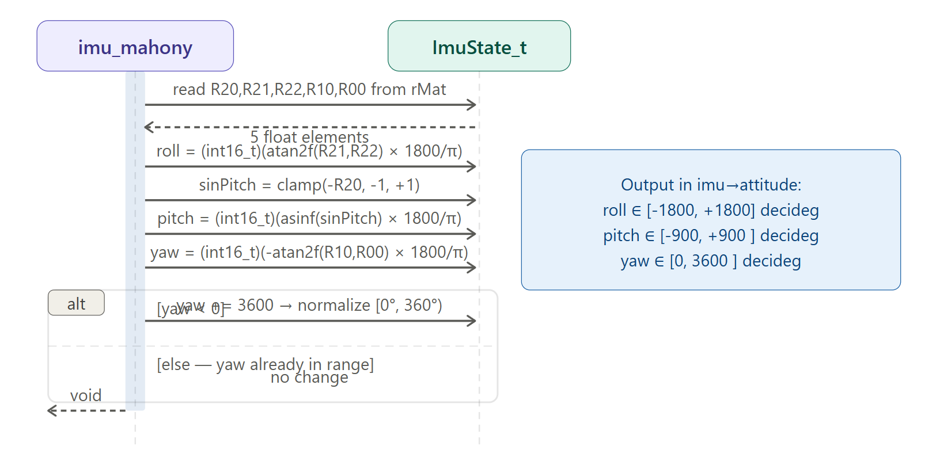
Fig. 13 — Sequence Diagram: imuComputeEuler(). The driver reads five rMat elements (R20, R21, R22, R10, R00) and writes three Euler angles to imu->attitude in decidegrees. A conditional normalization step adjusts yaw to [0°, 360°) if negative.

The sequence diagram for imuComputeEuler() shows that the function reads five elements from the rotation matrix and produces three integer angle values. Roll = atan2(R21, R22) × (1800/π), range [−1800, +1800] decidegrees. Pitch = asinf(−R20) × (1800/π), with a saturation clamp on the argument to avoid NaN from floating-point rounding outside [−1, +1]. Yaw = −atan2(R10, R00) × (1800/π); the negative sign follows the Betaflight convention where clockwise rotation is positive. A conditional normalization step ensures yaw is always in [0, 3600) by adding 3600 if the raw result is negative. This matches the Betaflight yaw convention and simplifies display and comparison logic in the application layer. All three angles are then stored as int16_t in decidegrees — halving the memory footprint vs. float storage.
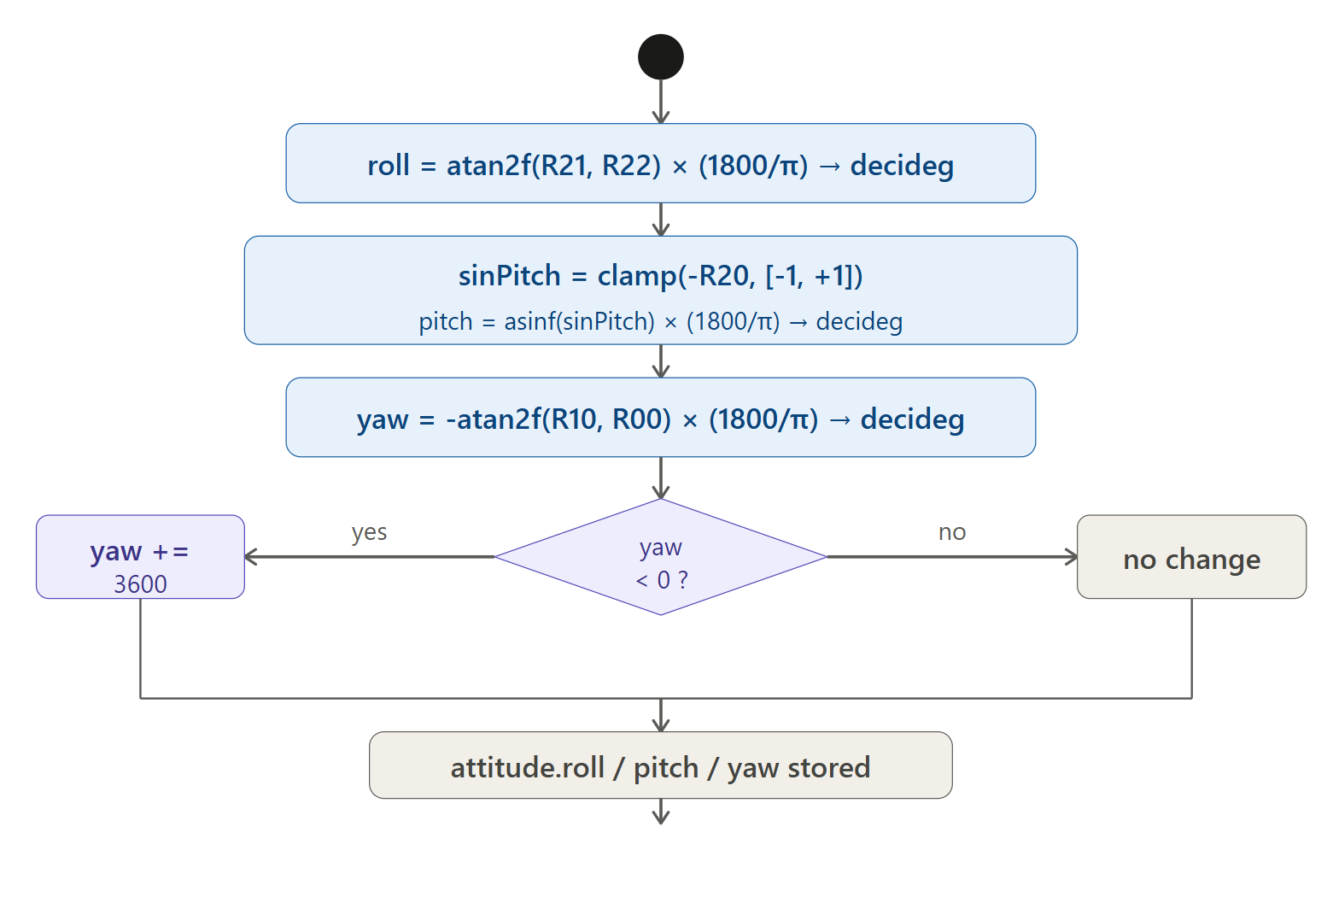Fig. 14 — Activity Diagram: imuComputeEuler(). Three sequential computation actions (roll, pitch, yaw from rMat) followed by one conditional decision node for yaw normalization. The pitch computation includes a saturation clamp shown as an inline guard. All paths converge before the function returns.

imuAccIsHealthy() — FR-6: Accelerometer Health Check
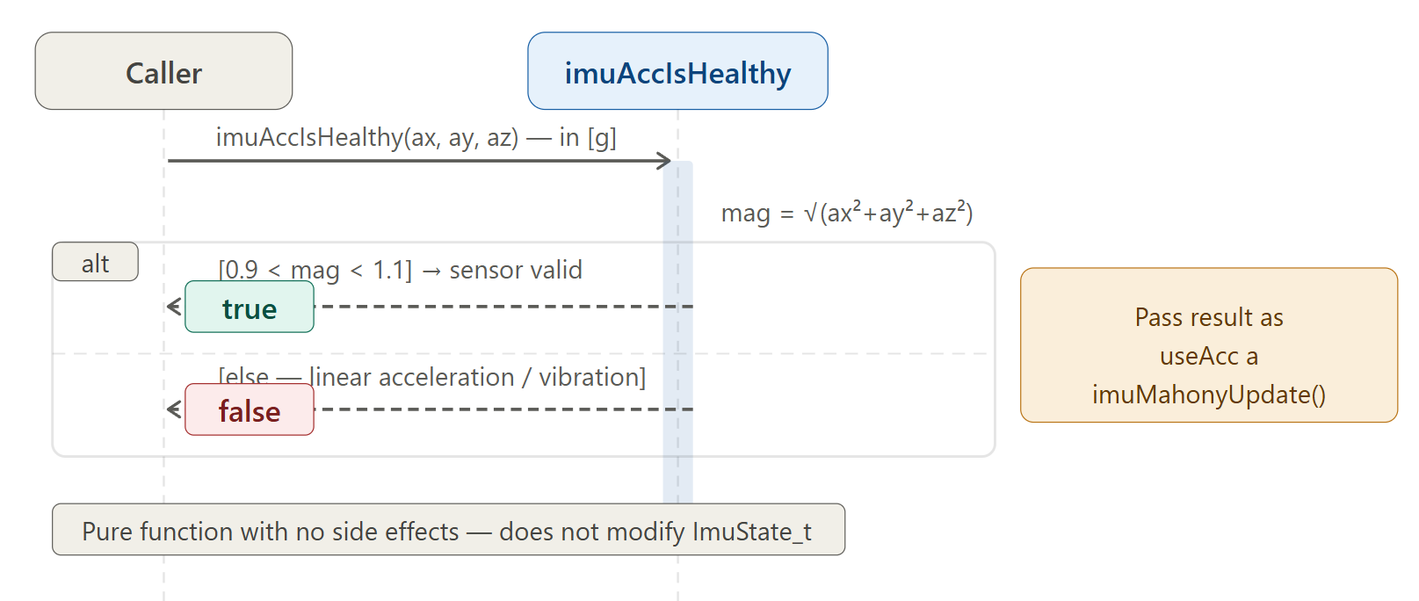
Fig. 15 — Sequence Diagram: imuAccIsHealthy(). The caller provides ax, ay, az in g. The driver computes the Euclidean magnitude and an alt fragment returns true only if strictly between 0.9g and 1.1g. The two return paths are labeled with their guard conditions.

The sequence diagram for imuAccIsHealthy() is the simplest in the driver. It receives three floating-point values (ax, ay, az already scaled to g by ACC_SCALE_G = 1/16384.0f) and returns a boolean. An alt combined fragment splits the flow at the magnitude check: the upper guard [0.9 < mag < 1.1] returns true — the sensor reads approximately 1 g of gravitational force and can be trusted for tilt correction. The lower [else] guard returns false — the drone is experiencing linear acceleration (maneuver, takeoff, landing, vibration), and using this reading would corrupt the orientation estimate. The caller must pass this result as the useAcc flag to imuMahonyUpdate(). This guard is the primary safety mechanism preventing accelerometer corruption of the AHRS during dynamic flight.
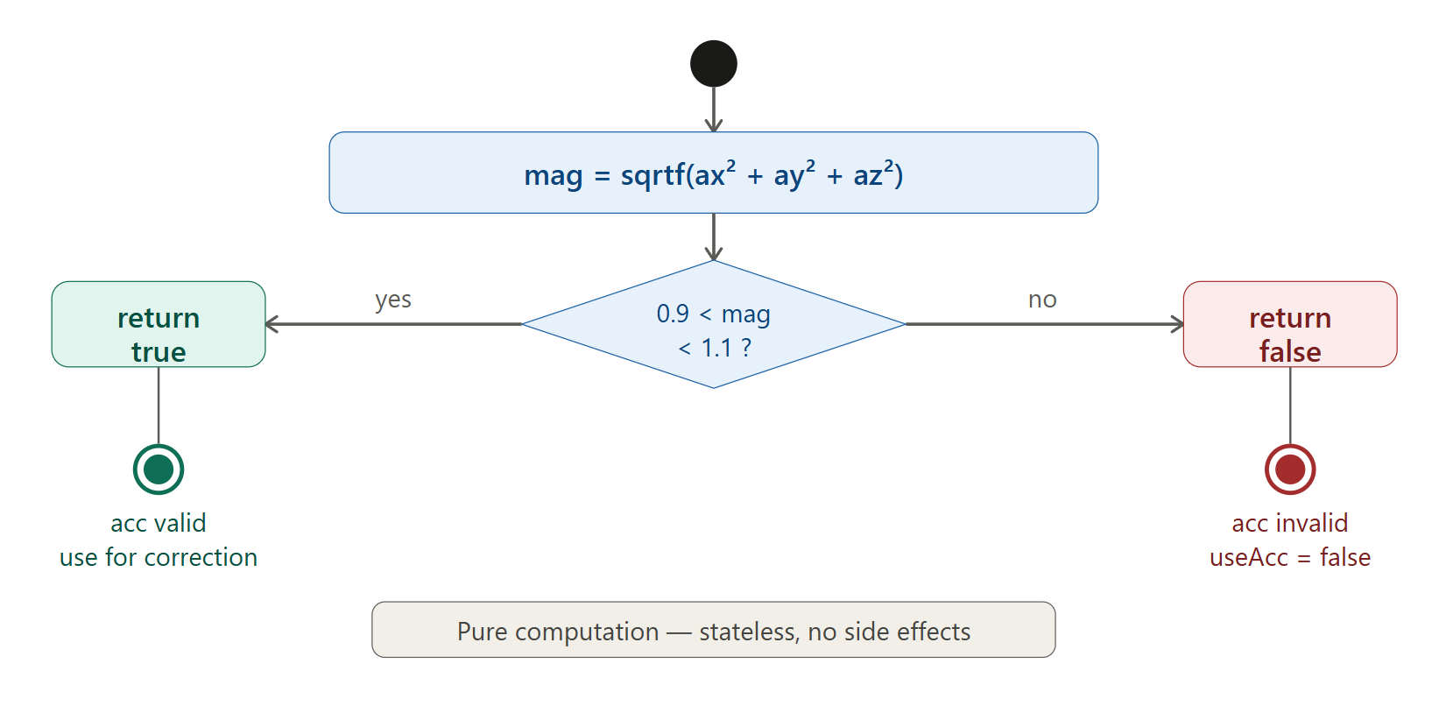
Fig. 16 — Activity Diagram: imuAccIsHealthy(). A single action (Euclidean magnitude computation via sqrtf) followed by a single decision diamond (0.9 < mag < 1.1). The true branch (green) returns true; the false branch (red) returns false. This is a pure stateless computation with no side effects.

3.3. imu_mahony Driver Description
The imu_mahony driver implements the Mahony Attitude and Heading Reference System. It is a stateful driver — all state is held in a caller-allocated ImuState_t structure passed by pointer. The driver exposes no global variables, making it inherently re-entrant.
Internal Data Structures
The driver exposes no mutable global state. All filter state is in ImuState_t: the orientation quaternion (q), the derived rotation matrix (rMat), the output Euler angles (attitude), the Mahony integral accumulators (integralFBx/y/z), the active gains (dcmKp, dcmKi), the fast-convergence counter (fastKpCycles), and the validity flag (attitudeIsEstablished). One internal static function encapsulates quaternion-to-matrix conversion:
- imuComputeRotationMatrix(imu): Converts q = {w,x,y,z} to the 3×3 rotation matrix using pre-computed cross-products to minimize redundant multiplications. rMat[2][0..2] is the estimated gravity direction used in the Mahony correction step.
Initialization Flow
imuInit() (FR-1, Fig. 3–4) clears the structure with memset, sets quaternion to identity, resets integral accumulators, configures high initial gain (dcmKp = 2.5f, fastKpCycles = 500), and computes the initial rotation matrix. The identity quaternion represents a drone at rest; the filter converges from this assumption to actual orientation within ~500 ms.
Update Loop Flow
Each call to imuMahonyUpdate() (FR-2/3/4, Fig. 5–12) executes eight steps:
- Dynamic gain: dcmKp transitions from 2.5f to 0.25f after fastKpCycles reaches zero.
- Spin rate: spin_rate = √(gx² + gy² + gz²) in rad/s.
- Accelerometer correction: Normalize acc vector, compute orientation error as cross product: rMat_row2 × acc_normalized. Error is zero if perfectly aligned.
- Integral update: Accumulate integralFBx/y/z if Ki > 0 and spin_rate < 20°/s; else reset to zero (anti-windup).
- Gyroscope correction: gCorrected = gyro + Kp × error + integralFB.
- Quaternion integration: First-order linearization of dq/dt = 0.5 × q ⊗ ω applied simultaneously to all four components.
- Quaternion normalization: invSqrt(|q|²) × q — maintains unit norm (NFR-3).
- Output: imuComputeRotationMatrix() → imuComputeEuler() → attitudeIsEstablished = true.
Euler Angle Computation
imuComputeEuler() (FR-5) uses the ZYX aerospace convention: Roll = atan2(R21, R22), Pitch = asin(−R20) with saturation clamp, Yaw = −atan2(R10, R00). All angles stored as int16_t decidegrees (×10). Yaw normalized to [0°, 360°) consistent with Betaflight convention.
Design Decisions and Rationale
- Quaternion over Euler: Eliminates gimbal lock at ±90° pitch, reduces storage from 9 floats to 4, normalizes trivially. Critical for a drone executing aggressive maneuvers.
- Caller-allocated state (ImuState_t *): Avoids global variables, makes the driver inherently re-entrant. Multiple AHRS instances can coexist in the same firmware.
- First-order quaternion integration: Valid and stable for dt = 0.001 s at up to ~2000°/s. Higher-order methods (RK4) improve accuracy at lower rates but are unnecessary at 1 kHz.
- Ki = 0 by default: MPU6050 gyroscope bias is small and stable at room temperature. Enabling Ki requires tuning to avoid slow oscillation; left as a future enhancement.
- invSqrt() instead of 1/sqrtf(): Fast approximation reduces the normalization cost, which is the bottleneck of the update loop.
- Spin rate gate on integral: Prevents integrator windup during rapid maneuvers where the accelerometer error term is large and unreliable.

4. Application Programming Interfaces

4.1. Data Types and Macros

Quaternion_t
Represents the drone's 3D orientation as a unit quaternion. Initialized to identity {1, 0, 0, 0} by imuInit(). Stored inside ImuState_t.
Member | Type | Notes
w | float | Scalar (real) component. |q|=1 maintained after each update.
x | float | Vector component — roll axis (body X).
y | float | Vector component — pitch axis (body Y).
z | float | Vector component — yaw axis (body Z).

Matrix33_t
3×3 rotation matrix derived from the quaternion. Row-major storage. Row 2 (m[2][*]) is the body Z-axis projected onto the world frame — the estimated gravity direction used in Mahony correction.
Member | Type | Notes
m[3][3] | float | Row-major 3×3 rotation matrix. m[2][0..2] = estimated gravity vector for Mahony error computation.

EulerAngles_t
Roll, pitch, and yaw stored in decidegrees (×10). Divide by 10.0f to convert to degrees. Uses int16_t to reduce memory vs. float.
Member | Type | Range | Notes
roll | int16_t | −1800 to +1800 | Rotation around body X axis. Positive = right bank.
pitch | int16_t | −900 to +900 | Rotation around body Y axis. Positive = nose up.
yaw | int16_t | 0 to 3600 | Rotation around body Z axis. Normalized [0°,360°). CW positive.

ImuState_t
Complete AHRS state structure. Caller is responsible for allocation (typically a file-scope variable). Passed by pointer to all driver functions.
Member | Type | Notes
q | Quaternion_t | Current orientation quaternion. Updated every call to imuMahonyUpdate().
rMat | Matrix33_t | Rotation matrix derived from q. Updated every call.
attitude | EulerAngles_t | Roll/pitch/yaw in decidegrees. Valid after first update.
integralFBx/y/z | float | Mahony integral error accumulators (Ki feedback). Always zero when Ki=0.
dcmKp | float | Active proportional gain. Starts 2.5f, drops to 0.25f after 500 cycles.
dcmKi | float | Integral gain. 0.0f by default (disabled).
fastKpCycles | uint32_t | Countdown for high-gain convergence phase. Counts from 500 to 0.
attitudeIsEstablished | bool | True after first successful imuMahonyUpdate() call.

Macros
Macro | Value | Description
IMU_DCM_KP | 0.25f | Normal proportional gain. Applied after fast convergence phase.
IMU_DCM_KI | 0.0f | Integral gain. Disabled by default; enables gyro bias compensation when non-zero.
IMU_DCM_KP_FAST | 2.5f | High gain for initial convergence (Kp × 10). Used during first 500 cycles.
IMU_SPIN_RATE_LIMIT_RAD | 0.3491 rad/s | Ki integrator gate threshold (≈ 20°/s). From Betaflight SPIN_RATE_LIMIT.
ACC_SCALE_G | 1/16384.0f | MPU6050 scale factor at ±2g. Converts raw ADC LSB to g units.
IMU_FAST_KP_CYCLES | 500 | Fast-convergence duration in update cycles. At 1 kHz = 500 ms.

4.2. Error Codes
Convention | Description
bool return (imuAccIsHealthy) | Returns true if accelerometer magnitude is in (0.9g, 1.1g); false otherwise.
void functions (imuInit, imuMahonyUpdate, imuComputeEuler) | No error code returned. Caller ensures valid non-NULL pointer and pre-scaled inputs. API contract documented in Section 4.3.
attitudeIsEstablished flag | Set to true after the first successful imuMahonyUpdate() call. Caller should not consume angles until this is true.

4.3. Public Function Definitions
Function: imuInit
Function Name |  | imuInit
Syntax |  | void imuInit(ImuState_t *imu)
Parameters (in) | — | None
Parameters (inout) | imu | Pointer to ImuState_t to initialize. Must point to valid allocated memory.
Parameters (out) | — | None
Return value | void | No return value.
Description |  | Initializes the AHRS state: clears all fields with memset, sets quaternion to identity {1,0,0,0}, resets integral accumulators, sets dcmKp = IMU_DCM_KP_FAST for the first 500 cycles, and computes the initial rotation matrix. Must be called once before any imuMahonyUpdate() call.
Constraints |  | Does not verify that imu is non-NULL. Caller is responsible for a valid pointer. Undefined behavior if imu == NULL.
Available via |  | imu_mahony.h

Function: imuMahonyUpdate
Function Name |  | imuMahonyUpdate
Syntax |  | void imuMahonyUpdate(ImuState_t *imu, float dt, float gx, float gy, float gz, bool useAcc, float ax, float ay, float az)
Parameters (in) | dt | Integration time step in seconds (e.g., 0.001 s at 1 kHz). Must be positive and non-zero.
 | gx, gy, gz | Gyroscope angular velocity in rad/s (already filtered and scaled). Body frame: X=roll, Y=pitch, Z=yaw.
 | useAcc | true if the accelerometer reading is valid. Call imuAccIsHealthy() and pass its result here.
 | ax, ay, az | Accelerometer reading in g units (normalized internally). Pass zeros if useAcc == false.
Parameters (inout) | imu | AHRS state updated in-place: quaternion, rotation matrix, Euler angles, integrals, and gain countdown.
Parameters (out) | — | None. Updated attitude available immediately in imu->attitude after return.
Return value | void | No return value. Sets imu->attitudeIsEstablished = true on first call.
Description |  | Core Mahony filter update. Executes all 8 steps: gain management, spin rate, accelerometer correction, integral update, gyroscope correction, quaternion integration, normalization, and Euler computation.
Constraints |  | Gyroscope input must be in rad/s. Driver does not filter gyroscope data — caller must apply any digital filter beforehand. Must be called at a fixed rate matching dt.
Available via |  | imu_mahony.h

Function: imuComputeEuler
Function Name |  | imuComputeEuler
Syntax |  | void imuComputeEuler(ImuState_t *imu)
Parameters (in) | — | None
Parameters (inout) | imu | AHRS state. Reads imu->rMat, writes imu->attitude (roll, pitch, yaw in decidegrees).
Parameters (out) | — | None
Return value | void | No return value.
Description |  | Converts the current rotation matrix to roll/pitch/yaw Euler angles (ZYX convention) in decidegrees. Called automatically at the end of imuMahonyUpdate(), but exposed publicly for standalone use. Yaw normalized to [0, 3600) decidegrees.
Constraints |  | rMat must be up to date. imuComputeRotationMatrix() must have been called previously.
Available via |  | imu_mahony.h

Function: imuAccIsHealthy
Function Name |  | imuAccIsHealthy
Syntax |  | bool imuAccIsHealthy(float ax, float ay, float az)
Parameters (in) | ax, ay, az | Accelerometer readings in g (scaled by ACC_SCALE_G = 1/16384.0f from raw MPU6050 LSB).
Parameters (inout) | — | None
Parameters (out) | — | None
Return value | bool | true if magnitude is strictly within (0.9g, 1.1g); false otherwise. Pass result to imuMahonyUpdate() as useAcc.
Description |  | Validates that the accelerometer vector represents approximately 1g. Used to gate the accelerometer correction step. If the drone is accelerating linearly (maneuver, vibration), the reading is invalid for tilt estimation.
Constraints |  | Inputs must be in g units. Passing raw LSB values will always return false.
Available via |  | imu_mahony.h

Inline Getters (imu_mahony.h)
Function | Returns | Formula / Notes
imuGetRollDeg(imu) | float | imu->attitude.roll × 0.1f
imuGetPitchDeg(imu) | float | imu->attitude.pitch × 0.1f
imuGetYawDeg(imu) | float | imu->attitude.yaw × 0.1f
imuIsHealthy(imu) | bool | imu->attitudeIsEstablished

4.4. Internal Function Definitions
Function: imuComputeRotationMatrix (internal)
Function Name |  | imuComputeRotationMatrix
Syntax |  | static void imuComputeRotationMatrix(ImuState_t *imu)
Parameters (in) | — | None
Parameters (inout) | imu | Reads imu->q (quaternion), writes imu->rMat (3×3 rotation matrix).
Parameters (out) | — | None
Return value | void | No return value.
Description |  | Converts unit quaternion q = {w,x,y,z} to the 3×3 rotation matrix rMat using standard quaternion-to-DCM formulas. Pre-computes 9 cross-products (wx,wy,wz,xy,xz,yz,xx,yy,zz) to minimize floating-point operations. rMat[2][*] is the estimated gravity direction used by the Mahony correction step.
Constraints |  | imu->q must be normalized (|q|=1.0f). Always called after normalization — never directly by the caller.

5. Future Enhancements
Enhancement | Description
Magnetometer Integration | Add a third correction term using a magnetometer (e.g., HMC5883L) to provide absolute yaw reference and eliminate yaw drift during long flights.
GPS Heading Correction | Restore Betaflight Course Over Ground (COG) correction for outdoor applications where GPS is available, providing absolute yaw without a magnetometer at sufficient groundspeed.
Configurable Spin Rate Limit | Expose IMU_SPIN_RATE_LIMIT_RAD as a runtime parameter in ImuState_t instead of a compile-time constant, allowing tuning without recompilation.
Ki Activation and Tuning | Test and tune a non-zero IMU_DCM_KI value for MPU6050 gyroscope bias compensation. Expected to improve long-term yaw stability on temperature-variable boards.
Sensor Calibration | Add gyroscope and accelerometer offset calibration within the driver. Currently assumed to be done externally before imuInit().
RTOS Compatibility | Add mutex or critical section hooks around quaternion read/write for use in FreeRTOS task contexts.
Higher-Order Integration | Replace first-order quaternion integration with Runge-Kutta 4th-order for improved accuracy at update rates below 500 Hz.

— End of Document —

