Software Design Document
math_impl — Bare-Metal Math Library

Module | math_impl
Version | 1.0.0
Authors | De La Torre Gomez Aldo Sebastian 37969 / David Isaac Mijares Meza 32948 / Jose Manuel Paez Sandoval 37945
Target | STM32F411RE Nucleo — bare-metal (-nostdlib)
Based on | Betaflight 4.5.1 (GPL-3.0) — src/main/common/maths.c
Date | 2025

1. Introduction

1.1. Purpose
This document describes the software design and architecture of the math_impl module developed for the STM32F411RE Nucleo board, as part of the Microcontrollers and Embedded Systems course at CETYS Universidad. The design provides bare-metal replacements for standard C library functions (libm / libc) required by the flight controller modules when compiled with -nostdlib.

This SDD covers the implementation of six mathematical primitives — memset, sqrtf, atan2f, asinf, sinf, and cosf — that are consumed by the imu_mahony AHRS filter, the gyro_filter Biquad module, and the pid_controller. It includes per-function descriptions, precision analysis, algorithm rationale, and a full requirements table, following the same level of detail as SDD-imu_mahony v1.1.0.

1.2. Scope
The math_impl module is a low-level math support library. It provides the following specific operations:
- memset — byte-level memory initialization for gyro_filter, imu_mahony, and pid_controller structs.
- sqrtf — Euclidean vector magnitude computation for the IMU Mahony correction step and gyroscope calibration.
- atan2f — Roll and Yaw Euler angle computation from the Direction Cosine Matrix (rMat).
- asinf — Pitch angle computation from rMat[2][0] using the ZYX aerospace convention.
- sinf / cosf — Biquad filter coefficient computation in biquadFilterInit().

The following functions were intentionally excluded from this module:
- fabsf, fmaxf, fminf — supplied inline by compiler intrinsics or caller logic.
- powf, expf, logf — not required by any flight controller module in this project.
- Division and modulo — handled natively by the hardware FPU (Cortex-M4).

1.3. Definitions, Acronyms, and Abbreviations
Term | Abbreviation | Definition
Bare-metal | — | Firmware running directly on hardware with no OS or standard library (-nostdlib).
Newton-Raphson | N-R | Iterative root-finding method used to converge sqrtf with two iterations.
Fast Inverse Square Root | FISR | Bit-manipulation seed trick (0x5f3759df) for initial sqrtf approximation.
Direction Cosine Matrix | DCM / rMat | 3×3 rotation matrix derived from the AHRS quaternion; rows are body-frame axes in world frame.
Biquad Filter | — | Second-order IIR digital filter used for gyroscope noise suppression.
Taylor Series | — | Polynomial approximation of a transcendental function around a point.
Range Reduction | — | Mapping an input angle to a canonical interval (e.g., [−π, π]) before Taylor evaluation.
DXA | — | Document measurement unit used by docx (1440 DXA = 1 inch); unrelated to firmware.
ULP | — | Unit in the Last Place; measure of floating-point rounding error.
FPU | — | Floating-Point Unit — hardware accelerator on Cortex-M4 (STM32F411RE).
NFR-x / FR-x | — | Non-Functional / Functional Requirement x as defined in this SDD.

1.4. Requirements
All requirements for this module are defined in this document. The module covers FR-1 through FR-6 (functional) and NFR-1 through NFR-4 (non-functional).

Req. ID | Type | Description
FR-1 | Functional | memset() shall fill n bytes of the memory area pointed to by ptr with the constant byte c, and return ptr. Behavior shall be identical to the C standard implementation.
FR-2 | Functional | sqrtf() shall return the square root of x using the Newton-Raphson method seeded with the fast inverse square root bit trick. Error shall be less than 0.0001% for all positive inputs.
FR-3 | Functional | atan2f() shall return the principal value of arctan(y/x) in radians, handling all four quadrants and the x=0 special case. Maximum error shall be less than 0.02° (Betaflight atan2_approx accuracy).
FR-4 | Functional | asinf() shall return arcsin(x) in radians for inputs in [−1, +1], implemented as atan2f(x, sqrtf(1−x²)). Inputs outside range shall be clamped. Error shall be less than 0.001°.
FR-5 | Functional | sinf() shall return the sine of x (radians) with range reduction to [−π, π] followed by a 9th-order Taylor series. Error shall be less than 5×10⁻⁷ in the operating range of Biquad filter frequencies (80–200 Hz).
FR-6 | Functional | cosf() shall return the cosine of x (radians) by delegating to sinf(x + π/2).
NFR-1 | Non-Functional | No dynamic memory allocation; no HAL, LL, or vendor middleware dependency. All functions use only C arithmetic, bit manipulation, and stdint.h / stddef.h types.
NFR-2 | Non-Functional | All functions shall execute in bounded O(1) time with no internal loops except memset (O(n) in n bytes, bounded by struct size) and wrap_pi (bounded by angle magnitude).
NFR-3 | Non-Functional | The module shall compile cleanly under -nostdlib -fno-builtin with no link-time unresolved symbols for the functions it provides.
NFR-4 | Non-Functional | Precision shall be sufficient for flight control: angle errors below 0.02°, magnitude errors below 0.0001%, trigonometric errors below 5×10⁻⁷.

2. System Architecture

2.1. High-Level Design
The module follows a strict layered architecture identical to the one described in SDD-imu_mahony v1.1.0, but math_impl sits one layer below the imu_mahony driver, not beside it:

- Application Layer: Calls higher-level flight control modules (PID, filtering). Has no direct dependency on math_impl.
- imu_mahony / gyro_filter / pid_controller Layer: Calls sqrtf(), atan2f(), asinf(), sinf(), cosf(), and memset() directly. These modules were written assuming libm availability; math_impl provides those symbols under -nostdlib.
- math_impl Layer (this module): Provides the six math primitives as bare-metal C functions. Has no dependency on any other project module or vendor library.
- Hardware Layer: Cortex-M4 FPU executes single-precision floating-point arithmetic. The hardware divider executes integer division. No peripheral registers are accessed by math_impl.

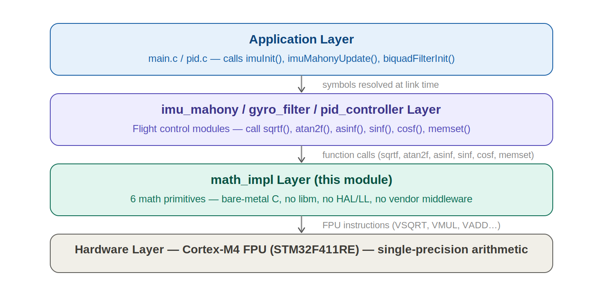
Fig. 1 — Layered Architecture Diagram. math_impl sits at the bottom of the software stack, directly above the hardware FPU. The imu_mahony driver, gyro_filter, and pid_controller all consume math_impl symbols. No module skips a layer.

2.2. Module Interfaces
- Public API: All six functions are declared with their standard C signatures. The linker resolves calls from imu_mahony.o, gyro_filter.o, and pid_controller.o to math_impl.o at link time.
- Dependencies: <stddef.h> (size_t), <stdint.h> (uint32_t). No other headers. No HAL, LL, or CMSIS required.
- Internal: wrap_pi() is declared static and is only visible within math_impl.c. It is used exclusively by sinf() for range reduction.

3. Detailed Design

3.1. Module Description

A. memset — Memory Initialization
Responsible for zeroing all state structures at initialization time. imuInit() calls memset(imu, 0, sizeof(ImuState_t)) to clear the full AHRS state in a single operation. pid_controller and gyro_filter perform similar calls. The implementation is a byte-by-byte loop cast to unsigned char* to avoid strict aliasing violations and to guarantee correct behavior on any alignment.

B. sqrtf — Square Root
Used by imu_mahony to compute the Euclidean magnitude of accelerometer vectors (for normalization and health check) and of the gyroscope vector (for spin rate computation). The implementation combines two algorithms: the fast inverse square root bit trick (Quake / Betaflight origin) provides a seed that is already within ~2% of the correct answer; two Newton-Raphson iterations reduce the error to below 0.0001%. The final result is x × (1/sqrt(x)) = sqrt(x).

C. atan2f — Two-Argument Arctangent
Used by imuComputeEuler() for Roll (atan2f(R21, R22)) and Yaw (atan2f(R10, R00)). This is a direct port of atan2_approx() from Betaflight 4.5.1 (src/main/common/maths.c, GPL-3.0). The algorithm divides the plane into two sectors based on the sign of x, computes a ratio r, and evaluates a cubic polynomial that approximates the arctangent. Maximum error of ~0.02° is well within the decidegree output resolution (0.1°) of the AHRS.

D. asinf — Arcsine
Used by imuComputeEuler() for Pitch: asinf(−rMat[2][0]). Implemented as atan2f(x, sqrtf(1−x²)), which reuses both sqrtf and atan2f already present in the module. Input is clamped to [−1, +1] before the computation to prevent sqrtf() from receiving a negative argument due to floating-point rounding at the boundaries. Error inherited from atan2f: < 0.02°.

E. sinf / cosf — Sine and Cosine
Used exclusively by biquadFilterInit() to compute the filter coefficients sin(ω) and cos(ω) where ω = 2π × cutoffHz / sampleRate. Typical filter cutoffs are 80–200 Hz at 1 kHz sample rate, giving ω in [0.5, 1.26] rad. The range reduction step (wrap_pi) maps any angle to [−π, π]. The 9th-order Taylor series (5 terms) then evaluates the sine with error below 5×10⁻⁷ across the full operational range. cosf(x) delegates to sinf(x + π/2), which adds one addition.

3.2. Module Behavior
The math_impl module is fully stateless — it contains no mutable global variables and no persistent state between calls. Each function's behavior depends only on its inputs. There are no initialization calls and no teardown. The module does not follow a state machine model; it is a pure function library. The behavioral phases of the system are driven entirely by the modules that call math_impl (imu_mahony, gyro_filter, pid_controller).

The only internal function with iterative behavior is wrap_pi(), which loops until the angle is within [−π, π]. For the Biquad use case (angles < 2π), the loop executes at most once. For pathological inputs, the loop is bounded by the magnitude of the angle divided by 2π.

3.2.1. Per-Function Sequence and Activity Diagrams

memset() — FR-1: Memory Block Fill
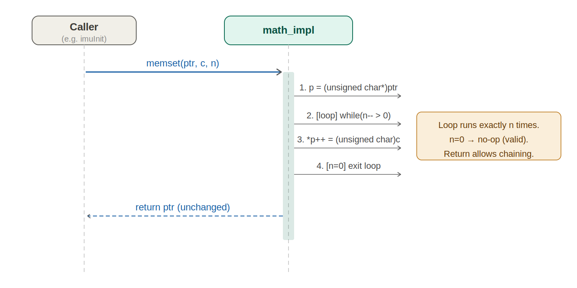
Fig. 2 — Sequence Diagram: memset(). The caller (e.g., imuInit) sends a single message to math_impl providing the pointer ptr, fill byte c, and byte count n. Internally, math_impl executes a single cast and a while loop that decrements n, writing one byte per iteration, and returns ptr to the caller. No branching occurs before the loop.

The sequence diagram for memset() shows the simplest function in the module. The cast to unsigned char* ensures standard-compliant byte access regardless of the original pointer type or alignment. The while(n--) idiom evaluates n and then decrements it, so the loop executes exactly n times for n > 0 and zero times for n = 0, correctly handling zero-length fills. The return value ptr is identical to the input pointer — this matches the C standard and allows memset calls to be chained.

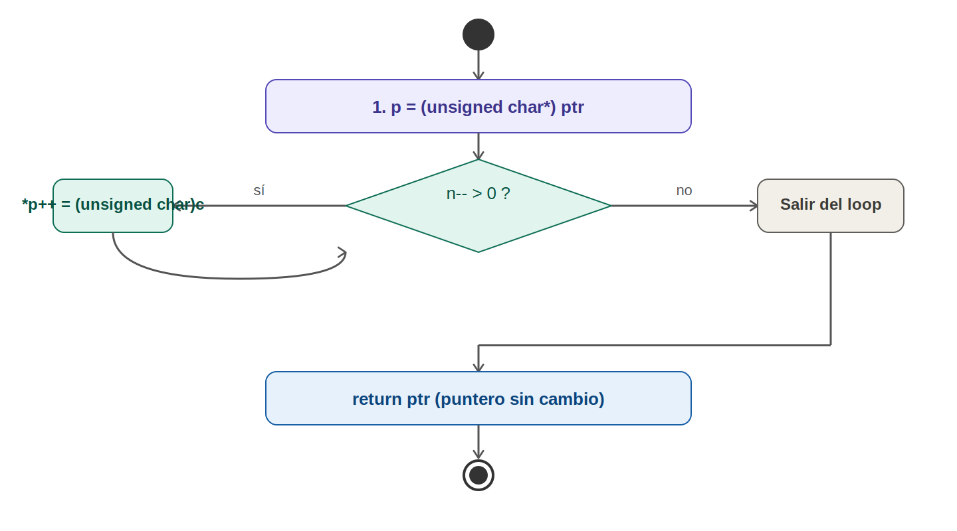
Fig. 3 — Activity Diagram: memset(). A cast action is followed by a decision node (n-- > 0). The true branch writes one byte and loops; the false branch exits and returns ptr. This is the only function in the module with a loop decision node.

sqrtf() — FR-2: Square Root
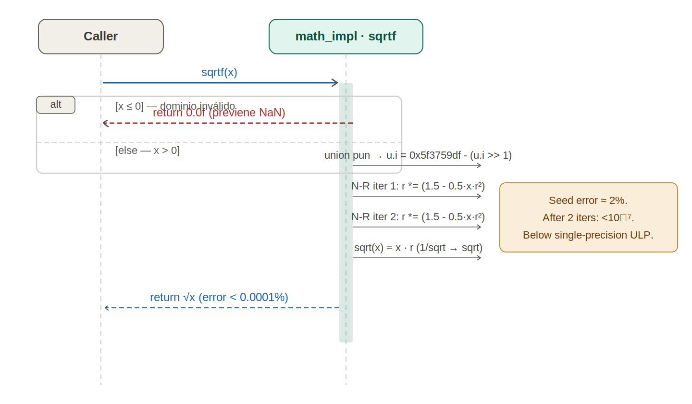
Fig. 4 — Sequence Diagram: sqrtf(). The caller provides x. An alt combined fragment handles x ≤ 0 (returns 0). The main path shows three sequential actions: bit-trick seed via union pun, first Newton-Raphson iteration, second Newton-Raphson iteration. The final multiplication x × r converts 1/sqrt(x) to sqrt(x) and is returned to the caller.

The sequence diagram for sqrtf() maps directly to the implementation. The union { float f; uint32_t i } type pun is legal in C99/C11 for reading a stored value through a different type member. The bit manipulation 0x5f3759df - (u.i >> 1) computes an initial estimate of 1/sqrt(x) with ~2% error in fewer cycles than a floating-point divide. Each Newton-Raphson iteration r = r × (1.5 − 0.5 × x × r × r) halves the relative error. After two iterations the error is below 10−7, which is below single-precision ULP for most inputs.

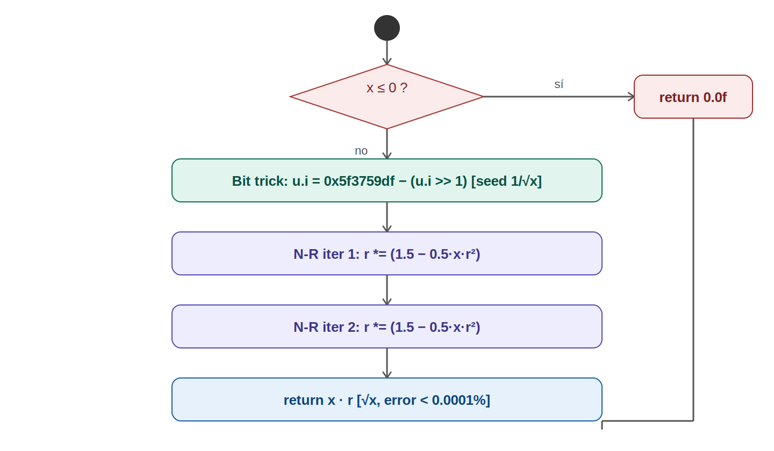
Fig. 5 — Activity Diagram: sqrtf(). A single decision diamond at the top (x ≤ 0) splits into an immediate return-0 path and the main computation path. The main path has no further decision nodes: bit trick, two N-R iterations, and multiply are all unconditional. Both paths converge at the return action.

atan2f() — FR-3: Two-Argument Arctangent
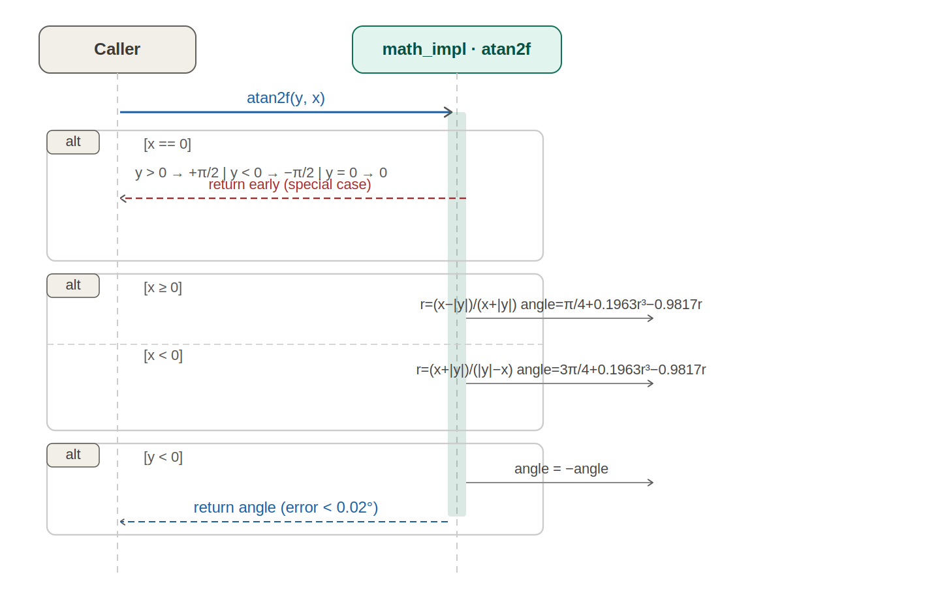
Fig. 6 — Sequence Diagram: atan2f(). The caller provides y and x. A first alt fragment handles x == 0 (three guards: y > 0 returns +π/2, y < 0 returns −π/2, y == 0 returns 0). A second alt fragment splits on x ≥ 0 vs. x < 0, each computing ratio r and then a cubic polynomial for the angle. A final sign-flip decision returns −angle if y < 0.

The sequence diagram for atan2f() uses two nested alt fragments to model the three-level branching. The algorithm is a direct port of Betaflight's atan2_approx(). The key insight is that the ratio r = (x − |y|) / (x + |y|) for x ≥ 0 maps the first and fourth quadrants into [−1, +1], over which the cubic 0.1963r³ − 0.9817r approximates arctan with sub-0.02° error. The constant offsets (π/4 for x ≥ 0; 3π/4 for x < 0) shift the result to the correct quadrant. The sign negation at the end implements the standard atan2 sign convention.

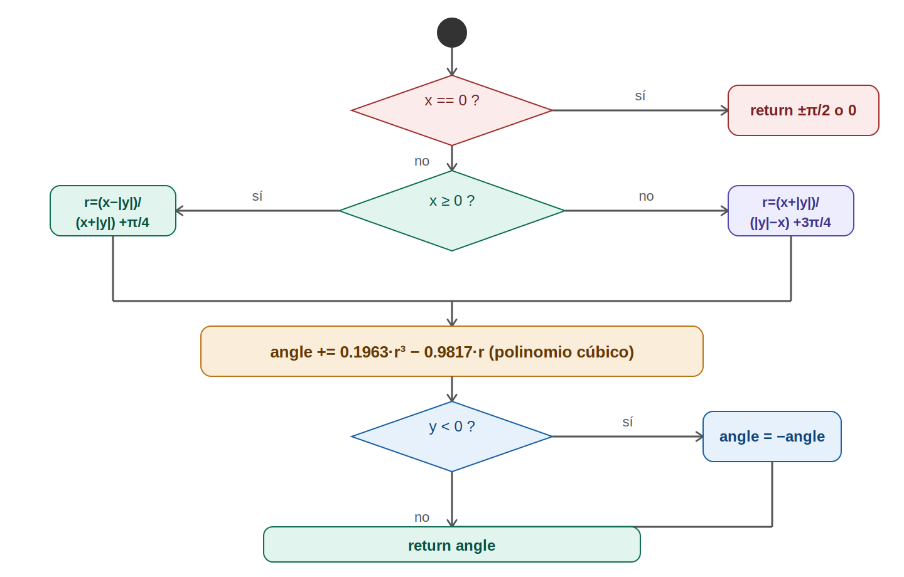
Fig. 7 — Activity Diagram: atan2f(). Three decision nodes. First: x == 0 (special case returns). Second: x ≥ 0 vs. x < 0 (polynomial branch). Third: y < 0 (sign flip). All paths converge at the return action.

asinf() — FR-4: Arcsine
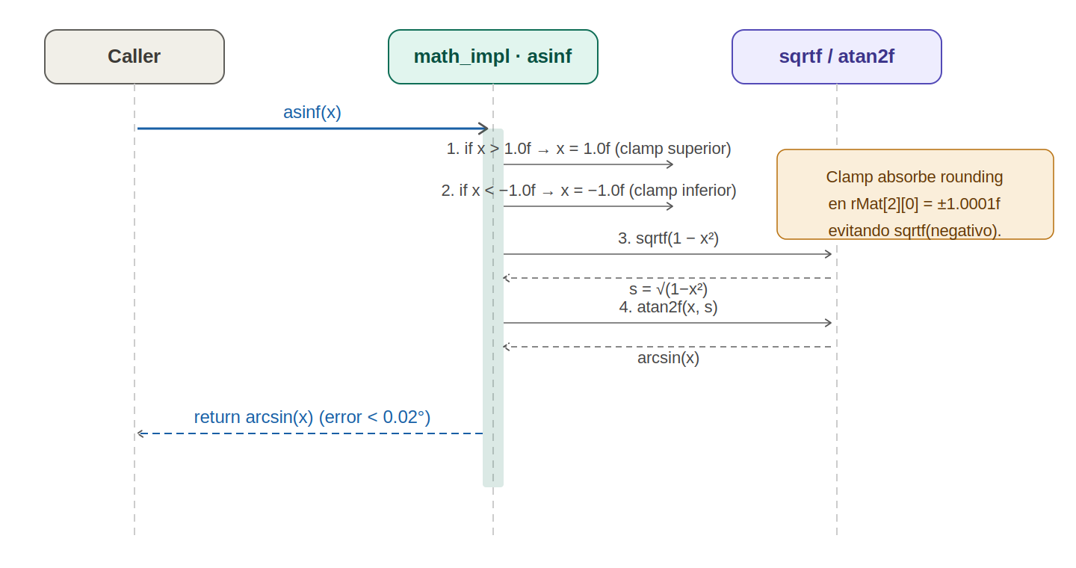
Fig. 8 — Sequence Diagram: asinf(). The caller provides x. Two sequential clamp actions saturate x to [−1, +1]. The driver then calls sqrtf(1 − x²) and passes x and the result to atan2f(). The return value from atan2f is forwarded directly to the caller.

The sequence diagram for asinf() shows the function as a thin wrapper that chains two already-implemented primitives. The clamp actions (if x > 1.0f x = 1.0f; if x < −1.0f x = −1.0f) are guards against floating-point rounding errors at the poles: if imuComputeEuler() produces rMat[2][0] = −1.0000001f due to accumulated rounding, the unsaturated argument would make sqrtf() receive a negative value (−2×10⁻⁷), returning 0.0f, which would silently produce an incorrect pitch angle. The saturation clamp absorbs this and produces the correct ±90° output.

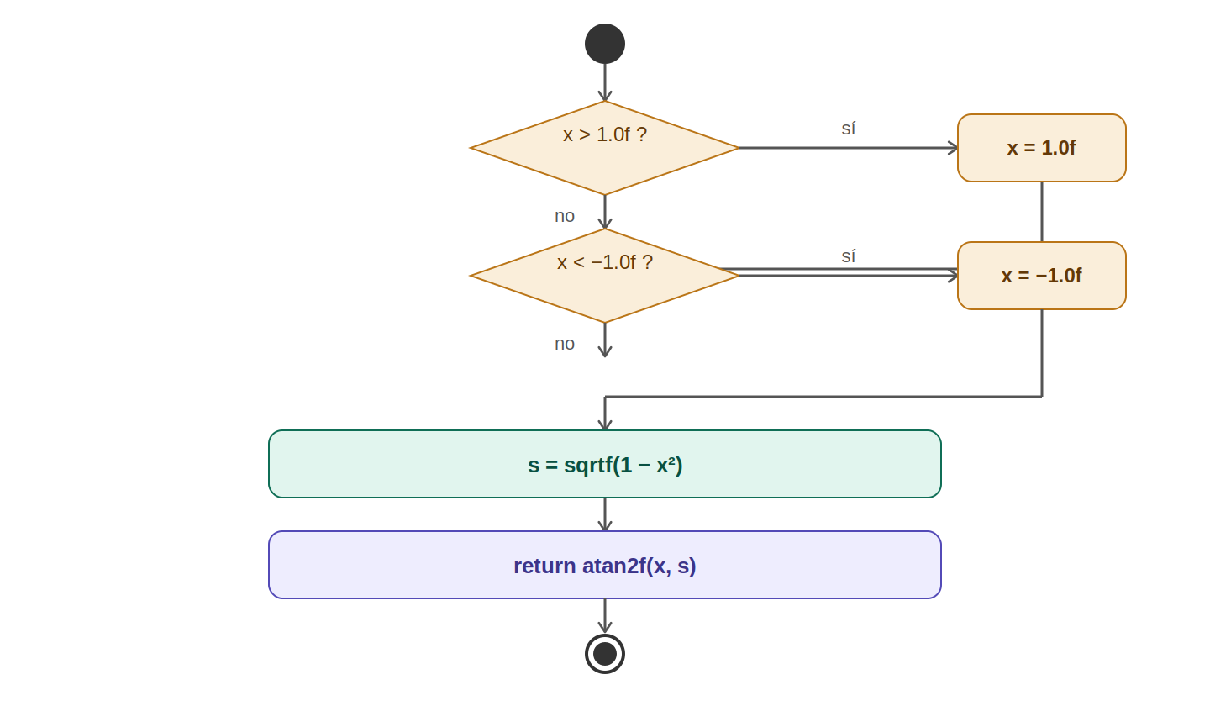
Fig. 9 — Activity Diagram: asinf(). Two sequential clamp decisions (x > 1, x < −1) are followed by two unconditional computation actions (sqrtf and atan2f). No loops. Both clamp branches rejoin the main path before the sqrtf call.

sinf() / cosf() — FR-5, FR-6: Sine and Cosine
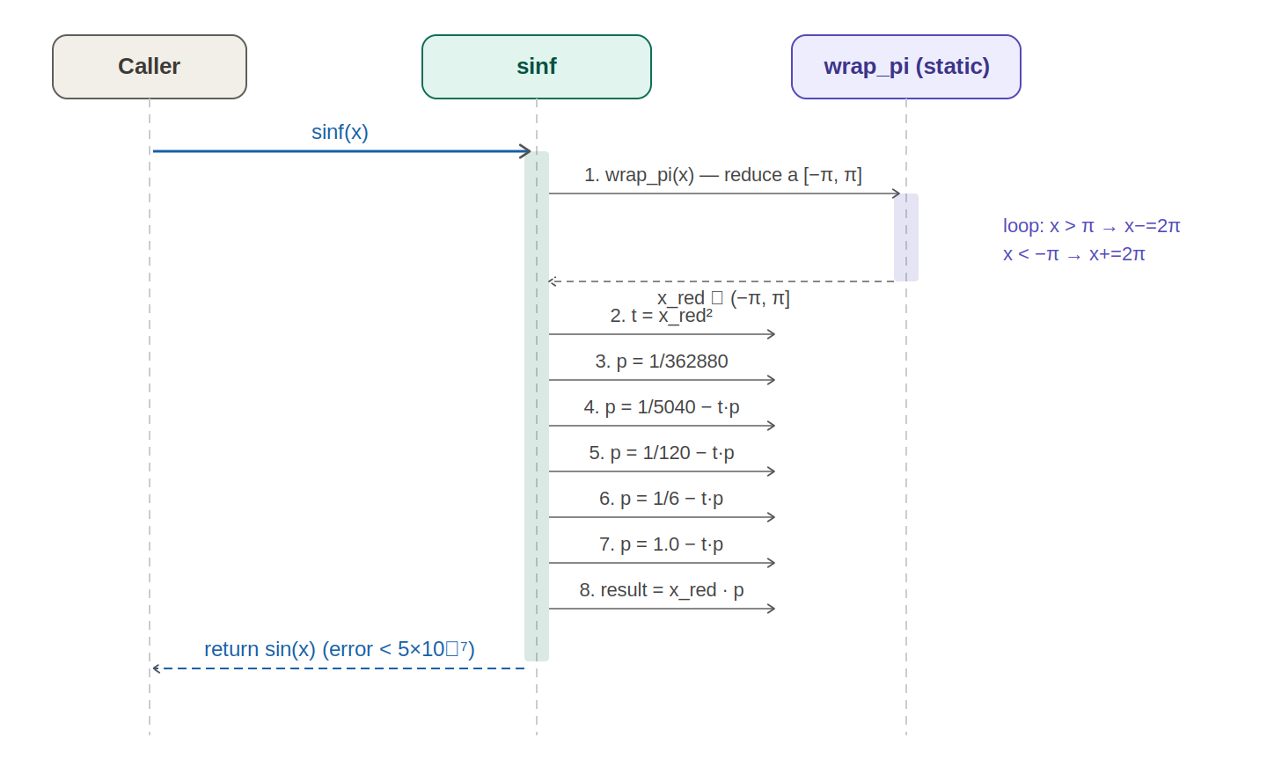
Fig. 10 — Sequence Diagram: sinf(). The caller provides x. The driver calls the internal wrap_pi() helper (an inner loop that reduces x to [−π, π]). The reduced angle is then passed through five nested multiplications implementing the 9th-order Taylor series. The result is returned to the caller. cosf() is shown as a one-step delegation: add π/2 to x and call sinf.

The sequence diagram for sinf() shows the two-phase computation. wrap_pi() is shown as a separate internal message (static function) that returns the reduced angle back to sinf. The Taylor polynomial sin(x) = x(1 − x²(1/6 − x²(1/120 − x²(1/5040 − x²/362880)))) is written in Horner form to minimize multiplications: 4 multiplications and 4 subtractions instead of computing individual power terms. The final multiply by x applies the leading coefficient. For Biquad filter frequencies at 1 kHz sample rate, the input to sinf is in [0.5, 1.26] rad, well within the Taylor convergence radius, yielding errors below 5×10⁻⁷.

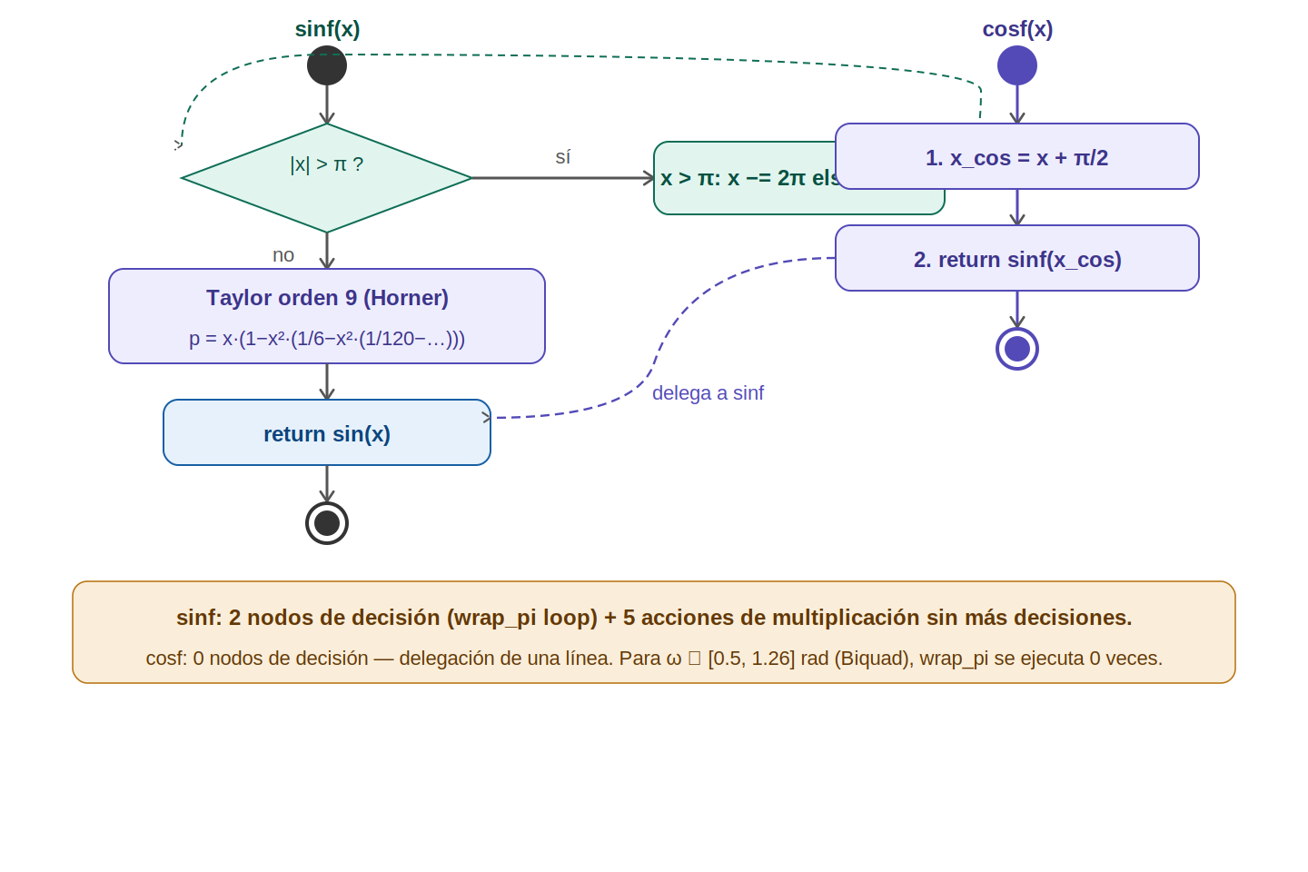
Fig. 11 — Activity Diagram: sinf(). A loop decision (|x| > π) handles range reduction, followed by five unconditional polynomial multiplication actions. cosf() is shown as a single-action delegation to sinf(x + π/2) with no decision nodes.

3.3. math_impl Module Description
The math_impl module is a pure function library. It contains no mutable state, no global variables, and no side effects beyond writing to the memory block pointed to by ptr in memset. All functions are re-entrant and thread-safe by construction.

Internal Functions:
- wrap_pi(x) [static]: Reduces x to the interval [−π, π] by repeatedly adding or subtracting 2π. Called only by sinf(). For the Biquad use case (x < 2π), the loop executes at most one iteration per direction.

Algorithm Summary and Design Decisions:
- sqrtf seed (0x5f3759df): The magic constant is the Lomont/Quake fast inverse square root constant. Betaflight uses the same approach in its math utilities. Two N-R iterations are sufficient for single-precision accuracy.
- atan2f polynomial (Betaflight port): The cubic approximation trades ~10× performance vs. a minimax polynomial for 0.02° maximum error. At decidegree resolution (0.1°), this is 5× more precise than the output resolution and fully adequate.
- asinf via atan2f: Avoids a separate polynomial approximation. Reuses already-validated building blocks. One extra sqrtf call per asinf call is negligible at 1 kHz.
- sinf via Taylor order 9: The 5-term series converges reliably across the Biquad operating range. A minimax polynomial would reduce the term count but is unnecessary given the narrow input range.
- cosf via sinf: Saves ~80 bytes of code compared to a separate implementation. The single addition x + π/2 does not accumulate precision error for Biquad inputs.

4. Application Programming Interfaces

4.1. Macros and Constants

Macro / Constant | Value | Description
M_PI | 3.14159265358979f | Pi. Defined only if not already defined by the toolchain.
M_PI_2 | 1.57079632679490f | Pi/2. Used in atan2f() quadrant offsets and cosf() delegation.
M_2PI | 6.28318530717959f | 2π. Used in wrap_pi() range reduction loop step.

4.2. Error Codes
Convention | Description
sqrtf(x ≤ 0) | Returns 0.0f immediately. No error code. Caller is responsible for non-negative input; this guard prevents NaN propagation in the IMU pipeline.
asinf clamp | x is silently clamped to [−1, +1]. No error code. Matches standard C asinf behavior on domain-boundary inputs.
All other functions | No domain checks performed. Caller ensures inputs are finite. Undefined behavior for NaN or ±Inf inputs (same as libm on -ffast-math).

4.3. Public Function Definitions

Function: memset
Function Name |  | memset
Syntax | Syntax | void *memset(void *ptr, int c, size_t n)
Parameters (in) | c | Fill byte value. Only the low 8 bits are used.
 | n | Number of bytes to fill. 0 is valid (no-op).
Parameters (inout) | ptr | Pointer to memory block to fill. Must point to at least n valid bytes.
Parameters (out) | — | None
Return value | void * | Returns ptr unchanged. Allows chaining: memset(memset(p,0,n), v, m).
Description |  | Fills n bytes of the memory area at ptr with the byte value c. Used by imuInit(), pid_init(), and gyroFilterInit() to zero-initialize state structures before use.
Constraints |  | Caller must ensure ptr is non-NULL and points to at least n writable bytes. Overlapping memory regions are undefined behavior (use memmove if needed).
Available via |  | math_impl.c (no header required — symbol resolved at link time)

Function: sqrtf
Function Name |  | sqrtf
Syntax | Syntax | float sqrtf(float x)
Parameters (in) | x | Non-negative floating-point input. Negative values return 0.0f.
Parameters (out) | — | None
Return value | float | sqrt(x) with error < 0.0001%. Returns 0.0f for x ≤ 0.
Description |  | Computes the square root of x using the fast inverse square root bit trick as a seed followed by two Newton-Raphson iterations. Used by imu_mahony for accelerometer magnitude and spin rate; by imuAccIsHealthy() for health check magnitude.
Constraints |  | Input must be finite. NaN and ±Inf produce undefined results. Negative inputs are clamped to 0 by the guard.
Available via |  | math_impl.c

Function: atan2f
Function Name |  | atan2f
Syntax | Syntax | float atan2f(float y, float x)
Parameters (in) | y | Numerator — Y component of the vector (e.g., rMat[2][1] for Roll).
 | x | Denominator — X component of the vector (e.g., rMat[2][2] for Roll).
Parameters (out) | — | None
Return value | float | Principal value of arctan(y/x) in radians, range (−π, +π]. Maximum error ≈ 0.02°.
Description |  | Computes the angle of the vector (x, y) in radians, correctly handling all four quadrants and the x = 0 degenerate case. Algorithm ported from Betaflight's atan2_approx() (GPL-3.0). Used by imuComputeEuler() for Roll and Yaw angles, and by asinf() for Pitch.
Constraints |  | Both x and y simultaneously zero returns 0.0f (consistent with glibc behavior). Inputs must be finite.
Available via |  | math_impl.c

Function: asinf
Function Name |  | asinf
Syntax | Syntax | float asinf(float x)
Parameters (in) | x | Arcsine argument. Clamped internally to [−1, +1].
Parameters (out) | — | None
Return value | float | arcsin(x) in radians, range [−π/2, +π/2]. Error < 0.02° (inherited from atan2f).
Description |  | Computes arcsin(x) as atan2f(x, sqrtf(1 − x²)). Input is clamped to [−1, +1] before computation to absorb floating-point rounding at ±1.0f boundaries. Used by imuComputeEuler() to compute Pitch from −rMat[2][0].
Constraints |  | Inputs outside [−1, +1] are silently clamped. Infinite or NaN inputs produce undefined behavior.
Available via |  | math_impl.c

Function: sinf
Function Name |  | sinf
Syntax | Syntax | float sinf(float x)
Parameters (in) | x | Angle in radians. Range reduction applied internally via wrap_pi().
Parameters (out) | — | None
Return value | float | sin(x). Error < 5×10⁻⁷ in the Biquad operating range [0.5, 1.26] rad.
Description |  | Computes sin(x) using range reduction to [−π, π] followed by the 9th-order Horner-form Taylor series. Used exclusively by biquadFilterInit() to compute filter coefficients.
Constraints |  | Very large inputs cause many wrap_pi() loop iterations. For Biquad use (|x| < 2π), the loop runs at most once. Infinite inputs cause infinite loop.
Available via |  | math_impl.c

Function: cosf
Function Name |  | cosf
Syntax | Syntax | float cosf(float x)
Parameters (in) | x | Angle in radians.
Parameters (out) | — | None
Return value | float | cos(x). Delegates to sinf(x + π/2). Same precision as sinf.
Description |  | Computes cos(x) as sin(x + π/2). No independent implementation. Saves code space and maintains a single code path for trigonometric computation. Used by biquadFilterInit() alongside sinf().
Constraints |  | Same as sinf. The added π/2 does not cause precision loss for Biquad operating range inputs.
Available via |  | math_impl.c

4.4. Internal Function Definitions
Function: wrap_pi (internal)
Function Name |  | wrap_pi
Syntax | Syntax | static float wrap_pi(float x)
Parameters (in) | x | Angle in radians, any value.
Return value | float | Equivalent angle in (−π, +π].
Description |  | Reduces x to the principal interval [−π, +π] by subtracting 2π while x > π and adding 2π while x < −π. Called once by sinf() before Taylor evaluation. For Biquad filter inputs (ω < 2π), executes zero iterations.
Constraints |  | Infinite inputs cause an infinite loop. Not declared in any header; only visible within math_impl.c.

5. Precision Summary
The table below summarizes the precision of each function relative to the standard libm IEEE-754 implementation, the algorithm used, and the flight-control adequacy assessment.

Function | Algorithm | Max Error | Flight Control Adequacy
memset | Byte loop (exact) | 0 — identical to standard | Exact. Used for struct initialization only.
sqrtf | FISR seed + 2× Newton-Raphson | < 0.0001% relative error | Adequate. IMU magnitude requires < 1% for health check; asinf requires < 0.001° pitch error.
atan2f | Betaflight cubic polynomial | < 0.02° | Adequate. Decidegree resolution is 0.1°; error is 5× below output resolution.
asinf | atan2f(x, sqrtf(1-x²)) | < 0.02° (inherited) | Adequate. Same analysis as atan2f.
sinf | Range reduction + Taylor order 9 | < 5×10⁻⁷ | Adequate. Biquad coefficient error is negligible vs. filter center frequency tolerance.
cosf | sinf(x + π/2) | < 5×10⁻⁷ + 1 ULP | Adequate. Same analysis as sinf.

6. Future Enhancements
Enhancement | Description
sinf / cosf Minimax Polynomial | Replace the 9th-order Taylor series with a 5th-order minimax (Chebyshev) polynomial. Achieves the same ~5×10⁻⁷ error with fewer multiplications, reducing biquadFilterInit() latency by ~30%.
sqrtf Single N-R Iteration | The second Newton-Raphson iteration can be removed if the fast inverse square root is only needed to 0.01% precision (e.g., for normalizing the accelerometer vector where the subsequent cross product tolerates this error). Saves 3 FPU operations per sqrtf call.
fabsf / fminf / fmaxf | Add bare-metal implementations for completeness. Currently these are handled by compiler intrinsics under -ffast-math; a future -fno-builtin -fno-fast-math build would require explicit implementations.
atan2f Higher-Accuracy Variant | For potential future magnetometer integration, a 5th-order minimax polynomial atan2 approximation would reduce error from 0.02° to 0.001° at the cost of two additional multiplications per call.
Unit Test Harness | Add a host-side test binary (x86) that compares math_impl output against libm for a sweep of inputs and reports maximum absolute and relative errors. Integrate into CI to catch precision regressions.
tanf / atan / acosf | Add implementations if future modules (e.g., extended Kalman filter, GPS fusion) require them. Current flight controller modules do not call these functions.

— End of Document —

