Software Design Document
PID Controller Driver Module
Microcontrollers and Embedded Systems
Module | PID Controller
Version | 1.0.0
Author(s) | J.M. Páez Sandoval, D. I. Mijares Meza, A. S. De La Torre Gomez.
Institution | CETYS Universidad
Date | 3/06/2026

1. Introduction

1.1 Purpose
This document describes the design and architecture of the pid_controller module, adapted from the Betaflight 4.5.1 flight control firmware. It covers the initialization of PID parameters, gain configuration, integral term management, and the execution of the main PID control loop for roll, pitch, and yaw axes. The implementation includes proportional, integral, and derivative calculations, D-term low-pass filtering using a PT1 filter, anti-windup protection through integral clamping, and output limiting for stable flight control. The module provides a simplified yet functional version of the Betaflight PID controller, preserving the derivative-on-measurement approach to avoid derivative kick while maintaining robust angular rate regulation for multirotor applications.

1.2 Scope
The pid_controller module is a low-level flight control component responsible for angular rate stabilization on the roll, pitch, and yaw axes. It implements a simplified version of the Betaflight 4.5.1 PID algorithm, operating at a fixed control loop frequency defined by PID_LOOP_HZ. The module performs proportional, integral, and derivative computations based on rate setpoints and gyroscope measurements, using a PT1 low-pass filter for D-term noise reduction and integral clamping for anti-windup protection. Advanced Betaflight features such as TPA, anti-gravity, iTerm relaxation, feedforward, D-max, crash recovery, launch control, and RPM filtering are intentionally omitted to maintain a minimal and stable control core. The module is used by the flight control application to generate PID correction outputs that are later consumed by the motor mixer and ESC control layers for real-time multirotor stabilization.

1.3 Definitions, Acronyms, and Abbreviations

Term | Definition
PID | Proportional–Integral–Derivative controller used to regulate angular rates on the roll, pitch, and yaw axes
Setpoint | Desired angular rate command provided by the flight control system for a specific axis
Gyro Rate | Measured angular velocity from the gyroscope, expressed in degrees per second (°/s)
Error Rate | Difference between the desired angular rate and the measured angular rate (setpoint - gyroRate)
P-Term | Proportional component of the PID controller. Produces an output proportional to the instantaneous error
I-Term | Integral component of the PID controller. Accumulates error over time to eliminate steady-state offsets
D-Term | Derivative component of the PID controller. Based on the rate of change of the measured gyro signal to provide damping and improve stability
PT1 Filter | First-order low-pass filter applied to the gyro signal before derivative calculation to reduce noise amplification in the D-term
Anti-Windup | Mechanism that limits the growth of the integral term by clamping it within predefined bounds
iTerm Limit | Maximum allowed magnitude of the integral term to prevent excessive accumulation
PID Sum Limit | Maximum allowed magnitude of the combined PID output (P + I + D + F)
PID Loop Frequency | Execution frequency of the PID controller, defined by PID_LOOP_HZ and used for derivative normalization
dt | Time interval between PID updates (1 / PID_LOOP_HZ), expressed in seconds
Derivative-on-Measurement | D-term implementation that computes the derivative using the gyro measurement rather than the control error, preventing derivative kick caused by abrupt setpoint changes
Roll | Rotation about the longitudinal axis of the aircraft
Pitch | Rotation about the lateral axis of the aircraft
Yaw | Rotation about the vertical axis of the aircraft
Feedforward (F-Term) | Additional control component that anticipates system response based on pilot commands. Present in the structure but not actively computed in this simplified implementation
Betaflight | Open-source multirotor flight control firmware from which the PID algorithm was adapted

2. System Architecture

2.1 High-Level Design
The pid_controller module sits within the flight-control layer of the system and operates directly on angular rate setpoints and gyroscope measurements. The module is responsible for computing PID correction outputs for the roll, pitch, and yaw axes using a simplified adaptation of the Betaflight 4.5.1 control algorithm. It depends only on the definitions, configuration parameters, and filter utilities provided by pid_controller.h and associated filtering modules. The controller maintains its own internal state, including proportional, integral, and derivative terms, filtered gyro history, gain parameters, and output limits. The generated PID outputs are intended to be consumed by higher-level mixer and motor-control modules to produce the final actuator commands required for aircraft stabilization.

Layer | Modules
Application | main.c / flight_controller.c — calls pidInit(), pidUpdate(), pidSetGains(), and reads PID outputs for attitude stabilization and motor mixing
PID Controller | pidInit(), pidUpdate(), pidSetGains(), pidResetIterm(), PT1 D-term filtering, P/I/D computation, anti-windup limiting, and PID output generation
Sensor Interface | Gyroscope measurements (gyroRoll, gyroPitch, gyroYaw) provided by the IMU driver and used as feedback for rate control
Hardware | STM32F411RE MCU executing the control loop at PID_LOOP_HZ. Gyroscope data is acquired from the IMU, while PID outputs are forwarded to the mixer and ESC/PWM driver to control the motors

2.2 Module Interfaces
The public API of the pid_controller module is declared in pid_controller.h. The module provides functions for controller initialization, gain configuration, integral reset, and PID computation. Dependencies are limited to the controller configuration definitions and filter utilities required for PT1 low-pass filtering; no vendor-specific middleware, hardware abstraction layer (HAL), or RTOS services are required. All PID state variables, gain parameters, filter instances, and output terms are encapsulated within the PidState_t structure, which is initialized by pidInit(). The application is only responsible for supplying angular rate setpoints and gyroscope measurements to pidUpdate() and reading the resulting PID outputs. Internal configuration of D-term filtering, anti-windup limiting, derivative history, and output saturation is handled entirely within the module and requires no external management.

3. Detailed Design

3.1 Module Behavior
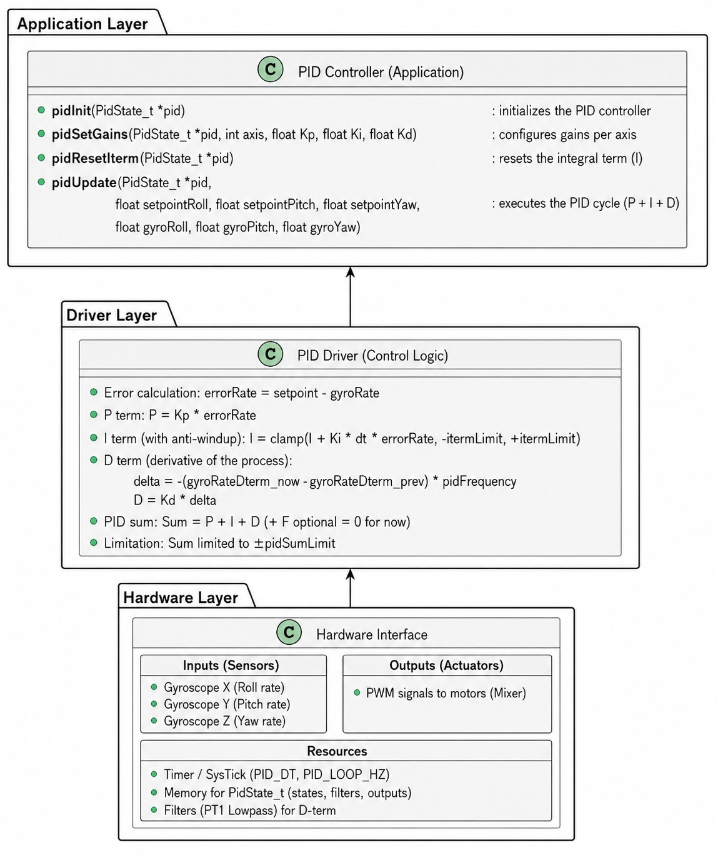
Figure 1. Class Diagram - PID Controller Driver

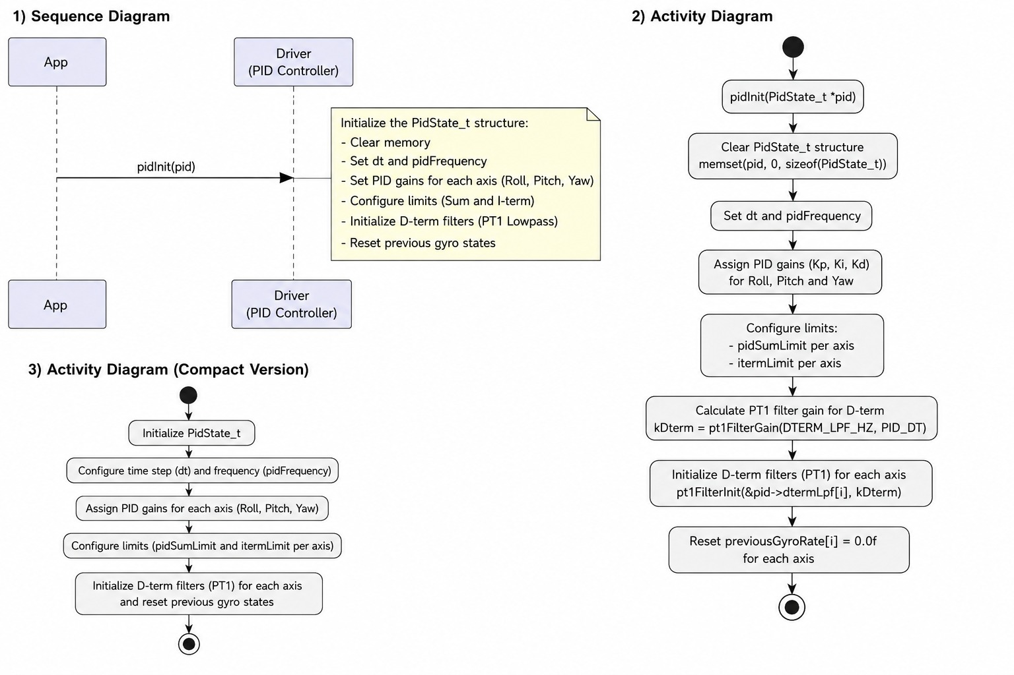

Figure 2. Sequence Diagram — pidInit()


Figure 3. Activity Diagram — pidInit()
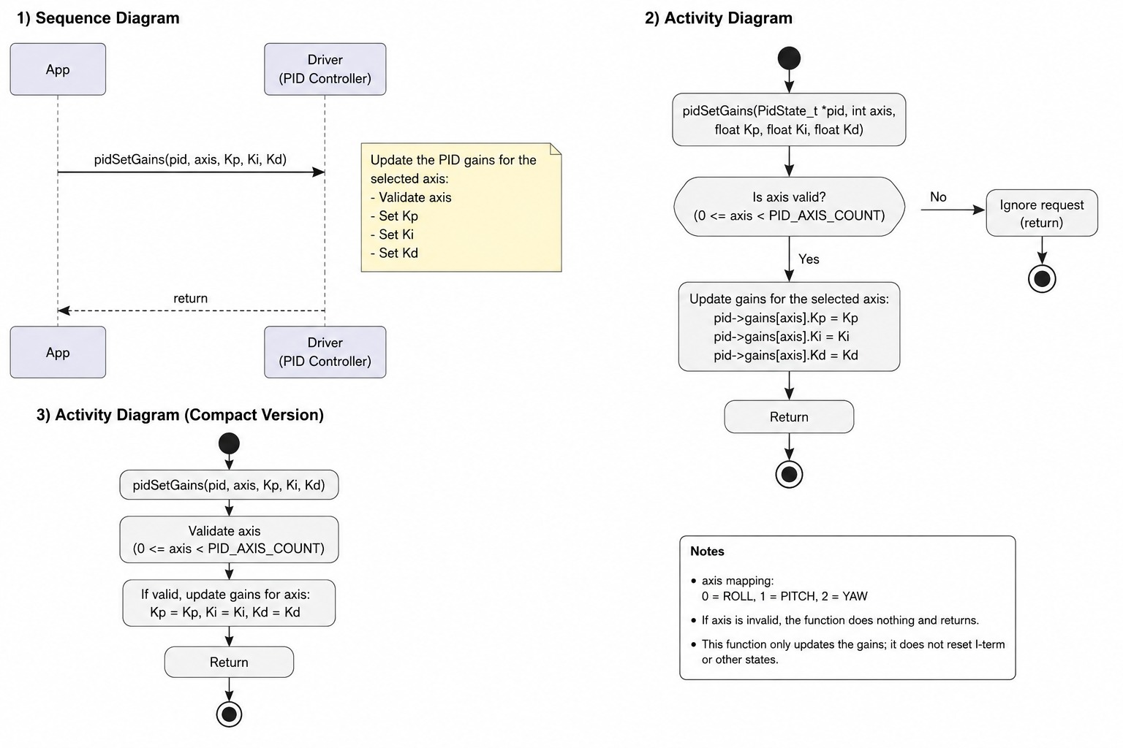

Figure 4. Sequence Diagram — pidSetGains()


Figure 5. Activity Diagram — pidSetGains()

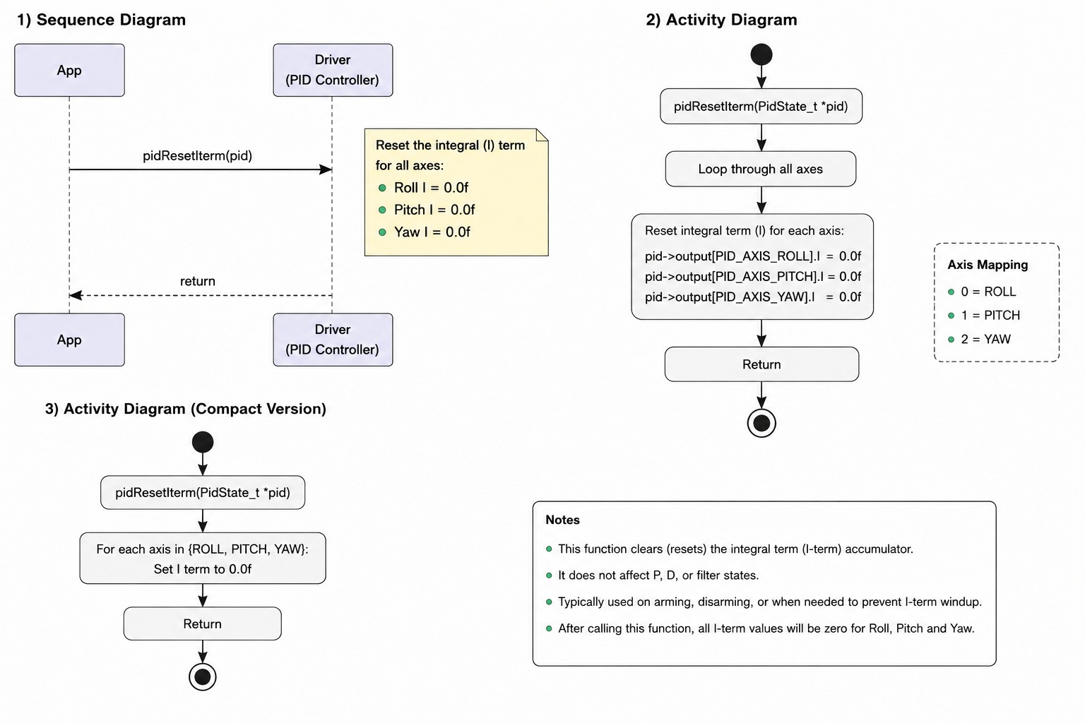
Figure 6. Sequence Diagram — pidResetIterm()


Figure 7. Activity Diagram — pidResetIterm()

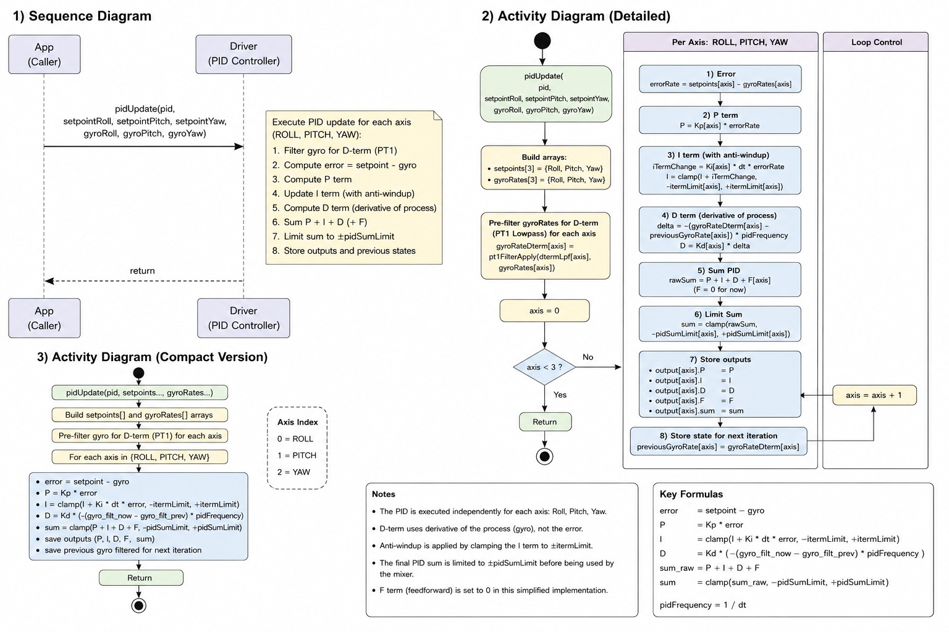
Figure 8. Sequence Diagram — pidUpdate()


Figure 9. Activity Diagram — pidUpdate()

3.2 PID Controller Driver Module Description
pidInit() initializes the PidState_t structure, clears all internal controller states, loads the default PID gains for the roll, pitch, and yaw axes, configures PID output and integral limits, and initializes the PT1 low-pass filters used by the D-term calculation. The function also stores the control-loop period (dt) and loop frequency (pidFrequency) and resets the filtered gyro history required for derivative computation.

pidSetGains() updates the proportional (Kp), integral (Ki), and derivative (Kd) gains for a selected control axis. The function validates the axis index before modifying the corresponding gain structure.

pidResetIterm() clears the accumulated integral term for all control axes. This function is typically used during arming, disarming, or controller reinitialization to prevent residual integral accumulation from affecting subsequent control cycles.

pidUpdate() implements the main PID control loop. The function receives angular rate setpoints and gyroscope measurements for the roll, pitch, and yaw axes. First, the gyro measurements are passed through a PT1 low-pass filter to generate the signals used by the D-term calculation. The controller then computes the rate error as the difference between the setpoint and measured angular rate.

The proportional term is calculated as the product of Kp and the rate error. The integral term is updated by integrating the error over the loop period (Ki × dt × error) and is constrained within predefined limits to prevent integral windup. The derivative term is calculated from the difference between the current and previous filtered gyro measurements rather than from the error signal. This derivative-on-measurement approach eliminates derivative kick caused by abrupt setpoint changes and provides damping proportional to angular acceleration.

After computing the P, I, and D contributions, the controller stores the current filtered gyro value for use during the next iteration. The individual terms, together with any feedforward contribution stored in the controller state, are summed to produce the final PID output. The resulting control command is constrained within the configured PID output limits before being stored in the corresponding axis output structure for use by the mixer and motor-control modules.

4. Application Programming Interfaces

4.1 Data Types and Macros

Macro / Constant | Value | Notes
PID_LOOP_HZ | Project-defined | PID controller execution frequency in Hertz. Used to determine controller update rate and derivative normalization.
PID_DT | 1 / PID_LOOP_HZ | Control-loop period in seconds. Used for integral accumulation and filter calculations.
DTERM_LPF_HZ | Project-defined | Cutoff frequency of the PT1 low-pass filter applied to the gyro signal before D-term computation.
PID_SUM_LIMIT | Project-defined | Maximum allowed magnitude of the PID output for the roll and pitch axes.
PID_SUM_LIMIT_YAW | Project-defined | Maximum allowed magnitude of the PID output for the yaw axis.
PID_ITERM_LIMIT | Project-defined | Maximum allowed magnitude of the integral term for the roll and pitch axes.
PID_ITERM_LIMIT_YAW | Project-defined | Maximum allowed magnitude of the integral term for the yaw axis.
PID_KP_ROLL, PID_KI_ROLL, PID_KD_ROLL | Project-defined | Default PID gains for the roll axis loaded during initialization.
PID_KP_PITCH, PID_KI_PITCH, PID_KD_PITCH | Project-defined | Default PID gains for the pitch axis loaded during initialization.
PID_KP_YAW, PID_KI_YAW, PID_KD_YAW | Project-defined | Default PID gains for the yaw axis loaded during initialization.
PID_AXIS_ROLL | 0 | Array index corresponding to the roll control axis.
PID_AXIS_PITCH | 1 | Array index corresponding to the pitch control axis.
PID_AXIS_YAW | 2 | Array index corresponding to the yaw control axis.
PID_AXIS_COUNT | 3 | Total number of supported control axes.
PidState_t | Structure | Main controller state containing gains, filters, historical data, limits, and PID outputs for all axes.
PidGain_t | Structure | Stores the proportional, integral, and derivative gains (Kp, Ki, Kd) for a single axis.
PidOutput_t | Structure | Stores the computed P, I, D, F, and summed PID outputs for a control axis.
Pt1Filter_t | Structure | First-order low-pass filter state used for D-term gyro filtering.

4.2 Error Codes
The pid_controller module does not define explicit error codes. All public functions either return void or update values directly within the provided PidState_t structure. Parameter validation is limited to basic axis-range checking in functions such as pidSetGains(), where invalid axis indices are ignored and no action is performed.

4.3 Function Definitions
pidInit
Field | Description
Function Name | pidInit
Syntax | void pidInit(PidState_t *pid)
Parameters (in) | pid – Pointer to the PID controller state structure to initialize.
Return value | void
Description | Initializes the PID controller state. Clears all internal variables, loads the default PID gains for roll, pitch, and yaw axes, configures PID output limits and integral limits, initializes the PT1 low-pass filters used by the D-term calculation, sets the controller time step (dt) and loop frequency (pidFrequency), and resets the stored gyro history required for derivative computation.
Constraints | Must be called before any other PID controller function. The pid pointer must reference a valid PidState_t instance. Configuration constants such as PID_LOOP_HZ, PID_DT, DTERM_LPF_HZ, and default gain values must be defined before compilation.
Available via | pid_controller.h

pidSetGains

Field | Description
Function Name | pidSetGains
Syntax | void pidSetGains(PidState_t *pid, int axis, float Kp, float Ki, float Kd)
Parameters (in) | pid – Pointer to the PID controller state.axis – Target control axis (PID_AXIS_ROLL, PID_AXIS_PITCH, or PID_AXIS_YAW).Kp – Proportional gain.Ki – Integral gain.Kd – Derivative gain.
Return value | void
Description | Updates the PID gains for the specified axis. The new proportional, integral, and derivative coefficients replace the currently configured values and are used during subsequent PID calculations.
Constraints | The axis parameter must be within the valid range [0, PID_AXIS_COUNT-1]. Invalid axis values are ignored and no modification is performed.
Available via | pid_controller.h

pidResetIterm

Field | Description
Function Name | pidResetIterm
Syntax | void pidResetIterm(PidState_t *pid)
Parameters (in) | pid – Pointer to the PID controller state.
Return value | void
Description | Clears the accumulated integral term (I) for all control axes. This prevents previously accumulated error from affecting future controller operation.
Constraints | Typically called during controller reset, arming/disarming events, or whenever accumulated integral error must be discarded.
Available via | pid_controller.h

pidUpdate

Field | Description
Function Name | pidUpdate
Syntax | void pidUpdate(PidState_t *pid, float setpointRoll, float setpointPitch, float setpointYaw, float gyroRoll, float gyroPitch, float gyroYaw)
Parameters (in) | pid – Pointer to the PID controller state.setpointRoll – Desired roll rate.setpointPitch – Desired pitch rate.setpointYaw – Desired yaw rate.gyroRoll – Measured roll angular rate.gyroPitch – Measured pitch angular rate.gyroYaw – Measured yaw angular rate.
Return value | void
Description | Executes one PID control cycle for the roll, pitch, and yaw axes. The function filters gyroscope measurements using PT1 low-pass filters, computes the control error, updates the proportional, integral, and derivative terms, applies integral anti-windup and output limiting, and stores the resulting PID outputs in the controller state structure. The derivative term is calculated from the filtered gyro signal (derivative-on-measurement) to avoid derivative kick caused by abrupt setpoint changes.
Constraints | Must be executed periodically at the frequency specified by PID_LOOP_HZ. The controller must be initialized using pidInit() before calling this function. Input rates and setpoints are expected to use consistent units (typically degrees per second).
Available via | pid_controller.h

pidConstrainf (Utility Function)

Field | Description
Function Name | pidConstrainf
Syntax | float pidConstrainf(float value, float min, float max)
Parameters (in) | value – Value to constrain.min – Minimum allowed value.max – Maximum allowed value.
Return value | Constrained floating-point value.
Description | Limits a floating-point value to the specified range. If the value exceeds the maximum limit, the maximum value is returned. If it falls below the minimum limit, the minimum value is returned. Otherwise, the original value is returned unchanged.
Constraints | The minimum value should be less than or equal to the maximum value. Used internally for integral anti-windup and PID output saturation.
Available via | pid_controller.h (if declared public) or internal module implementation.

4.4 Internal Function Definitions
The pid_controller module contains no private control-law helper functions. All PID computations, including proportional, integral, and derivative calculations, anti-windup limiting, D-term filtering, derivative history updates, and output saturation, are implemented directly within the public pidUpdate() function. Controller initialization and configuration tasks are similarly performed within the public API functions pidInit(), pidSetGains(), and pidResetIterm().

5. Future Enhancements
Several advanced features from the original Betaflight implementation were intentionally omitted to keep the current PID controller simple, deterministic, and easy to validate. Future development may include the following enhancements:
- Throttle PID Attenuation (TPA) to dynamically reduce proportional and derivative gains at high throttle levels, minimizing oscillations caused by increased motor authority.
- Anti-Gravity Compensation to temporarily boost the integral term during rapid throttle changes, improving attitude stability during aggressive climbs and descents.
- iTerm Relaxation to prevent excessive integral accumulation during fast pilot stick inputs, reducing overshoot and improving control responsiveness.
- iTerm Rotation Compensation to maintain correct integral behavior during rapid three-dimensional rotations of the aircraft.
- Feedforward Control (F-Term) based on pilot stick commands to improve tracking performance and reduce control latency during aggressive maneuvers.
- D-Max Adaptive D-Term Scaling to dynamically increase derivative gain only when large angular accelerations are detected, improving damping while minimizing noise sensitivity.
- Advanced D-Term Filtering through the addition of notch filters and secondary low-pass filters similar to those used in Betaflight to further suppress gyroscope noise.
- RPM-Based Dynamic Filtering using motor RPM telemetry to automatically track and attenuate motor-induced vibration frequencies.
- Crash Recovery Logic to detect loss-of-control events and temporarily modify controller behavior to assist aircraft recovery.
- Launch Control Mode to optimize controller response during takeoff and high-performance launch sequences.
- Runtime PID Tuning Interface allowing gain parameters and filter settings to be modified without recompiling firmware.
- NaN and Sensor Fault Detection to improve robustness by identifying invalid gyroscope measurements and preventing propagation of corrupted control outputs.
- Adaptive or Auto-Tuning Algorithms capable of estimating optimal PID gains based on flight behavior and system response characteristics.
- Support for Additional Control Loops, such as angle mode and attitude-hold controllers, layered on top of the existing rate PID implementation.
- Blackbox Logging Integration for recording PID terms, gyro data, and controller performance metrics to facilitate flight analysis and tuning.

