Waquoit Bay (WQB) National Estuarine Research Reserve Water Quality Metadata
January 2008-December 2008
Latest Update: September 21, 2020

I. Data Set & Research Descriptors

- Principal investigator & contact persons:

Address: Waquoit Bay NERR
PO Box 3092
149 Waquoit Highway

Waquoit, MA 02536
(508)-457-0495
Email: waquoit.bay@state.ma.us

Contact persons:
Dr. Chris Weidman, Research Coordinator
Email: Chris.Weidman@state.ma.us; (508)-457-0495 ext. 105
MaryKay Fox, Assistant Research Coordinator
Email: MaryKay.Fox@state.ma.us ; (508)-457-0495 ext. 109
Elizabeth Bonk, Research Technician
Email: Elizabeth.Bonk@state.ma.us ; (508)-457-0495 ext. 128

- Entry verification:

Deployment data are uploaded from the YSI data logger to a Personal Computer (IBM compatible). Files are exported from EcoWatch in a comma-delimited format (.CDF) and uploaded to the CDMO where they undergo automated primary QAQC; automated depth/level corrections for changes in barometric pressure (cDepth or cLevel parameters); and become part of the CDMO’s online provisional database. All pre- and post-deployment data are removed from the file prior to upload. During primary QAQC, data are flagged if they are missing or out of sensor range. The edited file is then returned to the Reserve for secondary QAQC where it is opened in Microsoft Excel and processed using the CDMO’s NERRQAQC Excel macro. The macro inserts station codes, creates metadata worksheets for flagged data and summary statistics, and graphs the data for review. It allows the user to apply QAQC flags and codes to the data, remove any overlapping deployment data, append files, and export the resulting data file for upload to the CDMO. Upload after secondary QAQC results in ingestion into the database as provisional plus data, recalculation of cDepth or cLevel parameters, and finally tertiary QAQC by the CDMO and assimilation into the CDMO’s authoritative online database. Where deployment overlap occurs between files, the data produced by the newly calibrated sonde is generally accepted as being the most accurate. For more information on QAQC flags and codes, see Sections 11 and 12.

Copies of all files are retained at the Reserve which includes the formatted PC6000 data files (.dat), as well as the raw text files (.csv) and final exported text files (.txt) archived at the CDMO site. During deployment year 2008, Research Technician Elizabeth Bonk was primarily responsible for performing all instrument calibrations. Research Coordinator Chris Weidman and Assistant Research Coordinator MaryKay Fox are responsible for data QA/QC.

- Research objectives:

For the NERR System-Wide Monitoring Program (SWMP), the YSI 6600 data loggers are programmed to record water quality parameters every 15 minutes. A total of four SWMP sites were located in the Waquoit Bay estuarine system during 2008. These four are: 1) Metoxit Point (MP), in operation since 1998, is located in the middle of Waquoit Bay’s main basin; 2) Menauhant (MH), in operation since March 2001, is located adjacent to Eel Pond Inlet on Vineyard Sound – one of the two tidal inlets into the Waquoit Bay estuary; 3) Child’s River (CR), in operation since May 2002, located near the head of the tidal section of Child’s River— one of the two main surface fresh water sources to Waquoit Bay; and 4) Sage Lot (SL), in operation since May 2002, located in Sage Lot Pond—a relatively pristine tidal pond surrounded by salt marsh and barrier beach, possessing one of the bay’s few remaining eelgrass stands.

The main purpose of the SWMP water quality monitoring program is to aid Waquoit Bay NERR in one of its priority missions - to perform as a natural laboratory and platform for coastal and estuarine research. The long term, continuous detailed monitoring of the estuary’s basic hydro-physical parameters is an essential tool and context for any research activities located here. Besides this overarching mission, there are also several specific research interests. One primary issue for the Waquoit Bay ecosystem is the influence of anthropogenic induced alterations by nitrogen enrichment. Waquoit Bay receives nitrogen from several sources, including but not limited to septic systems (their leachate percolates into groundwater which then enters the bay), run off from roads, run off containing domestic and agricultural fertilizer and animal waste, and atmospheric sources. This elevated nitrogen loading to the bay has resulted in enhanced eutrophication that has contributed to the alteration of the bay’s habitats. For example, thick mats of seaweeds (macroaglae) now cover the bottom where eelgrass meadows thrived in the 1970's. Unfortunately, there are few definitive records of the bay’s water quality conditions during that period, which makes it difficult to evaluate the rates of change. To facilitate future evaluation, long-term records from SWMP can be used to track water column conditions. Of particular interest, in this regard are measurements of dissolved oxygen (DO) and turbidity, as well as dissolved nitrogen and chlorophyll concentration (this data is available by contacting the reserve). Such records will facilitate evaluation of changes which may come about from a continuation of watershed alteration that result from current development patterns (i.e., non-sewered residential areas served by private septic systems typically consisting of septic tanks and leach fields) as well as non-industrial commercial development, such as golf courses, cranberry bogs, and retail shopping outlets. The records will be useful for evaluating the efficacy of remediation efforts intended to reduce the nitrogen loading from these sources to Waquoit Bay.

Another focus of long-term research interest is the detection of climate change and the determination of its effects on the estuarine environment. Characterizing the variability of the various water column parameters, such as their scale, magnitude and frequency, is likely to be an important aspect of the estuarine ecosystem that may be sensitive to climate change. Related to this focus is an interest in the impact of storms (hurricanes and northeasters) and other extreme meteorological events on the estuary. For example, what temperature and wind field thresholds exist that might bring about or trigger certain conditions within the bay? The observations recorded by the SWMP will allow for these types of studies.

- Research methods:

YSI 6600 series Sondes are deployed at each permanent water quality monitoring station at the Waquoit Bay Reserve. Since in-situ instrumentation can only record conditions at a specific location, permanent monitoring stations for SWMP are chosen to be in some way representative of the overall estuary. This is difficult in practice since estuaries by their very definition are coastal regions where large physical, chemical and biological variations tend to occur in space and time, so that often no particular location within the system is “typical” of the overall system. Establishing a number of stations can overcome this problem somewhat, and as of 2002 four permanent stations were established in the Waquoit Bay estuaries. Our current SWMP stations are situated to represent, as much as possible, the diversity of the estuary and its inputs/outputs. Additional details concerning the station characteristics are discussed in the next section.

The YSI Sondes measure and record ambient water temperature, specific conductivity (and calculate salinity), dissolved oxygen (mg/L and % saturated), turbidity (NTU), Chlorophyll-a (ug/L) water level (m), and pH at 15 minute intervals during deployment periods extending for approximately two to three weeks (three weeks during the winter months, two weeks during summer months due to fouling). Note that the pressure sensors currently in use are non-vented and so variations in atmospheric pressure are recorded as changes in water depth (atmospheric data are available from our SWMP meteorological station (as of January 2002) and other nearby meteorological observatories), so it is possible to make this correction to the depth data (approximately +1 cm of depth is equal to +1 mb of air pressure), for increased accuracy. Also, at our Metoxit Point site (from 12/2000 to 12/2008), Child’s River site (from 3/2003 through 12/2008), Menauhant site (from 7/2006 to 12/2008), and our Sage Lot site (from 6/2006 to 12/2008) we have been using a YSI 6025 optic chlorophyll fluorescence sensor and these data are available by contacting the reserve directly (and included in the raw files sent to CDMO).

Sondes are deployed and retrieved every two to three weeks. The “old” Sonde is retrieved and a “new” replacement Sonde is deployed immediately so that ideally no record gap occurs. The 2-3 week deployment duration is constrained by a combination of battery life (shorter life in colder waters) and fouling of the DO sensor (and other sensors to a lesser degree) during the warm summer months. Prior to deployment (usually within 24 hrs), each instrument is checked and its sensors re-calibrated using standard YSI (Operating Manual) protocols. Similarly, after a deployment, each Sonde is brought back to the laboratory for a post-deployment check, data downloading, instrument and sensor cleaning. Salinity sensors are calibrated with reference seawater that had been previously analyzed with a Guildline salinometer at the Woods Hole Oceanographic Institution (David Wellwood is currently the technician for this instrument). pH sensors are calibrated with 7.0 and 10.0 pH standard solutions (2-point calibrations). The turbidity standard used is YSI 6073G turbidity standard for 123.0 NTU, and distilled water (DI) for 0 NTU. Temperature sensors are checked periodically against a calibrated mercury thermometer. The chlorophyll probe is calibrated on a 2-point calibration with distilled water (DI) and a Fluorescent Red Dye (Rhodamine WT) at a 0.5 mg/ L concentration. Oxygen sensor membranes are inspected before and after each deployment. Oxygen sensor membranes are replaced 24 hours prior to each deployment when the sensor seemed to need reconditioning. Final DO calibration was not done until the membrane had been in place for at least 8 hours. As another check on instrument performance, in-situ measurements of air and water temperature, DO, salinity, Specific Conductance, and pH are made using a hand-held YSI 650 at deployment/retrieval times.

In 2008, SWMP water quality data were collected continuously at all our water sites (dockside sites, Child’s River and Menauhant, open water sites, Metoxit Point and Sage Lot). Ice conditions were minimal and did not require us to pull any Sondes during the winter months.

Two types of mooring silos house the sondes during their deployment. The Metoxit Point and Sage Lot stations are located offshore and away from shore structures. The Sonde moorings for these stations consist of a vertical PVC pipe tower (2” ID), about 1.5 meters in height extending from a 120 lb cast concrete base resting on the bottom. Attached to this tower is a 0.7 m PVC pipe section (4” ID), referred to as the silo, that holds the Sonde and is adjustable for setting the depth of the sensor package. The Sondes are lowered and inserted into the 4” PVC silo from the surface at low water, when the top of the tower is only about 0.3 m below the surface. The lower part of the silo section is perforated with numerous 1.5" holes to allow the YSI Sonde’s sensors direct exposure to the flow of ambient waters. The Metoxit Point and Sage Lot silos are set so that the sensor package is 0.7 m and 0.5 off the bottom, respectively. This ensures that the sensors are above the macro algal mats in the case of Metoxit Point, and sufficiently into the water column because of the thick eelgrass meadow in Sage Lot. The Menauhant and Child’s River stations are dock-side locations and their moorings are a more typical type of silo – a single PVC section (4” ID) mounted vertically on a pier piling. The Menauhant site, located at a yacht club dock, is adjacent to a tidal inlet, and the Child’s River site, located at commercial marina and boat yard, is adjacent to the upper reaches of a tidal river. The base of these silos is also ventilated with large holes (1.0” diameter) and their sensor packages (bottom of the Sonde) are both mounted about 0.4 m off the bottom. All mooring silos are painted with antifouling paint at the beginning of the spring season, and periodically checked and scrubbed during the summer season.

- Site location and character:

General description of Waquoit Bay estuarine system:
The Waquoit Bay National Estuarine Research Reserve (WBNERR) is located in the northeastern United States on the southern coast of Cape Cod, Massachusetts. About 8,000 people maintain permanent residency in Waquoit Bay's drainage area, which covers parts of the towns of Falmouth, Mashpee, and Sandwich. During summer months, the population swells 2-3 times with the greatest housing concentrations immediate to the coastline (water views and frontage). In addition, the upper portions of the watershed include a military base, Otis Air Force Base and the Massachusetts Military Reservation, portions of which have been designated by the EPA as Superfund sites due to past practices of dumping jet fuel and other volatile groundwater contaminants.

WBNERR’s estuaries are representative of shallow tidal lagoons that occur from Cape Cod to Sandy Hook, New Jersey. WBNERR is within the northern edge of the Virginian biogeographic province, on the transitional border (Cape Cod) with the Acadian biogeographic province to the north and east. Like many embayments located on glacial outwash plains, Waquoit Bay is shallow (< 5 m), fronted by prominent barrier beaches (i.e., those of South Cape Beach State Park and Washburn Island), and is backed by salt marshes and upland coastal forests of scrub pine and oak. Two narrow, navigable inlets, reinforced with granite jetties, pass through two barrier beaches to connect Waquoit Bay with Vineyard Sound to the south. A third shallow and generally un-navigable inlet opened through the Washburn Island barrier beach during Hurricane Bob in August 1991, and closed up in February 2002.

Bottom sediments in the bay are organic rich (Corg conc. ~ 3-4%) silts and medium sands. Sediment cores taken in summer of 2002 indicate that the depth of these estuarine sediments is up to 9 m thick in places. Dating work on these sediment cores suggests that the Waquoit Bay basin has been inundated by the sea for about 5000 years, and sedimentation rates over the past 500 years are estimated to be range from 1.6 to 4.9 mm/yr. Thick (up to 0.3 m) macroalgae (seaweed) mats overlie much of the bottom of the bay, and largely consist of species Cladophora vagabunda, Gracilaria tikvahiayae, and Enteromorpha. The dominant marsh vegetation in Waquoit Bay is Spartina alterniflora and Spartina patens. Dominant upland vegetation includes mixed forests of red oak, white oak, and pitch pine, and other shrubs and plants common to coastal New England. Land-use in the bay’s watershed is about 60% natural vegetation, but the remaining land is largely residential housing, with some commercial (retail malls), and minor amounts of agriculture (~3%) (cranberry bogs).
Dense housing developments cover the two peninsulas that form the western shore of the Waquoit Bay estuarine system. Although the developments themselves are outside of the Reserve boundaries, dissolved nitrogen in discharges from their septic systems (via groundwater) and in fertilizer run-off from their lawns has significant effects on the functioning of the Waquoit Bay ecosystem. These impacts have been a primary subject of study at the Reserve since its designation (1988). One outcome of this research has been the delineation of sub-watersheds within the overall drainage area for Waquoit Bay, of which WBNERR is a small part. This knowledge allows for the design of experiments based on the spatial variation of nutrient loading and other land-use related impacts.

At the northern end of the bay, an area comprising a separate sub-watershed, coastal bluffs of glacial till rise 30 feet above sea level. The northern basin of the bay, just below these bluffs, is its deepest area (approximately 3 m MLW), while much of the remainder of the bay is about 1.5 m. Bourne, Bog, and Caleb Ponds are freshwater kettle hole ponds on the northern-most shore of the bay. As components of the same sub-watershed, they have a common albeit minor freshwater outflow into the bay's northern basin via a narrow channel through a brackish marsh. To the east and south, other sub-watersheds surround several tidal and freshwater ponds, including Hamblin and Jehu Ponds, brackish salt ponds that are connected to the main bay by the tidal waters of Little and Great Rivers, respectively. The shorelines of the ponds are developed with residences that are occupied both seasonally and year round. Hamblin Pond and Little River are components of one sub-watershed, and Jehu Pond and Great River are elements of a separate sub-watershed. Further south lays Sage Lot Pond. It is in the least developed sub-watershed and also contains a barrier beach and salt marsh ecosystem of the reserve's South Cape Beach State Park. To the east of Sage Lot Pond and within the same sub-watershed, lies the highly brackish Flat Pond. It receives minimal tidal flows of salt water from Sage Lot Pond through a narrow, excavated and culverted channel. In the spring of 2008 two (2) channel culverts were replaced, one with a bridge and the second with a wider, less restrictive culvert to aid in tidal flushing of the pond. The preponderance of the input to Flat Pond is groundwater and run off, both of which are likely affected (e.g., nutrients, pesticides, bacteria) by an adjacent golf course and near-by upper-scale residential development.

The largest source of surface freshwater to Waquoit Bay is the Quashnet / Moonakis River.
Although named "river", this and Child’s River are more appropriately described as "streams” because of their small channels and discharge ~1.0 CFS. A component of yet another sub-watershed, the Quashnet River originates in Johns Pond situated north of the bay and traverses forests, cranberry bogs, residential areas, and the Quashnet Valley Golf Course before entering the bay near the southern "boundary" of the northern basin. ("Quashnet" applies to that portion of the river within the town of Mashpee, and "Moonakis" refers to the brackish estuary at the river's mouth, lying in the town of Falmouth. Quashnet will be used hereafter to refer to the entire river.) The Quashnet River’s tidal portion has sufficient numbers of coliform bacteria to cause it to be closed to shell fishing most of the time. The source(s) of these bacteria (human or avian) is unknown at this time.

The Childs River is the second largest input of surface freshwater to the bay. A component of another sub-watershed, it runs through densely developed residential areas. The Childs River sub-watershed receives the highest nitrogen loading and is the largest nitrogen contributor to the Waquoit Bay system of all the sub-watersheds. In the upper tidal portions of the river the highest nutrient and chlorophyll levels and the lowest dissolved oxygen readings of any region in the bay have been recorded and so this location represents an end-member for looking at anthropogenic inputs and impacts on the system. Another, albeit smaller, source of freshwater to Waquoit Bay is the discharge of Red Brook, through brackish marshlands, into Hamblin Pond. Additional freshwater enters the bay elsewhere through groundwater seepage (perhaps up to 50% of all freshwater input into the bay), precipitation and the flows of smaller brooks. There is relatively little surface water runoff entering directly into the bay due to the high percolation rates of Cape Cod's coarse, sandy soils.

Knowledge of the homo/heterogeneity of the water masses in Waquoit Bay was originally derived from measurements made by reserve staff and from data obtained by the reserve's volunteer water quality monitoring group, the Waquoit BayWatchers who have collected depth profiles of Waquoit Bay water quality since 1993. Subsequent research by reserve staff (including some numerical modeling by T. Isaji) has revealed that lateral mixing has considerable influence because tidal currents follow a general course through the bay. This results in an overall structure to horizontal patterns of water quality characteristics. The pattern it produces is a gyre in the central portion of the main bay whereby currents follow a generally counter-clockwise flow around a central area that exhibits reduced exchange with the remainder of the bay. The flushing rate within the gyre is diminished when compared with other more peripheral areas of the bay. The location of the gyre meanders slightly, apparently under the influence of tides and wind. Because of the shallow conditions, restricted tidal inlets, and low amplitude tidal forcing of Vineyard Sound here (tides are semi-diurnal with a range about 0.5 m) water levels in the bay are also strongly influenced by wind forcing. Southerly winds increase tidal heights and advance the phase of the flood and retard the phase of ebb (Northerly winds have the opposite effect).

The Metoxit Point station (MP) (41o 34.131' N 70o 31.294' W, 2.2 m deep) initiated in 1998, is located in the main basin of Waquoit Bay and was selected to be within or near the outer regions of the gyre (described above) and more or less represents “typical” water mass conditions and residence times for the bay. The location is at least a half mile from shore, well flushed by tides, and is in an area that is minimally disturbed by routine activities on the bay (e.g. boat traffic, shell fishing, etc.). Bottom sediments at the site are organic rich muds often overlain by thick algal (Cladophora) mats. Because of this site’s fairly open exposure to the south (greatest fetch over the bay), it has been observed that when sustained southerly winds are greater than about 20 kts, the Metoxit Point site experiences increased turbidity (sediment suspension events). In the autumn of 2003, the absolute elevation of the station relative to NGVD29 (National Geodetic Vertical Datum, sometimes referred to as 1929 Sea Level) was calibrated. Precision is uncertain at this time (but estimated to be within 0.1 m). Depth to base of the Sonde (base of the sensor guard) at the Metoxit Point site is -1.02 m NGVD. The calibrated mean depth sensor height above the guard base for our YSI 6600 instruments is 0.26 m (SD<0.01m). Therefore depth readings (uncorrected for air pressure) at this station can be approximately interpreted as water surface heights above -0.76 m NGVD. However, the Sonde silo at Metoxit is lifted from the bottom for maintenance about twice a year and repositioned slightly within a 20 m radius, so that elevation variations of up to approximately 0.25 m are possible for this open water site. A mean tidal range of 0.46m (SD = 0.17) is calculated based on one month of data (May 2003), with a minimum of 0.13 m and a maximum of 0.91 m. A mean monthly salinity range of 4.2 ppt, from a mean monthly min of 27.8 ppt to a mean monthly max of 32.0 ppt, has been calculated for this site based on one year of observations (2002).

The Menauhant station (MH) (41o 33.156' N 70o 32.912' W, 1.2 m deep), initiated in March 2001, is located within the Eel Pond Inlet at the Menauhant Yacht Club dock. Eel Pond Inlet is the westernmost of the two main tidal inlets into the Waquoit Bay system. The site was chosen because it occupies one of the strategic locations for gauging the system’s water mass characteristics. Entering waters represent the marine end-member while outflows represent the final product of estuarine water mass modification and export to shelf waters. The site also has easy walk-in access to a secure private pier that extends into the throat of the inlet. Also, because of the turbulent tidal flow within the inlet, conditions are vertically well mixed, and the site can be maintained year round even through ice-over conditions in the rest of the bay during severely cold winters. Bottom sediments at this site are clean sands and gravels with almost no attached bottom vegetation. Since inception, we have noted that strong south to southeast (onshore) winds tend to produce turbidity events at this site from the wave induced suspension of fine sediments and organic material in the upstream near-shore zone. While we have found that these types of turbidity events are localized to windward near-shore areas in the bay, the transport of these sediments at inlet mouths during such times is perhaps a dominant sedimentation process within the estuarine system. In other words, while the choice of our location may be producing a localized signal in one of our measured parameters that signal may reflect key processes in the system at large. In the summer 2006, the absolute elevation of the station relative to NGVD29 (National Geodetic Vertical Datum, sometimes referred to as 1929 Sea Level) and NAVD88 was calibrated. Precision is estimated to be 0.025 m. Depth to base of the Sonde (base of the sensor guard) at the Menauhant site is -0.786 m NGVD29. The calibrated mean depth sensor height above the guard base for our YSI 6600 instruments is 0.26 m (SD<0.01m). Therefore depth readings (uncorrected for air pressure) at this station for this year should be interpreted as water surface heights above -0.516 m NGVD29 or -0.779 NAVD88. A mean tidal range of 0.48m (SD = 0.19) is calculated based on one month of data (May 2003), with a minimum of 0.11 m and a maximum of 0.99 m. A mean monthly salinity range of 3.9 ppt, from a mean monthly min of 28.5 ppt to a mean monthly max of 32.4 ppt, has been calculated for this site based on one year of observations (2002).

In July of 2006, a Sutron Sat-Link2 transmitter was installed at this station and transmits data to the NOAA GOES satellite, NESDIS ID #3B030074 (where 3B030074 is the GOES ID for that particular station.) The transmissions are scheduled hourly and contain four (4) datasets reflecting fifteen minute data sampling intervals. Upon receipt by the CDMO, the data undergoes the same automated primary QAQC process detailed in Section 2 above. The “real-time” telemetry data become part of the “Provisional” dataset until undergoing secondary QAQC and assimilation in the CDMO’s “Authoritative” online database. This data can be viewed by going to http://cdmo.baruch.sc.edu.”

The Child’s River station (CR) (41o 34.793' N 70o 31.854' W, 1.2 m deep), initiated in May 2002, is located on a dock piling at Edwards Boat Yard, a commercial marina near the upper tidal reaches of Child’s River— one of the two main surface fresh water sources to Waquoit Bay (see general description of Waquoit Bay watershed above). This location is very strongly stratified, characterized by a salt wedge with fresher river water overlying saline ocean water. Vertical salinity ranges can run from 0-10 ppm at the surface to more than 30 ppm just 1 m below. The Sonde sensors are usually well within the salt wedge portion of the water column, nonetheless this location is also our freshest SWMP site, and is at the opposite end of Child’s River from the seaward Menauhant station. Bottom sediments are fine organic rich muds. This location represents the most terrigenously and anthropogenically-impacted SWMP site. Monthly water quality, collected near this location for the past decade, shows very high chlorophyll concentrations during the warmer months and more recent dissolved nutrient records show very high nutrient-loads. Boat traffic at the marina likely leads to increased turbidity during the boating season as well. As this site is dockside at a private marina, general security is high and access is easy available. The station is also serviceable year-round and usually not subject to seasonal shutdown due to ice over. In autumn 2003, the absolute elevation of the station to relative to NGVD29 (National Geodetic Vertical Datum, sometimes referred to as 1929 Sea Level) was calibrated. Precision is uncertain at this time (but estimated to be within 0.1 m). Depth to base of the Sonde (base of the sensor guard) at the Child’s River site is -0.86 m NGVD29. The calibrated mean depth sensor height above the guard base for our YSI 6600 instruments is 0.26 m (SD<0.01m). Therefore depth readings (uncorrected for air pressure) at this station for this year should be interpreted as water surface heights above -0.58 m NGVD29. A mean tidal range of 0.46 m (SD = 0.17) is calculated based on one month of data (May 2003), with a minimum of 0.11 m and a maximum of 0.95 m. A mean monthly salinity range of 14.7 ppt, from a mean monthly min of15.8 ppt to a mean monthly max of 30.5 ppt, has been calculated for this site based on one year of observations (2002).

The Sage Lot station (SL) (41o 33.254' N 70o 30.612' W, 1.2 m deep), initiated in May 2002, is located in a deeper portion of Sage Lot Pond – a small sub-estuary of Waquoit Bay (20 ha) surrounded by salt marsh and barrier beach. Its small watershed is the least developed of all of Waquoit Bay’s sub-watersheds and Sage Lot Pond is considered to be its least impacted and most pristine sub-estuary. Bottom sediments are organic rich muds. Sage Lot Pond possesses one of the few remaining eelgrass beds in the Waquoit Bay system. Indeed the Child’s River and Sage Lot Pond sites are considered to represent opposite end-members of nutrient-loading and human-induced influence. Researchers often locate their experiments in these two locations to take advantage of this difference. However, Sage Lot Pond is hydrologically connected to an upstream brackish source -- Flat Pond – via a series of tidal creeks, drainage ditches and culverts. Flat Pond borders a country club and golf course and some concern exists for its impact on the water quality of Sage Lot Pond. Currently, Sage Lot Pond is closed to shellfishing in summer months because of high fecal coliform concentrations, though these are thought to be of avian source. In summer 2006, the absolute elevation of the station to relative to NGVD29 (National Geodetic Vertical Datum, sometimes referred to as 1929 Sea Level) was calibrated. Precision is estimated to be within 0.025 m). Depth to base of the Sonde (base of the sensor guard) at the Sage Lot site is about -0.420 m NGVD29. The calibrated mean depth sensor height above the guard base for our YSI 6600 instruments is 0.26 m (SD<0.01m). Therefore depth readings (uncorrected for air pressure) at this station for this year should be interpreted as water surface heights above -0.160 m NGVD29. A mean tidal range of 0.40m (SD = 0.14) is calculated based on one month of data (May 2003), with a minimum of 0.11 m and a maximum of 0.67 m. A mean monthly salinity range of 4.9 ppt, from a mean monthly min of 27.2 ppt to a mean monthly max of 32.1 ppt, has been calculated for this site based on one year of observations (2002).

- Data collection period:

SWMP water quality monitoring in Waquoit Bay was initiated in 1995. Several different pilot sites (i.e., North Basin and Central Basin) were occupied for varying durations before settling on our first permanent long term site at Metoxit Point in summer 1998. The Menauhant site was our second permanent station and began operation in March 2001. Sage Lot and Childs River sites began operation in May 2002. For 2008, data loggers were deployed at the Metoxit Point (MP), Menauhant Yacht Club (MH), Childs River (CR), and Sage Lot (SL) sites as of on the first day of the year. The deployment dates and times for 2008 are indicated below:

Metoxit Point Site
BEGAN ENDED

12/19/2007, 13:00 01/08/2008, 15:45
*01/08/2008, 16:00 01/31/2008, 11:00
01/31/2008, 11:15 02/26/2008, 10:45
02/26/2008, 11:00 03/17/2008, 13:30
03/17/2008, 14:00 04/08/2008, 09:15
04/08/2008, 09:30 04/30/2008, 09:15
05/02/2008, 12:00 05/21/2008, 09:45
*05/21/2008, 10:00 06/06/2008, 10:15
06/06/2008, 10:30 06/18/2008, 12:00
06/18/2008, 12:15 07/01/2008, 09:30
07/01/2008, 09:45 07/15/2008, 09:30
*07/15/2008, 09:45 08/01/2008, 11:15
08/01/2008, 11:30 08/16/2008, 10:45
08/16/2008, 11:00 09/03/2008, 07:30
09/03/2008, 07:45 09/17/2008, 10:30
09/17/2008, 10:45 09/30/2008, 10:15
09/30/2008, 10:30 10/11/2008, 10:45
10/11/2008, 11:00 10/31/2008, 12:15
11/04/2008, 10:30 11/18/2008, 10:15
11/18/2008, 10:30 12/02/2008, 10:30
12/02/2008, 11:00 12/19/2008, 11:00
*12/19/2008, 11:15 01/06/2009, 09:00

Menauhant Site
BEGAN ENDED

12/18/2007, 11:45 01/09/2008, 14:15
01/09/2008, 14:30 01/30/2008, 11:00
01/30/2008, 11:15 02/22/2008, 14:45
02/22/2008, 15:00 03/11/2008, 11:15
03/11/2008, 11:30 04/03/2008, 10:30
04/03/2008, 10:45 04/23/2008, 13:15
04/23/2008, 13:30 05/09/2008, 12:00
05/09/2008, 12:15 05/28/2008, 13:30
05/28/2008, 14:00 06/17/2008, 13:45
06/17/2008, 14:00 06/30/2008, 15:30
06/30/2008, 15:45 07/15/2008, 13:00
07/15/2008, 13:15 08/01/2008, 09:15
08/01/2008, 09:30 08/16/2008, 13:00
08/16/2008, 13:15 09/03/2008, 12:30
09/03/2008, 12:45 09/17/2008, 12:15
09/17/2008, 12:30 10/01/2008, 10:15
*10/01/2008, 10:30 10/11/2008, 12:00
*10/11/2008, 12:16 10/20/2008, 09:45
12/23/2008, 10:45 01/09/2009, 10:45

Child’s River Site
BEGAN ENDED

12/18/2007, 12:00 01/08/2008, 10:30
01/08/2008, 10:45 01/30/2008, 11:15
01/30/2008, 11:45 02/19/2008, 12:30
*02/19/2008, 13:00 03/11/2008, 11:30
03/11/2008, 11:45 04/03/2008, 11:00
04/03/2008, 11:15 04/23/2008, 13:30
*04/23/2008, 14:00 05/09/2008, 13:15
05/09/2008, 13:30 05/28/2008, 14:00
05/28/2008, 14:15 06/17/2008, 14:00
*06/17/2008, 14:15 07/01/2008, 10:30
07/01/2008, 10:45 07/15/2008, 13:15
07/15/2008, 13:30 08/01/2008, 09:30
08/01/2008, 09:45 08/16/2008, 13:15
*08/16/2008, 13:30 09/03/2008, 13:00
09/03/2008, 13:15 09/17/2008, 12:30
09/17/2008, 12:45 10/01/2008, 10:30
10/01/2008, 10:45 10/11/2008, 12:15
10/11/2008, 12:30 11/03/2008, 14:30
11/03/2008, 14:45 11/18/2008, 13:00
*11/18/2008, 13:15 12/02/2008, 13:15
12/02/2008, 13:30 12/19/2008, 11:30
12/19/2008, 11:45 01/09/2009, 11:00

Sage Lot Site
BEGAN ENDED

12/20/2007, 09:45 01/10/2008, 10:30
01/10/2008, 10:45 02/05/2008, 11:15
02/05/2008, 11:30 02/26/2008, 12:15
02/26/2008, 12:30 03/18/2008, 13:45
*03/18/2008, 14:00 04/08/2008, 10:45
04/08/2008, 11:00 04/30/2008, 08:15
05/02/2008, 11:15 05/21/2008, 16:15
05/21/2008, 16:30 06/06/2008, 13:15
06/06/2008, 13:30 06/19/2008, 13:00
06/19/2008, 13:15 07/01/2008, 14:30
07/01/2008, 14:45 07/15/2008, 15:15
07/15/2008, 15:30 08/01/2008, 13:45
08/01/2008, 14:00 08/16/2008, 11:15
08/16/2008, 11:30 09/02/2008, 14:15
09/02/2008, 14:30 09/17/2008, 14:00
*09/17/2008, 14:15 09/30/2008, 13:00
09/30/2008, 13:15 10/11/2008, 10:15
10/11/2008, 10:30 11/06/2008, 12:00
11/06/2008, 12:15 11/18/2008, 12:00
11/18/2008, 12:15 12/02/2008, 12:15
12/02/2008, 12:30 12/19/2008, 09:45
12/19/2008, 10:00 01/08/2009, 13:30

* WQB used both Rapid pulse and ROX DO probes in 2008. Deployments noted with a (*) used a ROX ODO probe.

- Distribution:

According to the Ocean and Coastal Resource Management Data Dissemination Policy for the NERRS System-wide Monitoring Program:

NOAA/ERD retains the right to analyze, synthesize and publish summaries of the NERRS System-wide Monitoring Program data. The PI retains the right to be fully credited for having collected and processed the data. Following academic courtesy standards, the PI and NERR site where the data were collected will be contacted and fully acknowledged in any subsequent publications in which any part of the data are used. Manuscripts resulting from the NOAA/OCRM supported research that are produced for publication in open literature, including referred scientific journals, will acknowledge that the research was conducted under an award from the Estuarine Reserves Division, Office of Ocean and Coastal Resource Management, National Ocean Service, National Oceanic and Atmospheric Administration. The data set enclosed within this package/transmission is only as good as the quality assurance and quality control procedures outlined by the enclosed metadata reporting statement. The user bears all responsibility for its subsequent use/misuse in any further analyses or comparisons. The Federal government does not assume liability to the Recipient or third persons, nor will the Federal government reimburse or indemnify the Recipient for its liability due to any losses resulting in any way from the use of this data.

NERR water quality data and metadata can be obtained from the Data Manager at the Centralized Data Management Office (please see personnel directory under general information link on CDMO homepage) and online at the CDMO homepage http://cdmo.baruch.sc.edu or from the Research Coordinator at the individual NERR site (please see section 1. Principal Investigators and Contact Persons), from Data are available in text tab-delimited format, Microsoft Excel spreadsheet format and comma-delimited format.

- Associated researchers and projects:

The Reserve has carried out a citizen-staffed water quality monitoring program since 1993 called BayWatchers. Water quality measurements are carried out at 9 sites within Waquoit Bay estuary for the purposes of 1) constructing a long time series of water quality information to determine trends, as well as 2) providing a sentinel role to detect unusual changes and events. Monthly (October-May) and Bi-weekly (June-September) measurements are made year-round on a set schedule. Chl-a samples are processed and analyzed using a HACH spectrophotometer at WBNERR. Dissolved inorganic nutrient samples are currently analyzed by Matt Charrette at WHOI. All data is processed and archived at WBNERR and is publicly available through our web site.

A new procedure was initiated in July 2007. A ninth site was added at the south basin of Waquoit Bay at the first inlet buoy in the main channel. A change at this time was made from previous wet chemical measurements to utilizing hand-held YSI 85 meters to measure water temperature, salinity, and dissolved oxygen (% and mg/L). Each meter is calibrated each sampling period for dissolved oxygen. Measurements are taken at the surface (0.25m) and the bottom at each site. The bottom depth is recorded. Additionally, due to shallow depths in most sites, water clarity measurements with Secchi discs have been discarded for a more meaningful analysis of turbidity. Turbidities are run on a portable turbidity meter (Orbeco-Helige Model #3322). The direct-reading display gives results in 0.01 NTUs (Nephelometric Turbidity Units), has drift-free reading, has an automatic error-free decimal shift, and a low battery signal. The turbidity meter range and sensitivity are: Low: 0.00 to 19.99 NTU, resolution 0.01 NTU; Medium: 00.0 to 199.9 NTU, resolution 0.1 NTU; High: 000 to 999 NTU, resolution 1 NTU. Accuracy: ±2% of reading for low and medium ranges. Repeatability: ±1%. Design in accordance with USEPA Method 180.1., sample tubes are optically reproducible 28 mm O.D. X 61 mm glass vials with screw caps. The reserve utilizes three calibration standards:0 NTU and 40 NTU and 100 NTU; the standards are run after running five sites each time.
Two bottles of water are now collected at each site, at approximately 0.5m below the surface, by locking the bottles into a hand-held apparatus. The bottles are mounted to a pole and capped with rubber stoppers attached to a rope. When the bottles are lowered to a marked level (0.5m) on the apparatus, the rope is pulled and water enters the bottle. The cap is placed on the bottles and returned back to the lab for turbidity, chlorophyll, and nutrient analysis. Physical characterization of the site and sampling period are recorded each sampling date (time of sampling, weather conditions-sun/clouds/rain/fog, name of team members, etc) and any other observations are recorded.

II. Physical Structure Descriptors

- Sensor specifications:

YSI 600QS/YSI 650 EDS data logger (Hand-held YSI for field comparison)
Parameter: Temperature, Conductivity/ Salinity, Dissolved Oxygen, pH, Depth
See below for probe specifications.

YSI 6600/YSI 6600EDS data logger (nine (9) units)

Parameter: Temperature
Units: Celsius (C)
Sensor Type: Thermistor
Model #: 6560
Range: -5 to 45 °C
Accuracy: +/-0.15 °C
Resolution: 0.01 °C

Parameter: Chlorophyll
Units: microgram per Liter (µg/Liter)
Sensor Type: optical, fluorescence, with mechanical cleaning
Model #: 6025
Range: 0 to 400 µg/L Chl; 0-100 Percent Full Scale (%FS) Fluorescence
Accuracy: No specification provided
Resolution: 0.1 µg/L Chl; to 0.1 % FS

Parameter: Conductivity
Units: milli-Siemens per cm (mS/cm)
Sensor Type: 4-electrode cell with autoranging
Model #: 6560
Range: 0 to 100 mS/cm
Accuracy: +/-0.5% of reading + 0.001 mS/cm
Resolution: 0.001 mS/cm to 0.1 mS/cm (range dependent)

Parameter: Salinity
Units: parts per thousand (ppt)
Sensor Type: Calculated from conductivity and temperature
Range: 0 to 70 ppt
Accuracy: +/- 1.0% of reading or 0.1 ppt, whichever is greater
Resolution: 0.01 ppt

Parameter: Dissolved Oxygen % saturation
Units: percent air saturation (%)
Sensor Type: Rapid Pulse – Clark type, polarographic
Model #: 6562
Range: 0 to 500 % air saturation
Accuracy: 0-200 % air saturation, +/- 2 % of the reading or 2 % air saturation, whichever is greater; 200-500 % air saturation, +/- 6 % of the reading
Resolution: 0.1 % air saturation

Parameter: Dissolved Oxygen mg/L (Calculated from % air saturation, temperature and salinity)
Units: milligrams per Liter (mg/L)
Sensor Type: Rapid Pulse – Clark type, polarographic
Model #: 6562
Range: 0 to 50 mg/L
Accuracy: 0 to 20 mg/L, +/- 2 % of the reading or 0.2 mg/L, whichever is greater; 20 to 50 mg/L, +/- 6 % of the reading
Resolution: 0.01 mg/L

Parameter: Non-Vented Level – Shallow (Depth)
Units: feet or meters (ft or m)
Sensor Type: Stainless steel strain gauge
Range: 0 to 30 ft (9.1 m)
Accuracy: +/- 0.06 ft (0.018 m)
Resolution: 0.001 ft (0.001 m)

Parameter: pH
Units: units
Sensor Type: Glass combination electrode
Model #: 6561
Range: 0 to 14 units
Accuracy: +/- 0.2 units
Resolution: 0.01 units

Parameter: Turbidity
Units: nephelometric turbidity units (NTU)
Sensor Type: Optical, 90 ° scatter, with mechanical cleaning
Model #: 6136
Range: 0 to 1000 NTU
Accuracy: +/- 5 % reading or 2 NTU (whichever is greater)
Resolution: 0.1 NTU

YSI 6600 V2 data logger (one (1) unit)
All parameters are the same as the YSI 6600/YSI 6600EDS data logger except dissolved oxygen.

Parameter: Dissolved Oxygen % saturation
Units: percent air saturation (%)
Sensor Type: Optical, Luminescence Lifetime
Model#: 6150
Range :0 to 500% air saturation
Accuracy: 0-200% air saturation, +/-1% if the reading or 1% air saturation, Whichever is greater
200-500% air saturation, +/- 15% of reading; Relative to Calibration Gases.
Resolution: 0.1% air saturation

Parameter: Dissolved Oxygen mg/L (Calculated from % air saturation, temperature and salinity)
Units: milligrams per Liter (mg/L)
Sensor Type: Optical, Luminescence Lifetime
Model #: 6150
Range: 0 to 50 mg/L
Accuracy: 0 to 20 mg/L, +/- 1% of the reading or 0.1 mg/Lm whichever is greater
20 to 50 mg/L, +/- 15% of the reading; Relative to Calibration Gases.
Resolution: 0.01 mg/L

Dissolved Oxygen Qualifier:
The reliability of the dissolved oxygen (DO) data after 96 hours post-deployment for non-EDS (Extended Deployment System) data Sondes may be problematic due to fouling which forms on the DO probe membrane during some deployments(Wenner et al. 2001). Many reserves have upgraded to YSI 6600 EDS data Sondes, which increase DO accuracy and longevity by reducing the environmental effects of fouling. The user is therefore advised to consult the metadata and to exercise caution when utilizing the DO data beyond the initial 96-hour time period. However, this potential drift is not always problematic for some uses of the data, ie. periodicity analysis. It should be noted that the amount of fouling is very site specific and that not all data are affected. The Research Coordinator at the specific NERR site should be contacted concerning the reliability of the DO data because of the site and seasonal variation in the fouling of the DO sensor.

Depth Qualifier:
The NERR System-Wide Monitoring Program utilizes YSI data sondes that can be equipped with either vented or non-vented depth/level sensors. Readings for both vented and non-vented sensors are automatically compensated for water density change due to variations in temperature and salinity; but for all non-vented depth measurements, changes in atmospheric pressure between calibrations appear as changes in water depth. The error is equal to approximately 1.03 cm for every 1 millibar change in atmospheric pressure, and is eliminated for vented sensors because they are vented to the atmosphere throughout the deployment time interval.

Beginning in 2006, NERR SWMP standard calibration protocol calls for all non-vented depth sensors to read 0 meters at a (local) barometric pressure of 1013.25 mb (760 mm/hg). To achieve this, each site calibrates their depth sensor with a depth offset number, which is calculated using the actual atmospheric pressure at the time of calibration and the equation provided in the SWMP calibration sheet or digital calibration log. This offset procedure standardizes each depth calibration for the entire NERR System. If accurate atmospheric pressure data are available, non-vented sensor depth measurements at any NERR can be corrected.

In 2010, the CDMO began automatically correcting depth/level data for changes in barometric pressure as measured by the Reserve’s associated meteorological station during data ingestion. These corrected depth/level data are reported as cDepth and cLevel, and are assigned QAQC flags and codes based on QAQC protocols. Please see sections 11 and 12 for QAQC flag and code definitions.

All data Sondes used at the Waquoit Bay NERR sites in 2008 were non-vented models.

- Coded variable definitions:

All NERRS sites are required to use the following file naming convention.

File definitions: NERR Reserve/YSI deployment site/data type code/year
Station Codes:

Sampling Station Sampling Site Code Station Code
Metoxit Point MP wqbmpwq
Menauhant MH wqbmhwq
Child’s River CR wqbcrwq
Sage Lot SL wqbslwq
Example: wqbmpwq2008 (designates yearly water quality data for the Metoxit Point site)

- QAQC flag definitions:

QAQC flags provide documentation of the data and are applied to individual data points by insertion into the parameter’s associated flag column (header preceded by an F_). During primary automated QAQC (performed by the CDMO), -5, -4, and -2 flags are applied automatically to indicate data that is missing and above or below sensor range. All remaining data are then flagged 0, passing initial QAQC checks. During secondary and tertiary QAQC 1, -3, and 5 flags may be used to note data as suspect, rejected due to QAQC, or corrected.

-5 Outside High Sensor Range
-4 Outside Low Sensor Range
-3 Data Rejected due to QAQC
-2 Missing Data
-1 Optional SWMP Supported Parameter
0 Data Passed Initial QAQC Checks
1 Suspect Data
2 Open - reserved for later flag
3 Calculated data: non-vented depth/level sensor correction for changes in barometric pressure
4 Historical Data: Pre-Auto QAQC
5 Corrected Data

- QAQC code definitions:

QAQC codes are used in conjunction with QAQC flags to provide further documentation of the data and are also applied by insertion into the associated flag column. There are three (3) different code categories, general, sensor, and comment. General errors document general problems with the deployment or YSI datasonde, sensor errors are sensor specific, and comment codes are used to further document conditions or a problem with the data. Only one general or sensor error and one comment code can be applied to a particular data point, but some comment codes (marked with an * below) can be applied to the entire record in the F_Record column.

General Errors
GIC No instrument deployed due to ice
GIM Instrument malfunction
GIT Instrument recording error; recovered telemetry data
GMC No instrument deployed due to maintenance/calibration
GNF Deployment tube clogged / no flow
GOW Out of water event
GPF Power failure / low battery
GQR Data rejected due to QA/QC checks
GSM See metadata
Corrected Depth/Level Data Codes
GCC Calculated with data that were corrected during QA/QC
GCM Calculated value could not be determined due to missing data
GCR Calculated value could not be determined due to rejected data
GCS Calculated value suspect due to questionable data
GCU Calculated value could not be determined due to unavailable data

Sensor Errors
SBO Blocked optic
SCF Conductivity sensor failure
SDF Depth port frozen
SDG Suspect due to sensor diagnostics
SDO DO suspect
SDP DO membrane puncture
SIC Incorrect calibration / contaminated standard
SNV Negative value
SOW Sensor out of water
SPC Post calibration out of range
SQR Data rejected due to QAQC checks
SSD Sensor drift
SSM Sensor malfunction
SSR Sensor removed / not deployed
STF Catastrophic temperature sensor failure
STS Turbidity spike
SWM Wiper malfunction / loss

Comments
CAB* Algal bloom
CAF Acceptable calibration/accuracy error of sensor
CAP Depth sensor in water, affected by atmospheric pressure
CBF Biofouling
CCU Cause unknown
CDA* DO hypoxia (<3 mg/L)
CDB* Disturbed bottom
CDF Data appear to fit conditions
CFK* Fish kill
CIP* Surface ice present at sample station
CLT* Low tide
CMC* In field maintenance/cleaning
CMD* Mud in probe guard
CND New deployment begins
CRE* Significant rain event
CSM* See metadata
CTS Turbidity spike
CVT* Possible vandalism/tampering
CWD* Data collected at wrong depth
CWE* Significant weather event

- Post deployment information:

End of Deployment Post-calibration Readings in Standard Calibration Solutions:
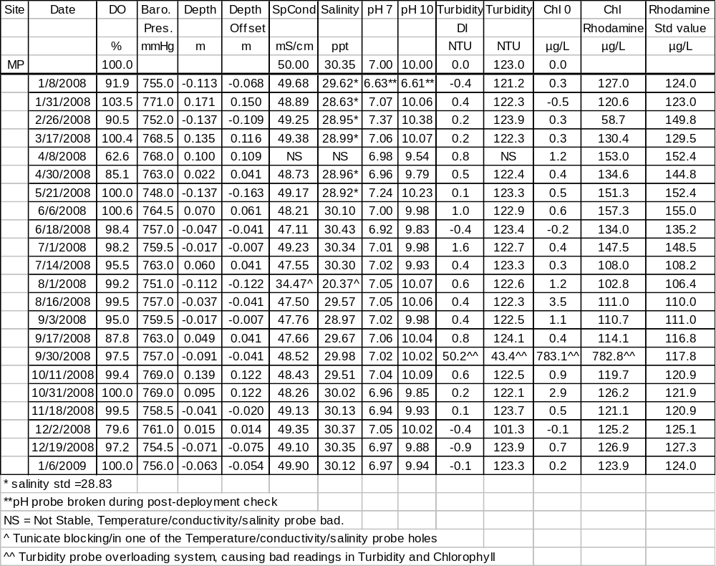
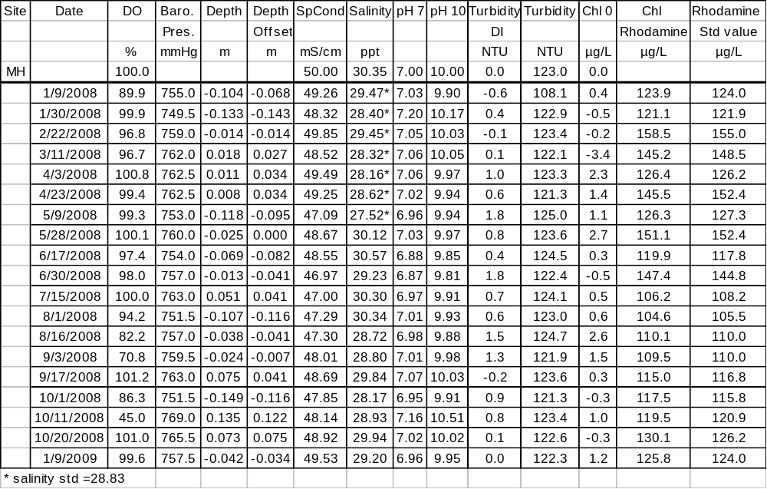
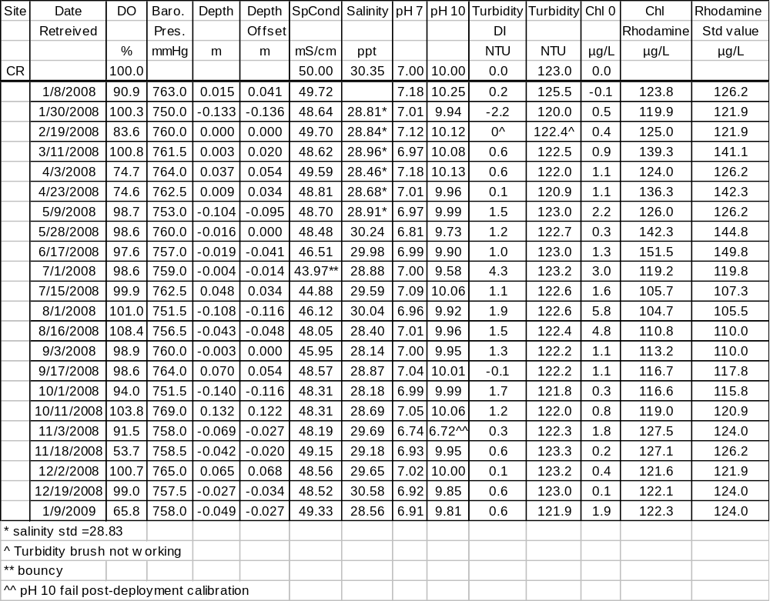
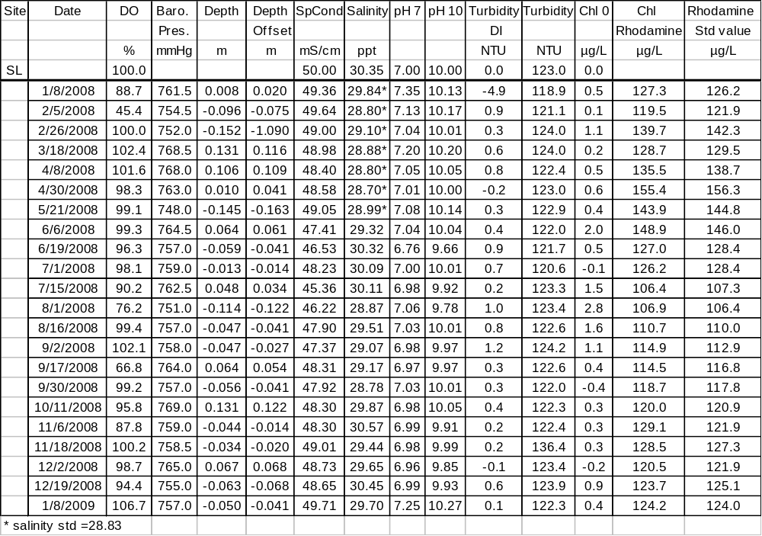

14) Other remarks/notes :

NOTE 1: SMALL NEGATIVE TURBIDITY ANOMALIES: Slight negative turbidity values sometimes occur as a result of small calibration offsets. Often these turbidity minimum values are between 0 and -2 NTU. All of these small negative turbidity values (the minimum for a given deployment) should be considered to be within 2 NTU of the true datum for correction purposes. Consequently, we have not rejected any of these small negative turbidity data.

NOTE 2: BIOLOGICAL-RELATED TURBIDITY ANOMALIES: This type anomaly includes turbidity readings that are either outside of the normal range or spikes way above background and unrelated to increased sediment suspension or decreased water column clarity. We believe these records are real (and not sensor malfunction), though not reflective of actual water column turbidity. These extreme values are likely due to biological factors (such as small fish, crabs, or other marine organisms). Our criteria for flagging these data are single spikes (above rather constant background) over 50NTU that are more than 10 times surrounding values. These readings were rejected <-3>.

NOTE 3: SUSPENSION EVENT RELATED TURBIDITY ANOMALIES: This type of anomaly includes turbidity readings that were either outside the normal range, or spikes way above background that are related to elevated turbidity levels indicative of wind wave-induced suspension (at the Menauhant site typically), or prop wash-related suspension events (at the Childs River site typically). We believe these are real (and not sensor malfunction), though not reflective of actual water column turbidity. These extreme values are likely due to large floating particles (i.e., seaweeds, detritus, etc.) suspended in the water column during storm events usually from strong southerly winds in the Waquoit Bay area. (see end of section 5 for more detail on these events at this site). Our criteria for flagging these data are values over 100NTU that are more than 5 times the magnitude of surrounding values, and linked to high winds. These readings were rejected <-3>.

NOTE 4: SMALL NEGATIVE DEPTH ANOMALIES: This type of anomaly occurs due to barometric pressure differences between time of calibration and the reading. In all such cases, barometric pressure differences are checked as well as comparison with other parameters for indications of aerial exposure to verify that all data are valid submerged readings.

NOTE 5: SHIFT TOWARDS HIGHER pH UNITS ANOMALIES. There is some concern within the NERRS SWMP community that since NERRS began using YSI flat glass pH probes. At WBNERR, the transition from bulb-type pH probes occurred from the Spring of 2004 throughout the summer when all Sondes were updated to the EDS system. Crabs and or fish destroyed the exposed bulb-type probes during this period. YSI stressed that the flat-glassed probes are more sensitive to static electricity which is affecting their performance, especially during the winter months at WBNERR. Therefore, all data from November, December, January, February and March have been marked as suspect (<1>) but retained.
Also, since telemetry was initiated at the Menauhant station in July 2006, there appears to be some potential for stray electrical interference with the pH signal as well. As of June 2008, we are evaluating the effect on our pH data. Based on data from past years, it appears that there is positive offset of between 0.5 to1.0 pH units during the months of November, December, January, February and March.

Other Field-worthy notes:
All times reported in Eastern Standard Time (EST)

January 2008
Child’s River
Boat yard (owners of dock the station is attached to) installed a deicer near sonde site. Present from the beginning of the year and removed sometime between March 11th and April 3rd.
Metoxit Point
1/8/2008 16:00 – 16:30. Discount all DO readings, optical DO cap left on.
1/8/2008 16:45. Sonde out of water to remove optical DO cap.
Sage Lot
1/27 at 15:30 to 2/5 12:00 – The tower had been dragged and tipped over by ice (not completely on side ~30 degree angle to bottom), not changed sooner due to ice. This shifted the probes roughly ~50cm deeper. This site is shallow (well-mixed) that the depth change doesn’t appear to have much impact on the other readings

February 2008
Menauhant
02/11/2008 04:45 – 10:15 and 17:45 – 22:00 Low tide, sensor likely out of water and frozen.

March 2008
Childs River
3/9/2008 04:00 – 3/9/2008 19:30 Drop in salinity and sp. conductivity correspond to increased stream discharge recorded by USGS.
Metoxit Point
3/17/2008 13:45. Deployment/Retrieval interval - missed sample because clock on YSI 650 was incorrect.

April 2008
Child’s River
04/01/2008 11:15 – 20:30 Rain event and increased stream discharge recorded by USGS.
Menauhant
04/29/2008 0:50 – 04/30/2008 Rain event and increased stream discharge recorded by USGS.
Metoxit Point
4/30/2008 9:15 – 5/2/2008 11:45. Sonde out of water. Tower pulled for painting and maintenance.
Sage Lot
4/30/2008 8:30 – 5/2/2008 11:00. Sonde out of water. Tower pulled for painting and maintence.

June 2008
Child’s River
6/26/2008 10:00 - 10:15. Sonde out of water to replace silo.
Menauhant
6/23/2008 8:15 – 8:45. Sonde out of water to replace silo.

July 2008
Sage Lot
7/24/2008 – 7/25/2008. Drop in salinity and sp. conductivity correspond to increased stream discharge recorded by USGS.

September 2008
Menauhant
9/26/2008 – 9/28/2008 Drop in salinity and sp. conductivity correspond to increased stream discharge recorded by USGS.

October 2008
Menauhant
10/20/2008 10:00 -12/23/2008 10:30. Sonde and tower removed. Private owners are reinforcing the bulkhead where the sonde tower is mounted. Station was slated to be moved to a piling where a floating dock is attached in the summer after the dock is taken out. Unfortunately the dock was not removed before work on the bulkhead was completed. Station was inactive for the duration. Telemetry down until owners until location on property is discussed and determined.

Metoxit Point
10/31/2008 12:30 – 11/4/2008 10:15. Able to retrieve sonde but not deploy, too rough.

December 2008
Menauhant
12/23/2008, 10:45. Sonde back in the water. Telemetry down for the rest of the year because owners want to change location on property.
Metoxit Point
12/2/2008 10:45. Deployment/Retrieval interval.
12/19/2008 – 1/6/2009. Tower may have been hit by a boat sometime during this deployment.
Sage Lot
12/19/2008 – 1/8/2009. Ice conditions in the pond during this deployment. Tower was moved >10 m to the East by ice.
12/21/2008 – 12/25/2008 Drop in salinity and sp. conductivity correspond to increased stream discharge recorded by USGS.

Data are missing due to equipment or associated specific probes not being deployed, equipment failure, time of maintenance or calibration of equipment, or repair/replacement of a sampling station platform. Any NANs in the dataset stand for “not a number” and are the result of low power, disconnected wires, or out of range readings. If additional information on missing data is needed, contact the Research Coordinator at the reserve submitting the data.

A hand-held YSI 650 was used for field calibration and data were recorded at YSI deployment depths. Sonde deployment and retrieval (or last / first) comparisons for each site in addition to the hand-held measurements are shown below in Tables 1-4. They represent another form of post-check on retrieved Sonde data as it is assumed that the recently calibrated deployed Sonde is highly accurate on its initial measurement. If the assumption holds true we should expect last / first readings to be quite similar within the usual 15 minute time difference between readings if the retrieved instrument was still reading accurately. Large differences indicate potential problems. However there are some caveats to this comparison approach. If time differences between retrieval and deployment are much greater than 15 minutes, then parameter differences should be also greater, and certainly lose any usefulness beyond a few hours. Also, at certain times some parameters are changing quite rapidly and a 15 minute interval could allow for real and rather large differences. One example is DO during late morning and early afternoon, when DO is often ramping up rapidly -- or salinity can change rapidly in areas where the gradients (both vertical and horizontal) are large (i.e., Child’s River).

Table 1: Metoxit Point:
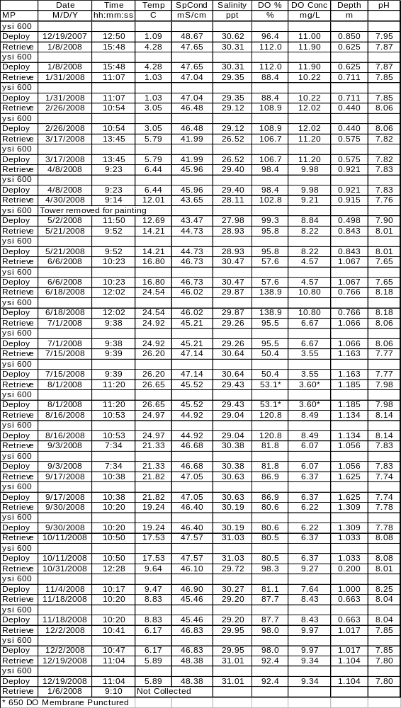

Table 2: Menauhant:
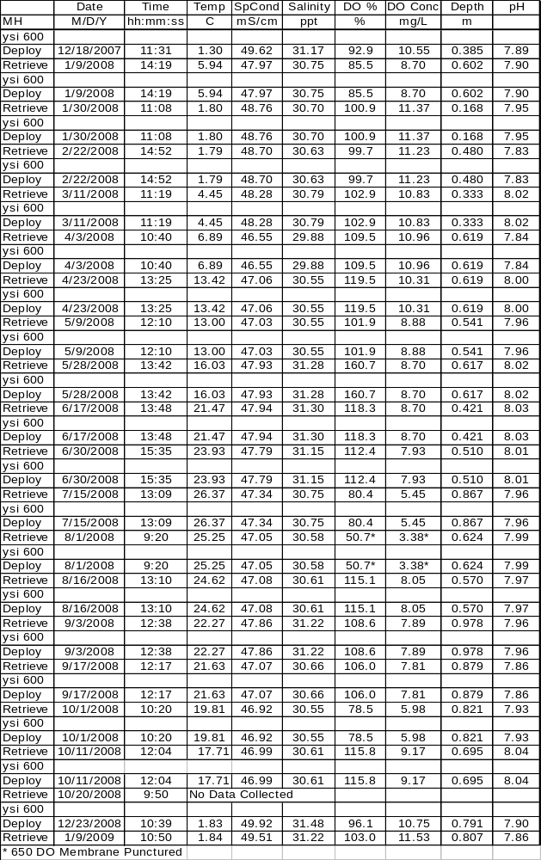

Table 3: Child’s River:
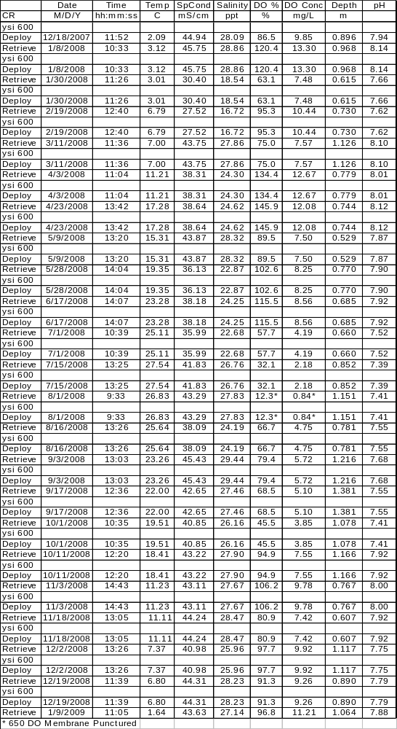
Table 4: Sage Lot:
