Troy McFarland
2021-03-09
Foundations of Programming, Python
Assignment_08
Git Hub: https://github.com/DJ-TMC/Assignment_08

Creating an Object Oriented Script based off Skeletal Pseudo-Code

Introduction
In this paper, I’ll be going over the eighth set of lessons for the Foundations of Programming, Python class taught by Dirk Biesinge and assisted by Douglas Klos. I’ll go over things learned about coding and researching OOP and insights I had coding longer programs in Spyder while working on assignment 8

Overview of New Things Learned in Module 8
- What is the difference between a class and the objects made from a class?
  - A class is essentially the blueprint or template
  - Objects instantiated from a class is the created data structure. Many can be made from one class.
- What are the components that make up the standard pattern of a class?
  - Fields, Constructor, Properties, including setters & getters and Methods
- What is the purpose of a class constructor?
  - It constructs the instances, and sets up how it will interact with other elements in the class.
  - This includes creating the arguments the instance will have.
- When do you use the keyword "self?"
  - When we want to make sure that the program knows that this method, etc. will be applied to the object on which it is a part of.
- When do you use the keyword "@staticmethod?"
  - When you want to make a method that affects the class and not the instance.
- How are fields and attributes and property functions related?
  - A property controls the interaction of the private attributes in a class. If the fields are public, they are not constrained, but if they are private, then the property will be able to control how things are assigned to them.
- What is the difference between a property and a method?
  - Methods are like functions in a functional script, properties control interaction with these methods.
- Why do you include a docstring in a class?
  - To help other programmers understand its use.

Object Oriented Programming in Python
I would say that my first exposure to Object Oriented Programing in python was quite a whip lash experience! I’m glad I learned the basics of functional programming first. It helped me get more used to ‘wiring’ variables in a way that kept each function as encapsulated as much as possible. This ‘wiring’ is magnified in OOP. It *feels* very different at first. I felt that most of my code was setting up the flow, and very little of it was actually doing anything functional. But I like the fact that this makes my code more reusable for myself and others. And I appreciate how encapsulation helps protect sections of my code from getting screwed up when other sections are changed.

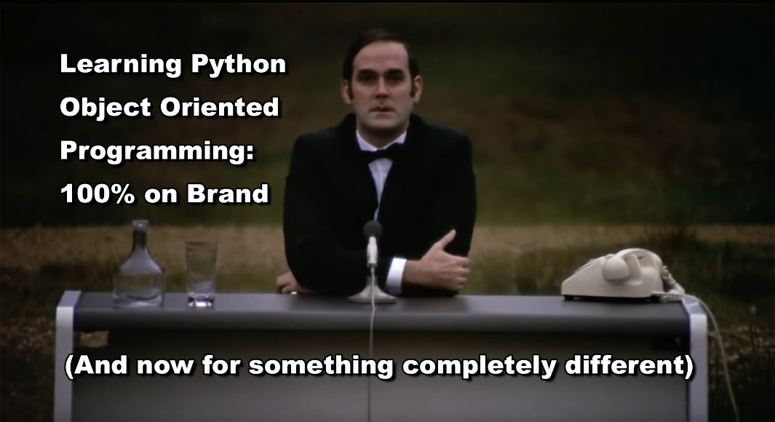
Figure 1: OOP first Impressions. References the ‘Monty Python’ British TV series, for which Python is named
One resource that helped me understand OOP a little better was this video on YouTube: https://www.youtube.com/watch?v=pTB0EiLXUC8 (external site)
It reinforced the four pillars of Object Oriented Programming:
Encapsulation
- On should group related variables into an object
- Car example:
  - Properties: make, model & color
  - Methods: start, stop, move
- Less/no parameters this way, as parameters already modeled with class
Abstractions
- Simpler interface for users
- Reduce impact of change (change anything inside a class, doesn’t hurt stuff outside)
Inheritance
- Mechanism to reduce/eliminate redundant code
- Define elements once, and then other objects inherit these elements.
Polymorphism
- Means: Many forms
- Implement a render method for each object, but it will have the ability to render each object a little differently, while still keeping the same code.

A few more things in this video that I learned that will help me down the road:

There are two ways to employ class variables shown in this video:
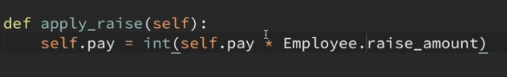
Listing 1: Class variable assigned directly ‘Employee’
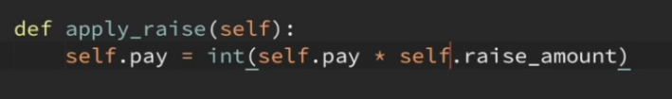
Listing2: Class variable assigned through instance ‘self’
While both seem to work just fine, the first example prevents the programmer from ‘overriding’ the variable. The second example has this ability.
I also learned that instances and classes have built in dictionaries! And, you can find out what’s in them by printing them:
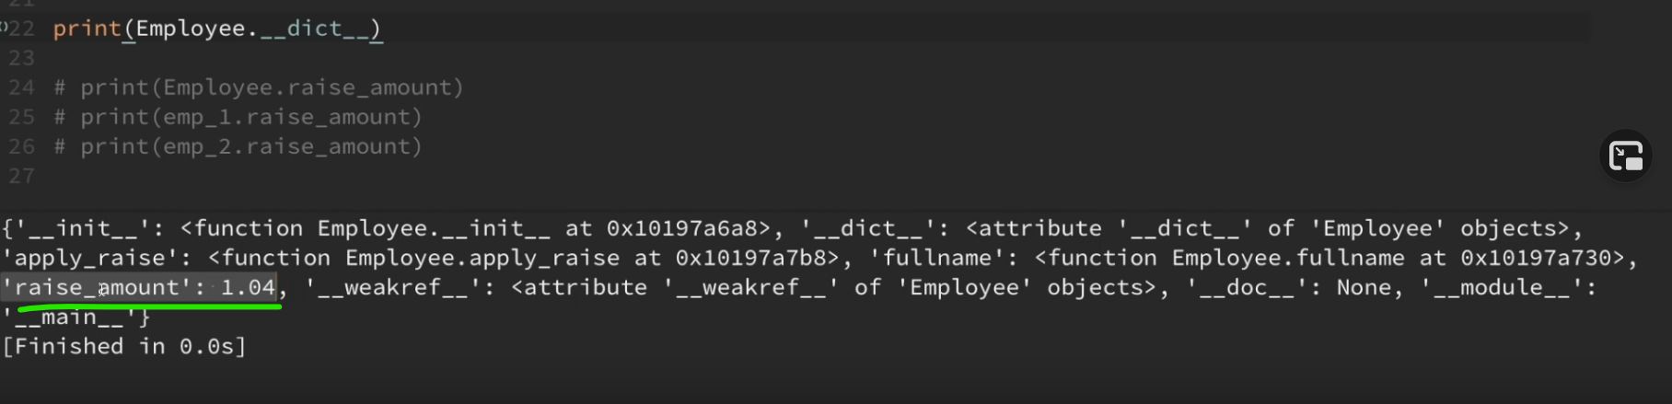
Listing 3: Class variable 'raise_amount'

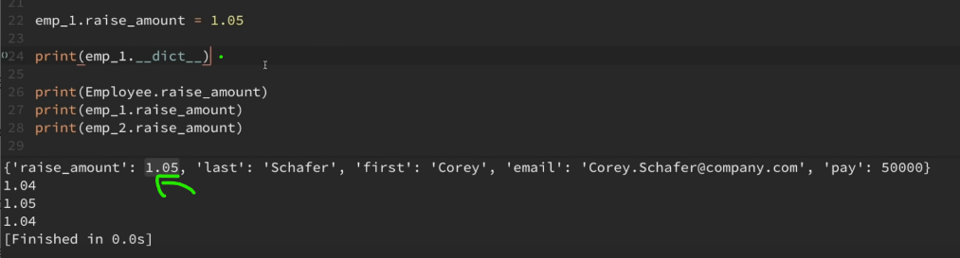
Listing 4: instance variable. If found, Program doesn't look in Class, effectively ‘overriding’ it
When you do an override, it’s now in the instance. If Python finds it there, it stops looking.

Assignment 8
This assignment was the most challenging yet. In addition to getting a late start on it due to assignment 7 taking longer than expected, OOP was just a different way to think about solving programing challenges. I really struggled with the syntax. Most of that was my own doing. We had done a fair amount of related code using lists and dictionaries. I thoughtlessly copied and pasted this code into my program, thinking I would only need to make minor changes. I was wrong. One good thing about doing it this way is that I got clearer on the specific syntax of lists and dictionaries. One does not access items in a list using values. That took a minute to figure out but was incredibly obvious when I finally figured this out.
Due to the overwhelming pasted code, I probably should have started over. But, I was invested in the process and kept it in. I found this technique of marking my code was more helpful than just the TODO giving me exclamation points in Spyder. I also found out by accident that four or more ‘?’ will make it display an exclamation point to remind me to revisit it:
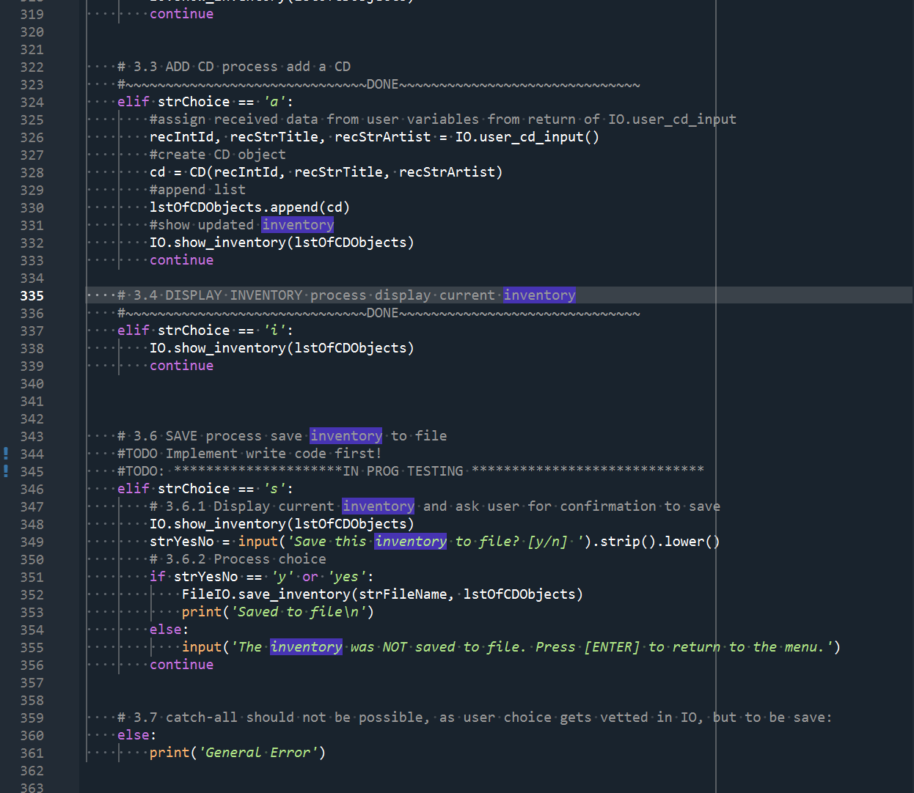
Listing 5: using ~~~~~DONE~~~~ and ******IN PROG******* to deliniate code sections

Assignment 08 Running in Spyder:
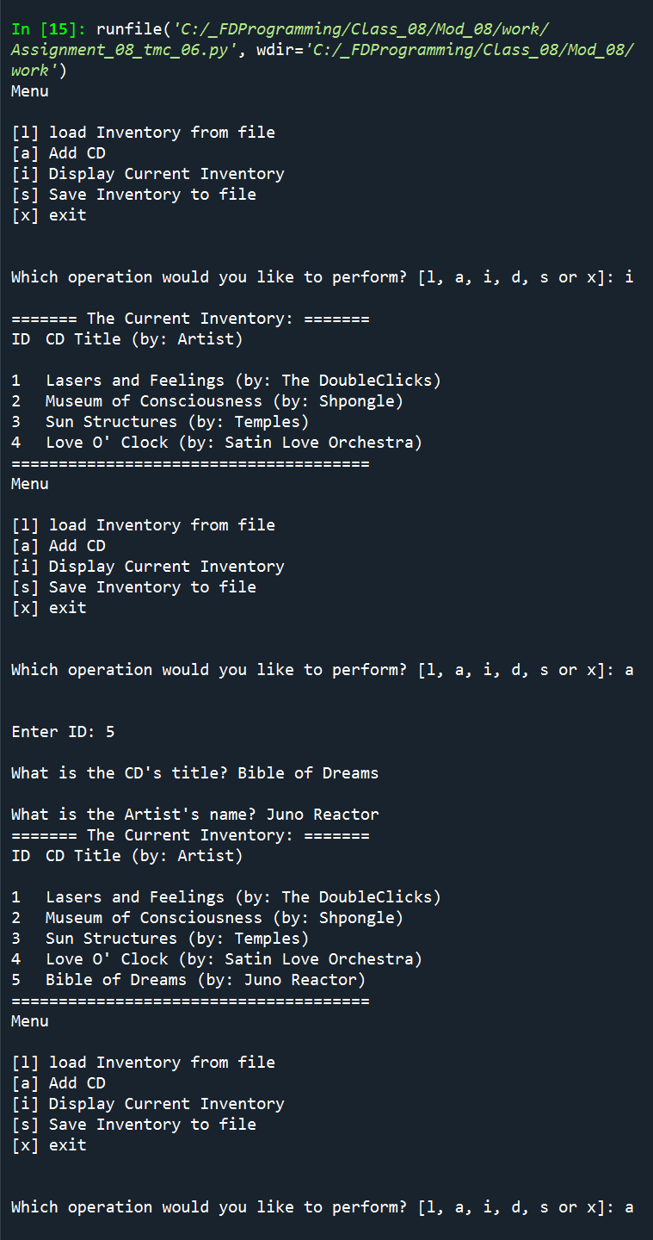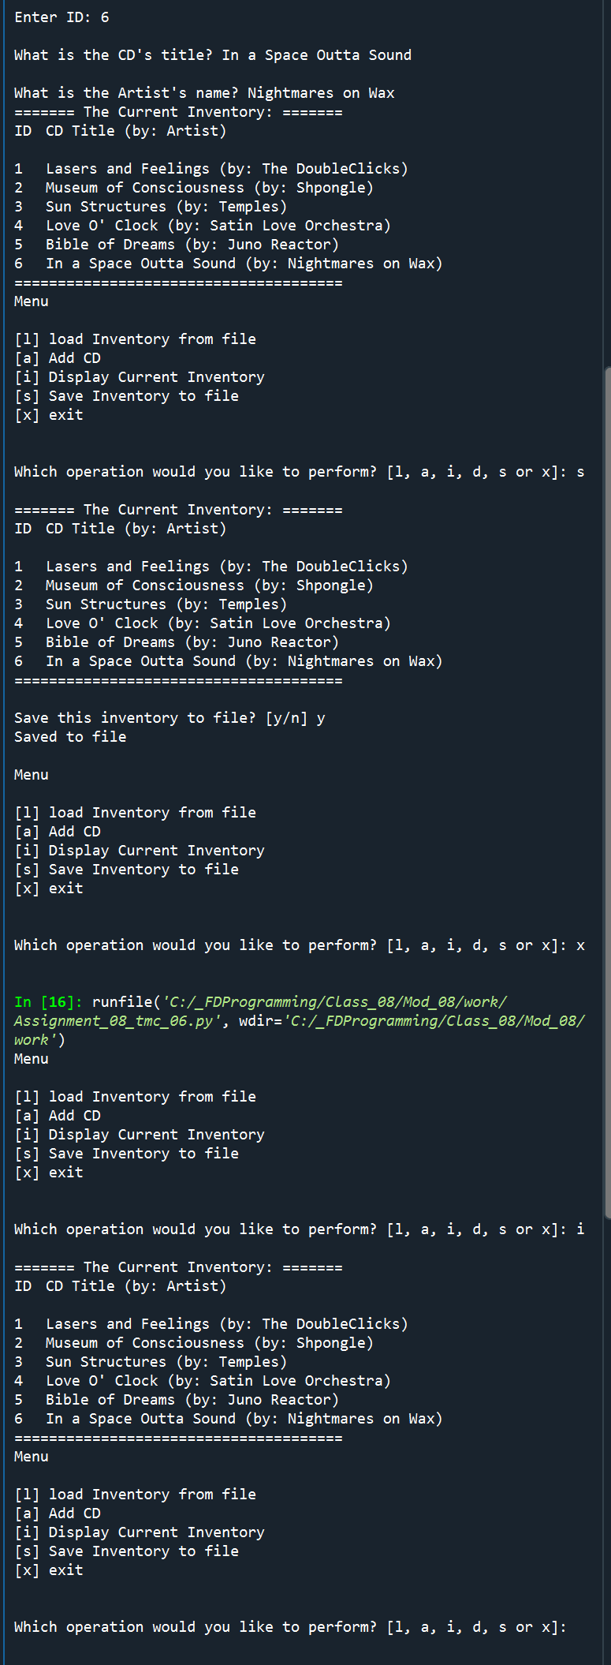
Figure 4: Spyder Results

Assignment 08 Running in the Anaconda Terminal:
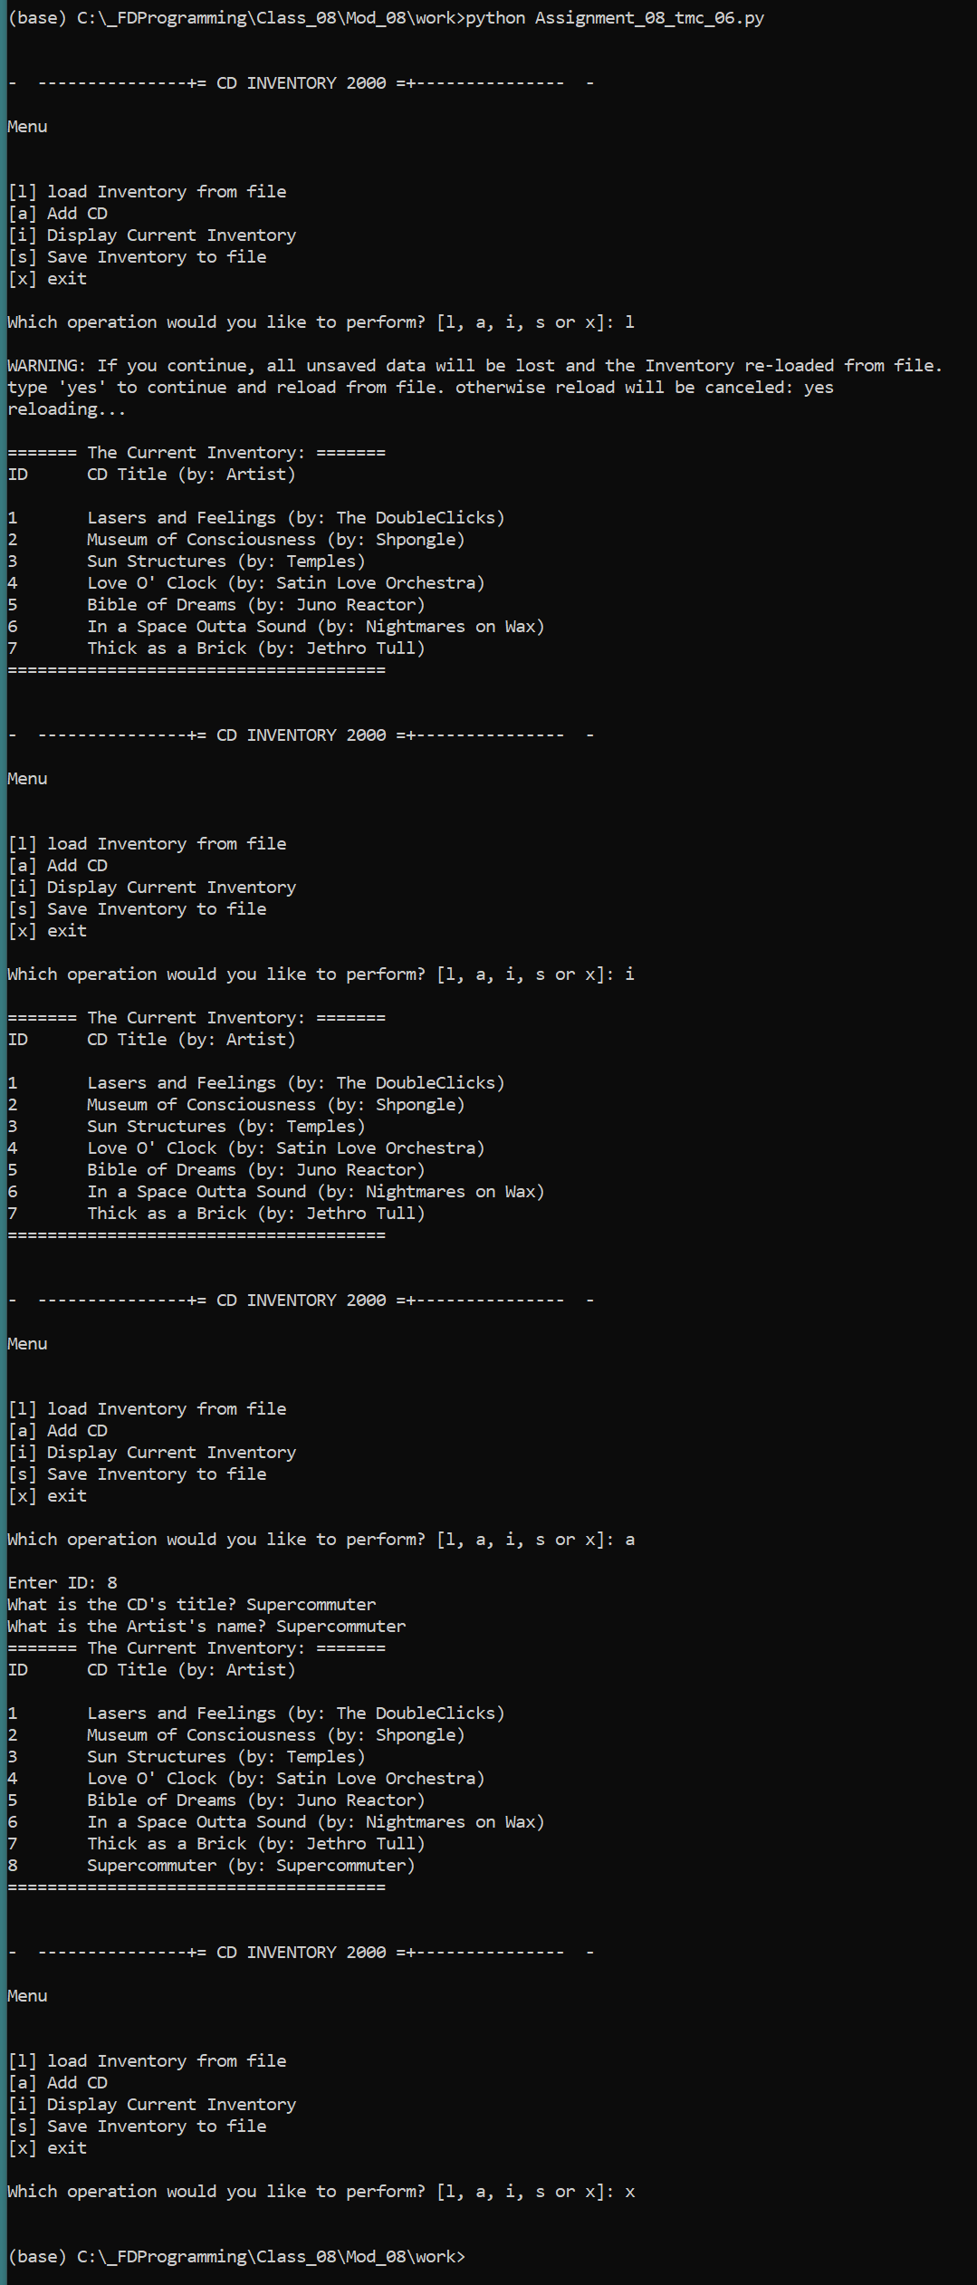
Figure 5: Anaconda Terminal Results

Summary
In this paper, I described my introduction to Object Oriented Programing theory and techniques. I talked about the four pillars of OOP, and some interesting findings regarding how variable assignment will affect one’s code, be it using a class variable or the instance variable, ‘self’. I went over the process of reusing older code and the inherent challenges that this presents and showed my results.

Appendix
Full Code of Assignment 8

- #------------------------------------------#
- # Title: Assignmen08.py
- # Desc: Assignnment 08 - Working with classes
- # Change Log: (Who, When, What)
- # DBiesinger, 2030-Jan-01, created file
- # DBiesinger, 2030-Jan-01, added pseudocode to complete assignment 08
- # TMcFarland, 2021-Mar-07, never faltered to create CD Class,
- # TMcFarland, 2021-Mar-07, gonna start over on IO
- # TMcFarland, 2021-Mar-08, give signficant attempt at general code flow
- # TMcFarland, 2021-Mar-09, you dealt with old sample code, got functionality with objects
- # TMcFarland, 2021-Mar-09, up to date comments and doc strings
- #------------------------------------------#

- import os.path

- # -- DATA -- #
- strFileName = 'cdInventory.txt'
- lstOfCDObjects = []

- class CD:
- """Stores data about a CD:

- properties:
- cd_id: (int) with CD ID
- cd_title: (string) with the title of the CD
- cd_artist: (string) with the artist of the CD
- methods:

- """
- # -- Constructor -- #
- def __init__(self, cid, cttl, cartst):
- # -- Attributes -- #
- self.__cd_id = None
- self.__cd_title = None
- self.__cd_artist = None
- self.cd_id = cid
- self.cd_title = cttl
- self.cd_artist = cartst

- # -- Properties -- #
- @property #getter
- def cd_id(self):
- return self.__cd_id

- @cd_id.setter
- def cd_id(self, value):
- if type(value) == int:
- self.__cd_id = value
- else:
- raise Exception('This entry requires an interger (whole positive number)')

- @property #getter
- def cd_title(self):
- return self.__cd_title

- @cd_title.setter
- def cd_title(self, value):
- if type(value) == str:
- self.__cd_title = value
- else:
- raise Exception('This entry requires a Stirng (just type in the title of the CD!')

- @property #getter
- def cd_artist(self):
- return self.__cd_artist

- @cd_artist.setter
- def cd_artist(self, value):
- if type(value) == str:
- self.__cd_artist = value
- else:
- raise Exception('This entry requires a String (Just type in the name of the artist!)')

- # -- Methods -- #
- def defaultResponse(self):
- return self.cd_id, self.cd_title, self.cd_artist

- def __str__(self):
- return self.defaultResponse()

- class FileIO:
- """Processes data to and from file:

- properties:

- methods:
- save_inventory(file_name, lst_Inventory): -> None
- Takes list of CD Objects
- Converts to text, CSV formatted
- Saves that to text file
- load_inventory(file_name): -> (a list of CD objects)
- Loads CSV formated .txt file
- When read is converted to multiple cd OBJECTS
- """

- @staticmethod
- def load_inventory(textFile, cdClass, cdTable):
- """Function to manage data ingestion from file to a list of objects

- Reads the data from file identified by textFile into a 2D table
- (list of objects). One line in the file represents one object in table.

- Args:
- textFile (string): name of file used to read the data from
- cdClass (Class): Uses as template to create objects
- table (list of objects): 2D data structure (list of objects) that holds the data during runtime

- Returns:
- None
- """
- cdTable.clear() # this clears existing data and allows to load data from file
- #check to see if database file already exists. If not, create blank one.
- fileCreated = False
- if os.path.exists(textFile):
- try:
- objFile = open(textFile, 'r')
- for row in objFile:
- cdObjInfo = row.strip().split(',')
- cdObj = cdClass(int(cdObjInfo[0]), cdObjInfo[1], cdObjInfo[2])
- cdTable.append(cdObj)
- objFile.close()
- except EOFError as e:
- print('Your CDInventory.dat file is blank!')
- print('Here\'s what the computer has to say about this:')
- print(type(e), e, e.__doc__, sep = '\n') #syntax from FDN_Py_module_07, pg 20, listing 12
- else:
- #create blank database in same folder as script
- objFile = open(textFile, 'w')
- objFile.close()
- fileCreated = True
- return fileCreated, cdTable

- @staticmethod
- def save_inventory(textFile, cdTable):
- """Writes List of Dicitonaries lstTbl from memory into a text file.
- Ensures proper comma seperated formatting for best storage and retrieval
- Args:
- testFile: references a text file, with comma three seperated values.
- cdTable: list of objects, each object holding three pieces of cd information

- Returns:
- None
- """
- objFile = open(textFile, 'w')
- for row in cdTable:
- objFile.write('{},{},{}\n'.format (row.cd_id, row.cd_title, row.cd_artist))
- objFile.close()

- # -- PRESENTATION (Input/Output) -- #
- class IO:

- """""Handling Input / Output. Takes input from user and adds to database. Loads database.

- properties:

- methods:
- print_menu: Displays menu to user
- menu_choice: Gets user input for menu selection
- show_inventory: Displays current inventory table
- user_cd_input: Receives user input for CD ID number, Album Title, and Artist Name
- """

- @staticmethod
- def print_menu():
- """Displays a menu of choices to the user

- Args:
- None.

- Returns:
- None.
- """

- print('\n\n- ---------------+= CD INVENTORY 2000 =+--------------- -')
- print('\nMenu')
- print('\n\n[l] load Inventory from file\n[a] Add CD\n[i] Display Current Inventory')
- print('[s] Save Inventory to file\n[x] exit\n')

- @staticmethod
- def menu_choice():
- """Gets user input for menu selection

- Args:
- None.

- Returns:
- choice (string): a lower case sting of the users input out of the choices l, a, i, s or x

- """
- choice = ' '
- while choice not in ['l', 'a', 'i', 's', 'x']:
- choice = input('Which operation would you like to perform? [l, a, i, s or x]: ').lower().strip()
- print() # Add extra space for layout
- return choice

- @staticmethod
- def show_inventory(table):
- """Displays current inventory table

- Args:
- table (list of objects: 2D data structure that holds the data during runtime.

- Returns:
- None.
- """

- print('======= The Current Inventory: =======')
- print('ID\tCD Title (by: Artist)\n')
- for row in table:
- print('{}\t{} (by: {})'.format (row.cd_id, row.cd_title, row.cd_artist))
- print('======================================')

- @staticmethod
- def user_cd_input():
- """ Receives user input for CD ID number, Album Title, and Artist Name
- Args:
- None
- Returns:
- CD ID number, CD Title, CD Artist Name
- """

- # Ask user for new ID, CD Title and Artist
- while True:
- try:
- intID = int(input('Enter ID: ').strip())
- break
- except ValueError as e:
- print('That does not appear to be an integer. Try again.')
- print('Here\'s what the computer has to say about this:')
- print(type(e), e, e.__doc__, sep = '\n') #syntax from FDN_Py_module_07, pg 20, listing 12
- except Exception as e:
- print('There was some sort of general error, please try again')
- print('Here\'s what the computer has to say about this:')
- print(type(e), e, e.__doc__, sep = '\n')
- while True:
- strTitle = input('What is the CD\'s title? ').strip()
- if strTitle == '':
- print('For the love of God, please enter *something*')
- continue
- else:
- break
- while True:
- strArtist = input('What is the Artist\'s name? ').strip()
- if strArtist == '':
- print('For the love of God, please enter *something*')
- continue
- else:
- break
- return intID, strTitle, strArtist

- # -- SCRIPT MAIN BODY -- #

- # Load text file & convert into List of Objects on Launch
- try:
- noDatFilePresent, lstOfCDObjects = FileIO.load_inventory(strFileName, CD, lstOfCDObjects)
- #check to see if FileProcessor.load_inventory returned a Bool of True. if so, DB file didn't exist
- if noDatFilePresent:
- print('\nCDInventory.txt didn\'t exist in folder. A blank version has been created\n')
- except:
- print('Error during file load, starting with empty database')

- while True:
- #Display Menu to user and get choice
- IO.print_menu()
- strChoice = IO.menu_choice()

- # MENU SELECTIONS
- # EXIT
- if strChoice == 'x':
- break

- # LOAD process load inventory
- if strChoice == 'l':
- print('WARNING: If you continue, all unsaved data will be lost and the Inventory re-loaded from file.')
- strYesNo = input('type \'yes\' to continue and reload from file. otherwise reload will be canceled: ')
- if strYesNo.lower() == 'yes':
- print('reloading...\n')
- fileCreated, lstOfCDObjects = FileIO.load_inventory(strFileName, CD, lstOfCDObjects)
- else:
- input('canceling... Inventory data NOT reloaded. Press [ENTER] to continue to the menu.\n')
- IO.show_inventory(lstOfCDObjects)
- continue

- # ADD CD: process add a CD
- elif strChoice == 'a':
- #assign received data from user variables from return of IO.user_cd_input
- recIntId, recStrTitle, recStrArtist = IO.user_cd_input()
- #create CD object
- cd = CD(recIntId, recStrTitle, recStrArtist)
- #append list
- lstOfCDObjects.append(cd)
- #show updated inventory
- IO.show_inventory(lstOfCDObjects)
- continue

- # DISPLAY INVENTORY: process display current inventory
- elif strChoice == 'i':
- IO.show_inventory(lstOfCDObjects)
- continue

- # SAVE: process save inventory to file
- elif strChoice == 's':
- # Display current inventory and ask user for confirmation to save
- IO.show_inventory(lstOfCDObjects)
- strYesNo = input('Save this inventory to file? [y/n] ').strip().lower()
- #Process choice
- if strYesNo == 'y' or 'yes':
- FileIO.save_inventory(strFileName, lstOfCDObjects)
- print('Saved to file\n')
- else:
- input('The inventory was NOT saved to file. Press [ENTER] to return to the menu.')
- continue

- # CATCH ALL
- else:
- print('General Error')

Accessed 2021-03-09

