1st-Jul-2015

FIX-pms 1.0.4

(Ed. Jul-2015)

Outline Specification

National Agriculture and Food Research Organization (NARO)
Agricultural Informatics Research Project Team
(Agricultural Information Systems Devision – NARO Agricultural Research Center)

Contents

1. Objective of the FIX-pms 1
2. Configuration of the FIX-pms 1
1) Summary 1
2) Definition of the schemas 1
3) Configuration of the definition file 1
3. Summary of the data structure of the FIX-pms 2
1) Principal data items and the data structure 2
2) Structure of the root elements <FIX-pms> 2
3) Schema definition (source codes) of the root elements <FIX-pms> 3
4) FIX-pms data items and their structure (framework) 6
5) An example of an FIX-pms document 7
4. Methods for the use of FIX-pms data and examples 9
1) General procedures for the use 9
2) Cases of tools for the definition of the XML Schemas (xsd.exe)
developed by Microsoft 10
5. Details of the data structure of the FIX-pms (references) 14
1) Import of external name space 14
2) FIX-pms references 14
(1) FIX-pms (root) elements 14
(2) Farm elements 15
(3) MasterContents elements 17
(4) Fields/Field elements 23
(5) Cultivations/Cultivation elements 25
(6) WorkProcesses/WorkProcess elements 27
(7) GrowthData/GrowthDatum elements 30
(8) SoilData/SoilDatum elements 31
(9) QualityData/QualityDatum elements 32
(10) ProductProcesses/ProductProcess elements 32
(11) Complex elements and types 35
(12) Simple elements and types 36
(13) Attribute groups 36
(14) Complex data types (complexType) 37
(15) Simple data types (simpleType) 38
(16) Imported elements, attributes, and data types 39
6. References 39
7. Appendix 39
1) FIX-pms schema source codes 39
(1) FIX-pms.xsd 39
(2) pmsWorkProcess.xsd 50
(3) pmsProductProcess.xsd 53
(4) pmsMaster.xsd 58
(5) pmsCommon.xsd 71
2) Samples of XSD command lines 93

[ Memo ]

Objective of the FIX-pms
The FIX-pms provides a common format for the exchange of data used by “farming information management systems”.
“Farming information management systems” have adopted a GUI interface to manage a variety of information on the process of agricultural production while relating it to spatiotemporal information. However, the FIX-pms covers a wider variety of systems including software systems that manage information on the process of agricultural production without using the field-map function.

Configuration of the FIX-pms

Summary
The FIX-pms is a set of specifications (standards) that define the data structures and formats of XML documents. The FIX-pms was designed to express the maximum part of data used by many different “farming information management systems” as common data for the management of the process of agricultural production, using the above-mentioned data structures and formats.

Definition of the schemas
The FIX-pms specifications are defined by the XML Schemas (W3C 2014). Therefore, the FIX-pms can be regarded as an XML document for the definition of schemas, written in accordance with the XML Schema format.

Configuration of the definition file
The FIX-pms Schema definition document consists of multiple XML documents (with the extension “xsd”). The following figure represents the reference relation (Figure 1), and the root document is “FIX-pms.xsd”.

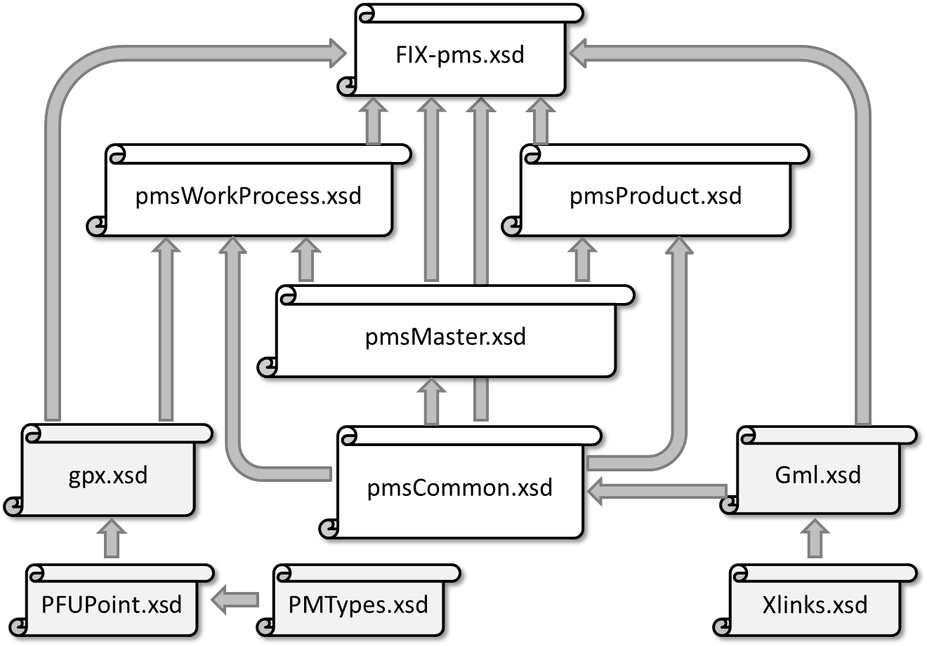
Fig.1 Configuration of the FIX-pms Schema definition document

Summary of the data structure of the FIX-pms

Principal data items and the data structure
The root elements of the “FIX-pms document”, an XML document, defined by the FIX-pms Schemas are <FIX-pms>. The relationships among the data items (Figure 2 (a)) and elements (Figure 2 (b)), expressed in the following tree-shaped structure (an excerpt), are based on these root elements:

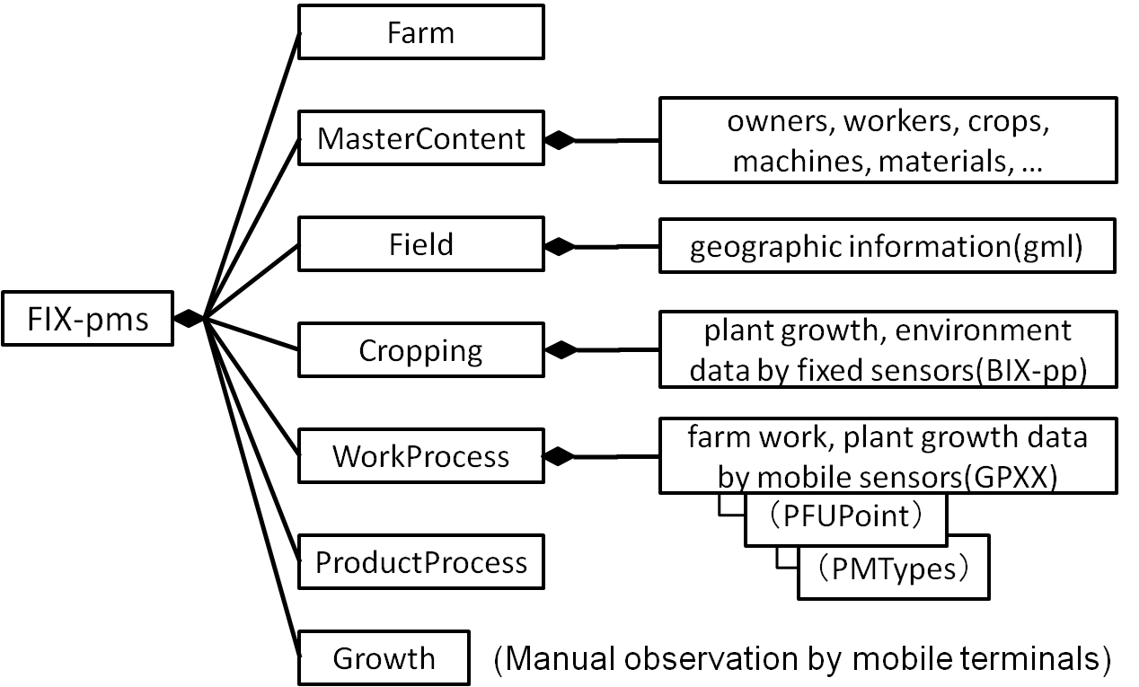
(a) Expression of data items

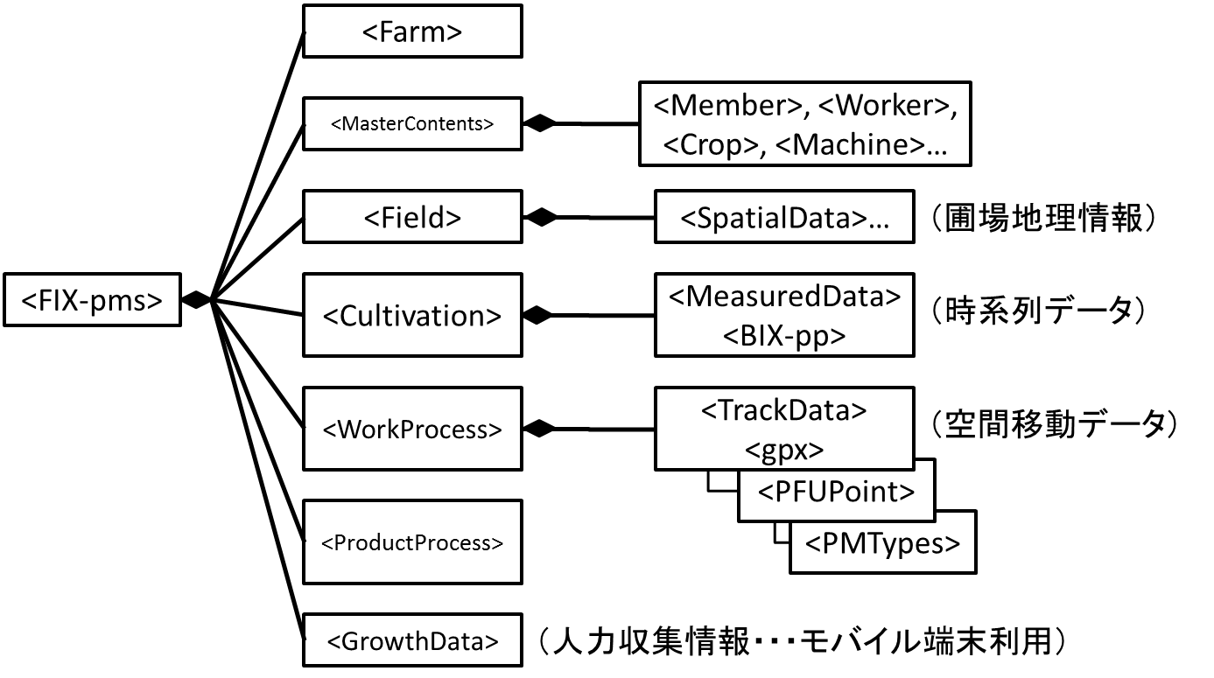
(b) Expression of data elements
Fig.2 Summary of the structure of data defined by the FIX-pms Schemas

Structure of the root elements <FIX-pms>
The following is the structure of the root elements <FIX-pms> (composition of the attributes and child elements positioned directly below the root elements) (Figure 3).

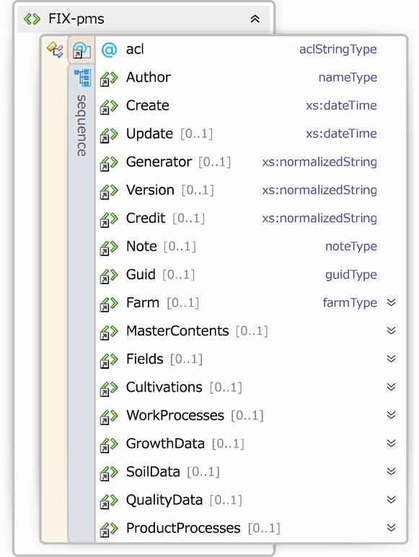
Fig.3 Group of the child elements of the root elements of the FIX-pms

This suggests that the <FIX-pms> elements consist of one attribute: “acl”, and 17 elements, including <Author> and <ProductProcesses> elements. As a characteristic of the XML Schema, its elements and the types of its attributes (data types) are clearly defined. Elements between the “acl” attribute and <Farm> elements have primitive data types (such as date/time and normalized character string types) defined by the XML Schema or simple/complex data types defined by the FIX-pms Schemas. Elements between the <MasterContents> and <ProductProcesses> serve as containers for their inclusive child elements. The frequency of each of these elements is expressed as “[0..1]”, 0 (omitted) or 1, which suggests that each element is not identified twice or more times (not as in the cases of arrays and lists).

Schema definition (source codes) of the root elements <FIX-pms>
The following is the XML Schema definition (source codes) of the root elements <FIX-pms>:

<xs:schema targetNamespace="http://www.aginfo.jp/PMS/FIX-pms/XMLSchema"
スキーマ宣言
elementFormDefault="qualified"
xmlns="http://www.aginfo.jp/PMS/FIX-pms/XMLSchema"
ネームスペース宣言
xmlns:fp ="http://www.aginfo.jp/PMS/FIX-pms/XMLSchema"
xmlns:gpx="http://www.topografix.com/GPX/1/1"
ネームスペースプリフェクス宣言
xmlns:gml="http://www.opengis.net/gml"
xmlns:bix="http://w3.fb.u-tokai.ac.jp/BIX-pp/XMLSchema"
xmlns:xs ="http://www.w3.org/2001/XMLSchema"
>
<xs:import namespace="http://www.opengis.net/gml" schemaLocation="./Gml.xsd"/>
<xs:import namespace="http://www.topografix.com/GPX/1/1" schemaLocation="./gpx.xsd"/>
<xs:import namespace="http://w3.fb.u-tokai.ac.jp/BIX-pp/XMLSchema" schemaLocation="./BIX-pp.xsd"/>
<xs:include schemaLocation="./pmsCommon.xsd"/>
<xs:include schemaLocation="./pmsMaster.xsd"/>
依存する定義ファイルの参照
<xs:include schemaLocation="./pmsWorkProcess.xsd"/>
<xs:include schemaLocation="./pmsProduct.xsd"/>

<!--ルート要素-->
“FIX-pms”要素の定義

<xs:element name="FIX-pms">
<xs:annotation>
<xs:documentation xml:lang="ja">FIX-pms文書のルートノードです</xs:documentation>
</xs:annotation>
以下，子要素シーケンスの定義
<xs:complexType>
<xs:sequence>
“Author”子要素の定義。以下同様に子要素を定義。（図3と比較して確認）
<!--header-meta-->
<xs:element ref="Author">
<xs:annotation>
<xs:documentation xml:lang="ja">文書作成者（オーナ）情報を格納します［必須項目］
</xs:documentation>
“ref”属性指定により”Create”要素自体は別の場所で定義されており，ここではそれを参照している。
</xs:annotation>
</xs:element>
<xs:element ref="Create">
<xs:annotation>
<xs:documentation xml:lang="ja">文書作成日時を格納します［必須項目］
“minOccurs”属性指定により”Update”要素の出現回数が0（出現しない）または1回（既定）を指定。
つまり，省略可能（任意）項目であることを指定。
</xs:documentation>
</xs:annotation>
</xs:element>
<xs:element ref="Update" minOccurs="0">
<xs:annotation>
<xs:documentation xml:lang="ja">文書更新日時を格納します［任意］</xs:documentation>
</xs:annotation>
</xs:element>
<xs:element ref="Generator" minOccurs="0">
<xs:annotation>
<xs:documentation xml:lang="ja">文書生成ツール情報を格納します［任意］
</xs:documentation>
</xs:annotation>
</xs:element>
<xs:element ref="Version" minOccurs="0">
<xs:annotation>
<xs:documentation xml:lang="ja">文書バージョン情報を格納します［任意］
</xs:documentation>
</xs:annotation>
</xs:element>
<xs:element ref="Credit" minOccurs="0">
<xs:annotation>
<xs:documentation xml:lang="ja">文書著作権情報を格納します［任意］
</xs:documentation>
</xs:annotation>
</xs:element>
<xs:element ref="Note" minOccurs="0">
<xs:annotation>
<xs:documentation xml:lang="ja">文書の任意コメント・備考を格納します［任意］
</xs:documentation>
</xs:annotation>
</xs:element>
<xs:element ref="Guid" minOccurs="0">
<xs:annotation>
<xs:documentation xml:lang="ja">この文書のGUIDを格納します［任意］
</xs:documentation>
</xs:annotation>
</xs:element>
<!--Node:Farm-->
<xs:element ref="Farm" minOccurs="0">
<xs:annotation>
<xs:documentation xml:lang="ja">「農場」全体の情報（組織情報などを想定）を格納します
</xs:documentation>
</xs:annotation>
</xs:element>
<!--Master-->
<xs:element ref="MasterContents" minOccurs="0">
<xs:annotation>
<xs:documentation xml:lang="ja">PMSマスターデータコンテンツを格納します
</xs:documentation>
</xs:annotation>
</xs:element>
<!--Ledger-->
<xs:element ref="Fields" minOccurs="0">
<xs:annotation>
<xs:documentation xml:lang="ja">PMS土地台帳情報を格納します</xs:documentation>
</xs:annotation>
</xs:element>
<xs:element ref="Cultivations" minOccurs="0">
<xs:annotation>
<xs:documentation xml:lang="ja">PMS作付（土地区画利用）台帳情報を格納します
</xs:documentation>
</xs:annotation>
</xs:element>
<xs:element ref="WorkProcesses" minOccurs="0">
<xs:annotation>
<xs:documentation xml:lang="ja">PMS栽培作業台帳情報を格納します</xs:documentation>
</xs:annotation>
</xs:element>
<xs:element ref="GrowthData" minOccurs="0">
<xs:annotation>
<xs:documentation xml:lang="ja">PMS生育台帳情報を格納します</xs:documentation>
</xs:annotation>
</xs:element>
<xs:element ref="SoilData" minOccurs="0">
<xs:annotation>
<xs:documentation xml:lang="ja">PMS土壌台帳情報を格納します</xs:documentation>
</xs:annotation>
</xs:element>
<xs:element ref="QualityData" minOccurs="0">
<xs:annotation>
<xs:documentation xml:lang="ja">PMS品質台帳情報を格納します</xs:documentation>
</xs:annotation>
</xs:element>
<xs:element ref="ProductProcesses" minOccurs="0">
<xs:annotation>
<xs:documentation xml:lang="ja">PMS生産出荷台帳情報を格納します</xs:documentation>
</xs:annotation>
</xs:element>
<FIX-pms>の要素の属性グループとして“acls”を定義。
“acls”属性グループ自体は別の場所で定義。
</xs:sequence>
<xs:attributeGroup ref="acls" />
</xs:complexType>
</xs:element>

</xs:schema>

The “ref” attribute of the XML Schema defines specific elements and attributes, which are defined by the FIX-pms Schemas, by referring to elements and attributes defined elsewhere. The reference-based definition of the child elements and attributes, expressed as a tree-shaped structure, is repeated until the lowest-order child elements are defined.

FIX-pms data items and their structure (framework)
The following figure is the framework of the FIX-pms Schemas expressed in a tree-shaped structure, which represents the definition of the schema and relationships among its child elements and attributes (Figure 4).
Comparison of this figure and Figure 2 suggests the correspondence of the data items to tree-shaped structure (elements and attributes).
Some of the child elements positioned directly below the <FIX-pms> elements are not in this figure, as suggested by a comparison of the composition of <FIX-pms> and child elements presented in this figure, Figure 3, and the schema source (for the <FIX-pms> root elements). Only the framework of the schema is presented in this document, because the figure may not clearly convey its point if all elements are shown in it. Therefore, to understand FIX-pms data items and the data structure in detail and accurately, it is necessary to refer to the schema sources.
Since the following tree-shaped structure diagram only represents the framework of the data structure, it is necessary to refer to the schema sources to accurately understand and confirm the data structure and definitions.

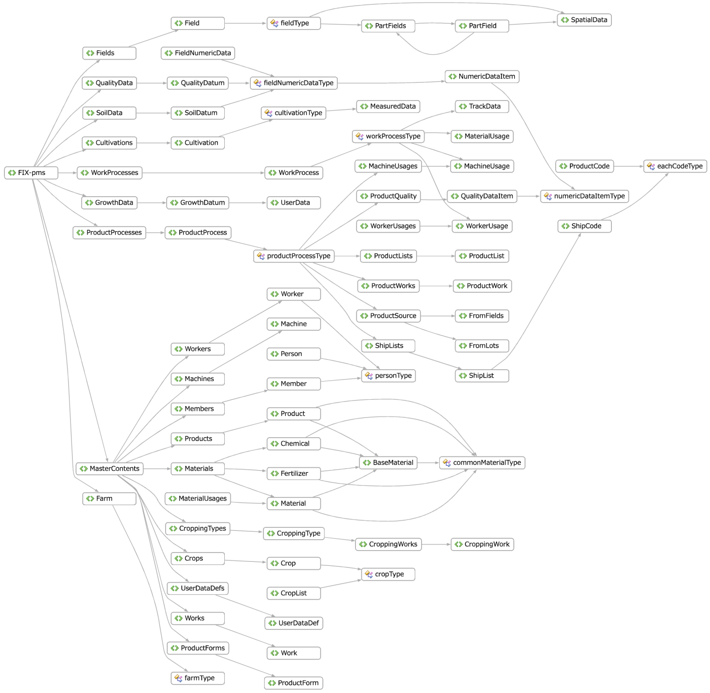
Fig.4 Framework of the data structure (definition of the schema) of the FIX-pms

An example of an FIX-pms document
The following is an example of an FIX-pms document stating the above-mentioned data items, elements, and structure in accordance with the XML Schema.
An XML document has a hierarchical structure. In the present document, only the typical areas of the tree are presented, and other areas are not displayed (folded or omitted).

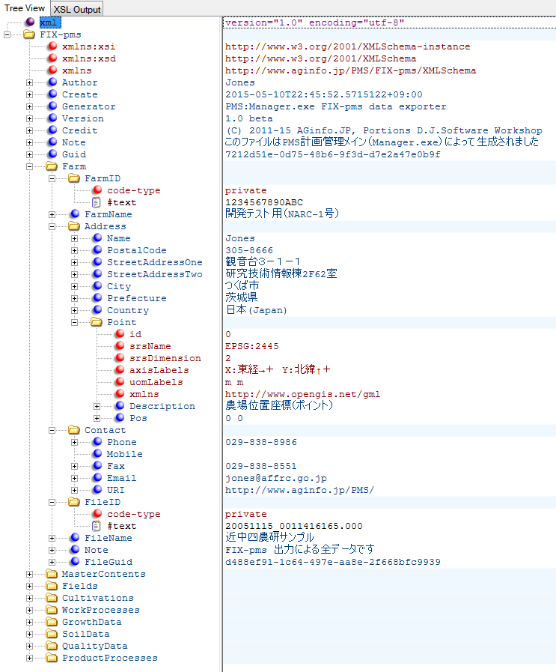

*An example of data displays on XML Notepad 2007 (Microsoft®)
*<Farm> elements and those positioned at lower levels are expanded to display all element data, and the following complex types are not displayed:

Fig.5 An example of an FIX-pms document

The following are codes of FIX-pms documents presented based on the same expansion style as adopted in this figure:

<FIX-pms xmlns:xsi="http://www.w3.org/2001/XMLSchema-instance" xmlns:xsd="http://www.w3.org/2001/XMLSchema" xmlns="http://www.aginfo.jp/PMS/FIX-pms/XMLSchema">
<Author>Jones</Author>
<Create>2015-05-10T22:45:52.5715122+09:00</Create>
<Generator>PMS:Manager.exe FIX-pms data exporter</Generator>
<Version>1.0 beta</Version>
<Credit>(C) 2011-15 AGinfo.JP, Portions D.J.Software Workshop</Credit>
<Note>このファイルはPMS計画管理メイン（Manager.exe）によって生成されました</Note>
<Guid>7212d51e-0d75-48b6-9f3d-d7e2a47e0b9f</Guid>
<Farm>
<FarmID code-type="private">1234567890ABC</FarmID>
<FarmName>開発テスト用（NARC-1号）</FarmName>
<Address>
<Name>Jones</Name>
<PostalCode>305-8666</PostalCode>
<StreetAddressOne>観音台３－１－１</StreetAddressOne>
<StreetAddressTwo>研究技術情報棟2F62室</StreetAddressTwo>
<City>つくば市</City>
<Prefecture>茨城県</Prefecture>
<Country>日本(Japan)</Country>
<Point xmlns="http://www.opengis.net/gml" id="0" srsName="EPSG:2445"
srsDimension="2" axisLabels="X:東経→＋ Y:北緯↑＋" uomLabels="m m">
<Description>農場位置座標（ポイント）</Description>
<Pos>0 0</Pos>
</Point>
</Address>
<Contact>
<Phone>029-838-8986</Phone>
<Mobile></Mobile>
<Fax>029-838-8551</Fax>
<Email>jones@affrc.go.jp</Email>
<URI>http://www.aginfo.jp/PMS/</URI>
</Contact>
<FileID code-type="private">20051115_0011416165.000</FileID>
<FileName>近中四農研サンプル</FileName>
<Note>FIX-pms 出力による全データです</Note>
<FileGuid>d488ef91-1c64-497e-aa8e-2f668bfc9939</FileGuid>
</Farm>
<MasterContents>...</MasterContents>
<Fields>...</Fields>
<Cultivations>...</Cultivations>
<WorkProcesses>...</WorkProcesses>
<GrowthData>...</GrowthData>
<SoilData>...</SoilData>
<QualityData>...</QualityData>
<ProductProcesses>...</ProductProcesses>
</FIX-pms>

Methods for the use of FIX-pms data and examples

General procedures for the use
A document described in accordance with the FIX-pms Schemas (“FIX-pms document”) is a type of XML document, and the specifications of the documents are defined by the XML Schema. Therefore, when FIX-pms documents are used by computers, it is necessary to apply the FIX-pms Schemas (defined by multiple xsd documents as stated in the preceding paragraphs) to libraries and development support functions supported by the processing systems to implement the input-output and other functions of FIX-pms documents on target applications.
Since methods for the use of specific FIX-pms Schemas (xsd documents) vary depending on the processing system, the users should take into account the system.

Cases of tools for the definition of the XML Schemas (xsd.exe) developed by Microsoft
This paragraph presents examples of the use of the “Xml Schemas/DataTypes support utilities”, tools for the definition of XML Schemas: xsd.exe (XSD), that can be used in Visual Studio series or “.net framework SDK” from Microsoft.
The XSD, as it literally means, is a utility tool to exchange the Xml schemas and “data types” in the “.NET programming environment”. The tool exchanges the XML Schemas and data type descriptions using “.NET programming languages”, such as C#, VB, and Jscript.
As an example of application to the FIX-pms Scheme (*.xsd), or conversion using this tool, in the C# language environment, <FIX-pms> or the root elements of the FIX-pms are converted to “FIX-pms class” codes (“FIXpms within the code”) written by C#. In classes below the “FIXpms” class, the result of the code generation, data mapping and input-output processing are written in its own application to describe and implement applications that can be applied to specific FIXpms documents.

/// <remarks/>
[System.CodeDom.Compiler.GeneratedCodeAttribute( "xsd", "4.0.30319.1" )]
[System.SerializableAttribute()]
[System.Diagnostics.DebuggerStepThroughAttribute()]
[System.ComponentModel.DesignerCategoryAttribute( "code" )]
[System.Xml.Serialization.XmlTypeAttribute( AnonymousType = true, Namespace = "http://www.aginfo.jp/PMS/FIX-pms/XMLSchema" )]
[System.Xml.Serialization.XmlRootAttribute( "FIX-pms", Namespace = "http://www.aginfo.jp/PMS/FIX-pms/XMLSchema", IsNullable = false )]
public partial class FIXpms
{

private string authorField;
private System.DateTime createField;
private System.DateTime updateField;
private bool updateFieldSpecified;
private string generatorField;
private string versionField;
private string creditField;
private string noteField;
private string guidField;
private farmType farmField;
private MasterContents masterContentsField;
private Fields fieldsField;
private Cultivations cultivationsField;
private WorkProcesses workProcessesField;
private GrowthData growthDataField;
private SoilData soilDataField;
private QualityData qualityDataField;
private ProductProcesses productProcessesField;
private aclStringType aclField;

public FIXpms()
{
this.aclField = aclStringType.Owner;
}

/// <remarks/>
[System.Xml.Serialization.XmlElementAttribute( DataType = "normalizedString" )]
public string Author
{
get { return this.authorField; }
set { this.authorField = value; }
}

/// <remarks/>
public System.DateTime Create
{
get { return this.createField; }
set { this.createField = value; }
}

/// <remarks/>
public System.DateTime Update
{
get{ return this.updateField; }
set{ this.updateField = value; }
}

/// <remarks/>
[System.Xml.Serialization.XmlIgnoreAttribute()]
public bool UpdateSpecified
{
get{ return this.updateFieldSpecified; }
set{ this.updateFieldSpecified = value; }
}

/// <remarks/>
[System.Xml.Serialization.XmlElementAttribute( DataType = "normalizedString" )]
public string Generator
{
get{ return this.generatorField; }
set{ this.generatorField = value; }
}

/// <remarks/>
[System.Xml.Serialization.XmlElementAttribute( DataType = "normalizedString" )]
public string Version
{
get{ return this.versionField; }
set{ this.versionField = value; }
}

/// <remarks/>
[System.Xml.Serialization.XmlElementAttribute( DataType = "normalizedString" )]
public string Credit
{
get{ return this.creditField; }
set{ this.creditField = value; }
}

/// <remarks/>
[System.Xml.Serialization.XmlElementAttribute( DataType = "normalizedString" )]
public string Note
{
get{ return this.noteField; }
set{ this.noteField = value; }
}

/// <remarks/>
[System.Xml.Serialization.XmlElementAttribute( DataType = "normalizedString" )]
public string Guid
{
get{ return this.guidField; }
set{ this.guidField = value; }
}

/// <remarks/>
public farmType Farm
{
get{ return this.farmField; }
set{ this.farmField = value; }
}

/// <remarks/>
public MasterContents MasterContents
{
get{ return this.masterContentsField; }
set{ this.masterContentsField = value; }
}

/// <remarks/>
public Fields Fields
{
get{ return this.fieldsField; }
set{ this.fieldsField = value; }
}

/// <remarks/>
public Cultivations Cultivations
{
get{ return this.cultivationsField; }
set{ this.cultivationsField = value; }
}

/// <remarks/>
public WorkProcesses WorkProcesses
{
get{ return this.workProcessesField; }
set{ this.workProcessesField = value; }
}

/// <remarks/>
public GrowthData GrowthData
{
get{ return this.growthDataField; }
set{ this.growthDataField = value; }
}

/// <remarks/>
public SoilData SoilData
{
get{ return this.soilDataField; }
set{ this.soilDataField = value; }
}

/// <remarks/>
public QualityData QualityData
{
get{ return this.qualityDataField; }
set{ this.qualityDataField = value; }
}

/// <remarks/>
public ProductProcesses ProductProcesses
{
get{ return this.productProcessesField; }
set{ this.productProcessesField = value; }
}

/// <remarks/>
[System.Xml.Serialization.XmlAttributeAttribute()]
[System.ComponentModel.DefaultValueAttribute( aclStringType.Owner )]
public aclStringType acl
{
get{ return this.aclField; }
set{ this.aclField = value; }
}
}

Elements that have primitive data types (such as “string” and “DateTime” implemented in accordance with language specifications) as their child elements are converted into data types of the corresponding language specifications. All other complex types are defined as “classes” (the majority of the class-type reference area in aqua). Although the definitions of the types of class reference are not presented in the above-mentioned source codes, all of these classes are defined in other sections of the source codes generated by the XSD utility (excluding those presented in the above-mentioned source codes).
In a class definition converted into a programming language code by the XSD utility, all XML elements and attributes that define the structure of FIX-pms are basically described as member fields and properties within the class, since an FIX-pms Schema defines the structure of data and its expression type. Methods are not generated.
When codes are generated as FIXpms class objects in a C# language (.net framework) environment, input/output to/from XML documents can be processed using the XML serializer function prepared in the “.net framework” environment. This allows the developers of applications using FIX-pms documents to focus on data exchange with FIXpms class objects (instances).
However, when the style of implementation (early binding) using this FIX-pms Schema is adopted, attention should be given to changes in the FIX-pms Schema. Since modifications to a schema change the class definition, the developed application will be required to be modified and rebuilt in most cases; the process of data exchange with FIX-pms class objects will be required to be revised depending on the modified area.

Details of the data structure of the FIX-pms (references)

Import of external name space
The FIX-pms Schemas, as schemas with external name space, import the definition of the specifications of the XML Schema itself. In addition, the subset of the GML (OGC 2015), which provides information on geographical space, GPXX or an extension of the GPS interchange format (GPX) (Yoshida et al., 2013), and the BIX-pp (Hoshi et al., 2003) or an EDI standard for plant production (Hoshi et al., 2003) are also imported. For the details, please refer to their schema definition sources and the above-mentioned documents.
The FIX-pms Schemas use prefixes presented in Table 1 as name space prefixes in accordance with these imports.
The name space URI of the FIX-pms Schemas is “http://www.aginfo.jp/PMS/ FIX-pms/XML Schema”. Elements and attributes with no prefix or the prefix “fp” are effective in the FIX-pms Schema definition document (FIX-pms name space).

Table 1 Name space defined by the FIX-pms
Prefixes | URIs to identify name space | Explanation
fp | http://www.aginfo.jp/PMS/FIX-pms/XMLSchema | FIX-pms space
gpx | http://www.topografix.com/GPX/1/1 | GPX name space
gml | http://www.opengis.net/gml | GML name space
bix | http://w3.fb.u-tokai.ac.jp/BIX-pp/XMLSchema | BIX-pp name space
xs | http://www.w3.org/2001/XMLSchema | XML Schema name space

FIX-pms references
In the following paragraphs, the components and attributes of FIX-pms documents are explained in accordance with the definition of the FIX-pms Schemas; <FIX-pms> elements, or root elements, are first explained:

FIX-pms (root) elements
As explained in the preceding paragraphs, <FIX-pms> elements are the root elements of FIX-pms documents, and they are stated prior to any other items.
Two mandatory (that are required to be described) and fifteen optional (that can be omitted) elements have been defined as the child elements of <FIX-pms> elements.

Table 2 Definition of <FIX-pms> elements
Child elements/  Attributes | Name space ¹⁾ | Data types/elements²⁾ | Frequency | Purposes, meanings, etc.
Author |  | nameType | 1 | Author/creator of the document
Create |  | xs:dateTime | 1 | Date and time of the creation of the document
Update |  | xs:dateTime | 0-1 | Date and time of the update of the document
Generator |  | xs:normalizedString | 0-1 | Software to create the document
Version |  | xs:normalizedString | 0-1 | Version of the document
Credit |  | xs:normalizedString | 0-1 | Statement of copyright
Note |  | noteType | 0-1 | Notes/special notes
Guid |  | guidType | 0-1 | GUID for the document
Farm |  | <Farm> | 0-1 | Information on the farm
MasterContnts |  | <MasterContents> | 0-1 | Colle Information on the master contents
Fields |  | [<Field>] | 0-1 | <Field> collection (1 to a given value)
Cultivations |  | [<Cultivation>] | 0-1 | <Cultivation> collection (1 to a given value)
WorkProcesses |  | [<WorkProcess>] | 0-1 | <WorkProcess> collection (1 to a given value)
GrowthData |  | [<GrowthDatum>] | 0-1 | <GrowthDatum> collection (1 to a given value)
SoilData |  | [<SoilDatum>] | 0-1 | <SoilDatum> collection (1 to a given value)
QualityData |  | [<QualityDatum>] | 0-1 | <QualityDatun> collection (1 to a given value)
ProductProcesses |  | [<ProductProcess>] | 0-1 | <ProductProcess> collection (1 to a given value)
Attributes
smlns |  | xs:anyURI | 1 | Specification of name space for the schema
xsd |  | xs:anyURI | 1 | Specification of name space for the xsd prefix
xsi |  | xs:anyURI | 1 | Specification of name space for the xsi prefix
1) If the field is blank, the name space is referred to as “FIX-pms space (fp)”.
2) “<>” and “[]” represent a reference to an element and collection, respectively. For the details of elements that refer to external elements, please read the explanations of the external elements.

Farm elements
Farm elements are the child elements of arbitrarily described FIX-pms elements, the root elements, and their data structures are defined by farmType.
Thirteen arbitrary child elements, which may be omitted, have been defined, although none of them are mandatory. When describing the <Farm> elements, it is necessary to describe at least one of the thirteen arbitrary child elements.

Table 3 Definition of <Farm> elements
Child elements/  Attributes | Namespace ¹⁾ | Data types/elements²⁾ | Frequency | Purposes, meanings, etc.
FarmID |  | positiveCodeType | 0-1 | Author/creator of the document
FarmCode |  | stringCodeType | 0-1 | Date and time of the creation of the document
FarmName |  | longNameType | 0-1 | Date and time of the update of the document
FarmerID |  | positiveCodeType | 0-1 | Software to create the document
FarmerCode |  | stringCodeType | 0-1 | Version of the document
FarmerName |  | nameType | 0-1 | Statement of copyright
Address |  | <Address> | 0-1 | Notes/special notes
Contact |  | <Contact> | 0-1 | GUID for the document
FileID |  | stringCodeType | 0-1 | Information on the farm
FileName |  | xs:normalizedString | 0-1 | Colle Information on the master contents
Note |  | noteType | 0-1 | <Field> collection (1 to a given value)
FarmGuid |  | guidType | 0-1 | <Cultivation> collection (1 to a given value)
FileGuid |  | guidType | 0-1 | <WorkProcess> collection (1 to a given value)
Attributes
acls |  | acl attribute | 0-1 | Setting the access right of the <Farm> element
1) If the field is blank, the name space is referred to as “FIX-pms space (fp)”.
2) “<>” and “[]” represent a reference to an element and collection, respectively. For the details of elements that refer to external elements, please read the explanations of the external elements.

The compositions of <Address> (addressType) and <Contact> (contactType) elements are as follows:

Table 4 <Address> elements
Child elements/  Attributes | Namespace ¹⁾ | Data types/elements²⁾ | Frequency | Purposes, meanings, etc.
Title |  | nameType | 0-1 | Job title
Name |  | nameType | 1 | Name
FirstName |  | nameType | 0-1 | First name (of a person)
LastName |  | nameType | 0-1 | Last name (of a person)
POBoxNumber |  | xs:normalizedString | 0-1 | Post-office box number
PostalCode |  | xs:normalizedString | 0-1 | Postal code
StreetAddressOne |  | xs:normalizedString | 0-1 | Address (street)
StreetAddressTwo |  | xs:normalizedString | 0-1 | Title of the building/Room number
City |  | xs:normalizedString | 0-1 | Address (city, town, etc.)
Prefecture |  | xs:normalizedString | 0-1 | Prefecture
Country |  | xs:normalizedString | 1 | Country
Point | gml | <gml:Point> | 0-1 | Typical point on the farm
1) If the field is blank, the name space is referred to as “FIX-pms space (fp)”.
2) “<>” and “[]” represent a reference to an element and collection, respectively. For the details of elements that refer to external elements, please read the explanations of the external elements.

Table 5 <Contact> elements
Child elements/  Attributes | Namespace ¹⁾ | Data types/elements²⁾ | Frequency | Purposes, meanings, etc.
Phone |  | xs:normalizedString | 0-1 | Telephone number
Mobile |  | xs:normalizedString | 0-1 | Mobile-phone number
Fax |  | xs:normalizedString | 0-1 | Fax number
Email |  | xs:normalizedString | 0-1 | E-mail address
URI |  | xs:normalizedString | 0-1 | URI of the web address
1) If the field is blank, the name space is referred to as “FIX-pms space (fp)”.

MasterContents elements
<MasterContents> elements are child elements of arbitrarily described <FIX-pms> elements. The following are the compositions of <MasterContents> elements:

Table 6 Definition of <MasterContents> elements
Child elements/  Attributes | Namespace ¹⁾ | Data types/elements²⁾ | Frequency | Purposes, meanings, etc.
Members |  | [Member] | 0-1 | Master information on farms, corporations, clients, etc.
Workers |  | [Worker] | 0-1 | Master information on workers/employees
Crops |  | [Crop] | 0-1 | Master information on crops and varieties
Works |  | [Work] | 0-1 | Master information on work
CroppingTypes |  | [CroppingType] | 0-1 | Master information on cropping types and work systems
Machines |  | [Machine] | 0-1 | Master information on equipment and tools
Materials |  | [Material] | 0-1 | Information on fertilizers, agricultural chemicals, seeds, seedlings, and other materials
Products |  | [Product] | 0-1 | Master information on agricultural and other products
ProductForms |  | [ProductForm] | 0-1 | Master information on packages of products
UserDataDefs |  | [UserDataDef] | 0-1 | Information on user-definition data types
Attributes
acls |  | acl attribute | 0-1 | Setting the access right of the <MasterContents> element
1) If the field is blank, the name space is referred to as “FIX-pms space (fp)”.
2) “<>” and “[]” represent a reference to an element and collection, respectively. For the details of elements that refer to external elements, please read the explanations of the external elements.

The following are child elements that comprise <MasterContents> elements:

Table 7 <Member> elements
Child elements/  Attributes | Namespace ¹⁾ | Data types/elements²⁾ | Frequency | Purposes, meanings, etc.
[Person] |  | personType | 1 | Basic information on persons and organizations→Reference to “personType”
ResidentialArea |  | nameType | 0-1 | Residential area (address)
MemberFlag |  | xs:boolean | 0-1 | Flag to determine whether or not the person is a non-management member
CustomerFlag |  | xs:boolean | 0-1 | Flag to determine whether or not the element is a client
SupplierFlag |  | xs:boolean | 0-1 | Flag to determine whether or not the element is a supplier
JAN |  | barcodeType | 0-1 | JAN codes allocated to the members (up to 20 characters)
MemberNote |  | noteType | 0-1 | Note written by a member
1) If the field is blank, the name space is referred to as “FIX-pms space (fp)”.

A <Member> element consists of a core “personType” and extension elements. <Worker> elements also have the same structure (although the extension elements are different).

Table 8 <Worker> elements
Child elements/  Attributes | Namespace ¹⁾ | Data types/elements²⁾ | Frequency | Purposes, meanings, etc.
[Person] |  | personType | 1 | Basic information on persons /organizations → Reference to personType
UnitCost |  | unitCostType | 0-1 | Wage per person (monthly salary, daily and hourly wage, etc.)
JAN |  | barcodeType | 0-1 | JAN code allocated to workers/employees (within 20 characters)
WorkerNote |  | noteType | 0-1 | Notes written by workers/employees
1) If the field is blank, the name space is referred to as “FIX-pms space (fp)”.

A <Crop> element consists of a core “cropType” (equivalent to a <CropList> element) and extension elements.

Table 9 <Crop> element
Child elements/  Attributes | Namespace ¹⁾ | Data types/elements²⁾ | Frequency | Purposes, meanings, etc.
[CropList] |  | cropType | 1 | Crop name/Code
VarietyID |  | positiveCodeType | 0-1 | Variety ID
VarietyCode |  | stringCodeType | 0-1 | Variety code
VarietyName |  | nameType | 1 | Variety name
Yield |  | yieldType | 0-1 | Yield (complete harvest)
SeedAmount |  | amountPerAreaType | 0-1 | Amount of seeds/10a
SeedingFrom |  | xs:date | 0-1 | Initiation of the seeding period
SeedingUpto |  | xs:date | 0-1 | Completion of the seeding period
MaterialKindID |  | positiveCodeType | 0-1 | Material type specific ID
MaterialKindCode |  | stringCodeType | 0-1 | Material type code
MaterialKind |  | nameType | 0-1 | Material type
MaterialID |  | positiveCodeType | 0-1 | Material ID
MaterialCode |  | stringCodeType | 0-1 | Material code
MaterialName |  | nameType | 0-1 | Material name
JAN |  | barcodeType | 0-1 | JAN codes etc. (for external transactions/distribution management)
Note |  | noteType | 0-1 | Remarks/notes on crops and varieties
1) If the field is blank, the name space is referred to as “FIX-pms space (fp)”.

A <Work> element, which expresses work-related information such as the names and types of work, consists of the name of work and the elements of information on the crop to which the work corresponds.

Table 10 <Work> elements
Child elements/  Attributes | Namespace ¹⁾ | Data types/elements²⁾ | Frequency | Purposes, meanings, etc.
WorkID |  | positiveCodeType | 0-1 | Work code ID
WorkCode |  | stringCodeType | 0-1 | Work code
WorkName |  | nameType | 1 | Work name (mandatory)
CropID |  | positiveCodeType | 0-1 | Produced crop ID
CropCode |  | stringCodeType | 0-1 | Produced crop code
CropName |  | nameType | 0-1 | Produced crop ID name
ProduceWorkFlag |  | xs:Boolean | 0-1 | Flag to determine whether or not specific work procedures should be recorded in the cultivation book
JAN |  | barcodeType | 0-1 | JAN codes allocated to tasks (within 20 characters)
Note |  | noteType | 0-1 | Notes and remarks on work procedures

A <CroppingType> element, which provides information on the work type and system, consists of the elements of information on the crop, cropping season, and a work list that comprises the work system.

Table 11 <CroppingType> elements
Child elements/  Attributes | Namespace ¹⁾ | Data types/elements²⁾ | Frequency | Purposes, meanings, etc.
CroppingTypeID |  | positiveCodeType | 0-1 | Cropping type/work system ID
CroppingTypeCode |  | stringCodeType | 0-1 | Cropping type/work system code
CroppingTypeName |  | nameType | 1 | Cropping type/work system name (mandatory)
CropID |  | positiveCodeType | 0-1 | Produced crop ID
CropCode |  | stringCodeType | 0-1 | Produced crop code
CropName |  | nameType | 0-1 | Produced crop name
CroppingTermStart |  | xs:positiveInteger | 0-1 | Start of the cropping period (MMdd integer representation)
CroppingTermEnd |  | xs:positiveInteger | 0-1 | End of the cropping period (MMdd integer representation)
Note |  | noteType | 0-1 | Notes and remarks on specific work procedures
CroppingWorks |  | [CroppingWork] | 1 | Notes on work systems (a list of work systems)

The work list that comprises the work system is expressed as a list (collection) of <CroppingWork> elements.

Table 12 <CroppingWork> elements
Child elements/  Attributes | Namespace ¹⁾ | Data types/elements²⁾ | Frequency | Purposes, meanings, etc.
WorkID |  | positiveCodeType | 0-1 | Work ID
WorkCode |  | stringCodeType | 0-1 | Work code
WorkName |  | nameType | 0-1 | Work name
WorkTermStart |  | xs:positiveInteger | 0-1 | Initiation of work (MMdd integer representation)
WorkTermEnd |  | xs:positiveInteger | 0-1 | Completion of work (MMdd integer representation)
Note |  | noteType | 0-1 | Notes and remarks on work systems

The <Machine> element, which provides information on machines and tools required for work, consists of child elements that represent the names of machines and forms of their ownership.

Table 13 <Machine> element
Child elements/  Attributes | Namespace ¹⁾ | Data types/elements²⁾ | Frequency | Purposes, meanings, etc.
MachineKindID |  | positiveCodeType | 0-1 | Equipment type specific ID
MachineKindCode |  | stringCodeType | 0-1 | Equipment type specific code
MachineKindName |  | nameType | 1 | Equipment type specific name (mandatory)
MachineID |  | positiveCodeType | 0-1 | Equipment ID
MachineCode |  | stringCodeType | 0-1 | Equipment code
MachineName |  | nameType | 1 | Equipment name (mandatory)
NumOfOperator |  | xs:boolean | 0-1 | Number of operators
Performance |  | performanceType | 0-1 | Work performance
OwnFlag |  | xs:boolean | 0-1 | Self-owned
DieselFuelFlag |  | xs:boolean | 0-1 | Use of diesel oil
JAN |  | barcodeType | 0-1 | JAN codes of equipment (within 20 characters)
Note |  | noteType | 0-1 | Notes and remarks on work systems

The <Material> element, which provides information on common materials, inherits the <BaseMaterial> element (commonMaterialType), or a higher-order (virtual) element, and has no additional child elements. In other words, the composition of the <Material> element is the same as that of the <BaseMaterial> element.
On the other hand, the <Fertilizer>, <Chemical>, and <Product> elements, which represent fertilizers, chemicals, and products, respectively, have additional extension elements.

Table 14 <Material> element (commonMaterialType)
Child elements/  Attributes | Namespace ¹⁾ | Data types/elements²⁾ | Frequency | Purposes, meanings, etc.
MaterialKindID |  | positiveCodeType | 0-1 | Material type specific ID
MaterialKindCode |  | stringCodeType | 0-1 | Material type specific code
MaterialKind |  | nameType | 1 | Material type specific name (mandatory)
MaterialID |  | positiveCodeType | 0-1 | Material ID
MaterialCode |  | stringCodeType | 0-1 | Material code
MaterialName |  | nameType | 1 | Material name (mandatory)
FormAmount |  | amountType | 0-1 | Weight/volume per package
AmountUnit |  | unitStringType | 0-1 | Amount/package character strings
FormPrice |  | priceType | 0-1 | Material purchase price (per package)
FormUnit |  | unitStringType | 0-1 | Package unit character strings
SupplierID |  | positiveCodeType | 0-1 | Material supplier ID
SupplierCode |  | stringCodeType | 0-1 | Material supplier code
StockPrice |  | priceType | 0-1 | Material stock price (per package)
ShipPrice |  | priceType | 0-1 | Material shipping price (per package)
JAN |  | barcodeType | 0-1 | JAN codes for materials (within 20 characters)
Note |  | noteType | 0-1 | Notes and remarks on materials

The <Product> element, which provides information on crops and products, inherits the <BaseMaterial> element and contains information on crops and their varieties as production materials and forms of packages as extension elements.

Table 15 <Product> element
Child elements/  Attributes | Namespace ¹⁾ | Data types/elements²⁾ | Frequency | Purposes, meanings, etc.
[BaseMaterial] |  | commonMaterialType | 1 | Information on (common) materials
CropID |  | positiveCodeType | 0-1 | Crop ID
CropCode |  | stringCodeType | 0-1 | Crop code
CropName |  | nameType | 0-1 | Crop name
VarietyID |  | positiveCodeType | 0-1 | Variety ID
VarietyCode |  | stringCodeType | 0-1 | Variety code
VarietyName |  | nameType | 0-1 | Variety name
FormID |  | positiveCodeType | 0-1 | Package ID
FormCode |  | stringCodeType | 0-1 | Package code
FormName |  | nameType | 0-1 | Package name

The <Chemical> element, which provides information on agricultural chemicals, is an extension of the <RegisteredChemical> element.

Table 16 <Chemical> elements
Child elements/  Attributes | Namespace ¹⁾ | Data types/elements²⁾ | Frequency | Purposes, meanings, etc.
[BaseMaterial] |  | commonMaterialType | 1 | Information on (common) materials
RegisteredChemical |  |  | 1 | Information on the registration of agricultural chemicals

The <RegisteredChemical> element consists of principal items related to the registry of agricultural chemicals managed by the government.

Table 17 <RegisteredChemical> element
Child elements/  Attributes | Namespace ¹⁾ | Data types/elements²⁾ | Frequency | Purposes, meanings, etc.
RegNo |  | xs:positiveInteger | 1 | Chemical registration number
Kind |  | xs:normalizedString | 0-1 | Types of chemical
Maker |  | xs:normalizedString | 0-1 | Manufacturers
Ingredient |  | xs:normalizedString | 0-1 | Active ingredients
Usage |  | xs:normalizedString | 0-1 | Usage
Type |  | xs:normalizedString | 0-1 | Formulations
Application |  | xs:normalizedString | 0-1 | Applications

The <Fertilizer> element, which provides information on fertilizers, can be regarded as an extension of the <FertilizerComponent> element consisting of items related to the components of fertilizers in terms of the composition, whereas the <BaseMaterial> element provides basic information on materials.

Table 18 <Fertilizer> elements
Child elements/  Attributes | Namespace ¹⁾ | Data types/elements²⁾ | Frequency | Purposes, meanings, etc.
[BaseMaterial] |  | commonMaterialType | 1 | Information on (common) materials
FertilizerComponent |  |  | 1 | Information on the components of fertilizers

The <FertilizerComponent> element consists of a group of child elements that represent “large and small quantities of principal fertilizer components contained in products”.

Table 19 <FertilizerComponent> elements
Child elements/  Attributes | Namespace ¹⁾ | Data types/elements²⁾ | Frequency | Purposes, meanings, etc.
N |  | ingredientWeightPercentType | 0-1 | Nitrogen component content (mass percent, etc.)
P |  | ingredientWeightPercentType | 0-1 | Phosphorous component content
K |  | ingredientWeightPercentType | 0-1 | Potassium component content
Ca |  | ingredientWeightPercentType | 0-1 | Calcium component content
Mg |  | ingredientWeightPercentType | 0-1 | Magnesium component content
S |  | ingredientWeightPercentType | 0-1 | Sulfur component content
Mn |  | ingredientWeightPercentType | 0-1 | Manganese component content
B |  | ingredientWeightPercentType | 0-1 | Boron component content
Fe |  | ingredientWeightPercentType | 0-1 | Iron component content
Cu |  | ingredientWeightPercentType | 0-1 | Copper component content
Zn |  | ingredientWeightPercentType | 0-1 | Zinc component content
Cl |  | ingredientWeightPercentType | 0-1 | Chlorine component content
Mo |  | ingredientWeightPercentType | 0-1 | Molybdenum component content
Si |  | ingredientWeightPercentType | 0-1 | Silicon component content

The <ProductForm> element, which provides information on the forms of the packages of agricultural products, consists of child elements that represent the types of package, IDs/codes, information on the crop, and weights/volumes of packages as well as their units.

Table 20 <ProductForm> elements
Child elements/  Attributes | Namespace ¹⁾ | Data types/elements²⁾ | Frequency | Purposes, meanings, etc.
CropID |  | positiveCodeType | 0-1 | Crop ID
CropCode |  | stringCodeType | 0-1 | Crop code
CropName |  | nameType | 0-1 | Crop name
FormID |  | positiveCodeType | 0-1 | Package ID
FormCode |  | stringCodeType | 0-1 | Package code
FormName |  | nameType | 1 | Package name
Capacity |  | amountType | 1 | Weight/volume per package
AmountUnit |  | unitStringType | 1 | Package unit of weight/volume (kg, L, etc.)
FormUnit |  | unitStringType | 1 | Package unit character strings (books, bags, boxes, etc.)

The <UserDataDef> element contains information for the definition of given data types based on the key value (also referred to as “property”) style to provide information on a variety of items. The <UserDataDef> element consists of child elements that represent the crops, names of defined data items, their data types, and basic character strings of data values.

Table 21 <UserDataDef> elements
Child elements/  Attributes | Namespace ¹⁾ | Data types/elements²⁾ | Frequency | Purposes, meanings, etc.
CropID |  | positiveCodeType | 0-1 | Crop ID
CropCode |  | stringCodeType | 0-1 | Crop code
CropName |  | nameType | 0-1 | Crop name
DataCode |  | positiveCodeType | 0-1 | Data item ID
DataName |  | nameType | 1 | Data item name
DataType |  | dataTypeStringType | 1 | Data type definition character strings
UnitString |  | unitStringType | 0-1 | Data unit character strings
Note |  | noteType | 0-1 | Notes/remarks on data items

Fields/Field elements
The <Field> element, which provides information on each compartment, consists of child elements that represent management IDs/codes, compartment areas including their numbers and names, areas (registered and managed areas), owners and managers, spatial information on compartments, and information on compartment areas (Figure 6).
The <Fields> element, which represents groups of fields, is a collection of <Field> elements (no upper limit).

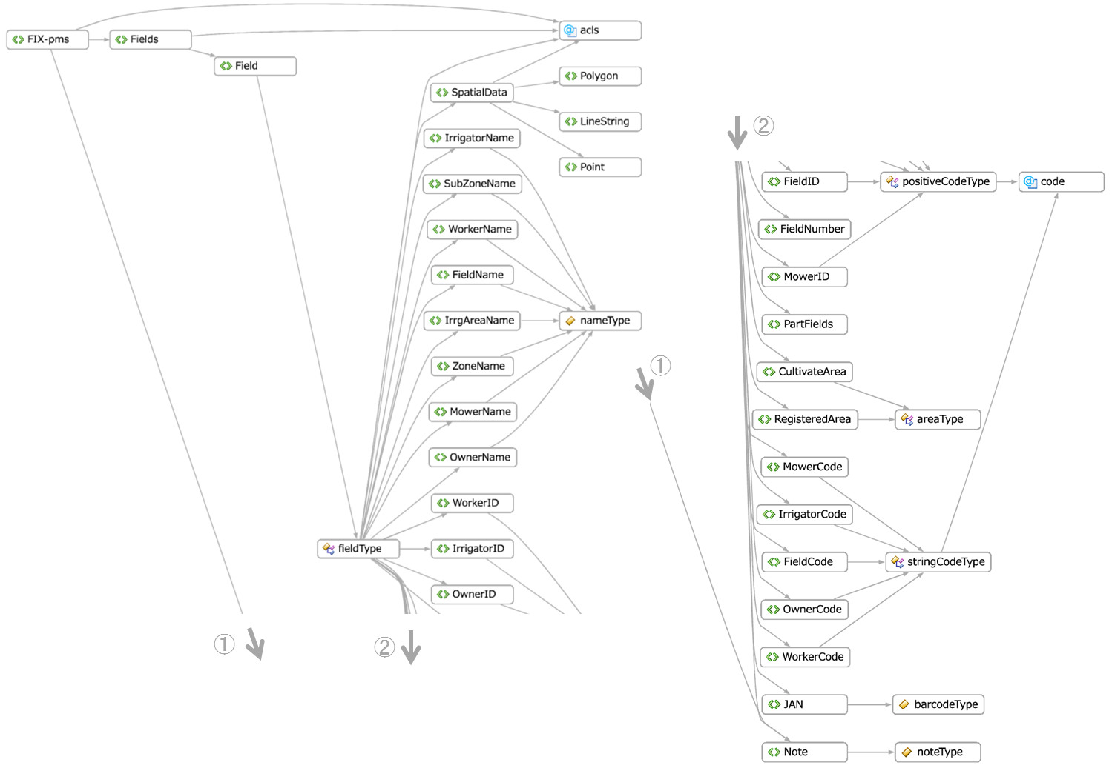
Fig.6 A summary of the composition of <Field> elements

Table 22 <Field> elements
Child elements/  Attributes | Namespace ¹⁾ | Data types/elements²⁾ | Frequency | Purposes, meanings, etc.
FieldID |  | positiveCodeType | 0-1 | Field ID (sequential number)
FieldCode |  | stringCodeType | 0-1 | Field code
FieldNumber |  | xs:string | 0-1 | Field number
FieldName |  | nameType | 0-1 | Field name (title)
RegisteredArea |  | areaType | 0-1 | Registered field area
CultivateArea |  | areaType | 1 | Cultivated/Paddy field areas
OwnerID |  | positiveCodeType | 0-1 | Field owner ID
OwnerCode |  | stringCodeType | 0-1 | Field owner code
OwnerName |  | nameType | 0-1 | Field owner name
WorkerID |  | positiveCodeType | 0-1 | ID number for the person in charge of the management of fields
WorkerCode |  | stringCodeType | 0-1 | Code for the person in charge of the management of fields
WorkerName |  | nameType | 0-1 | Name of the person in charge of the management of fields
MowerID |  | positiveCodeType | 0-1 | ID number for the person in charge of mowing in furrows
MowerCode |  | stringCodeType | 0-1 | Code for the person in charge of mowing in furrows
MowerName |  | nameType | 0-1 | Name of the person in charge of mowing in furrows
IrrigatorID |  | positiveCodeType | 0-1 | ID number for the person in charge of irrigation management
IrrigatorCode |  | stringCodeType | 0-1 | Code for the person in charge of irrigation management
IrrigatorName |  | nameType | 0-1 | Name of the person in charge of irrigation management
ZoneName |  | nameType | 0-1 | Area name
SubZoneName |  | nameType | 0-1 | Sub-area name
IrrgAreaName |  | nameType | 0-1 | Irrigation area/system names
JAN |  | barcodeType | 0-1 | Bar code type for the identification of fields
Note |  | noteType | 0-1 | Remarks/notes on data items
SpatialData |  | SpatialDataType | 0-1 | Spatial information on compartments of fields
PartFields |  | [PartField] | 0-1 | Information on part of fields and registered compartments of fields

The <PartFields> element is a collection of <PartField> elements that describe information on part of fields within compartments and field compartments that belong to each owner.

Table 23 <PartField> elements
Child elements/  Attributes | Namespace ¹⁾ | Data types / elements²⁾ | Frequency | Purposes, meanings, etc.
FieldID |  | positiveCodeType | 0-1 | Field ID (sequential management number)
FieldCode |  | stringCodeType | 0-1 | Field code
ParentFieldID |  | positiveCodeType | 0-1 | Field ID of parent fields ( sequential management number)
FieldNumber |  | xs:string | 0-1 | Field number
FieldName |  | nameType | 0-1 | Field name (title)
RegisteredArea |  | areaType | 0-1 | Registered field area
CultivateArea |  | areaType | 0-1 | Cultivated/Paddy field areas
OwnerID |  | positiveCodeType | 0-1 | Field owner ID
OwnerCode |  | stringCodeType | 0-1 | Field owner code
OwnerName |  | nameType | 0-1 | Field owner name
WorkerID |  | positiveCodeType | 0-1 | ID number for the person in charge of the management of fields
WorkerCode |  | stringCodeType | 0-1 | Code for the person in charge of the management of fields
WorkerName |  | nameType | 0-1 | Name of the person in charge of the management of fields
MowerID |  | positiveCodeType | 0-1 | ID number for the person in charge of mowing in furrows
MowerCode |  | stringCodeType | 0-1 | Code for the person in charge of mowing in furrows
MowerName |  | nameType | 0-1 | Name of the person in charge of mowing in furrows
IrrigatorID |  | positiveCodeType | 0-1 | ID number for the person in charge of irrigation management
IrrigatorCode |  | stringCodeType | 0-1 | Code for the person in charge of irrigation management
IrrigatorName |  | nameType | 0-1 | Name of the person in charge of irrigation management
JAN |  | barcodeType | 0-1 | Bar code type for the identification of fields
Note |  | noteType | 0-1 | Remarks/notes on data items
SpatialData |  | SpatialDataType | 0-1 | Spatial information on compartments of fields
PartFields |  | [PartField] | 0-1 | Information on part of fields and registered compartments of fields

<SpatialData> element, which provides spatial information on fields, consists of the spatial point (gml: Point), line (gml: LineString), and polygon (gml: Polygon) elements, defined by the GML advocated by the OGC (Open Geospatial Consortium).

Table 24 <SpatialData> element
Child elements /  Attributes | Namespace ¹⁾ | Data types/elements²⁾ | Frequency | Purposes, meanings, etc.
Point | gml | PointType | 0-1 | Point
LineString | gml | LineStringType | 0-1 | Line (multiple line segments)
Polygon | gml | PolygonType | 0-1 | Polygon

Cultivations/Cultivation elements
The <Cultivation> element, which provides information on cropping and cultivation in each compartment as well as its use, consists of child elements that represent management IDs/codes, the types/varieties of crop, types/systems of cultivation, and yields in each cropping.
The <Cultivations> element, which represents multiple cultivations and use of compartments (history of using fields), is a collection of <Cultivation> elements (no upper limit).

Table 25 <Cultivation> elements
Child elements/  Attributes | Namespace ¹⁾ | Data types/elements²⁾ | Frequency | Purposes, meanings, etc.
FieldID |  | positiveCodeType | 1 | Field ID (sequential management number)
FieldCode |  | stringCodeType | 0-1 | Field code
CroppingNo |  | xs:positiveInteger | 1 | Cropping number
CroppingName |  | nameType | 0-1 | Cropping name
CropID |  | positiveCodeType | 0-1 | Crop ID
CropCode |  | stringCodeType | 0-1 | Crop code
CropName |  | nameType | 0-1 | Crop name
VarietyID |  | positiveCodeType | 0-1 | Variety ID
VarietyCode |  | stringCodeType | 0-1 | Variety code
VarietyName |  | nameType | 0-1 | Variety name
CroppingTypeID |  | positiveCodeType | 0-1 | Cropping type ID
CroppingTypeCode |  | stringCodeType | 0-1 | Cropping type code
CroppingTypeName |  | nameType | 0-1 | Cropping type name
CroppingYear |  | yearType | 0-1 | Cropping year (western calendar)
CroppingStart |  | xs:date | 0-1 | Date of the initiation of cropping (use of fields)
CroppingEnd |  | xs:date | 0-1 | Date of the completion of cropping (use of fields)
CroppingArea |  | areaType | 0-1 | Cropping area
Yield10a |  | yieldPerAreaType | 0-1 | Yield per area
Yield |  | yieldType | 0-1 | Actual yield
Note |  | noteType | 0-1 | Remarks/notes on data items
MeasureData |  | [bix:BIX-pp] | 0-1 | Data on longitudinal, fixed-point observations

The <MeasureData> element, a child element which stores and expresses data on longitudinal, fixed-point observations on specific fields and in cultivations, is a collection of <BIX-pp> elements in the “bix” name space.

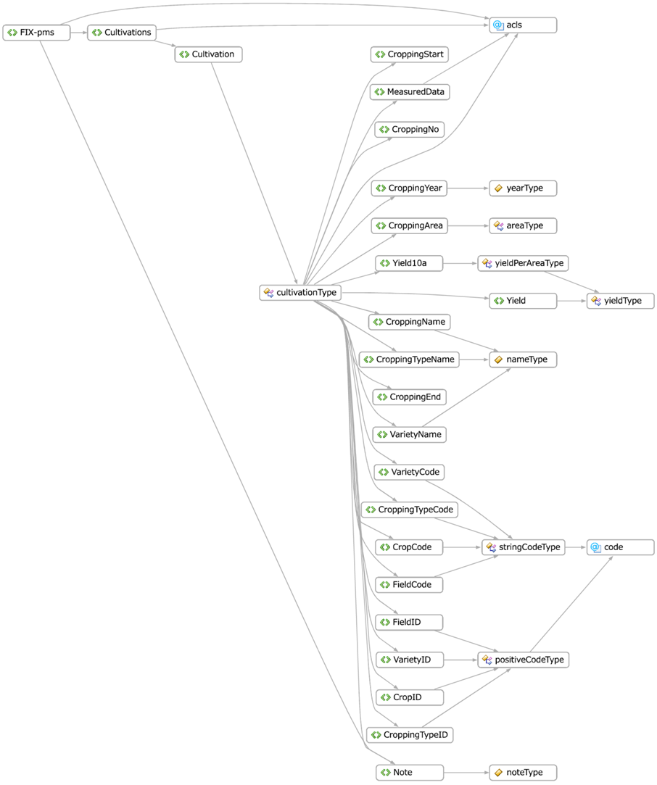
Fig.7 A summary of the composition of <Cultivation> elements

WorkProcesses/WorkProcess elements
<WorkProcess> elements, which provide information on daily routine work in each field and cropping, consist of child elements that represent field, cropping, and crop IDs used to refer to fields, cultivations, and crops, as well as work plans and their results, including the titles of tasks, workers (employees), date and time of work, and equipment and materials used.

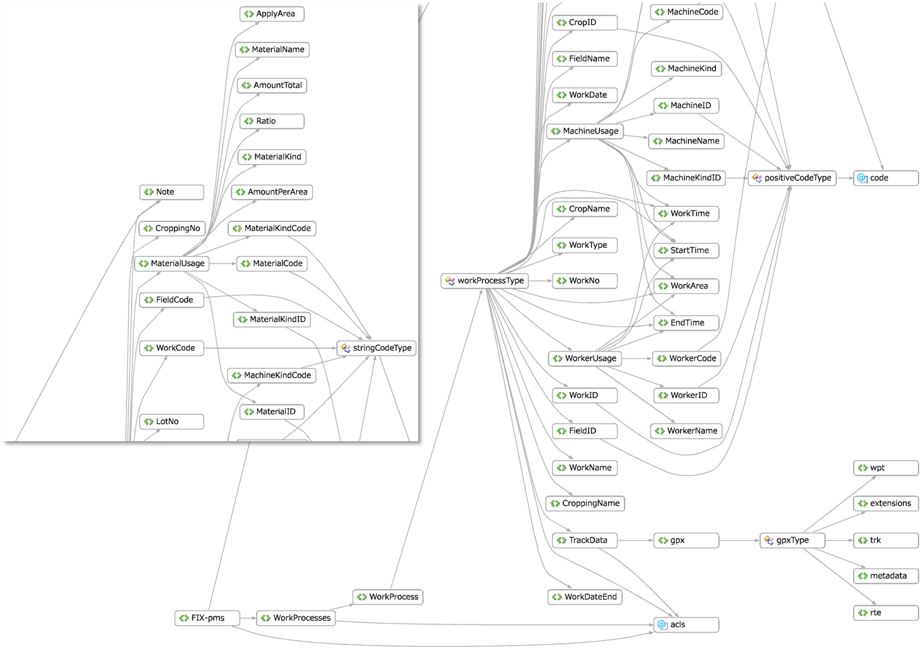
Fig.8 A summary of the composition of <WorkProcess> elements

Table 26 <WorkProcess> element
Child elements/  Attributes | Namespace ¹⁾ | Data types/elements²⁾ | Frequency | Purposes, meanings, etc.
FieldID |  | positiveCodeType | 0-1 | Field ID (sequential management number)
FieldCode |  | stringCodeType | 0-1 | Field code
FieldName |  | nameType | 0-1 | Field number
CroppingNo |  | xs:positiveInteger | 0-1 | Crop number
CroppingName |  | nameType | 0-1 | Crop name
CropID |  | positiveCodeType | 0-1 | Crop ID
CropCode |  | stringCodeType | 0-1 | Crop code
CropName |  | nameType | 0-1 | Crop name
WorkNo |  | xs:positiveInteger | 0-1 | Work number (sequential work management number)
WorkID |  | positiveCodeType | 0-1 | Work ID
WorkCode |  | stringCodeType | 0-1 | Work code
WorkName |  | nameType | 0-1 | Work name
WorkDate |  | xs:date | 1 | Work date (date of its initiation if the working period continues for two or more days)
WorkDateEnd |  | xs:date | 0-1 | Date of the completion of work
WorkTime |  | durationType | 0-1 | Time required for work
StartTime |  | xs:dateTime | 0-1 | Date of the initiation of work
EndTime |  | xs:dateTime | 0-1 | Date of the completion of work
WorkArea |  | areaType | 0-1 | Working area
WorkerUsage |  | [Refer to Table 27] | 0-* | Information on workers (Refer to Table 27)
MachineUsage |  | [Refer to Table 28] | 0-* | Information on the use of equipment (Refer to Table 28)
MaterialUsage |  | [Refer to Table 29] | 0-* | Information on the use of materials (Refer to Table 29)
LotNo |  | xs:positiveInteger | 0-1 | Lot numbers for packaging
Note |  | noteType | 0-1 | Remarks/notes on data items
TrackData |  | [gpx:gpx] | 0-1 | Data on spatiotemporal observations during transfer tasks
WorkType |  | workTypeNumberType | 0-1 | Type of work record (initial state, plans, and results)

Tables 27 to 29 represent workers, equipment, and the use of materials.

Table 27 <WorkerUsage> elements
Child elements/  Attributes | Namespace ¹⁾ | Data types/elements²⁾ | Frequency | Purposes, meanings, etc.
WorkerID |  | positiveCodeType | 0-1 | Worker ID
WorkerCode |  | stringCodeType | 0-1 | Worker code
WorkerName |  | nameType | 0-1 | Worker name
WorkTime |  | positiveCodeType | 1 | Work time
StartTime |  | xs:dateTime | 0-1 | Date/time of the initiation of work
EndTime |  | xs:dateTime | 0-1 | Date/time of the completion of work
WorkArea |  | areaType | 0-1 | Working area

Table 28 <MachineUsage> elements
Child elements/  Attributes | Namespace ¹⁾ | Data types/elements²⁾ | Frequency | Purposes, meanings, etc.
MachineKindID |  | positiveCodeType | 0-1 | Equipment type ID
MachineKindCode |  | stringCodeType | 0-1 | Equipment type code
MachineKind |  | nameType | 0-1 | Equipment type name
MachineID |  | positiveCodeType | 0-1 | Equipment ID
MachineCode |  | stringCodeType | 0-1 | Equipment code
MachineName |  | nameType | 0-1 | Equipment name
WorkTime |  | positiveCodeType | 1 | Work time
StartTime |  | xs:dateTime | 0-1 | Date/time of the initiation of work
EndTime |  | xs:dateTime | 0-1 | Date/time of the completion of work
WorkArea |  | areaType | 0-1 | Working area

Table 29 <MaterialUsage> elements
Child elements/  Attributes | Namespace ¹⁾ | Data types/elements²⁾ | Frequency | Purposes, meanings, etc.
MaterialKindID |  | positiveCodeType | 0-1 | ID according to the type of the material
MaterialKindCode |  | stringCodeType | 0-1 | Code according to the type of the material
MaterialKind |  | nameType | 0-1 | Name according to the type of the material
MaterialID |  | positiveCodeType | 0-1 | Material ID
MaterialCode |  | stringCodeType | 0-1 | Material code
MaterialName |  | nameType | 0-1 | Material name
AmountPerArea |  | amountPerAreaType | 1 | Amount of materials used per area
Ratio |  | ratioType | 0-1 | Material dilution ratio
ApplyArea |  | areaType | 0-1 | Areas to which materials were applied
AmountTotal |  | amountType | 0-1 | Amount of materials used

GrowthData/GrowthDatum elements
<GrowthDatum> elements, which express and store user data defined for each field and crop, consist of child elements that represent the ID numbers of the fields/crops, date data, and ID numbers of related tasks. A <GrowthData> element is a collection of <GrowthDatum> elements.

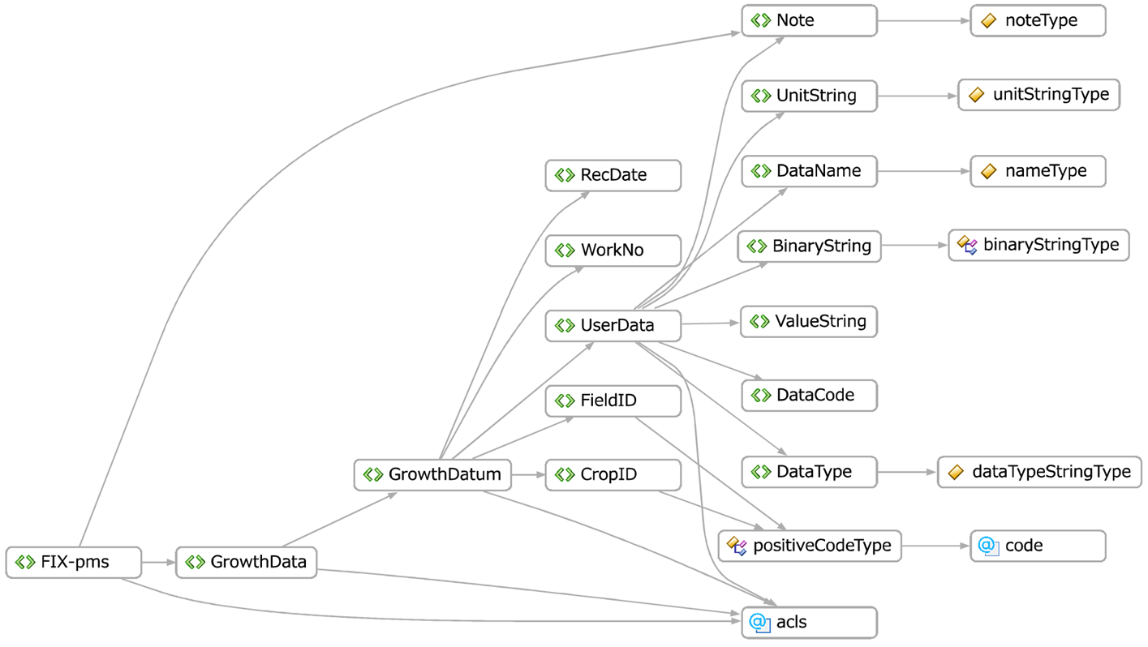
Fig.9 A summary of the composition of <GrowthDatum> elements

Table 30 <GrowthDatum> elements
Child elements/  Attributes | Namespace ¹⁾ | Data types/elements²⁾ | Frequency | Purposes, meanings, etc.
FieldID |  | positiveCodeType | 1 | Field ID (sequential management number)
CropID |  | positiveCodeType | 1 | Crop ID
RecDate |  | xs:dateTime | 1 | Date and time of recording data
UserData |  | [Refer to Table 31] | 1 | User data (Refer to Table 31)
WorkNo |  | xs:positiveInteger | 0-1 | ID numbers for the tasks related to the data

The <UserData> element is a complex element that stores and expresses given data items in accordance with the definition of the <UserDataDef> element. The following is the structure of the <UserData> element.

Table 31 <UserData> element
Child elements/  Attributes | Namespace ¹⁾ | Data types/elements²⁾ | Frequency | Purposes, meanings, etc.
DataCode |  | positiveCodeType | 1 | Field ID (sequential management numbers)
DataName |  | positiveCodeType | 1 | Crop ID
DataType |  | xs:dateTime | 1 | Date/time data
UnitString |  | unitStringType | 1 | Unit string characters of data
ValueString |  | xs:normalizedString | 1 | Data value or binary character strings
BinaryString |  | binaryStringType | 1 | Data value or binary character strings
Note |  | noteType | 0-1 | Remarks and notes

SoilData/SoilDatum elements
The <SoilDatum> element, which provides the results of soil analysis for each field and cultivation, consists of information on the fields and cultivations, crops from these cultivations, and a collection of numerical data set elements (key value pairs consisting of analysis items and values) that represent the results of soil analyses.
The <SoilData> element is a collection of <SoilDatum> elements.

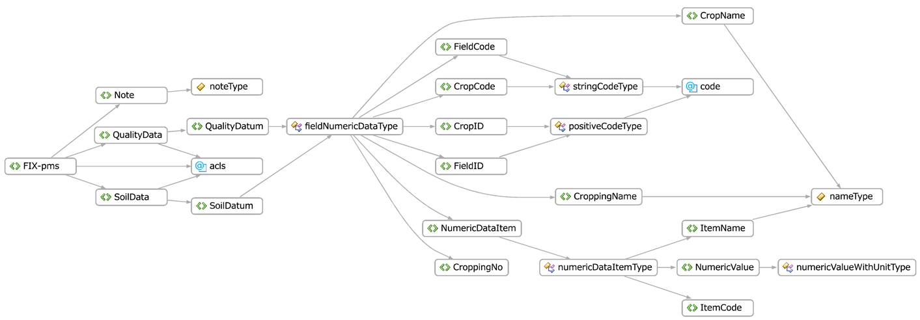
Fig.10 A summary of the composition of <SoilData> and <QualityData> elements

Table 32 <SoilDatum/QualityDatum> elements (fieldNumericDataType)
Child elements/  Attributes | Namespace ¹⁾ | Data types/elements²⁾ | Frequency | Purposes, meanings, etc.
FieldID |  | positiveCodeType | 1 | Field ID (sequential  management number)
FieldCode |  | stringCodeType | 0-1 | Field code
CroppingNo |  | xs:positiveInteger | 1 | Cropping number
CroppingName |  | nameType | 0-1 | Cropping name
CropID |  | positiveCodeType | 1 | Crop ID
CropCode |  | stringCodeType | 0-1 | Crop code
CropName |  | nameType | 0-1 | Crop name
NumericDataItem |  | numericDataItemType | 1-* | Numeric value data set  (key value)

<NumericDataItem> (numericDataItemType) is a complex-type element that has data items names (keys) and numerical data (values) as well as their definitions as its child elements.

Table 33 <NumericDataItem> element (NumericDataItemType)
Child elements/  Attributes | Namespace ¹⁾ | Data types/elements²⁾ | Frequency | Purposes, meanings, etc.
ItemCode |  | xs:nonNegativeInteger | 1 | Numeric data item code (positive integers)
ItemName |  | nameType | 1 | Numeric data item name
NumericValue |  | numericValueWithUnitType | 1 | Numeric value data including units

QualityData/QualityDatum elements
QualityData elements, which represent information on quality analyses in each field and cultivation, consist of collections of the elements of numerical data sets that represent information on the fields, cultivations, crops, and results of soil analyses.
A <Quality Data> element is a collection of <QualityDatum> elements.
Although the composition of data is the same as that of <SoilDatum> elements, <Quality Data> elements have different items (keys) of internal numerical data sets.

ProductProcesses/ProductProcess elements
<ProductProcess> elements, which express data on the process of agricultural production in the unit of lots following harvests from fields, consist of child elements that represent information on lot numbers (for management), cultivations, crops, and varieties, the data the products were put into boxes, yields of agricultural products as well as production areas and years, fields for the production of each crop, quality, the use of equipment, and product and shipment lists.

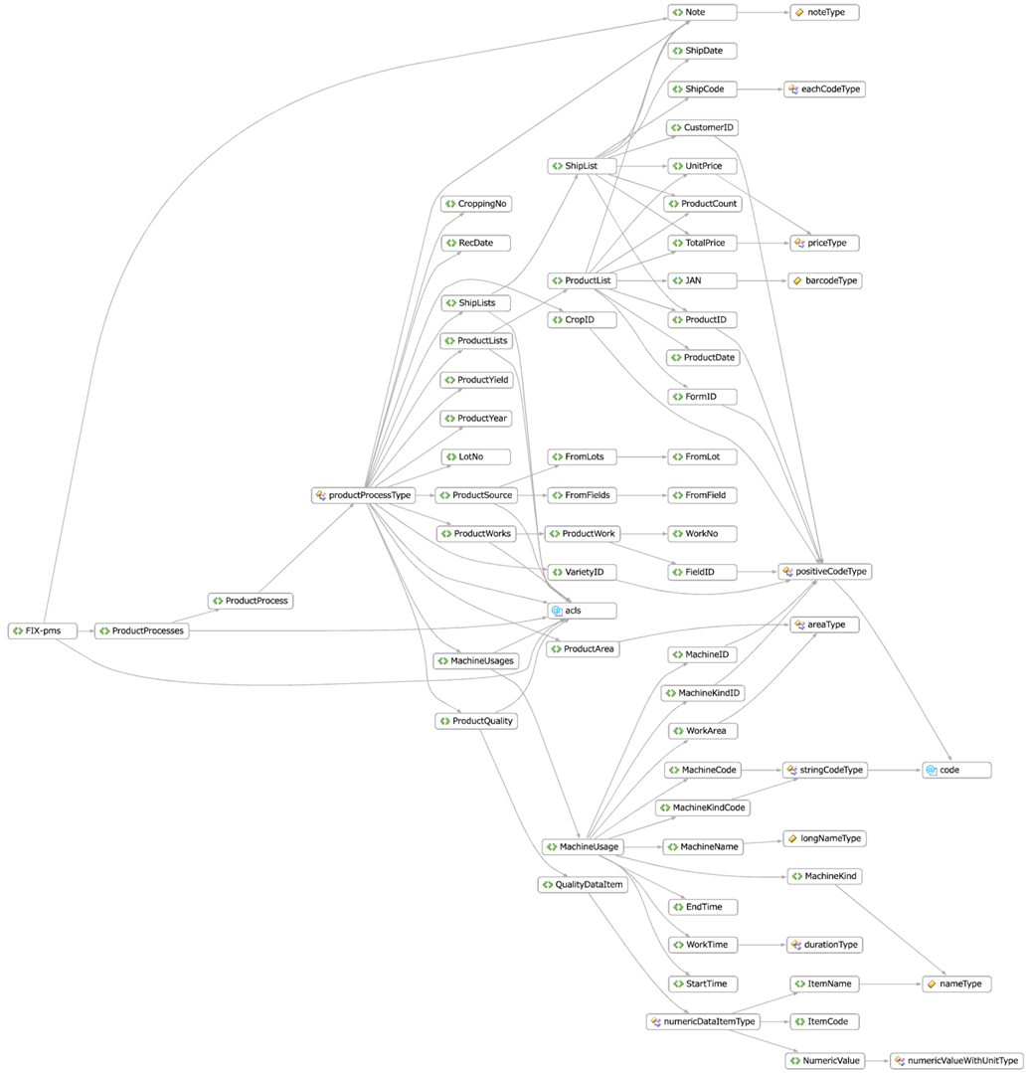
Fig.11 A summary of the composition of <ProductProcess> elements

Table 34 <ProductProcess> elements
Child elements/  Attributes | Namespace | Data types/elements | Frequency | Purposes, meanings, etc.
LotNo |  | xs:positiveInteger | 1 | Lot number
CroppingNo |  | xs:positiveInteger | 1 | Cropping number
CropID |  | positiveCodeType | 0-1 | Crop ID number
CropCode |  | stringCodeType | 0-1 | Crop code
VarietyID |  | positiveCodeType | 0-1 | Variety ID number
VarietyCode |  | stringCodeType | 0-1 | Variety code
RecDate |  | xs:dateTime | 1 | Date and time when production lots were decided
ProductYield |  | yieldType | 0-1 | Yield
ProductArea |  | areaType | 0-1 | Area of production
ProductYear |  | yearType | 0-1 | Area of production (western calendar)
Note |  | noteType | 0-1 | Notes and remarks
ProductSource |  | [Refer to Table 35] | 1 | Information on the sources of products
ProductQuality |  | [QualityDataItem] | 0-1 | Information on the quality of products
MachineUsages |  | [Refer to Table 28] | 0-1 | Information on the use of equipment
ProductWorks |  | [Refer to Table 36] | 0-1 | Information on production
ProductLists |  | [Refer to Table 37] | 0-1 | Information on products in lots
ShippingLists |  | [Refer to Table 38] | 0-1 | Information on the shipping of products in lots

Table 35 <ProductSource> elements
Child elements/  Attributes | Namespace | Data types/elements | Frequency | Purposes, meanings, etc.
FromFields |  | [FromField] | 0-1 | List of production (harvest)-specific fields
FromLots |  | [FromLot] | 0-1 | List of production (raw material)-specific lot numbers

Table 36 <ProductWork> elements
Child elements/  Attributes | Namespace | Data types/elements | Frequency | Purposes, meanings, etc.
FieldID |  | xs:nonNegativeInteger | 0-1 | Field (production compartment) ID
FieldCode |  | nameType | 0-1 | Field (production compartment) code
WorkNo |  | xs:positiveInteger | 1 | Seriel work number (for reference to the <WorkProcess> elements)

Table 37 <ProductList> elements
Child elements/  Attributes | Namespace | Data types/elements | Frequency | Purposes, meanings, etc.
ProductID |  | positiveCodeType | 0-1 | Product ID
ProductCode |  | stringCodeType | 0-1 | Product code
ProductDate |  | xs:date | 1 | Date of the production (registration) of products
FormID |  | positiveCodeType | 0-1 | Product package ID
FormCode |  | stringCodeType | 0-1 | Product package code
UnitPrice |  | priceType | 0-1 | Unit price
ProductCount |  | positiveCodeType | 0-1 | Number of products
TotalPrice |  | priceType | 0-1 | Total price
JAN |  | barcodeType | 0-1 | JAN and other distribution codes
Note |  | noteType | 0-1 | Notes and remarks
ProductOutCode |  | eachCodeType | 0-* | List of the codes of products shipped

Table 38 <ShippingList> elements
Child elements/  Attributes | Namespace | Data types/elements²⁾ | Frequency | Purposes, meanings, etc.
ProductID |  | positiveCodeType | 1 | Product ID
ShipDate |  | xs:date | 1 | Shipping date
CustomerID |  | xs:positiveInteger | 0-1 | Ship-to ID
UnitPrice |  | priceType | 0-1 | Unit price
ProductCount |  | positiveCodeType | 0-1 | Number of products shipped
TotalPrice |  | priceType | 0-1 | Total shipment value
Note |  | noteType | 0-1 | Notes, remarks
ShippingCode |  | eachCodeType | 0-* | List of shipment codes

Complex elements and types

Table 39 A list of complex elements
Element names | Definition of base types/types | Purposes, meanings, etc.
Person | personType | Information on persons and organizations
Address | addressType | Address information
Contact | contactType | Contact information
CropList | cropType | Crop information
Yield | yieldType | Information on yields from complete harvest
ProductOutCode  ShippingCode | eachCodeType | Product, shipping, and other codes

Table 40 <Person> elements (personType)
Element names | Data types/elements | Purposes, meanings, etc.
PersonID | positiveCodeType | ID added to information on persons and organizations (positive integer code type)
PersonCode | stringCodeType | Code added to information on persons and organizations (string code type)
Address | addressType | Information on the addresses of persons and organizations
Contact | contactType | Information on the contact addresses of persons and organizations
Birth | xs:date | Date of birth/establishment (date type)
Age | xs:nonNegativeInteger | Age/Number of years of working (positive integer type)
Note | noteType | Note (within 100 characters)

Table 41 <Address> elements (addressType)
Element names | Data types/elements | Purposes, meanings, etc.
Title | nameType | Job title, rank/position
Name | nameType | Name of a person or an organization
FirstName | nameType | First name of a person
LastName | nameType | Last name of a person
POBoxNumber | xs:normalizedString | Post-office box number
PostalCode | xs:normalizedString | Postal code
StreetAddressOne | xs:normalizedString | Address 1
StreetAddressTwo | xs:normalizedString | Address 2
City | xs:normalizedString | City, town, village
Prefecture | xs:normalizedString | Prefecture
Country | xs:normalizedString | Country, state, area
Point | gml:PointType | 2D (surface) position coordinates

Table 42 <Contact> elements (contactType)
Element names | Data types/elements | Purposes, meanings, etc.
Phone | xs:normalizedString | Telephone number
Mobile | xs:normalizedString | Mobile phone number
Fax | xs:normalizedString | Fax number
Email | xs:normalizedString | E-mail address
URI | xs:normalizedString | URI of the website

Table 43 <CropList> elements (cropType)
Element names | Data types/elements | Purposes, meanings, etc.
CropID | positiveCodeType | Crop ID
CropCode | stringCodeType | Crop code
CropName | nameType | Name of the crop (item)

“amountType” is a data type that represents the weight or volume of a product or material. Its element is <Weight>, <Volume>, or <Count> (<Choice sequence>).

Table 44 amountType
Element names | Data types/elements | Purposes, meanings, etc.
Weight | weightType | Weight including the unit attribute
Volume | volumeType | Volume including the unit attribute
Count | countType | Counts (Numbers of crops, boxes, and bags) including the unit attribute

“yieldType” is a data type that represents yields, its element is <Weight> or <Count> (optional element).

Table 45 yieldType
Element names | Data types/elements | Purposes, meanings, etc.
Weight | weightType | Weight including the unit attribute
Count | countType | Counts (Numbers of crops, boxes, and bags)

Table 46 eachCodeType
Element names | Data types/elements | Purposes, meanings, etc.
ScanDate | xs:dateTime | Date of code operation
Code | barcodeType | Product code
Target | barcodeType | Ship-to code

Simple elements and types

Table 47 A list of simple type elements
Element names | Definition of base types/types | Purposes, meanings, etc.
FromField | xs:positiveInteger | Production field numbers for specific lots (Refer to “FieldID”)
FromLot | xs:positiveInteger | Lot numbers for each lot (Refer to LotNo)
QualityDataItem | numericDataItemType | Key value store of numeric data

Attribute groups
The following are attribute groups defined by the FIX-pms Schemas:

Table 48 Acls attribute groups
Attributes of the structure | Definition of base types/types | Description | Purposes, meanings, etc.
acl | aclStringType | Arbitrary | “Owner”, “Group”, “Friend”, or “Public”  “Owner” by default (or when omitted)

Table 49 Code attribute groups
Attributes of the structure | Definition of base types/types | Description | Purposes, meanings, etc.
code-type | codeType | Arbitrary | “undefined”, “private”, “group”, or “public”  “undefined” by default
code-id | codeTypeID | Arbitrary | Code system of non-negative integers (0 or larger)
code-name | codeTypeName | Arbitrary | Name of the code system (up to 30 characters)
code-author | xs:string | Arbitrary | Developer of code systems
code-uri | xs:anyURI | Arbitrary | URI to identify/refer to the code system
code-ref | xs:anyURI | Arbitrary | URI to refer to information on the definition of the code system

In principle, “ID” and “code” represent numerical and character string types, respectively, in the definition of the FIX-pms Schemas. However, the uses and definitions of some schemas are exceptional due to the historical process of the schema definition.

Complex data types (complexType)
The following are complex data types defined in the FIX-pms Schemas, excluding those explained in the preceding paragraphs on complex elements:

Table 50 Complex data types defined in the FIX-pms Schemas (complexType)
Data type name | Definition of base types / types | Purposes, meanings, etc.
numericCodeType | xs:integer | Integer code including information on code systems as its attribute
positiveCodeType | xs:positiveInteger | Positive integer code including information on code systems as its attribute
nonNegativeCodeType | xs:nonNegativeInteger | Non-negative integer code including information on code systems as its attribute
stringCodeType | xs:normalizedString:100 | Character string code including information on code systems as its attribute
unitCostType | xs:decimal | Unit cost including unit cost character strings as its attribute
amountPerAreaType | amountType | Amount (weight or volume) used per area; the area is specified by the attribute
yieldPerAreaType | yieldType | Yield per area; the area is specified by the attribute
performanceType | xs:double | Value of the work performance; the unit is specified by the attribute
numericValueWithUnitType | xs:double | Numeric value including the attributes of the unit (physical quantity)
weightType | xs:double | Value of the weight including the attributes of the unit (weightUnitType)
volumeType | xs:double | Value of the volume including the attributes of the unit (volumeUnitType)
countType | xs:double | Value of the count including the attributes of the unit (countUnitType)
areaType | xs:double | Value of the area including the attributes of the unit (areaUnitType)
performanceType | xs:double | Value of the performance including the attributes of the unit (performanceUnitType)
ingredientWeightPercentType | xs:double | Ingredient content rate, weight in percentage
ingredientWeightRatioType | xs:double | Ingredient content ratio, weight ratio (mg/100g)
priceType | xs:decimal | Price including the attributes of the unit (unitStringType)
unitCostType | xs:decimal | Cost per worker including the attributes of the unit (unitCostUnitType)
durationType | xs:nonNegativeInteger | Time required including the attributes of the unit (timeUnitType)

Simple data types (simpleType)
The following are simple data types defined in the FIX-pms Schemas and specified data types used in the FIX-pms Schemas (defined in the XML Schemas) :

Table 51 SimpleType defined in the FIX-pms Schemas
Data type name | Definition of base types/types | Purposes, meanings, etc.
nameType | xs:normalizedString:20 | Names of objects (up to 20 characters)
longNameType | xs:normalizedString:50 | Names of objects (up to 50 characters)
noteType | xs:normalizedString:100 | Names of objects (up to 100 characters)
note400Type | xs:normalizedString:400 | Names of objects (up to 400 characters)
guidType | xs:normalizedString | 32 alphanumeric characters:  [8]-[4]-[4]-[4]-[12]
numOfPersonType | xs:nonNegativeInteger | Number of persons, including the “unit” attribute (“person” by default)
barcodeType | xs:normalizedString:20 | Character code (up to 20 characters)
rationType | xs:double | Magnification value, defined value (0)
unitStringType | xs:normalizedString:10 | Unit character string type (up to 10 characters)
timeUnitType | unitStringType | Time unit character string type
weightUnitType | unitStringType | Weight unit character string type
volumeUnitType | unitStringType | Volume unit character string type
countUnitType | unitStringType | Count unit character string type
areaUnitType | unitStringType | Area unit character string type
performanceUnitType | unitStringType | Performance unit character string type
unitCostUnitType | unitStringType | Cost unit character string type
yearType | xs:integer | Year (western calendar) (between 1900 to 2100)
dataTypeStringType | xs:normalizedString | Character string type using a character for the definition of data types
workTypeNumberType | xs:int | Work record type enumerated type (0: Initial status, 1: Implementation, 2: Result)

The following is a list of standard data types defined by the XML Schemas that are referred to in the definition of FIX-pms Schemas :

Table 52 (Specified) data types referred to by the XML Schemas
Data type name | Purposes, meanings, etc.
xs:dateTime | Date type
xs:normalizedString | Normalized character strings (character strings excluding TAB, LF, and CR)
xs:String | Character string type
xs:aryURI | URI reference type
xs:positiveInteger | Positive integers (1 and larger natural numbers)
xs:nonNegativeInteger | Non-negative integers (positive integers including 0)
xs:date | Date type
xs:double | Approximate numeric values (floating-point data type)
xs:decimal | Decimal real numbers (stated without rounding: e.g., the amount of money)
xs:boolean | Boolean type (true｜false)
xs:integer | Integers
xs:int | Integers (implementation-dependent)

Imported elements, attributes, and data types
The following are imports of externally defined elements, attributes, and data types, excluding those explained in the preceding paragraphs:

Table 53 Imported elements, attributes, and data types
Element/attribute/type | Classification | Purposes, meanings, etc.
gml:Point | Elements | Points in the expression of Gml geographical information
gml:LineString | Elements | Multi-lines in the expression of Gml geographical information
gml:Polygon | Elements | Polygons in the expression of Gml geographical information
bix:BIX-pp | Elements | Data on longitudinal, fixed-point observations
gpx:gpx | Elements | Data on spatiotemporal observations during transfer tasks

References
Hoshi, T., T. Suzuki, E. Shiozawa and T. Kameoka (2003) Proposed XML-based Plant Production Information Exchange Standard for EDI, Agricultural Information Research, 12(4): 327-335.
OGC (2015) Geography Markup Language, < http://www.opengeospatial.org/ standards/gml>, referred on 6th-Jul-2015.
Yoshida, T., M. Ohmine, T. Kiura, T. Nanseki (2013) Measured Data Exchange by GPX Extended Format, J. of Jpn. Soc. of Agricultural Machinery.
W3C (2014) XML Schema, <http://www.w3.org/XML/Schema>, referred on 2nd-Jul-2015.

Appendix

FIX-pms schema source codes
Source codes for the FIX-pms Schemas are presented on the following pages; as these codes published in this document at the end of June 2015 may not be the most recent ones, please refer to the PMS website (http://www.aginfo.jp/PMS/) for the latest versions:
Explanations of codes (related to GML, GPXX, and BIX-pp) that import external schemas are omitted because space that can be used for them is limited. Please refer to the PMS website also for the details of those codes.

FIX-pms.xsd

<?xml version="1.0" encoding="utf-8"?>

<!--
FIX-pms スキーマ
Version 1.0.0.1 on 21-Jul-2011 by D.J. ・・・ 初版
Version 1.0.0.2 on 06-Oct-2011 by D.J. ・・・ 一部冗長な定義を削除，アノテーション（ドキュメント）追加
Version 1.0.0.3 on 17-Nov-2011 by D.J. ・・・ 生育管理データ表現要素<userDataType>にデータ項目コード（整数値）を追加：PMSでのインポート処理時にコード解決が必要なことが判明したため（これまでのスキーマでは生育マスタ情報が無かったので解決不能だった）
Version 1.0.0.4 on 17-Nov-2011 by D.J. ・・・ 数値データ配列表現要素<numericDataItemType>に項目コード（整数値）を追加：上記と同じ理由（土壌・品質台帳）
Version 1.0.0.5 on 19-Nov-2011 by D.J. ・・・ バーコード配列表現要素<eachCodeType>に対象コード（文字列）を追加：個別出荷用に出荷コードに加え製品コード（Target要素）を追加
Version 1.0.0.6 on 14-Jan-2012 by D.J. ・・・ 商品要素<Product>・同配列表現要素<Products>追加
Version 1.0.1.0 on 25-May-2012 by D.J. ・・・ パートフィールド構造追加（圃場データの階層構造化），BIX-pp引用・固定点連続計測データ追加，など
Version 1.0.1.1 on 04-Jul-2012 by D.J. ・・・ パートフィールドに空間データ要素追加（漏れていたバグ修正：部分区画にも空間情報は必要でしょう^^;ゞ）
Version 1.0.2.0 on 09-Jul-2012 by D.J. ・・・ ユーザデータ型定義情報（生育データ）型・要素追加 → "pmsMaster.xsd"
Version 1.0.2.1 on 20-Jul-2012 by D.J. ・・・ 作業データ種別型・要素追加（当初・計画・実績を識別），ユーザデータ型定義で定義可能なデータ型に'B'：バーコード型を追加
Version 1.0.2.2 on 04-Dec-2012 by D.J. ・・・ 主要要素にACL属性を追加
Version 1.0.2.3 on 21-Mar-2013 by D.J. ・・・ 一部要素にACL属性を追加（前回追加漏れの対応）
Version 1.0.3.0 on 13-Jan-2014 by D.J. ・・・ 要素一部追加，型～要素定義整理（冗長定義削除）
Version 1.0.4.0 on 09-May-2015 by D.J. ・・・ コード体系定義追加→コード定義更新，成分量単位型追加→肥料成分定義更新
Version 1.0.4.1 on 08-Jun-2015 by D.J. ・・・ 文字コード型単独要素追加 <FarmerCode>, <OwnerCode>, ....
【メイン】
-->

<xs:schema targetNamespace="http://www.aginfo.jp/PMS/FIX-pms/XMLSchema"
elementFormDefault="qualified"
xmlns="http://www.aginfo.jp/PMS/FIX-pms/XMLSchema"
xmlns:fp ="http://www.aginfo.jp/PMS/FIX-pms/XMLSchema"
xmlns:gpx="http://www.topografix.com/GPX/1/1"
xmlns:gml="http://www.opengis.net/gml"
xmlns:bix="http://w3.fb.u-tokai.ac.jp/BIX-pp/XMLSchema"
xmlns:xs ="http://www.w3.org/2001/XMLSchema"
>
<xs:import namespace="http://www.opengis.net/gml" schemaLocation="./Gml.xsd"/>
<xs:import namespace="http://www.topografix.com/GPX/1/1" schemaLocation="./gpx.xsd"/>
<xs:import namespace="http://w3.fb.u-tokai.ac.jp/BIX-pp/XMLSchema" schemaLocation="./BIX-pp.xsd"/>
<xs:include schemaLocation="./pmsCommon.xsd"/>
<xs:include schemaLocation="./pmsMaster.xsd"/>
<xs:include schemaLocation="./pmsWorkProcess.xsd"/>
<xs:include schemaLocation="./pmsProduct.xsd"/>

<!--空間情報（GML引用）-->
<xs:element name="SpatialData">
<xs:annotation>
<xs:documentation xml:lang="ja">
関連する要素の空間情報を点，線，面の座標値として格納します（→ SpatialDataType型）</xs:documentation>
</xs:annotation>
<xs:complexType>
<xs:annotation>
<xs:documentation xml:lang="ja">OpenGISのGMLに従い，定義空間データ（GISデータ）型を定義しています</xs:documentation>
</xs:annotation>
<xs:sequence>
<xs:element ref="gml:Point" minOccurs="0" maxOccurs="unbounded">
<xs:annotation>
<xs:documentation xml:lang="ja">圃場要素では区画代表点（中心点）を保持します。</xs:documentation>
</xs:annotation>
</xs:element>
<xs:element ref="gml:LineString" minOccurs="0" maxOccurs="unbounded">
<xs:annotation>
<xs:documentation xml:lang="ja">
作業要素では作業軌跡（地点の一次元集合）を保持します。通常作業軌跡表現にはGPXXが使用されますが，単純な軌跡情報としての利用も可能です。
</xs:documentation>
</xs:annotation>
</xs:element>
<xs:element ref="gml:Polygon" minOccurs="0" maxOccurs="unbounded">
<xs:annotation>
<xs:documentation xml:lang="ja">圃場要素では区画形状（頂点集合）を保持します。</xs:documentation>
</xs:annotation>
</xs:element>
</xs:sequence>
<xs:attributeGroup ref="acls"/>
</xs:complexType>
</xs:element>

<!-- 計測情報（BIX-pp引用）：将来的には他の規格も並べて引用可 -->
<xs:element name="MeasuredData">
<xs:annotation>
<xs:documentation xml:lang="ja">
固定設置センサによる連続計測データを保持する要素です。現在はBIX-pp3.0によるデータのみです。
</xs:documentation>
</xs:annotation>
<xs:complexType>
<xs:annotation>
<xs:documentation xml:lang="ja">
固定設置センサ等による連続計測データを保持します。内部では東海大学で提唱されている"BIX-pp 3.0"規格を引用しています。将来的には他の規格もシーケンスに加えるという含み（拡張性）を残しています。
</xs:documentation>
</xs:annotation>
<xs:sequence>
<xs:element ref="bix:BIX-pp" minOccurs="0" maxOccurs="unbounded">
<xs:annotation>
<xs:documentation xml:lang="ja">
BIX-pp規格による連続計測データ表現を定義しています。
</xs:documentation>
</xs:annotation>
</xs:element>
</xs:sequence>
<xs:attributeGroup ref="acls"/>
</xs:complexType>
</xs:element>

<!--農場情報（管理ファイル情報を含む）-->
<!-- 型定義 -->
<xs:complexType name="farmType">
<xs:annotation>
<xs:documentation>「農場」タイプを定義しています</xs:documentation>
</xs:annotation>
<xs:sequence>
<xs:element ref="FarmID" minOccurs="0">
<xs:annotation>
<xs:documentation xml:lang="ja">
農場を識別するコード：現バージョンでは正整数です
</xs:documentation>
</xs:annotation>
</xs:element>
<xs:element ref="FarmCode" minOccurs="0">
<xs:annotation>
<xs:documentation xml:lang="ja">
農場を識別するコード：上記の正整数に対して，こちらは文字列コードを想定
</xs:documentation>
</xs:annotation>
</xs:element>
<xs:element ref="FarmName" minOccurs="0">
<xs:annotation>
<xs:documentation xml:lang="ja">農場名称</xs:documentation>
</xs:annotation>
</xs:element>
<xs:element ref="FarmerID" minOccurs="0">
<xs:annotation>
<xs:documentation xml:lang="ja">農家ID：正整数値</xs:documentation>
</xs:annotation>
</xs:element>
<xs:element ref="FarmerCode" minOccurs="0">
<xs:annotation>
<xs:documentation xml:lang="ja">農家コード：文字列</xs:documentation>
</xs:annotation>
</xs:element>
<xs:element ref="FarmerName" minOccurs="0">
<xs:annotation>
<xs:documentation xml:lang="ja">農家名</xs:documentation>
</xs:annotation>
</xs:element>
<xs:element ref="Address" minOccurs="0">
<xs:annotation>
<xs:documentation xml:lang="ja">農場の住所等</xs:documentation>
</xs:annotation>
</xs:element>
<xs:element ref="Contact" minOccurs="0">
<xs:annotation>
<xs:documentation xml:lang="ja">農場の連絡先情報</xs:documentation>
</xs:annotation>
</xs:element>
<xs:element ref="FileID" minOccurs="0">
<xs:annotation>
<xs:documentation xml:lang="ja">
このドキュメントインスタンスに対応するPMSの管理ファイル識別コード
</xs:documentation>
</xs:annotation>
</xs:element>
<xs:element ref="FileName" minOccurs="0">
<xs:annotation>
<xs:documentation xml:lang="ja">
前項管理ファイルコードに対応する管理ファイルの識別名称
</xs:documentation>
</xs:annotation>
</xs:element>
<xs:element ref="Note" minOccurs="0">
<xs:annotation>
<xs:documentation xml:lang="ja">農場についての備考・任意のメモ</xs:documentation>
</xs:annotation>
</xs:element>
<xs:element ref="FarmGuid" minOccurs="0">
<xs:annotation>
<xs:documentation xml:lang="ja">農場を識別するGUIDコード</xs:documentation>
</xs:annotation>
</xs:element>
<xs:element ref="FileGuid" minOccurs="0">
<xs:annotation>
<xs:documentation xml:lang="ja">対応する管理ファイルを識別するGUIDコード</xs:documentation>
</xs:annotation>
</xs:element>
</xs:sequence>
<xs:attributeGroup ref="acls" />
</xs:complexType>
<!--農場要素-->
<xs:element name="Farm" type="farmType">
<xs:annotation>
<xs:documentation xml:lang="ja">農場情報要素です（→ farmType型）</xs:documentation>
</xs:annotation>
</xs:element>

<!--台帳情報-->

<!--土地台帳：単一圃場情報型-->
<!-- 部分圃場要素 -->
<xs:element name="PartField">
<xs:annotation>
<xs:documentation xml:lang="ja">
「部分圃場」要素です。通常，耕作圃場内の分筆区画や合筆圃場内の地主別区画を保持します。また，圃場内を細分化して管理したい場合にも使用します。
</xs:documentation>
</xs:annotation>
<!-- 部分圃場型 -->
<xs:complexType>
<xs:annotation>
<xs:documentation xml:lang="ja">部分圃場タイプを定義しています on 25-May-2012 by D.J.</xs:documentation>
</xs:annotation>
<xs:sequence>
<xs:element ref="FieldID" minOccurs="0"/>
<xs:element ref="FieldCode" minOccurs="0"/>
<xs:element name="ParentFieldID" type="positiveCodeType" minOccurs="0">
<xs:annotation>
<xs:documentation xml:lang="ja">
この「部分圃場（区画）」を保持する親圃場ID（連番値）を保持します
</xs:documentation>
</xs:annotation>
</xs:element>
<xs:element ref="FieldNumber" minOccurs="0"/>
<xs:element ref="FieldName" minOccurs="0"/>
<xs:element ref="RegisteredArea" minOccurs="0"/>
<xs:element ref="CultivateArea" minOccurs="0"/>
<xs:element ref="OwnerID" minOccurs="0"/>
<xs:element ref="OwnerCode" minOccurs="0"/>
<xs:element ref="OwnerName" minOccurs="0"/>
<xs:element ref="WorkerID" minOccurs="0"/>
<xs:element ref="WorkerCode" minOccurs="0"/>
<xs:element ref="WorkerName" minOccurs="0"/>
<xs:element ref="MowerID" minOccurs="0"/>
<xs:element ref="MowerCode" minOccurs="0"/>
<xs:element ref="MowerName" minOccurs="0"/>
<xs:element ref="IrrigatorID" minOccurs="0"/>
<xs:element ref="IrrigatorCode" minOccurs="0"/>
<xs:element ref="IrrigatorName" minOccurs="0"/>
<xs:element ref="JAN" minOccurs="0"/>
<xs:element ref="Note" minOccurs="0"/>
<xs:element ref="SpatialData" minOccurs="0"/>
<xs:element ref="PartFields" minOccurs="0"/>
</xs:sequence>
<xs:attributeGroup ref="acls"/>
</xs:complexType>
</xs:element>
<!-- 部分圃場コンテナ要素 -->
<xs:element name="PartFields">
<xs:annotation>
<xs:documentation xml:lang="ja">「部分圃場」コンテナです。圃場内の複数の部分圃場を保持します。</xs:documentation>
</xs:annotation>
<xs:complexType>
<xs:sequence>
<xs:element ref="PartField" maxOccurs="unbounded"/>
</xs:sequence>
</xs:complexType>
</xs:element>
<!-- 単一圃場型 -->
<xs:complexType name="fieldType">
<xs:annotation>
<xs:documentation>「圃場」タイプを定義しています</xs:documentation>
</xs:annotation>
<xs:sequence>
<xs:element ref="FieldID" minOccurs="0">
<xs:annotation>
<xs:documentation xml:lang="ja">圃場連番値（シリアル番号）</xs:documentation>
</xs:annotation>
</xs:element>
<xs:element ref="FieldCode" minOccurs="0">
<xs:annotation>
<xs:documentation xml:lang="ja">圃場コード</xs:documentation>
</xs:annotation>
</xs:element>
<xs:element ref="FieldNumber" minOccurs="0">
<xs:annotation>
<xs:documentation xml:lang="ja">地番</xs:documentation>
</xs:annotation>
</xs:element>
<xs:element ref="FieldName" minOccurs="0">
<xs:annotation>
<xs:documentation xml:lang="ja">地名（圃場名）</xs:documentation>
</xs:annotation>
</xs:element>
<xs:element ref="RegisteredArea" minOccurs="0">
<xs:annotation>
<xs:documentation xml:lang="ja">地籍（登記）面積</xs:documentation>
</xs:annotation>
</xs:element>
<xs:element ref="CultivateArea">
<xs:annotation>
<xs:documentation xml:lang="ja">耕作面積・水張り面積</xs:documentation>
</xs:annotation>
</xs:element>
<xs:element ref="OwnerID" minOccurs="0">
<xs:annotation>
<xs:documentation xml:lang="ja">
地主（圃場所有者）コード：農家・組織マスタの PersonID を引用
</xs:documentation>
</xs:annotation>
</xs:element>
<xs:element ref="OwnerCode" minOccurs="0"/>
<xs:element ref="OwnerName" minOccurs="0"/>
<xs:element ref="WorkerID" minOccurs="0">
<xs:annotation>
<xs:documentation xml:lang="ja">耕作担当者コード：農家・組織マスタの PersonID を引用</xs:documentation>
</xs:annotation>
</xs:element>
<xs:element ref="WorkerCode" minOccurs="0"/>
<xs:element ref="WorkerName" minOccurs="0"/>
<xs:element ref="MowerID" minOccurs="0">
<xs:annotation>
<xs:documentation xml:lang="ja">畦畔管理担当者コード：農家・組織マスタの PersonID を引用</xs:documentation>
</xs:annotation>
</xs:element>
<xs:element ref="MowerCode" minOccurs="0"/>
<xs:element ref="MowerName" minOccurs="0"/>
<xs:element ref="IrrigatorID" minOccurs="0">
<xs:annotation>
<xs:documentation xml:lang="ja">水管理担当者コード：農家・組織マスタの PersonID を引用</xs:documentation>
</xs:annotation>
</xs:element>
<xs:element ref="IrrigatorCode" minOccurs="0"/>
<xs:element ref="IrrigatorName" minOccurs="0"/>
<xs:element ref="ZoneName" minOccurs="0">
<xs:annotation>
<xs:documentation xml:lang="ja">地区名（大字など）</xs:documentation>
</xs:annotation>
</xs:element>
<xs:element ref="SubZoneName" minOccurs="0">
<xs:annotation>
<xs:documentation xml:lang="ja">地区詳細名（小字など）</xs:documentation>
</xs:annotation>
</xs:element>
<xs:element ref="IrrgAreaName" minOccurs="0">
<xs:annotation>
<xs:documentation xml:lang="ja">水域・水系名</xs:documentation>
</xs:annotation>
</xs:element>
<xs:element ref="JAN" minOccurs="0">
<xs:annotation>
<xs:documentation xml:lang="ja">圃場を識別するJAN相当コード（最大20文字）</xs:documentation>
</xs:annotation>
</xs:element>
<xs:element ref="Note" minOccurs="0">
<xs:annotation>
<xs:documentation xml:lang="ja">備考・任意のメモ</xs:documentation>
</xs:annotation>
</xs:element>
<xs:element ref="SpatialData" minOccurs="0"/>
<xs:element ref="PartFields" minOccurs="0">
<xs:annotation>
<xs:documentation xml:lang="ja">圃場内の部分区画</xs:documentation>
</xs:annotation>
</xs:element>
</xs:sequence>
<xs:attributeGroup ref="acls"/>
</xs:complexType>
<!--単一圃場情報要素-->
<xs:element name="Field" type="fieldType">
<xs:annotation>
<xs:documentation xml:lang="ja">単一の圃場情報要素です（→ fieldType型）</xs:documentation>
</xs:annotation>
</xs:element>
<!--圃場群要素-->
<xs:element name="Fields">
<xs:annotation>
<xs:documentation xml:lang="ja">単一圃場要素の繰り返し</xs:documentation>
</xs:annotation>
<xs:complexType>
<xs:sequence>
<xs:element ref="Field" maxOccurs="unbounded"/>
</xs:sequence>
<xs:attributeGroup ref="acls"/>
</xs:complexType>
</xs:element>

<!--作付・土地利用台帳-->
<xs:complexType name="cultivationType">
<xs:annotation>
<xs:documentation xml:lang="ja">「栽培（作付，土地利用情報）」タイプを定義しています</xs:documentation>
</xs:annotation>
<xs:sequence>
<xs:element ref="FieldID">
<xs:annotation>
<xs:documentation xml:lang="ja">作付対象圃場の圃場番号：圃場情報（Field要素）のFieldIDを引用</xs:documentation>
</xs:annotation>
</xs:element>
<xs:element ref="FieldCode" minOccurs="0"/>
<xs:element ref="CroppingNo">
<xs:annotation>
<xs:documentation xml:lang="ja">対象圃場の作付番号（正整数）</xs:documentation>
</xs:annotation>
</xs:element>
<xs:element ref="CroppingName" minOccurs="0">
<xs:annotation>
<xs:documentation xml:lang="ja">作付け名（文字列：最大20文字）</xs:documentation>
</xs:annotation>
</xs:element>
<xs:element ref="CropID" minOccurs="0">
<xs:annotation>
<xs:documentation xml:lang="ja">作付けられている作物コード（正整数）：作物情報（Crop要素）のCropIDを引用</xs:documentation>
</xs:annotation>
</xs:element>
<xs:element ref="CropCode" minOccurs="0"/>
<xs:element ref="VarietyID" minOccurs="0">
<xs:annotation>
<xs:documentation xml:lang="ja">作付けられている品種コード（正整数）：作物情報（Crop要素）のVarietyIDを引用</xs:documentation>
</xs:annotation>
</xs:element>
<xs:element ref="VarietyCode" minOccurs="0"/>
<xs:element ref="VarietyName" minOccurs="0"/>
<!-- 作型参照要素 added on 29-Aug-2014 by D.J. -->
<xs:element ref="CroppingTypeID" minOccurs="0">
<xs:annotation>
<xs:documentation xml:lang="ja">作付の作型コード（正整数）：作型情報（CroppingType要素）のCroppingTypeIDを引用</xs:documentation>
</xs:annotation>
</xs:element>
<xs:element ref="CroppingTypeCode" minOccurs="0"/>
<xs:element ref="CroppingTypeName" minOccurs="0"/>
<xs:element ref="CroppingYear" minOccurs="0">
<xs:annotation>
<xs:documentation xml:lang="ja">作付年</xs:documentation>
</xs:annotation>
</xs:element>
<xs:element ref="CroppingStart" minOccurs="0">
<xs:annotation>
<xs:documentation xml:lang="ja">作付開始日</xs:documentation>
</xs:annotation>
</xs:element>
<xs:element ref="CroppingEnd" minOccurs="0">
<xs:annotation>
<xs:documentation xml:lang="ja">作付終了日</xs:documentation>
</xs:annotation>
</xs:element>
<xs:element ref="CroppingArea" minOccurs="0">
<xs:annotation>
<xs:documentation xml:lang="ja">作付面積</xs:documentation>
</xs:annotation>
</xs:element>
<xs:element ref="Yield10a" minOccurs="0">
<xs:annotation>
<xs:documentation xml:lang="ja">反当収量(既定：kg)</xs:documentation>
</xs:annotation>
</xs:element>
<xs:element ref="Yield" minOccurs="0">
<xs:annotation>
<xs:documentation xml:lang="ja">圃場全刈り収量(既定：kg)</xs:documentation>
</xs:annotation>
</xs:element>
<xs:element ref="Note" minOccurs="0">
<xs:annotation>
<xs:documentation xml:lang="ja">任意のメモ</xs:documentation>
</xs:annotation>
</xs:element>
<xs:element ref="MeasuredData" minOccurs="0">
<xs:annotation>
<xs:documentation xml:lang="ja">定点連続計測データ</xs:documentation>
</xs:annotation>
</xs:element>
</xs:sequence>
<xs:attributeGroup ref="acls"/>
</xs:complexType>
<!--単一作付情報要素-->
<xs:element name="Cultivation" type="cultivationType">
<xs:annotation>
<xs:documentation xml:lang="ja">単一の作付・土地利用情報要素です</xs:documentation>
</xs:annotation>
</xs:element>
<!--作付群要素-->
<xs:element name="Cultivations">
<xs:annotation>
<xs:documentation xml:lang="ja">単一作付要素の繰り返し（コンテナ要素）です</xs:documentation>
</xs:annotation>
<xs:complexType>
<xs:sequence>
<xs:element ref="Cultivation" maxOccurs="unbounded"/>
</xs:sequence>
<xs:attributeGroup ref="acls"/>
</xs:complexType>
</xs:element>

<!--土壌管理台帳-->
<xs:element name="SoilDatum" type="fieldNumericDataType">
<xs:annotation>
<xs:documentation xml:lang="ja">「土壌成分」情報要素です（→ fieldNumericDataType型）</xs:documentation>
</xs:annotation>
</xs:element>
<xs:element name="SoilData">
<xs:annotation>
<xs:documentation xml:lang="ja">単一土壌成分要素の繰り返し（コンテナ要素）です</xs:documentation>
</xs:annotation>
<xs:complexType>
<xs:sequence>
<xs:element ref="SoilDatum" maxOccurs="unbounded"/>
</xs:sequence>
<xs:attributeGroup ref="acls"/>
</xs:complexType>
</xs:element>

<!--品質管理台帳-->
<xs:element name="QualityDatum" type="fieldNumericDataType">
<xs:annotation>
<xs:documentation xml:lang="ja">「品質管理値」情報要素です（→ fieldNumericDataType型）</xs:documentation>
</xs:annotation>
</xs:element>
<xs:element name="QualityData">
<xs:annotation>
<xs:documentation xml:lang="ja">単一品質要素の繰り返し（コンテナ要素）です</xs:documentation>
</xs:annotation>
<xs:complexType>
<xs:sequence>
<xs:element ref="QualityDatum" maxOccurs="unbounded"/>
</xs:sequence>
<xs:attributeGroup ref="acls"/>
</xs:complexType>
</xs:element>

<!--生育管理台帳-->
<xs:element name="GrowthDatum">
<xs:annotation>
<xs:documentation xml:lang="ja">単一の生育データ要素です</xs:documentation>
</xs:annotation>
<xs:complexType>
<xs:sequence>
<xs:element ref="FieldID"/>
<xs:element ref="CropID"/>
<xs:element ref="RecDate"/>
<xs:element ref="UserData"/>
<xs:element ref="WorkNo" minOccurs="0" />
<!-- added on 04-Jul-2012 by D.J. 作業台帳上の作業データとのリンク用 -->
</xs:sequence>
<xs:attributeGroup ref="acls" />
</xs:complexType>
</xs:element>
<xs:element name="GrowthData">
<xs:annotation>
<xs:documentation xml:lang="ja">生育データ管理項目（要素）の繰り返し（コンテナ要素）です
</xs:documentation>
</xs:annotation>
<xs:complexType>
<xs:sequence>
<xs:element ref="GrowthDatum" maxOccurs="unbounded"/>
</xs:sequence>
<xs:attributeGroup ref="acls" />
</xs:complexType>
</xs:element>

<!--ルート要素-->

<xs:element name="FIX-pms">
<xs:annotation>
<xs:documentation xml:lang="ja">FIX-pms文書のルートノードです</xs:documentation>
</xs:annotation>
<xs:complexType>
<xs:sequence>
<!--header-meta-->
<xs:element ref="Author">
<xs:annotation>
<xs:documentation xml:lang="ja">文書作成者（オーナ）情報を格納します［必須項目］
</xs:documentation>
</xs:annotation>
</xs:element>
<xs:element ref="Create">
<xs:annotation>
<xs:documentation xml:lang="ja">文書作成日時を格納します［必須項目］</xs:documentation>
</xs:annotation>
</xs:element>
<xs:element ref="Update" minOccurs="0">
<xs:annotation>
<xs:documentation xml:lang="ja">文書更新日時を格納します［任意］</xs:documentation>
</xs:annotation>
</xs:element>
<xs:element ref="Generator" minOccurs="0">
<xs:annotation>
<xs:documentation xml:lang="ja">文書生成ツール情報を格納します［任意］</xs:documentation>
</xs:annotation>
</xs:element>
<xs:element ref="Version" minOccurs="0">
<xs:annotation>
<xs:documentation xml:lang="ja">文書バージョン情報を格納します［任意］</xs:documentation>
</xs:annotation>
</xs:element>
<xs:element ref="Credit" minOccurs="0">
<xs:annotation>
<xs:documentation xml:lang="ja">文書著作権情報を格納します［任意］</xs:documentation>
</xs:annotation>
</xs:element>
<xs:element ref="Note" minOccurs="0">
<xs:annotation>
<xs:documentation xml:lang="ja">文書の任意コメント・備考を格納します［任意］
</xs:documentation>
</xs:annotation>
</xs:element>
<xs:element ref="Guid" minOccurs="0">
<xs:annotation>
<xs:documentation xml:lang="ja">この文書のGUIDを格納します［任意］</xs:documentation>
</xs:annotation>
</xs:element>
<!--Node:Farm-->
<xs:element ref="Farm" minOccurs="0">
<xs:annotation>
<xs:documentation xml:lang="ja">「農場」全体の情報（組織情報などを想定）を格納します
</xs:documentation>
</xs:annotation>
</xs:element>
<!--Master-->
<xs:element ref="MasterContents" minOccurs="0">
<xs:annotation>
<xs:documentation xml:lang="ja">PMSマスターデータコンテンツを格納します</xs:documentation>
</xs:annotation>
</xs:element>
<!--Ledger-->
<xs:element ref="Fields" minOccurs="0">
<xs:annotation>
<xs:documentation xml:lang="ja">PMS土地台帳情報を格納します</xs:documentation>
</xs:annotation>
</xs:element>
<xs:element ref="Cultivations" minOccurs="0">
<xs:annotation>
<xs:documentation xml:lang="ja">PMS作付（土地区画利用）台帳情報を格納します
</xs:documentation>
</xs:annotation>
</xs:element>
<xs:element ref="WorkProcesses" minOccurs="0">
<xs:annotation>
<xs:documentation xml:lang="ja">PMS栽培作業台帳情報を格納します</xs:documentation>
</xs:annotation>
</xs:element>
<xs:element ref="GrowthData" minOccurs="0">
<xs:annotation>
<xs:documentation xml:lang="ja">PMS生育台帳情報を格納します</xs:documentation>
</xs:annotation>
</xs:element>
<xs:element ref="SoilData" minOccurs="0">
<xs:annotation>
<xs:documentation xml:lang="ja">PMS土壌台帳情報を格納します</xs:documentation>
</xs:annotation>
</xs:element>
<xs:element ref="QualityData" minOccurs="0">
<xs:annotation>
<xs:documentation xml:lang="ja">PMS品質台帳情報を格納します</xs:documentation>
</xs:annotation>
</xs:element>
<xs:element ref="ProductProcesses" minOccurs="0">
<xs:annotation>
<xs:documentation xml:lang="ja">PMS生産出荷台帳情報を格納します</xs:documentation>
</xs:annotation>
</xs:element>
</xs:sequence>
<xs:attributeGroup ref="acls" />
</xs:complexType>
</xs:element>

</xs:schema>

pmsWorkProcess.xsd

<?xml version="1.0" encoding="utf-8"?>

<!--
FIX-pms スキーマ
Version 1.0.0.1 on 21-Jul-2011 by D.J.
Version 1.0.0.2 on 05-Oct-2011 by D.J.
Version 1.0.2.1 on 20-Jul-2012 by D.J.
Version 1.0.2.2 on 13-Jan-2014 by D.J. －－－ 型～要素定義整理（冗長定義削除）
Version 1.0.4.1 on 08-Jun-2015 by D.J.
【作業データ】
-->

<xs:schema targetNamespace="http://www.aginfo.jp/PMS/FIX-pms/XMLSchema"
elementFormDefault="qualified"
xmlns="http://www.aginfo.jp/PMS/FIX-pms/XMLSchema"
xmlns:fp="http://www.aginfo.jp/PMS/FIX-pms/XMLSchema"
xmlns:gpx="http://www.topografix.com/GPX/1/1"
xmlns:xs="http://www.w3.org/2001/XMLSchema"
>
<xs:import namespace="http://www.topografix.com/GPX/1/1" schemaLocation="./gpx.xsd"/>
<xs:include schemaLocation="./pmsCommon.xsd"/>
<xs:include schemaLocation="./pmsMaster.xsd"/>

<!--作業軌跡要素-->
<xs:element name="TrackData">
<xs:annotation>
<xs:documentation xml:lang="ja">圃場（区画）内作業軌跡・詳細地点データを GPXX1.1 で格納します</xs:documentation>
</xs:annotation>
<xs:complexType>
<xs:sequence>
<xs:element ref="gpx:gpx" maxOccurs="unbounded"/>
</xs:sequence>
<xs:attributeGroup ref="acls"/>
</xs:complexType>
</xs:element>

<!--単一作業型-->
<xs:complexType name="workProcessType">
<xs:annotation>
<xs:documentation xml:lang="ja">「栽培作業」タイプを定義しています</xs:documentation>
</xs:annotation>
<xs:sequence>
<!--圃場参照-->
<xs:element ref="FieldID" minOccurs="0">
<xs:annotation>
<xs:documentation xml:lang="ja">作業対象圃場の識別番号（圃場連番値）：Fields-Field要素で定義され，Cultivation要素で引用されているFieldIDをここでも引用して圃場を特定</xs:documentation>
</xs:annotation>
</xs:element>
<xs:element ref="FieldCode" minOccurs="0"/>
<xs:element ref="FieldName" minOccurs="0"/>
<!--作付け参照-->
<xs:element ref="CroppingNo" minOccurs="0">
<xs:annotation>
<xs:documentation xml:lang="ja">作業対象の作付番号：Cultivations-Cultivation要素で定義されているCroppingNoを引用して作付番号を特定</xs:documentation>
</xs:annotation>
</xs:element>
<xs:element ref="CroppingName" minOccurs="0"/>
<!--作物参照-->
<xs:element ref="CropID" minOccurs="0">
<xs:annotation>
<xs:documentation xml:lang="ja">作業対象の作物番号：FieldIDとCroppingNoが決まれば，Cultivation要素からFieldIDとCroppingNoで特定できる</xs:documentation>
</xs:annotation>
</xs:element>
<xs:element ref="CropName" minOccurs="0"/>
<!--作業番号：シリアル値-->
<xs:element ref="WorkNo" minOccurs="0">
<xs:annotation>
<xs:documentation xml:lang="ja">作業連番値：PMS栽培作業台帳内での作業識別・管理用番号</xs:documentation>
</xs:annotation>
</xs:element>
<!--作業名参照-->
<xs:element ref="WorkID" minOccurs="0">
<xs:annotation>
<xs:documentation xml:lang="ja">作業マスタWorks-Work要素で定義されている作業コード：このコードで作業マスタを参照して作業名などを取得できる</xs:documentation>
</xs:annotation>
</xs:element>
<xs:element ref="WorkCode" minOccurs="0"/>
<xs:element ref="WorkName" minOccurs="0"/>
<!--作業日-->
<xs:element ref="WorkDate">
<xs:annotation>
<xs:documentation xml:lang="ja">作業日（日付型）</xs:documentation>
</xs:annotation>
</xs:element>
<xs:element ref="WorkDateEnd" minOccurs="0">
<xs:annotation>
<xs:documentation xml:lang="ja">作業終了日（日付型）</xs:documentation>
</xs:annotation>
</xs:element>
<xs:element ref="WorkTime">
<xs:annotation>
<xs:documentation xml:lang="ja">作業所要時間（分単位の正整数）</xs:documentation>
</xs:annotation>
</xs:element>
<xs:element ref="StartTime" minOccurs="0">
<xs:annotation>
<xs:documentation xml:lang="ja">作業開始日時（日時型）</xs:documentation>
</xs:annotation>
</xs:element>
<xs:element ref="EndTime" minOccurs="0">
<xs:annotation>
<xs:documentation xml:lang="ja">作業終了日時（日時型）</xs:documentation>
</xs:annotation>
</xs:element>
<xs:element ref="WorkArea" minOccurs="0">
<xs:annotation>
<xs:documentation xml:lang="ja">実際の作業面積（作業した面積）</xs:documentation>
</xs:annotation>
</xs:element>
<xs:element ref="WorkerUsage" minOccurs="0" maxOccurs="unbounded">
<xs:annotation>
<xs:documentation xml:lang="ja">作業者使用状況</xs:documentation>
</xs:annotation>
</xs:element>
<xs:element ref="MachineUsage" minOccurs="0" maxOccurs="unbounded">
<xs:annotation>
<xs:documentation xml:lang="ja">機材使用状況</xs:documentation>
</xs:annotation>
</xs:element>
<xs:element ref="MaterialUsage" minOccurs="0" maxOccurs="unbounded">
<xs:annotation>
<xs:documentation xml:lang="ja">資材（肥料・農薬含む）使用状況</xs:documentation>
</xs:annotation>
</xs:element>
<xs:element ref="LotNo" minOccurs="0">
<xs:annotation>
<xs:documentation xml:lang="ja">ロット作業の場合の対象ロット番号</xs:documentation>
</xs:annotation>
</xs:element>
<xs:element ref="Note" minOccurs="0">
<xs:annotation>
<xs:documentation xml:lang="ja">この作業に関する任意のメモ・備考（100文字以内）</xs:documentation>
</xs:annotation>
</xs:element>
<xs:element ref="TrackData" minOccurs="0">
<xs:annotation>
<xs:documentation xml:lang="ja">この作業の詳細作業軌跡データ：GPXX形式によるGPSトラックログと各地点での属性データセット</xs:documentation>
</xs:annotation>
</xs:element>
<xs:element ref="WorkType" minOccurs="0">
<xs:annotation>
<xs:documentation xml:lang="ja">この作業レコードの種別値，既定値は2:作業実績として処理する，added on 20-Jul-2012 by D.J.</xs:documentation>
</xs:annotation>
</xs:element>
</xs:sequence>
<xs:attributeGroup ref="acls"/>
</xs:complexType>
<!--単一作業要素-->
<xs:element name="WorkProcess" type="workProcessType">
<xs:annotation>
<xs:documentation xml:lang="ja">作業実績情報要素です（→ workProcessType型）</xs:documentation>
</xs:annotation>
</xs:element>

<!--作業群要素-->
<xs:element name="WorkProcesses">
<!--作業群型（作業型の任意数繰り返し）-->
<xs:annotation>
<xs:documentation xml:lang="ja">一連の作業情報を保持します（コンテナ要素）</xs:documentation>
</xs:annotation>
<xs:complexType>
<xs:sequence>
<xs:element ref="WorkProcess" maxOccurs="unbounded"/>
</xs:sequence>
<xs:attributeGroup ref="acls"/>
</xs:complexType>
</xs:element>

</xs:schema>

pmsProductProcess.xsd

<?xml version="1.0" encoding="utf-8"?>

<!--
FIX-pms スキーマ
Version 1.0.0.1 on 21-Jul-2011 by D.J.
Version 1.0.0.2 on 05-Oct-2011 by D.J.
Version 1.0.0.3 on 04-Dec-2012 by D.J. －－－ 主要要素ACL属性追加
Version 1.0.0.4 on 13-Jan-2014 by D.J. －－－ 型～要素整理（冗長定義削除）
Version 1.0.4.1 on 17-Jun-2015 by D.J. －－－ 文字コード型拡充への対応
【生産出荷（ロット管理）データ】
-->

<xs:schema targetNamespace="http://www.aginfo.jp/PMS/FIX-pms/XMLSchema"
elementFormDefault="qualified"
xmlns="http://www.aginfo.jp/PMS/FIX-pms/XMLSchema"
xmlns:fp="http://www.aginfo.jp/PMS/FIX-pms/XMLSchema"
xmlns:xs="http://www.w3.org/2001/XMLSchema"
>
<xs:include schemaLocation="./pmsCommon.xsd"/>
<xs:include schemaLocation="./pmsMaster.xsd"/>

<xs:element name="QualityDataItem" type="numericDataItemType">
<xs:annotation>
<xs:documentation xml:lang="ja">生産出荷ロットの個別品質情報要素です（→ numericDataItemType型）</xs:documentation>
<xs:documentation xml:lang="ja">マスタ定義ファイル内で定義されている'numericDataItemType'を流用して定義</xs:documentation>
</xs:annotation>
</xs:element>

<xs:element name="ProductQuality">
<xs:annotation>
<xs:documentation xml:lang="ja">生産出荷ロットの品質情報要素です</xs:documentation>
</xs:annotation>
<xs:complexType>
<xs:sequence>
<xs:element ref="QualityDataItem" maxOccurs="unbounded"/>
</xs:sequence>
<xs:attributeGroup ref="acls"/>
</xs:complexType>
</xs:element>

<xs:element name="FromFields">
<xs:annotation>
<xs:documentation xml:lang="ja">ロット構成圃場番号リスト要素です</xs:documentation>
</xs:annotation>
<xs:complexType>
<xs:sequence>
<xs:element ref="FromField" maxOccurs="unbounded"/>
</xs:sequence>
</xs:complexType>
</xs:element>

<xs:element name="FromLots">
<xs:annotation>
<xs:documentation xml:lang="ja">ロット構成前処理ロット番号リスト要素です</xs:documentation>
</xs:annotation>
<xs:complexType>
<xs:sequence>
<xs:element ref="FromLot" maxOccurs="unbounded"/>
</xs:sequence>
</xs:complexType>
</xs:element>

<xs:element name="ProductSource">
<xs:annotation>
<xs:documentation xml:lang="ja">ロットの由来情報要素です</xs:documentation>
</xs:annotation>
<xs:complexType>
<!-- xs:choice>
<xs:element ref="FromFields" />
<xs:element ref="FromLots" />
</xs:choice -->
<xs:sequence>
<xs:element ref="FromFields" minOccurs="0" /> <!-- 'choice' is changed to 'sequence' on 19-Jan-2014 by D.J. -->
<xs:element ref="FromLots" minOccurs="0" />
</xs:sequence>
<xs:attributeGroup ref="acls"/>
</xs:complexType>
</xs:element>

<xs:element name="ProductWork">
<xs:annotation>
<xs:documentation xml:lang="ja">ロット作業情報の参照先情報要素です</xs:documentation>
</xs:annotation>
<xs:complexType>
<xs:sequence>
<xs:element ref="FieldID" minOccurs="0"/>
<xs:element ref="FieldCode" minOccurs="0"/>
<xs:element ref="WorkNo"/>
</xs:sequence>
</xs:complexType>
</xs:element>
<xs:element name="ProductWorks">
<xs:annotation>
<xs:documentation xml:lang="ja">ロット作業リスト要素</xs:documentation>
</xs:annotation>
<xs:complexType>
<xs:sequence>
<xs:element ref="ProductWork" maxOccurs="unbounded" />
</xs:sequence>
<xs:attributeGroup ref="acls"/>
</xs:complexType>
</xs:element>

<xs:complexType name="eachCodeType">
<xs:annotation>
<xs:documentation xml:lang="ja">製品・商品の個別コード，出荷コード型を定義しています</xs:documentation>
</xs:annotation>
<xs:sequence>
<xs:element name="ScanDate" type="xs:dateTime"/>
<xs:element name="Code" type="fp:barcodeType"/>
<xs:element name="Target" type="fp:barcodeType" minOccurs="0"/>
</xs:sequence>
</xs:complexType>
<xs:element name="ProductOutCode" type="eachCodeType">
<xs:annotation>
<xs:documentation xml:lang="ja">製品個別の製品コード情報要素です（→ eachCodeType型）</xs:documentation>
</xs:annotation>
</xs:element>
<xs:element name="ShippingCode" type="eachCodeType">
<xs:annotation>
<xs:documentation xml:lang="ja">個別の製品出荷コード情報要素です（→ eachCodeType型）</xs:documentation>
</xs:annotation>
</xs:element>

<xs:element name="ProductList">
<xs:annotation>
<xs:documentation xml:lang="ja">単一の製品情報要素です</xs:documentation>
</xs:annotation>
<xs:complexType>
<xs:sequence>
<xs:element ref="ProductID" minOccurs="0"/>
<xs:element ref="ProductCode" minOccurs="0"/>
<xs:element ref="ProductDate"/>
<xs:element ref="FormID" minOccurs="0"/>
<xs:element ref="FormCode" minOccurs="0"/>
<xs:element ref="UnitPrice" minOccurs="0"/>
<xs:element ref="ProductCount" minOccurs="0"/>
<xs:element ref="TotalPrice" minOccurs="0"/>
<xs:element ref="JAN" minOccurs="0"/>
<xs:element ref="Note" minOccurs="0"/>
<xs:element ref="ProductOutCode" minOccurs="0" maxOccurs="unbounded"/>
</xs:sequence>
</xs:complexType>
</xs:element>
<xs:element name="ProductLists">
<xs:annotation>
<xs:documentation xml:lang="ja">製品情報リスト要素</xs:documentation>
</xs:annotation>
<xs:complexType>
<xs:sequence>
<xs:element ref="ProductList" maxOccurs="unbounded" />
</xs:sequence>
<xs:attributeGroup ref="acls"/>
</xs:complexType>
</xs:element>

<xs:element name="ShippingList">
<xs:annotation>
<xs:documentation xml:lang="ja">単一の出荷情報要素です</xs:documentation>
</xs:annotation>
<xs:complexType>
<xs:sequence>
<xs:element ref="ProductID"/>
<xs:element ref="ShipDate"/>
<xs:element ref="CustomerID" minOccurs="0"/>
<xs:element ref="UnitPrice" minOccurs="0"/>
<xs:element ref="ProductCount" minOccurs="0"/>
<xs:element ref="TotalPrice" minOccurs="0"/>
<xs:element ref="Note" minOccurs="0"/>
<xs:element ref="ShippingCode" minOccurs="0" maxOccurs="unbounded"/>
</xs:sequence>
</xs:complexType>
</xs:element>
<xs:element name="ShippingLists">
<xs:annotation>
<xs:documentation xml:lang="ja">出荷情報リスト要素</xs:documentation>
</xs:annotation>
<xs:complexType>
<xs:sequence>
<xs:element ref="ShippingList" maxOccurs="unbounded" />
</xs:sequence>
<xs:attributeGroup ref="acls"/>
</xs:complexType>
</xs:element>

<!--
生産出荷台帳情報
-->
<!-- 型定義 -->
<xs:complexType name="productProcessType">
<xs:annotation>
<xs:documentation xml:lang="ja">生産物調製加工・出荷情報タイプを定義しています</xs:documentation>
</xs:annotation>
<xs:sequence>
<xs:element ref="LotNo"/>
<xs:element ref="CroppingNo"/>
<xs:element ref="CropID" minOccurs="0"/>
<xs:element ref="CropCode" minOccurs="0"/>
<xs:element ref="VarietyID" minOccurs="0"/>
<xs:element ref="VarietyCode" minOccurs="0"/>
<xs:element ref="RecDate"/>
<xs:element ref="ProductYield" minOccurs="0"/>
<xs:element ref="ProductArea" minOccurs="0"/>
<xs:element ref="ProductYear" minOccurs="0"/>
<xs:element ref="Note" minOccurs="0"/>
<xs:element ref="ProductSource">
<xs:annotation>
<xs:documentation xml:lang="ja">ロットの構成元（圃場またはロットのリスト）を格納します</xs:documentation>
</xs:annotation>
</xs:element>
<xs:element ref="ProductQuality" minOccurs="0">
<xs:annotation>
<xs:documentation xml:lang="ja">ロットの品質データ（項目名と値のセット）リストを格納します</xs:documentation>
</xs:annotation>
</xs:element>
<xs:element ref="MachineUsages" minOccurs="0">
<xs:annotation>
<xs:documentation xml:lang="ja">ロット作業固有の使用機材情報を格納します</xs:documentation>
</xs:annotation>
</xs:element>
<xs:element ref="ProductWorks" minOccurs="0">
<xs:annotation>
<xs:documentation xml:lang="ja">ロットの個別作業情報（への参照ID）を格納します</xs:documentation>
</xs:annotation>
</xs:element>
<xs:element ref="ProductLists" minOccurs="0">
<xs:annotation>
<xs:documentation xml:lang="ja">ロットから生産される製品一覧（製品ごとの個別コード込み）を格納します</xs:documentation>
</xs:annotation>
</xs:element>
<xs:element ref="ShippingLists" minOccurs="0">
<xs:annotation>
<xs:documentation xml:lang="ja">ロットから出荷される製品リスト（製品ごと）を格納します</xs:documentation>
</xs:annotation>
</xs:element>
</xs:sequence>
<xs:attributeGroup ref="acls"/>
</xs:complexType>
<!--単一生産工程ロットデータ要素-->
<xs:element name="ProductProcess" type="productProcessType">
<xs:annotation>
<xs:documentation xml:lang="ja">単一の生産ロット情報要素です（→ productProcessType型）</xs:documentation>
</xs:annotation>
</xs:element>
<!--生産出荷工程データ群要素-->
<xs:element name="ProductProcesses">
<xs:annotation>
<xs:documentation xml:lang="ja">単一生産出荷工程（ロット）データの繰り返し（コンテナ要素）</xs:documentation>
</xs:annotation>
<xs:complexType>
<xs:sequence>
<xs:element ref="ProductProcess" maxOccurs="unbounded"/>
</xs:sequence>
<xs:attributeGroup ref="acls"/>
</xs:complexType>
</xs:element>

</xs:schema>

pmsMaster.xsd

<?xml version="1.0" encoding="utf-8"?>

<!--
FIX-pms スキーマ
Version 1.0.0.1 on 18-Jul-2011 by D.J.
Version 1.0.0.2 on 05-Oct-2011 by D.J.
Version 1.0.0.3 on 14-Jan-2012 by D.J. 商品型<productType>，商品要素<Product>追加
Version 1.0.1.0 on 25-May-2012 by D.J. ユーザ定義データ（生育観察）構造微修正
Version 1.0.2.0 on 09-Jul-2012 by D.J. ユーザ定義データの定義情報（マスタ）要素追加・・・これに伴いuserDataTypeをマスタ参照・簡素化できるがそれは見送り（現状のままとする）
Version 1.0.2.1 on 04-Dec-2012 by D.J. 主要要素へのACL属性追加
Version 1.0.2.2 on 13-Jan-2013 by D.J. 型と要素の定義関係整理（不要な型定義を省略して軽量化）
Version 1.0.2.3 on 29-Aug-2014 by D.J. 作型マスタ要素追加
Version 1.0.4.1 on 08-Jun-2015 by D.J. 文字コード型追加に伴うコード要素追加
【マスタデータ】
-->

<xs:schema targetNamespace="http://www.aginfo.jp/PMS/FIX-pms/XMLSchema"
elementFormDefault="qualified"
xmlns="http://www.aginfo.jp/PMS/FIX-pms/XMLSchema"
xmlns:fp="http://www.aginfo.jp/PMS/FIX-pms/XMLSchema"
xmlns:xs="http://www.w3.org/2001/XMLSchema"
>
<xs:include schemaLocation="./pmsCommon.xsd"/>

<!--**********-->
<!--マスタ情報-->
<!--**********-->

<!-- 人物関係 -->
<xs:complexType name="personType">
<xs:annotation>
<xs:documentation xml:lang="ja">人物情報</xs:documentation>
</xs:annotation>
<xs:sequence>
<xs:element ref="PersonID" minOccurs="0"/>
<xs:element ref="PersonCode" minOccurs="0"/>
<xs:element ref="Address"/>
<xs:element ref="Contact" minOccurs="0"/>
<xs:element ref="Birth" minOccurs="0"/>
<xs:element ref="Age" minOccurs="0"/>
<xs:element ref="Note" minOccurs="0"/>
</xs:sequence>
</xs:complexType>

<xs:element name="Person" type="personType">
<xs:annotation>
<xs:documentation xml:lang="ja">個人・組織の基本情報要素です（→ personType型）</xs:documentation>
</xs:annotation>
</xs:element>

<xs:element name="Member">
<xs:annotation>
<xs:documentation xml:lang="ja">メンバ（地主・農家，取引先（仕入れ先，顧客）などの個人・法人）情報要素です</xs:documentation>
</xs:annotation>
<xs:complexType>
<xs:annotation>
<xs:documentation xml:lang="ja">地主・農家・取引先情報：人物情報を拡張して，属性，地区などを追加</xs:documentation>
</xs:annotation>
<xs:complexContent>
<xs:extension base="personType">
<xs:sequence>
<xs:element ref="ResidentialArea" minOccurs="0"/>
<xs:element ref="MemberFlag" minOccurs="0"/>
<xs:element ref="CustomerFlag" minOccurs="0"/>
<xs:element ref="SupplierFlag" minOccurs="0"/>
<xs:element ref="JAN" minOccurs="0"/>
<xs:element ref="MemberNote" minOccurs="0"/>
</xs:sequence>
</xs:extension>
</xs:complexContent>
</xs:complexType>
</xs:element>

<xs:element name="Worker">
<xs:annotation>
<xs:documentation xml:lang="ja">作業者情報要素です</xs:documentation>
</xs:annotation>
<xs:complexType>
<xs:annotation>
<xs:documentation xml:lang="ja">作業者情報：人物情報（personType）を拡張して，給料単価を追加</xs:documentation>
</xs:annotation>
<xs:complexContent>
<xs:extension base="personType">
<xs:sequence>
<xs:element ref="UnitCost" minOccurs="0"/>
<xs:element ref="JAN" minOccurs="0"/>
<xs:element ref="WorkerNote" minOccurs="0"/>
</xs:sequence>
</xs:extension>
</xs:complexContent>
</xs:complexType>
</xs:element>

<xs:complexType name="cropType">
<xs:annotation>
<xs:documentation xml:lang="ja">作物名：本当なら作物リストから選択（制限）したい</xs:documentation>
</xs:annotation>
<xs:sequence>
<xs:element ref="CropID" minOccurs="0"/>
<xs:element ref="CropCode" minOccurs="0"/>
<xs:element ref="CropName"/>
</xs:sequence>
</xs:complexType>

<!-- 作物関係 -->
<xs:element name="CropList" type="cropType">
<xs:annotation>
<xs:documentation xml:lang="ja">作物情報要素です（→ cropType型）</xs:documentation>
</xs:annotation>
</xs:element>

<xs:element name="Crop">
<xs:annotation>
<xs:documentation xml:lang="ja">作物・品種情報要素です</xs:documentation>
</xs:annotation>
<xs:complexType>
<xs:annotation>
<xs:documentation xml:lang="ja">品種名：本当なら品種リストから選択（制限）したい</xs:documentation>
</xs:annotation>
<xs:complexContent>
<xs:extension base="cropType">
<xs:sequence>
<xs:element ref="VarietyID" minOccurs="0"/>
<xs:element ref="VarietyCode" minOccurs="0"/>
<xs:element ref="VarietyName"/>
<xs:element ref="Yield" minOccurs="0"/>
<xs:element ref="SeedAmount" minOccurs="0"/>
<xs:element ref="SeedingFrom" minOccurs="0"/>
<xs:element ref="SeedingUpto" minOccurs="0"/>
<xs:element ref="MaterialKindID" minOccurs="0"/>
<xs:element ref="MaterialKindCode" minOccurs="0"/>
<xs:element ref="MaterialKind" minOccurs="0"/>
<xs:element ref="MaterialID" minOccurs="0"/>
<xs:element ref="MaterialCode" minOccurs="0"/>
<xs:element ref="MaterialName" minOccurs="0"/>
<xs:element ref="JAN" minOccurs="0"/>
<xs:element ref="Note" minOccurs="0"/>
</xs:sequence>
</xs:extension>
</xs:complexContent>
</xs:complexType>
</xs:element>

<xs:element name="Work">
<xs:annotation>
<xs:documentation xml:lang="ja">作業情報要素です</xs:documentation>
</xs:annotation>
<xs:complexType>
<xs:sequence>
<xs:element ref="WorkID" minOccurs="0"/>
<xs:element ref="WorkCode" minOccurs="0"/>
<xs:element ref="WorkName"/>
<xs:element ref="CropID" minOccurs="0"/>
<xs:element ref="CropCode" minOccurs="0"/>
<xs:element ref="CropName" minOccurs="0"/>
<xs:element ref="ProduceWorkFlag" minOccurs="0"/>
<!--xs:element name="SeedingWorkFlag" type="xs:boolean"/-->
<xs:element ref="JAN" minOccurs="0"/>
<xs:element ref="Note" minOccurs="0"/>
</xs:sequence>
</xs:complexType>
</xs:element>

<!-- 作型関係 -->
<xs:element name="CroppingWork">
<xs:annotation>
<xs:documentation xml:lang="ja">作型における個々の作業情報です</xs:documentation>
</xs:annotation>
<xs:complexType>
<xs:sequence>
<xs:element ref="WorkID" minOccurs="0"/>
<xs:element ref="WorkCode" minOccurs="0"/>
<xs:element ref="WorkName" minOccurs="0"/>
<xs:element ref="WorkTermStart" minOccurs="0"/>
<xs:element ref="WorkTermEnd" minOccurs="0"/>
<xs:element ref="Note" minOccurs="0"/>
</xs:sequence>
</xs:complexType>
</xs:element>
<xs:element name="CroppingWorks">
<xs:annotation>
<xs:documentation xml:lang="ja">作型における一連の作業情報リストです</xs:documentation>
</xs:annotation>
<xs:complexType>
<xs:sequence>
<xs:element ref="CroppingWork" maxOccurs="unbounded"/>
</xs:sequence>
</xs:complexType>
</xs:element>
<xs:element name="CroppingType">
<xs:annotation>
<xs:documentation xml:lang="ja">作型情報要素です</xs:documentation>
</xs:annotation>
<xs:complexType>
<xs:sequence>
<xs:element ref="CroppingTypeID" minOccurs="0"/>
<xs:element ref="CroppingTypeCode" minOccurs="0"/>
<xs:element ref="CroppingTypeName"/>
<xs:element ref="CropID" minOccurs="0"/>
<xs:element ref="CropCode" minOccurs="0"/>
<xs:element ref="CropName" minOccurs="0"/>
<xs:element ref="CroppingTermStart" minOccurs="0"/>
<xs:element ref="CroppingTermEnd" minOccurs="0"/>
<xs:element ref="Note" minOccurs="0"/>
<xs:element ref="CroppingWorks"/>
</xs:sequence>
</xs:complexType>
</xs:element>

<!-- 生産リソース関係 -->
<xs:element name="Machine">
<xs:annotation>
<xs:documentation xml:lang="ja">機材情報要素です</xs:documentation>
</xs:annotation>
<xs:complexType>
<xs:sequence>
<xs:element ref="MachineKindID" minOccurs="0"/>
<xs:element ref="MachineKindCode" minOccurs="0"/>
<xs:element ref="MachineKind" minOccurs="0"/>
<xs:element ref="MachineID" minOccurs="0"/>
<xs:element ref="MachineCode" minOccurs="0"/>
<xs:element ref="MachineName"/>
<xs:element ref="NumOfOperator" minOccurs="0"/>
<xs:element ref="Performance" minOccurs="0"/>
<xs:element ref="OwnFlag" minOccurs="0"/>
<xs:element ref="DieselFuelFlag" minOccurs="0"/>
<xs:element ref="JAN" minOccurs="0"/>
<xs:element ref="Note" minOccurs="0"/>
</xs:sequence>
</xs:complexType>
</xs:element>

<xs:complexType name="commonMaterialType" abstract="true">
<xs:annotation>
<xs:documentation xml:lang="ja">資材情報型を定義しています</xs:documentation>
</xs:annotation>
<xs:sequence>
<xs:element ref="MaterialKindID" minOccurs="0"/>
<xs:element ref="MaterialKindCode" minOccurs="0"/>
<xs:element ref="MaterialKind" minOccurs="0"/>
<xs:element ref="MaterialID" minOccurs="0"/>
<xs:element ref="MaterialCode" minOccurs="0"/>
<xs:element ref="MaterialName"/>
<xs:element ref="FormAmount" minOccurs="0"/>
<xs:element ref="AmountUnit" minOccurs="0"/>
<xs:element ref="FormPrice" minOccurs="0"/>
<xs:element ref="FormUnit" minOccurs="0"/>
<xs:element ref="SupplierID" minOccurs="0"/>
<xs:element ref="SupplierCode" minOccurs="0"/>
<xs:element ref="StockPrice" minOccurs="0"/>
<xs:element ref="ShipPrice" minOccurs="0"/>
<xs:element ref="JAN" minOccurs="0"/>
<xs:element ref="Note" minOccurs="0"/>
</xs:sequence>
</xs:complexType>
<xs:element name="BaseMaterial" type="commonMaterialType" abstract="true">
<xs:annotation>
<xs:documentation xml:lang="ja">共通資材情報要素です（→ commonMaterialType型）。この要素は抽象要素で，継承要素である肥料・農薬・その他資材・商品要素でオーバライドされます。</xs:documentation>
</xs:annotation>
</xs:element>

<xs:element name="Material" substitutionGroup="BaseMaterial">
<xs:annotation>
<xs:documentation xml:lang="ja">一般農業資材（肥料・農薬以外）情報要素です</xs:documentation>
</xs:annotation>
<xs:complexType>
<xs:complexContent>
<xs:extension base="commonMaterialType">
<xs:annotation>
<xs:documentation xml:lang="ja">共通資材型をベースに拡張（現在はそのまま）</xs:documentation>
</xs:annotation>
</xs:extension>
</xs:complexContent>
</xs:complexType>
</xs:element>

<xs:element name="Product" substitutionGroup="BaseMaterial">
<xs:annotation>
<xs:documentation xml:lang="ja">商品情報要素です</xs:documentation>
</xs:annotation>
<xs:complexType>
<xs:complexContent>
<xs:extension base="commonMaterialType">
<xs:annotation>
<xs:documentation xml:lang="ja">共通資材型をベースに商品情報を拡張</xs:documentation>
</xs:annotation>
<xs:sequence>
<xs:element ref="CropID" minOccurs="0"/>
<xs:element ref="CropCode" minOccurs="0"/>
<xs:element ref="CropName" minOccurs="0"/>
<xs:element ref="VarietyID" minOccurs="0"/>
<xs:element ref="VarietyCode" minOccurs="0"/>
<xs:element ref="VarietyName" minOccurs="0"/>
<xs:element ref="FormID" minOccurs="0"/>
<xs:element ref="FormCode" minOccurs="0"/>
<xs:element ref="FormName" minOccurs="0"/>
</xs:sequence>
</xs:extension>
</xs:complexContent>
</xs:complexType>
</xs:element>

<xs:element name="Chemical" substitutionGroup="BaseMaterial">
<xs:annotation>
<xs:documentation xml:lang="ja">農薬情報要素です</xs:documentation>
</xs:annotation>
<xs:complexType>
<xs:complexContent>
<xs:extension base="commonMaterialType">
<xs:annotation>
<xs:documentation xml:lang="ja">共通資材型をベースに農薬登録情報を拡張</xs:documentation>
</xs:annotation>
<xs:sequence>
<xs:element ref="RegisteredChemical" minOccurs="0"/>
</xs:sequence>
</xs:extension>
</xs:complexContent>
</xs:complexType>
</xs:element>

<xs:element name="Fertilizer" substitutionGroup="BaseMaterial">
<xs:annotation>
<xs:documentation xml:lang="ja">肥料情報要素です</xs:documentation>
</xs:annotation>
<xs:complexType>
<xs:complexContent>
<xs:extension base="commonMaterialType">
<xs:annotation>
<xs:documentation xml:lang="ja">共通資材型をベースに肥料成分情報を拡張</xs:documentation>
</xs:annotation>
<xs:sequence>
<xs:element ref="FertilizerComponent" minOccurs="0"/>
</xs:sequence>
</xs:extension>
</xs:complexContent>
</xs:complexType>
</xs:element>

<xs:element name="ProductForm">
<xs:annotation>
<xs:documentation xml:lang="ja">製品・商品の荷姿情報要素です</xs:documentation>
</xs:annotation>
<xs:complexType>
<xs:sequence>
<xs:element ref="CropID" minOccurs="0"/>
<xs:element ref="CropCode" minOccurs="0"/>
<xs:element ref="CropName" minOccurs="0"/>
<xs:element ref="FormID" minOccurs="0"/>
<xs:element ref="FormCode" minOccurs="0"/>
<xs:element ref="FormName"/>
<xs:element ref="Capacity"/>
<xs:element ref="AmountUnit"/>
<xs:element ref="FormUnit"/>
</xs:sequence>
</xs:complexType>
</xs:element>

<!--ユーザ定義数値データ情報：土壌・品質台帳用-->
<xs:complexType name="numericDataItemType">
<xs:annotation>
<xs:documentation xml:lang="ja">名前＋数値データ項目タイプを定義しています。主に土壌台帳・品質台帳の数値配列データ用に使用されます</xs:documentation>
</xs:annotation>
<xs:sequence>
<xs:element ref="ItemCode">
<xs:annotation>
<xs:documentation xml:lang="ja">数値データ項目のコード番号（数値：通常1から始まるシリアル値）（2011/11/17に追加：インポート時にコード解決が必要となったため</xs:documentation>
</xs:annotation>
</xs:element>
<xs:element ref="ItemName">
<xs:annotation>
<xs:documentation xml:lang="ja">数値データ項目の名称</xs:documentation>
</xs:annotation>
</xs:element>
<xs:element ref="NumericValue">
<xs:annotation>
<xs:documentation xml:lang="ja">数値データ項目の値。実数値を想定</xs:documentation>
</xs:annotation>
</xs:element>
</xs:sequence>
</xs:complexType>
<xs:element name="NumericDataItem" type="numericDataItemType">
<xs:annotation>
<xs:documentation xml:lang="ja">単一の名前－数値（KeyValue）要素です</xs:documentation>
</xs:annotation>
</xs:element>

<xs:complexType name="fieldNumericDataType">
<xs:annotation>
<xs:documentation xml:lang="ja">圃場ごとの数値データ項目型を定義しています</xs:documentation>
</xs:annotation>
<xs:sequence>
<xs:element ref="FieldID"/>
<xs:element ref="FieldCode" minOccurs="0"/>
<xs:element ref="CroppingNo"/>
<xs:element ref="CroppingName" minOccurs="0"/>
<xs:element ref="CropID"/>
<xs:element ref="CropCode" minOccurs="0"/>
<xs:element ref="CropName" minOccurs="0"/>
<xs:element ref="NumericDataItem" maxOccurs="unbounded"/>
</xs:sequence>
</xs:complexType>
<xs:element name="FieldNumericData" type="fieldNumericDataType">
<xs:annotation>
<xs:documentation xml:lang="ja">圃場ごとの数値データ項目（KeyValue）要素です</xs:documentation>
</xs:annotation>
</xs:element>

<!-- ユーザ定義データ情報：生育台帳用 -->
<!-- ユーザ型定義情報 -->
<xs:element name="UserDataDef">
<xs:annotation>
<xs:documentation xml:lang="ja">ユーザ定義型情報（マスタ要素）</xs:documentation>
</xs:annotation>
<xs:complexType>
<xs:annotation>
<xs:documentation xml:lang="ja">生育台帳ユーザ定義型情報（マスタ）を定義しています（この型は09-Jul-2012に追加されました）</xs:documentation>
</xs:annotation>
<xs:sequence>
<xs:element ref="CropID">
<xs:annotation>
<xs:documentation xml:lang="ja">作物コード：ユーザ定義型情報は作物コードに依存しています</xs:documentation>
</xs:annotation>
</xs:element>
<xs:element ref="CropCode" minOccurs="0"/>
<xs:element ref="CropName" minOccurs="0"/>
<xs:element ref="DataCode">
<xs:annotation>
<xs:documentation xml:lang="ja">データ項目コード（2011/11/17に追加：インポート時に項目コード解決が必要と判明したため</xs:documentation>
</xs:annotation>
</xs:element>
<xs:element ref="DataName">
<xs:annotation>
<xs:documentation xml:lang="ja">データ項目名</xs:documentation>
</xs:annotation>
</xs:element>
<xs:element ref="DataType">
<xs:annotation>
<xs:documentation xml:lang="ja">データタイプ識別文字：C,N,F,L,D,S,Iなど</xs:documentation>
</xs:annotation>
</xs:element>
<xs:element ref="UnitString" minOccurs="0">
<xs:annotation>
<xs:documentation xml:lang="ja">データ項目の単位文字列（Unit of measure）</xs:documentation>
</xs:annotation>
</xs:element>
<xs:element ref="Note" minOccurs="0">
<xs:annotation>
<xs:documentation xml:lang="ja">任意のメモ</xs:documentation>
</xs:annotation>
</xs:element>
</xs:sequence>
<xs:attributeGroup ref="acls"/>
</xs:complexType>
</xs:element>
<!-- ユーザデータ -->
<xs:element name="UserData">
<xs:annotation>
<xs:documentation xml:lang="ja">生育台帳ユーザ定義データ要素です</xs:documentation>
</xs:annotation>
<xs:complexType>
<xs:sequence>
<xs:element ref="DataCode">
<xs:annotation>
<xs:documentation xml:lang="ja">データ項目コード（2011/11/17に追加：インポート時に項目コード解決が必要と判明したため</xs:documentation>
</xs:annotation>
</xs:element>
<xs:element ref="DataName">
<xs:annotation>
<xs:documentation xml:lang="ja">データ項目名</xs:documentation>
</xs:annotation>
</xs:element>
<xs:element ref="DataType">
<xs:annotation>
<xs:documentation xml:lang="ja">データタイプ識別文字：C,N,F,L,D,S,Iなど</xs:documentation>
</xs:annotation>
</xs:element>
<xs:element ref="UnitString" minOccurs="0">
<xs:annotation>
<xs:documentation xml:lang="ja">データ項目の単位文字列（Unit of measure）</xs:documentation>
</xs:annotation>
</xs:element>
<xs:choice>
<xs:element ref="ValueString">
<xs:annotation>
<xs:documentation xml:lang="ja">DataTypeが'I,M,A'以外の場合に値を文字列表現して格納</xs:documentation>
</xs:annotation>
</xs:element>
<xs:element ref="BinaryString">
<xs:annotation>
<xs:documentation xml:lang="ja">DataTypeが'I,M,A'（画像などバイナリデータ）の場合に使用</xs:documentation>
</xs:annotation>
</xs:element>
</xs:choice>
<xs:element ref="Note" minOccurs="0">
<xs:annotation>
<xs:documentation xml:lang="ja">任意のメモ</xs:documentation>
</xs:annotation>
</xs:element>
</xs:sequence>
<xs:attributeGroup ref="acls"/>
</xs:complexType>
</xs:element>

<!--マスタ要素-->
<xs:element name="Members">
<xs:annotation>
<xs:documentation xml:lang="ja">農家・地主，仕入れ先・販売顧客などの人・組織情報（Member要素）の繰り返しを保持します（コンテナ要素）</xs:documentation>
</xs:annotation>
<xs:complexType>
<xs:sequence>
<xs:element ref="Member" maxOccurs="unbounded"/>
</xs:sequence>
<xs:attributeGroup ref="acls"/>
</xs:complexType>
</xs:element>

<xs:element name="Workers">
<xs:annotation>
<xs:documentation xml:lang="ja">作業者リスト（作業者情報：Worker要素）の繰り返しを保持します（コンテナ要素）</xs:documentation>
</xs:annotation>
<xs:complexType>
<xs:sequence>
<xs:element ref="Worker" maxOccurs="unbounded"/>
</xs:sequence>
<xs:attributeGroup ref="acls"/>
</xs:complexType>
</xs:element>

<xs:element name="Crops">
<xs:annotation>
<xs:documentation xml:lang="ja">作物リスト（作物・品種情報：Crop要素）の繰り返しを保持します（コンテナ要素）</xs:documentation>
</xs:annotation>
<xs:complexType>
<xs:sequence>
<xs:element ref="Crop" maxOccurs="unbounded"/>
</xs:sequence>
<xs:attributeGroup ref="acls"/>
</xs:complexType>
</xs:element>

<xs:element name="Works">
<xs:annotation>
<xs:documentation xml:lang="ja">作業リスト（作業情報：Work要素）の繰り返しを保持します（コンテナ要素）</xs:documentation>
</xs:annotation>
<xs:complexType>
<xs:sequence>
<xs:element ref="Work" maxOccurs="unbounded"/>
</xs:sequence>
<xs:attributeGroup ref="acls"/>
</xs:complexType>
</xs:element>

<xs:element name="CroppingTypes">
<xs:annotation>
<xs:documentation xml:lang="ja">作型リスト（作型情報：CroppingType要素）の繰り返しを保持します（コンテナ要素）</xs:documentation>
</xs:annotation>
<xs:complexType>
<xs:sequence>
<xs:element ref="CroppingType" maxOccurs="unbounded"/>
</xs:sequence>
<xs:attributeGroup ref="acls"/>
</xs:complexType>
</xs:element>

<xs:element name="Machines">
<xs:annotation>
<xs:documentation xml:lang="ja">機材リスト（機材情報：Machine要素）の繰り返しを保持します（コンテナ要素）</xs:documentation>
</xs:annotation>
<xs:complexType>
<xs:sequence>
<xs:element ref="Machine" maxOccurs="unbounded"/>
</xs:sequence>
<xs:attributeGroup ref="acls"/>
</xs:complexType>
</xs:element>

<xs:element name="Materials">
<xs:annotation>
<xs:documentation xml:lang="ja">生産資材マスタには肥料・農薬とその他一般資材の3要素がそれぞれ任意数登録されます：06-Oct-2011更新（それまでは基本クラスで代表していたが，まずいだろうということでスキーマ構造を修正）</xs:documentation>
</xs:annotation>
<xs:complexType>
<xs:sequence>
<!--xs:element ref="BaseMaterial" minOccurs="0" maxOccurs="unbounded"/-->
<xs:element ref="Fertilizer" minOccurs="0" maxOccurs="unbounded"/>
<xs:element ref="Chemical" minOccurs="0" maxOccurs="unbounded"/>
<xs:element ref="Material" minOccurs="0" maxOccurs="unbounded"/>
</xs:sequence>
<xs:attributeGroup ref="acls"/>
</xs:complexType>
</xs:element>

<xs:element name="Products">
<xs:annotation>
<xs:documentation xml:lang="ja">製品・商品リスト（商品情報：Product要素）の繰り返しを保持します（コンテナ要素）</xs:documentation>
</xs:annotation>
<xs:complexType>
<xs:sequence>
<xs:element ref="Product" maxOccurs="unbounded"/>
</xs:sequence>
<xs:attributeGroup ref="acls"/>
</xs:complexType>
</xs:element>

<xs:element name="ProductForms">
<xs:annotation>
<xs:documentation xml:lang="ja">製品・商品の荷姿情報要素：ProductFormの繰り返しを保持します（コンテナ要素）</xs:documentation>
</xs:annotation>
<xs:complexType>
<xs:sequence>
<xs:element ref="ProductForm" maxOccurs="unbounded"/>
</xs:sequence>
<xs:attributeGroup ref="acls"/>
</xs:complexType>
</xs:element>

<xs:element name="UserDataDefs">
<xs:annotation>
<xs:documentation xml:lang="ja">ユーザ定義データ型情報要素：UserDataDef要素の繰り返しを保持します（コンテナ要素）</xs:documentation>
</xs:annotation>
<xs:complexType>
<xs:sequence>
<xs:element ref="UserDataDef" maxOccurs="unbounded"/>
</xs:sequence>
<xs:attributeGroup ref="acls"/>
</xs:complexType>
</xs:element>

<!--マスターデータコンテナ-->
<xs:element name="MasterContents">
<xs:annotation>
<xs:documentation xml:lang="ja">マスターデータコンテナ要素を定義しています</xs:documentation>
</xs:annotation>
<xs:complexType>
<xs:sequence>
<xs:element ref="Members" minOccurs="0">
<xs:annotation>
<xs:documentation xml:lang="ja">農家マスタ情報</xs:documentation>
</xs:annotation>
</xs:element>
<xs:element ref="Workers" minOccurs="0">
<xs:annotation>
<xs:documentation xml:lang="ja">作業者マスタ情報</xs:documentation>
</xs:annotation>
</xs:element>
<xs:element ref="Crops" minOccurs="0">
<xs:annotation>
<xs:documentation xml:lang="ja">作物マスタ情報</xs:documentation>
</xs:annotation>
</xs:element>
<xs:element ref="Works" minOccurs="0">
<xs:annotation>
<xs:documentation xml:lang="ja">作業マスタ情報</xs:documentation>
</xs:annotation>
</xs:element>
<xs:element ref="CroppingTypes" minOccurs="0">
<xs:annotation>
<xs:documentation xml:lang="ja">作型マスタ情報</xs:documentation>
</xs:annotation>
</xs:element>
<xs:element ref="Machines" minOccurs="0">
<xs:annotation>
<xs:documentation xml:lang="ja">機材マスタ情報</xs:documentation>
</xs:annotation>
</xs:element>
<xs:element ref="Materials" minOccurs="0">
<xs:annotation>
<xs:documentation xml:lang="ja">肥料・農薬・資材マスタ情報</xs:documentation>
</xs:annotation>
</xs:element>
<xs:element ref="Products" minOccurs="0">
<xs:annotation>
<xs:documentation xml:lang="ja">商品情報</xs:documentation>
</xs:annotation>
</xs:element>
<xs:element ref="ProductForms" minOccurs="0">
<xs:annotation>
<xs:documentation xml:lang="ja">製品出荷荷姿情報</xs:documentation>
</xs:annotation>
</xs:element>
<xs:element ref="UserDataDefs" minOccurs="0">
<xs:annotation>
<xs:documentation xml:lang="ja">ユーザデータ型定義情報 added on 09-Jul-2012 by D.J.</xs:documentation>
</xs:annotation>
</xs:element>
</xs:sequence>
<xs:attributeGroup ref="acls"/>
</xs:complexType>
</xs:element>

<!--作業リソース-->
<xs:element name="WorkerUsage">
<xs:annotation>
<xs:documentation xml:lang="ja">作業者の作業状況（時間・面積など）情報要素です</xs:documentation>
</xs:annotation>
<xs:complexType>
<xs:sequence>
<xs:element ref="WorkerID" minOccurs="0"/>
<xs:element ref="WorkerCode" minOccurs="0"/>
<xs:element ref="WorkerName" minOccurs="0"/>
<xs:element ref="WorkTime"/>
<xs:element ref="StartTime" minOccurs="0"/>
<xs:element ref="EndTime" minOccurs="0"/>
<xs:element ref="WorkArea" minOccurs="0"/>
</xs:sequence>
</xs:complexType>
</xs:element>
<xs:element name="WorkerUsages">
<xs:annotation>
<xs:documentation xml:lang="ja">作業者使用状況リスト要素</xs:documentation>
</xs:annotation>
<xs:complexType>
<xs:sequence>
<xs:element ref="WorkerUsage" maxOccurs="unbounded" />
</xs:sequence>
<xs:attributeGroup ref="acls"/>
</xs:complexType>
</xs:element>

<xs:element name="MachineUsage">
<xs:annotation>
<xs:documentation xml:lang="ja">機材使用情報要素です</xs:documentation>
</xs:annotation>
<xs:complexType>
<xs:sequence>
<xs:element ref="MachineKindID" minOccurs="0"/>
<xs:element ref="MachineKindCode" minOccurs="0"/>
<xs:element ref="MachineKind" minOccurs="0"/>
<xs:element ref="MachineID" minOccurs="0"/>
<xs:element ref="MachineCode" minOccurs="0"/>
<xs:element ref="MachineName" minOccurs="0"/>
<xs:element ref="WorkTime"/>
<xs:element ref="StartTime" minOccurs="0"/>
<xs:element ref="EndTime" minOccurs="0"/>
<xs:element ref="WorkArea" minOccurs="0"/>
</xs:sequence>
</xs:complexType>
</xs:element>
<xs:element name="MachineUsages">
<xs:annotation>
<xs:documentation xml:lang="ja">機材使用情報リスト要素です</xs:documentation>
</xs:annotation>
<xs:complexType>
<xs:sequence>
<xs:element ref="MachineUsage" maxOccurs="unbounded" />
</xs:sequence>
<xs:attributeGroup ref="acls"/>
</xs:complexType>
</xs:element>

<xs:element name="MaterialUsage">
<xs:annotation>
<xs:documentation xml:lang="ja">資材使用情報要素です</xs:documentation>
</xs:annotation>
<xs:complexType>
<xs:sequence>
<xs:element ref="MaterialKindID" minOccurs="0"/>
<xs:element ref="MaterialKindCode" minOccurs="0"/>
<xs:element ref="MaterialKind" minOccurs="0"/>
<xs:element ref="MaterialID" minOccurs="0"/>
<xs:element ref="MaterialCode" minOccurs="0"/>
<xs:element ref="MaterialName" minOccurs="0"/>
<xs:element ref="AmountPerArea"/>
<xs:element ref="Ratio" minOccurs="0"/>
<xs:element ref="ApplyArea" minOccurs="0"/>
<xs:element ref="AmountTotal" minOccurs="0"/>
</xs:sequence>
</xs:complexType>
</xs:element>
<xs:element name="MaterialUsages">
<xs:annotation>
<xs:documentation xml:lang="ja">資材使用情報リスト要素です</xs:documentation>
</xs:annotation>
<xs:complexType>
<xs:sequence>
<xs:element ref="Material" maxOccurs="unbounded" />
</xs:sequence>
<xs:attributeGroup ref="acls"/>
</xs:complexType>
</xs:element>

</xs:schema>

pmsCommon.xsd

<?xml version="1.0" encoding="utf-8"?>

<!--
FIX-pms スキーマ
Version 1.0.0.0 on 13-Jul-2011 by D.J.
Version 1.0.1.0 on 25-May-2012 by D.J. userDataType typeStringType(SimpleType)にタイプ文字（Enumueration）追加：'M'（動画），'A'（音）
Version 1.0.1.1 on 04-Jul-2012 by D.J. RecDate要素を日付型から日時型に変更（記録時刻もキーとするように仕様変更：日単位→秒単位の記録対応）
Version 1.0.1.2 on 04-Dec-2012 by D.J. ACL(access control list)型追加 → 要素のアクセス権限指定に対応
Version 1.0.2.0 on 13-Jan-2014 by D.J. GUID, Yield10a, WorkDateEnd要素，単位既定値など追加 型定義整理（冗長定義削除）
Version 1.0.2.1 on 25-Aug-2014 by D.J. MowerID, IrrigaterIDなどの追加
Version 1.0.2.2 on 28-Aug-2014 by D.J. yieldPerArea型修正：面積単位が抜けていたのを修正
Version 1.0.2.3 on 29-Aug-2014 by D.J. 作型関連要素追加
Version 1.0.4.0 on 09-May-2015 by D.J. コード型定義追加：コード自体の体系メタ情報を記載できるように型・要素定義追加→数値・文字コード定義変更，成分単位型追加→肥料成分定義変更
Version 1.0.4.1 on 08-Jun-2015 by D.J. 文字コード型単独要素追加 <FarmerCode>, <OwnerCode>, ....
【共通データ】
-->

<xs:schema targetNamespace="http://www.aginfo.jp/PMS/FIX-pms/XMLSchema"
elementFormDefault="qualified"
xmlns="http://www.aginfo.jp/PMS/FIX-pms/XMLSchema"
xmlns:fp="http://www.aginfo.jp/PMS/FIX-pms/XMLSchema"
xmlns:gml="http://www.opengis.net/gml"
xmlns:xs="http://www.w3.org/2001/XMLSchema"
>

<!--外部参照-->
<xs:import namespace="http://www.opengis.net/gml" schemaLocation="Gml.xsd"/>

<!--ACL型-->
<xs:simpleType name="aclStringType">
<xs:restriction base="xs:normalizedString">
<xs:enumeration value="Owner"/>
<xs:enumeration value="Group"/>
<xs:enumeration value="Friend"/>
<xs:enumeration value="Public"/>
</xs:restriction>
</xs:simpleType>

<!--コード体系記述-->
<xs:simpleType name="codeType">
<xs:annotation>
<xs:documentation xml:lang="ja">コード体系の種別を規定します</xs:documentation>
</xs:annotation>
<xs:restriction base="xs:normalizedString">
<xs:enumeration value="undefined" />
<xs:enumeration value="private" />
<xs:enumeration value="group" />
<xs:enumeration value="public" />
</xs:restriction>
</xs:simpleType>

<xs:simpleType name="codeTypeID">
<xs:annotation>
<xs:documentation xml:lang="ja">コート体系のIDを規定します</xs:documentation>
<xs:documentation xml:lang="ja">将来的には利用可能な体系IDを列挙する予定ですが，当面は正整数にとどめています</xs:documentation>
</xs:annotation>
<xs:restriction base="xs:nonNegativeInteger" />
</xs:simpleType>

<xs:simpleType name="codeTypeName">
<xs:annotation>
<xs:documentation xml:lang="ja">コート体系の名称を規定します</xs:documentation>
<xs:documentation xml:lang="ja">将来的には利用可能な体系名を列挙する予定ですが，当面は文字列型にとどめています</xs:documentation>
</xs:annotation>
<xs:restriction base="xs:normalizedString">
<xs:maxLength value="30" />
</xs:restriction>
</xs:simpleType>

<!-- 単位文字列型 -->
<xs:simpleType name="unitStringType">
<xs:annotation>
<xs:documentation xml:lang="ja">単位文字列は10文字以内とする</xs:documentation>
</xs:annotation>
<xs:restriction base="xs:normalizedString">
<xs:maxLength value="10"/>
</xs:restriction>
</xs:simpleType>

<!-- 時間単位文字列型 -->
<xs:simpleType name="timeUnitType">
<xs:restriction base="unitStringType">
<xs:enumeration value="sec"/>
<xs:enumeration value="s"/>
<xs:enumeration value="秒"/>
<xs:enumeration value="min">
<xs:annotation>
<xs:documentation xml:lang="en">Duration time is stored in unit of minute by PMS.</xs:documentation>
</xs:annotation>
</xs:enumeration>
<xs:enumeration value="分">
<xs:annotation>
<xs:documentation xml:lang="ja">PMSでは所要時間の管理単位は分（minute）です</xs:documentation>
</xs:annotation>
</xs:enumeration>
<xs:enumeration value="h"/>
<xs:enumeration value="hour"/>
<xs:enumeration value="時"/>
<xs:enumeration value="day"/>
<xs:enumeration value="日"/>
<xs:enumeration value="5days"/>
<xs:enumeration value="半旬"/>
<xs:enumeration value="10days"/>
<xs:enumeration value="旬"/>
<xs:enumeration value="month"/>
<xs:enumeration value="月"/>
<xs:enumeration value="year"/>
<xs:enumeration value="年"/>
</xs:restriction>
</xs:simpleType>

<!-- 面積単位文字列型 -->
<xs:simpleType name="areaUnitType">
<xs:annotation>
<xs:documentation xml:lang="ja">面積単位文字列型</xs:documentation>
</xs:annotation>
<xs:restriction base="unitStringType">
<xs:enumeration value="m2"/>
<xs:enumeration value="a"/>
<xs:enumeration value="10a"/>
<xs:enumeration value="ha"/>
<xs:enumeration value="km2"/>
</xs:restriction>
</xs:simpleType>

<!-- 重量単位文字列型 -->
<xs:simpleType name="weightUnitType">
<xs:restriction base="unitStringType">
<xs:enumeration value="mg"/>
<xs:enumeration value="g"/>
<xs:enumeration value="kg"/>
<xs:enumeration value="t"/>
</xs:restriction>
</xs:simpleType>

<!-- 容量単位文字列型 -->
<xs:simpleType name="volumeUnitType">
<xs:annotation>
<xs:documentation xml:lang="ja">容積・容量単位文字列型</xs:documentation>
</xs:annotation>
<xs:restriction base="unitStringType">
<xs:enumeration value="cc"/>
<xs:enumeration value="cm3"/>
<xs:enumeration value="ml"/>
<xs:enumeration value="mL"/>
<xs:enumeration value="dl"/>
<xs:enumeration value="dL"/>
<xs:enumeration value="l" />
<xs:enumeration value="L" />
<xs:enumeration value="m3"/>
</xs:restriction>
</xs:simpleType>

<!-- 汎用(Countable)単位文字列型 -->
<xs:simpleType name="countUnitType">
<xs:restriction base="unitStringType">
<xs:enumeration value="本"/>
<xs:enumeration value="枚"/>
<xs:enumeration value="粒"/>
<xs:enumeration value="袋"/>
<xs:enumeration value="箱"/>
<xs:enumeration value="個"/>
<xs:enumeration value="包"/>
<xs:enumeration value="束"/>
<xs:enumeration value="回"/>
<xs:enumeration value="件"/>
<xs:enumeration value="式"/>
<xs:enumeration value="瓶"/>
<xs:enumeration value="坪"/>
<xs:enumeration value="反"/>
<xs:enumeration value="頭"/>
<xs:enumeration value="匹"/>
<xs:enumeration value="羽"/>
<xs:enumeration value="人"/>
</xs:restriction>
</xs:simpleType>

<!-- 能率単位面積 -->
<xs:simpleType name="performanceUnitType">
<xs:restriction base="unitStringType">
<xs:enumeration value="a/h"/>
<xs:enumeration value="h/10a"/>
</xs:restriction>
</xs:simpleType>

<!-- 単価単位型 -->
<xs:simpleType name="unitCostUnitType">
<xs:restriction base="unitStringType">
<xs:enumeration value="円/時"/>
<xs:enumeration value="円/日"/>
<xs:enumeration value="円/月"/>
</xs:restriction>
</xs:simpleType>

<!-- 任意単位文字列付き数値型（汎用） -->
<xs:complexType name="numericValueWithUnitType">
<xs:annotation>
<xs:documentation xml:lang="ja">単位付き数値（実数値）---単位は要素属性として</xs:documentation>
</xs:annotation>
<xs:simpleContent>
<xs:extension base="xs:double">
<xs:attribute name="uom" type="unitStringType" use="optional"/>
</xs:extension>
</xs:simpleContent>
</xs:complexType>

<!-- 面積数値型 -->
<xs:complexType name="areaType">
<xs:annotation>
<xs:documentation xml:lang="ja">面積型で属性に単位文字列付面積数値</xs:documentation>
</xs:annotation>
<xs:simpleContent>
<xs:extension base="xs:double">
<xs:attribute name="uom" type="areaUnitType" use="required" />
</xs:extension>
</xs:simpleContent>
</xs:complexType>

<!-- 重量数値型 -->
<xs:complexType name="weightType">
<xs:annotation>
<xs:documentation xml:lang="ja">質量・重量型で属性に単位を定義</xs:documentation>
</xs:annotation>
<xs:simpleContent>
<xs:extension base="xs:double">
<xs:attribute name="uom" type="weightUnitType" use="required" />
</xs:extension>
</xs:simpleContent>
</xs:complexType>

<!-- 容量数値型 -->
<xs:complexType name="volumeType">
<xs:annotation>
<xs:documentation xml:lang="ja">容積・容量型で属性に単位を定義</xs:documentation>
</xs:annotation>
<xs:simpleContent>
<xs:extension base="xs:double">
<xs:attribute name="uom" type="volumeUnitType" use="required" />
</xs:extension>
</xs:simpleContent>
</xs:complexType>

<!-- 可算(Countable)数値型 -->
<xs:complexType name="countType">
<xs:annotation>
<xs:documentation xml:lang="ja">数量カウントで属性に単位を定義</xs:documentation>
</xs:annotation>
<xs:simpleContent>
<xs:extension base="xs:double">
<xs:attribute name="uom" type="countUnitType" use="required" />
</xs:extension>
</xs:simpleContent>
</xs:complexType>

<!-- 使用量型 -->
<xs:complexType name="amountType">
<xs:choice>
<xs:element name="Weight" type="weightType"/>
<xs:element name="Volume" type="volumeType"/>
<xs:element name="Count" type="countType"/>
</xs:choice>
</xs:complexType>

<!-- 収量型 -->
<xs:complexType name="yieldType">
<xs:choice>
<xs:element name="Weight" type="weightType"/>
<xs:element name="Count" type="countType"/>
</xs:choice>
</xs:complexType>

<!-- 単位面積使用量型 -->
<xs:complexType name="amountPerAreaType">
<xs:annotation>
<xs:documentation xml:lang="ja">面積当たり使用量（重量，容量，員数）</xs:documentation>
</xs:annotation>
<xs:complexContent>
<xs:extension base="amountType">
<xs:attribute name="uoa" type="areaUnitType" use="required" />
</xs:extension>
</xs:complexContent>
</xs:complexType>

<!-- 単位面積収量型 -->
<xs:complexType name="yieldPerAreaType">
<xs:annotation>
<xs:documentation xml:lang="ja">面積当たり収量（重量・員数）</xs:documentation>
</xs:annotation>
<xs:complexContent>
<xs:extension base="yieldType">
<xs:attribute name="uoa" type="areaUnitType" use="required" />
</xs:extension>
</xs:complexContent>
</xs:complexType>

<!-- 面積能率型 -->
<xs:complexType name="performanceType">
<xs:annotation>
<xs:documentation xml:lang="ja">機械作業能率</xs:documentation>
</xs:annotation>
<xs:simpleContent>
<xs:extension base="xs:double">
<xs:attribute name="uom" type="performanceUnitType" use="required" />
</xs:extension>
</xs:simpleContent>
</xs:complexType>

<!-- 倍率｜比率型 -->
<xs:simpleType name="ratioType">
<xs:annotation>
<xs:documentation xml:lang="ja">希釈倍率</xs:documentation>
</xs:annotation>
<xs:restriction base="xs:double">
<xs:minExclusive value="0.0"/>
</xs:restriction>
</xs:simpleType>

<!-- 成分比率型 -->
<xs:complexType name="ingredientWeightPercentType">
<xs:annotation>
<xs:documentation xml:lang="ja">重量成分比率（重量百分率）</xs:documentation>
</xs:annotation>
<xs:simpleContent>
<xs:extension base="xs:double">
<xs:attribute name="uom" type="unitStringType" default="%" />
</xs:extension>
</xs:simpleContent>
</xs:complexType>
<xs:complexType name="ingredientWeightRatioType">
<xs:annotation>
<xs:documentation xml:lang="ja">重量成分比</xs:documentation>
</xs:annotation>
<xs:simpleContent>
<xs:extension base="xs:double">
<xs:attribute name="uom" type="unitStringType" default="mg/100g" />
</xs:extension>
</xs:simpleContent>
</xs:complexType>

<!-- 価格型 -->
<xs:complexType name="priceType">
<xs:annotation>
<xs:documentation xml:lang="ja">金額（単位文字列付き）</xs:documentation>
</xs:annotation>
<xs:simpleContent>
<xs:extension base="xs:decimal">
<xs:attribute name="uom" type="unitStringType" default="円"/>
</xs:extension>
</xs:simpleContent>
</xs:complexType>

<!-- 単価型 -->
<xs:complexType name="unitCostType">
<xs:annotation>
<xs:documentation xml:lang="ja">作業者単価（時給，日給，月給...）</xs:documentation>
</xs:annotation>
<xs:simpleContent>
<xs:extension base="xs:decimal">
<xs:attribute name="uom" type="unitCostUnitType" use="required" />
</xs:extension>
</xs:simpleContent>
</xs:complexType>

<!-- 西暦年型 -->
<xs:simpleType name="yearType">
<xs:annotation>
<xs:documentation xml:lang="ja">1900年以降の西暦年とする</xs:documentation>
</xs:annotation>
<xs:restriction base="xs:integer">
<xs:minInclusive value="1900"/>
<xs:maxInclusive value="2100"/>
</xs:restriction>
</xs:simpleType>

<!-- 期間・所要時間型 -->
<xs:complexType name="durationType">
<xs:annotation>
<xs:documentation xml:lang="ja">所要時間型を定義しています</xs:documentation>
</xs:annotation>
<xs:simpleContent>
<xs:extension base="xs:nonNegativeInteger">
<xs:attribute name="uom" type="timeUnitType" use="required" />
</xs:extension>
</xs:simpleContent>
</xs:complexType>

<xs:simpleType name="nameType">
<xs:annotation>
<xs:documentation xml:lang="ja">名称の文字数上限を20文字とする</xs:documentation>
</xs:annotation>
<xs:restriction base="xs:normalizedString">
<xs:maxLength value="20"/>
</xs:restriction>
</xs:simpleType>

<xs:simpleType name="longNameType">
<xs:annotation>
<xs:documentation xml:lang="ja">長い名称の文字数上限を50文字とする</xs:documentation>
</xs:annotation>
<xs:restriction base="xs:normalizedString">
<xs:maxLength value="50"/>
</xs:restriction>
</xs:simpleType>

<!-- 人数型 -->
<xs:complexType name="numOfPersonType">
<xs:simpleContent>
<xs:extension base="xs:nonNegativeInteger">
<xs:attribute name="uom" type="unitStringType" default="人"/>
</xs:extension>
</xs:simpleContent>
</xs:complexType>

<!-- バーコード型 -->
<xs:simpleType name="barcodeType">
<xs:annotation>
<xs:documentation xml:lang="ja">JANコードなどのバーコード文字列（最長20文字）</xs:documentation>
</xs:annotation>
<xs:restriction base="xs:normalizedString">
<xs:maxLength value="20"/>
</xs:restriction>
</xs:simpleType>

<!-- 住所型 -->
<xs:complexType name="addressType">
<xs:annotation>
<xs:documentation xml:lang="de">Vorheriger deutscher Name: NameAndAddressType. orientiert an organicXML, angelehnt an EAN-UCC, http://organicxml.com/schema/xsd/organicXML-0.1b/NameAndAddress.xsd</xs:documentation>
<xs:documentation xml:lang="en">Previous german name: NameAndAddressType</xs:documentation>
<xs:documentation xml:lang="ja">agroXML:NameAndAddressTypeを参考に定義したユーザ情報</xs:documentation>
</xs:annotation>
<xs:sequence>
<xs:element name="Title" type="nameType" minOccurs="0"/>
<xs:element name="Name" type="nameType"/>
<xs:element name="FirstName" type="nameType" minOccurs="0"/>
<xs:element name="LastName" type="nameType" minOccurs="0"/>
<xs:element name="POBoxNumber" type="xs:normalizedString" minOccurs="0"/>
<xs:element name="PostalCode" type="xs:normalizedString" minOccurs="0"/>
<xs:element name="StreetAddressOne" type="xs:normalizedString" minOccurs="0"/>
<xs:element name="StreetAddressTwo" type="xs:normalizedString" minOccurs="0"/>
<xs:element name="City" type="xs:normalizedString" minOccurs="0"/>
<xs:element name="Prefecture" type="xs:normalizedString" minOccurs="0"/>
<xs:element name="Country" type="xs:normalizedString"/>
<xs:element ref="gml:Point" minOccurs="0"/>
</xs:sequence>
</xs:complexType>

<!-- 連絡先型 -->
<xs:complexType name="contactType">
<xs:annotation>
<xs:documentation xml:lang="de">Vorheriger deutscher Name: KontaktType. orientiert an organicXML, angelehnt an EAN-UCC, http://organicxml.com/schema/xsd/organicXML-0.1b/NameAndAddress.xsd</xs:documentation>
<xs:documentation xml:lang="en">Elements for values of contact informations like phone and mail.</xs:documentation>
</xs:annotation>
<xs:sequence>
<xs:element name="Phone" type="xs:normalizedString" minOccurs="0"/>
<xs:element name="Mobile" type="xs:normalizedString" minOccurs="0"/>
<xs:element name="Fax" type="xs:normalizedString" minOccurs="0"/>
<xs:element name="Email" type="xs:normalizedString" minOccurs="0"/>
<xs:element name="URI" type="xs:normalizedString" minOccurs="0"/>
</xs:sequence>
</xs:complexType>

<!-- 特記事項 -->
<xs:simpleType name="noteType">
<xs:annotation>
<xs:documentation xml:lang="ja">備考メモ・特記事項（自由記入内容）最大100文字のデータ型</xs:documentation>
</xs:annotation>
<xs:restriction base="xs:normalizedString">
<xs:maxLength value="100"/>
</xs:restriction>
</xs:simpleType>

<xs:simpleType name="note400Type">
<xs:annotation>
<xs:documentation xml:lang="ja">備考メモ・特記事項（自由記入内容）最大400文字のデータ型</xs:documentation>
</xs:annotation>
<xs:restriction base="xs:normalizedString">
<xs:maxLength value="400"/>
</xs:restriction>
</xs:simpleType>

<!-- ユーザ定義データ型識別文字型 -->
<xs:simpleType name="dataTypeStringType">
<xs:annotation>
<xs:documentation xml:lang="ja">ユーザ定義データ型識別子（1文字）文字型</xs:documentation>
</xs:annotation>
<xs:restriction base="xs:normalizedString">
<xs:enumeration value="C"/> <!-- 文字列（テキスト） -->
<xs:enumeration value="N"/> <!-- 整数型 -->
<xs:enumeration value="F"/> <!-- 実数型 -->
<xs:enumeration value="D"/> <!-- 日時型 -->
<xs:enumeration value="L"/> <!-- 論理型 -->
<xs:enumeration value="U"/> <!-- URL型 -->
<xs:enumeration value="I"/> <!-- 画像型 -->
<xs:enumeration value="S"/> <!-- 選択型 -->
<xs:enumeration value="M"/> <!-- 動画型 added on 25-May-2012 by D.J. : for Movie type -->
<xs:enumeration value="A"/> <!-- 音声型 added on 25-May-2012 by D.J. : for Audio type -->
<xs:enumeration value="B"/> <!-- バーコード型 added on 20-Jul-2012 by D.J. : for Barcode type -->
</xs:restriction>
</xs:simpleType>

<!-- バイナリ文字列型 -->
<xs:complexType name="binaryStringType">
<xs:annotation>
<xs:documentation xml:lang="ja">バイナリデータ表現としていずれかを使用・・・</xs:documentation>
</xs:annotation>
<xs:choice>
<xs:element name="Base64" type="xs:base64Binary"/>
<xs:element name="Hex" type="xs:hexBinary"/>
<xs:element name="URI" type="xs:anyURI">
<xs:annotation>
<xs:documentation xml:lang="ja">外部参照利用</xs:documentation>
</xs:annotation>
</xs:element>
</xs:choice>
</xs:complexType>

<!-- 作業データ種別型 -->
<xs:simpleType name="workTypeNumberType">
<xs:annotation>
<xs:documentation xml:lang="ja">作業レコードタイプ（0:当初，1:実行，2:実績）, added on 20-Jul-2012 by D.J.</xs:documentation>
</xs:annotation>
<xs:restriction base="xs:int">
<xs:enumeration value="0"/> <!-- 当初計画 -->
<xs:enumeration value="1"/> <!-- 実行計画 -->
<xs:enumeration value="2"/> <!-- 実績 -->
</xs:restriction>
</xs:simpleType>

<!-- GUID型 -->
<xs:simpleType name="guidType">
<xs:annotation>
<xs:documentation xml:lang="ja">GUID型（文字列）を定義しています。</xs:documentation>
</xs:annotation>
<xs:restriction base="xs:normalizedString">
<xs:pattern value="[a-fA-F0-9]{8}-[a-fA-F0-9]{4}-[a-fA-F0-9]{4}-[a-fA-F0-9]{4}-[a-fA-F0-9]{12}" />
</xs:restriction>
</xs:simpleType>

<!--********-->
<!--単純属性-->
<!--********-->
<xs:attribute name="acl" type="aclStringType" default="Owner">
<xs:annotation>
<xs:documentation xml:lang="ja">ACL指定属性：既定は所有者（Owner）</xs:documentation>
</xs:annotation>
</xs:attribute>

<xs:attribute name="code-type" type="codeType" default="undefined">
<xs:annotation>
<xs:documentation xml:lang="ja">コード体系指定属性：既定は未定義(undefined)</xs:documentation>
</xs:annotation>
</xs:attribute>

<xs:attribute name="code-id" type="codeTypeID">
<xs:annotation>
<xs:documentation xml:lang="ja">コード体系ID指定属性</xs:documentation>
</xs:annotation>
</xs:attribute>

<xs:attribute name="code-name" type="codeTypeName">
<xs:annotation>
<xs:documentation xml:lang="ja">コード体系名指定属性</xs:documentation>
</xs:annotation>
</xs:attribute>

<xs:attribute name="code-author" type="xs:string">
<xs:annotation>
<xs:documentation xml:lang="ja">コード体系定義者名</xs:documentation>
</xs:annotation>
</xs:attribute>

<xs:attribute name="code-uri" type="xs:anyURI">
<xs:annotation>
<xs:documentation xml:lang="ja">コード体系参照URI：コード体系自体の定義情報を参照するURI</xs:documentation>
</xs:annotation>
</xs:attribute>

<xs:attribute name="code-ref" type="xs:anyURI">
<xs:annotation>
<xs:documentation xml:lang="ja">コード体系参照先：コード体系を定義運営している団体等，コード体系についての参照URI</xs:documentation>
</xs:annotation>
</xs:attribute>

<!--************-->
<!--属性グループ-->
<!--************-->
<xs:attributeGroup name="acls">
<xs:attribute name="acl" type="aclStringType" use="optional" default="Owner"/>
</xs:attributeGroup>

<xs:attributeGroup name="code">
<xs:annotation>
<xs:documentation xml:lang="ja">コート体系メタ情報記述属性グループを規定</xs:documentation>
</xs:annotation>
<xs:attribute name="code-type" type="codeType" use="optional" default="undefined"/>
<xs:attribute name="code-id" type="codeTypeID" use="optional" />
<xs:attribute name="code-name" type="codeTypeName" use="optional" />
<xs:attribute name="code-author" type="xs:string" use="optional" />
<xs:attribute name="code-uri" type="xs:anyURI" use="optional"/>
<xs:attribute name="code-ref" type="xs:anyURI" use="optional"/>
</xs:attributeGroup>

<!--********-->
<!--コード型-->
<!--********-->
<xs:complexType name="numericCodeType">
<xs:annotation>
<xs:documentation xml:lang="ja">数値コード（ID値）型</xs:documentation>
</xs:annotation>
<xs:simpleContent>
<xs:extension base="xs:integer">
<xs:attributeGroup ref="fp:code" />
</xs:extension>
</xs:simpleContent>
</xs:complexType>

<xs:complexType name="positiveCodeType">
<xs:simpleContent>
<xs:extension base="xs:positiveInteger">
<xs:attributeGroup ref="fp:code" />
</xs:extension>
</xs:simpleContent>
</xs:complexType>

<xs:complexType name="nonNegativeCodeType">
<xs:simpleContent>
<xs:extension base="xs:nonNegativeInteger">
<xs:attributeGroup ref="fp:code" />
</xs:extension>
</xs:simpleContent>
</xs:complexType>

<xs:complexType name="stringCodeType">
<xs:annotation>
<xs:documentation xml:lang="ja">文字コード型</xs:documentation>
</xs:annotation>
<xs:simpleContent>
<xs:extension base="xs:normalizedString">
<xs:attributeGroup ref="fp:code" />
</xs:extension>
</xs:simpleContent>
</xs:complexType>

<!--********-->
<!--単純要素-->
<!--********-->
<!--ドキュメントヘッダに使われる要素-->
<xs:element name="Author" type="nameType">
<xs:annotation>
<xs:documentation xml:lang="ja">ドキュメントの作成者：通常このスキーマに沿ったドキュメントを生成した主体（人・組織など）</xs:documentation>
</xs:annotation>
</xs:element>
<xs:element name="Create" type="xs:dateTime">
<xs:annotation>
<xs:documentation xml:lang="ja">ドキュメントの生成日時</xs:documentation>
</xs:annotation>
</xs:element>
<xs:element name="Update" type="xs:dateTime">
<xs:annotation>
<xs:documentation xml:lang="ja">ドキュメントの更新日時</xs:documentation>
</xs:annotation>
</xs:element>
<xs:element name="Generator" type="xs:normalizedString">
<xs:annotation>
<xs:documentation xml:lang="ja">ドキュメントを生成したプログラム名など</xs:documentation>
</xs:annotation>
</xs:element>
<xs:element name="Version" type="xs:normalizedString">
<xs:annotation>
<xs:documentation xml:lang ="ja">ドキュメントバージョン</xs:documentation>
</xs:annotation>
</xs:element>
<xs:element name="Credit" type="xs:normalizedString">
<xs:annotation>
<xs:documentation xml:lang="ja">ドキュメントのクレジット表示</xs:documentation>
</xs:annotation>
</xs:element>
<xs:element name="Guid" type="guidType">
<xs:annotation>
<xs:documentation xml:lang="ja">汎用GUID（ここではこの文書自体の識別用GUID）</xs:documentation>
</xs:annotation>
</xs:element>

<!--農家・作業者等人物・組織の共通情報-->
<!--xs:element name="PersonID" type="xs:positiveInteger"-->
<xs:element name="PersonID" type="positiveCodeType">
<xs:annotation>
<xs:documentation xml:lang="ja">農家・作業者・組織などの識別コード（正整数）</xs:documentation>
</xs:annotation>
</xs:element>
<xs:element name="PersonCode" type="stringCodeType"/>
<xs:element name="PersonName" type="nameType"/>
<xs:element name="OrganizationID" type="positiveCodeType"/>
<xs:element name="OrganizationCode" type="stringCodeType"/>
<xs:element name="OrganizationName" type="longNameType"/>
<xs:element name="Birth" type="xs:date">
<xs:annotation>
<xs:documentation xml:lang="ja">誕生日・設立日など（日付型）</xs:documentation>
</xs:annotation>
</xs:element>
<xs:element name="Age" type="xs:nonNegativeInteger">
<xs:annotation>
<xs:documentation xml:lang="ja">年齢</xs:documentation>
</xs:annotation>
</xs:element>
<xs:element name="Note" type="noteType">
<xs:annotation>
<xs:documentation xml:lang="ja">任意の目的に使用するメモ（備考欄）100文字以内</xs:documentation>
</xs:annotation>
</xs:element>

<!--農家・作業者情報（農家マスタ・作業者マスタ）関係要素-->
<xs:element name="ResidentialArea" type="nameType">
<xs:annotation>
<xs:documentation xml:lang="ja">農家・組織等の住所地区名</xs:documentation>
</xs:annotation>
</xs:element>
<xs:element name="MemberFlag" type="xs:boolean">
<xs:annotation>
<xs:documentation xml:lang="ja">組合員か否か</xs:documentation>
</xs:annotation>
</xs:element>
<xs:element name="CustomerFlag" type="xs:boolean">
<xs:annotation>
<xs:documentation xml:lang="ja">顧客（出荷先）か否か</xs:documentation>
</xs:annotation>
</xs:element>
<xs:element name="SupplierFlag" type="xs:boolean">
<xs:annotation>
<xs:documentation xml:lang="ja">仕入れ先か否か</xs:documentation>
</xs:annotation>
</xs:element>
<xs:element name="JAN" type="barcodeType">
<xs:annotation>
<xs:documentation xml:lang="ja">項目に対するJAN相当コード文字列（最大20文字）：各種マスタ・台帳で使用される</xs:documentation>
</xs:annotation>
</xs:element>
<xs:element name="WorkerNote" type="noteType">
<xs:annotation>
<xs:documentation xml:lang="ja">作業者についての特記事項</xs:documentation>
</xs:annotation>
</xs:element>
<xs:element name="MemberNote" type="noteType">
<xs:annotation>
<xs:documentation xml:lang="ja">農家・組織等についての特記事項</xs:documentation>
</xs:annotation>
</xs:element>
<xs:element name="UnitCost" type="unitCostType">
<xs:annotation>
<xs:documentation xml:lang="ja">作業者の単価（月給，日給，時給など）</xs:documentation>
</xs:annotation>
</xs:element>

<!--農場情報：Farm子要素（他の要素でも使用されます）-->
<!--xs:element name="FarmID" type="xs:positiveInteger"-->
<xs:element name="FarmID" type="positiveCodeType">
<xs:annotation>
<xs:documentation xml:lang="ja">農場識別コード（正整数⇒文字列にすべき？多分文字コードに変更でしょう）</xs:documentation>
</xs:annotation>
</xs:element>
<xs:element name="FarmCode" type="stringCodeType">
<xs:annotation>
<xs:documentation xml:lang="ja">農場識別コード（文字列型のコード）</xs:documentation>
</xs:annotation>
</xs:element>
<xs:element name="FarmName" type="longNameType">
<xs:annotation>
<xs:documentation xml:lang="ja">農場の名称</xs:documentation>
</xs:annotation>
</xs:element>
<xs:element name="FarmGuid" type="guidType">
<xs:annotation>
<xs:documentation xml:lang="ja">農場GUID</xs:documentation>
</xs:annotation>
</xs:element>
<xs:element name="Address" type="addressType">
<xs:annotation>
<xs:documentation xml:lang="ja">農場，作業者，組織等主体の住所</xs:documentation>
</xs:annotation>
</xs:element>
<xs:element name="Contact" type="contactType">
<xs:annotation>
<xs:documentation xml:lang="ja">主体の連絡先</xs:documentation>
</xs:annotation>
</xs:element>
<!--xs:element name="FileID" type="xs:normalizedString"-->
<xs:element name="FileID" type="stringCodeType">
<xs:annotation>
<xs:documentation xml:lang="ja">ドキュメントに対応するPMS管理ファイルコード</xs:documentation>
</xs:annotation>
</xs:element>
<xs:element name="FileName" type="xs:normalizedString">
<xs:annotation>
<xs:documentation xml:lang="ja">ドキュメントに対応するPMS管理ファイルの名称</xs:documentation>
</xs:annotation>
</xs:element>
<xs:element name="FileGuid" type="guidType">
<xs:annotation>
<xs:documentation xml:lang="ja">管理ファイルGUID</xs:documentation>
</xs:annotation>
</xs:element>

<!--主に土地情報：Fieldの子要素-->
<!--xs:element name="FieldID" type="xs:positiveInteger"-->
<xs:element name="FieldID" type="positiveCodeType">
<xs:annotation>
<xs:documentation xml:lang="ja">圃場番号（連番値）：圃場を特定するキーとして各所で使用される</xs:documentation>
</xs:annotation>
</xs:element>
<!--xs:element name="FieldCode" type="xs:normalizedString"-->
<xs:element name="FieldCode" type="stringCodeType">
<xs:annotation>
<xs:documentation xml:lang="ja">圃場コード：圃場を識別するコード文字列（対人用）</xs:documentation>
</xs:annotation>
</xs:element>
<xs:element name="ZoneName" type="nameType">
<xs:annotation>
<xs:documentation xml:lang="ja">圃場の属する地区名（大字など）</xs:documentation>
</xs:annotation>
</xs:element>
<xs:element name="SubZoneName" type="nameType">
<xs:annotation>
<xs:documentation xml:lang="ja">圃場の属する地区詳細名（小字など）：前項の地区名を細区分した地区名</xs:documentation>
</xs:annotation>
</xs:element>
<xs:element name="IrrgAreaName" type="nameType">
<xs:annotation>
<xs:documentation xml:lang="ja">圃場の属する水域・水系名</xs:documentation>
</xs:annotation>
</xs:element>
<xs:element name="FieldNumber" type="xs:string">
<xs:annotation>
<xs:documentation xml:lang="ja">圃場の地番（地区・地区詳細以下の番地）</xs:documentation>
</xs:annotation>
</xs:element>
<xs:element name="FieldName" type="nameType">
<xs:annotation>
<xs:documentation xml:lang="ja">圃場の名称・呼び名・通称など</xs:documentation>
</xs:annotation>
</xs:element>
<xs:element name="RegisteredArea" type="areaType">
<xs:annotation>
<xs:documentation xml:lang="ja">地籍（登記）上の面積（地積）</xs:documentation>
</xs:annotation>
</xs:element>
<xs:element name="CultivateArea" type="areaType">
<xs:annotation>
<xs:documentation xml:lang="ja">耕作面積・水張り面積など，実際に作付可能な面積</xs:documentation>
</xs:annotation>
</xs:element>

<xs:element name="FarmerID" type="positiveCodeType">
<xs:annotation>
<xs:documentation xml:lang="ja">農業者コード（正整数型）</xs:documentation>
</xs:annotation>
</xs:element>
<xs:element name="FarmerCode" type="stringCodeType">
<xs:annotation>
<xs:documentation xml:lang="ja">農業者コード（文字列型）</xs:documentation>
</xs:annotation>
</xs:element>
<xs:element name="FarmerName" type="nameType"/>
<!--xs:element name="OwnerID" type="xs:positiveInteger"-->
<xs:element name="OwnerID" type="positiveCodeType">
<xs:annotation>
<xs:documentation xml:lang="ja">圃場の所有者（地主）のPersionID</xs:documentation>
</xs:annotation>
</xs:element>
<xs:element name="OwnerCode" type="stringCodeType"/>
<xs:element name="OwnerName" type="nameType"/>
<!--xs:element name="WorkerID" type="xs:positiveInteger"-->
<xs:element name="WorkerID" type="positiveCodeType">
<xs:annotation>
<xs:documentation xml:lang="ja">圃場の耕作・管理担当者のPersonID</xs:documentation>
</xs:annotation>
</xs:element>
<xs:element name="WorkerCode" type="stringCodeType"/>
<xs:element name="WorkerName" type="nameType"/>
<!--xs:element name="MowerID" type="xs:positiveInteger"-->
<xs:element name="MowerID" type="positiveCodeType">
<xs:annotation>
<xs:documentation xml:lang="ja">圃場の草管理担当者のPersonID</xs:documentation>
</xs:annotation>
</xs:element>
<xs:element name="MowerCode" type="stringCodeType"/>
<xs:element name="MowerName" type="nameType"/>
<!--xs:element name="IrrigatorID" type="xs:positiveInteger"-->
<xs:element name="IrrigatorID" type="positiveCodeType">
<xs:annotation>
<xs:documentation xml:lang="ja">圃場の水管理担当者のPersonID</xs:documentation>
</xs:annotation>
</xs:element>
<xs:element name="IrrigatorCode" type="stringCodeType"/>
<xs:element name="IrrigatorName" type="nameType"/>

<!--主に作物マスタ：Cropの子要素-->
<!--xs:element name="CropID" type="xs:positiveInteger"-->
<xs:element name="CropID" type="positiveCodeType">
<xs:annotation>
<xs:documentation xml:lang="ja">作物コード（正整数）：作物マスタで定義され，作付情報など各所で参照される</xs:documentation>
</xs:annotation>
</xs:element>
<xs:element name="CropCode" type="stringCodeType"/>
<xs:element name="CropName" type="nameType">
<xs:annotation>
<xs:documentation xml:lang="ja">作物名</xs:documentation>
</xs:annotation>
</xs:element>
<!--xs:element name="VarietyID" type="xs:positiveInteger"-->
<xs:element name="VarietyID" type="positiveCodeType">
<xs:annotation>
<xs:documentation xml:lang="ja">品種コード（正整数）：作物マスタで作物ごとに定義され（作物依存=作物ごとにユニーク），作付情報など各所で参照される</xs:documentation>
</xs:annotation>
</xs:element>
<xs:element name="VarietyCode" type="stringCodeType"/>
<xs:element name="VarietyName" type="nameType">
<xs:annotation>
<xs:documentation xml:lang="ja">品種名</xs:documentation>
</xs:annotation>
</xs:element>
<xs:element name="SeedAmount" type="amountPerAreaType">
<xs:annotation>
<xs:documentation xml:lang="ja">反当種子量</xs:documentation>
</xs:annotation>
</xs:element>
<xs:element name="SeedingFrom" type="xs:date">
<xs:annotation>
<xs:documentation xml:lang="ja">播種開始日</xs:documentation>
</xs:annotation>
</xs:element>
<xs:element name="SeedingUpto" type="xs:date">
<xs:annotation>
<xs:documentation xml:lang="ja">播種終了日</xs:documentation>
</xs:annotation>
</xs:element>

<!-- 主に作型マスタ：CroppingTypeの子要素 -->
<!-- 作型コード 29-Aug-2014 by D.J. -->
<!--xs:element name="CroppingTypeID" type="xs:positiveInteger"-->
<xs:element name="CroppingTypeID" type="positiveCodeType">
<xs:annotation>
<xs:documentation xml:lang="ja">作型コード（正整数）</xs:documentation>
</xs:annotation>
</xs:element>
<xs:element name="CroppingTypeCode" type="stringCodeType"/>
<xs:element name="CroppingTypeName" type="nameType">
<xs:annotation>
<xs:documentation xml:lang="ja">作型名</xs:documentation>
</xs:annotation>
</xs:element>
<xs:element name="CroppingTermStart" type="xs:positiveInteger">
<xs:annotation>
<xs:documentation xml:lang="ja">作型開始日</xs:documentation>
</xs:annotation>
</xs:element>
<xs:element name="CroppingTermEnd" type="xs:positiveInteger">
<xs:annotation>
<xs:documentation xml:lang="ja">作型終了日</xs:documentation>
</xs:annotation>
</xs:element>
<xs:element name="WorkTermStart" type="xs:positiveInteger">
<xs:annotation>
<xs:documentation xml:lang="ja">作業時期開始日</xs:documentation>
</xs:annotation>
</xs:element>
<xs:element name="WorkTermEnd" type="xs:positiveInteger">
<xs:annotation>
<xs:documentation xml:lang="ja">作業時期終了日</xs:documentation>
</xs:annotation>
</xs:element>

<!--主に作付・土地利用情報：Cultivationの子要素-->
<xs:element name="CroppingNo" type="xs:positiveInteger">
<xs:annotation>
<xs:documentation xml:lang="ja">作付番号（正整数）：圃場（FieldID）ごとの作付を識別する番号</xs:documentation>
</xs:annotation>
</xs:element>
<xs:element name="CroppingName" type="nameType">
<xs:annotation>
<xs:documentation xml:lang="ja">作付け名</xs:documentation>
</xs:annotation>
</xs:element>
<xs:element name="CroppingYear" type="yearType">
<xs:annotation>
<xs:documentation xml:lang="ja">作付年</xs:documentation>
</xs:annotation>
</xs:element>
<xs:element name="CroppingStart" type="xs:date">
<xs:annotation>
<xs:documentation xml:lang="ja">作付開始日</xs:documentation>
</xs:annotation>
</xs:element>
<xs:element name="CroppingEnd" type="xs:date">
<xs:annotation>
<xs:documentation xml:lang="ja">作付終了日</xs:documentation>
</xs:annotation>
</xs:element>
<xs:element name="CroppingArea" type="areaType">
<xs:annotation>
<xs:documentation xml:lang="ja">作付面積</xs:documentation>
</xs:annotation>
</xs:element>
<xs:element name="Yield10a" type="yieldPerAreaType">
<xs:annotation>
<xs:documentation xml:lang="ja">反収</xs:documentation>
</xs:annotation>
</xs:element>
<xs:element name="Yield" type="yieldType">
<xs:annotation>
<xs:documentation xml:lang="ja">収量</xs:documentation>
</xs:annotation>
</xs:element>

<!--作業マスタ情報:Workの子要素-->
<!--xs:element name="WorkID" type="xs:positiveInteger"-->
<xs:element name="WorkID" type="positiveCodeType">
<xs:annotation>
<xs:documentation xml:lang="ja">作業コード（正整数）：作物（CropID）ごとに定義される作業の識別コード，作物ごとにユニーク</xs:documentation>
</xs:annotation>
</xs:element>
<xs:element name="WorkCode" type="stringCodeType"/>
<xs:element name="WorkName" type="nameType">
<xs:annotation>
<xs:documentation xml:lang="ja">作業名</xs:documentation>
</xs:annotation>
</xs:element>
<xs:element name="ProduceWorkFlag" type="xs:boolean" default="false">
<xs:annotation>
<xs:documentation xml:lang="ja">圃場でなくロットを対象とした作業か？（真の場合はロット作業）</xs:documentation>
</xs:annotation>
</xs:element>

<!--作業情報：WorkProcessの子要素-->
<xs:element name="WorkNo" type="xs:positiveInteger">
<xs:annotation>
<xs:documentation xml:lang="ja">作業識別番号（連番値：正整数）：作業繰り返し等を識別するための管理用番号（PMS内部処理用：ユーザは通常意識する必要は無い）</xs:documentation>
</xs:annotation>
</xs:element>
<xs:element name="WorkDate" type="xs:date">
<xs:annotation>
<xs:documentation xml:lang="ja">作業日（日付型）</xs:documentation>
</xs:annotation>
</xs:element>
<xs:element name="WorkDateEnd" type="xs:date">
<xs:annotation>
<xs:documentation xml:lang="ja">作業終了日（日付型）</xs:documentation>
</xs:annotation>
</xs:element>
<xs:element name="WorkTime" type="durationType">
<xs:annotation>
<xs:documentation xml:lang="ja">作業時間（所要時間），単位は分（値は整数値となる）</xs:documentation>
</xs:annotation>
</xs:element>
<xs:element name="StartTime" type="xs:dateTime">
<xs:annotation>
<xs:documentation xml:lang="ja">作業開始日時（日時型）</xs:documentation>
</xs:annotation>
</xs:element>
<xs:element name="EndTime" type="xs:dateTime">
<xs:annotation>
<xs:documentation xml:lang="ja">作業終了日時（日時型）</xs:documentation>
</xs:annotation>
</xs:element>
<xs:element name="WorkArea" type="areaType">
<xs:annotation>
<xs:documentation xml:lang="ja">作業面積（実際に作業できた面積）</xs:documentation>
</xs:annotation>
</xs:element>
<xs:element name="AmountPerArea" type="amountPerAreaType">
<xs:annotation>
<xs:documentation xml:lang="ja">資材の反当（10アール当たり）使用量</xs:documentation>
</xs:annotation>
</xs:element>
<xs:element name="Ratio" type="ratioType">
<xs:annotation>
<xs:documentation xml:lang="ja">資材の希釈倍率：反当使用量×希釈倍率×散布面積が実際の散布総量となる（単位換算は別途必要）</xs:documentation>
</xs:annotation>
</xs:element>
<xs:element name="ApplyArea" type="areaType">
<xs:annotation>
<xs:documentation xml:lang="ja">散布面積</xs:documentation>
</xs:annotation>
</xs:element>
<xs:element name="AmountTotal" type="amountType">
<xs:annotation>
<xs:documentation xml:lang="ja">実散布量（散布総量）</xs:documentation>
</xs:annotation>
</xs:element>
<xs:element name="LotNo" type="xs:positiveInteger" nillable="true">
<xs:annotation>
<xs:documentation xml:lang="ja">ロット作業の場合はそのロット番号（圃場作業の場合は0またはNull）</xs:documentation>
</xs:annotation>
</xs:element>
<xs:element name="WorkType" type="workTypeNumberType" default="2">
<xs:annotation>
<xs:documentation xml:lang="ja">作業データの種別（0:当初計画，1:実行計画，2:実績），既定は2:実績で特にしていない場合は作業実績レコードと見なす！ added on 20-Jul-2012 by D.J.</xs:documentation>
</xs:annotation>
</xs:element>

<!--機材情報：Machineの子要素-->
<!--xs:element name="MachineKindID" type="xs:positiveInteger"-->
<xs:element name="MachineKindID" type="positiveCodeType">
<xs:annotation>
<xs:documentation xml:lang="ja">機材種別コード（正整数）：機材の種類を識別するコード番号</xs:documentation>
</xs:annotation>
</xs:element>
<xs:element name="MachineKindCode" type="stringCodeType"/>
<xs:element name="MachineKind" type="nameType">
<xs:annotation>
<xs:documentation xml:lang="ja">機材種別名</xs:documentation>
</xs:annotation>
</xs:element>
<!--xs:element name="MachineID" type="xs:positiveInteger"-->
<xs:element name="MachineID" type="positiveCodeType">
<xs:annotation>
<xs:documentation xml:lang="ja">機材コード（正整数）：機材個体を識別するコード番号，機材種別コードとペアで機材を特定する（キー），機材コードは機材種別依存で機材種別ごとにユニーク</xs:documentation>
</xs:annotation>
</xs:element>
<xs:element name="MachineCode" type="stringCodeType"/>
<xs:element name="MachineName" type="longNameType">
<xs:annotation>
<xs:documentation xml:lang="ja">機材名</xs:documentation>
</xs:annotation>
</xs:element>
<xs:element name="NumOfOperator" type="numOfPersonType">
<xs:annotation>
<xs:documentation xml:lang="ja">操作人数</xs:documentation>
</xs:annotation>
</xs:element>
<xs:element name="Performance" type="performanceType">
<xs:annotation>
<xs:documentation xml:lang="ja">作業能力・能率</xs:documentation>
</xs:annotation>
</xs:element>
<xs:element name="OwnFlag" type="xs:boolean">
<xs:annotation>
<xs:documentation xml:lang="ja">自己所有か否か</xs:documentation>
</xs:annotation>
</xs:element>
<xs:element name="DieselFuelFlag" type="xs:boolean">
<xs:annotation>
<xs:documentation xml:lang="ja">ディーゼル燃料か否か</xs:documentation>
</xs:annotation>
</xs:element>

<!--資材情報：Materialの子要素-->
<!--xs:element name="MaterialKindID" type="xs:positiveInteger"-->
<xs:element name="MaterialKindID" type="positiveCodeType">
<xs:annotation>
<xs:documentation xml:lang="ja">資材種別コード（正整数）：資材の種類を識別するコード番号，肥料は"9999"，農薬は"9998"で固定（予約），その他の資材は任意（ユーザ指定）</xs:documentation>
</xs:annotation>
</xs:element>
<xs:element name="MaterialKindCode" type="stringCodeType"/>
<xs:element name="MaterialKind" type="nameType">
<xs:annotation>
<xs:documentation xml:lang="ja">資材種別名称</xs:documentation>
</xs:annotation>
</xs:element>
<!--xs:element name="MaterialID" type="xs:positiveInteger"-->
<xs:element name="MaterialID" type="positiveCodeType">
<xs:annotation>
<xs:documentation xml:lang="ja">資材コード（正整数）：資材（肥料・農薬含む）を識別するコード番号，種別コードとペアで資材を特定する（キー），資材コードは資材種別依存で資材種別ごとにユニーク</xs:documentation>
</xs:annotation>
</xs:element>
<xs:element name="MaterialCode" type="stringCodeType"/>
<xs:element name="MaterialName" type="longNameType">
<xs:annotation>
<xs:documentation xml:lang="ja">資材名称</xs:documentation>
</xs:annotation>
</xs:element>
<xs:element name="FormAmount" type="amountType">
<xs:annotation>
<xs:documentation xml:lang="ja">一荷姿当たりの重量・容量：荷姿単位の使用量を重量・容量単位の使用量に変換する際の乗数として使用される（その逆もあり）</xs:documentation>
</xs:annotation>
</xs:element>
<xs:element name="AmountUnit" type="unitStringType">
<xs:annotation>
<xs:documentation xml:lang="ja">重量・容量の単位文字（kg，L，など）</xs:documentation>
</xs:annotation>
</xs:element>
<xs:element name="FormPrice" type="priceType">
<xs:annotation>
<xs:documentation xml:lang="ja">一荷姿当たりの価格（仕入れ単価，入庫単価）</xs:documentation>
</xs:annotation>
</xs:element>
<xs:element name="FormUnit" type="unitStringType">
<xs:annotation>
<xs:documentation xml:lang="ja">荷姿の単位文字（袋，本，瓶など）</xs:documentation>
</xs:annotation>
</xs:element>
<!--xs:element name="SupplierID" type="xs:positiveInteger"-->
<xs:element name="SupplierID" type="positiveCodeType">
<xs:annotation>
<xs:documentation xml:lang="ja">資材仕入れ先（購入先）のPersonID</xs:documentation>
</xs:annotation>
</xs:element>
<xs:element name="SupplierCode" type="stringCodeType"/>
<xs:element name="StockPrice" type="priceType">
<xs:annotation>
<xs:documentation xml:lang="ja">資材在庫単価</xs:documentation>
</xs:annotation>
</xs:element>
<xs:element name="ShipPrice" type="priceType">
<xs:annotation>
<xs:documentation xml:lang="ja">資材出庫単価</xs:documentation>
</xs:annotation>
</xs:element>

<!--肥料・農薬の資材拡張子要素-->
<xs:element name="FertilizerComponent">
<xs:annotation>
<xs:documentation xml:lang="ja">資材を拡張する肥料独自のマスタ情報：肥料成分構成値など</xs:documentation>
<xs:documentation xml:lang="ja">データ型を変更して単位文字列を追加 on 09-May-2015 by D.J.</xs:documentation>
</xs:annotation>
<xs:complexType>
<xs:sequence>
<xs:element name="N" type="ingredientWeightPercentType" minOccurs="0" />
<xs:element name="P" type="ingredientWeightPercentType" minOccurs="0" />
<xs:element name="K" type="ingredientWeightPercentType" minOccurs="0" />
<xs:element name="Ca" type="ingredientWeightPercentType" minOccurs="0" />
<xs:element name="Mg" type="ingredientWeightPercentType" minOccurs="0" />
<xs:element name="S" type="ingredientWeightPercentType" minOccurs="0" />
<xs:element name="Mn" type="ingredientWeightPercentType" minOccurs="0" />
<xs:element name="B" type="ingredientWeightPercentType" minOccurs="0" />
<xs:element name="Fe" type="ingredientWeightPercentType" minOccurs="0" />
<xs:element name="Cu" type="ingredientWeightPercentType" minOccurs="0" />
<xs:element name="Zn" type="ingredientWeightPercentType" minOccurs="0" />
<xs:element name="Cl" type="ingredientWeightPercentType" minOccurs="0" />
<xs:element name="Mo" type="ingredientWeightPercentType" minOccurs="0" />
<xs:element name="Si" type="ingredientWeightPercentType" minOccurs="0" />
</xs:sequence>
</xs:complexType>
</xs:element>

<xs:element name="RegisteredChemical">
<xs:annotation>
<xs:documentation xml:lang="ja">資材を拡張する農薬独自のマスタ情報：農薬登録情報など
</xs:documentation>
</xs:annotation>
<xs:complexType>
<xs:sequence>
<xs:element name="RegNo" type="xs:positiveInteger"/>
<xs:element name="Kind" type="xs:normalizedString" minOccurs="0"/>
<xs:element name="Maker" type="xs:normalizedString" minOccurs="0"/>
<xs:element name="Ingredient" type="xs:normalizedString" minOccurs="0"/>
<xs:element name="Usage" type="xs:normalizedString" minOccurs="0"/>
<xs:element name="Type" type="xs:normalizedString" minOccurs="0"/>
<xs:element name="Application" type="xs:normalizedString" minOccurs="0"/>
</xs:sequence>
</xs:complexType>
</xs:element>

<!--生育情報関係-->
<xs:element name="ItemCode" type="xs:nonNegativeInteger"/> <!-- added on 17-Nov-2011 by D.J. -->
<xs:element name="ItemName" type="nameType"/>
<xs:element name="NumericValue" type="numericValueWithUnitType"/>
<xs:element name="DataCode" type="xs:nonNegativeInteger"/> <!-- added on 17-Nov-2011 by D.J. -->
<xs:element name="DataName" type="nameType"/>
<xs:element name="DataType" type="dataTypeStringType"/>
<xs:element name="UnitString" type="unitStringType"/>
<xs:element name="ValueString" type="xs:normalizedString"/>
<xs:element name="BinaryString" type="binaryStringType"/>

<xs:element name="RecDate" type="xs:dateTime"/> <!-- changed 'date' to 'dateTime' on 04-Jul-2012 by D.J. -->
<xs:element name="ProductYear" type="yearType"/>
<xs:element name="ProductArea" type="areaType"/>
<xs:element name="ProductYield" type="yieldType"/>

<!--出荷荷姿情報の子要素-->
<!--xs:element name="FormID" type="xs:positiveInteger"/-->
<xs:element name="FormID" type="positiveCodeType"/>
<xs:element name="FormCode" type="stringCodeType"/>
<xs:element name="FormName" type="nameType"/>
<xs:element name="Capacity" type="amountType"/>

<!--生産出荷関係の子要素-->
<!--xs:element name="ProductID" type="xs:positiveInteger"/-->
<xs:element name="ProductID" type="positiveCodeType"/>
<xs:element name="ProductCode" type="stringCodeType"/>
<xs:element name="ProductName" type="nameType"/>
<xs:element name="FromField" type="xs:positiveInteger"/>
<xs:element name="FromLot" type="xs:positiveInteger"/>
<xs:element name="ProductDate" type="xs:date"/>
<xs:element name="UnitPrice" type="priceType"/>
<xs:element name="ProductCount" type="xs:nonNegativeInteger"/>
<xs:element name="TotalPrice" type="priceType"/>
<xs:element name="ShipDate" type="xs:date"/>
<!--xs:element name="CustomerID" type="xs:positiveInteger"/-->
<xs:element name="CustomerID" type="positiveCodeType"/>
<xs:element name="CustomerCode" type="stringCodeType"/>
<xs:element name="CustomerName" type="nameType"/>

</xs:schema>

This is the end of the source codes for the FIX-pms Schemas.

Samples of XSD command lines
The following are examples of XSD command lines (executed in the command prompt window) to convert the FIX-pms schemas into those for C# (.net framework):

@echo off
rem
echo Generating C# source code from XML schema code...
rem
xsd /c FIX-pms.xsd gml.xsd xlinks.xsd gpx.xsd pfupoint.xsd pmtypes.xsd BIX-pp.xsd
rem
echo Finished!
pause

These are examples of command lines created as “command (batch) files”, which are executed in the command prompt window.

Outline Specification of “FIX-pms ver.1.0.4”
Document Version 1.0

Copyright © 2015
National Agriculture and Food Research Organization (NARO)
Agricultural Informatics Research Project Team
NARO Agricultural Research Center (ARC)
Agricultural Information Systems Devision



In this form of implementation, schemas are fixed as classes in advance (when the application is built), as suggested by the name of the method: “Early bind”. On the other hand, in the style of implementation referred to as “Late bind”, the formation of classes and instantiation are dynamically implemented while referring to and reading the schemas at the time of the execution of the application.
Procedures that are especially required may be added in relation to the member variables within the class by editing the properties (they are actually property methods) on an as-required basis.

