Behavioral Health Overpayments: What Internal and External Teams Find
Exploratory data analysis report · 26 October 2026 · Prepared by Divyajyothi
Data: BigQuery table Z_N669730_BH_claims_Track_details_2. Claims processed January 2025 to August 2026. All figures come from notebook Cells 1–23 of the current run; anything not produced there is marked as not available.
Contents

1. Executive summary
External vendors find 1 in 8 BH overpayment records, but 1 in 6 overpaid dollars and almost half of the money not yet recovered. Most of what they find is either information Internal does not hold (other commercial coverage, accident liability) or complex facility claims (residential, partial hospitalization, many-line and high-dollar bills).
Measure | Value
Claims processed | 5,008,274 · $806.51M paid
Overpaid claims | 75,396 (1.51% of claims)
Overpayment records | 76,075 · $13.17M (1.6% of paid dollars)
Recovered (estimated) | $11.83M (90%)
Found by Internal | 67,061 records · $10.85M · 93% recovered
Found by External | 9,014 records (11.8%) · $2.32M (17.6%) · 73% recovered
Still open | $1.34M, of which External $0.62M (46%)
Claims worked by both teams | 71 (0.1% of overpaid claims), no double recoveries

The five things the data says
- External mostly works a different problem. 73% of External records (59% of its dollars) use OP reasons Internal never records, led by commercial other-coverage investigations (4,279 records) and subrogation (1,150).
- Complexity and setting decide who finds it. External finds 62% of overpayments on claims billed $20K+, 57% on claims with 11+ lines, 28.5% on facility claims and 34–50% in BH inpatient, residential, partial-hospitalization and ER settings, against 11.8% overall.
- Contract pricing is where External's dollars concentrate. In the Contract – Administration category External has 4% of records but 50% of dollars; per diem errors alone are $452K, 84% found by External.
- External's recoveries lag. External recovers 73 cents per dollar against Internal's 93. Subrogation recovers 35%, and $633K of External dollars are awaiting recovery or pended.
- The data needs a few fixes before modelling. Recent months are not yet mature, one provider ID carries 13% of all records at about $10 each, and several reason, concept and status fields need cleaning.

2. Dataset overview
Item | Detail
Source | edp-prod-hcbstorage.edp_hcb_svcops_piabrpt.Z_N669730_BH_claims_Track_details_2
Period | Claims processed 1 Jan 2025 – 31 Aug 2026 (20 months). The configured end date is 30 Sep 2026, but no September claims loaded.
Grain handled | One row per claim segment and line after de-duplication (claim_id_TEMP × line number); claim-level paid amounts are summed across segments.
Claims | 5,008,274 claims, 216K–288K per month
Overpaid claims | 75,396 (Overpayment flag = 1)
Overpayment records | 76,075 OP_Ids on 75,396 overpaid claims; a claim can carry several records.
Team rule | Business Area Level 1 = "NCO OA External Supplier" → External; any other value → Internal; blank → NA. No records were NA.
Financial fields available | Total paid (claim), billed charge (line), overpayment amount, original amount, remaining balance
Financial fields not loaded | Allowed amount, member liability, contract rate
Claim dimensions available | Place of service, procedure code, revenue code, modifier, primary diagnosis, provider type, specialty, PIN, TIN, billing NPI, member and service state, claim lines, billed band
Overpayment dimensions available | Reason, reason category, status, lifecycle, constituent, concept (Project_Name), bucket, business area, validation date
Not available | Service units, service dates and length of stay, payer or funding type, member ID, provider contract terms, column-level null counts and data types

Attribution rule. Claim attributes (codes, setting, provider) come from each claim's highest-charge line. A recheck counting codes on any line gave the same results in Cells 19–20.

Who records the overpayments
Business Area Level 1 | Team | Records | Overpaid $ | Recovered
National Accounts | Internal | 26,749 | $4.88M | 98%
NCO OA DM/COE | Internal | 16,755 | $3.33M | 84%
Regional Business MM/ISM | Internal | 13,656 | $2.55M | 97%
NCO OA OPT ADMIN | Internal | 9,901 | $0.09M | 100%
NCO OA External Supplier | External | 9,014 | $2.32M | 73%

3. Data quality assessment
No column-level null, type or duplicate profile was run, so the table lists the issues visible in the outputs. None of these is assumed to be an error until checked.
Issue | Evidence | Records | Impact | Action
Recent months not mature | OP rate falls from ~1% to 0.33% (Jul 2026) and 0.12% (Aug 2026); 10% of Internal records validate 441+ days after processing | Jun–Aug 2026 claims | Trend and rate understated for recent months; labels incomplete | Exclude the latest 6+ months from rates and model labels, or report them as provisional
September 2026 missing | Totals return 20 months although the period ends 30 Sep 2026 | — | Period stated in config is longer than the data | Check the pipeline's validation-date window
One provider dominates record counts | PIN 0006402711: 10,054 records (13% of all), $107K, about $11 each, 0.2% External. NCO OA OPT ADMIN: 9,901 records, $89K, about $9 each | ~10,000 | Inflates Internal counts and drags down External's record share | Confirm whether these are the same records and report counts with and without them
Recovery estimate treats Closed as recovered | Recovered = amount − remaining balance; Closed records show 100% recovered | 2,431 ($121K) | Recovery rates slightly overstated | Report Closed separately from Recovered
Zero-dollar and "No Overpayment" records | 988 "No Overpayment" records (661 External) still carry $38K External amount; several External reasons have a $0 median | ≥988 | Counts include cases that recovered nothing | Flag $0 records and decide whether to exclude
Same issue, different reason labels | COB-Commercial Not Known: External records "Commercial OBD Error" (99.8% External), Internal mostly "COB other carrier info not avail" (1% External) | 8,733 | Reason-level views overstate how separate the teams' work is | Map reasons to a common issue taxonomy before comparing
Concept and bucket mostly blank | Concept (Project_Name) missing on 90% of External records; bucket missing on 100% | 8,161 / 9,014 | Concept cannot explain External patterns | Source concepts from the vendor feed if available
Billing NPI "0" | Placeholder NPI with 58.1% External share | 853 | Looks like a provider signal but is a missing value | Treat as missing
Non-BH primary diagnoses | Z5111 (chemotherapy) and M542 (neck pain) on overpaid BH claims | 76 | May indicate a secondary-diagnosis BH flag or scope leak | Check which diagnosis position the BH flag uses
Reason name not matched | "Incorrect Rev Code" returned no records in Cell 22 | — | Shared-reason total may be understated | List distinct reason values
Notebook text out of date | Cell 10 chart titles state 79%, 7 in 10, "almost half" and "claim size strongest"; the current data gives 73%, 62%, 28.5% and TIN. Cell 16 types in figures not produced by this run | — | Charts and the saved .docx would mislead readers | Compute titles from the data; do not circulate the Cell 16 document
Non-BH code checks | Cells 17, 19–21 test surgical, implant and CT codes: 0 records | 0 | Uninformative for BH | Retire these checks; Cells 19 and 20 also overwrite the same Excel file

4. Univariate analysis

Overpayment amounts
Team | Records | Overpaid $ | Median | Average | Recovered
Internal | 67,061 | $10.85M | $107 | $162 | 93.4%
External | 9,014 | $2.32M | $122 | $257 | 73.3%
All | 76,075 | $13.17M | — | $173 | 89.9%

Observation Amounts are heavily right-skewed: the average is well above the median for both teams, so a small number of large overpayments carries much of the money. Full percentiles and a histogram are not available in the provided EDA outputs.

Claim size and shape
Billed on claim | Records | % of records | Overpaid $
Under $200 | 14,759 | 19.4% | $1.56M
$200–500 | 51,751 | 68.0% | $5.89M
$500–1K | 6,504 | 8.5% | $1.47M
$1K–5K | 2,143 | 2.8% | $1.74M
$5K–20K | 629 | 0.8% | $1.38M
$20K+ | 289 | 0.4% | $1.12M

Observation 80% of records are single-line claims (61,146) and 68% are billed $200–500, which is the typical single psychotherapy or E/M visit. Claims billed $5K+ are 1.2% of records but 19% of overpaid dollars.

Reason category
Reason category | Records | Overpaid $ | External share of records
Other | 35,589 | $6.53M | 2.3%
Contract – Administration | 10,571 | $0.68M | 4.0%
Termination | 9,987 | $1.57M | 2.5%
COB – Commercial Not Known | 8,733 | $1.48M | 48.5%
Provider Billing Error | 2,858 | $0.94M | 21.5%
Eligibility | 1,459 | $0.24M | 29.7%
Contract – Set-Up | 1,215 | $0.18M | 3.9%
External Vendor – Subro | 1,150 | $0.17M | 100%
COB – Ident Commercial Cov | 834 | $0.13M | 41.2%
Policy – Auth/CXT | 656 | $0.32M | 19.2%

Interpretation "Other" is 47% of all records and 59% of Internal's dollars, so the category field explains little of Internal's work. The reason field is more useful.

Status, setting, provider and state
- Status: Recovered 69,065 records; Awaiting Recovery 3,621 ($1.08M); Closed 2,431 ($0.12M); Pended 958 ($0.31M).
- Claim type: Professional 71,831 records ($8.90M); Facility 4,244 records ($4.27M). Facility is 5.6% of records but 32% of dollars.
- Place of service: telehealth not in the home (02) 32,043; office (11) 21,334; telehealth in the home (10) 17,384; on-campus outpatient hospital (22) 3,957. Inpatient, ER, residential and partial hospitalization together: 788.
- Provider type: BHG 14,539; CP 13,005; PH 11,886; LPC 9,948; SW 9,479; PN 5,016; MT 3,364; NP 2,332; HO 1,737.
- Member state: NY 14,368; CA 10,613; FL 5,456; NJ 4,753; TX 4,376; MD 4,103.

5. Bivariate and multivariate analysis
Most of this section compares the External share of overpayment records in each group with the 11.8% overall share. A share above 17.7% (1.5 times the average) is treated as External-heavy.

Claim complexity
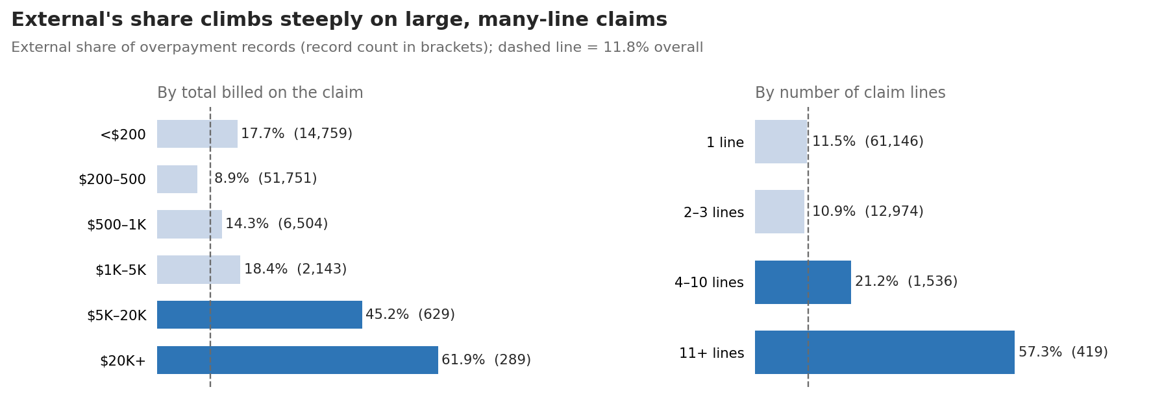
Source: Cell 7. External share by billed amount and by number of lines.
Observation The pattern is U-shaped by bill size: External is above average on very small bills (17.7% under $200), below on the typical $200–500 visit (8.9%), and dominant on large bills (45–62%). Interpretation Small bills are likely COB and eligibility cases; large bills are facility stays.

Setting
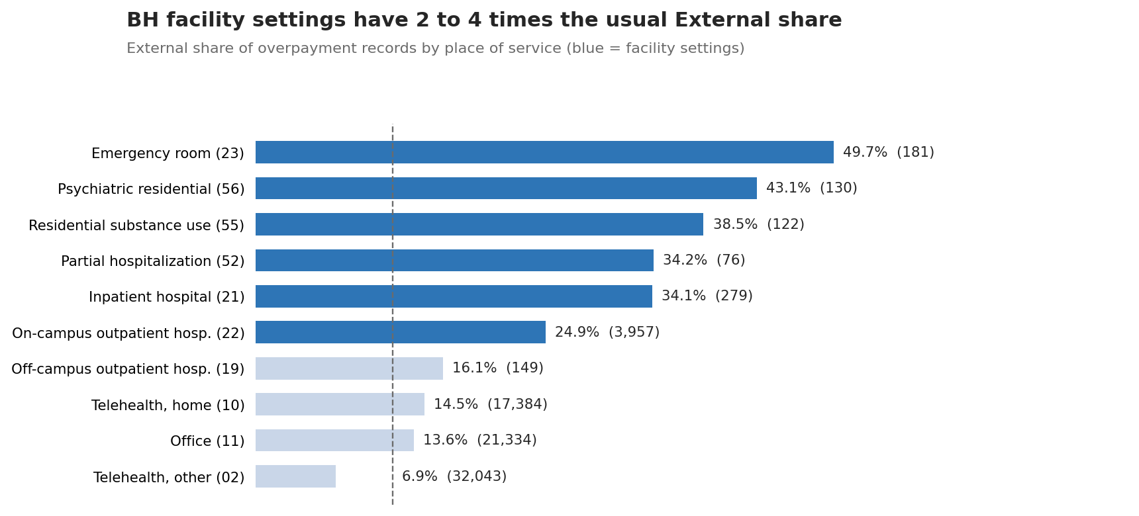
Source: Cells 3 and 7. External share by place of service; record counts in brackets.
Setting group | Records | External share | Overpaid $ | External share of $
Facility claims | 4,244 | 28.5% | $4.27M | 28.2%
Professional claims | 71,831 | 10.9% | $8.90M | 12.5%

Observation 52% of External's dollars come from facility claims against 28% of Internal's. Within each setting the average External and Internal overpayment is similar (for example office $177 vs $158, inpatient $1,489 vs $1,828). Interpretation External's higher average is a mix effect: it works more expensive claim types rather than finding bigger errors on the same claim.
Observation Telehealth modifiers sit below average: GT 8.9% and 95 11.0% External, against 16.9% where no modifier is recorded.

Provider, state and code
Group | Records | External share | Excess External records*
Provider type SA (facility) | 338 | 55.0% | +146
Provider type RTF | 312 | 40.4% | +89
Provider type PD | 353 | 32.9% | +74
Provider type PSH | 421 | 29.5% | +74
Provider type HO | 1,737 | 22.9% | +191
Provider type LPC | 9,948 | 15.9% | +404
Provider type SW | 9,479 | 15.7% | +364
Member state WI | 224 | 38.8% | +60
Member state MN | 608 | 22.4% | +64
Member state MA | 2,067 | 19.8% | +164
Member state CA | 10,613 | 15.4% | +375
Diagnosis F1020 (alcohol dependence) | 970 | 29.9% | +175
Diagnosis F4310 (PTSD) | 1,906 | 18.5% | +127
CPT 90791 (diagnostic evaluation) | 3,104 | 19.0% | +223

* External records above what 11.8% would predict. This measures impact; the share measures strength.

Combinations
Combination | Records | External share | External $
Diagnosis F1020 + provider SA + facility | 200 | 63.0% | $132K
Facility claim + ER (POS 23) | 143 | 58.0% | $140K
Provider SA + facility | 336 | 55.4% | $199K
H0018 + facility | 234 | 54.3% | $236K
Rev 128 + facility | 268 | 52.6% | $184K
California + POS 22 + facility | 361 | 44.3% | $204K
Rev 900 + facility | 380 | 42.9% | $72K
Provider RTF + facility | 312 | 40.4% | $159K
Diagnosis F1020 + facility | 699 | 37.8% | $219K
CPT 90791 + telehealth home (POS 10) | 818 | 34.8% | $36K
POS 22 + facility (largest by dollars) | 3,567 | 25.3% | $659K
Provider HO + facility | 1,734 | 22.8% | $444K

Decision tree check
Observation A depth-5 tree on claim features only (reason and business area excluded) ranked TIN first (importance 0.43), then billed band (0.12), member state (0.11), claim type (0.09) and provider type (0.07). Revenue code scored 0. The most External-heavy leaf was facility claims outside NY with 11+ lines: 344 records, 65.4% External, $332K. Facility claims outside NY with fewer lines, excluding hospital (HO) providers, held 1,580 records at 40.3%.
Interpretation TIN ranks first mainly because a few high-volume providers are almost entirely Internal, for example one leaf of 10,157 records with 0.2% External. The tree was fitted on all records with no hold-out, so it describes the data rather than predicting.

Timing
Days from processing to validation | 25th pct | Median | 75th pct | 90th pct
Internal | 30 | 63 | 143 | 441
External | 34 | 72 | 149 | 261

Observation Both teams validate on a similar timeline. Internal has a longer tail, so it is not true that External always comes later.
Every relationship in this section is an association. None shows that a claim feature causes an overpayment or causes Internal to miss one.

6. Overpayment-focused analysis

Overall rates
Measure | Definition | Value
Claim overpayment rate | Overpaid claims ÷ claims processed | 75,396 ÷ 5,008,274 = 1.51%
Leakage rate | Overpaid $ ÷ paid $ | $13.17M ÷ $806.51M = 1.6%
Recovery rate (claims) | Claims whose largest record is Recovered ÷ overpaid claims | 68,541 ÷ 75,396 = 91%
Recovery rate (dollars) | (Amount − remaining) ÷ amount | $11.83M ÷ $13.17M = 90%

Trend
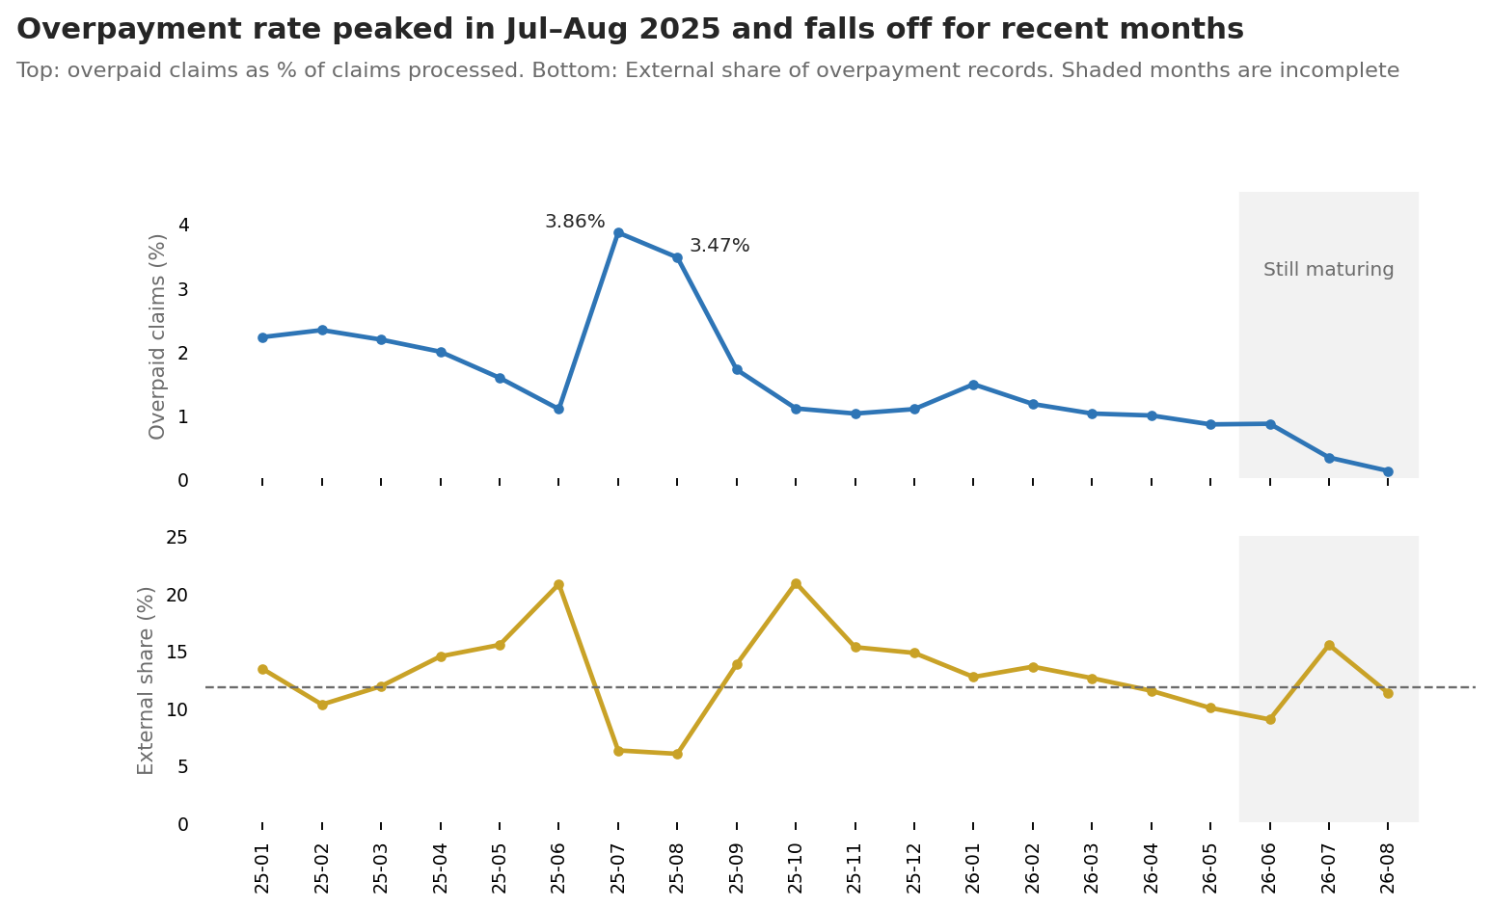
Source: Cells 3 and 4. Monthly overpayment rate and External share, by processing month.
Observation The rate ran at about 2.0–2.3% in early 2025, spiked to 3.86% and 3.47% in July–August 2025, and settled near 1.0–1.5%. The spike is Internal: Internal-only claims jumped to 8,294 and 9,350 in those months, against 2,000–4,700 in other months, which pushed External's share down to 6%.
Hypothesis The July–August 2025 spike is a one-off Internal project or batch of small automated recoveries. Checking whether those records belong to PIN 0006402711 or NCO OA OPT ADMIN would confirm or rule this out.

What External finds
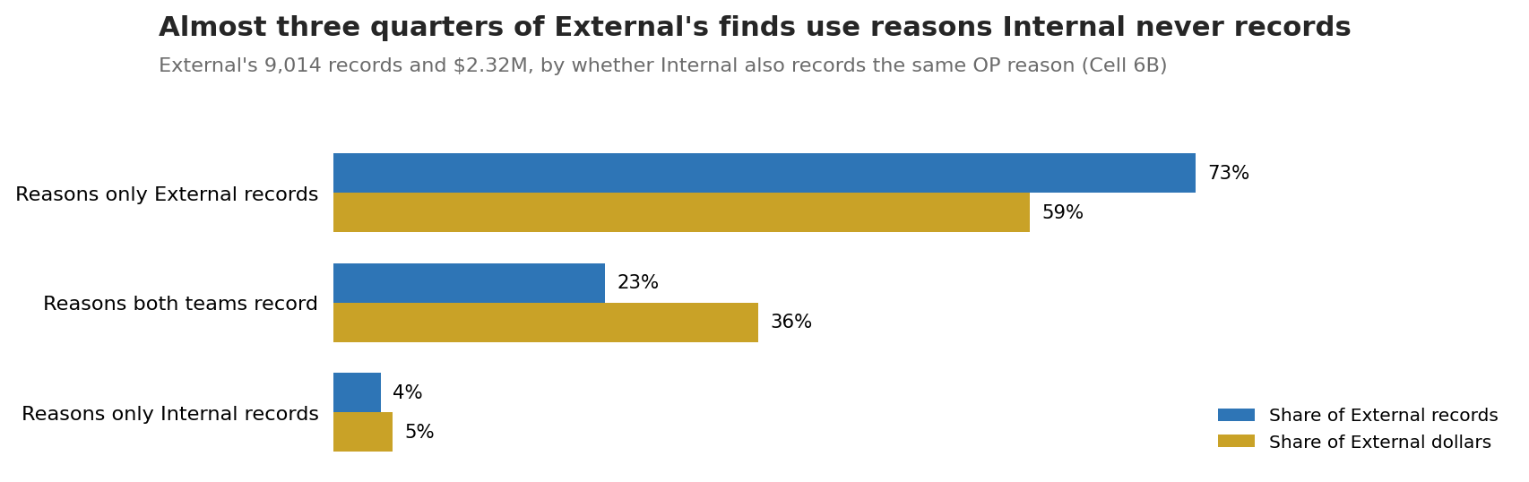
Source: Cell 6B. External records and dollars by reason type.
External reason | Records | % of External records | Overpaid $ | Recovered
Investigation/OBD – Commercial OBD Error | 4,279 | 47.5% | $840K | 75%
Subrogation – Non-Provider | 1,150 | 12.8% | $174K | 35%
No Overpayment | 661 | 7.3% | $38K | 36%
No Aetna Coverage (ACAS/ASH/MDCR only) | 432 | 4.8% | $79K | 66%
Incorrect Per Diem Rate | 367 | 4.1% | $323K | 75%
Number of Services | 276 | 3.1% | $51K | 96%
Retro Term | 264 | 2.9% | $43K | 88%
Incorrect procedure code | 192 | 2.1% | $91K | 47%

Observation Pareto: the top two reasons are 60% of External records, and the top five are 76%. By dollars, commercial OBD, per diem and subrogation make up 58%.

Where both teams record the same category
Reason category | External records | Internal records | External $ | Internal $ | External share of $
COB – Commercial Not Known | 4,234 | 4,499 | $852K | $631K | 57%
Contract – Administration | 426 | 10,145 | $345K | $339K | 50%
Provider Billing Error | 615 | 2,243 | $224K | $719K | 24%
Eligibility | 433 | 1,026 | $79K | $164K | 33%
Policy – Auth/CXT | 126 | 530 | $80K | $242K | 25%

Observation In Contract – Administration, External's average record is $810 against Internal's $33. Most of that gap appears to come from per diem errors: 438 records, $452K, 83.8% found by External. Contract financial comments are found by External 97.9% of the time (48 records, $105K).
Observation Commercial COB is split roughly evenly between the teams, but they record it under different reasons. In the state view, COB is especially External-heavy in Texas (79%), Maryland (72%) and Virginia (66%), and largest in California (958 External records, $249K).

Recovery
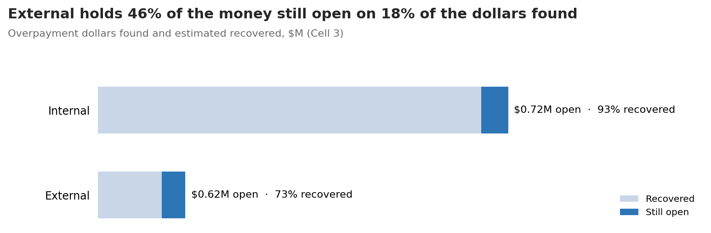
Source: Cell 3. Overpaid dollars found and estimated recovered, by team.
Status | External records | External $ | Internal records | Internal $
Recovered | 5,642 | $1.59M | 63,423 | $10.06M
Awaiting Recovery | 1,502 | $474K | 2,119 | $606K
Pended | 528 | $159K | 430 | $153K
Closed | 1,342 | $94K | 1,089 | $27K

Observation External recovery is lowest for subrogation (35%), workers' compensation (35%) and incorrect procedure code (47%), and in Georgia (45%), Texas (58%) and Maryland (62%). Internal recovers 88–99% in every top state. External facility recovery is 72% vs Internal 87%.

Claims worked by both teams
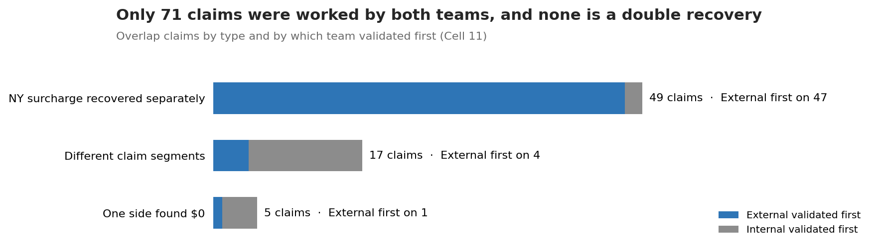
Source: Cell 11. Overlap claims by type.
- Observation 71 claims (0.1% of overpaid claims) have both an Internal and an External record. None has the same reason and the same amount on the same segment, and none has Internal plus External above what the claim paid.
- Observation 49 are New York claims where External recovers from the provider and Internal separately recovers the NY surcharge (NYHCRA constituent). Internal's amount is about 11% of External's, and External validated first on 47 of 49.
- Observation 17 are different segments of the same claim (rework or a new version), 115 days apart at the median. 5 have one side at $0.
- Interpretation Overlap is not a duplicate-recovery risk in this period.

7. Behavioral health-specific analysis
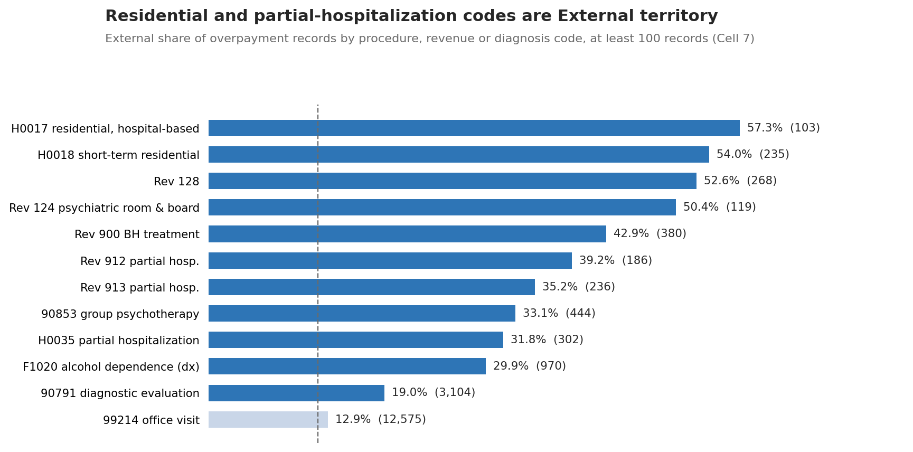
Source: Cell 7. External share by BH procedure, revenue and diagnosis codes with at least 100 records.
- Observation Residential care. H0017 (residential, hospital-based) 57.3% External and H0018 (short-term residential) 54.0%. Psychiatric residential (POS 56) is 43.1% and residential substance use (POS 55) 38.5%. Together H0017, H0018 and H0035 carry 640 records and $1.58M.
- Observation Partial hospitalization and intensive programs. H0035 31.8%, revenue codes 912 and 913 at 39.2% and 35.2%, POS 52 at 34.2%.
- Observation Room and board. Revenue code 124 (psychiatric) 50.4% and 128 52.6%, with $166K and $184K of External dollars.
- Observation Substance use. Alcohol dependence (F1020) is the most External-heavy common diagnosis: 970 records, 29.9% External, $225K External. With provider type SA on a facility claim it reaches 63%.
- Observation Outpatient therapy. Diagnostic evaluations (90791) are 19.0% External, rising to 34.8% in home telehealth. Routine psychotherapy and E/M visits (90834, 99214) sit close to average.
- Observation Telehealth. POS 02 and 10 hold 49,427 records (65%); External finds 9.5% of them.
- Hypothesis Residential and partial-hospitalization claims are paid per diem under facility contracts, and Internal checks do not compare the paid daily rate or room-and-board lines with the contract. Reviewing a sample of the 367 External per diem records against contract terms would test this.
- Units, session frequency, length of stay and overlapping dates: not available in the provided EDA outputs.
Treat these as areas to investigate. Each needs checking against the provider contract, coding rules and benefit policy before it is called a billing issue.

8. Key findings and evidence
Finding | Supporting evidence | Financial impact | Claim volume | Business significance | Confidence / limitation
External finds 11.8% of records but 17.6% of dollars | Cell 3 team split | $2.32M External of $13.17M | 8,883 claims | External's work is higher value per case | High
Most External work uses reasons Internal never records | Cell 6B: 73% of External records, 59% of $ | $1.36M | 6,570 records | These require outside data or new Internal capability | Medium: reason labels differ by team for the same COB issue
Commercial COB is External's largest area | Commercial OBD Error 4,279 records, 99.8% External; category split ~50/50 | $852K External | 4,213 claims | Biggest single area to bring in-house | High for size; data source behind External's finds unknown
Complex and facility claims are External-heavy | $20K+ 61.9%, 11+ lines 57.3%, facility 28.5% | Facility $4.27M; External $1.20M | 4,244 facility records | Internal coverage is thinnest on high-value claims | High
BH residential and partial-hospitalization codes are External territory | H0017 57%, H0018 54%, rev 124/128 50–53%, POS 55/56 39–43% | $1.58M on H0017/H0018/H0035 | 640 records | Clear, codeable target for an Internal check | Medium: small counts per code
Per diem and contract comments are found almost only by External | Per diem 83.8%, contract comments 97.9% | $452K + $105K | 486 records | Contract rules Internal can learn | High for counts; cause untested
External recovers less | 73% vs 93%; subrogation 35%; GA 45% | $619K External open | 2,030 awaiting or pended records | Money found is not yet money returned | High; Closed counted as recovered
Overlap carries no double-recovery risk | Cell 11: 0 same-issue duplicates, 0 over-paid claims | $43K Internal + $71K External | 71 claims | No action beyond monitoring NY surcharge pairs | High
Rates for recent months are understated | Aug 2026 OP rate 0.12% vs ~1% norm; validation tail of 441 days | — | Jun–Aug 2026 | Trends and labels must allow for maturity | High

9. Recommended visualizations
Charts 1–7 in this report are built from the current outputs. Before reusing the notebook's own charts, compute their titles from the data (Cell 10 titles are out of date). These would add the most next:
- Histogram and box plot of overpayment amount on a log scale, by team.
- Pareto curves of overpaid dollars by reason and by TIN, with and without PIN 0006402711.
- Heatmap of External share by reason category and place of service.
- Scatter of claim volume against overpayment rate by provider, sized by dollars (needs all-claim denominators per provider).
- Recovery curve: share of dollars recovered by days since validation, by team.

10. Limitations and further investigation
Confirmed in the data | Hypothesis to test
73% of External records use reasons Internal never records | External uses outside data, such as commercial coverage files (a business area code contains "CAQH") and accident claims, that Internal does not have
External's share is 28.5% on facility claims and 54–57% on residential codes | Internal edits target professional claims and do not apply facility contract terms
External finds 83.8% of per diem errors | Internal has no automated comparison of paid per diem with contracted per diem
Internal records spiked in Jul–Aug 2025 | A one-off Internal project or bulk small recoveries, possibly PIN 0006402711
External recovers 73% vs Internal 93% | Third-party cases are slower to collect, or vendor follow-up differs by state

- Workflow bias: claims reach External after Internal, so External only sees what Internal left. External's share is partly built into the process.
- Exposure: External share compares overpayment records only. Rates against all claims exist only at the total and monthly level and for revenue code 450.
- Attribution: using the highest-charge line can hide the line that was actually overpaid.
- Missing data: allowed amount, units, length of stay, contract terms and column-level quality checks.
- Small groups: several BH settings and codes have 100–300 records, so their shares can move with a few cases.

11. Next steps toward machine learning
- Business objective. Let Internal catch, before External does, the overpayments External catches today.
- Target. Option A: among claims that passed Internal review, "an External overpayment was later validated". Option B, broader: "claim overpaid" across all 5.0M claims. Option A matches the objective; option B needs all-claim features, not just overpaid records.
- Labels and imbalance. Positives for option A are about 8,900 claims out of millions reviewed (well under 1%). Only use processing months old enough for labels to mature, for example up to February 2026, and confirm that a claim with no External record was actually eligible for vendor review.
- Features. Claim type, place of service, procedure and revenue codes, diagnosis, provider type and specialty, member and service state, billed amount, number of lines, modifiers, plus engineered flags for residential and partial-hospitalization codes and per diem contracts. Add other-coverage indicators if they can be sourced.
- Leakage. Exclude OP reason and category, business area, status, lifecycle, concept, bucket, validation dates, recovery amounts and anything recorded after payment. Treat TIN with care: it fits the training data well but may not carry over to new providers.
- Validation. Train on earlier processing months and test on later ones. Report results by setting and claim type, not just overall.
- Models. Start with a rules baseline (facility + residential or PHP code + billed over $5K), then logistic regression, then gradient-boosted trees.
- Evaluation. PR-AUC, precision and recall at the review capacity, calibration, and overpaid dollars found per 100 claims reviewed.
- Threshold. Set from the number of claims reviewers can work and the cost of a missed overpayment versus a wasted review.
- Use. The model ranks claims for Internal review; auditors confirm every overpayment before recovery.
No model has been trained, so there is no evidence yet of how well one would work.

Management summary

Answers to the three questions
Question | Answer
What does the BH claims dataset tell us? | 5.0M claims, $806.5M paid, 1.51% of claims overpaid, $13.17M overpaid and 90% recovered. Internal finds 88% of records; External finds the rest.
What patterns and financial risks are visible? | External concentrates on other-coverage, subrogation and complex facility claims, especially residential and partial hospitalization, and holds 46% of the unrecovered money.
What should we investigate before building a model? | Data maturity, the PIN 0006402711 records, reason-label mapping, Closed-status recovery, and a contract review of External's per diem finds.

Five evidence-backed findings
- External finds 11.8% of overpayment records but 17.6% of the dollars and 46% of the money still open.
- 73% of External records use reasons Internal never records, led by commercial COB investigations (4,279) and subrogation (1,150).
- External's share rises to 28.5% on facility claims, 57–62% on large or many-line claims, and 54–57% on residential codes H0017 and H0018.
- In contract administration External finds half the dollars with 4% of the records; per diem errors are $452K, 84% External.
- External recovers 73% of what it finds against Internal's 93%, with subrogation at 35% and $633K awaiting or pended.

Prioritized action plan
Priority | Action | Owner | Money in scope
1 | Fix the data issues in Section 3: maturity cut-off, PIN 0006402711 check, Closed vs Recovered, $0 records, notebook chart titles | Analytics | Foundation for all figures
2 | Work down External's awaiting and pended backlog, largest first, starting with subrogation | Recovery team with vendors | $633K
3 | Review External per diem and contract-comment finds against facility contracts, then design an Internal check for residential and PHP claims (H0017, H0018, H0035, rev 124/128/912/913, POS 52/55/56) | Analytics with contract set-up | $557K found; $1.58M on these codes
4 | Compare External's commercial COB process and data sources with Internal's "other carrier" process | Internal COB team | $852K External COB
5 | Agree a common issue taxonomy so both teams' reasons can be compared | Business owners | —
6 | Agree the model target, label window and review capacity before training | Analytics and business owner | —

Terms used in this report
Term | Meaning
Overpayment record | One OP_Id: one overpayment found on a claim. A claim can have several.
Internal / External | Our own review areas / outside vendors (Business Area Level 1 = "NCO OA External Supplier").
External share | External records ÷ all records in the group. 11.8% overall.
Excess External records | External records above what 11.8% would predict for the group.
Leakage rate | Overpaid dollars ÷ paid dollars.
COB / OBD | Coordination of benefits / other benefits: another plan should have paid first.
Subrogation | Recovering money from a third party, usually after an accident.
Per diem | A fixed daily payment set in a facility contract.
Place of service (POS) | 02/10 telehealth, 11 office, 21 inpatient, 22 on-campus outpatient hospital, 23 ER, 52 partial hospitalization, 55/56 residential treatment.
Mix effect | An overall average that differs because groups work different kinds of cases, not because they differ within each kind.

Claim, provider and member details stay in the notebook files inside the approved environment.

