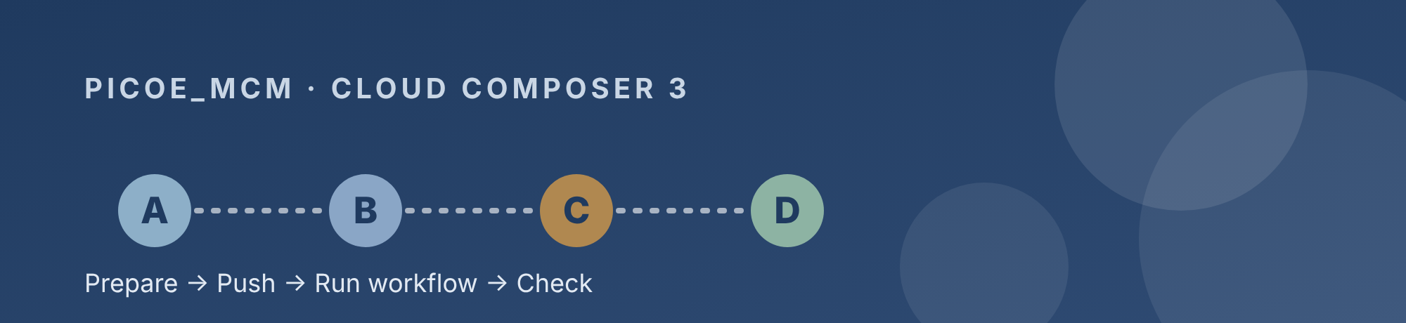

How to Add or Update a DAG
User and technical guide for the picoe_mcm repo on Cloud Composer 3
Repository | cvs-health-source-code/picoe_mcm
Composer 3 environment | hcb-prod-cmpsr3-04 (project edp-prod-hcb-cmpsr, region us-east4)
Main route | Vertex AI Workbench terminal (alternative: laptop, Git Bash)
Deploy branch | prod-unrestricted (see Open items)
Audience | Developers who add or change DAGs
Time needed | About 15 minutes once your setup is done
Date | October 23, 2026

The four parts
A  Prepare  Edit and test in Vertex AI | B  Push  Add, commit, push to GitHub | C  Run  Start the Composer CICD workflow | D  Check  Confirm it works in Airflow

Overview
This guide shows how to add or update a DAG in the picoe_mcm repo and get it running on Composer 3. It has four parts and takes about 15 minutes once your setup is done. The main route works entirely from Vertex AI Workbench; a laptop route is described near the end as an alternative.
- Part A: prepare the DAG file in Vertex AI Workbench
- Part B: push it to GitHub (add, commit, push)
- Part C: run the Composer CICD workflow
- Part D: check the DAG in Airflow
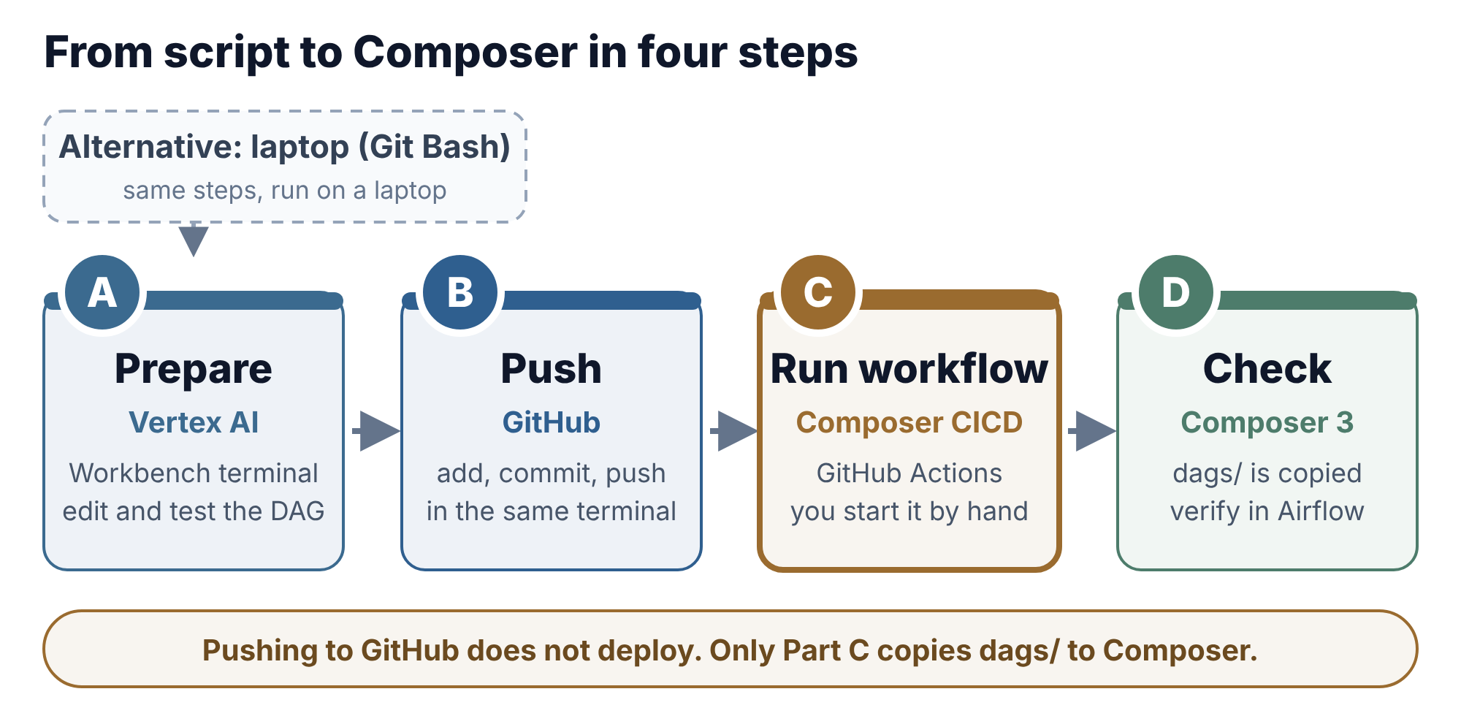
Figure 1. The DAG update flow. Main route: Vertex AI Workbench. Alternative: laptop.
Read the picture left to right: you edit and push from Vertex AI Workbench, start the workflow yourself, then check the DAG in Airflow.
Pushing does not deploy
A push only saves your code in GitHub. Nothing reaches Composer until someone runs the Composer CICD workflow by hand (Part C).

Before you start
You need five things in place once. After that, adding a DAG takes about 15 minutes.
- GitHub access: write access to cvs-health-source-code/picoe_mcm, and a saved git login on the Vertex machine so git push works (you already use this for add, commit, push).
- Vertex AI Workbench with JupyterLab and a terminal. This is the main route.
- Local clone of the repo at /home/jupyter/PICOE_MCM (see below).
- Airflow UI access for the Composer 3 environment hcb-prod-cmpsr3-04 (project edp-prod-hcb-cmpsr, region us-east4).
- Laptop with Git Bash (only for the alternative route).
One-time: clone the repo. Skip this if the folder already exists.
cd /home/jupyter
git clone https://github.com/cvs-health-source-code/picoe_mcm.git PICOE_MCM
cd PICOE_MCM
git remote -v

git remote -v must show cvs-health-source-code/picoe_mcm. If git asks for a login, use the saved GitHub credentials you already use for pushes.

Repo layout and DAG rules
Only the dags/ folder is deployed to Composer, so everything a DAG needs must live inside it.
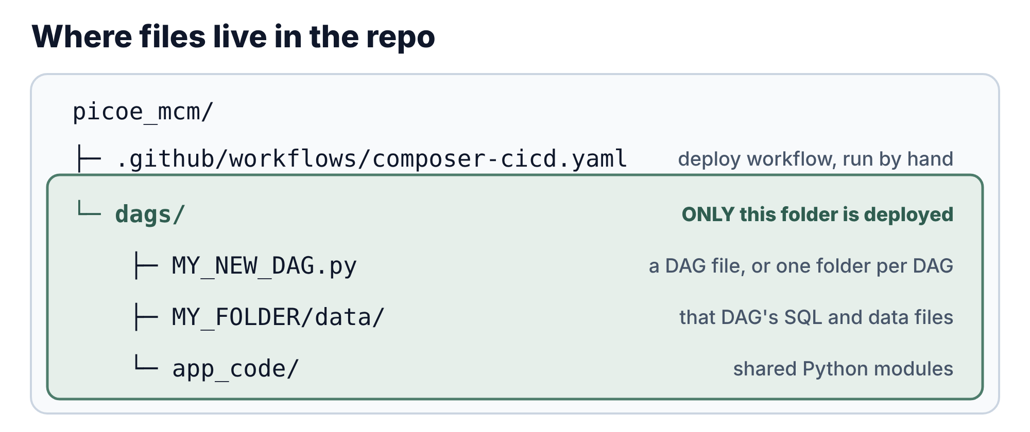
Figure 2. Only the dags/ folder is deployed
Follow these rules for every new or changed DAG. Each one comes from a real failure during the Composer 3 migration.
Rule | Why
Keep the DAG, its data and shared code under dags/ | Only dags/ deploys reliably; direct access to the Composer bucket is not allowed
Use a unique dag_id | Two DAGs with the same id show as one and confuse Airflow
Authenticate by impersonating the pipeline service account gchcbsvcopspiabconppp@edp-prod-serviceops.iam.gserviceaccount.com | The Composer worker account has minimal rights; the worker composer-wkr@edp-prod-hcb-cmpsr.iam.gserviceaccount.com must hold Token Creator on the pipeline account
Run BigQuery jobs in compute project edp-prod-svcops-piabrpt | The table project and the job project can differ; the job project needs bigquery.jobs.create
Do not use JSON key files | Impersonation replaces them
In PythonVirtualenvOperator, put imports and credentials inside the callable | Only the callable runs in the isolated venv; helper functions, module variables and airflow are not available there
Pin pandas<2.2 in venv requirements | pandas 3.x breaks pd.to_datetime(errors='ignore')
Send email with from airflow.utils.email import send_email | Direct smtplib to the mail server times out from Composer 3
Do not hardcode tokens or passwords | Use Secret Manager; the existing Quickbase token in the MCSP scripts is a known, approved exception
Do not commit copies such as -Copy1.py | Airflow parses every .py file in dags/

Part A | Prepare the DAG
Do these steps in the Vertex AI Workbench terminal (in JupyterLab: File, New, Terminal).
- Open the repo folder and get the latest code. Replace prod-unrestricted with the current deploy branch if it has changed (see Open items).
cd /home/jupyter/PICOE_MCM
git fetch origin
git checkout prod-unrestricted
git pull
git status

git status must say "working tree clean". If it lists changes you don't recognise, stop and ask before going on.
- Create the DAG file. New DAG: make a folder and put your script in it. Existing DAG: open its file and edit it. Use the JupyterLab file browser and editor, or the terminal.
mkdir -p dags/MY_FOLDER
nano dags/MY_FOLDER/MY_NEW_DAG.py

- Add data files, if the DAG reads any. Put SQL, CSV or text files in dags/MY_FOLDER/data/. Shared Python code goes in dags/app_code/.
- Optional: test the logic in a notebook first. In JupyterLab, try the code in a notebook before it goes into dags/. In a notebook, pass no command-line arguments to scripts that use argparse, or use parse_known_args().
- Check the file before you push. Run all four checks from the repo folder and compare each result with the notes below.
python -m py_compile dags/MY_FOLDER/MY_NEW_DAG.py
grep -rn 'dag_id="MY_NEW_DAG"' dags/
grep -rn "smtplib" dags/ --include="*.py"
grep -n -i -E "token|password|secret" dags/MY_FOLDER/MY_NEW_DAG.py

› Check 1 prints nothing when the file is valid. A syntax error is printed with its line number; fix it before going on.
› Check 2 must show one line, the new file. Two lines mean a duplicate dag_id.
› Check 3 must be empty, because email goes through send_email.
› Check 4 must show no real credentials. Variable names are fine; values are not.
- Confirm only your files changed.
git status

You should see only the DAG file and any data files as new or modified.

Part B | Push to GitHub (add, commit, push)
This is the ACP step: Add, Commit, Push. Run it in the same Vertex terminal, in the repo folder.
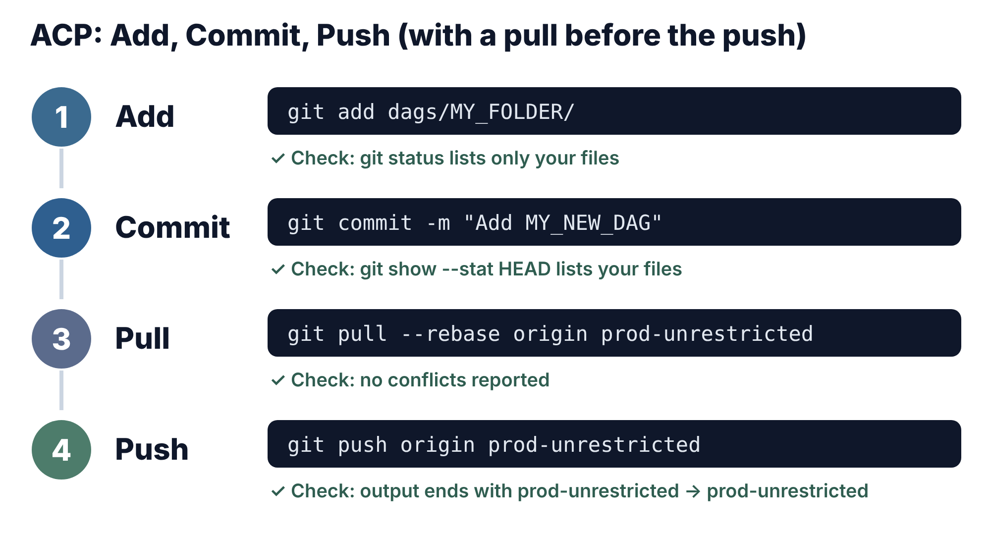
Figure 3. The ACP sequence
- Add only your files. Avoid git add ., which can pick up files you did not mean to include.
git add dags/MY_FOLDER/MY_NEW_DAG.py
git add dags/MY_FOLDER/data/
git status

git status should list your files under "Changes to be committed". A warning that LF will be replaced by CRLF is harmless.
- Commit with a clear message that says what changed and why.
git commit -m "Add MY_NEW_DAG: <one line on what it does>"
git show --stat HEAD

git show --stat HEAD must list your files. If it does not, the edit was not saved or not added; fix that before pushing.
- Pull teammates' latest changes. Others also push to this branch, and a push is rejected if you are behind.
git pull --rebase origin prod-unrestricted

- Push. Always name the branch, so the push cannot go somewhere else by accident.
git push origin prod-unrestricted

Success ends with a line like prod-unrestricted -> prod-unrestricted.
- Confirm on GitHub.
git log --oneline -3

Your commit should be the newest on the branch. You can also open the repo page in your browser to see it.
Git name and email
If git says your name and email were configured automatically, that is fine for work commits. To set them, run git config user.name "Your Name" and git config user.email "you@company.com".

Part C | Run the Composer CICD workflow
Pushing to GitHub does not deploy anything. The workflow Composer CICD runs only when someone starts it by hand, and it copies the dags/ folder to Composer. Route 1 works from any browser and is the one to use from Vertex. Route 2 is for a laptop.

Route 1: GitHub website
- Open https://github.com/cvs-health-source-code/picoe_mcm and click the Actions tab.
- In the left list, click Composer CICD.
- Click the Run workflow dropdown on the right.
- In Use workflow from, pick the branch you pushed to (prod-unrestricted).
- Click the green Run workflow button.
- Refresh the page after a few seconds. A new run appears at the top; click it.
- Watch the job. A green tick means the deploy finished; a red cross means it failed, so open the failed step and read the log.
No Run workflow button?
You do not have write access to the repo. Ask a repo admin.

Route 2: command line (laptop Git Bash)
gh workflow run "Composer CICD" --ref prod-unrestricted
gh run list --workflow "Composer CICD" --limit 3
gh run watch

gh run list shows the new run with its status. gh run watch lets you pick a run and follows it until it ends. Do not use Route 2 on Vertex: its gh is a different tool of the same name.
After the run
Note the run number (for example #158). It is the Run ID in the deployment summary report, together with the date, who ran it, the branch and the result.

Part D | Check the DAG in Airflow
A green workflow run only proves the files were copied. Confirm the DAG itself works.
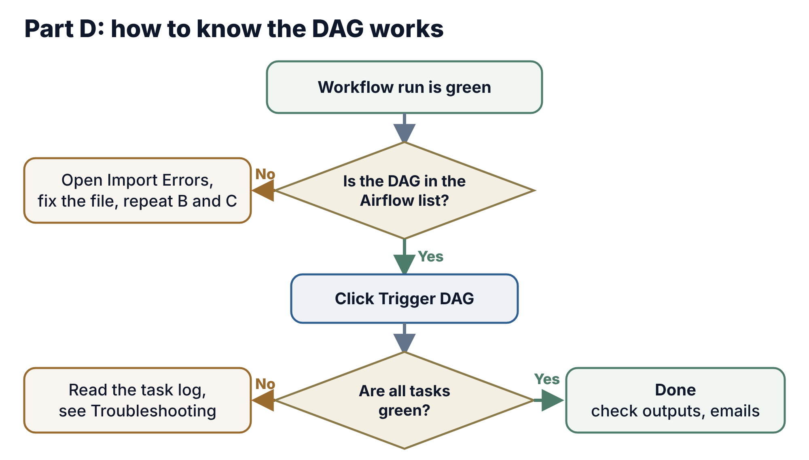
Figure 4. How to know the DAG works
- In the Google Cloud console open Composer, then Environments, then hcb-prod-cmpsr3-04 (project edp-prod-hcb-cmpsr, region us-east4), and click Airflow to open the Airflow UI.
- On the DAGs page, search for your dag_id. Allow a few minutes after the deploy for Airflow to read the new file.
- If the DAG is missing, look for a red DAG Import Errors banner at the top of the page and click it. It names the file and the line. Fix the file, then repeat Parts B and C.
- If the DAG is paused (the toggle on its row is grey), switch it on. Leave a manual-only DAG (schedule=None) unpaused so it can be triggered.
- Click the Trigger DAG play button on the right of the row to start a test run.
- Open the run in Grid view. Click a task square, then Logs, to read its output.
- Wait until every task is green.
First-run checklist for every new or changed DAG:
- DAG appears in the list with no import error
- A test run finishes with all tasks green
- Task logs show no 403, Access Denied or getAccessToken errors
- Output files, tables or emails arrive where expected
- The schedule shown on the DAG page is the one you intended

Troubleshooting
These are errors we hit during the Composer 3 migration. Find your message in the first column.
What you see | Likely cause | Fix
Broken DAG or SyntaxError in Import Errors | Typo or stray text in the file | Fix the line named; run python -m py_compile <file> before pushing
run_process() missing 1 required positional argument | A task still uses PythonOperator, or an argument is missing from op_kwargs | Use PythonVirtualenvOperator for all tasks and pass every argument in op_kwargs
NameError: name '<function>' is not defined in a venv task | Helper function sits outside the callable, so it is not shipped into the venv | Move the helper code and imports inside the callable
AssertionError at pd.to_datetime(errors='ignore') | pandas 3.x in the venv | Add "pandas<2.2" to the venv requirements
iam.serviceAccounts.getAccessToken denied | Pipeline service account name has a typo, or the worker lacks Token Creator on it | Copy the exact name from the rules section; ask the platform team for roles/iam.serviceAccountTokenCreator
404 Account disabled for a service account | Wrong or inactive account name | Confirm the account name with the team
403 bigquery.jobs.create | Query job is running in a project where you cannot create jobs | Set the BigQuery client project to edp-prod-svcops-piabrpt
403 Access Denied reading a table or view | The pipeline account has no data access | Request "Dataset and Policy Access" in DataPortal for that account and view
[Errno 110] Connection timed out sending email | Direct smtplib is blocked from Composer 3 | Use from airflow.utils.email import send_email
git push rejected, "fetch first" or "non-fast-forward" | A teammate pushed first | git pull --rebase origin prod-unrestricted, then push again
Commit made but the change is missing | File was not saved or not added | git show --stat HEAD; save, git add and git commit --amend before pushing
DAG not in Airflow after a green run | Import error, or the file is not under dags/ | Open the Import Errors banner; check the file path
gh api fails with "unrecognized arguments" | Wrong gh: Vertex AI Workbench has a different tool of the same name | Run gh commands in Git Bash on a laptop, or start the workflow from the GitHub website
A file is broken after pasting a long block into the terminal | Terminal paste cut or mixed the text | Create files in the JupyterLab editor or VS Code and paste there
git push asks for a password or says authentication failed on Vertex | The saved git login on the Vertex machine is missing or expired | Sign in to git again the way you did before, or push from a laptop (alternative route)

Alternative route: laptop (Git Bash)
Use this if Vertex AI Workbench is unavailable. The steps in Parts A to D stay the same; only where you run them changes.
- Clone the repo on the laptop, once. Keep it outside OneDrive, because OneDrive syncing slows git down.
mkdir -p /c/Users/<your-id>/repos
cd /c/Users/<your-id>/repos
git clone https://github.com/cvs-health-source-code/picoe_mcm.git
cd picoe_mcm
git remote -v

- Get your DAG files into the laptop clone. Either write them there, or zip them in Vertex and download the zip (JupyterLab file browser, right-click, Download), then unzip it in the clone.
# in the Vertex terminal
cd /home/jupyter/PICOE_MCM
zip -r ~/my_dag.zip dags/MY_FOLDER -x "*__pycache__*"

# in Git Bash on the laptop
cd /c/Users/<your-id>/repos/picoe_mcm
unzip -o /c/Users/<your-id>/Downloads/my_dag.zip
git status

- Continue with the same steps. Run the four checks (Part A step 5), then add, commit, pull and push (Part B). Start the workflow from the GitHub website or with gh in Git Bash (Part C), then verify in Airflow (Part D).

Rollback, quick reference and open items

Roll back a bad change
Revert the commit with git, then redeploy. Never force-push.
git log --oneline -5
git revert <bad-commit-id>
git push origin prod-unrestricted
# then run Composer CICD from the GitHub Actions tab (Part C)

git revert adds a new commit that undoes the bad one, so history stays intact. Then check the DAG again in Airflow (Part D).

Quick reference: update or add a DAG
cd /home/jupyter/PICOE_MCM
git fetch origin && git checkout prod-unrestricted && git pull
# edit or add files under dags/
python -m py_compile dags/MY_FOLDER/MY_NEW_DAG.py
git add dags/MY_FOLDER/
git commit -m "Add MY_NEW_DAG: <what it does>"
git pull --rebase origin prod-unrestricted
git push origin prod-unrestricted
# then run Composer CICD from the GitHub Actions tab (Part C)

Open items to confirm
These are not settled yet, so check them before relying on this guide for them.
- Deploy branch: this guide uses prod-unrestricted, where the deploys have run so far. main now holds the same code, minus three unused -Copy1.py files. Ask the platform team whether the shared workflow composer-dag-cicd.yaml@v5 picks its target by branch before you deploy from main.
- Snyk scan: not active yet. It will be a separate workflow that scans pull requests into main and never deploys. Add a note here when it is live.
- Vertex git login: this guide assumes git push already works from the Vertex machine. If your team has a standard way to sign in to git there, add it here.
- Hardcoded Quickbase token in the MCSP scripts: approved for now; move it to Secret Manager later.

