Q 1. What is hierarchical approach in naming? How look up request is performed to find a location in a hierarchically organized location service? Analyse with a necessary diagram.

**Ans.**

The hierarchical approach to naming involves a methodical approach to name resolution, organizing names into a tree-like structure where each level represents a more specific domain. This technique finds widespread use in systems such as file systems and domain name systems (DNS).

In a hierarchical naming system, names are composed of components separated by delimiters like slashes (/) or dots (.). Each component signifies a node within the hierarchy, progressing from the broadest to the most specific. For instance, in the domain name www.yahoo.com, ".com" denotes the top-level domain, "yahoo" represents a second-level domain, and "www" functions as a hostname.

Lookup Process in a Hierarchically Organized Location Service:

The lookup procedure in a hierarchical naming system involves descending the tree from the root, following the path indicated by the hierarchical name. Here’s a step-by-step outline of this process:

**Initiate at Root:** The resolution process commences at the root of the hierarchy.

**Traverse Downward:** The resolver dissects the name component by component, progressing down the hierarchy.

**Query Nodes:** At each node, a query is executed to locate the subsequent component (e.g., sub-domain, directory) along the path.

**Reach Target or Encounter Error:** The procedure persists until the target is located or an error arises (e.g., "name not found").

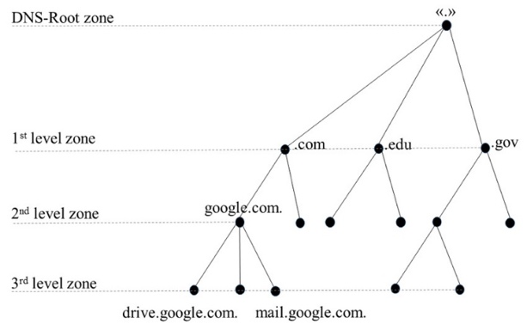

Q 2. What is a naming graph in structured naming? How namespaces are represented in naming graph? What is the role of path name in naming graph? Analyse each of the concepts with the help of appropriate figures.

**Ans.**

A naming graph within structured naming is a directed graph structure wherein nodes depict naming contexts such as directories or domains, while edges symbolize connections between these contexts. This graphical representation serves to elucidate the structure and resolution of names within a given system.

**Representation of Namespaces in a Naming Graph**:

Within a naming graph, namespaces are depicted as nodes, each node encapsulating a context where names can be designated. The connections (edges) between these nodes signify potential transitions from one namespace to another, facilitated by segments of a name.

**Role of Pathname in a Naming Graph**:

In the context of a naming graph, a pathname refers to a series of name components that delineate a path through the graph, typically originating from a root node and terminating at a target node. This pathname guides the navigation process throughout the naming graph, dictating which edges to traverse in order to resolve the complete name."

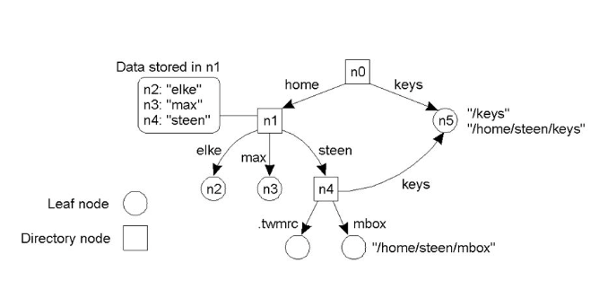

**Questions based on Self-Directed Learning (SDL) Component.**

The following research paper is assigned as SDL.

Wiangwiset T, Surawanitkun C, Wongsinlatam W, Remsungnen T, Siritaratiwat A, Srichan C, Thepparat P, Bunsuk W, Kaewchan A, Namvong A. ***Design and Implementation of a Real-Time Crowd Monitoring System Based on Public Wi-Fi Infrastructure: A Case Study on the Sri Chiang Mai Smart City***. Smart Cities. 2023; 6(2):987-1008. https://doi.org/10.3390/smartcities6020048

Q 3. Analyse the case study on the Sri Chiang Mai Smart City with the help of figure demonstrating the placement of public Wi-Fi hotspots.

**Ans.**

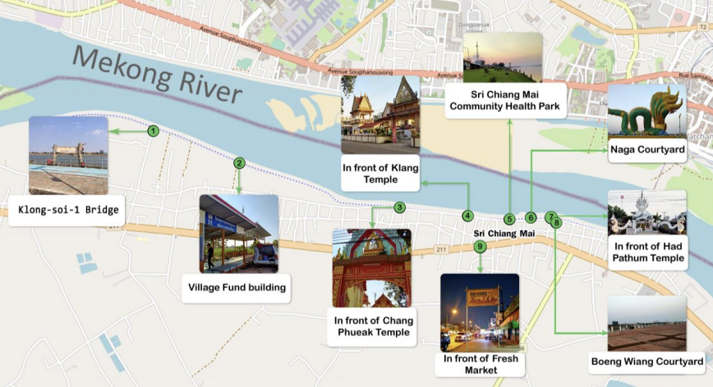

1. **Optimal Coverage Strategy:**

The Wi-Fi Access Points (APs) are strategically positioned along the Mekong River to cover key points of interest and public gathering areas. This placement maximizes coverage in high-density areas, facilitating effective crowd monitoring. For instance:

APs placed near the Klong-soi-1 Bridge, Village Fund building, and Fresh Market target community hubs.

Locations like in front of Chang Phueak Temple, Klang Temple, and Had Pathum Temple cater to religious and cultural gatherings.

1. **Data Collection for Crowd Monitoring:**

Each AP captures data from nearby devices, enabling the system to estimate crowd densities accurately. Precise latitude and longitude details aid in mapping crowd distribution and understanding urban behaviour patterns. This data is vital for real-time monitoring and historical analysis.

1. **Public Safety and Urban Planning:**

The AP locations help city administrators enhance public safety measures by identifying areas of congregation for better emergency planning. Allocating resources during high-attendance events or abnormal crowd behaviour situations becomes more effective.

1. **Infrastructure Evaluation and Expansion:**

Coordinates assist in evaluating existing infrastructure effectiveness and planning future expansions. They highlight signal strength weaknesses and coverage gaps, crucial for improving the Wi-Fi network's reliability and accuracy.

1. **Data Visualization and Community Engagement:**

Mapping technologies like Leaflet, integrated into the project's web application, enable the visualization of data on maps. This promotes transparency and informed decision-making among city planners and the public by presenting real-time or historical data in a geographical context.

1. **Urban Development Guidance:**

Analysing AP placement and usage data can inform future urban development, guiding decisions on infrastructure construction, service enhancement, and traffic management. This data-driven approach to urban planning optimizes resource allocation and enhances city liveability.

**Conclusion:**

The strategic placement of Wi-Fi hotspots in the Sri Chiang Mai Smart City project is fundamental for effective crowd monitoring. This setup not only ensures comprehensive coverage and data collection but also enhances the city’s capacity to manage urban dynamics proactively. Integrating this system with urban planning and safety protocols exemplifies a forward-thinking approach to city management, promoting efficiency and safety.

**Q 4**. Give an architecture of communication domain and show how data processing is done. What is the encryption process involved? Analyse with an example.

**Ans.**

**Architecture Overview:**

The Sri Chiang Mai Smart City real-time crowd monitoring system features a sophisticated three-tiered architecture that seamlessly integrates data acquisition, communication, and processing:

1. **Sensing Domain:**

Public Wi-Fi access points serve as sensors, detecting mobile devices by intercepting probe requests. Strategically distributed across nine locations, these APs form a robust network for data collection.

1. **Communication Domain:**

The Wi-Fi network is divided into nine subnetworks, each forming a virtual local area network (VLAN) for a corresponding hotspot station. Each VLAN connects to an Optical Line Terminal (OLT) via an Optical Network Unit (ONU), ensuring efficient data transfer to the central processing server.

1. **Computing Domain:**

Responsible for processing, visualization, and analysis of data. Encrypted data from APs undergo pre-processing to eliminate errors and transform into a structured format suitable for analysis. The data is then stored in a relational database for further processing and visualization.

**Data Processing and Encryption:**

* **Data processing involves several key steps:**
* **Data Collection:** Recording sensing data such as MAC addresses, detection times, and data collector identity.
* **Data Transmission**: Encrypting and transmitting data to the processing server. Encryption involves adding a 'pepper' to the MAC address and using SHA-256 hashing for privacy and security. HTTPS secures all transmissions.
* **Data Pre-processing and Storage:** Pre-processing data at the server to eliminate errors and format it appropriately for storage in a relational database, enabling real-time and historical analysis.
* **Analysis:** Processed data enables administrators to monitor crowd densities and movement patterns, providing insights for urban planning and crowd management, particularly relevant for maintaining social distancing protocols during events.

**Example of Application:**

The architecture supports Sri Chiang Mai Smart City's goal to enhance public safety and urban management. Encrypted and processed data analysis enables effective crowd density management across various locations. Real-time visualizations of crowd movements facilitate informed decisions, ensuring efficient urban space utilization and enhancing public safety.

**Conclusion:**

This integrated approach utilizes existing infrastructure while enhancing it with advanced data processing and encryption techniques, offering a comprehensive solution for real-time crowd monitoring and urban planning.

Q 5. Analyse data visualisation and data analysis in case of computing domain.

**Ans.**

**Data Visualization in the Computing Domain:**

Data visualization is pivotal within the computing domain, aimed at presenting real-time and historical data in an accessible manner. Key features of this system include:

* **Web Application Development:** A web application is designed to display the number of devices detected at each AP location, visualizing crowd densities on a map. This application employs PHP and the Express.js web framework for robust backend processing and dynamic data handling.
* **Mapping and Graphing Technologies**: Front-end visualization utilizes technologies like Leaflet for mapping and High charts for interactive line graphs depicting historical trends. This enables users to observe crowd movement and density changes over time.
* **Real-time and Historical Displays:** The visualization module not only presents current data but also stores and showcases historical data, facilitating long-term trend assessment and future predictions.

**Data Analysis in the Computing Domain:**

Data analysis utilizes advanced computational tools to derive meaningful insights:

* **Utilization of Colab**: Colab, a Jupyter notebook-based service, is extensively utilized for running Python scripts due to its ease of use, web browser accessibility, and provision of free computing resources, including GPUs. It is well-suited for complex data analysis, machine learning projects, and educational purposes.
* **Analysis Techniques:** The system examines the frequency and quantity of people at different times and locations to discern usage patterns and event impacts on crowd density, aiding understanding of city dynamics under various conditions.
* **Data-Driven Decision Making:** By correlating data with events and analysing usage patterns, the system furnishes vital information for city planners and policymakers. This includes optimizing AP placement and adjustments to improve crowd management strategies effectively.

**Applications of Visualization and Analysis:**

Combined capabilities of data visualization and analysis play a crucial role in urban planning and management:

* **Urban Planning Insights:** Insights gleaned aid urban planners in making informed decisions concerning infrastructure development and event management.
* **Strategic AP Management:** Analysis of crowd patterns helps determine optimal locations for new AP installations or adjustments to existing ones, ensuring efficient crowd management and bolstering public safety.
* **Policy Formulation:** The system's depiction of crowd behaviours and area usage supports policy formulation addressing urban challenges like overcrowding and traffic management, particularly during peak hours and special events.