1. Write a query to get a Product list (id, name, unit price) where current products cost less than $20.

Solution query:

Select * from products

SELECT ProductID, ProductName, UnitPrice

FROM Products

WHERE UnitPrive < 20 AND Discocntinued = ‘0’

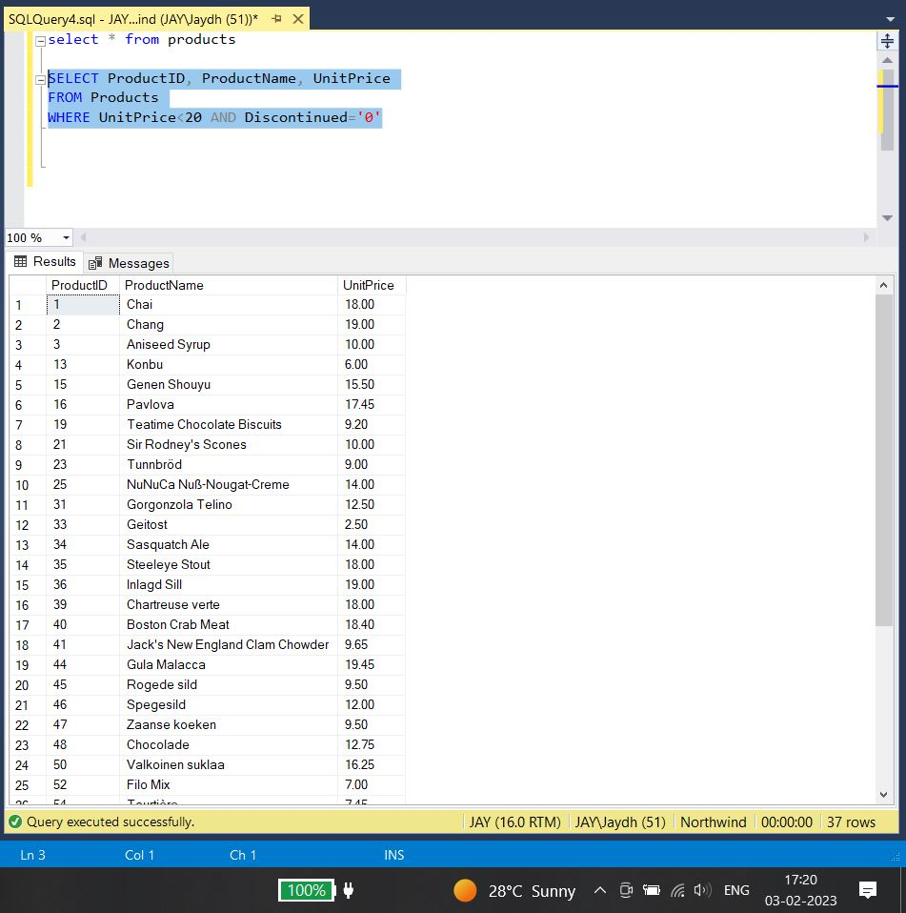

2. Write a query to get Product list (id, name, unit price) where products cost between $15 and $25

Query solution:

SELECT ProductID, ProductName, UnitPrice

FROM Products

WHERE UnitPrice > 15 AND UnitPrice < 25 AND Discontinued = ‘0’

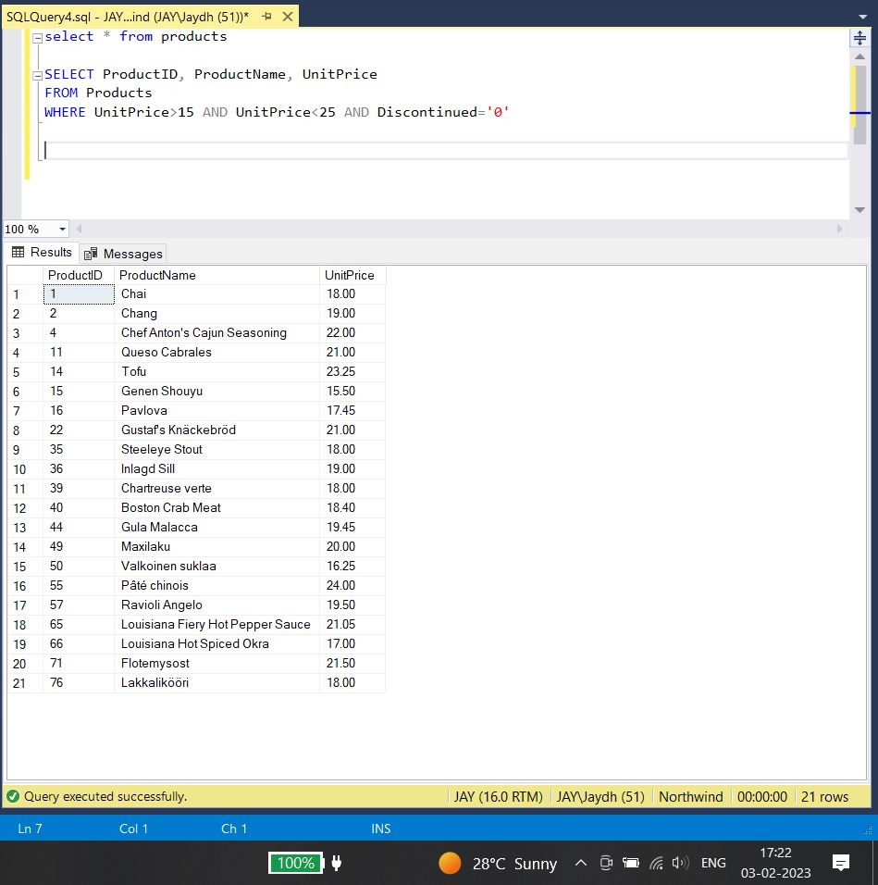

3. Write a query to get Product list (name, unit price) of above average price.

Query solution:

Declare @avg_price FLOAT;

Select @avg_price = avg (unitPrice) from Products;

Select productName, UnitPrice

From products

Where unitPrice > @avg_price

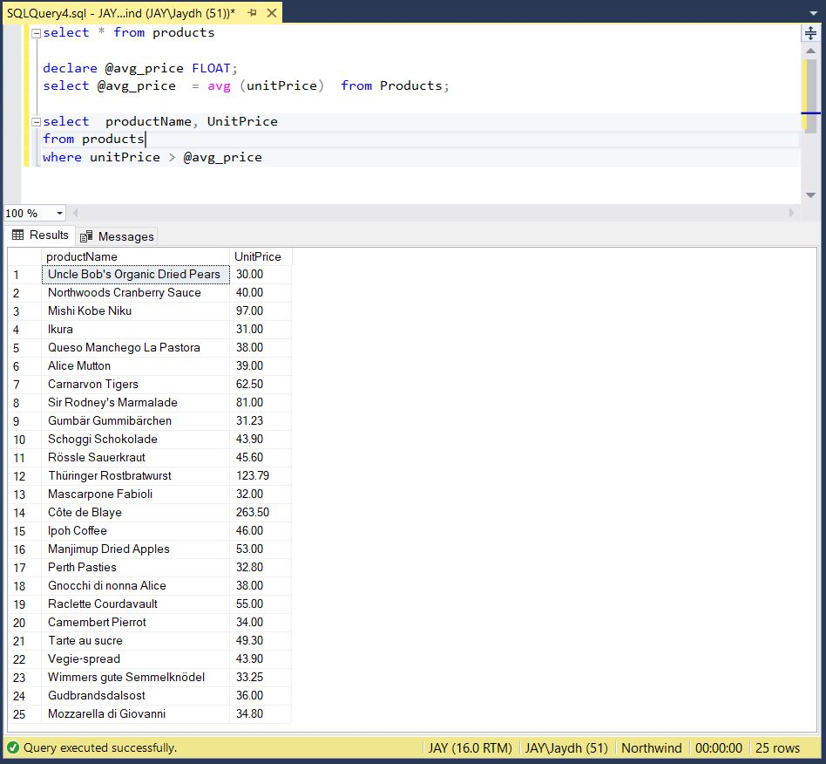

4. Write a query to get Product list (name, unit price) of ten most expensive products

Query solution:

Select ProductName, UnitPrice

FROM Products As a

WHERE 10 >= (SELECT COUNT(DISTINCT UnitPrice)

FROM Products AS b

WHERE b.UnitPrice >= a.UnitPrice)

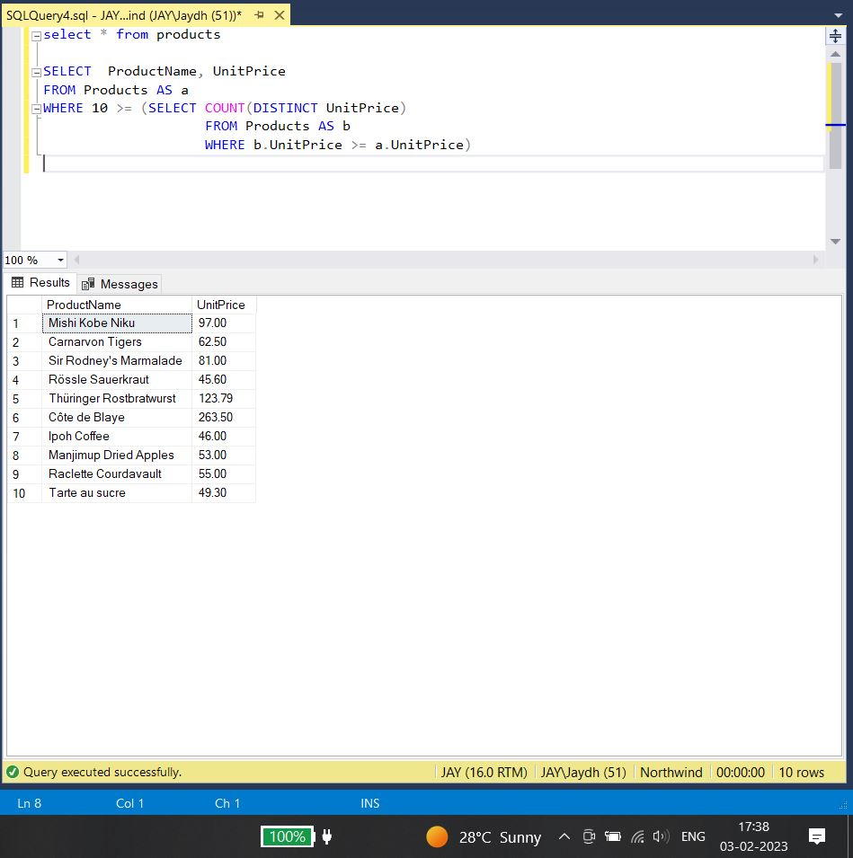

5. Write a query to count current and discontinued products

Query solution:

SELECT Count (ProductName)

FROM Products

Group BY Discontinued;

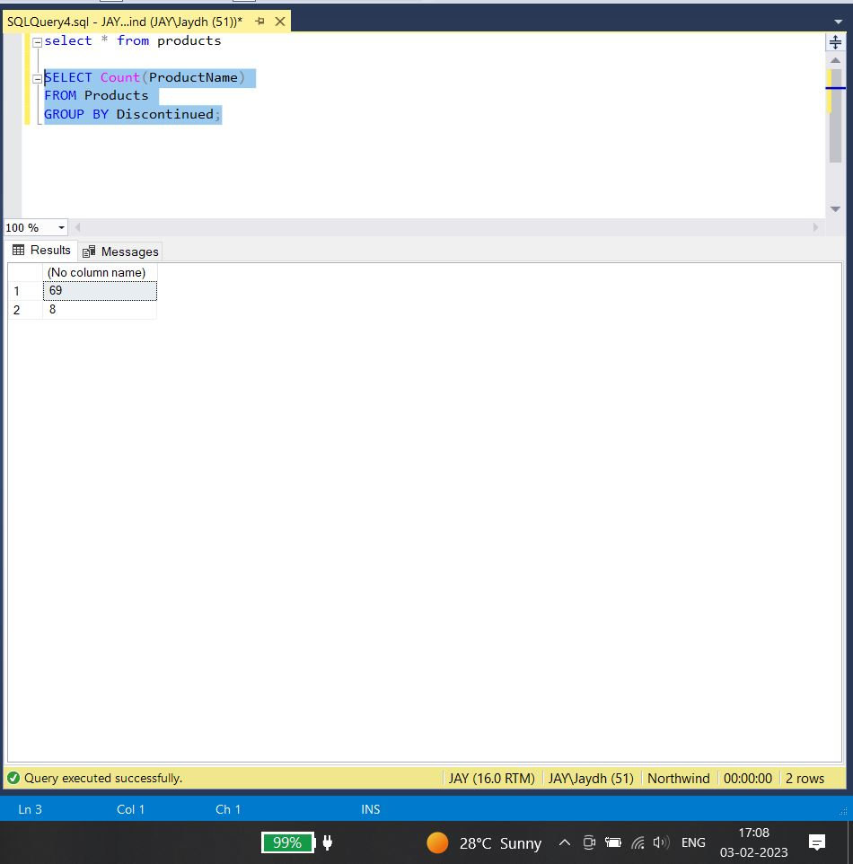

6. Write a query to get Product list (name, units on order , units in stock) of stock is less than the quantity on order.

Select ProductName, UnitOnOrder, UnitsInStock

From Products

Where Discontinued = ‘0’ AND UnitsInStock < UnitsOnOrder;

