Drowsiness Detection System

## A PROJECT REPORT

*Submitted by*

**Darshit Jakhaniya(190320107028)**

***In partial fulfilment for the award of degree***

***of Bachelor of Engineering in Computer Engineering***



## COMPUTER ENGINEERING DEPARTMENT

**L. J. INSTITUTE OF ENGINEERING AND TECHNOLOGY GUJARAT TECHNOLOGICAL UNIVERSITY**

## AHMEDABAD

**YEAR, 2022-23**

**L. J. INSTITUTE OF ENGINEERING AND TECHNOLOGY COMPUTER ENGINEERING DEPARTMENT**

**YEAR, 2022-23**



CERTIFICATE

This is to certify that the Project entitled **”Drowsiness Detection System”** submitted by **Darshit Jakhaniya(190320107028)**, towards the partial fulfilment of the requirements for the degree of Bachelor of Engineering in Computer Engineering of L.J. Institute of Engineering and Technology, Ahmedabad, under the Gujarat Technological University, Ahmedabad is the record of work carried out by her under my supervision and guidance. In my opinion, the submitted work has reached a level required for being accepted for examination. The results embodied in this project, to the best of my knowledge, haven’t been submitted to any other university or institution for award of any degree or diploma.

Prof. Bhumin Madaliya Prof. Shruti Raval

(Assistant Professor) (HOD-CE)

**Student’s Declaration**

I hereby declare that the Project Report titled“ Drowsiness Detection System” is a result of my own work and my indebtedness to other work publications, references, if any, have been duly acknowledged. If I am found guilty of copying from any other report or published information and showing as my original work, or extending plagiarism limit, I understand that I shall be liable and punishable by the university, which may include **Failing me** **in examination or any other punishment that university may deem fit.**

|  |  |  |
| --- | --- | --- |
| **Enrollment no.** | **Name** | **Signature** |
| **190320107028** | **Darshit Jakhaniya** |  |

Place: Ahmedabad Date: 09/07/22

Prof. Bhumin Madaliya

# Acknowledgement

I wish to express my heartfelt appreciation to all those who have contributed to this project, both explicitly and implicitly, without the co-operation of whom, it would not have been possible to complete this project.

I would like to thank our **H.O.D Prof. Shruti Raval** and **Prof. Bhumin Madaliya** for constantly guiding and showing me the correct path to reach towards our desired goal. Also, we thank them for sharing their experience, knowledge and valuable time with me and showing their concern in my project to make it better. I am grateful to my college **L.J. Institute of Engineering and Technology** for providing me all the required resources and a good working environment.

I also thank all the other faculties who directly or indirectly supported me in making this project successful by sharing their ideas and knowledge.

At last, I would like to thank my parents and friends who have directly or indirectly helped me in making the project work successful**.**

|  |  |
| --- | --- |
| Darshit Jakhaniya | 190320107028 |

# Abstract

Drowsiness detection System is most powerful technique decrease the accident on road. As we already know there are lots of accident are occurred due to Drowsiness of driver. Due to drowsiness Driver lost his control over the vehicle and will result in accident. So this is one Solution to prevent from this type of accident.

There is alarm system when drowsiness is detected. To complete the given task I created a ML program using pretrained model to detect the drowsiness of driver. First I captured frames from given video. Then on each frame i find landmarks near the both eyes using dlib + Python. Then I calculate the Eye Aspect Ratio (EAR) using central vertical distance to central horizontal distance. Here the distance is Euclidean distance. If EAR is < 0.26 then classify frame as driver is drowsy else not drowsy.

|  |  |  |
| --- | --- | --- |
| **Sr. No** | **Index** | **Page** |
| I | **Acknowledgement** | I |
| II | **Abstract** | II |
| III | **Table of Content** | III |
| IV | **List of Figures** | IV |
| V | **List of Abbreviation** | V |
| **Chapter 1** | **Introduction** | 1 |
| 1.1 | Introduction to System. | 1 |
| 1.2 | Limitation of Existing System. | 1 |
| 1.3 | Objective of the new system. | 1 |
| 1.4 | Problem definition. | 2 |
| **Chapter 2** | **Project Explanation** | 3 |
| 2.1 | Basic Understanding | 3 |
| 2.2 | What is ML | 5 |
| 2.3 | What is Dlib | 6 |
| 2.4 | What are the facial landmark | 8 |
| 2.5 | How to find Eye Aspect Ratio | 9 |
| 2.6 | Work on drowsiness Driver | 12 |
| 2.7 | Pros and Cons | 15 |
| **Chapter 3** | **System Design** | 16 |
| 3.1 | Use case Diagram | 16 |
| 3.2 | Dataflow Diagram | 17 |
| 3.3 | Algorithm | 19 |
| 3.4 | UML Diagram | 20 |
| **Chapter 4** | **Snapshot** | 21 |
| **Chapter 5** | **Conclusion** | 25 |
| **Chapter 6** | **Reference** | 26 |

|  |  |  |
| --- | --- | --- |
| **Sr. No** | **Figures** | **Page** |
| 1 | Basic | 3 |
| 2 | Face Landmark | 7 |
| 3 | EAR 1 | 9 |
| 4 | EAR 2 | 10 |
| 5 | No Drowsiness Face | 13 |
| 6 | Drowsiness Face | 14 |
| 7 | UseCase Diagram | 16 |
| 8 | Dataflow Diagram | 18 |
| 9 | Algorithm | 19 |
| 10 | UML Diagram | 20 |
| 11 | Snapshots | 21-24 |

**List of Abbreviation**

1. AI: Artificial Intelligence
2. ML: Machine Learning
3. CRRI: Central Road Research Institute
4. EAR: Eye Aspect Ratio

5 UML: Unified Modeling Language

# Chapter 1. Introduction

## Introduction to System

* Every year 1.35 million people lose their lives in road crashes, and an additional 20-50 million suffer non-fatal injuries, often resulting in long-term disabilities.

* In India alone 449,002 accidents took place in the country during the calendar year 2019 leading to 151,113 deaths and 451,361 injuries.

* A major cause for road accidents is drowsy and distracted driving. A study by the Central Road Research Institute (CRRI) says Exhausted drivers who doze off at the wheel are responsible for about 40% of road accidents

## Limitation of Existing System

* There are some Applications, which exists right now in the market. But there is lack of accuracy. That means they are enable to detect the drowsiness of the driver.
* In this type of application most important factor is accuracy. In my project there is no 100% accuracy but I tried my best to resolve it.

## Objective of the New System

**Asses Driving Behavior :**

• To understand the risks for the future, Platform Transforms the DATA, by assessing the events happened, decision made by Drivers to handle the event and behavior analysis of the drivers.

• high risk events listing managers will gain knowledge on driving anomalies like distractions, braking, collision warnings which will help them to reduce losses due to lack of visibility.

• Driver Detect, understand the context and generate driving assistance alerts to help Driver to be more attentive.

• IN-CABIN VOICE ALERTS FOR SAFE DRIVING Collision Alerts for safe distance at a speed to avoid sudden risks of collisions.

• CONTEXTUAL ALERTS WHEN DRIVERS ARE DISTRACTED Maintaining driver’s attentiveness is a key to safety. Drivers are prone to distractions by using phone, talking, fatigue. Understanding the surrounding of the vehicle from outside, drivers are alerted for focusing on the road for long-haul journeys. Typical alerts are,

1)Distraction

2)Drowsiness

3)Mobile phone usage

4)Driver Looking Up

5)Driver Looking Down

6)Driver Looking left

7) Driver Looking Right

## Problem Definition

* As we already know there are lots of accident are occurred due to Drowsiness of driver. Due to Drowsiness Driver lost his control over the vehicle and will result in accident.

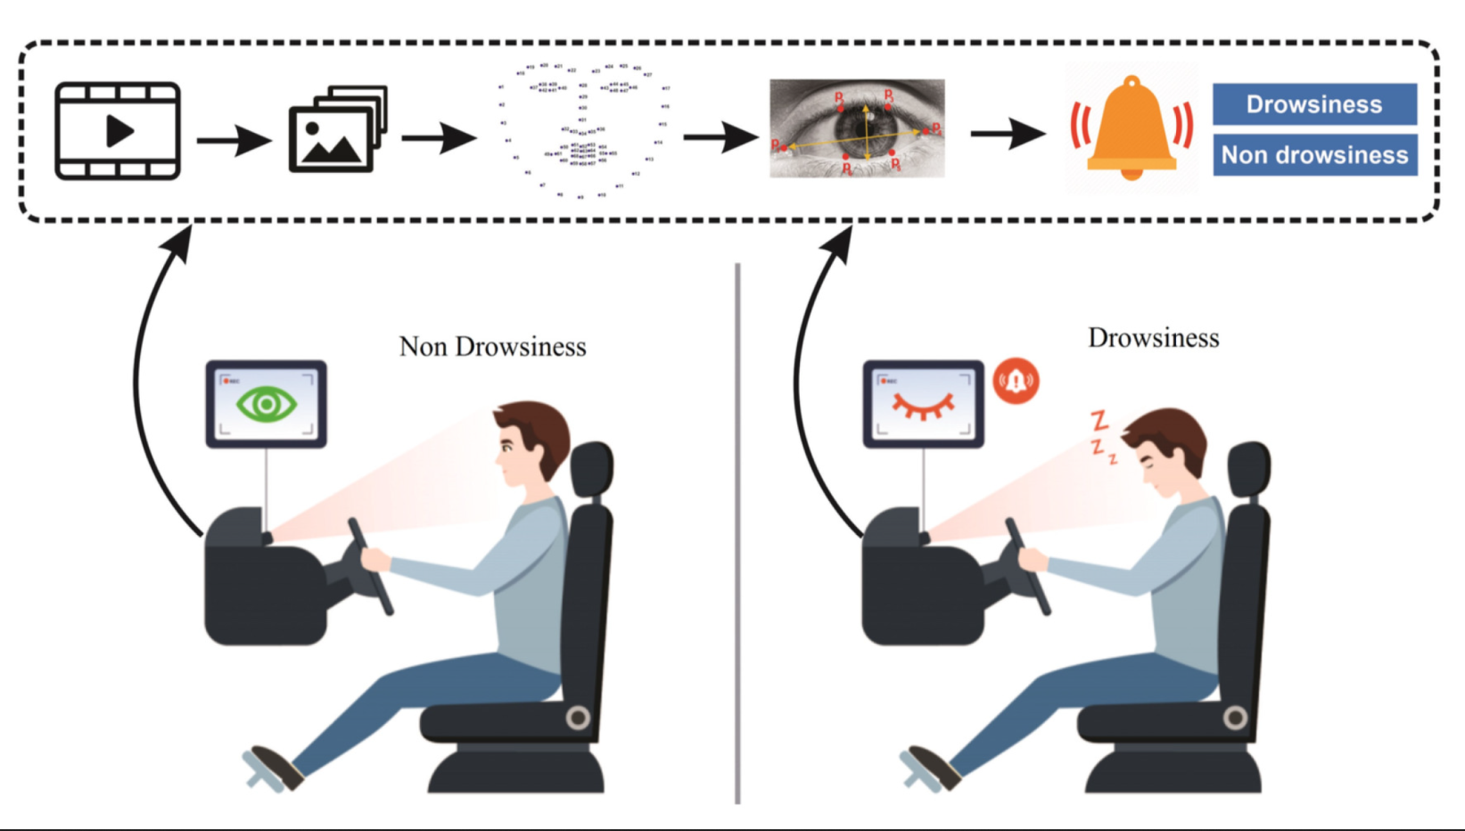

Figure 1. Basic

**Chapter 2:**

**2.1 : Drowsiness Detection System Using Python and Dlib:**

With this Python project, we will be making a drowsiness detection system. A countless number of people drive on the highway day and night. Taxi drivers, bus drivers, truck drivers and people traveling long-distance suffer from lack of sleep. Due to which it becomes very dangerous to drive when feeling sleepy.

The majority of accidents happen due to the drowsiness of the driver. So, to prevent these accidents we will build a system using Python, OpenCV, and Keras which will alert the driver when he feels sleepy.

Drowsiness detection System is most powerful technique decrease the accident on road. As we already know there are lots of accident are occurred due to Drowsiness of driver. Due to drowsiness Driver lost his control over the vehicle and will result in accident. So this is one Solution to prevent from this type of accident.

There is alarm system when drowsiness is detected. To complete the given task I created a ML program using pretrained model to detect the drowsiness of driver. First I captured frames from given video. Then on each frame i find landmarks near the both eyes using dlib + Python. Then I calculate the Eye Aspect Ratio (EAR) using central vertical distance to central horizontal distance. Here the distance is Euclidean distance. If EAR is < 0.26 then classify frame as driver is drowsy else not drowsy.

**2.2 : What IS Machine Learning:**

Machine learning (ML) is a type of artificial intelligence ([AI](https://www.techtarget.com/searchenterpriseai/definition/AI-Artificial-Intelligence)) that allows software applications to become more accurate at predicting outcomes without being explicitly programmed to do so. Machine learning [algorithms](https://www.techtarget.com/whatis/definition/algorithm) use historical data as input to predict new output values.

[Recommendation engines](https://www.techtarget.com/whatis/definition/recommendation-engine) are a common use case for machine learning. Other popular uses include fraud detection, spam filtering, malware threat detection, [business process automation](https://www.techtarget.com/searchcio/definition/business-process-automation) (BPA) and Predictive maintenance.

### Why is machine learning important?

Machine learning is important because it gives enterprises a view of trends in customer behavior and business operational patterns, as well as supports the development of new products. Many of today's leading companies, such as Facebook, Google and Uber, make machine learning a central part of their operations. Machine learning has become a significant competitive differentiator for many companies.

Often we come across the terms [Artificial Intelligence and Machine Learning being used interchangeably](https://viso.ai/deep-learning/deep-learning-vs-machine-learning/). Therefore many may wonder what a machine learning model is and how it is different from an AI model.

Well, both AI and ML are part of computer science and contribute to the creation of intelligent systems. But while these two technologies are related, these are not synonymous terms.

AI is a larger concept associated with the creation of machines that can simulate human behavioral and intelligence.

**2.3 : What IS Dlib:**

Dlib-ml is a cross platform open source software library written in the C++ programming language. Its design is heavily influenced by ideas from design by contract and component-based software engineering. This means it is first and foremost a collection of independent software components, each accompanied by extensive documentation and thorough debugging modes.

Moreover, the library is intended to be useful in both research and real world commercial projects and has been carefully designed to make it easy to integrate into a user’s C++ application.

There are a number of well known machine learning libraries. However, many of these libraries focus on providing a good environment for doing research using languages other than C++. Two examples of this kind of project are the Shogun (Sonnenburg et al., 2006) and Torch (Collobert and Bengio, 2001) toolkits which, while they are implemented in C++, are not focused on providing support for developing machine learning software in that language.

Instead they are primarily intended to be used with languages like R, Python, Matlab, or Lua. Then there are toolkits such as Shark (Igel et al., 2008) and dlib-ml which are explicitly targeted at users who wish to develop software in C++. Given these considerations, dlib-ml attempts to help fill some of the gaps in tool support not already filled by libraries such as Shark. It is hoped that these efforts will prove useful for researchers and engineers who wish to develop machine learning software in this language.

Dlib-ml is **an open source library, targeted at both engineers and research scientists, which aims to provide a similarly rich environment for developing machine learning software in the C++ language**.

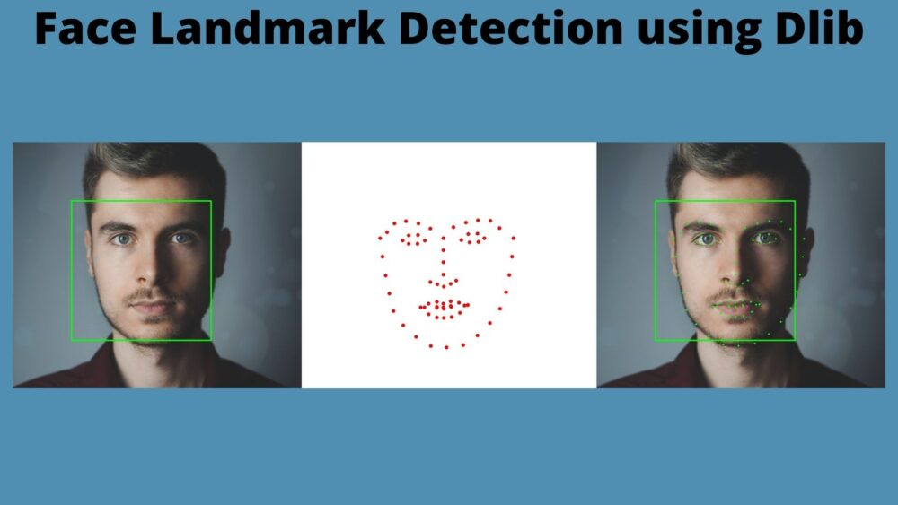

Figure 2.Face Landmark

**2.4 : What are the Facial Landmark That Dlib detects**

The dlib library can be used to detect a face in an image and then find 68 facial landmarks on the detected face.

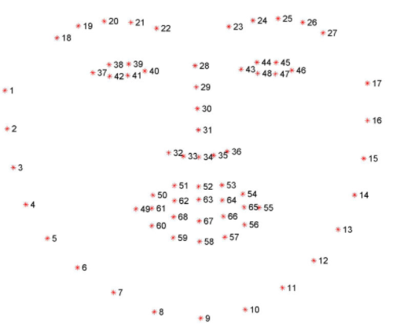

68 facial landmarks that dlib finds in a face

I will not go into details about how does it detect a face and locate facial landmarks. The order of the detected facial landmarks will always be the same irrespective of image dimensions or face size, which means 1–17 will always represent an outline of the face. 43–48 would always represent the left eye. The exact code of how this is done comes later in this article.

# 2.5 :How to find Eye Aspect Ratio(EAR)

If you notice, each eye is represented using 6 landmarks points.

The EAR for a single eye is calculated using this formula:

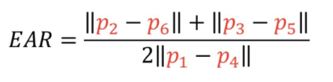

||p2-p6|| means the distance between points p2 and p6

*The more the EAR, the more widely eye is open. We would decide a minimum EAR value and used this to decide if the eye is closed or not.*

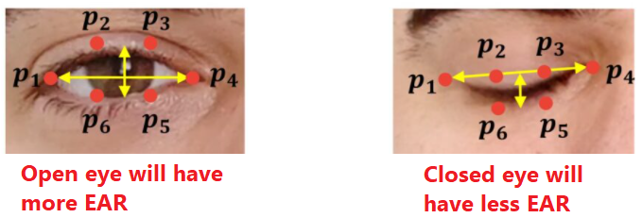

*Figure 3.EAR 1*

The numerator of this equation computes the distance between the vertical eye landmarks while the denominator computes the distance between horizontal eye landmarks, weighting the denominator appropriately since there is only one set of horizontal points but two sets of vertical points.

Why is this equation so interesting?

Well, as we’ll find out, the eye aspect ratio is approximately constant while the eye is open, but will rapidly fall to zero when a blink is taking place.

Using this simple equation, we can avoid image processing techniques and simply rely on the ratio of eye landmark distances to determine if a person is blinking.

To make this more clear, consider the following figure:

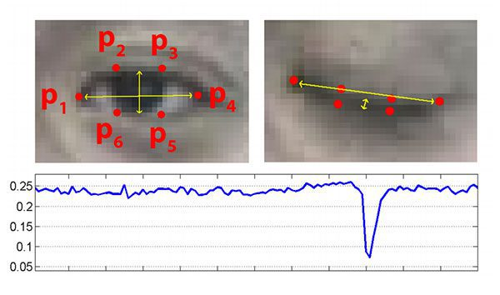

*Figure 4.EAR 2*

On the top-left we have an eye that is fully open — the eye aspect ratio here would be large(r) and relatively constant over time.

However, once the person blinks (top-right) the eye aspect ratio decreases dramatically, approaching zero.

The bottom figure plots a graph of the eye aspect ratio over time for a video clip. As we can see, the eye aspect ratio is constant, then rapidly drops close to zero, then increases again, indicating a single blink has taken place.

In our next section, we’ll learn how to implement the eye aspect ratio for blink detection using facial landmarks, OpenCV, Python, and dlib.

2.6 Work on driver drowsiness detection

Detect drowsiness of driver from the video:

To complete the given task I created a ML program using pretrained model to detect the drowsiness of driver.

First I captured frames from given video. Then on each frame i find landmarks near the both eyes using dlib + Python.

Then I calculate the Eye Aspect Ratio (EAR) using central vertical distance to central horizontal distance. Here the distance is Euclidean distance.

If EAR is < 0.26 then classify frame as driver is drowsy else not drowsy

The EAR is mostly constant when an eye is open and is getting close to zero while closing an eye.

Dlib’s hog face detector pre-trained model finds faces.

On the each frames, and for each faces landmarks are derived near to eye(37-42) and (43-48).

EAR of left and right eye is averaged. If average EAR of 6 frames is less than 0.26 than It classified as drowsy.

No Drowsy Face

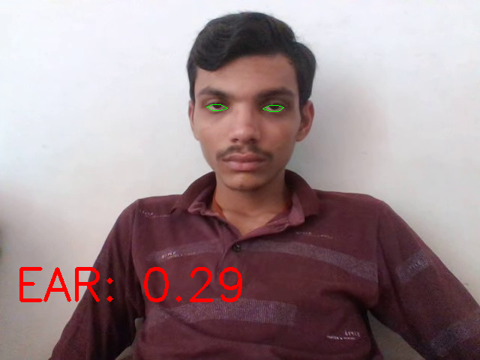

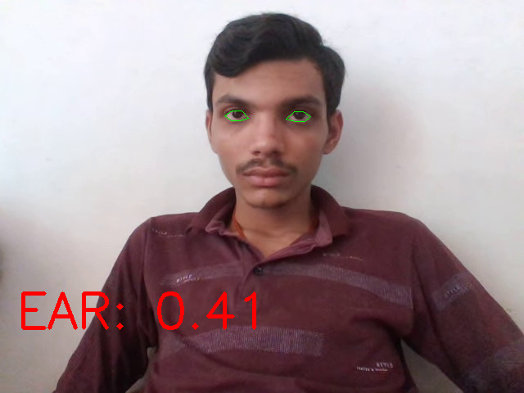

Figure 5.No Drowsiness Face

Drowsy Face

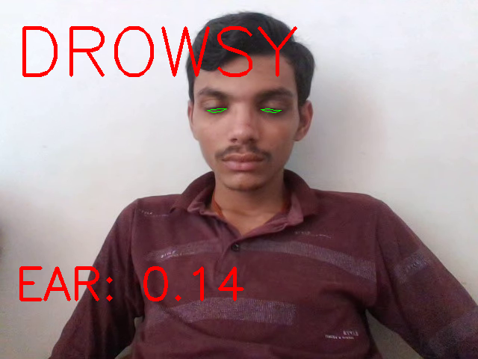

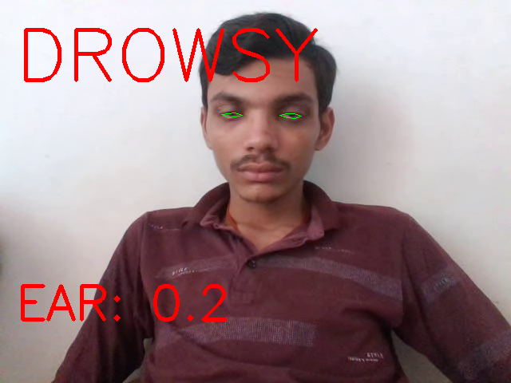

Figure 6. Drowsiness Face

2.7:Pros and Cons

* PROS:

* Real time response

* High powerful CPU is not necessary to run model.

*Life of the driver can be saved by alerting him using the alarm system.

*Speed of the vehicle can be controlled.

*Traffic management can be maintained by reducing accidents.

*Practically applicable

* CONS:
* * Lower accuracy in dark surrounding, if face is not oriented steady, if face wears spectacles, or in case face is not clear.

# Chapter 3. System Design

## :Use Case Diagram

Use case diagrams are usually referred to as [behavioral diagrams](https://www.uml-diagrams.org/uml-25-diagrams.html#behavior-diagram) used to describe a set of actions ([use cases](https://www.uml-diagrams.org/use-case.html)) that some system or systems should or can perform in collaboration with one or more external users of the system ([actors](https://www.uml-diagrams.org/use-case-actor.html)). Each use case should provide some observable and valuable result to the actors or other stakeholders of the system.

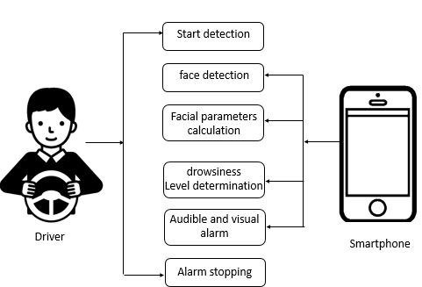

Figure 7.Use Case Diagram

## 3.2:Data Flow Diagram Context Level

A data flow diagram is a graphical depiction of flow of data through intended software system and is used as 1st step to create an overview of system. It’s really useful as it provides overview of data as well as functionality to software designers. A level 0 DFD, also called a fundamental system model or a context model. It represents the entire software element as a single process with input and output data. All the external entities should be identified and shown.

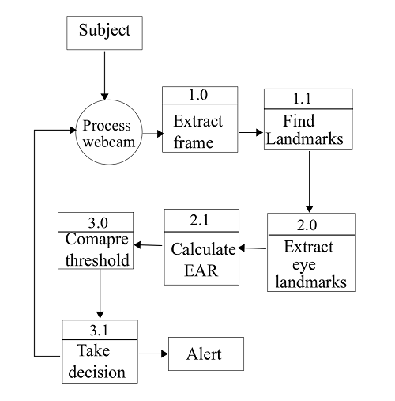

Figure 8. Context Level

3.3 Algorithm 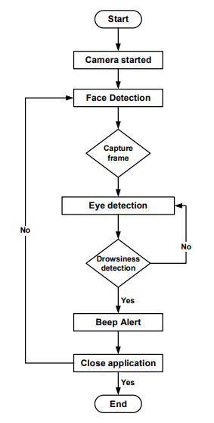

Figure 9.Algorithm

3.4:UML Diagram

A UML diagram is a diagram based on the UML (Unified Modeling Language) with the purpose of visually representing a system along with its main actors, roles, actions, artifacts or classes, in order to better understand, alter, maintain, or document information about the system.

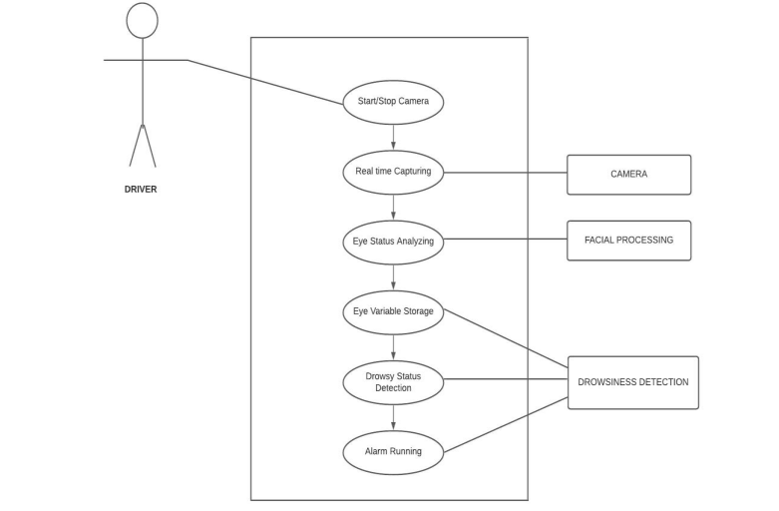

Figure 10.UML Diagram

**Chapter:4 Snapshots**

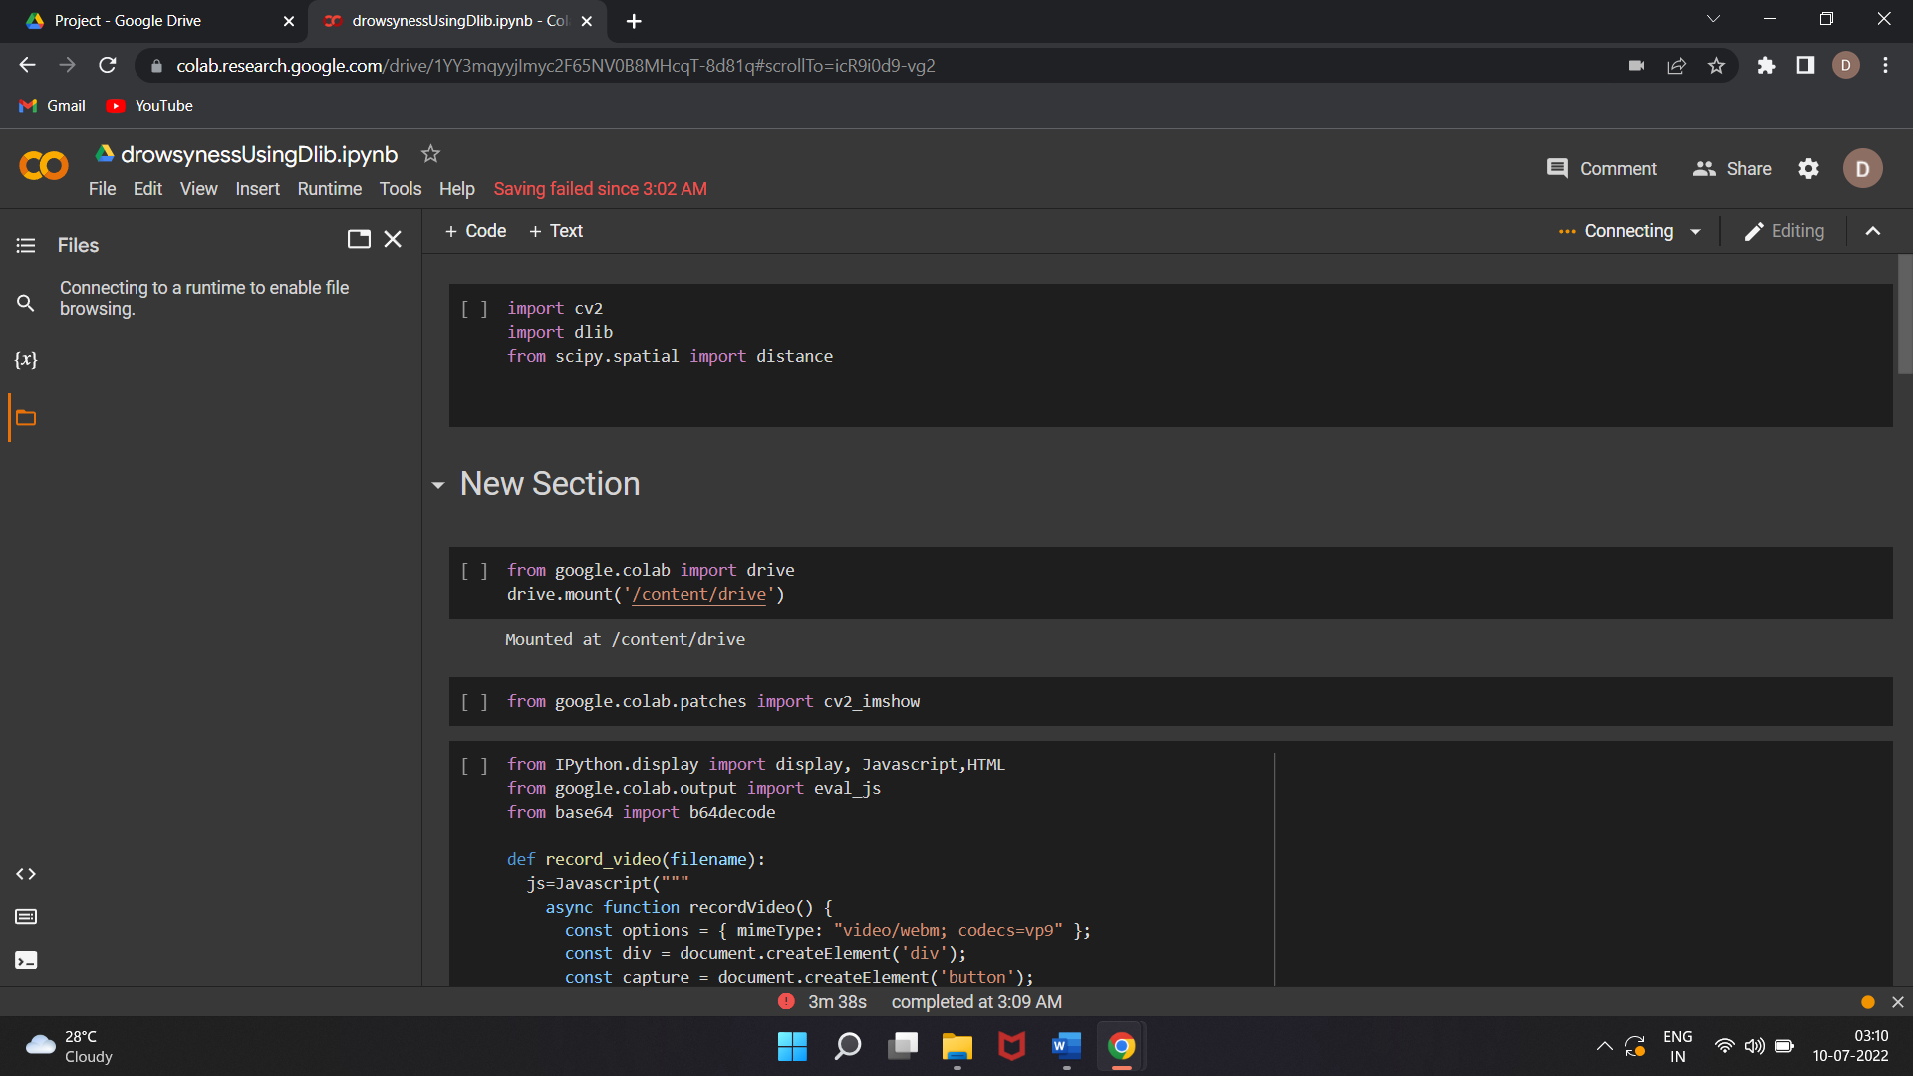

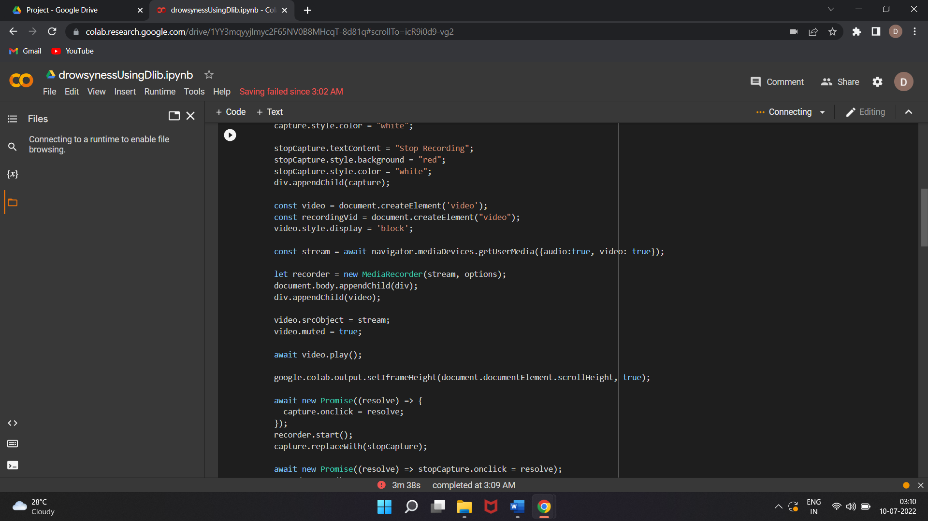

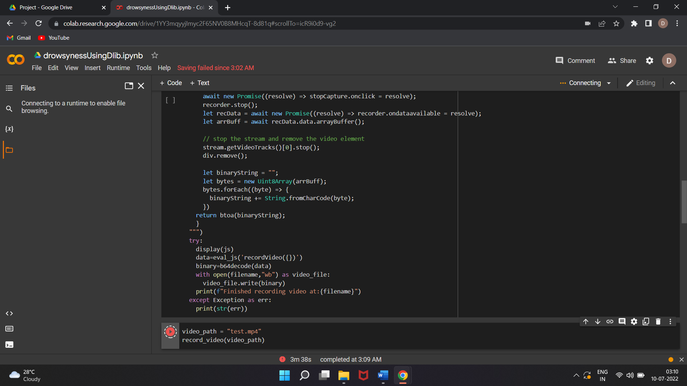

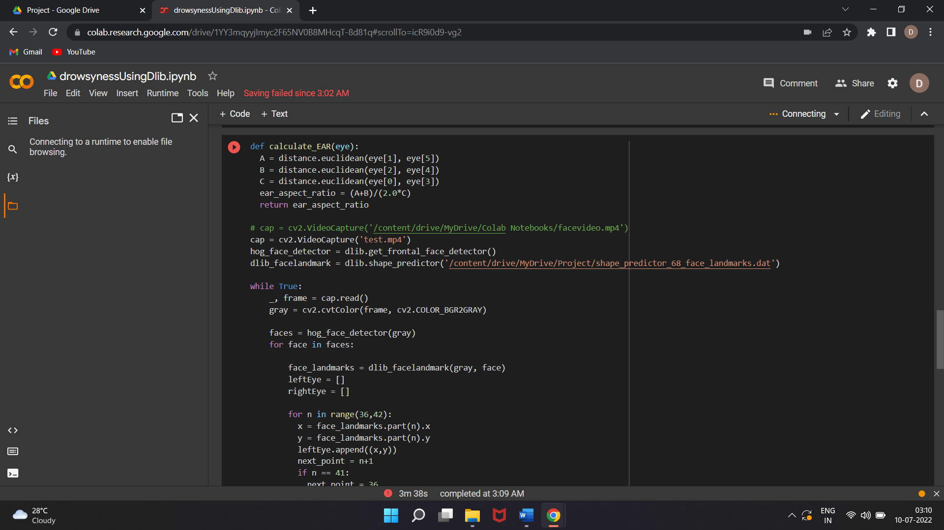

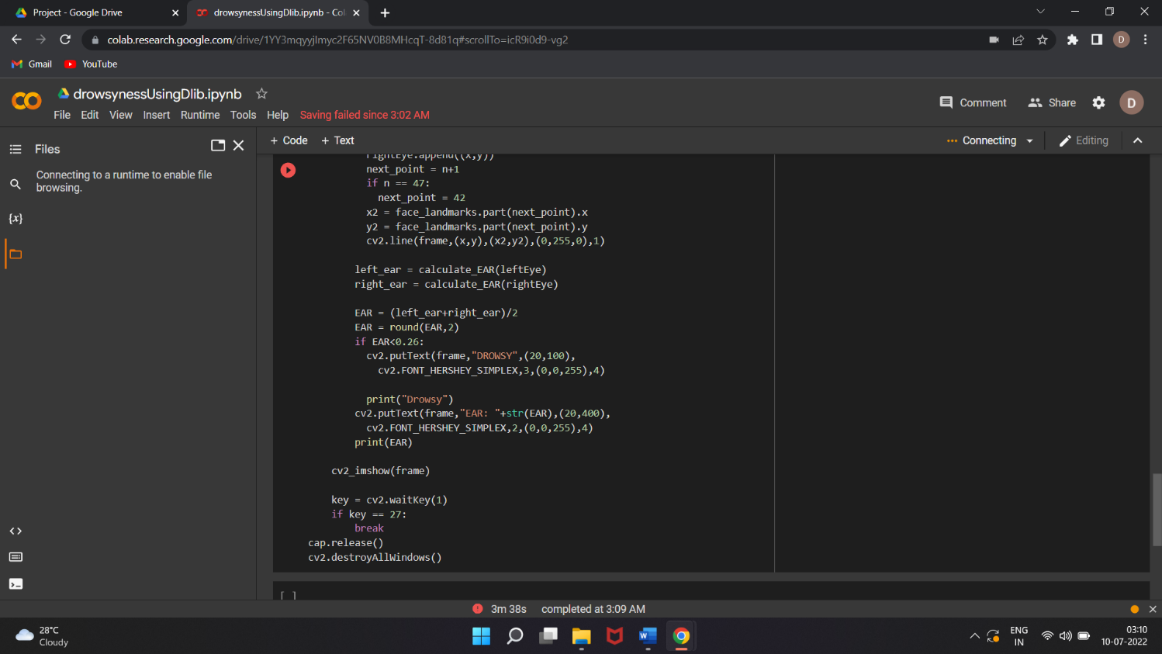

Video Recording:

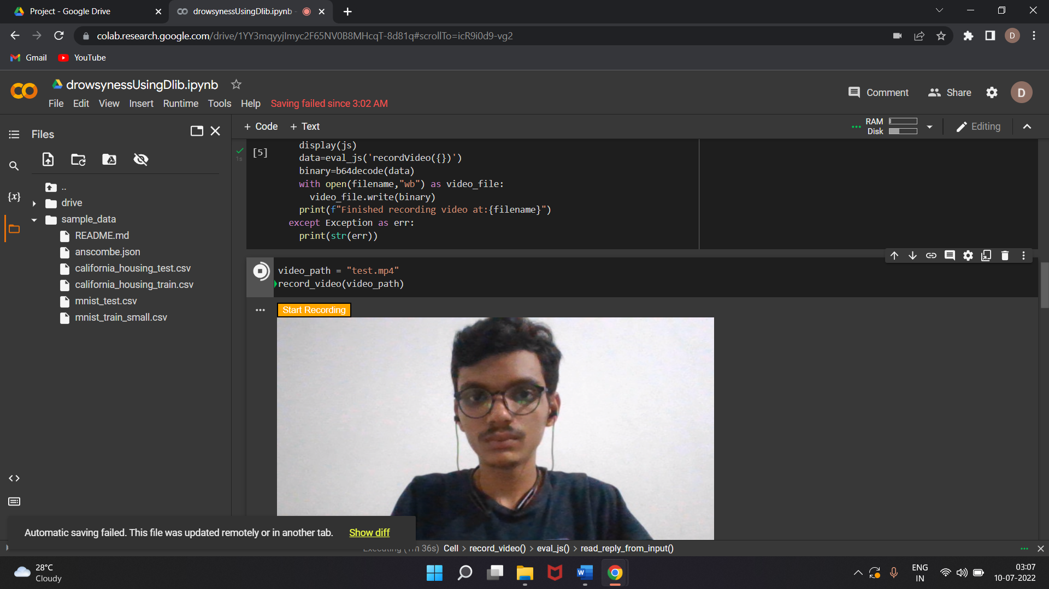

# Chapter 5. Conclusion

The drowsiness detection system is capable of detecting drowsiness in quickly. The system which can differentiate normal eye blink and drowsiness can prevent the driver from entering the state of sleepiness while driving. The system works well irrespective of driver wearing spectacles and under low light conditions also. During the monitoring, the system is able to decide if the eyes are closed or opened. When the eyes have been closed for too long a warning signal is issued.

The ultimate goal of the system is to check the drowsiness condition of the driver. Based on the eye movements of the driver, the drowsiness is detected and according o eye blink, the alarm will be generated to alert the driver and to reduce the speed of the vehicle along with the indication of parking light. By doing this, many accidents will be reduced and provides safety to the driver and vehicle. A system that is driver safety and car security is presented only in luxurious costly cars. Using eye detection, driver security and safety can be implemented din normal car also.

**Chapter 6: Reference**

**Websites:**

1.Class Diagram:<https://creately.com/diagram/example/htomjucv1/driver-fatigue-detection-system-classic>

2.ML:[https://monkeylearn.com/machinelearning/#:~:text=Machine%20learning%20(ML)%20is%20a,to%20make%20their%20own%20predictions](https://monkeylearn.com/machinelearning/%23:~:text=Machine%20learning%20(ML)%20is%20a,to%20make%20their%20own%20predictions).

3.Face Landmark: <https://pyimagesearch.com/2017/05/08/drowsiness-detection-opencv>

4.Eye Aspect Ratio: <https://medium.com/analytics-vidhya/eye-aspect-ratio-ear-and-drowsiness-detector-using-dlib-a0b2c292d706>

5.Eye Aspect Ratio[: https://pyimagesearch.com/2017/04/24/eye-blink-detection-opencv-python-dlib/](:%20https:/pyimagesearch.com/2017/04/24/eye-blink-detection-opencv-python-dlib/)