CS 6120 Assignment 2

NUID: 001669685 DHEERAJ JOSHI

Q.1)

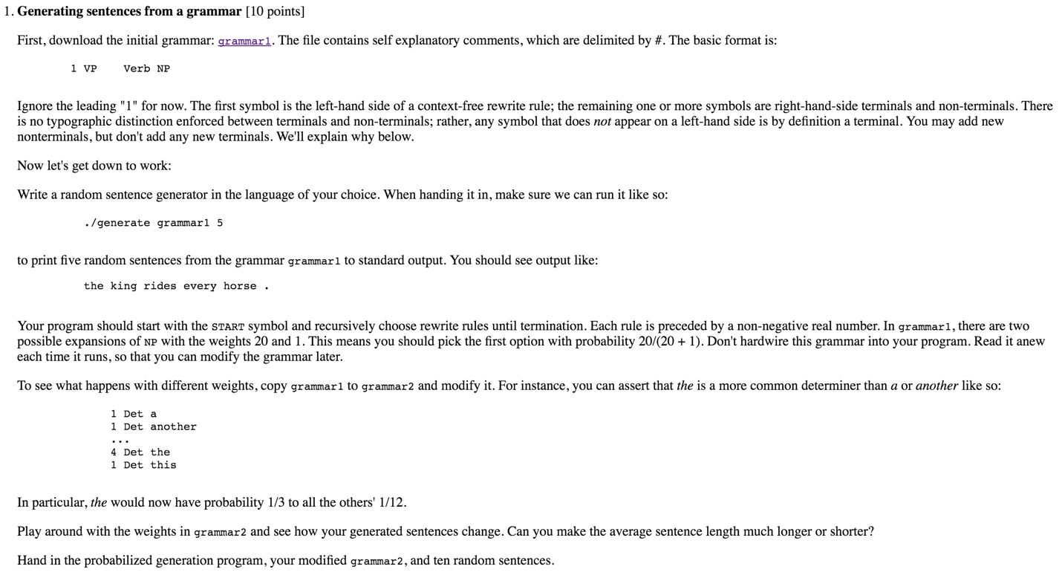

**Solution:**

Unzip the GenerateJAR.zip file from the unzipped HW2 folder. (The README for JAR Executable is also in the folder with environment variables essential explained)

The classes used are:

* ContextFreeLanguage : Parses the Grammar into Terminal & Non-terminal symbols
* Rule: Applies the set of rules described by the given grammar
* GrammarReader: Reads & Parses the grammar for weights and rules
* SentenceBuilder: Builds the sentence using the rules determined
* IntermediateSentence: Builds intermediate sentences based on subject and auxillaries
* RandomNumberGenerator: Returns a random number
* HW2: Executes the Project using the main function.

The HW2 project can be directly imported to Netbeans or the JAR can be executed on the console as follows:

* java -jar hw2.jar
* Enter the file name: grammar1.txt
* Enter the number of sentences to print: 5

**Sample output:**

another pound has no corner .

each husk is this swallow .

the story rides another husk .

any weight carries any winter .

that sun covers a swallow .

* java -jar hw2.jar
* Enter the file name: grammar2.txt
* Enter the number of sentences to print: 10

**Sample output:**

the husk drinks the servant .

every husk covers that corner .

each fruit is that sovereign .

every master has a servant .

that horse is the fruit at the master at Uther Pendragon over no home into each story .

a corner rides this sovereign for that fruit for any quest .

no sun carries a winter by this story near the swallow on the sun at a sun on this corner .

a coconut is the king .

the master covers the king .

this sovereign covers each land .

Q.2)

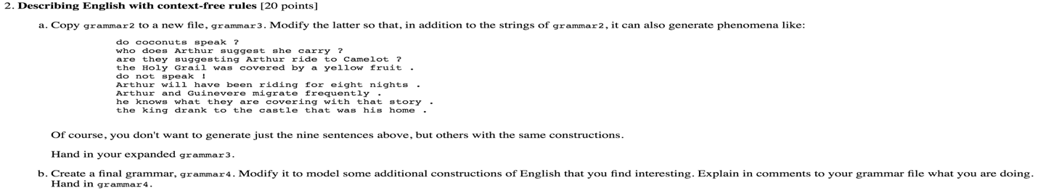

**Solution:**

1. The same directory consists of grammar3.txt

The steps to execute are:

* java -jar hw2.jar
* Enter the file name: grammar3.txt
* Enter the number of sentences to print: 5

**Sample output:**

what does another Holy Grail Round Table speak halves have already ?

ridden spoke this sun .

drink the chalice suggest currently ?

what ride Sir Lancelot be frequently ?

five nights have .

1. The same directory consists of grammar4.txt

The steps to execute are:

* java -jar hw2.jar
* Enter the file name: grammar4.txt
* Enter the number of sentences to print: 5

**Sample output:**

another castle covers every coconut .

to a coconut who Sir Lancelot known could carried rides any defeater knows that this sun known can grow is the pound this fruit .

who do any fruit speak precisely ?

another sun drunk would suggest ride unfortunately .

because each master ride already his pound .

Q.3)

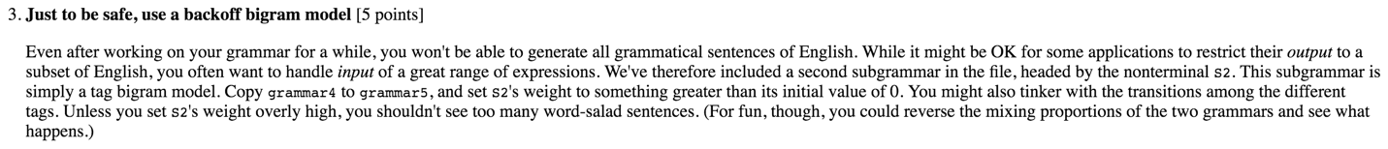

**Solution:**

The same directory consists of grammar3.txt

The steps to execute are:

* java -jar hw2.jar
* Enter the file name: grammar5.txt
* Enter the number of sentences to print: 5

**Sample output:**

a swallow was the quest .

to that defeater should spoken to this corner it .

suggests any swallow suggesting the story to she what five snows suggesting below this fruit near that fruit ?

does nights having above any coconut ?

eight strangers grow .