**BackEnd Overview:**

**API in Springboot:**

I have created 3 layer to Put and Pull data from MongoDB

1. Created a Service layer to fetch customer data by emailID and save data
2. Created JPA repository for entity/collection
3. Created controller that has endpoints to access data based on HTTP request

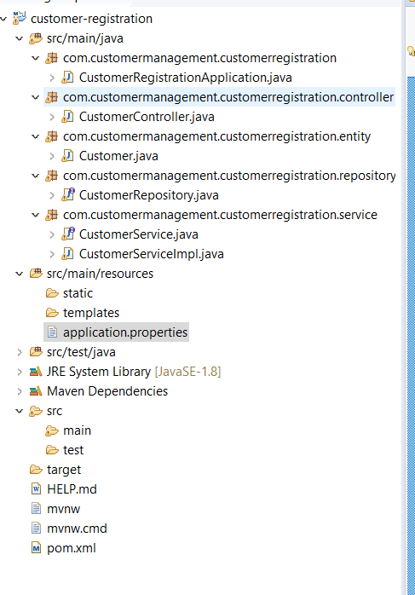

**API definations that are use in APP.**

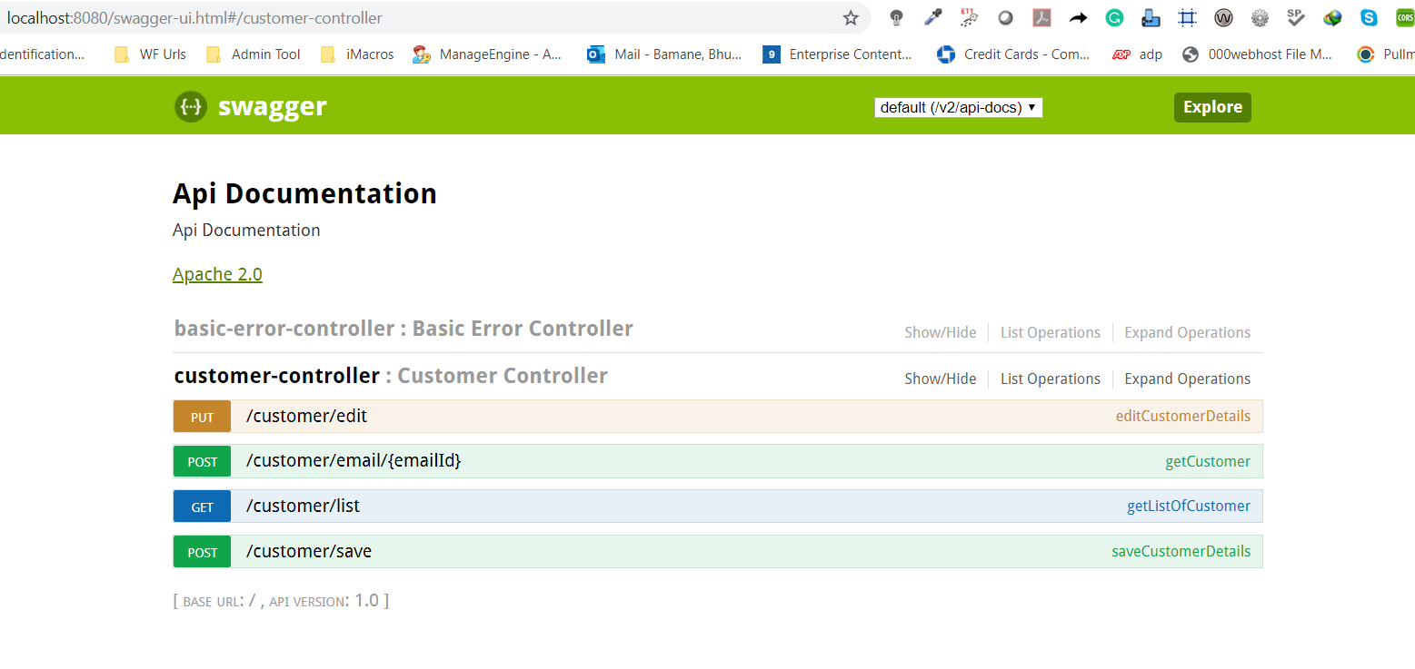

**FronEnd overview:**

Login Page:

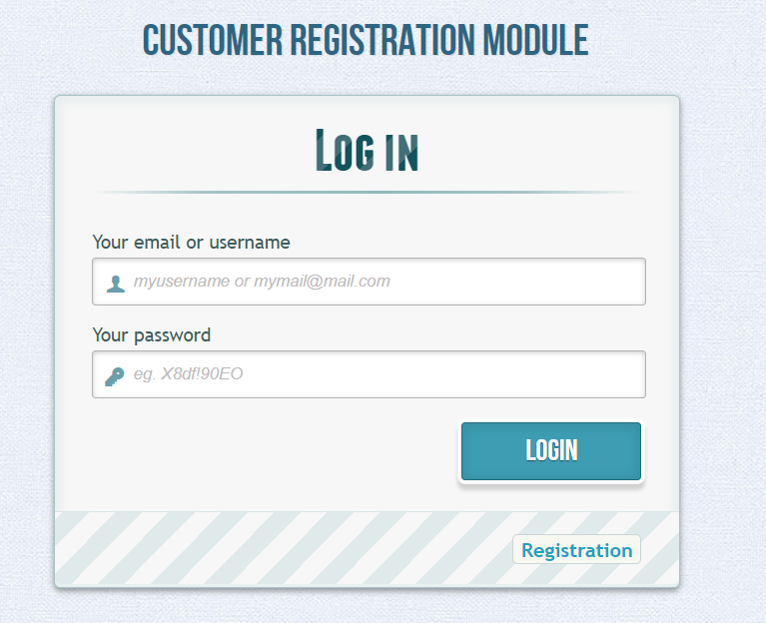

Pop-up for Login Success:

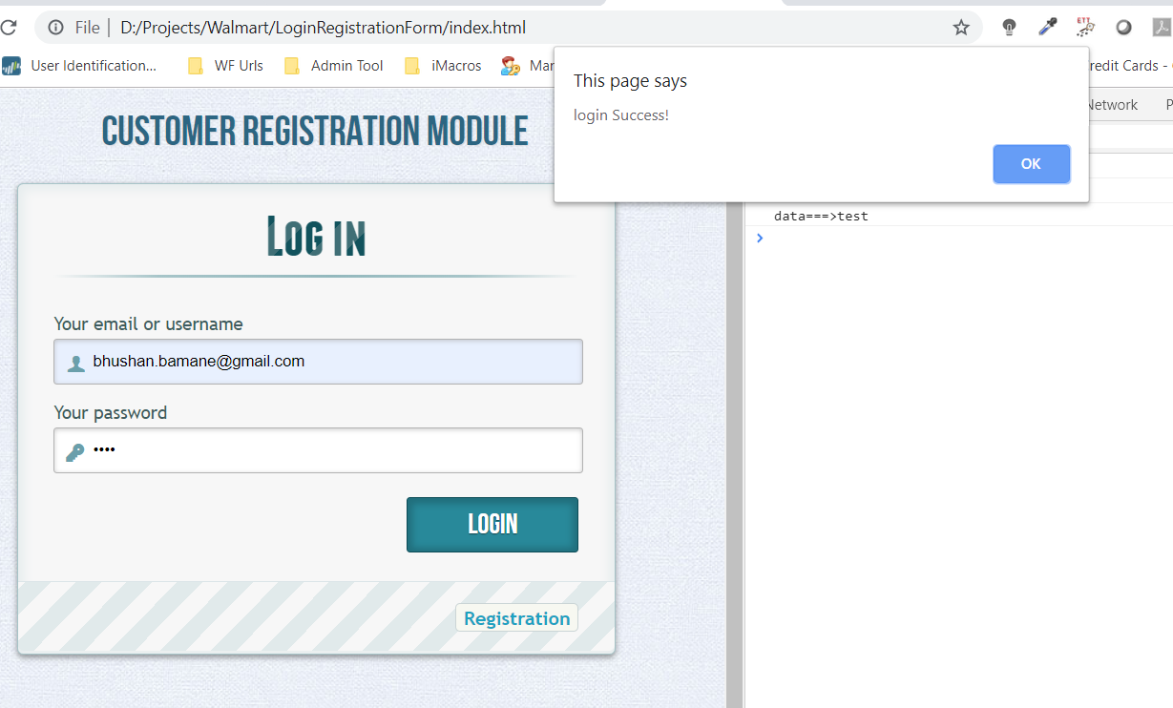

List Customer details after login:

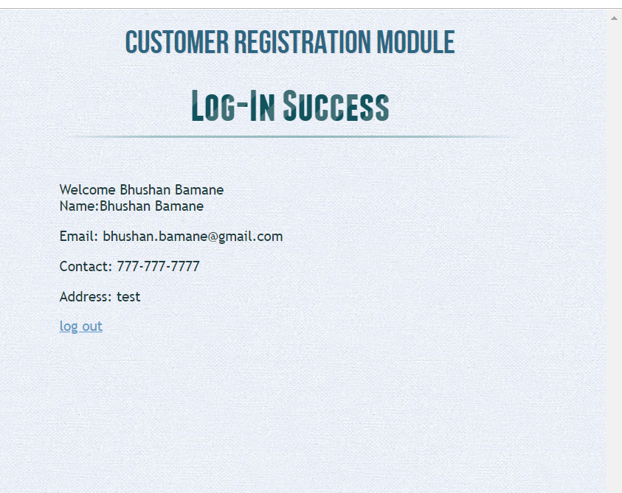

API response for : **POST /customer/email/{emailId}**

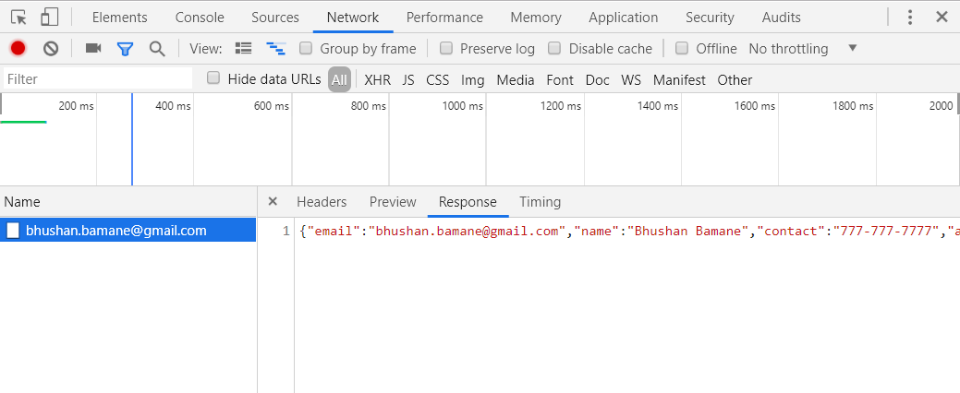

Customer registration:

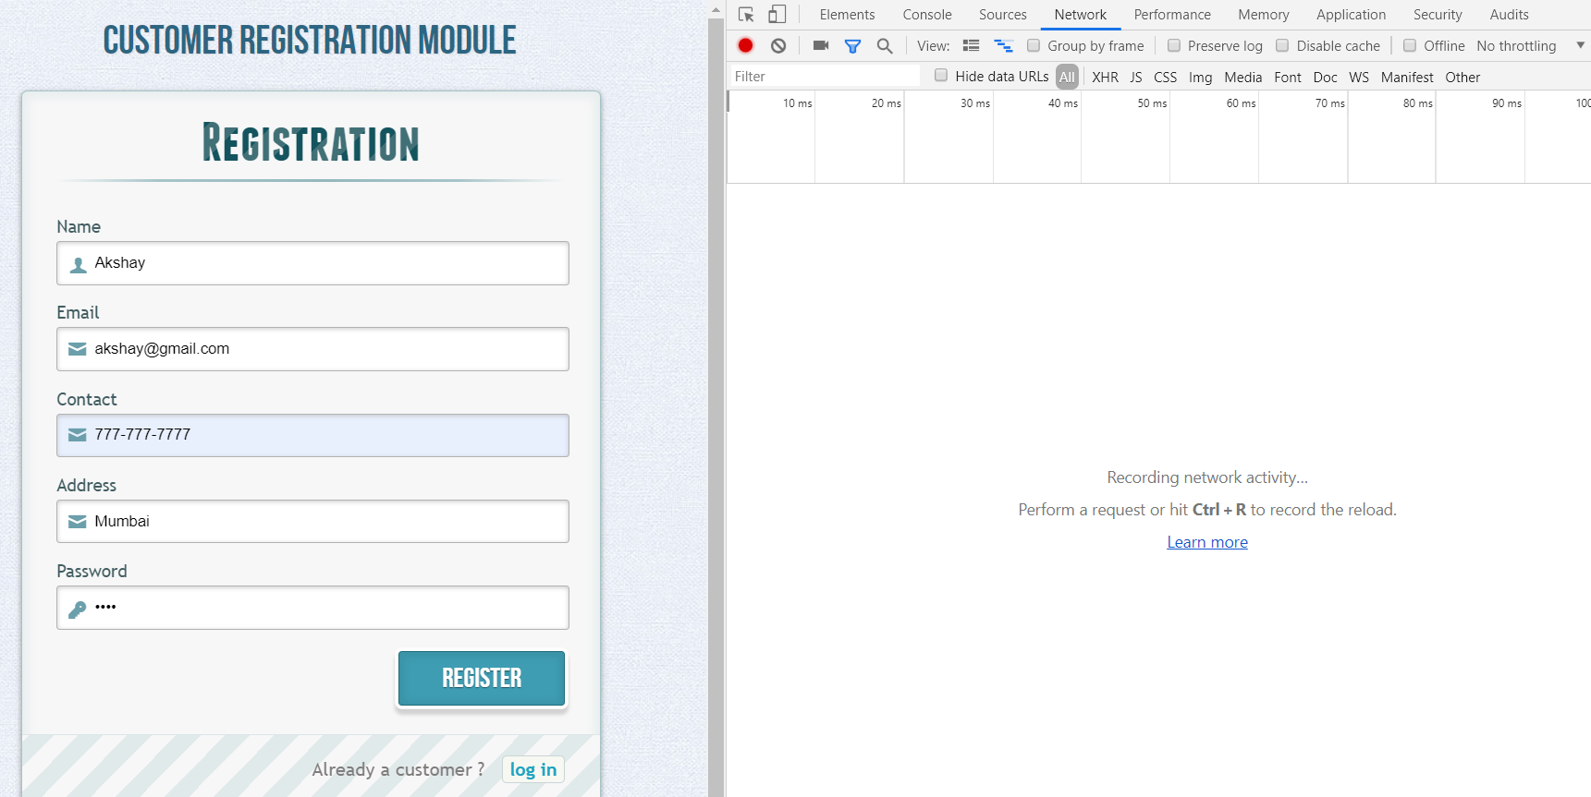

API response for : **POST /customer/save**

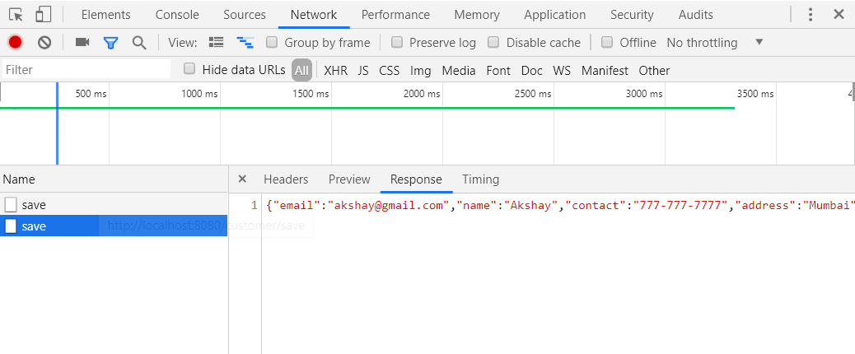

**DB: Collection Overview:**

