**KATIE BROWN**

**CREATIVE TECHNOLOGY  
WEEK ONE**

To kickstart this project we worked as a team to transform our masters studio into a working studio environment and to throw away our student mentality. We brainstormed and voted on a name for our working studio and named this “**HUBMO.**” This word means a creative and forward-thinking space where ideas are explored. We felt that this was a great message for our studio and we began to re-design or ‘hack’ the space around us to suit our design activities and needs.

Our initial theme for this project is **the connected home**. And we were asked to write our own brief from this topic, taking initial inspiration from the Mozilla Connected Homes Design Sprint. This design sprint focused on users and the interactions observed and products used within their own homes. It showed clever ways to improve or change these through design.

We were introduced to the arduino software and hardware, we began to learn the building blocks of this technology, and then with this fresh understanding we began to create circuits that addressed stories, scenarios and ideas inspired by the connected home. Some of my own ideas involved environmental stimulus, led lighting as a form of signal and then began to largely focus onhow arduino circuits could **communicate to and with people.**

Out of the nine stories I created, I decided to focus on one in particular. This story was inspired by my own experience in my term time home and was based on interactions between myself and my flatmate. We both have opposing schedules/ commitments and sometimes struggle to find a situation or a space in time when we are both in the flat, to stop and just sit and talk to each other.

My proposed idea for this was to find a way to schedule this communication into our daily activities. Something we quite often do in the flat is shout to each other when the kettle is boiled, in case we would like to use the water in the kettle while it’s hot. But when we do this we tend to make cups of tea for ourselves one at a time. My idea was to create a tilt switch circuit, activated by the pouring of a kettle, linked to an led, that would notify flatmates, that their flatmate is making a cup of tea. This was to encourage the other flatmates to come through to the kitchen, sit, and drink a cup of tea together allowing them to then communicate and share stories.

When analysing this simple act of communication within the wider world, the concept of this was quite simple.To **encourage people to come together, communicate and discuss their ideas or issues.**This could be compared to political issues within the world, eg to encourage a civil discussion and debate on the Scottish Independence Referendum last year.

My challenge and personal goal for the next three weeks, is to develop this initial idea into a design that features arduino or other relevant technologies to bring people together, and to make an impact with design prototyping, inspired by me having a cup of tea with my flatmate.

**WEEK 2**

**THE CONNECTED HOME**

**KATIE BROWN**

Last week I ended with a loose plan of what I wanted my design to do. “To encourage people to come together, communicate and discuss their ideas or issues.” This week I focused on how to make it bigger than a cup of tea and a chat. I briefly discussed how encouraging conversation could be used to raise awareness on political issues such as the Scottish Independence Referendum held last year. I decided to run with the idea of getting people talking about political events happening in the world and started to research into this.

Firstly I would define “political” topics to include economic and environmental issues as well as elections and government political events. As I began to research into this area, I found that a high percentage of political debate happens via social media. This is expected to be a growing platform for political debate since the 2008 American election, where Barack Obama successfully ran his campaign using social media. This was the first time a political agenda had been so widely spread and updated via social networking sites. Ever since this campaign political parties have been utilizing social media as a form of communication with the general public. The Scottish Referendum in 2015 was another showcase of the power of social media. It was the first time profile pictures on facebook were used to broadcast a political opinion bearing the emblems of ‘yes’ or ‘no thanks.’ Even after the outcome of the Scottish Referendum, many of the yes voters continued to show their political status by adding a blue 45 number to their profile picture after the extremely close vote outcome to show continued support, “We are the 45%.” This was an example of a continued support on social media for a political cause after a voting outcome.

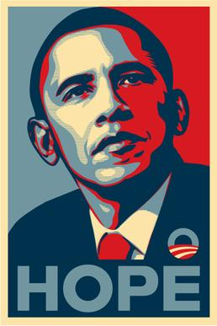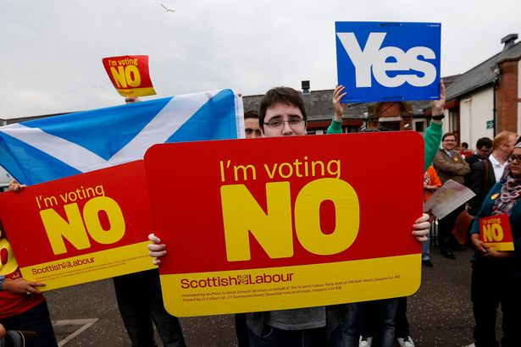

*Barack Obama campaign poster (2008) Widely shared ‘No’ vote campaign picture*



*Widely shared “Yes” Campaign picture “We are the 45%” Facebook profile picture*

Personally, I like many people who are active on social media, tend to share videos and pictures with a political agenda on social media sites. I posted a picture after voting on the referendum, I shared my views on the outcome and continue to use social media as a format to voice opinions and concerns. But social media seems like a quick fix for people who want to voice political opinions. Often the media that is shared is out of context and the sources for it are not always reliable, due to social media being accessible by anyone, and requiring a limited call for evidence or statistics to back up opinion.

Social media is beginning to mimic other media sources that are published with an existing bias. UK newspapers for example, have historically had strong allegiance with a single political party. The Sun and The Times famously switched their 1997 onwards alliance with Labour in 2005, and began to back the Conservative party. In fact most major newspapers within the UK support either Conservative or Labour policies, fueling the two horse race that still exists within UK politics. Whereas social media has encouraged the rise of political parties in the UK such as the Green Party and SNP.

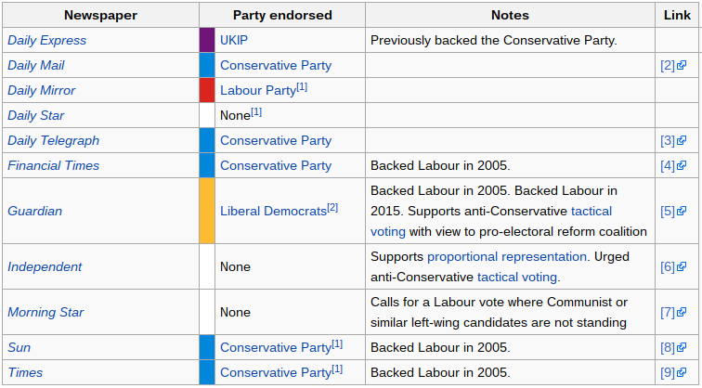

It is widely believed that online and offline deliberation on politics can improve decisions. But many people don’t want to talk politics online, let alone in person. When googling how to encourage conversation on politics, the suggested results show that people actively avoid walking into the minefield of politics.

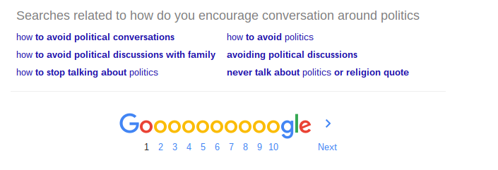

If my intended outcome is “To encourage people to come together, communicate and discuss their ideas or issues,” politics is something that really needs to be discussed.

So how do I get people interested in politics? One of my ideas was to remove the ‘face’ of politics and let people discuss policies and speeches made without linking them to a particular politician or party. This could be through receiving daily political updates from not only UK but International politics (eg the current American elections) and having the names and parties removed then read out by an AI style voice such as SIRI or ECHO/ALEXA for the listener to come to their own conclusions and be able to choose if they want to know the source after listening. However this idea is addressing individual opinions but it doesn’t necessarily facilitate a conversation around the area. Also sourcing material that is not bias and leading to the listener proves very hard in practice.

The real question I need to address is how do I get people to TALK about politics? I want to encourage a conversation and not just an individual view. In order to do this the input and output of this design has to be more inclusive. This has led to me think that my design needs reliable sources, it needs to support understanding and it has to allow for a conversation.

Upon realising these design essentials I was encouraged to research an example of a design using well sourced material. This was “The Prayer Companion” a device used to help nuns who have limited exposure to the wider world, receive worldwide and local news to include in their daily prayers. The sourcing for this device consisted of existing media that the nuns were exposed to as well as a mixture of international news sources. In summary of the designs sourcing methods the group wrote, “The point of using multiple, international RSS feeds was to counter media bias associated with any one source by exposing multiple voices.”

This is the same approach that I plan to take with my sourcing, using multiple sources and possibly allowing for factual evidence to be part of the devices communication. I also think that the object itself has to either be intrusive and playful or something non intrusive and ‘safe.’ Currently I am playing with a combination of my “social kettle” idea and how to link this social act to a political conversation.

My plan for next week is to draw on my existing research from this week, confirm a list of sources, explore the possibility of a “fact checker” element, play with a physical prototype of the device, begin to wire up arduino components and explore processing as being a critical part of the designs input.

So if “politics is the art of looking for trouble, finding it everywhere, diagnosing it incorrectly and applying the wrong remedies.” Discuss?

**WEEK 3**

**THE CONNECTED HOME  
KATIE BROWN**

This week I addressed two main factors of my prototype, firstly how will it work? And secondly, what will it look like? To recap on last week I decided that I wanted to encourage conversation around politics. Following examples like the prayer companion, I want to create something that will fit into the home, without being intrusive. Both in the way it appears and functions. The prototype should resemble a household object and be subtle in the way it projects information. I decided this week that the information would be written and communicated via an LCD screen. (I would have loved to have been able to play with spoken audio, but I was unable to source the parts and code required.)

The information that the LCD screen would ideally display, will be political news feed ‘stories’ from the RSS news feeds. This would provide a “topic” for conversation and personal research. At this stage I am simply exploring the arduino code and wiring setup required to make the LCD screen display text so this may change, depending on the processing element of this design.

I want to make a prototype that creates conversation without drawing focus away from the topic by being an ‘alien’ object. After brainstorming ideas including, but not limited to, an ornamental head, a clock and a salt shaker. I thought, “where would an lcd screen look at home, in the home?” And decided that this would only be, on an existing piece of technology that you expected an lcd screen to be a part of. So I thought, “how does someone interact with an LCD screen?” And I decided “well, you would read from an lcd screen.” This led me to the theme of books. I decided to create a false ‘book’ casing that would hold the LCD screen within and function when opened to be read.

In reflection of this decision, I have realised that a book is probably not a conversational object in the sense that it’s not inclusive. Reading is something often done alone. Although, the content of a book is something that you would often discuss when with friends. Recommending reading something that moved you, or quoting something memorable. This is perhaps the area that I need to focus on and develop what ‘story’ I want my book to tell.

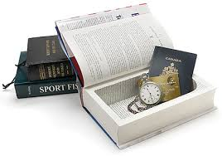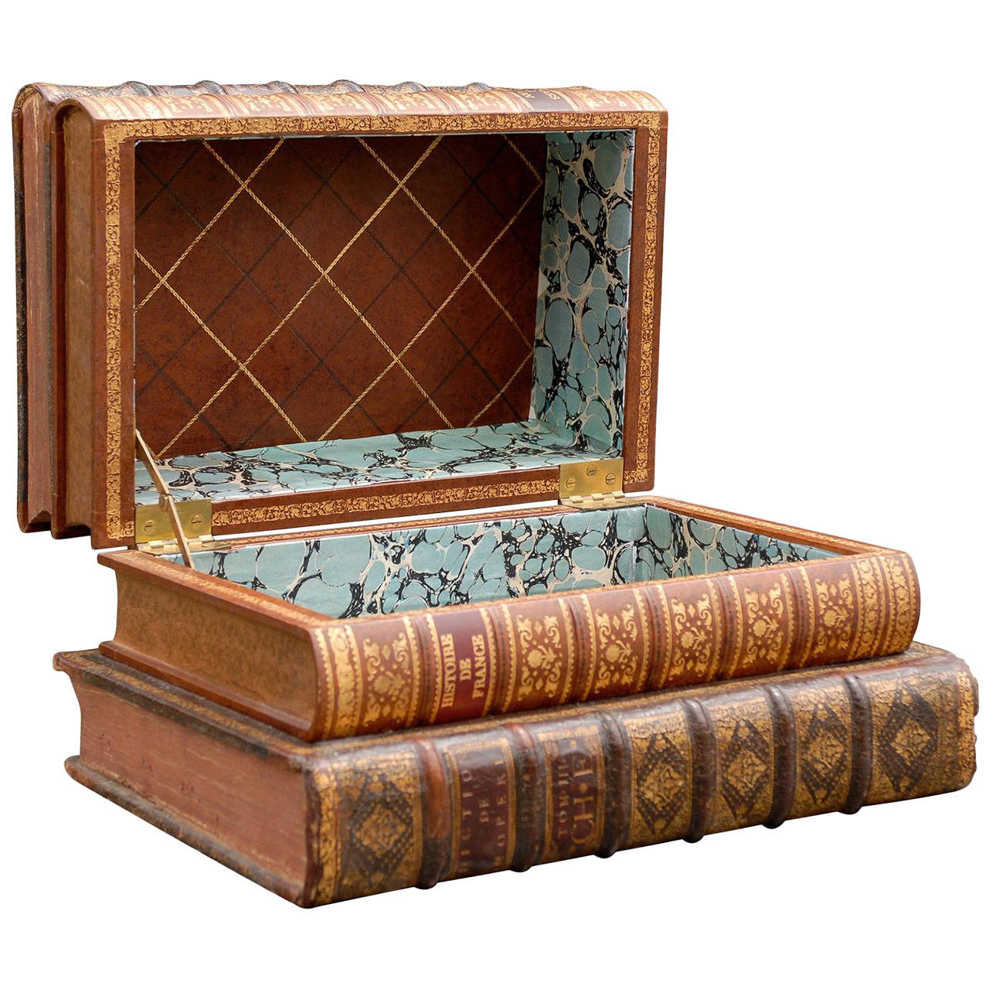

**WEEK 4/ THE BIG PICTURE**

**THE CONNECTED HOME  
KATIE BROWN**

This week I created a finalised working prototype. I decided on a scale to house the arduino circuit, I created an illustrator file of the housing, laser cut this and assembled it. I then added hinges to the inner box.

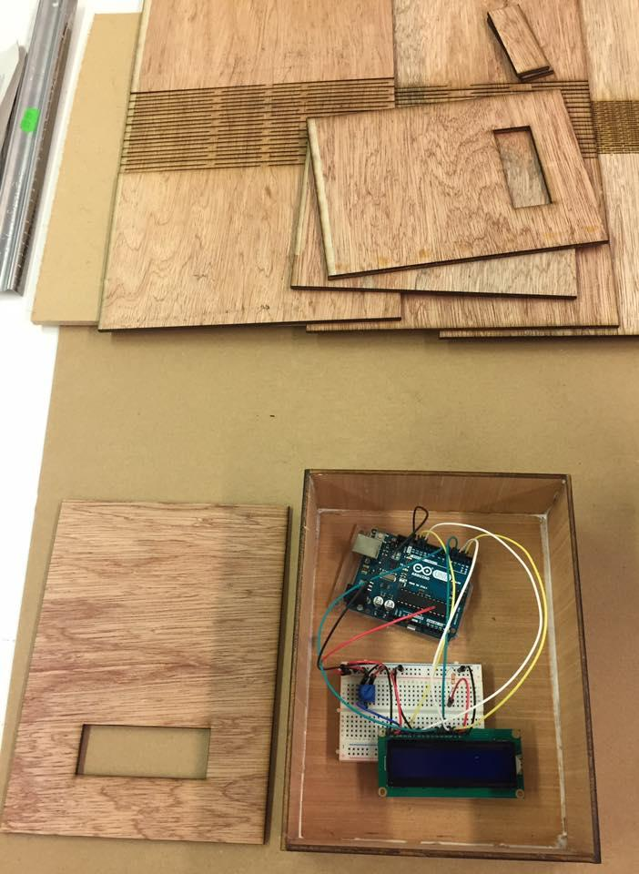14925575_1326862494005201_6736196195448266856_n.jpg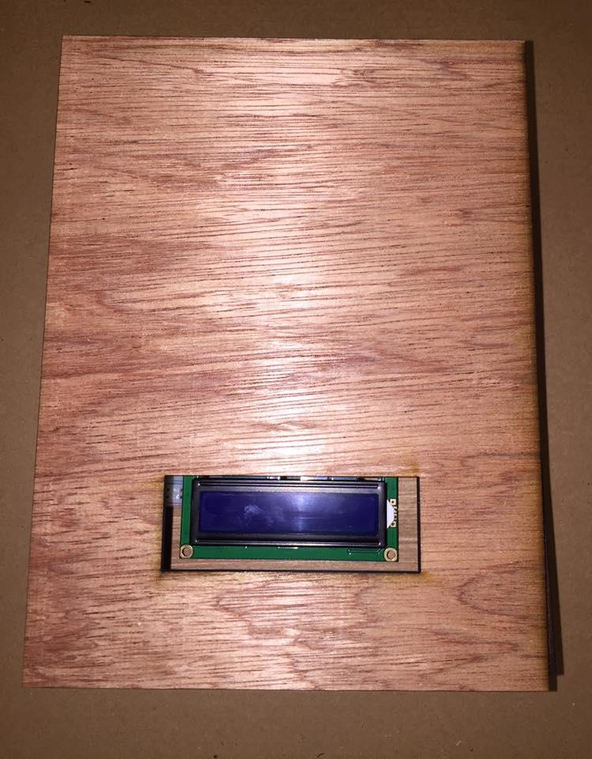

**PROTOTYPE SUMMARY:**

My experience prototype ‘Dialogue’ is designed to look like a book. Hidden within the book is an lcd, operated by arduino and processing 2.0. The book itself is laser cut, and the spine is created by cutting a pattern into the plywood, making it flexible.

Processing connects to the internet, receiving` real time updates from the BBC’s RSS newsfeeds.

Any of the seven BBC news feeds can be selected, this example is from the BBC Politics Feed.

Then from the data provided, the headline or “story” is selected and made into a string of text.

This is transmitted to the LCD screen and displayed.

While researching conversation topics, the particular area that people tend to avoid discussing is politics. This device was created specifically to encourage conversation around politics, it provides the user with a topic or story to discuss. By using a popular news website, more information on the subject can then be accessed easily. The aim of this device is to be an icebreaker and provide initial information, for a conversation on politics.

**REFLECTION**

Looking back at this project, I feel I could have spent more time working physically with the prototype to create a better housing for the arduino. The ‘book’ concept I still quite like, but if I was to continue further with this project I would reconsider the physical form of the object to perhaps be something more linked to conversations than stories.

Perhaps embed the arduino into an object that is in a space where conversations take place. Like into a coffee or dinner table, and the device could be turned on by the use of a communal object like a salt shaker. Or it could use infrared to sense when two or more people sit at the table. The device could even become more intrusive by alarming and not stopping until viewed or vibrating etc.

I am however incredibly proud that the arduino and processing code is not in any way mocked up, it is fully functioning and connected to the internet and data. There is the choice of 7 BBC RSS feeds to edit the code with to receive the different stories from. The reason that I chose the BBC’s feeds is that their RSS code was fairly easy to interpret and filter through to access the headline. Other websites had more layers and would require more coding to access. Ideally I would like to be able to draw upon multiple RSS feeds and not just the BBC to remove bias from headlines.

I think that this prototype has factors that could be developed into a technology driven way to start conversations. There are definitely a lot of areas that need improvement, but I think user testing would allow me to understand more about the conversations themselves and re-edit the prototype to really focus on creating conversation.