**WEEK 2**

**THE CONNECTED HOME**

**KATIE BROWN**

Last week I ended with a loose plan of what I wanted my design to do. “To encourage people to come together, communicate and discuss their ideas or issues.” This week I focused on how to make it bigger than a cup of tea and a chat. I briefly discussed how encouraging conversation could be used to raise awareness on political issues such as the Scottish Independence Referendum held last year. I decided to run with the idea of getting people talking about political events happening in the world and started to research into this.

Firstly I would define “political” topics to include economic and environmental issues as well as elections and government political events. As I began to research into this area, I found that a high percentage of political debate happens via social media. This is expected to be a growing platform for political debate since the 2008 American election, where Barack Obama successfully ran his campaign using social media. This was the first time a political agenda had been so widely spread and updated via social networking sites. Ever since this campaign political parties have been utilizing social media as a form of communication with the general public. The Scottish Referendum in 2015 was another showcase of the power of social media. It was the first time profile pictures on facebook were used to broadcast a political opinion bearing the emblems of ‘yes’ or ‘no thanks.’ Even after the outcome of the Scottish Referendum, many of the yes voters continued to show their political status by adding a blue 45 number to their profile picture after the extremely close vote outcome to show continued support, “We are the 45%.” This was an example of a continued support on social media for a political cause after a voting outcome.

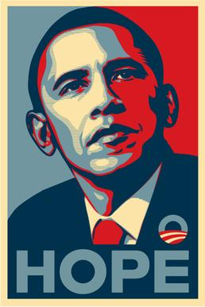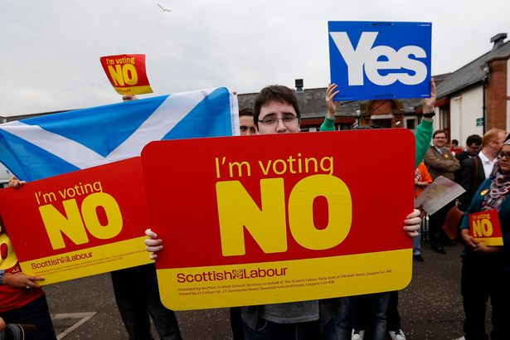

*Barack Obama campaign poster (2008) Widely shared ‘No’ vote campaign picture*

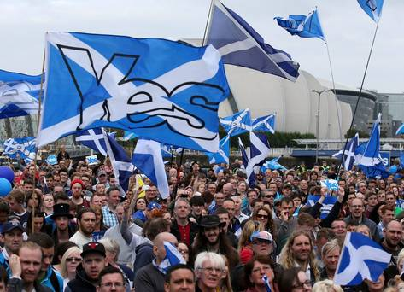

*Widely shared “Yes” Campaign picture “We are the 45%” Facebook profile picture*

Personally, I like many people who are active on social media, tend to share videos and pictures with a political agenda on social media sites. I posted a picture after voting on the referendum, I shared my views on the outcome and continue to use social media as a format to voice opinions and concerns. But social media seems like a quick fix for people who want to voice political opinions. Often the media that is shared is out of context and the sources for it are not always reliable, due to social media being accessible by anyone, and requiring a limited call for evidence or statistics to back up opinion.

Social media is beginning to mimic other media sources that are published with an existing bias. UK newspapers for example, have historically had strong allegiance with a single political party. The Sun and The Times famously switched their 1997 onwards alliance with Labour in 2005, and began to back the Conservative party. In fact most major newspapers within the UK support either Conservative or Labour policies, fueling the two horse race that still exists within UK politics. Whereas social media has encouraged the rise of political parties in the UK such as the Green Party and SNP.

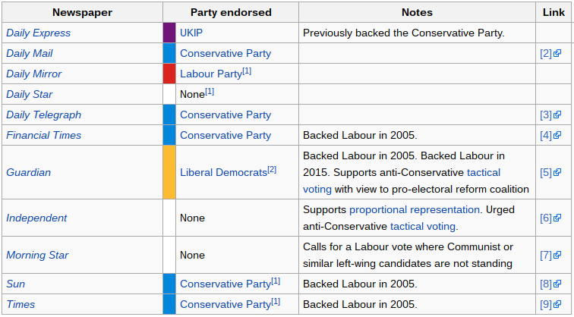

It is widely believed that online and offline deliberation on politics can improve decisions. But many people don’t want to talk politics online, let alone in person. When googling how to encourage conversation on politics, the suggested results show that people actively avoid walking into the minefield of politics.

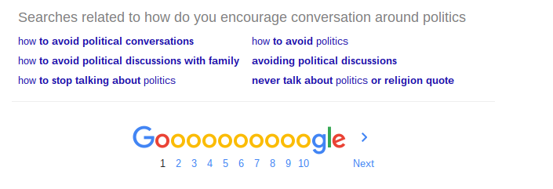

If my intended outcome is “To encourage people to come together, communicate and discuss their ideas or issues,” politics is something that really needs to be discussed.

So how do I get people interested in politics? One of my ideas was to remove the ‘face’ of politics and let people discuss policies and speeches made without linking them to a particular politician or party. This could be through receiving daily political updates from not only UK but International politics (eg the current American elections) and having the names and parties removed then read out by an AI style voice such as SIRI or ECHO/ALEXA for the listener to come to their own conclusions and be able to choose if they want to know the source after listening. However this idea is addressing individual opinions but it doesn’t necessarily facilitate a conversation around the area. Also sourcing material that is not bias and leading to the listener proves very hard in practice.

The real question I need to address is how do I get people to TALK about politics? I want to encourage a conversation and not just an individual view. In order to do this the input and output of this design has to be more inclusive. This has led to me think that my design needs reliable sources, it needs to support understanding and it has to allow for a conversation.

Upon realising these design essentials I was encouraged to research an example of a design using well sourced material. This was “The Prayer Companion” a device used to help nuns who have limited exposure to the wider world, receive worldwide and local news to include in their daily prayers. The sourcing for this device consisted of existing media that the nuns were exposed to as well as a mixture of international news sources. In summary of the designs sourcing methods the group wrote, “The point of using multiple, international RSS feeds was to counter media bias associated with any one source by exposing multiple voices.”

This is the same approach that I plan to take with my sourcing, using multiple sources and possibly allowing for factual evidence to be part of the devices communication. I also think that the object itself has to either be intrusive and playful or something non intrusive and ‘safe.’ Currently I am playing with a combination of my “social kettle” idea and how to link this social act to a political conversation.

My plan for next week is to draw on my existing research from this week, confirm a list of sources, explore the possibility of a “fact checker” element, play with a physical prototype of the device, begin to wire up arduino components and explore processing as being a critical part of the designs input.

So if “politics is the art of looking for trouble, finding it everywhere, diagnosing it incorrectly and applying the wrong remedies.” Discuss?